Supplement

Table of Contents
1. sTable 1: Spearman’s correlations between included variables
2. sFigures 1: Violin plots
a. Sensory processing sensitivity
b. Pain variables at baseline
3. sTable 2: Descriptive statistics by mood induction group
4. Differences between sensory sensitivity groups: Additional results
5. sFigures 2: Interaction plots
a. Sensitivity and pain variables combined with emotion regulation and social support
b. Sensitivity and pain variables combined with social support and parental bonding

- sTable 1: Spearman’s correlations between included variables
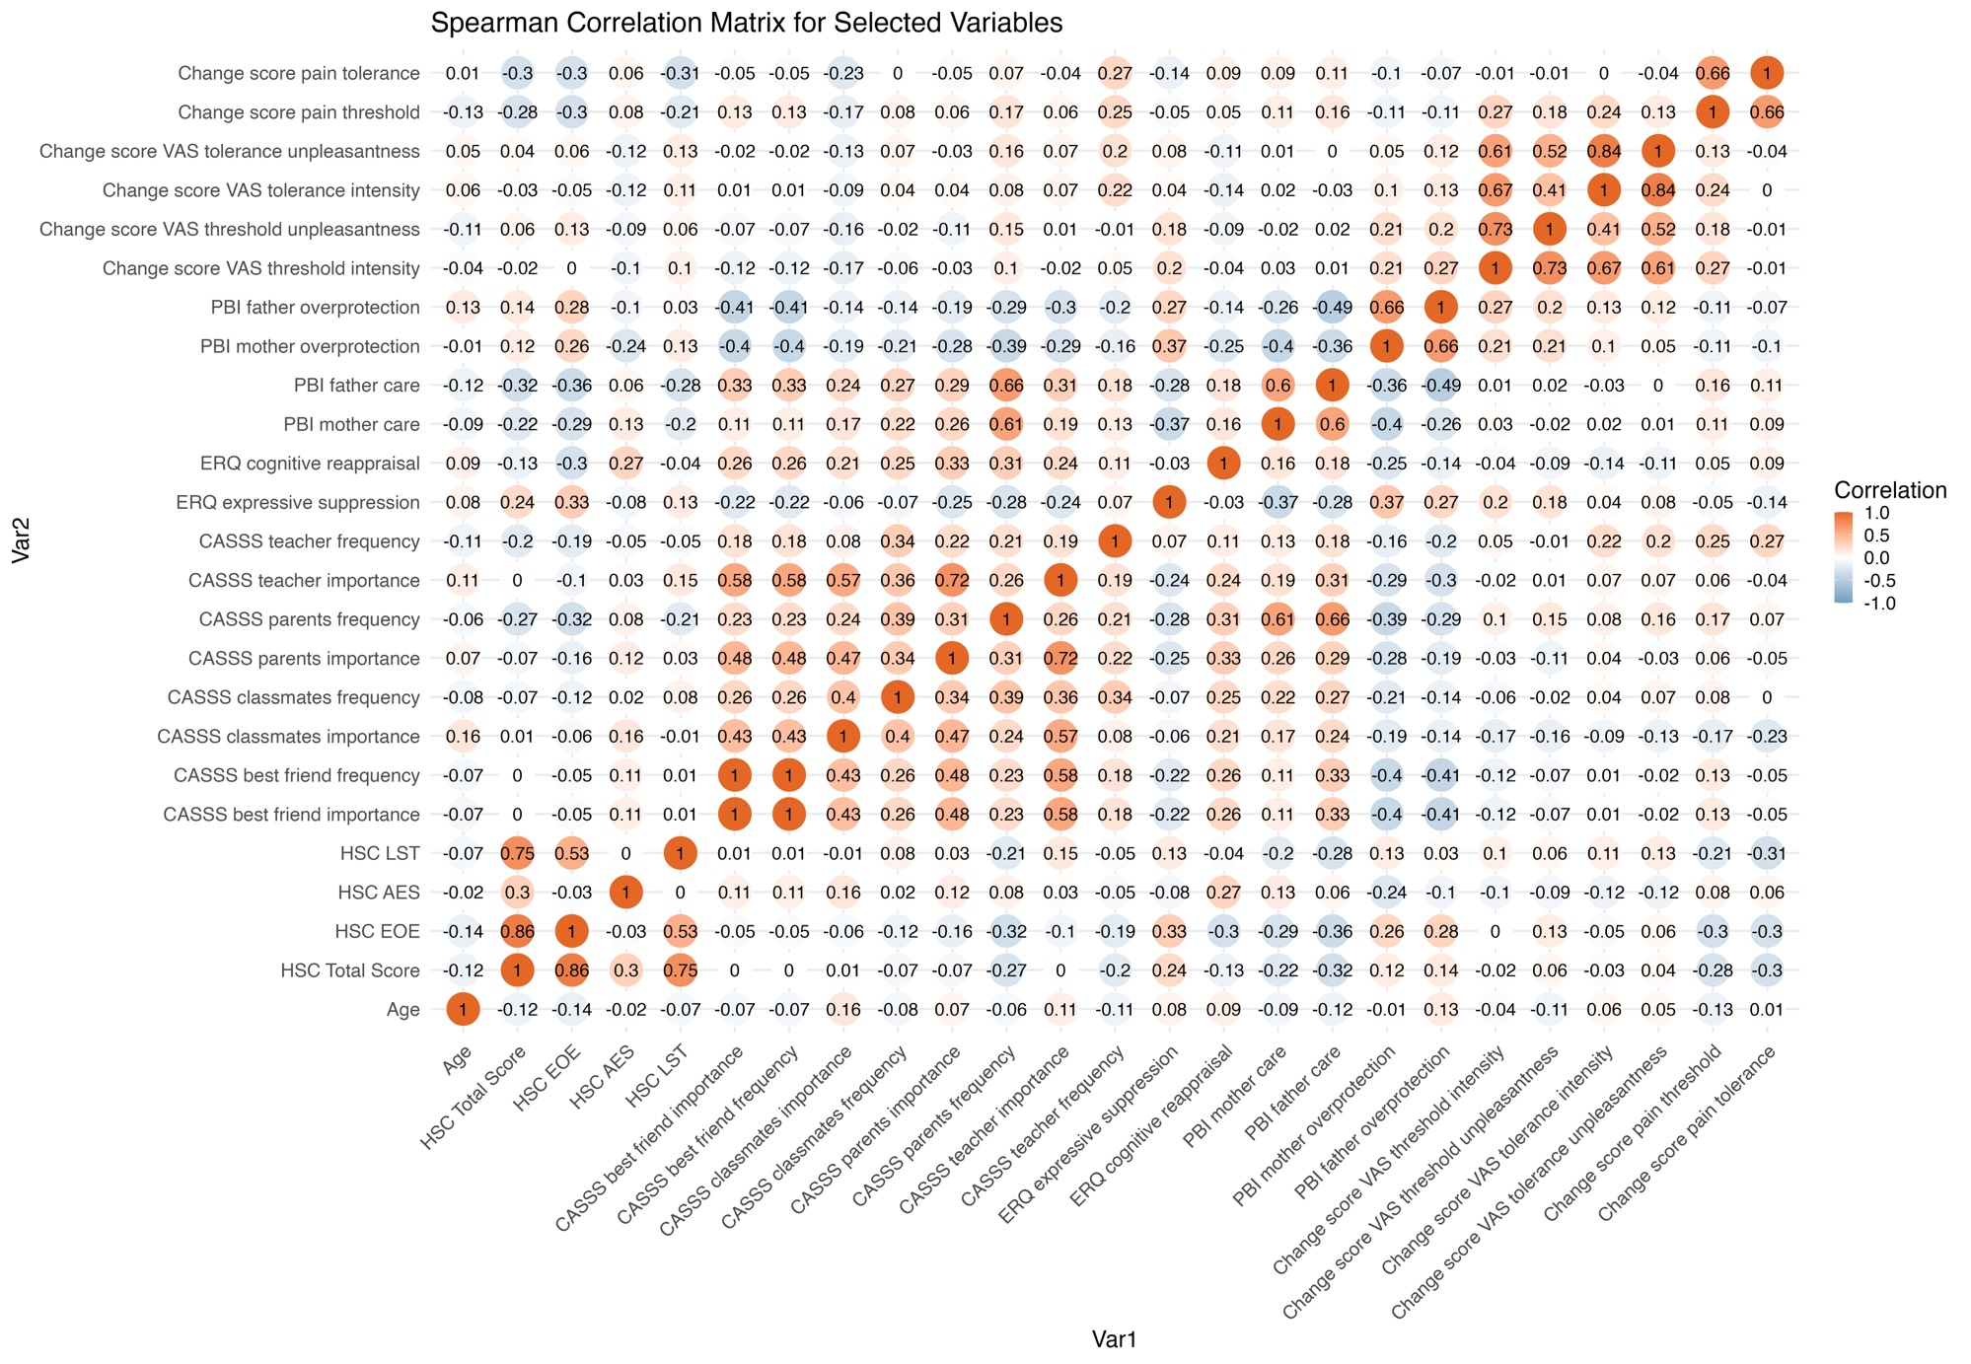
2a. sFigure 1: Violin plots: Sensory processing sensitivity

Note. HSC = Highly Sensitive Child Scale. (ai) Total score (HSC); (aii) Ease of excitation (HSC); (aiii) Aesthetic sensitivity (HSC); (aiv) Low sensory sensitivity.
2b. Violin plots: Pain variables at baseline

Note. M = Mean. (bi) Baseline VAS threshold intensity mean; (bii) Baseline VAS threshold unpleasantness mean; (biii) Baseline VAS tolerance intensity mean; (biv) Baseline VAS tolerance unpleasantness mean; (bv) Baseline Pain Tolerance, mean; (bvi) Baseline Pain Threshold mean.
3. sTable 2: Descriptive statistics by mood induction group
Variable |  | Induced emotional state neutral (N = 33) |  |  | Induced emotional state negative (N = 33) | Induced emotional state positive (N = 34) | p
Baseline
 | VAS threshold intensity, M (SD) |  | 45.32 (160.54) |  | 24.39 (79.72) | 5.38 (2.23) | .012
 | VAS threshold unpleasantness, M (SD) |  | 4.23 (2.93) |  | 3.57 (2.47) | 4.25 (2.75) | .800
 | VAS tolerance intensity, M (SD) |  | 17.18 (57.93) |  | 6.51 (2.08) | 16.94 (56.89) | .579
 | VAS tolerance unpleasantness, M (SD) |  | 6.38 (3.05) |  | 5.92 (2.41) | 6.5 (2.55) | .620
 | Heat pain tolerance, M (SD) |  | 48.52 (1.67) |  | 49.01 (1.21) | 48.69 (1.66) | .627
 | Heat pain threshold, M (SD) |  | 46.13 (2.86) |  | 46.3 (1.94) | 45.13 (3.31) | .425
Post mood induction
 | VAS threshold intensity, M (SD) |  | 14.89 (59.09) |  | 13.15 (57.45) | 13.96 (56.41) | .400
 | VAS threshold unpleasantness, M (SD) |  | 3.01 (2.6) |  | 2.4 (1.92) | 3.14 (2.22) | .566
 | VAS tolerance intensity, M (SD) |  | 16.75 (57.9) |  | 16.62 (56.89) | 16.74 (57.04) | .192
 | VAS tolerance unpleasantness, M (SD) |  | 5.83 (3.01) |  | 5.98 (2.57) | 6.4 (2.73) | .482
 | Heat pain tolerance, M (SD) |  | 47.88 (2.12) |  | 48.51 (1.45) | 48.15 (1.87) | .520
 | Heat pain threshold, M (SD) |  | 43.7 (3.84) |  | 43.51 (3.08) | 43.43 (3.6) | .348
Highly sensitive child scale values
 | Total score, M (SD) |  | 4.6 (0.77) |  | 4.53 (0.58) | 4.72 (0.69) | .693
 | Ease of excitation (EOE), M (SD) |  | 4.32 (1.25) |  | 4.27 (0.82) | 4.3 (1.06) | .403
 | Aesthetic sensitivity (AES), M (SD) |  | 5.77 (0.68) |  | 5.73 (0.86) | 5.81 (0.7) | .815
 | Low sensory threshold (LST), M (SD) |  | 3.52 (1.1) |  | 3.35 (1.07) | 3.95 (1.24) | .143
 | Low sensitivity group, n (%) |  | 4 (12.12) |  | 1 (3.03) | 2 (5.88)
 | Medium sensitivity group, n (%) |  | 13 (39.39) |  | 19 (57.58) | 17 (50.00)
 | High sensitivity group, n (%) |  | 6 (48.48) |  | 13 (39.39) | 15 (44.12)
Note. M and SD are used to represent mean and standard deviation. p is used to describe the p-value.

4. Differences between sensory sensitivity groups: Additional results
Group differences were additionally found for the ERQ subscale for expressive suppression (F_{(2,97)} = 6.116, p < 0.05). The highest sensitivity group scored highest (M = 4.16, SD = 1.08), followed by the medium (M = 3.90, SD = 1.17) and the lowest group (M = 3.30, SD = 1.40).
Significant group differences were also found on the CASSS subscale for frequency of classmate support (F_{(2,97)} = 3.091, p < 0.05). The highest scoring group was the low sensitivity group (M = 3.68, SD = 0.95), followed by the high sensitivity group (M = 3.51, SD = 0.59) and the medium sensitivity group (M = 3.18, SD = 0.94; see Table 4). The same pattern was found for the CASSS subscale for frequency of teacher support (F_{(2,96)} = 4.340, p < 0.05) (low sensitivity group, M = 3.52, SD = 1.07; high sensitivity group M = 2.99, SD = 0.73; medium sensitivity group, M = 2.93, SD = 0.82).
Also, significant differences were also found for father care of the PBI scale (F_{(2,97)} = 4.989, p < 0.01). The highest scoring group was the low sensitivity group (M = 27.8, SD = 1.25), followed by the medium (M = 25.2, SD = 1.18) and low (M = 22.2, SD = 1.25) group.
No differences were found in cognitive reappraisal (ERQ), all CASSS subscales except the teacher and classmate frequency subscale, and the two PBI subscales for overprotection and maternal care.

Fixed-Effects ANOVA concerning sensitivity group differences
Predictor | Sum  of  Squares | df | Mean  Square | F | p | _{partial} η² | _{partial} η²  90% CI  [LL, UL]
Expressive suppression (ERQ)
(Intercept) | 1428.66 | 1 | 1428.66 | 957.49 | .000
Sensitivity group | 12.23 | 2 | 6.12 | 4.10 | .020 | .08 | [.01, .16]
Error | 144.73 | 97 | 1.49
Classmates frequency (CASSS)
(Intercept) | 1190.20 | 1 | 1190.20 | 1653.01 | .000
Sensitivity group | 4.45 | 2 | 2.23 | 3.09 | .050 | .06 | [.00, .14]
Error | 69.84 | 97 | 0.72
Teacher frequency (CASSS)
(Intercept) | 974.70 | 1 | 974.70 | 1239.81 | .000
Sensitivity group | 6.82 | 2 | 3.41 | 4.34 | .016 | .08 | [.01, .17]
Error | 75.47 | 96 | 0.79
Father care (PBI)
(Intercept) | 62671.68 | 1 | 62671.68 | 1244.94 | .000
Sensitivity group | 502.27 | 2 | 251.13 | 4.99 | .009 | .09 | [.01, .18]
Error | 4883.09 | 97 | 50.34
Note. LL and UL represent the lower-limit and upper-limit of the partial η² confidence interval, respectively.

5a. sFigure 2: Interaction plots: Sensitivity and pain variables combined with emotion regulation and social support
(ai) Interaction between low sensory threshold and expressive suppression; (aii) Interaction between aesthetic sensitivity and best friend importance; (aiii) Interaction between aesthetic sensitivity and best friend importance; (aiv) Interaction between aesthetic sensitivity and best friend frequency; (av) Interaction between aesthetic sensitivity and best friend frequency.
5b. Interaction plots: Sensitivity and pain variables combined with social support and parental bonding
(bi) Interaction between aesthetic sensitivity and teacher importance; (bii) Interaction between aesthetic sensitivity and teacher importance; (biii) Interaction between aesthetic sensitivity and teacher frequency; (biv) Interaction between aesthetic sensitivity and father overprotection; (bv) Interaction between low sensory threshold and father overprotection.

