SUPPLEMENTARY MATERIAL
Seo et al
Impact of Demographics and Insurance Coverage on Schizophrenia Treatment and Healthcare Resource Utilization Within an Integrated Healthcare System

Table of Contents
Supplemental Figure 1. Patient attrition. 2
Supplemental Table 1. Multivariable logistic regression analyses 3

Supplemental Figure 1. Patient attrition.

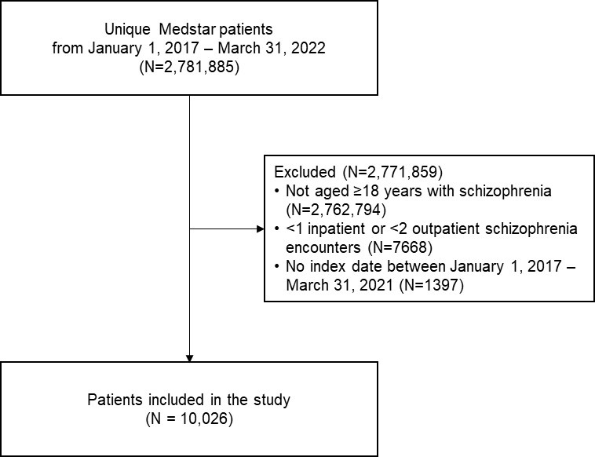

Supplemental Table 1. Multivariable logistic regression analyses
Parameter | Model A  (Insurance type only) |  | Model B  (Insurance type & age) |  | Model C  (Insurance type, age &  race/ethnicity)
Parameter | OR (95% CI) | P value | OR_{a} (95% CI) | P value | OR_{a} (95% CI) | P value
Second-generation antipsychotic
Medicare vs Medicaid | 0.80 (0.73–0.88) | <.001 | 0.88 (0.79–0.97) | .012 | 0.87 (0.79–0.96) | .008
Other vs Medicaid | 0.92 (0.80–1.05) | NS | 0.89 (0.78–1.02) | NS | 0.87 (0.76–1.00) | NS
Inpatient visits
Medicare vs Medicaid | 0.69 (0.63–0.75) | <.001 | 0.74 (0.68–0.82) | <.001 | 0.75 (0.68–0.82) | <.001
Other vs Medicaid | 0.83 (0.73–0.94) | .005 | 0.78 (0.69–0.89) | <.001 | 0.77 (0.67–0.87) | <.001
Outpatient visits
Medicare vs Medicaid | 1.99 (1.83–2.17) | <.001 | 1.44 (1.31–1.58) | <.001 | 1.42 (1.29–1.57) | <.001
Other vs Medicaid | 0.94 (0.83–1.07) | NS | 1.00 (0.88–1.14) | NS | 1.01 (0.89–1.15) | NS
Emergency department visits
Medicare vs Medicaid | 0.73 (0.67–0.80) | <.001 | 0.83 (0.76–0.91) | <.001 | 0.83 (0.75–0.91) | <.001
Other vs Medicaid | 0.60 (0.53–0.68) | <.001 | 0.61 (0.54–0.69) | <.001 | 0.62 (0.55–0.70) | <.001
CI, confidence interval; NS, not significant; OR, odds ratio; OR_{a}, adjusted odds ratio.

