Supplementary material

Contents:

1. NMR and HRMS of target compounds 1-32 (Figure S1-S96)
2. IC₅₀ of compounds 30-32 on PDHK1 (Figure S97-S99)
3. IC₅₀ of compounds 30-32 on PDHK4 (Figure S100-S102)
4. Drug-likeness properties and Predicted ADME/T profiles of compound 32 (Table S1-S2)

1. NMR and HRMS of target compounds 1-32
- ¹H-NMR-compound 1
Figure S1. ¹H NMR of compound 1
- ¹³C-NMR-compound 1
Figure S2. ¹³C NMR of compound 1
- HRMS of compound 1
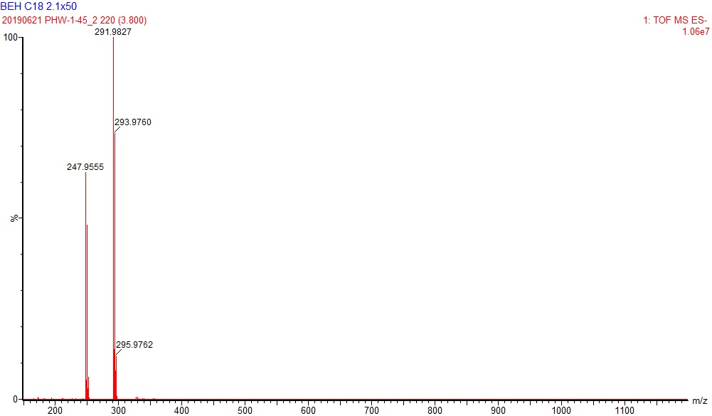
Figure S3.HRMS(ESI) of compound 1.

- ¹H-NMR-compound 2
Figure S4.¹H NMR of compound 2
- ¹³C-NMR-compound 2
Figure S5.¹³C NMR of compound 2

- HRMS of compound 2
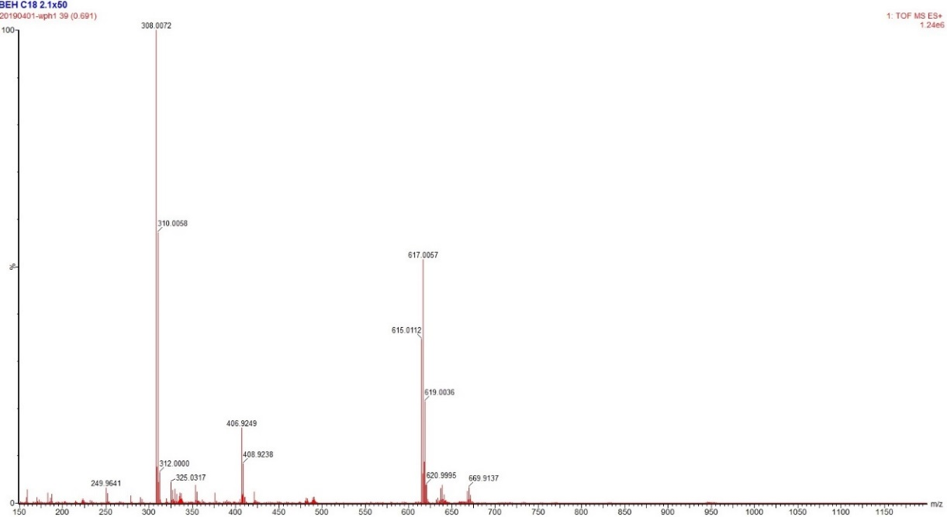
Figure S6. HRMS(ESI) of compound 2.

- ¹H-NMR-compound 3
Figure S7. ¹H NMR of compound 3
- ¹³C-NMR-compound 3
Figure S8. ¹³C NMR of compound 3

- HRMS of compound 3
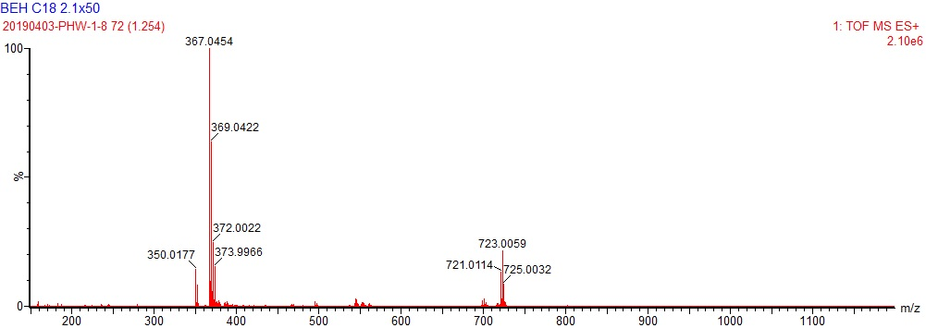
Figure S9. HRMS(ESI) of compound 3.

- ¹H-NMR-compound 4
Figure S10. ¹H NMR of compound 4

- ¹³C-NMR-compound 4
Figure S11. ¹³C NMR of compound 4

- HRMS of compound 4
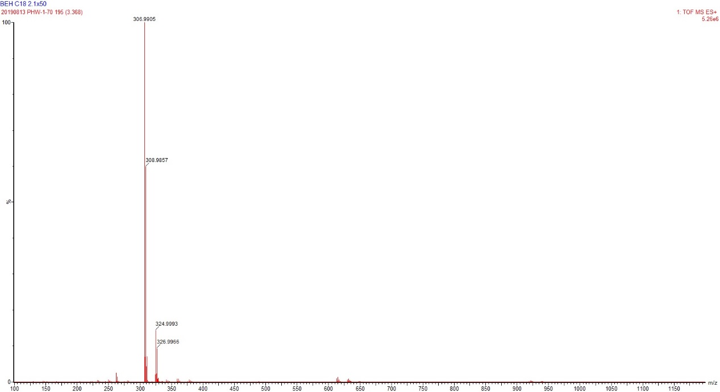
Figure S12. HRMS(ESI) of compound 4.

- ¹H-NMR-compound 5
Figure S13. ¹H NMR of compound 5
- ¹³C-NMR-compound 5
Figure S14. ¹³C NMR of compound 5
- HRMS of compound 5
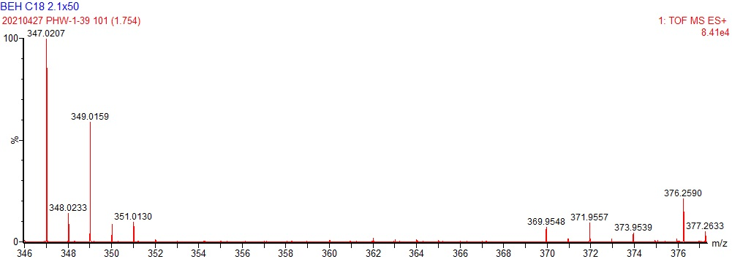
Figure S15. HRMS(ESI) of compound 5.

- ¹H-NMR-compound 6
Figure S16. ¹H NMR of compound 6
- ¹³C-NMR-compound 6
Figure S17. ¹³C NMR of compound 6

- HRMS of compound 6
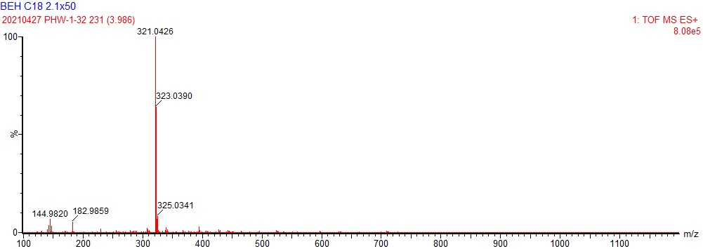
Figure S18. HRMS(ESI) of compound 6.

- ¹H-NMR-compound 7
Figure S19. ¹H NMR of compound 7
- ¹³C-NMR-compound 7
Figure S20. ¹³C NMR of compound 7
- HRMS of compound 7
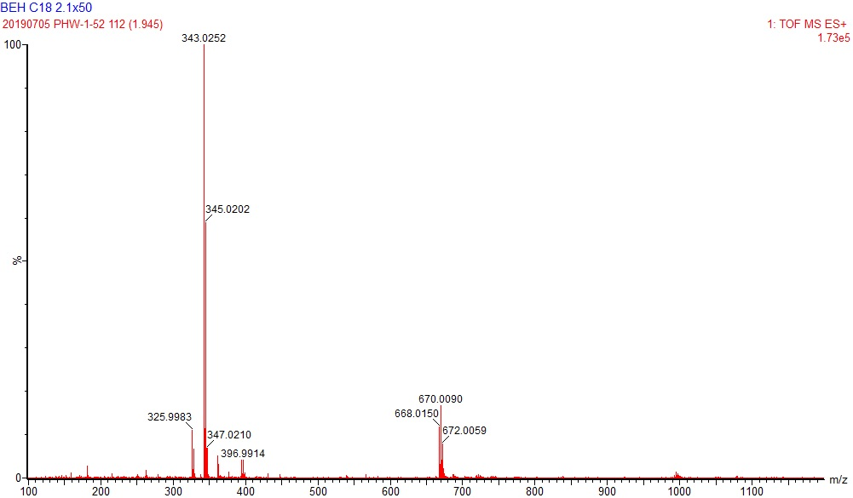
Figure S21. HRMS(ESI) of compound 7.

- ¹H-NMR-compound 8
Figure S22. ¹H NMR of compound 8

- ¹³C-NMR-compound 8
Figure S23. ¹³C NMR of compound 8

- HRMS of compound 8
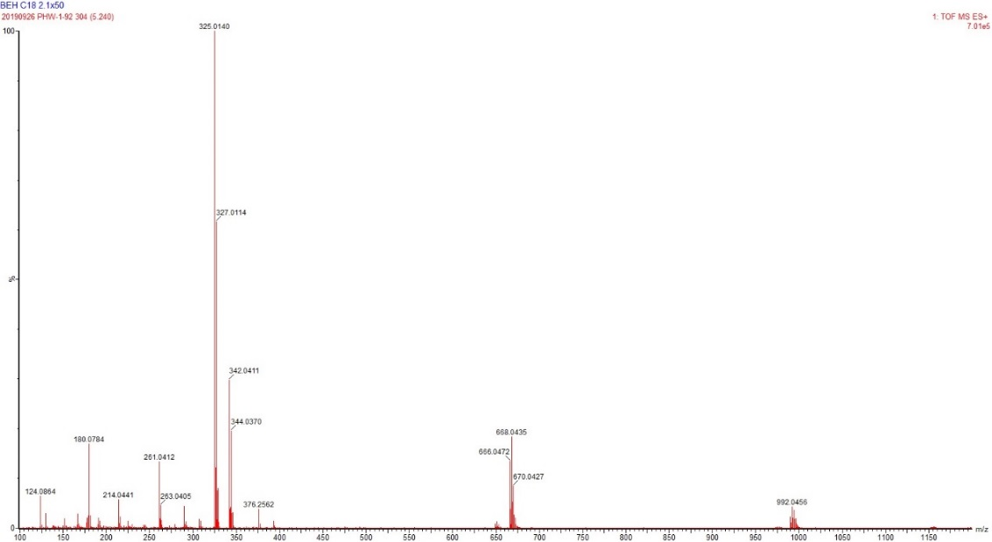
Figure S24. HRMS(ESI) of compound 8.

- ¹H-NMR-compound 9
Figure S25. ¹H NMR of compound 9
- ¹³C-NMR-compound 9
Figure S26. ¹³C NMR of compound 9
- HRMS of compound 9
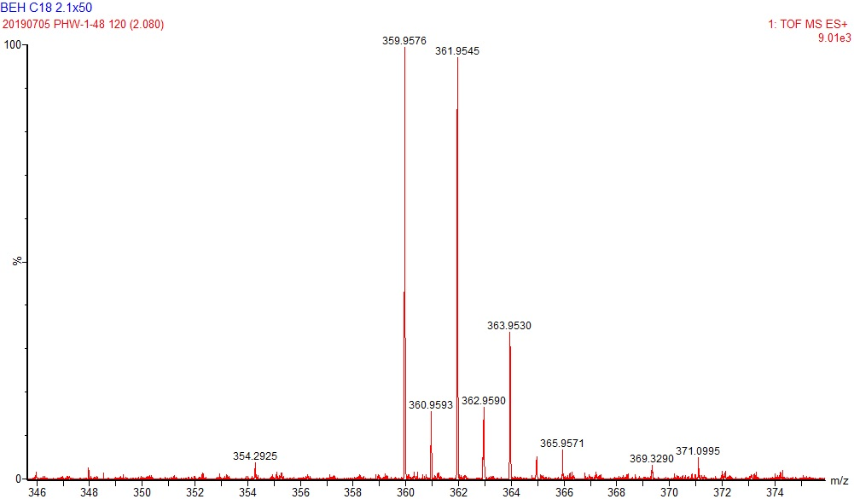
Figure S27. HRMS(ESI) of compound 9.

- ¹H-NMR-compound 10
Figure S28. ¹H NMR of compound 10
- ¹³C-NMR-compound 10
Figure S29. ¹³C NMR of compound 10
- HRMS of compound 10
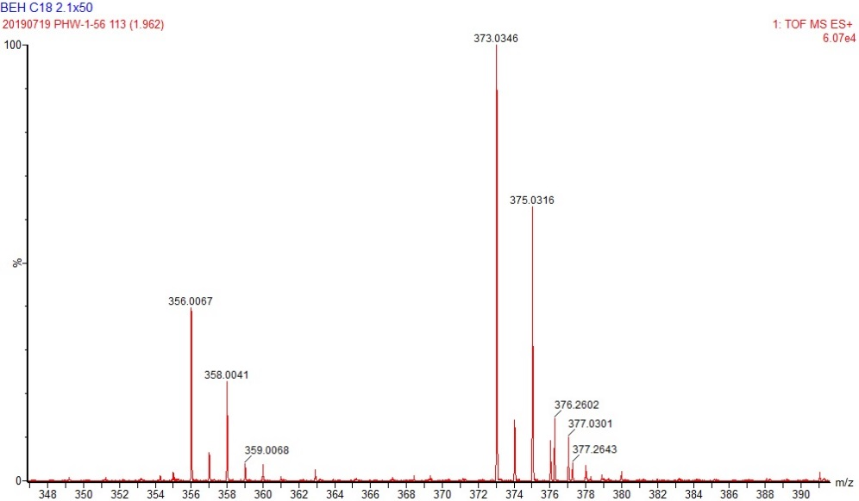
Figure S30. HRMS(ESI) of compound 10.

- ¹H-NMR-compound 11
Figure S31. ¹H NMR of compound 11
- ¹³C-NMR-compound 11
Figure S32. ¹³C NMR of compound 11
- HRMS of compound 11
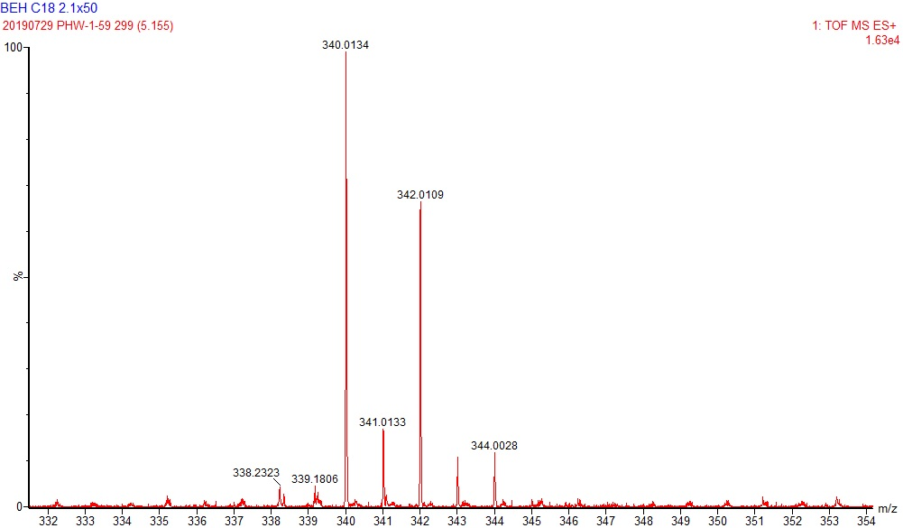
Figure S33. HRMS(ESI) of compound 11.

- ¹H-NMR-compound 12
Figure S34. ¹H NMR of compound 12
- ¹³C-NMR-compound 12
Figure S35. ¹³C NMR of compound 12

- HRMS of compound 12
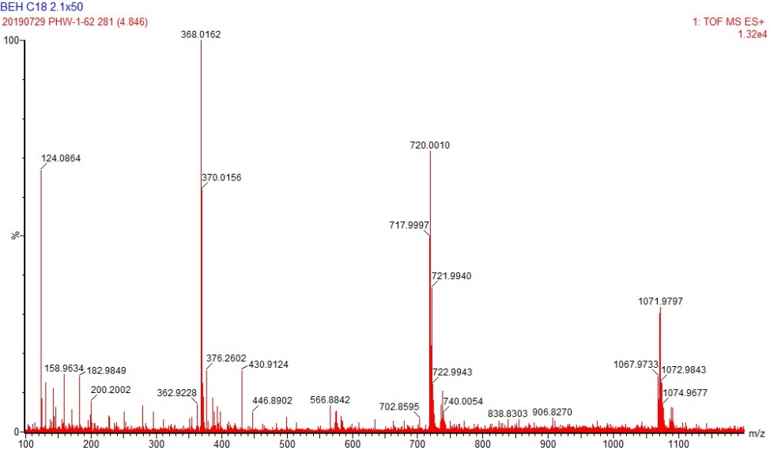
Figure S36. HRMS(ESI) of compound 12.

- ¹H-NMR-compound 13
Figure S37. ¹H NMR of compound 13
- ¹³C-NMR-compound 13
Figure S38. ¹³C NMR of compound 13
- HRMS of compound 13
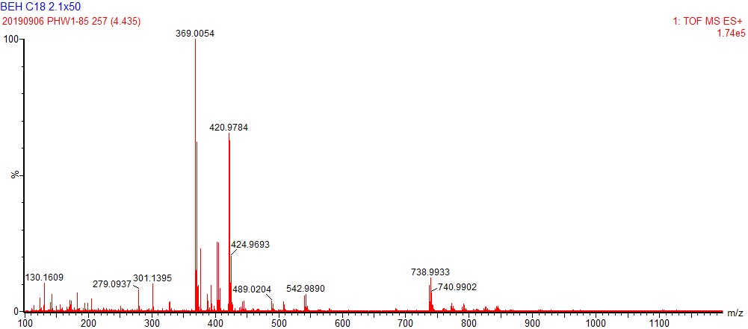
Figure S39. HRMS(ESI) of compound 13.

- ¹H-NMR-compound 14
Figure S40. ¹H NMR of compound 14
- ¹³C-NMR-compound 14
Figure S41. ¹³C NMR of compound 14

- HRMS of compound 14
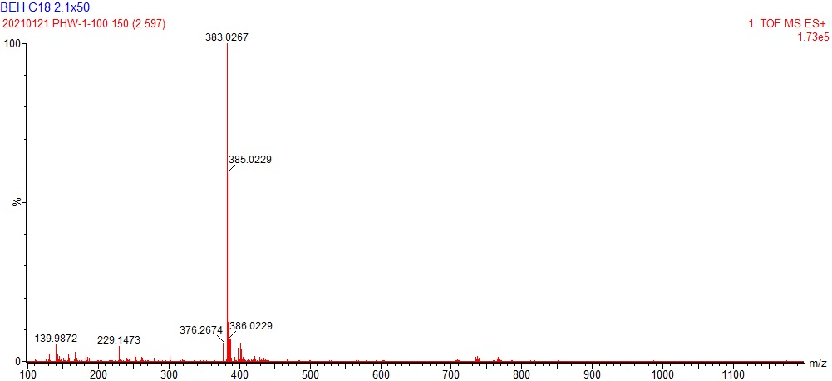
Figure S42. HRMS(ESI) of compound 14.

- ¹H-NMR-compound 15
Figure S43. ¹H NMR of compound 15
- ¹³C-NMR-compound 15
Figure S44. ¹³C NMR of compound 15

- HRMS of compound 15
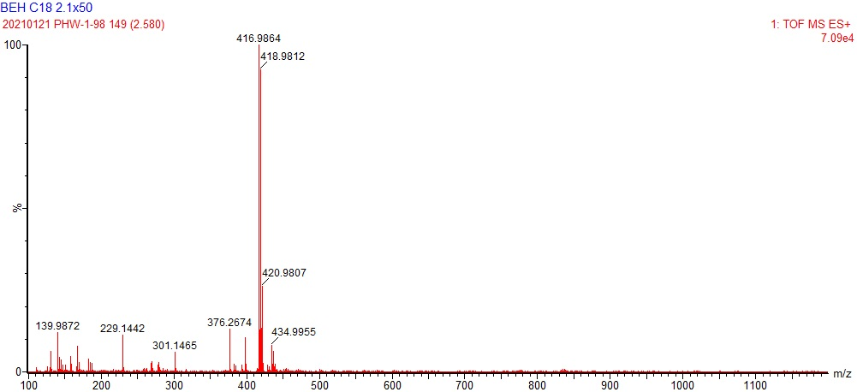
Figure S45. HRMS(ESI) of compound 15.

- ¹H-NMR-compound 16
Figure S46. ¹H NMR of compound 16
- ¹³C-NMR-compound 16
Figure S47. ¹³C NMR of compound 16

- HRMS of compound 16
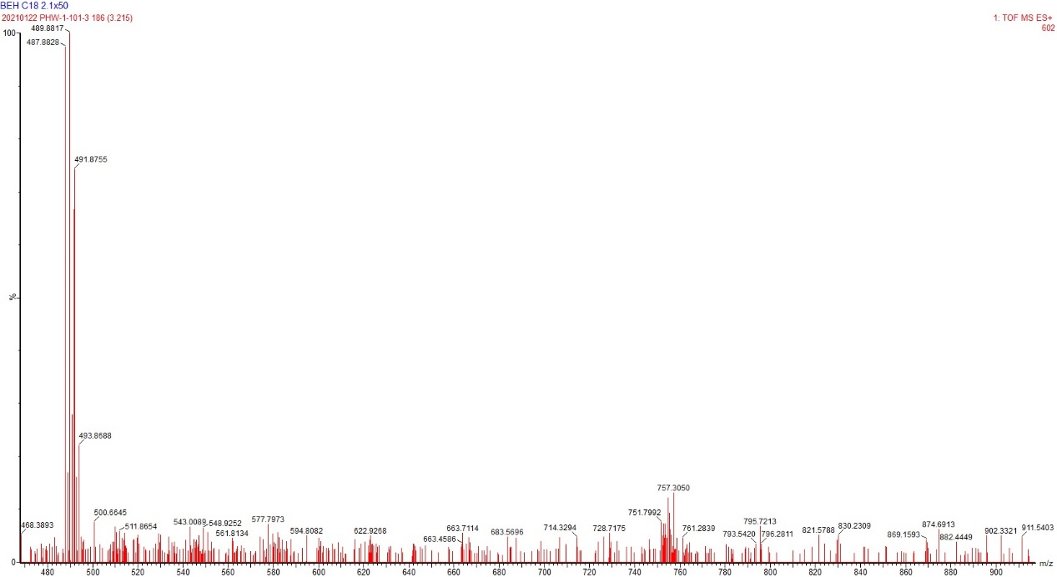
Figure S48. HRMS(ESI) of compound 16.

- ¹H-NMR-compound 17
Figure S49. ¹H NMR of compound 17
- ¹³C-NMR-compound 17
Figure S50. ¹³C NMR of compound 17
- HRMS of compound 17
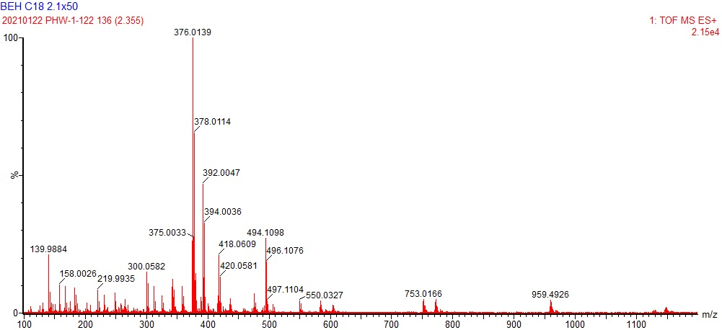
Figure S51. HRMS(ESI) of compound 17.

- ¹H-NMR-compound 18
Figure S52. ¹H NMR of compound 18
- ¹³C-NMR-compound 18
Figure S53. ¹³C NMR of compound 18
- HRMS of compound 18
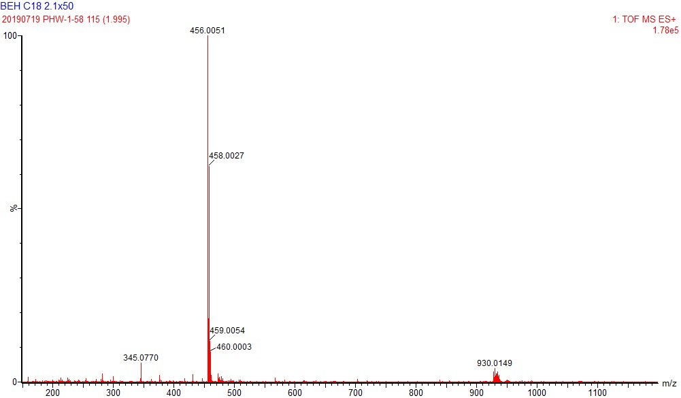Figure S54. HRMS(ESI) of compound 18.

- ¹H-NMR-compound 19
Figure S55. ¹H NMR of compound 19
- ¹³C-NMR-compound 19
Figure S56. ¹³C NMR of compound 19
- HRMS of compound 19
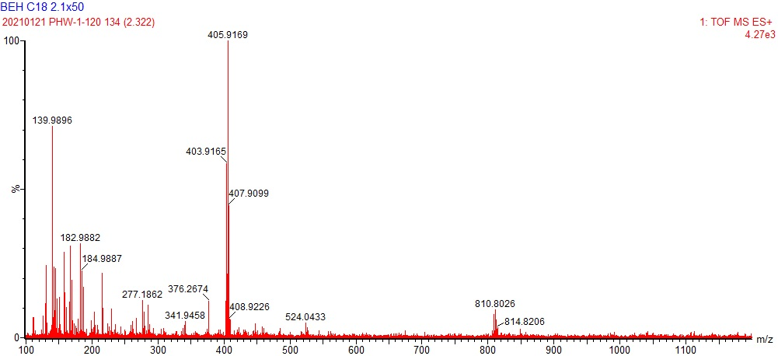
Figure S57. HRMS(ESI) of compound 19.

- ¹H-NMR-compound 20
Figure S58. ¹H NMR of compound 20
- ¹³C-NMR-compound 20
Figure S59. ¹³C NMR of compound 20

- HRMS of compound 20
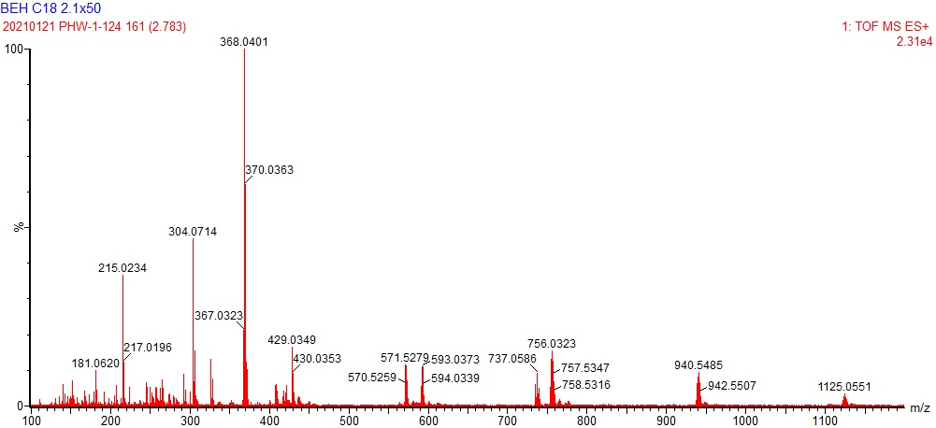
Figure S60. HRMS(ESI) of compound 20.

- ¹H-NMR-compound 21
Figure S61. ¹H NMR of compound 21
- ¹³C-NMR-compound 21
Figure S62. ¹³C NMR of compound 21
- HRMS of compound 21
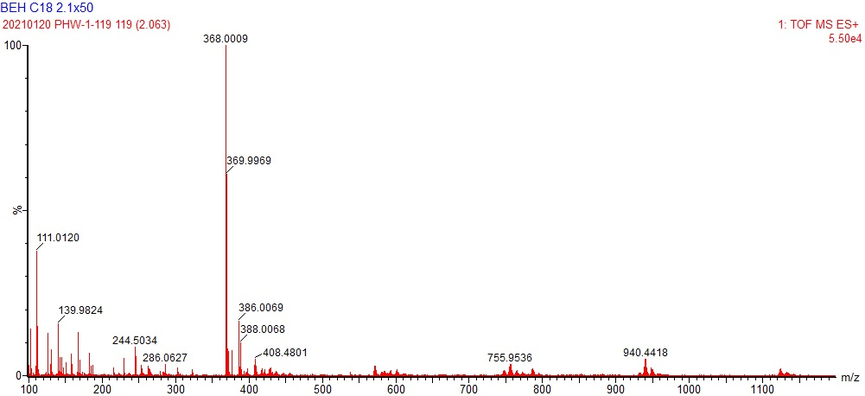
Figure S63. HRMS(ESI) of compound 21.

- ¹H-NMR-compound 22
Figure S64. ¹H NMR of compound 22

- ¹³C-NMR-compound 22
Figure S65. ¹³C NMR of compound 22

- HRMS of compound 22
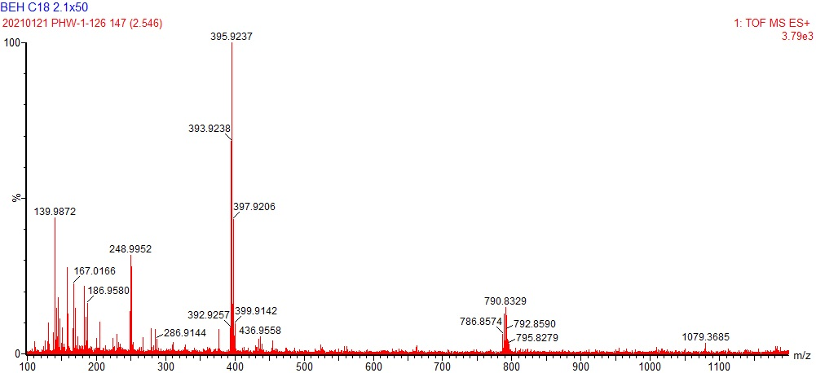Figure S66. HRMS(ESI) of compound 22.

- ¹H-NMR-compound 23
Figure S67. ¹H NMR of compound 23
- ¹³C-NMR-compound 23
Figure S68. ¹³C NMR of compound 23
- HRMS of compound 23
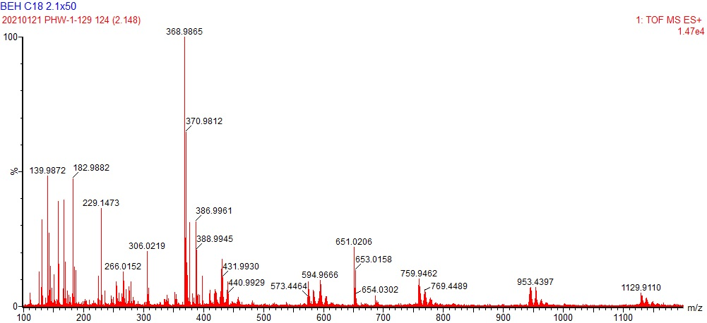
Figure S69. HRMS(ESI) of compound 23.

- ¹H-NMR-compound 24
Figure S70. ¹H NMR of compound 24
- ¹³C-NMR-compound 24
Figure S71. ¹³C NMR of compound 24

- HRMS of compound 24
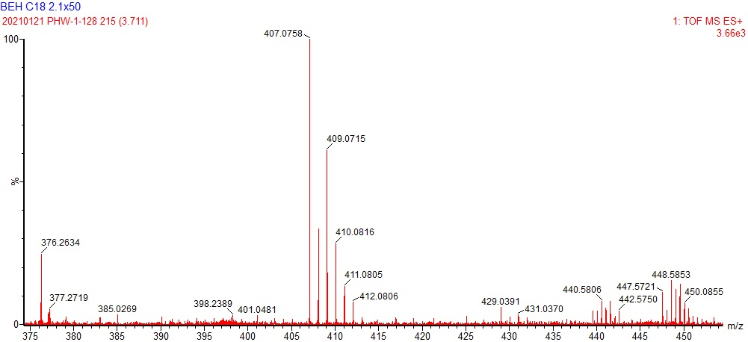
Figure S72. HRMS(ESI) of compound 24.

- ¹H-NMR-compound 25
Figure S73. ¹H NMR of compound 25
- ¹³C-NMR-compound 25
Figure S74. ¹³C NMR of compound 25
- HRMS of compound 25
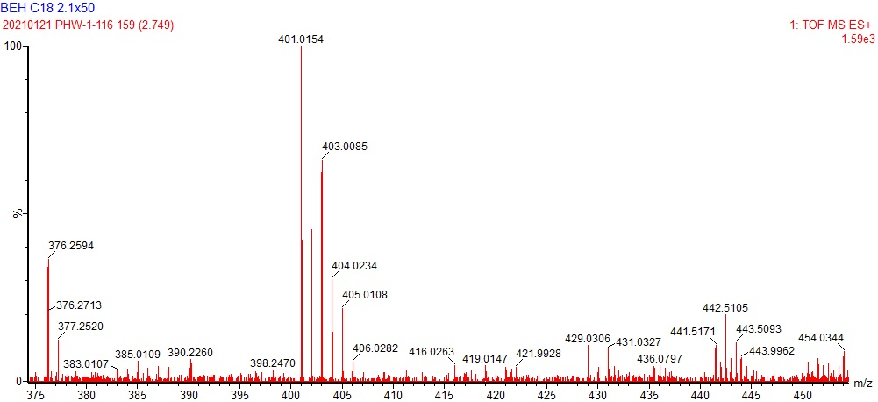
Figure S75. HRMS(ESI) of compound 25.

- ¹H-NMR-compound 26
Figure S76. ¹H NMR of compound 26
- ¹³C-NMR-compound 26
Figure S77. ¹³C NMR of compound 26

- HRMS of compound 26
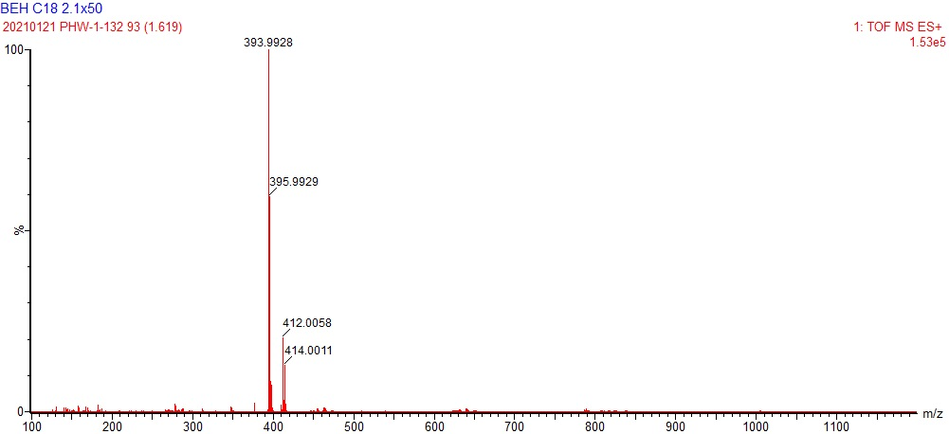
Figure S78. HRMS(ESI) of compound 26.

- ¹H-NMR-compound 27
Figure S79. ¹H NMR of compound 27
- ¹³C-NMR-compound 27
Figure S80. ¹³C NMR of compound 27
- HRMS of compound 27
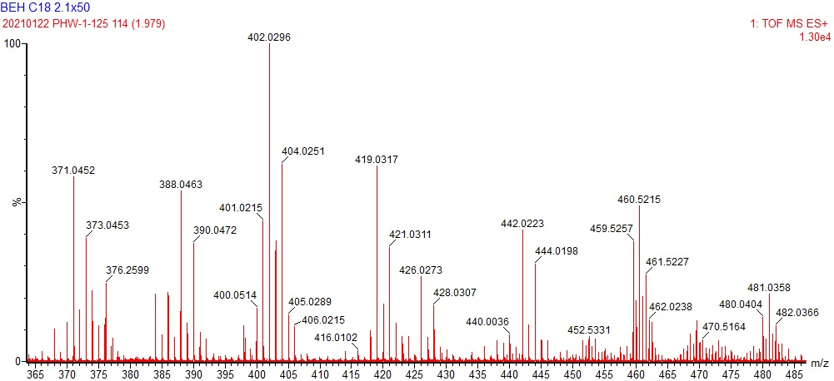
Figure S81. HRMS(ESI) of compound 27.

- ¹H-NMR-compound 28
Figure S82. ¹H NMR of compound 28
- ¹³C-NMR-compound 28
Figure S83. ¹³C NMR of compound 28

- HRMS of compound 28
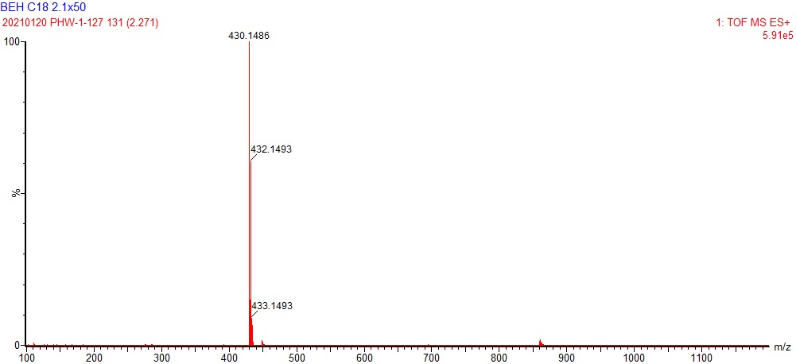
Figure S84. HRMS(ESI) of compound 28.

- ¹H-NMR-compound 29
Figure S85. ¹H NMR of compound 29
- ¹³C-NMR-compound 29
Figure S86. ¹³C NMR of compound 29
- HRMS of compound 29
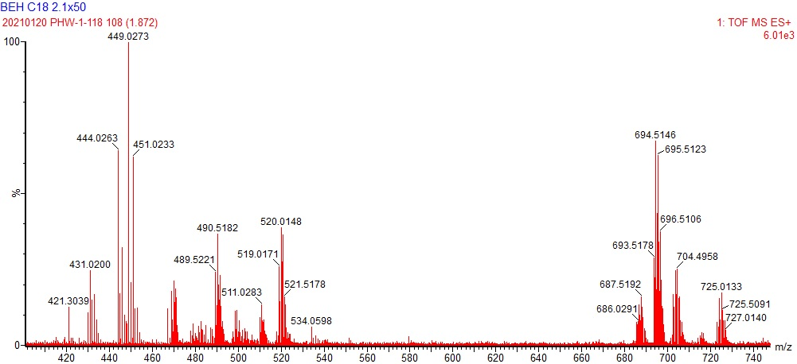Figure S87. HRMS(ESI) of compound 29.

- ¹H-NMR-compound 30
Figure S88. ¹H NMR of compound 30
- ¹³C-NMR-compound 30
Figure S89. ¹³C NMR of compound 30

- HRMS of compound 30
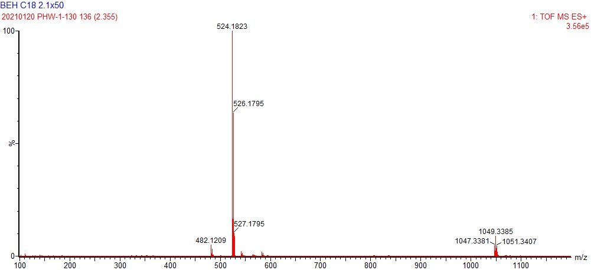Figure S90. HRMS(ESI) of compound 30.

- ¹H-NMR-compound 31
Figure S91. ¹H NMR of compound 31
- ¹³C-NMR-compound 31
Figure S92. ¹³C NMR of compound 31
- HRMS of compound 31
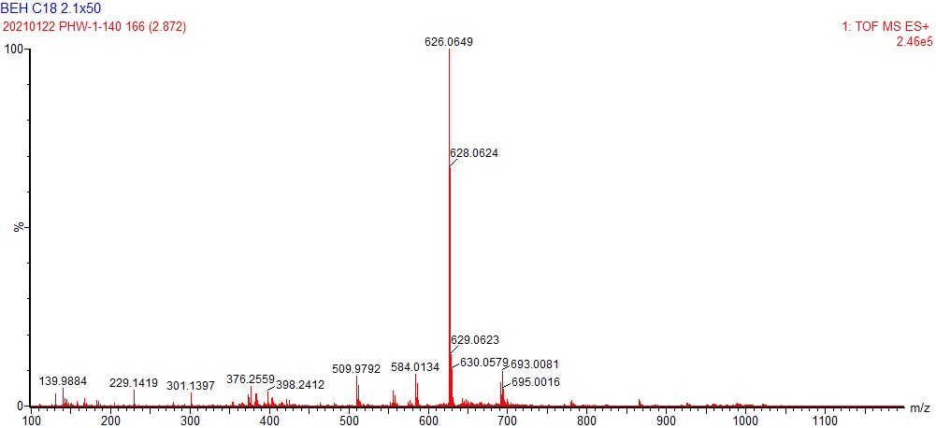Figure S93. HRMS(ESI) of compound 31.

- ¹H-NMR-compound 32
Figure S94. ¹H NMR of compound 32
- ¹³C-NMR-compound 32
Figure S95. ¹³C NMR of compound 32

- HRMS of compound 32
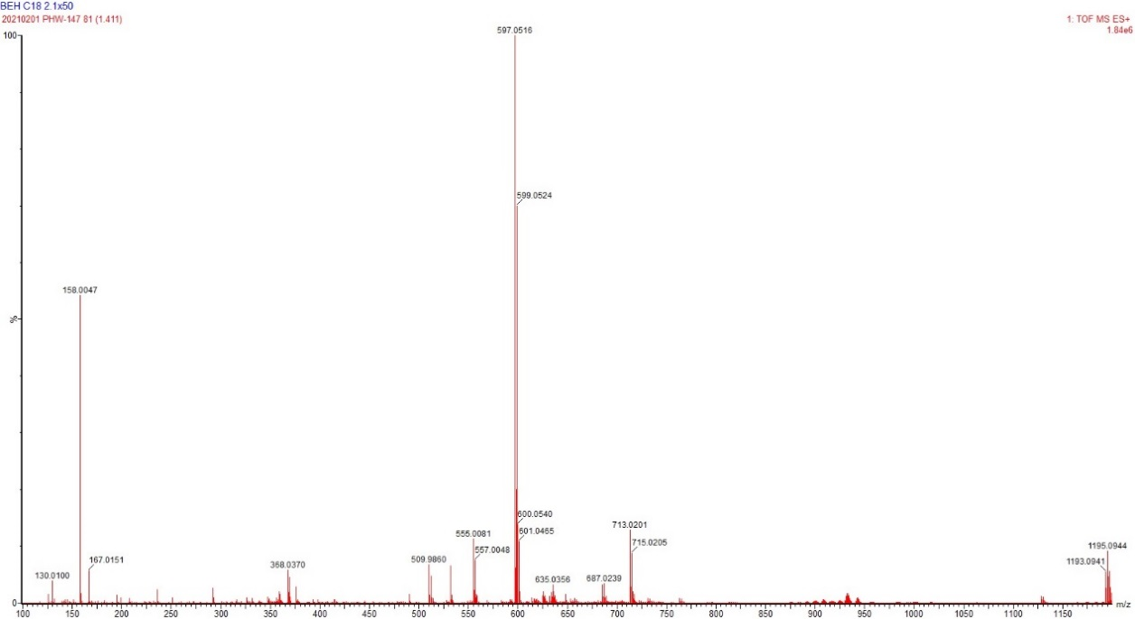Figure S96. HRMS(ESI) of compound 32.

3. IC₅₀ of compounds 30-32 on PDHK1
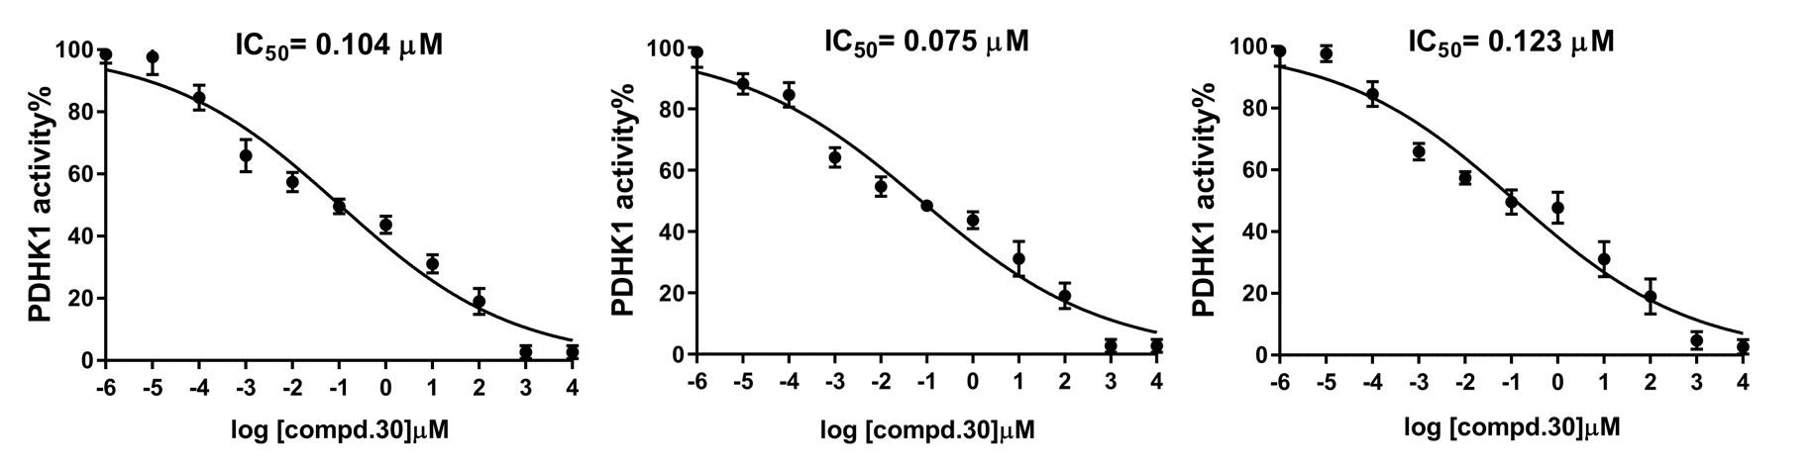
Figure S97. IC₅₀ curves of compound 30 on PDHK1

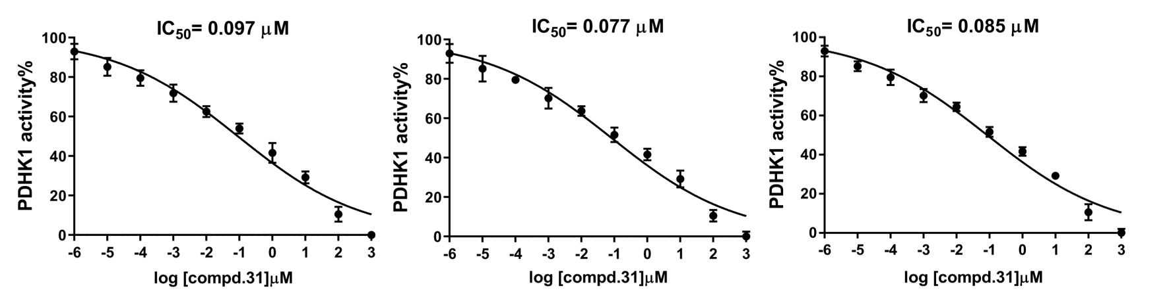
Figure S98. IC₅₀ curves of compound 31 on PDHK1

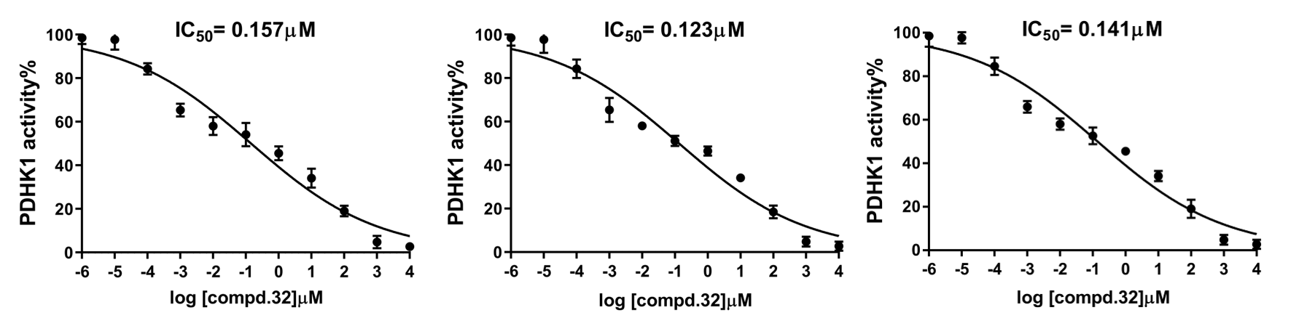
Figure S99. IC₅₀ curves of compound 32 on PDHK1

4. IC₅₀ of compounds 30-32 on PDHK4
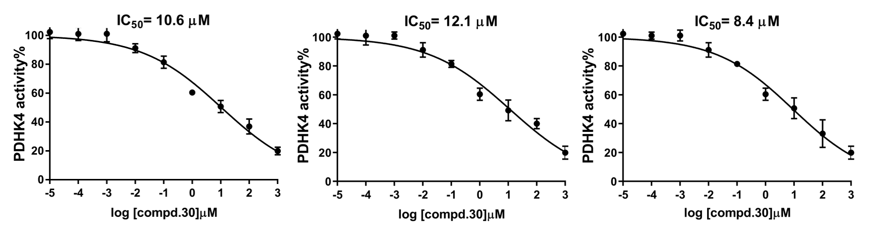
Figure S100. IC₅₀ curves of compound 30 on PDHK4
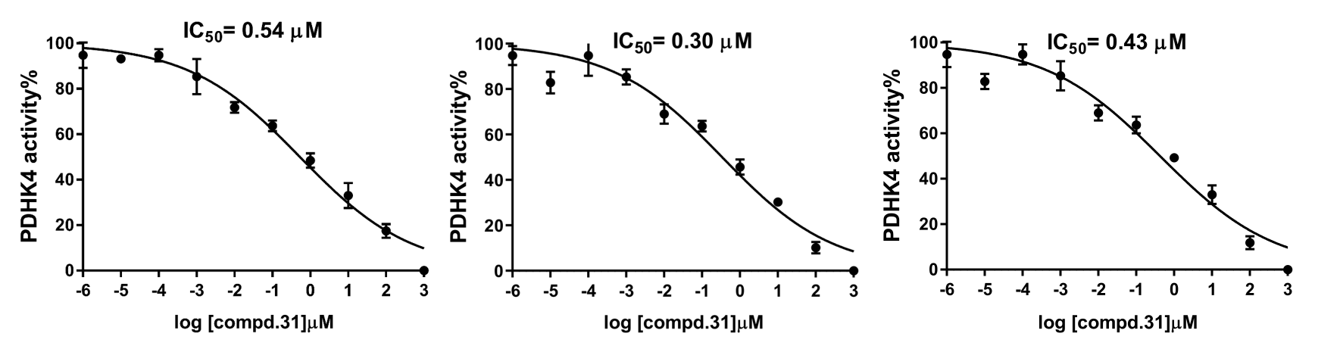
Figure S101. IC₅₀ curves of compound 31 on PDHK4

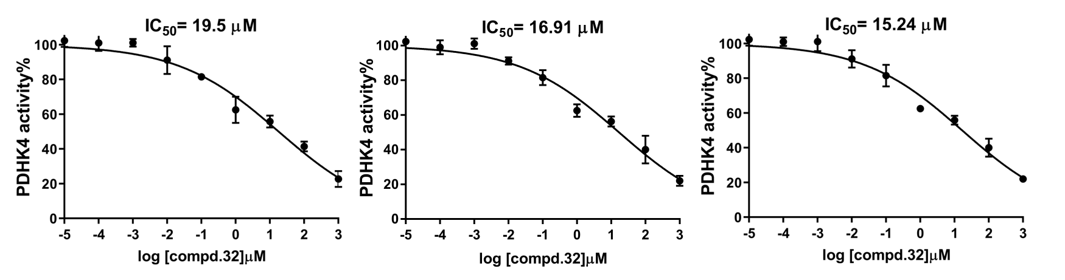
Figure S102. IC₅₀ curves of compound 32 on PDHK4

5. Drug-likeness properties and Predicted ADME/T profiles of compound 32

Table S1. Physicochemical drug-likeness properties of compound 32.
Compd. | MWª | HBA^{b} | HBD^{c} | tPSA^{d} (Å²) | MlogP^{e} |  | MlogS^{f}（mg/L） |  | Drug-likeness score^{g}
32 | 596.04 | 9 | 2 | 131.17 | 4.11 | 16.8 |  | 0.01
Notes: ªMW: molecular weight. ^{b}HBA: hydrogen-bond acceptors. ^{c}HBD: hydrogen-bond donors. ^{d}tPSA: topological polar surface area. ^{e}MlogP: calculated logarithm of the octanol-water partition coefficient. ^{f}MlogS: calculated water solubility. ^{g}The drug-likeness values calculated by Molsoft/Drug-likeness prediction tool (http://molsoft.com/mprop/).

Table S2. Predicted ADME/T profiles of compound 32.
ADME/T profiles* | Compd. 32
Human intestinal absorption (HIA, %) | 97.1
MDCK cell permeability | 0.046
P-glycoprotein (P-gp) inhibition | inhibitor
Plasma protein binding (%) | 94.6
Blood-brain barrier penetration (BBB) | 0.20
Acute algae toxicity | negative
hERG inhibition | ambiguous
Notes: *The values calculated at https://preadmet.bmdrc.kr

