Investigations on Alkaline Phosphatase Activity in Planktonic and Biofilm State
AP production by mixed culture of planktonic and biofilm of M. luteus was studied. For planktonic, 10⁵ CFU/mL of preactivated M. luteus were propagated in TSB glucose (1%) for 18 – 21 h at 37 °C, under shaking. The grown planktonic culture was transferred to a tube, pelleted by centrifugation at 5,000 rpm for 5 min, and washed 3 times with PBS to remove any biofilm formed.
In a separate setup, a mixed biofilm was obtained after inoculating 21 glass beads with 10⁵ CFU/mL of preactivated M. luteus in TSB glucose (1%) for 18 – 21 h at 37 °C, under shaking. Biofilm was washed 3 times with PBS to remove planktonic bacteria.
Bacterial counts for planktonic and biofilm were determined, and AP activity was quantified as detailed in section 2.8.2 and 2.8.4, respectively. It was observed that around 25 times higher AP activity levels were expressed by biofilm compared to planktonic M. luteus co-cultures, as visualized in Figure S1.
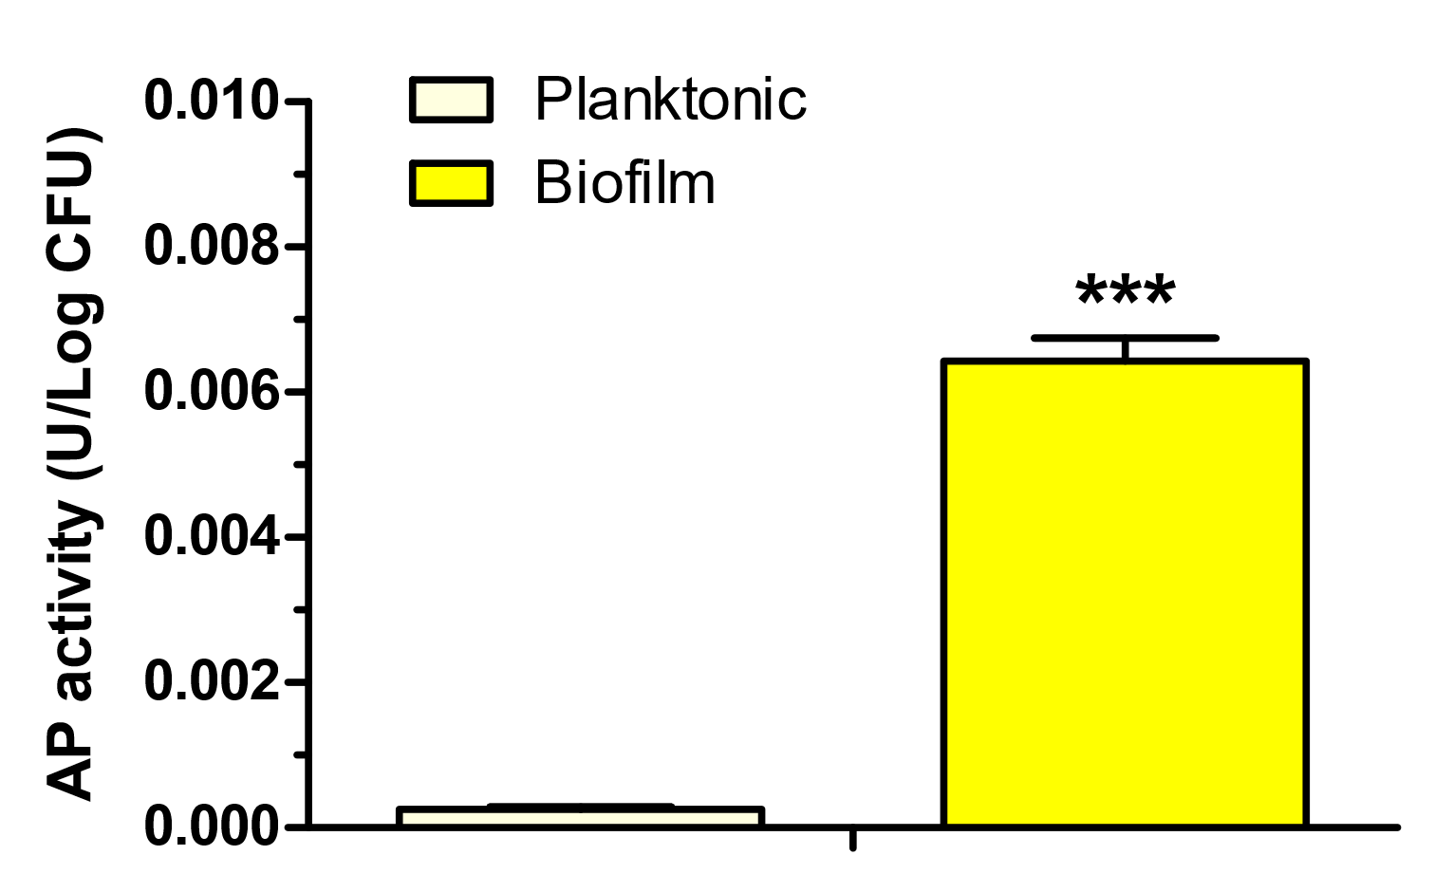
Figure S1: Differential AP activity produced by a co-culture of M. luteus in planktonic and biofilm state. Data are means (n=4) ± standard deviation. A significant difference is indicated as ***p<0.001.

Set-up Conditions for Micrococcus luteus Biofilm Development
For studies involving M. luteus biofilm, several parameters were screened in order to define the conditions for obtaining biofilm. M. luteus biofilm grown on glass beads in TSB glucose 1% showed higher biomass compared to TSB only (Figure S2) and was therefore chosen for setting up the biofilm model.

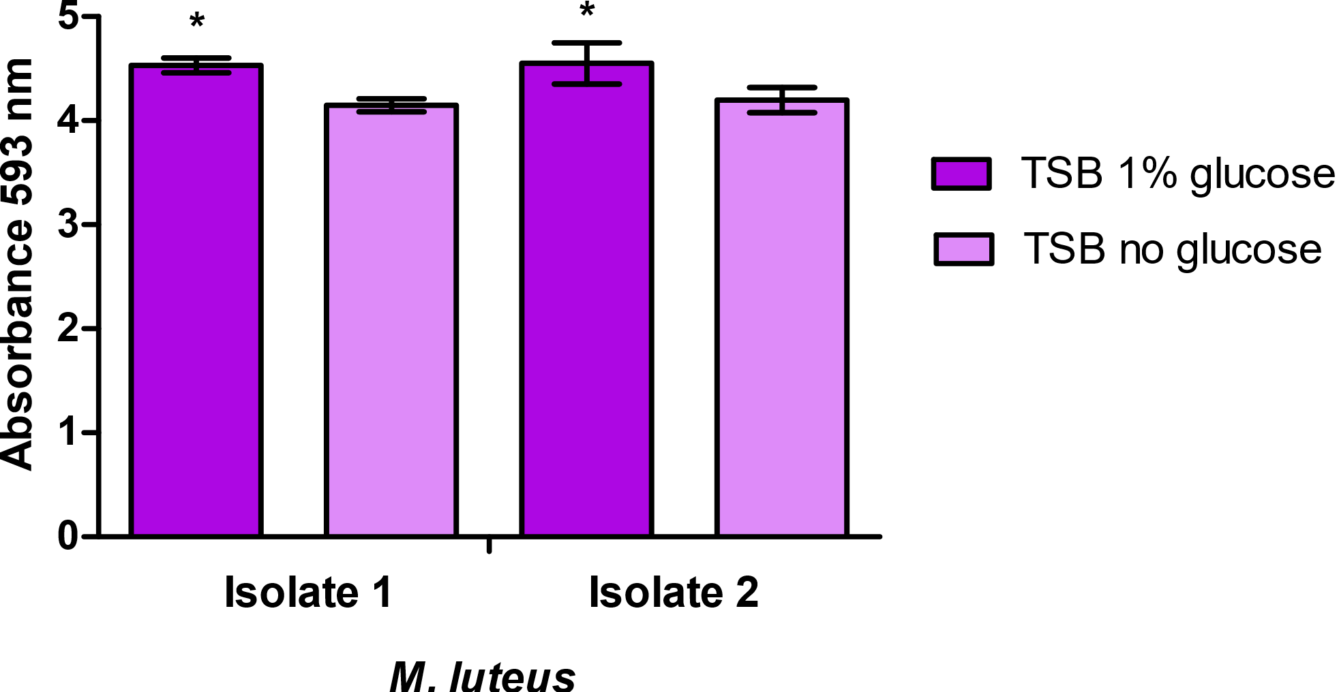
Figure S2: Biofilm biomass revealed by crystal violet when M. luteus isolates are incubated in the presence and absence of glucose (1 %). Data are means (n=3) ± standard deviation. Significant differences are indicated as *p<0.05.

SEM Images of Biofilm Dispersal
SEM images (750x magnification) after treatment with colistin and CP-NPs are shown in Figure S3 and highlight biofilm dispersal by both agents.

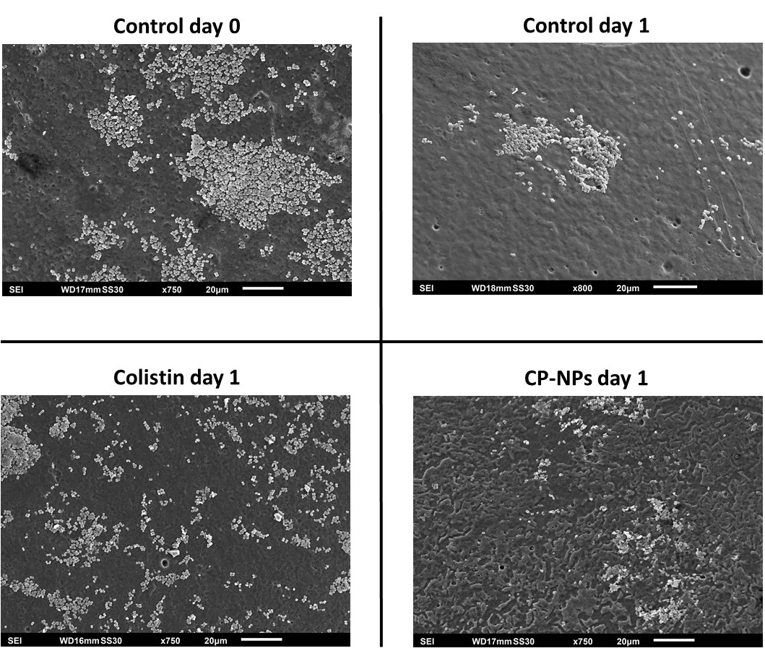
Figure S3: SEM images (750x) of M. luteus biofilms at day 0 and day 1 after treatment with colistin, CP-NPs and HEPES buffer pH 7.4.

