Supporting Information

Figure S1 (A) Equipment for assessing the tissue-penetration capability. (B) Temperature change of Au@mPDA (25 μg/mL) under the irradiation of tissue-penetrating 808 nm laser.

Figure S2 (A) CLSM images and (B) corresponding DOX fluorescence intensity of Au@mPDA@DOX after incubation with 4T1 cells for various durations. The data are presented as the mean ± SD (n = 3). *P < 0.05, ***P < 0.005. Cell viability of 4T1 cells after (C) DOX or (D) Au@mPDA treatment at various concentrations. The data are presented as mean ± SD (n = 4). ****P < 0.001.

Figure S3 Calcein-AM staining of 4T1 cells after laser irradiation.

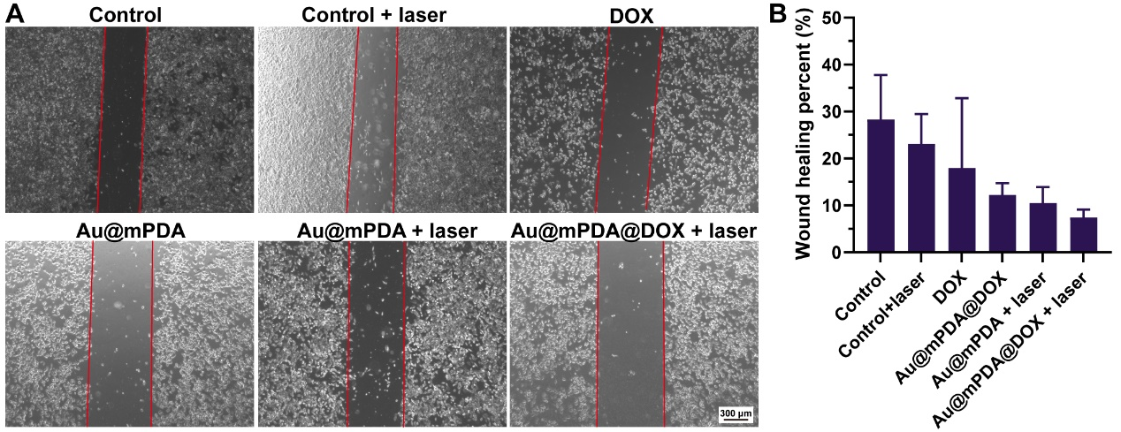
Figure S4 Migration inhibition assay. (A) Wound edge images after various treatment. (B) Wound healing rate after treatment. The data are presented as mean ± SD (n = 3).

Figure S5 CD31 (green) staining of tumor sections after Au@mPDA@ICG injection. Cell nuclei were stained with DAPI (blue). Au@mPDA@ICG were observed as red fluorescence.
Figure S6 Tumor volume of mice after saline, DOX, Au@mPDA, Au@mPDA + laser, Au@mPDA@DOX, or Au@mPDA@DOX + laser treatment.
Figure S7 TUNEL staining images of tumor after saline, DOX, Au@mPDA, Au@mPDA + laser, Au@mPDA@DOX, or Au@mPDA@DOX + laser treatment.
Figure S8 Ki67 staining images of tumor after saline, DOX, Au@mPDA, Au@mPDA + laser, Au@mPDA@DOX, or Au@mPDA@DOX + laser treatment.

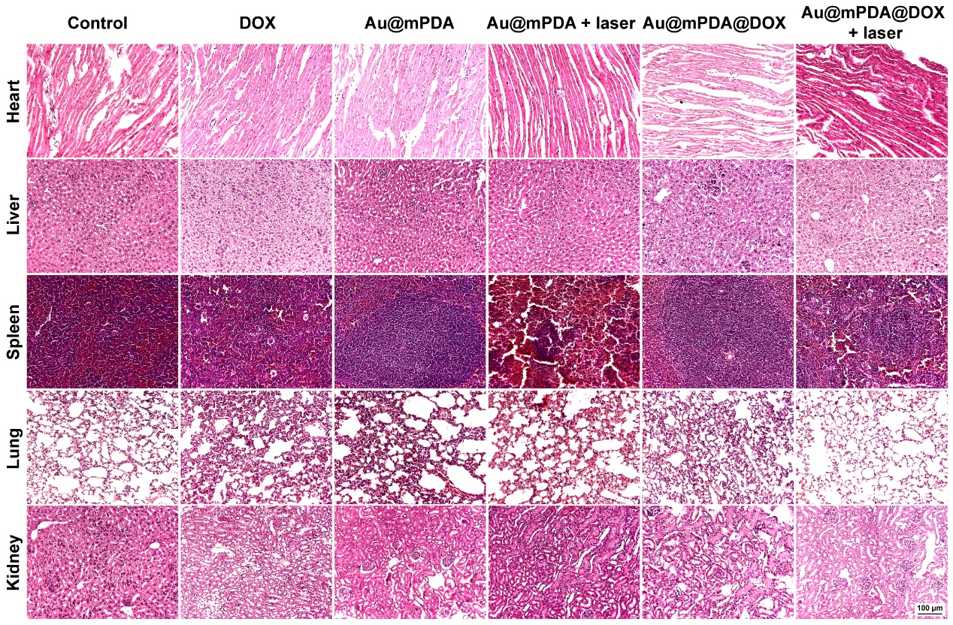
Figure S9 H&E staining images of major organs after saline, DOX, Au@mPDA, Au@mPDA + laser, Au@mPDA@DOX, or Au@mPDA@DOX + laser treatment.

