Supplementary materials

Table S1 Logistic regression analysis of factors associated with hospitalization and ICU admission among older ED patients
Variables | Hospitalization |  |  |  | ICU admission
Variables | Unadjusted Model |  | Adjusted Model |  | Unadjusted Model |  | Adjusted Model
Variables | OR (95% CI) | P Value | OR (95% CI) | P Value | OR (95% CI) | P Value | OR (95% CI) | P Value
Age (1-year increase) | 1.02 (1.00-1.04) | 0.054 | 1.01 (0.98-1.03) | 0.551 | 1.02 (0.98-1.07) | 0.389 | 1.00 (0.94-1.06) | 0.980
TTAS level (1-level decrease) | 1.03 (0.78-1.38) | 0.821 | 1.06 (0.79-1.42) | 0.712 | 0.84 (0.47-1.51) | 0.566 | 1.12 (0.52-2.42) | 0.778
Gender (male vs female) | 1.08 (0.74-1.59) | 0.696 | 1.17 (0.79-1.75) | 0.428 | 0.49 (1.91-1.25) | 0.134 | 0.53 (0.17-1.73) | 0.296
CFS score (1-score increase) | 1.19 (1.08-1.31) | <0.001 | 1.18 (1.06-1.31) | 0.003 | 1.24 (0.96-1.60) | 0.099 | 1.23 (0.93-1.63) | 0.146
ED, emergency department; ICU, intensive care unit; OR, odds ratio; CI, confidence interval; TTAS, Taiwan triage and acuity scale; CFS, Clinical Frailty Scale.

Table S2 Logistic regression analysis of factors associated with 30-day and 180-day mortality among older ED patients
Variables | 30-day mortality |  |  |  | 180-day mortality
Variables | Unadjusted Model |  | Adjusted Model |  | Unadjusted Model |  | Adjusted Model
Variables | OR (95% CI) | P Value | OR (95% CI) | P Value | OR (95% CI) | P Value | OR (95% CI) | P Value
Age (1-year increase) | 1.03 (1.00-1.07) | 0.075 | 1.01 (0.97-1.06) | 0.597 | 1.01 (0.99-1.04) | 0.391 | 0.99 (0.95-1.02) | 0.394
TTAS level (1-level decrease) | 0.74 (0.48-1.14) | 0.168 | 0.81 (0.46-1.43) | 0.471 | 0.75 (0.54-1.04) | 0.086 | 0.84 (0.57-1.25) | 0.395
Gender (male vs female) | 1.07 (0.56-2.03) | 0.837 | 1.23 (0.53-2.81) | 0.631 | 1.02 (0.63-1.65) | 0.951 | 1.12 (0.63-1.98) | 0.703
CFS score (1-score increase) | 1.19 (0.97-1.45) | 0.091 | 1.15 (0.93-1.44) | 0.197 | 1.27 (1.11-1.46) | 0.001 | 1.30 (1.12-1.52) | 0.001
ED, emergency department; OR, odds ratio; CI, confidence interval; TTAS, Taiwan triage and acuity scale; CFS, Clinical Frailty Scale.

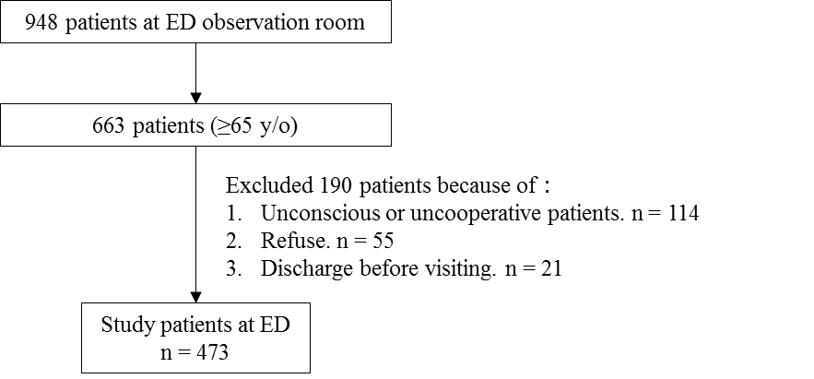

Figure S1 Study enrollment flow chart for the older patients in the emergency department (ED)

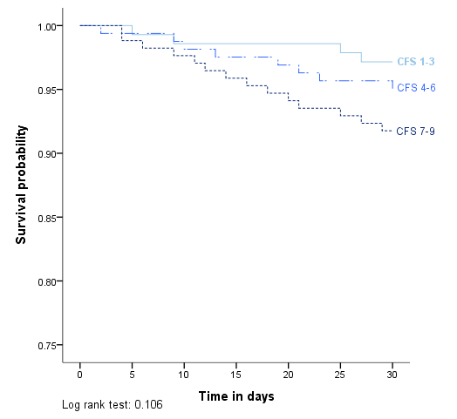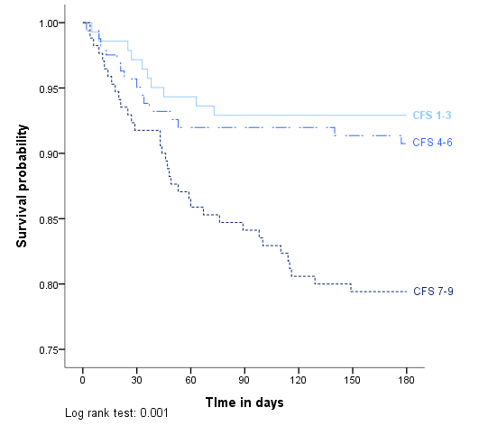
Figure S2 Survival curve of 30-day and 180-day mortality stratified by the Clinical Frailty Scale (CFS) score

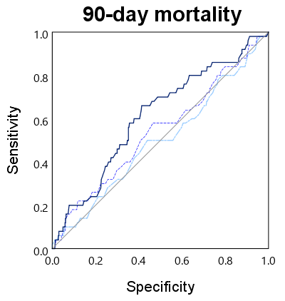
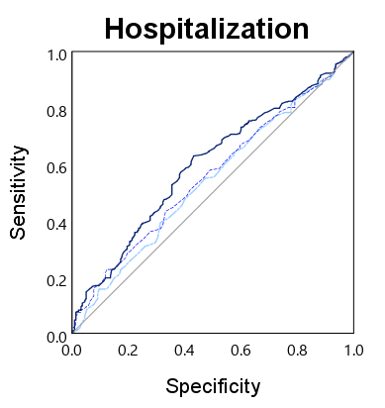
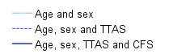
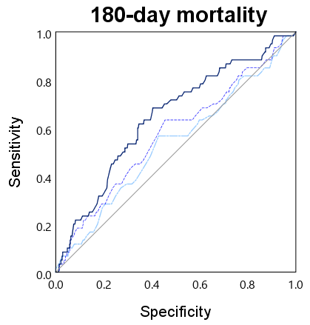
Figure S3 Receiver operator characteristic (ROC) curves for predicting hospitalization, 90-day mortality, and 180-day mortality in older ED patients. Comparison of three logistic regression models: Model 1 (covariates: age, sex), Model 2 (covariates: age, sex, TTAS), Model 3 (covariates: age, sex, TTAS, CFS). For hospitalization, the AUROC of the model 1 was 0.54 (95% CI 0.49 to 0.59), of the model 2 was 0.56 (95% CI 0.51 to 0.60), and of the model 3 was 0.60 (95% CI 0.55 to 0.64). For 90-day mortality, the AUROC of the model 1 was 0.50 (95% CI 0.41 to 0.58), of the model 2 was 0.54 (95% CI 0.45 to 0.63), and of the model 3 was 0.61 (95% CI 0.53 to 0.69). For 180-day mortality, the AUROC of the model 1 was 0.53 (95% CI 0.45 to 0.62), of the model 2 was 0.57 (95% CI 0.49 to 0.65), and of the model 3 was 0.64 (95% CI 0.57 to 0.72) (Abbreviations: TTAS, Taiwan triage and acuity scale; CFS, Clinical Frailty Scale; AUROC, area under the Receiver operator characteristic curve; CI, confidence interval)

