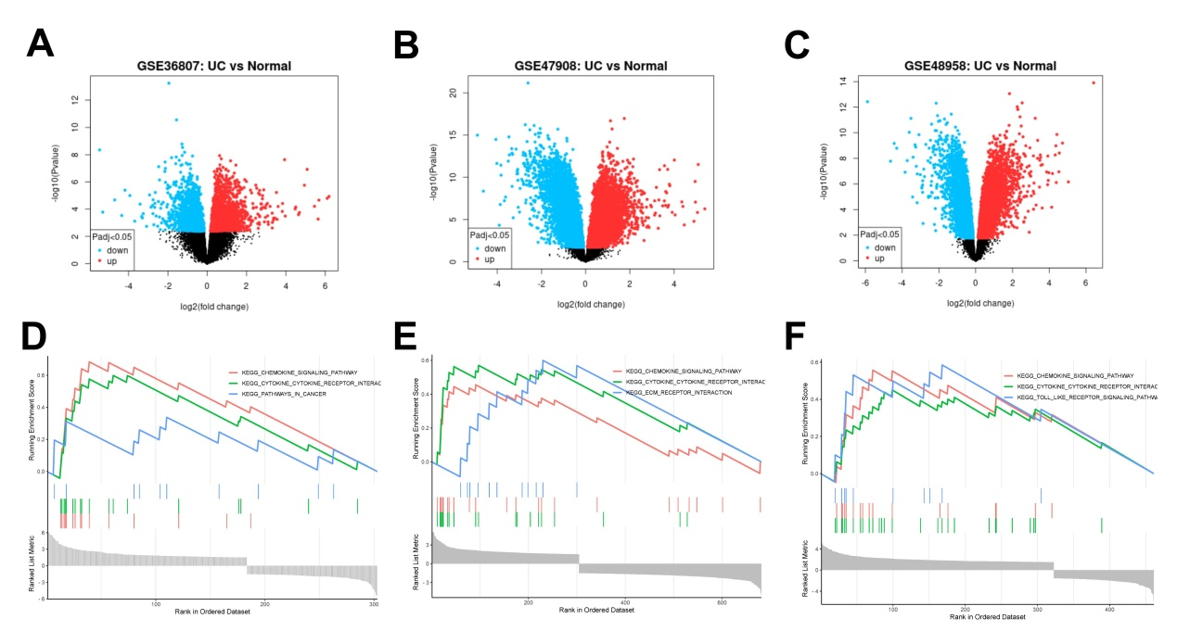
Supplement figure 1. A-C. The volcano plots of GSE36807, GSE47908 and GSE48958 are shown successively. The horizontal coordinate is log2FoldChange, the vertical coordinate is -log10, with red points representing up-regulated genes and blue poins representing down-regulated genes. D-F. GSE36807, GSE47908 and GSE48958 datasets differential expression genes (DEGs) enrichment analysis results. The three most significant pathways are shown in the figure.

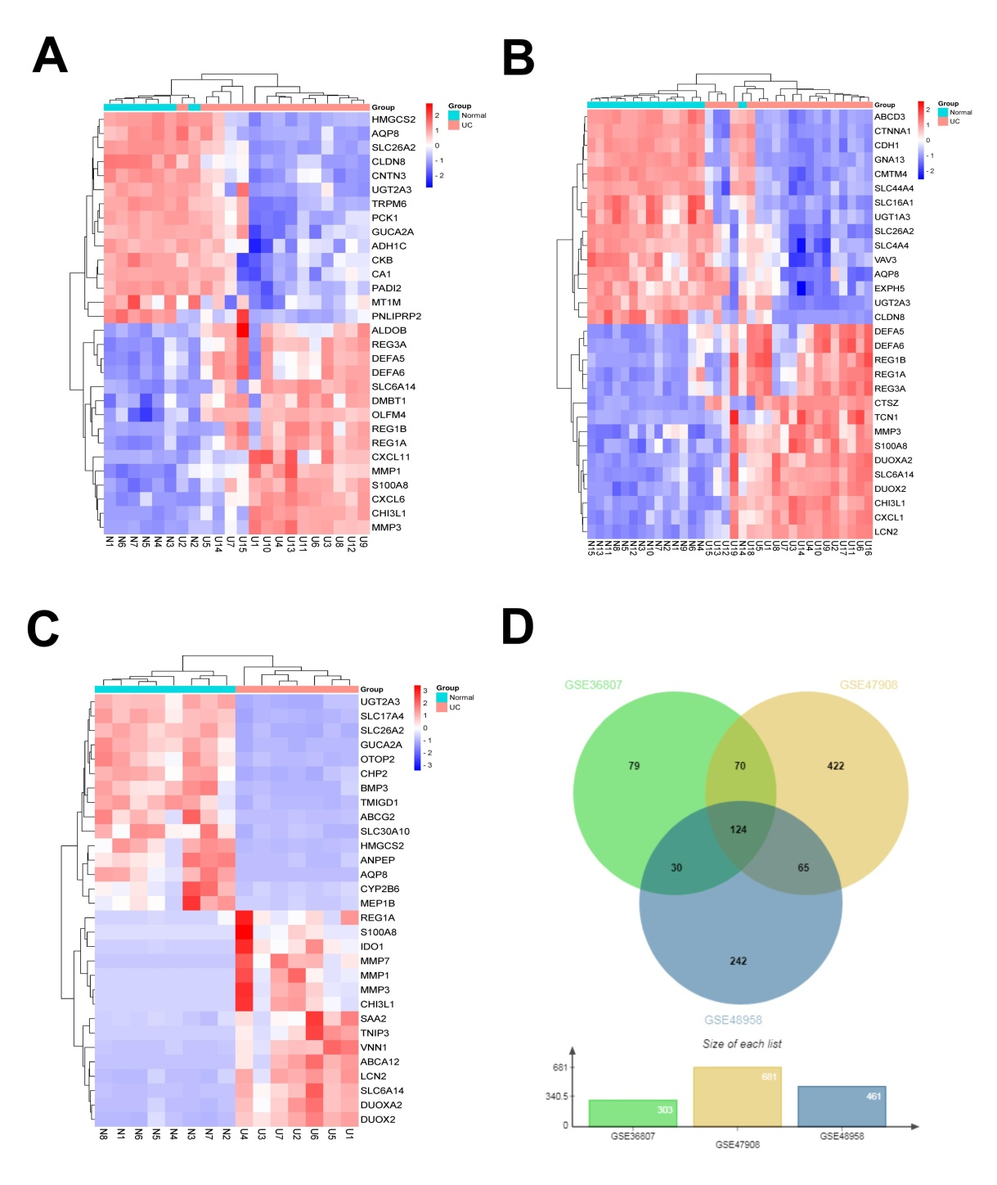
Supplement figure 2. A-C. Heatmaps of the top 15 differentially expressed genes (DEGs) in the GSE36807, GSE47908 and GSE48958 datasets. Genes are represented horizontally, one sample per column, with red representing highly expressed genes and blue representing low-expressed genes. D. Venn diagram of DEGs. The sum of the numbers in each circle represents the number of DEGs in the dataset, and the overlapping part of the circle represents the common DEGs between different datasets.
Supplement Table1 The primer sequence used in this study
Name | Sequence（5’-3’）
GAPDH-F | GAGTCAACGGATTTGGTCGT
GAPDH-R | TTGATTTTGGAGGGATCTCG
Occludin -F | CCTCCAATGGCAAAGTGAAT
Occludin -R | CTCCCCACCTGTCGTGTAGT
ZO-1 -F | CCACCTCTGTCCAGCTCTTC
ZO-1 -R | CACCGGAGTGATGGTTTTCT
Claudin-1 -F | TTTTCCCGATGACCTTTCTG
Claudin-1-R | AGTTTGCAGGATCTGGGATG

Supplementary Table 2
The mobile phase parameters in ultra-high performance liquid chromatography (UHPLC) experiments.
Time (min) | Flow rate (mL/min) | Phase A : water (%) | Phase B : acetonitrile (%)
0 | 400 | 95 | 5
3.5 | 400 | 85 | 15
6 | 400 | 70 | 30
6.5 | 400 | 70 | 30
12 | 400 | 30 | 70
12.5 | 400 | 30 | 70
18 | 400 | 0 | 100
22 | 400 | 0 | 100
25 | 400 | 0 | 100
26 | 400 | 95 | 5
30 | 400 | 95 | 5

Supplementary Table 3
Analysis of the top 10 chemical composition of Xuanbi yuyang decoction in the positive electrospray ionization modes.

ID | NameEN | Formula | mzmed | rtmed | MS2
1 | (9S,10E,12Z,15 | C18H30O3 | 277.216633 | 753.116 | 277.215082;278.079879;93.070382;135.116886;107.086506
2 | (all-E)-6'-Apo- | C32H42O | 443.335207 | 946.962 | 443.337548;444.34871;316.706889;108.713875;115.626952
3 | [(1S,3R,5R,6S, | C30H32O12 | 623.154379 | 529.526 | 623.147983;624.152163;92.6578;241.757832;404.266263
4 | 18 beta-Glycy | C30H46O4 | 471.347126 | 601.448 | 471.345145;472.346284;135.116828;189.165328;52.371799
5 | 2-(8-hydroxy- | C15H24O3 | 270.206678 | 568.88 | 235.167965;271.060092;175.112554;217.160309;99.081003
6 | 3-ethenyl-4-[2 | C23H28O14 | 529.157244 | 203.523 | 153.017794;529.304739;151.076005;315.071669;197.082255
7 | 3-O-Protocat | C37H50O8 | 623.355917 | 807.955 | 623.354236;624.357663;69.261853;77.94508;473.301947
8 | 3,19-Dihydrox | C30H46O6 | 503.338016 | 767.848 | 107.085376;513.862635;135.116865;119.085916;378.374107
9 | 4-Hydroxy-1H | C10H8N2O | 173.071221 | 2.79062 | 146.059833;174.056103;128.049143;173.071042;149.941034
10 | 4,4,8,10,14-pe | C30H46O5 | 487.342159 | 579.932 | 487.337761;488.348478;189.162587;317.210264;54.149149

Supplementary Table 4
Analysis of the top 10 chemical composition of Xuanbi yuyang decoction in the negative electrospray ionization modes.

ID | NameEN | Formula | mzmed | rtmed | MS2
1 | (1R,2R,5S,8R,1 | C30H46O5 | 485.326223 | 806.525 | 485.322963;486.327808;125.143654;212.883554;187.861776
2 | (1S,2S,3R,4S,7 | C31H38O11 | 631.242144 | 484.644 | 631.239099;632.247583;96.9585;241.000308;543.19329
3 | 1,2-Dihydroxy | C14H8O4 | 239.033264 | 647.346 | 239.032529;240.037945;211.039578;195.043203;212.043492
4 | 1,7-bis(4-hydr | C19H22O3 | 297.151617 | 850.537 | 297.15064;298.154259;183.010024;134.89222;184.019158
5 | 11-hydroxy-9- | C36H56O11 | 663.372762 | 641.473 | 663.372254;664.376897;75.007212;116.926524;85.027319
6 | 14-hydroxy-1 | C20H32O4 | 335.221593 | 489.505 | 335.223497;336.22682;96.958528;92.657461;299.029896
7 | 2-Hydroxyant | C14H8O3 | 223.038565 | 626.357 | 223.037185;224.041923;195.043506;108.950528;173.9712
8 | 2-Isopropylm | C7H12O5 | 175.059463 | 157.386 | 87.007292;176.033017;175.059968;113.059451;85.063839
9 | Agarotetrol | C17H18O6 | 317.1053 | 623.681 | 96.958477;317.209794;318.214387;244.911703;188.714544
10 | Alisol A | C30H50O5 | 535.36236 | 758.884 | 535.364517;536.363965;92.657461;472.346469;401.955745

