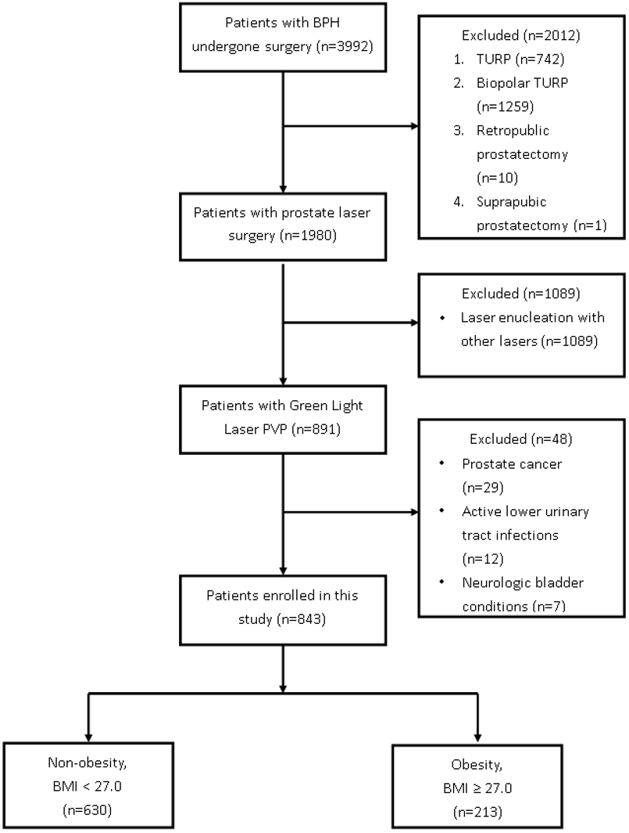
Supplementary Figure 1. Flowchart of the patient enrollment in this study.
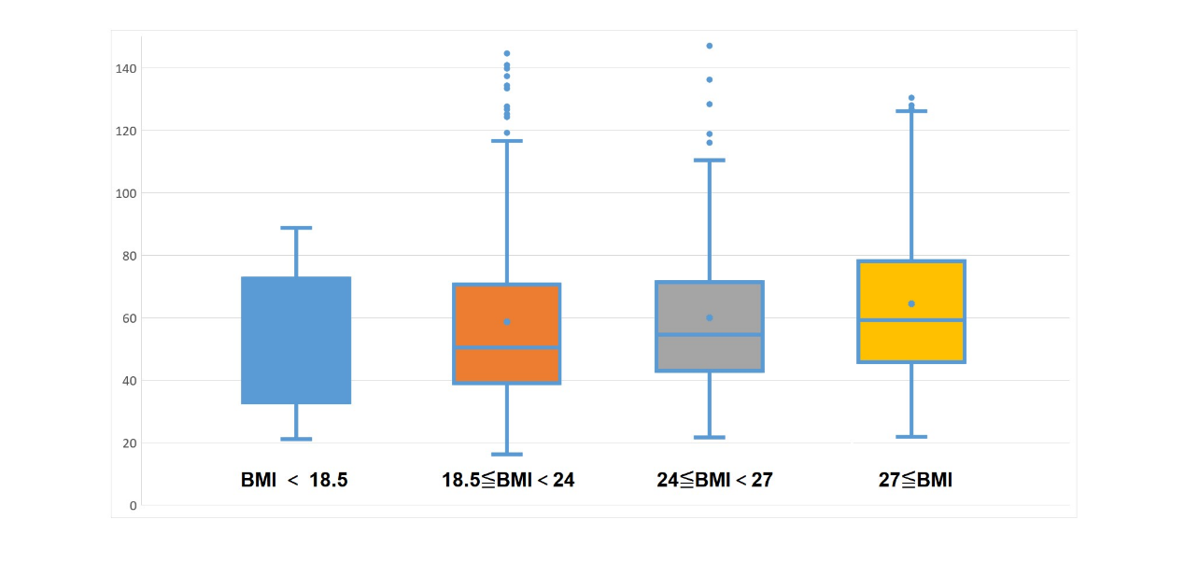
Supplementary Figure 2. TPV in different BMI sub-groups.

