Table S1. The Simplified Molecular Input Line Entry System (SMILES) for the secondary metabolites identified in Aspergillus sydowii, Aspergillus flavus, and Aspergillus welwitschiae.
Aspergillus sydowii
Name of Metabolite | SMILES
1- Diorcinolic acid | CC1=CC(=CC(=C1C(=O)O)OC2=CC(=C(C(=C2)C)C(=O)O)O)O
2- β-d-glucopyranosyl Aspergillusene A | CC(C)CC/C=C(\C)/c1ccc(cc1O)CO[C@H]2C[C@H]([C@@H]([C@H](O2)CO)O)O
3- Violaceol II | CC1=CC(=C(C(=C1)O)OC2=CC(=CC(=C2O)O)C)O
4- Cordyol C | CC1=CC(=CC(=C1)OC2=CC(=CC(=C2O)O)C)O
5- Cyclo-(L-Phe-L-Trp) | C1=CC=C(C=C1)CC2C(=O)NC(C(=O)N2)CC3=CNC4=CC=CC=C43
6- 7-hydroxy-2-(2-hydroxypropyl)-5-methyl chromone | CC(O)CC1=CC(=O)C2=C(O1)C=C(O)C=C2C
7- n-acetylserotonin glucuronide | CC(=O)NCCC1=CNC2=C1C=C(C=C2)OC3C(C(C(C(O3)C(=O)O)O)O)O
8- Shornephine A methyl ester | CC(C)(C=C)C1(C2=C(C(=CC=C2)O)NC1=O)CC(C(=O)OC)NC(=O)C(CC3=CC=CC=C3)O
9- 1-methylpyrogallol | CC1(C=CC=C(C1O)O)O
Aspergillus flavus
Name | SMILES
1- Aflavinine | CC1CCC2(C(CCC(C23C1C(=C(CC3)C(C)C)C4=CNC5=CC=CC=C54)O)C)C
2- Dihydro-24-hydroxyaflavinine | C[C@](CC1)([C@@H](C2)C)[C@@](CC3)(C[C@H]2O)[C@]([C@@H]1C)([H])[C@](C4=CC5=CC=CC=C5N4)([H])[C@@H]3C(C)(O)C
3- Phomaligin A | CCC(C)C(=O)C1=C(C(C(=O)C(=C1OC)C)(C)O)NCCO
4- Hydroxysydonic acid | CC(C)(CCCC(C)(C1=C(C=C(C=C1)C(=O)O)O)O)O
5- Gregatin B | CCC=CC=CC1(C(=O)C(=C(O1)C)C(=O)OC)C
6- Pulvinulin A | CC/C=C/C=C/[C@](OC1CCCCC)(C)C(C1C(OC)=O)=O
7- Chrysogine | CC(C1=NC2=CC=CC=C2C(=O)N1)O
8- Aspergillic acid | CCC(C)C1=CN=C(C(=O)N1O)CC(C)C
9- Aflatoxin B1 | COC1=C2C3=C(C(=O)CC3)C(=O)OC2=C4C5C=COC5OC4=C1
10- Aflatoxin G1 | COC1=C2C3=C(C(=O)OCC3)C(=O)OC2=C4C5C=COC5OC4=C1
Aspergillus welwitschiae
Name | SMILES
1- Atromentin | C1=CC(=CC=C1C2=C(C(=O)C(=C(C2=O)O)C3=CC=C(C=C3)O)O)O
2- Fonsecin B | CC1(CC(=O)C2=C(C3=C(C=C(C=C3C=C2O1)OC)OC)O)O
3- Funalenone | CC1=CC(=O)C2=C(C(=C(C3=C2C1=C(C=C3O)O)O)OC)O
4- Rubrofusarin | CC1=CC(=O)C2=C(C3=C(C=C(C=C3C=C2O1)OC)O)O
5- Aurasperone E | CC1=CC(=O)C2=C(C3=C(C=C(C=C3OC)OC)C(=C2O1)C4=C(C5=C(C6=C(C=C5C=C4OC)OC(CC6=O)(C)O)O)OC)O
6- Aurasperone D | CC1=CC(=O)C2=C(O1)C=C3C=C(C(=C(C3=C2O)OC)C4=C5C(=C(C6=C4C=C(C=C6O)OC)O)C(=O)C=C(O5)C)OC
7- Aurasperone C | CC1(CC(=O)C2=C(C3=C(C(=C(C=C3C=C2O1)O)C4=C5C(=C(C6=C4C=C(C=C6OC)OC)O)C(=O)CC(O5)(C)O)OC)O)O
8- Nigerone | CC1=CC(=O)C2=C(C3=C(C=C(C=C3OC)OC)C(=C2O1)C4=C5C(=C(C6=C4C=C(C=C6OC)OC)O)C(=O)C=C(O5)C)O
9- αβ-dehydrocurvularin | CC1CCCC=CC(=O)C2=C(CC(=O)O1)C=C(C=C2O)O

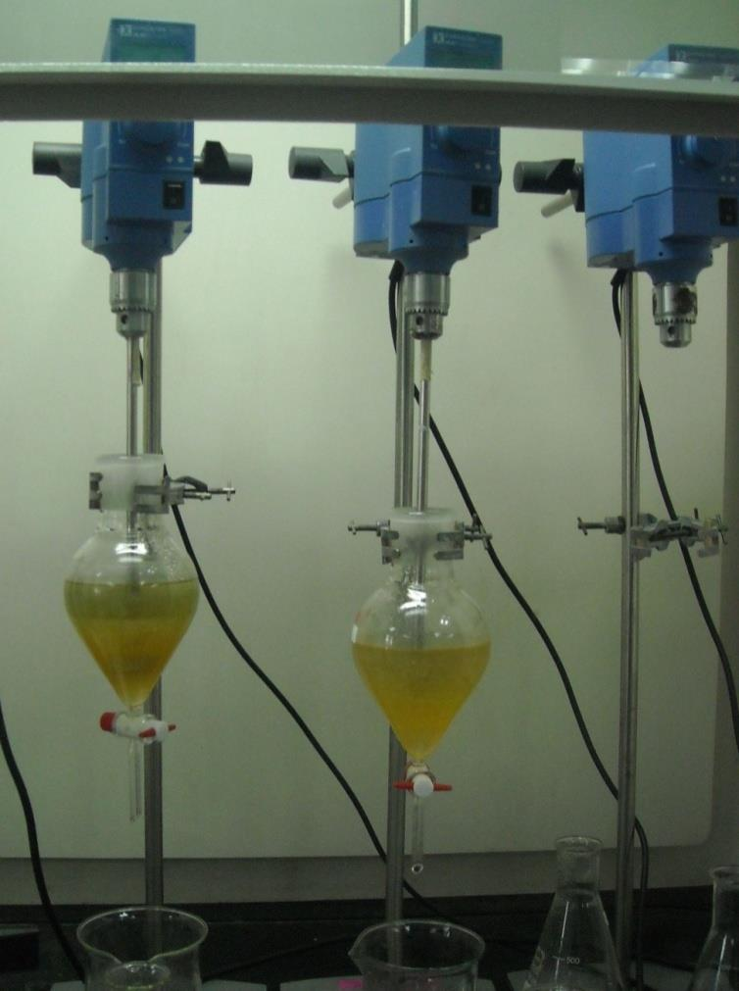
Figure S1: Specially designed apparatus for extraction process.

