Supplementary Table S1

Supplementary Figure S1
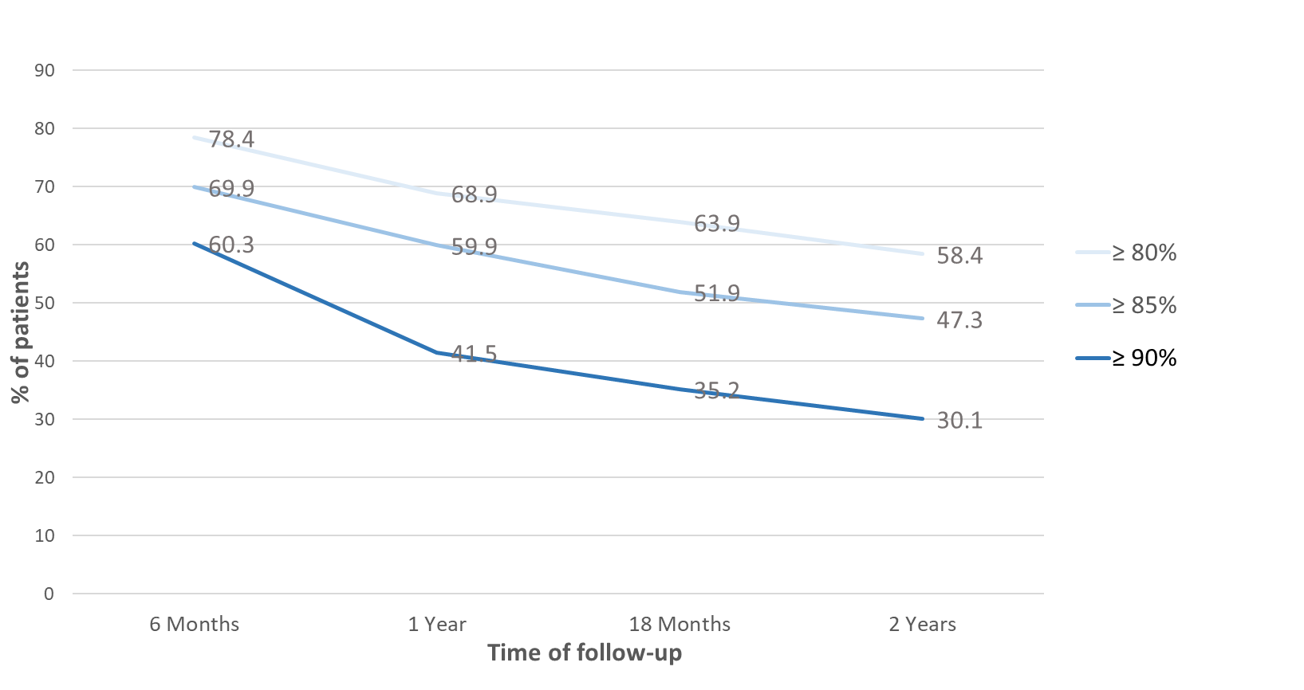
LEGEND : Supplementary Figure S1. Evolution over 2 years of imatinib adherence among patients with chronic myeloid leukemia depending of the threshold used to define optimal adherence, Belgium, 2004-2016
Supplementary Figure S2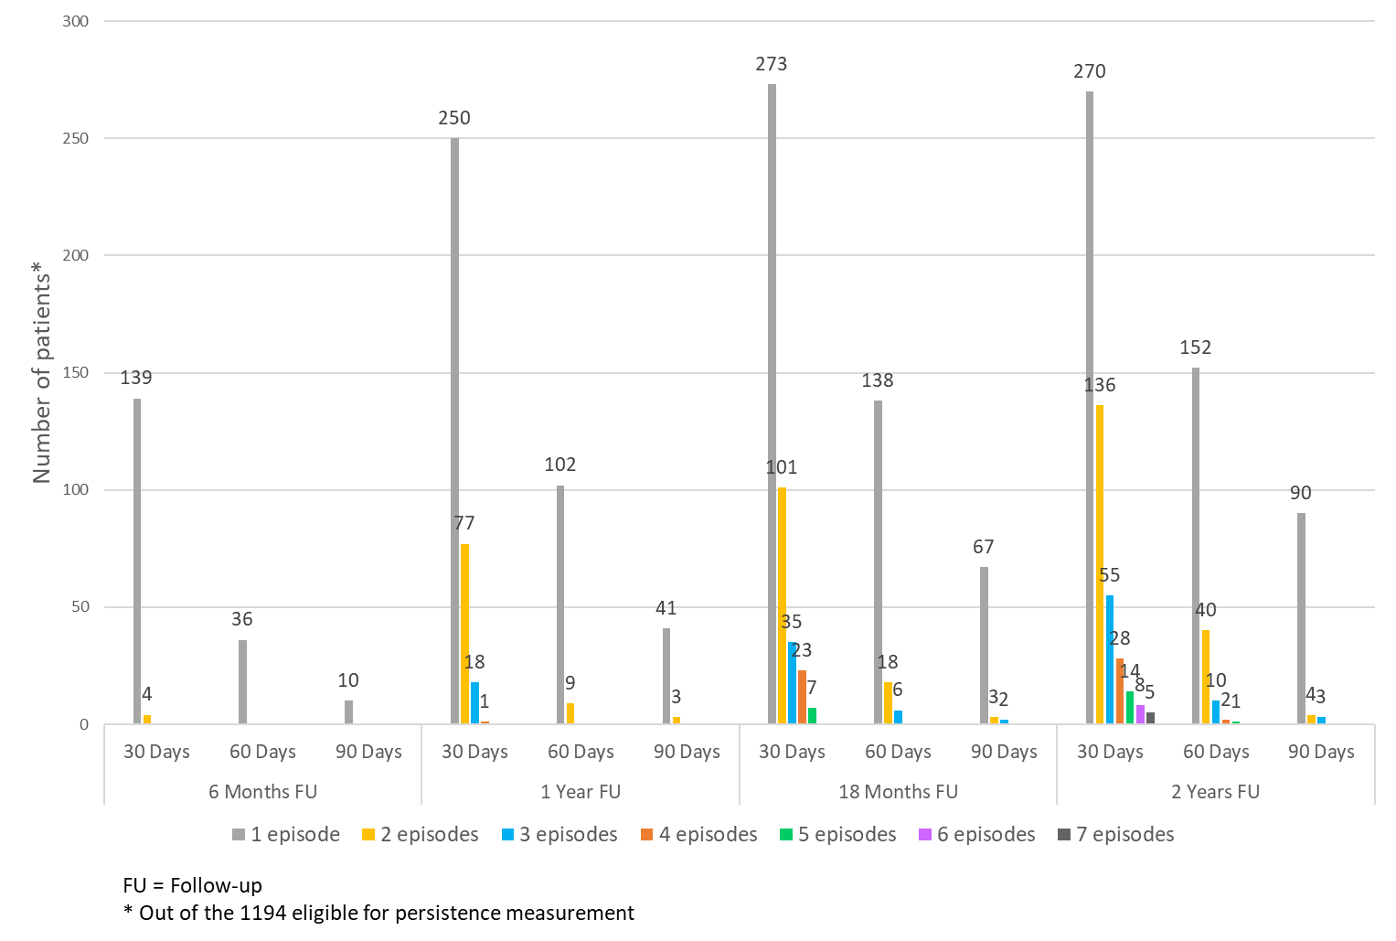
LEGEND: Supplementary Figure S2: Episodes of 30-, 60- and 90-consecutive days imatinib interruption in 1194 patients with chronic myeloid leukemia

Supplementary Table S2

Supplementary Table S3

Supplementary Table S4

Supplementary Table S5

Supplementary Table S6

Supplementary Table S7

