SUPPLEMENTARY DATA

Croton oligandrus Pierre & Hutch (Euphorbiaceae) extracts and isolated compounds reverse HIV-1 latency
Chantal Emade Nkwelle^{1,2}
Smith B. Babiaka^{3,4}
Clovis S. Metuge^{2,3}
Kimberly Liang⁵
Unique Stephens⁵
Seraphine Nkie Esemu¹
David S. Zuzga⁵
Kristy Shuda McGuire⁵
Luis J. Montaner⁵
Roland N. Ndip¹
Ian Tietjen⁵*
Fidele Ntie-Kang^{2,3,6} *

¹Department of Microbiology and Parasitology, Faculty of Science, University of Buea, Buea, Cameroon; ²Center for Drug Discovery, Faculty of Science, University of Buea, Buea, Cameroon;
³Department of Chemistry, Faculty of Science, University of Buea, Buea, Cameroon; ⁴Department of Microbial Bioactive Compound, University of Tübingen, Tübingen Germany; ⁵The Wistar Institute of Anatomy and Biology, Philadelphia, PA, USA; ⁶Institute of Pharmacy, Martin-Luther University Halle-Wittenberg, Kurt-Mothes-Str. 4, 06120 Halle (Saale), Germany
Correspondence: Ian Tietjen [The Wistar Institute, 3601 Spruce Street, Philadelphia, PA 19104, USA] and Fidele Ntie-Kang [Center for Drug Discovery, Faculty of Science, P. O. Box 63, University of Buea, Buea, Cameroon]
Tel +1 215-898-3938 (IT) +237 673872475 (FNK)
Email: itietjen@wistar.org (IT) fidele.ntie-kang@ubuea.cm (FNK)

Table S1: ¹H NMR and ¹³ C NMR of CO1 (Lupeol)
Positions | C/H | ¹ H NMR of isolated compound/ppm | ¹³ C NMR of isolated compound/ppm | ¹ H NMR from literature (Shwe et al., 2019)/ppm | ¹³ C NMR from literature ( Shwe et al., 2019)/ppm
1 | CH₂ | 1.24, 1.49 | 38.5 | 0.90, 1.65 | 38.1
2 | CH₂ | 1.72, 1.47 | 27.4 | 1.52, 1.67 | 27.4
3 | CH | 3.15 | 79.0 | 3.21 | 79.1
4 | C |  | 38.8 |  | 38.7
5 | CH | 1.39 | 55.2 | 0.67 | 55.3
6 | CH₂ | 1.52, 1.27 | 17.6 | 1.37, 1.52 | 18.3
7 | CH₂ | 1.49, 1.24 | 33.4 | 1.39 | 34.3
8 | C |  | 40.2 |  | 40.9
9 | CH | 1.39 | 50.3 | 1.25 | 50.5
10 | C |  | 37.4 |  | 37.2
11 | CH₂ | 1.53, 1.24 | 21.7 | 1.20, 1.40 | 20.9
12 | CH | 1.52, 1.27 | 25.4 | 1.06, 1.62 | 25.2
13 | CH | 1.40 | 39.0 | 1.66 | 40.0
14 | C |  | 42.4 |  | 38.5
15 | CH₂ | 1.49, 1.23 | 28.4 | 1.05, 1.60 | 27.4
16 | CH₂ | 1.49, 1.23 | 35.8 | 1.36, 1.45 | 35.6
17 | C |  | 43.0 |  | 43.5
18 | CH | 1.43 | 48.40 | 1.36, 1.37 | 48.3
19 | CH | 2.18 | 48.9 | 2.4 | 48.0
20 | C |  | 151.0 |  | 151.0
21 | CH₂ | 1.38, 1.91 | 29.8 | 1.30, 1.91 | 29.9
22 | CH₂ | 1.30, 1.55 | 40.0 | 1.18, 1.37 | 40.3
23 | CH₃ | 1.20 | 23.4 | 0.90 (s) | 27.50
24 | CH₃ | 0.69 | 23.4 | 0.76 (s) | 15.36
25 | CH₃ | 1.18 | 16.1 | 0.83 (s) | 16.11
26 | CH₃ | 1.15 | 16.3 | 1.03 (s) | 15.98
27 | CH₃ | 1.16 | 15.0 | 0.96 (s) | 14.59
28 | CH₃ | 0.83 | 18.5 | 0.79 (s) | 18.00
29 | CH₂ | 4.63, 4.88 | 110.0 | 4.57, 4.68 | 109.32
30 | CH₃ | 1.71 | 21.7 | 1.67 (s) | 19.31

Table S2: ¹H NMR and ¹³ C NMR of CO2 (Betulin)

Positions | C/H | ¹ H NMR of isolated compound/ppm | ¹³ C NMR of isolated compound/ppm | ¹ H NMR from literature (Green et al., 1985)/ppm | ¹³ C NMR from literature (Green et al., 1985)/ppm
1 | CH₂ | 1.49 | 33.4 | 1.46 | 40.2
2 | CH₂ | 1.72 | 27.4 | 1.63 | 28.2
3 | CH | 3.15, 2.00(OH) | 80.6 | 3.20, 3.18(OH) | 79.8
4 | C |  | 41.0 |  | 40.0
5 | CH | 1.39 | 44.8 | 1.38 | 47.6
6 | CH₂ | 1.52 | 17.5 | 1.51 | 19.6
7 | CH₂ | 1.49 | 35.3 | 1.40 | 35.7
8 | C |  | 36.1 |  | 36.8
9 | CH | 1.39 | 47.3 | 1.26 | 49.7
10 | C |  | 32.1 |  | 33.3
11 | CH₂ | 1.52 | 24.6 | 1.49 | 24.9
12 | CH | 1.52 | 30.6 | 1.63 | 31.4
13 | CH | 1.40 | 39.5 | 1.45 | 39.8
14 | C |  | 52.5 |  | 51.8
15 | CH₂ | 1.49 | 26.8 | 1.54 | 26.7
16 | CH₂ | 1.50 | 33.9 | 1.53 | 31.9
17 | C |  | 49.5 |  | 49.7
18 | CH | 1.43 | 42.3 | 1.56 | 43.0
19 | CH | 2.18 | 48.3 | 2.38 | 49.8
20 | C |  | 147.8 |  | 150.1
21 | CH₂ | 1.63 | 33.1 | 1.42 | 31.8
22 | CH₂ | 1.55 | 35.0 | 1.53 | 37.0
23 | CH₃ | 1.11 | 19.5 | 1.20 | 18.6
24 | CH₃ | 1.11 | 19.5 | 1.19 | 18.8
25 | CH₃ | 1.16 | 21.6 | 0.95 | 20.9
26 | CH₃ | 1.17 | 14.2 | 0.98 | 14.1
27 | CH₃ | 1.17 | 18.5 | 0.99 | 18.9
28 | CH₂ | 3.58, 2.0(OH) | 63.2 | 3.80 | 64.2
29 | CH₂ | 4.88, 4.85 | 110.6 | 4.68, 4.58 | 110.3
30 | CH₃ | 1.71 | 21.7 | 1.65 | 20.9

Table S3: ¹H NMR and ¹³ C NMR of CO3 (β-stigmasterol)
Positions | C/H | ¹ H NMR of isolated compound/ppm | ¹³ C NMR of isolated compound/ppm | ¹ H NMR from literature (Cayme and Ragasa,  2004)/ppm | ¹³ C NMR from literature
1 | CH₂ | 1.38 | 30.1 |  | 37.1
2 | CH₂ | 1.57 | 31.8 |  | 32.2
3 | CH | 3.25, 2.0(OH) | 71.8 | 3.39, OH(2.00) | 74.8
4 | CH₂ | 2.23 | 41.9 |  | 39.8
5 | C |  | 140.8 |  | 140.9
6 | CH | 5.37 | 121.7 | 5.35 | 122.1
7 | CH₂ | 2.04 | 30.0 |  | 31.8
8 | CH | 1.45 | 31.9 |  | 31.7
9 | CH | 1.44 | 50.8 |  | 50.2
10 | C |  | 37.8 |  | 36.6
11 | CH₂ | 1.52 | 22.7 |  | 21.3
12 | CH₂ | 1.49 | 37.3 |  | 40.2
13 | C |  | 44.1 |  | 41.0
14 | CH | 1.40 | 56.6 |  | 56.8
15 | CH₂ | 1.60 | 27.8 |  | 27.3
16 | CH₂ |  | 27.4 |  | 27.5
17 | CH | 1.51 | 56.4 |  | 56.2
18 | CH | 2.33 | 40.1 |  | 40.6
19 | CH₃ | 1.03 | 20.2 | 1.02 | 20.7
20 | CH | 5.38 | 138.3 | 5.15 | 138.6
21 | CH | 5.46 | 129.3 | 5.02 | 129.6
22 | CH | 2.15 | 52.2 |  | 46.1
23 | CH₂ | 1.33 | 26.6 |  | 25.4
24 | CH₃ | 0.85 | 12.3 | 0.80 | 12.1
25 | CH | 1.86 | 31.9 |  | 29.6
26 | CH₃ | 1.01 | 21.1 | 0.79 | 20.2
27 | CH₃ | 0.94 | 21.1 | 0.83 | 19.8
28 | CH₃ | 1.26 | 23.2 |  | 18.9
29 | CH₃ | 0.71 | 20.8 | 0.80 | 12.2

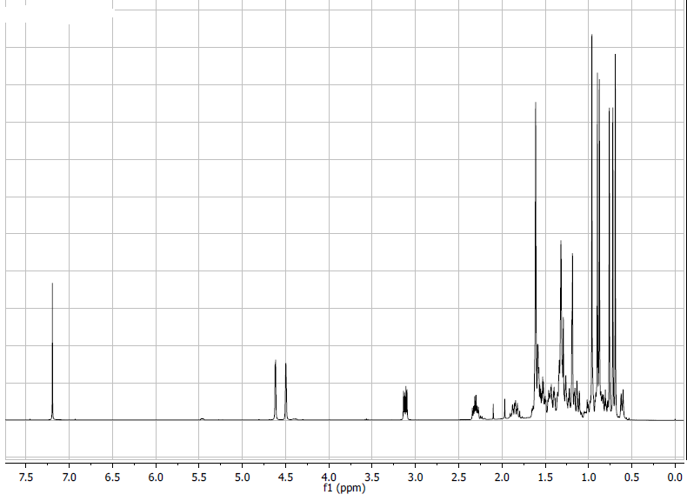
Figure S1. ¹H NMR (400 MHz, CDCl₃) spectrum of lupeol.
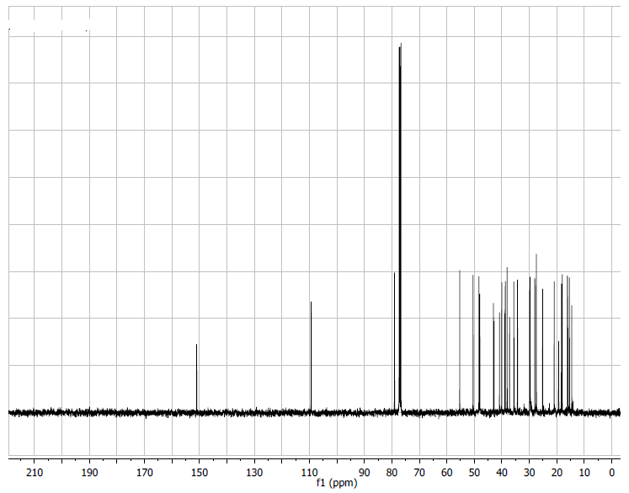
Figure S2. ¹³C NMR (100 MHz, CDCl₃) spectrum of lupeol.
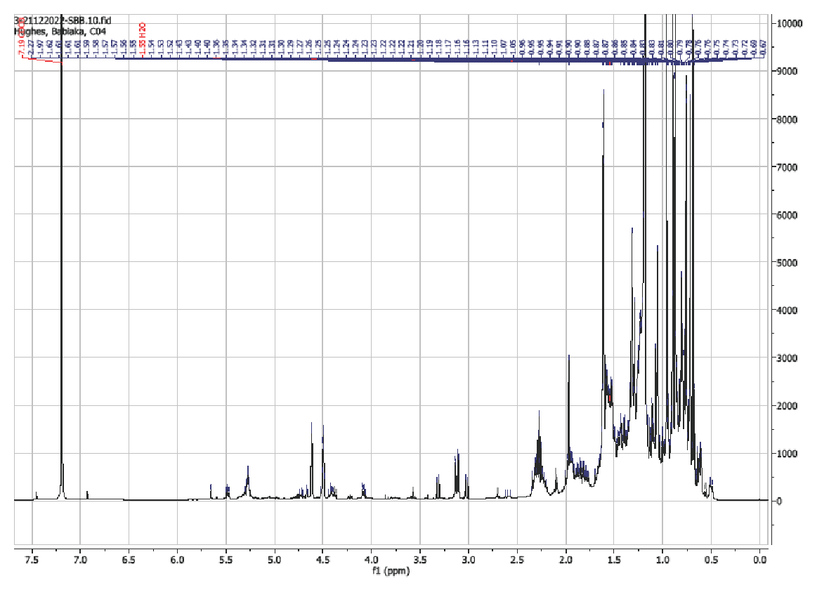
Figure S3. ¹H NMR (400 MHz, CDCl₃) spectrum of betulin.
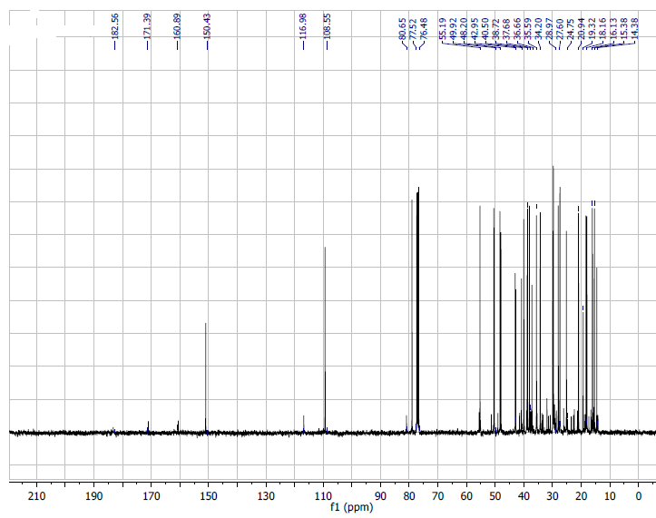
Figure S4. ¹³C NMR (100 MHz, CDCl₃) spectrum of betulin.

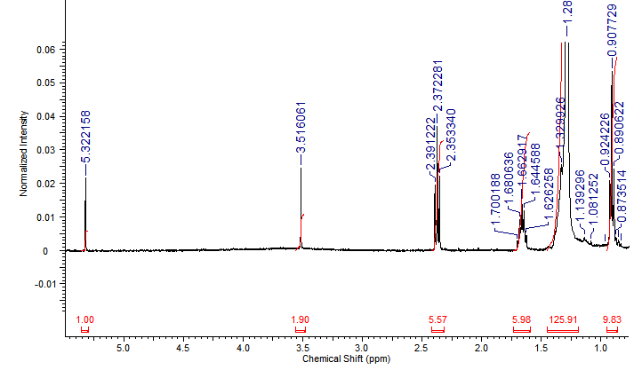
Figure S5. ¹H NMR (400 MHz, CDCl₃) spectrum of β-stigmasterol.

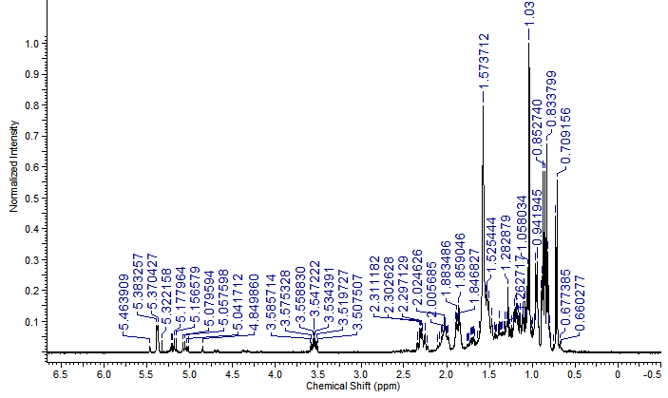

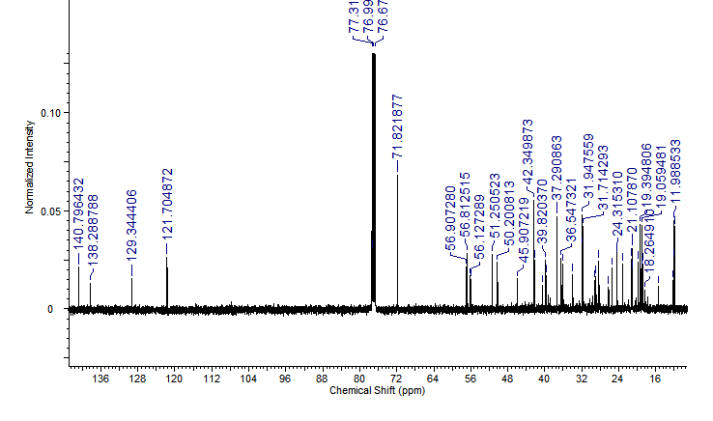
Figure S6. ¹³C NMR (100 MHz, CDCl₃) spectrum of β-stigmasterol.

