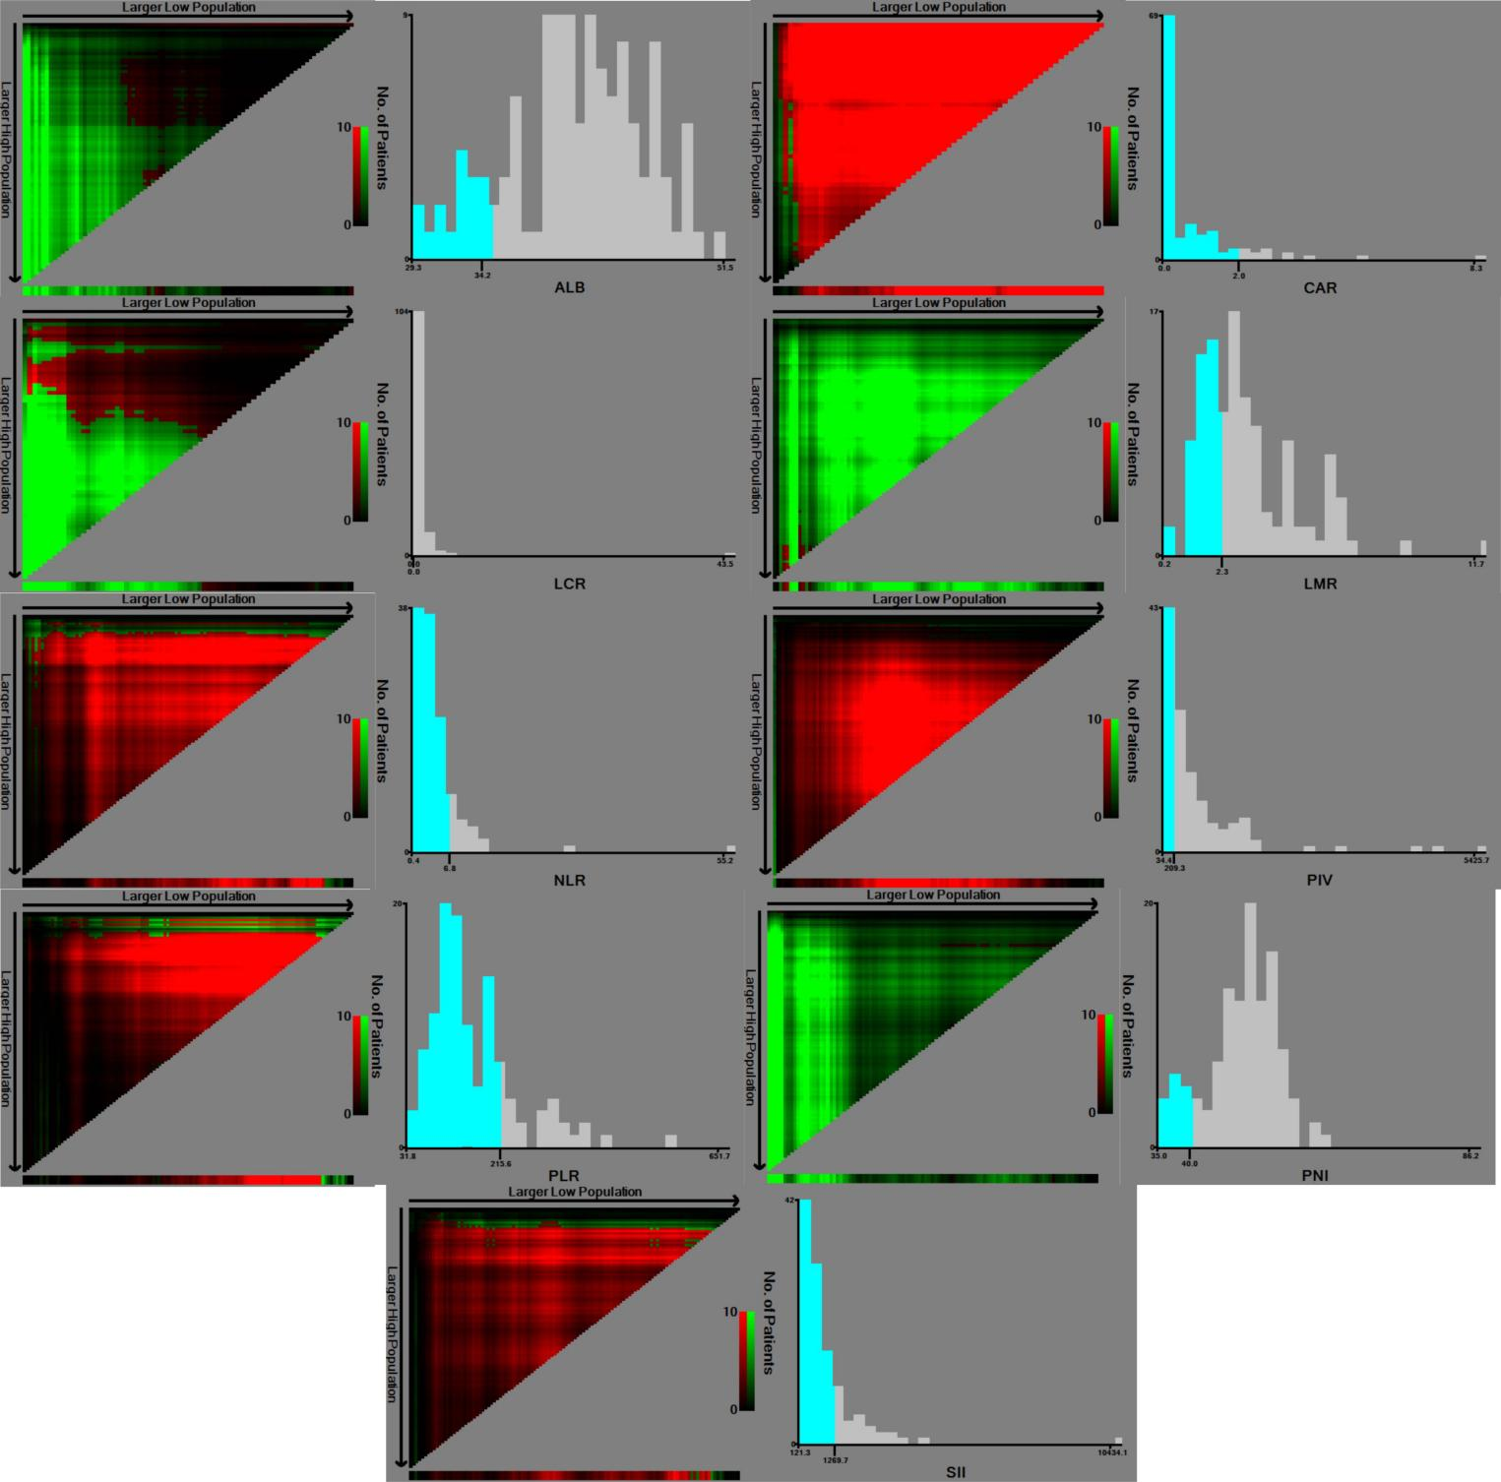
Supplemental Figure 1 Schematic diagram of the method to determine the optimal cutoff points for survival prediction for ALB, PLR, NLR, LCR, LMR, SII, CAR, PNI, and PIV using X-tile software for survival prediction.

Supplemental Table 1 The reported prognostive value of inflammation based scores for immunotherapy efficacy in patients with biliary tract carcinoma.

Author | Published journal and date | The IBS studied | Primary tumor | Intervention | Enrolled patients number | Result  (Positive/Negative)
Yuting Pan et al. | J ONCOL.2022 | lung immune prognostic index (LIPI) | Advanced BTCs | Immunotherapy | 110 | Positive
Jingjing Li et al | Clin Transl Med  . 2020 | Inflammation-related indicators | Advanced microsatellite stable BTCs | Immunotherapy | 26 | Negative
Fei Du et al. | J LEUKOCYTE BIOL. 2021 | immune-inflammation index (SII) ,cytokine IFN-inducible protein-10(IP-10) and macrophage inflammatory protein-1β | Advanced BTCs | Immunotherapy | 60 | Positive
Zhenyun Yang et al. | Inflamm Res  . 2022 | C-reactive protein score | Intrahepatic Cholangiocarcinoma | Anti-PD-1 therapy | 73 | Positive
Abbreviations: IBS, Inflammation based score; BTC, Bilary tract carcinoma; PD-1, programmed cell death protein 1.

