Supporting Information
A machine learning-driven Surface-Enhanced Raman Scattering analysis platform for the label-free detection and identification of gastric lesions

Fengsong Chen¹, Yanhua Huang¹, Yayun Qian³, Ya Zhao³, Chiwen Bu²*, Dong Zhang²*
¹Department of Gastroenterology, Haimen People’s Hospital, Nantong 226000, China
²Institute of Surgery, Guanyun People’s Hospital, Guanyun 222200, China
³Institute of Translational Medicine, Medical College, Yangzhou University, Yangzhou 225001, China
*Correspondence: Dong Zhang; Chiwen Bu, Email gyxrmyykjk@163.com; gyxrmyybcw@163.com

Materials and methods
Materials
Nile Rule A (NBA), and polydimethylsiloxane (PDMS) were obtained from Sinopharm Chemical Reagent Suzhou Co. Concentrated sulfuric acid (98%), hydrogen peroxide (30%), and anhydrous ethanol were sourced from China National Pharmaceutical Group Chemical Reagent Co., Ltd. Polystyrene microsphere (PS) suspension (5 wt%) was procured from Zhongke Leiming (Beijing) Technology Co., Ltd. Sulfur hexafluoride (SF₆) was acquired from Luoyang Filier Special Gas Co., Ltd. All glassware used in the experiments underwent cleaning with aqua regia immersion, and deionized water (18.2 MΩ) was utilized throughout the experiments.
Instrumentation
Transmission electron microscopy (TEM) observation was obtained by using a FEI Tecnai G2 F30 S-twin field-emission transmission electron microscopy. The scanning electron microscopy (SEM) image was obtained via Hitachi S-4800II field emission scanning electron microscope. UV-Vis absorption spectra were recorded with a Shimadzu UV3600 spectroscopy. Raman measurements were conducted with a Thermo Fisher DXR Smart Raman spectrometer. A laser with the wavelength of 785 nm was applied as the excitation source with the laser power and collection time of 80 mW and 10 s, respectively.
Fabrication of AuLS nanoarrays
To begin, the silicon wafers were initially treated hydrophilically. Then, a sequence of techniques including gas-liquid interface self-assembly and reactive ion etching (RIE) was employed to fabricate AuLS nanoarrays. Tightly arranged arrays of polystyrene (PS) nanospheres were incorporated into the RIE instrument under precise conditions: employing a working power of 150 W and maintaining an internal pressure of 2.0 Pa. SF6 etching ensued at a flow rate of 60 sccm/min for a duration of 30 seconds. Afterward, the sample was subjected to heating in a muffle furnace at 600 ℃ for a period of 2 hours to develop structured Si NCAs. Following this thermal treatment, a layer of gold (Au) was deposited onto the uneven etched surface through sputtering, lasting 5 minutes at a current of 30 mA. The morphology of the resulting AuLS nanoarrays was then scrutinized using scanning electron microscopy (SEM).
SERS measurement and data analysis
Origin 2021 software was used to process all SERS spectral data (frequency shift range truncation, smoothing, baseline correction, and normalization). The frequency shift truncation range of SERS spectrum in the study was 600 cm⁻¹～1800 cm⁻¹. Savitzky-Golay smoothing sets the window parameter to 40 and polynomial order to 2. After normalization, the average of 50 different normalized SERS spectra for each stage is calculated to obtain the representative spectrum on HL, LGIN, HGIN and GC. The characteristic peaks of the average spectra were analyzed by Origin 2021 software. All processed spectral data were subjected to using PCA-MLMNN multivariate analysis by Origin 2021 and Matlab 2020. In PCA, the characteristics of SERS spectra of different degrees of gastric lesions were analyzed and identified using scree plot, score plot, loading plot, and box plot. It selected the first two and first three PCs in the score plot (accounting for 73.6% and 81.9% of the total variance, respectively) demonstrated the clustering patterns. The first eleven PCs which accounted for 95% of the total variance were taken as PCA-MLMNN input. The accuracy, sensitivity, and specificity of the model have been analyzed. The accuracy of the model under different parameters was drawed using Matlab 2020. The optimal value was selected to draw the confusion matrix through the confusion function.
Results and discussion
Comparison of average SERS spectra of collected serum of different degrees
Figure S1 The average SERS spectra of serum of HGIN, Stage Ⅰ GC.
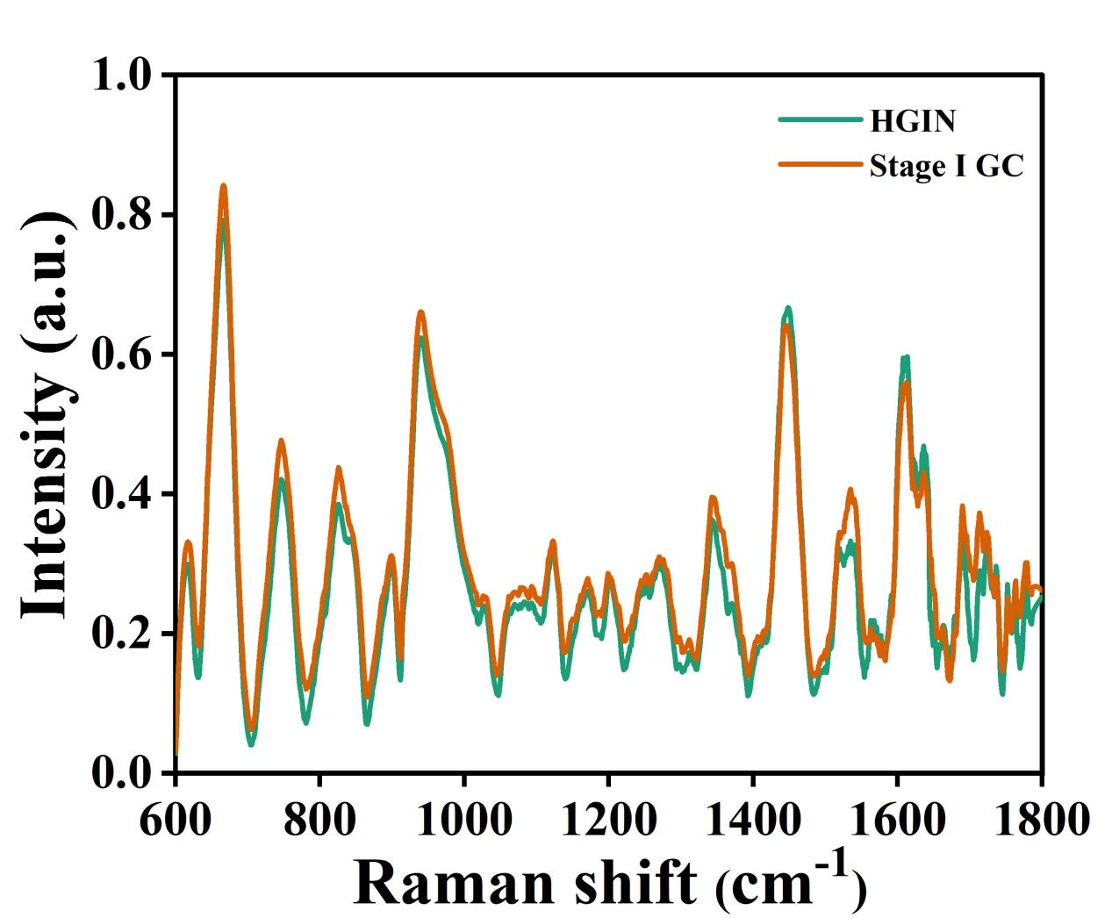
Figure S1 compared the Raman spectra of patients with high-grade intraepithelial neoplasia (HGIN) and Stage I gastric cancer (GC). The two spectra represented the average SERS spectra of HGIN (green) and Stage I GC (orange) patients. It was observed that although the SERS spectra of both conditions were very similar in waveform, there were differences in intensity at certain characteristic peaks.
Table S1 The detailed assignments of characteristic peaks.
Raman shift (cm⁻¹) | Assignment | Reference
616 | C-C twisting (protein) | 1
659 | - S stretching mode of cystine (collagen type I) | 2, 3
747 | T (ring breathing mode of DNA/RNA bases) | 1
825 | Phosphodiester | 4
899 | Phosphodiester, Deoxyribose | 4
941 | Skeletal modes (polysaccharides, amylose) | 5
1032 | CH₂CH₃ bending modes of collagen & phospholipids | 6
1099 | ν(C-N) | 3
1124 | ν(C-C) skeletal of acyl backbone in lipid | 3
1172 | $δ$(C-H), tyrosine (protein assignment) | 6
1203 | C-C₆H₅ stretch mode (one of C-C ring vibration to be expected in aromatic structure of xylene) | 7
1280 | Amide III & CH₂ wagging vibrations from glycine backbone & proline  side chains | 8
1342 | G (DNA/RNA), CH deformation (proteins and carbohydrates) | 9
1404 | Bending modes of methyl groups (one of vibrational modes of collagen) | 8
1450 | CH₂ bending, C-H deformation bands (CH functional groups in lipids | 8, 10
1536 | Amide carbonyl group vibrations and aromatic hydrogens | 11
1605 | Cytosine (NH₂), Phenylalanine, tyrosine, C==C (protein) | 1, 4
1621 | Tryptophan, Tryptophan &/or β-sheet | 3, 12
1691 | Amide I (disordered structure; non hydrogen bonded) | 5
1713 | C==O | 13
The serum was mainly composed of carbohydrate, lipids, proteins, amino acids, DNA and and some other substances. SERS spectra achieved on the AuLS nanoarrays substrate would contain information of biomolecules of serum of different degrees of gastric lesions. Their SERS spectra contains many similar characteristic peaks, but the peak intensities of SERS spectra were quite different. The assignment of characteristic peaks was shown in Table S1.
Multivariate analysis
Figure S2 The box plots of obvious characteristic peaks of PC1, PC2 and PC3 loading plots quantitatively distinguished the SERS spectra of different degrees of gastric lesions by t test (*p < 0.05, **p < 0.01, ***p < 0.001). (A) 659 cm⁻¹, (B) 941 cm⁻¹, (C) 1450 cm⁻¹ and (D) 1621 cm⁻¹.
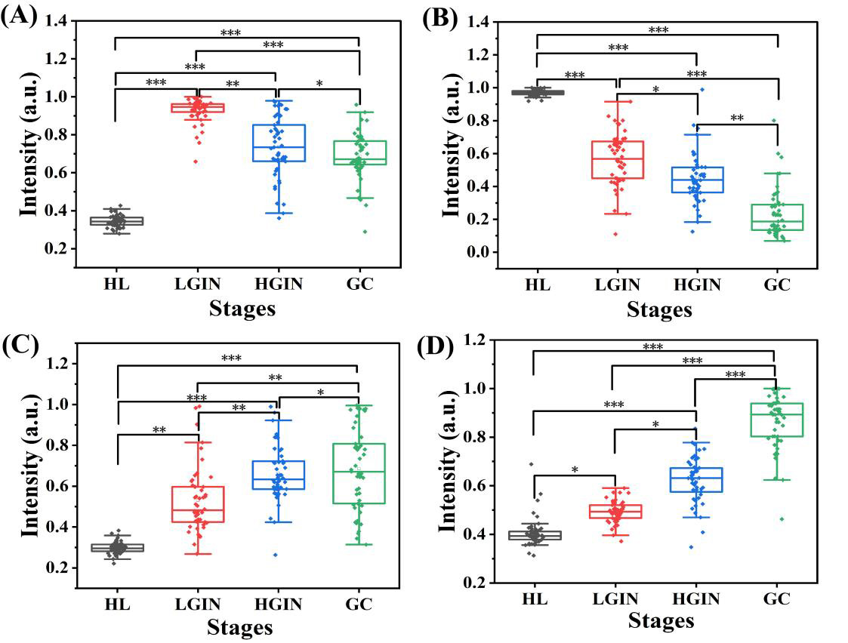
The box plots of obvious characteristic peaks of PC1, PC2 and PC3 loading plots quantitatively distinguished the SERS spectra at different stages (HL, LGIN, HGIN, and GC) by t test (*p < 0.05, **p < 0.01, ***p < 0.001) (Figure S2). As mentioned previously, the high load value of the 4 different key characteristic peaks from PC1, PC2, and PC3 Loadings can serve as a key identifying factor for different degrees of gastric lesions.
Figure S3 MLMNN classification principle in the 2-dimensional space. (A) MLMNN found the nearest centroid neighbors of the test samples. (B) The representation coefficients of these nearest centroid neighbors.
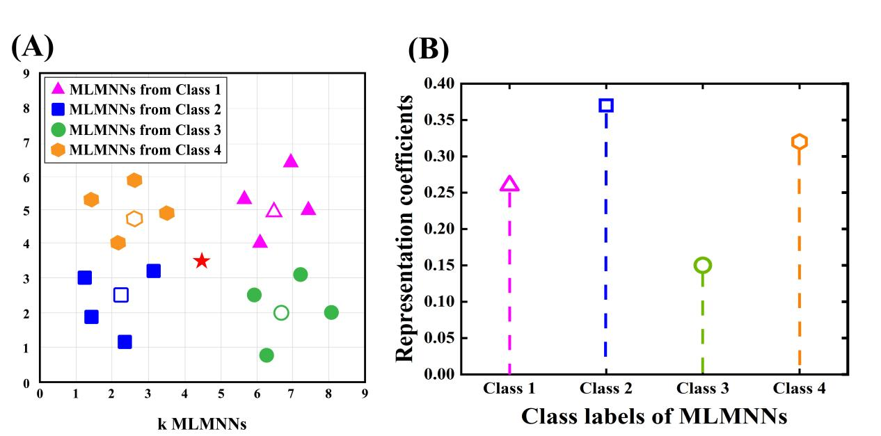
The classification principle of MLMNN is shown in Figure S3. The red pentagram is the query sample. Firstly, we find the k nearest neighbors (K=4) of this query sample from each class (Figure S3A). Secondly, we use the k nearest neighbor class to sequentially calculate the local average vector for classification. These local mean vectors are hollow triangle, hollow square, hollow circle, and hollow hexagon, respectively. Thirdly, the query sample is represented by a linear combination of local mean vectors in each class. These categorical local mean vectors are involved in making classification decision. The representation coefficient of each local mean vector is viewed as the weighted contribution to classifying the query sample (Figure S3B). Finally, the distance based representation coefficients is achieved for classifying the query sample. The query sample is classified into the class 2 that has the minimum distance based representation coefficients among all classes.
Table S2 Sensitivity and specifificity values of PCA-MLMNN, PCA-KNN, and KNN for HL&LGIN,HGIN,GC, LGIN&HL,HGIN,GC, HGIN&HL,LGIN,GC, and GC&HL, LGIN,HGIN.
Treatment stages | PCA-MLMNN |  | PCA-KNN |  | KNN
Treatment stages | Sensitivity | Specificity | Sensitivity | Specificity | Sensitivity | Specificity
HL&LGIN,  HGIN,GC | 100.0% | 100.0% | 100.0% | 96.7% | 90.0% | 96.7%
LGIN&HL,  HGIN,GC | 96.7% | 100.0% | 90.0% | 93.3% | 90.0% | 80.0%
HGIN&HL,  LGIN,GC | 97.5% | 95.0% | 97.5% | 96.7% | 96.7% | 93.3%
GC&HL, LGIN,HGIN | 100.0% | 96.7% | 93.3% | 100.0% | 96.7% | 90.0%
The sensitivity and specificity of PCA-MLMNN, PCA-KNN, and KNN for HL&LGIN,HGIN,GC, LGIN&HL,HGIN,GC, HGIN&HL,LGIN,GC, and GC&HL, LGIN,HGIN were analyzed (Table S2). It clearly showed the performance for the two models gave superior values, especially HL&LGIN,HGIN,GC, and GC&HL, LGIN,HGIN. The sensitivity and specificity of PCA-MLMNN were generally superior to the current model. The sensitivity of PCA-MLMNN (95.0%) was higher than that of KNN (93.3%) for HGIN&HL,LGIN,GC, while MLMNN showed a slightly lower sensitivity relative to PCA-KNN (96.7%). The specificity of PCA-MLMNN (96.7%) was higher than that of KNN (90.0%) for GC&HL, LGIN,HGIN, while MLMNN showed a slightly lower specificity relative to PCA-KNN (100.0%). The result demonstrated that PCA-MLMNN has significant advantages in SERS spectral data analysis.
References
- Chan JW, Taylor DS, Zwerdling T, et al. Micro-Raman spectroscopy detects individual neoplastic and normal hematopoietic cells. Biophys. J. 2006; 90 (2): 648-656.
- Stone N, Kendell C, Shepherd N, et al. Near-infrared Raman spectroscopy for the classification of epithelial pre-cancers and cancers. J. Raman Spectrosc. 2002; 33 (7): 564-573.
- Cheng WT, Liu MT, Liu HN, et al. Micro-Raman spectroscopy used to identify and grade human skin pilomatrixoma. Microsc. Res. Techniq. 2005; 68 (2): 75-79.
- Ruiz-Chica AJ, Medina MA, Sanchez-Jimenez F, et al. Characterization by Raman spectroscopy of conformational changes on guaninecytosine and adenine-thymine oligonucleotides induced by aminooxy analogues of spermidine. J. Raman Spectrosc. 2004; 35: 93-100.
- Shetty G, Kedall C, Shepherd N, et al. Raman spectroscopy: Evaluation of biochemical changes in carcinogenesis of oesophagus. Brit. J. Cancer. 2006; 94: 1460-1464.
- Huang Z, McWilliams A, Lui M, et al. Near-infrared Raman spectroscopy for optical diagnosis of lung cancer. Int. J. Cancer. 2003; 107 (6): 1047-1052.
- Faolain EO, Hunter MB, Byrne JM. A study examining the effects of tissue processing on human tissue sections using vibrational spectroscopy. Vib. Spectrosc. 2005; 38 (1): 121-127.
- Dukor RK. Vibrational spectroscopy in the detection of cancer. Bio. Appli. 2002; 5: 3335-3359.
- Notingher I, Green C, Dyer C. Discrimination between ricin and sulphur mustard toxicity in vitro using Raman spectroscopy. J. R. Soc. Interface. 2004; 1 (1): 79- 90.
- Kaminaka S, Ito T, Yamazaki H, et al. Nearinfrared multichannel Raman spectroscopy toward real-time in vivo cancer diagnosis. J. Raman Spectrosc. 2002; 33:498-502.
- Wood BR, Quinn MA, Tait B, et al. FTIR microspectroscopic study of cell types and potential confounding variables in screening for cervical malignancies. Biospectroscopy. 1998; 4: 75-91.
- Lakshimi RJ, Kartha VB, Krishna CM, et al. Tissue Raman spectroscopy for the study of radiation damage: Brain irradiation of mice Radiation Research. Vib. Spectrosc. 2002; 157:175-182.
- Krafft C, Neudert L, Simat T, et al. Near infrared Raman spectra of human brain lipids. Spectrochim. Acta. A. 2004; 61: 1529-1535.

