Appendix
Appendix Figure 1
Item Characteristic Curves for Item 1
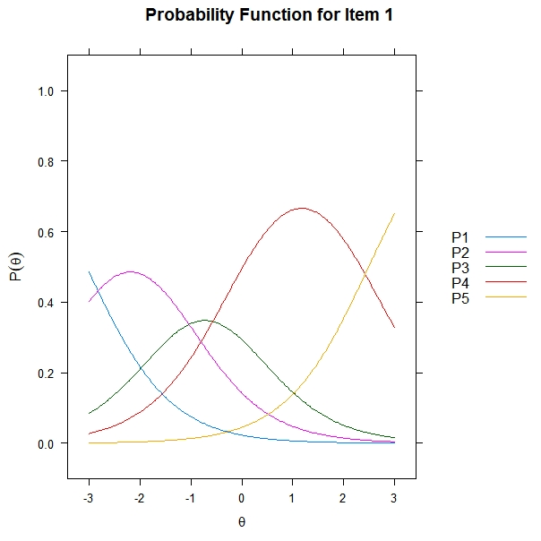

Appendix Figure 2
Item Characteristic Curves for Item 2
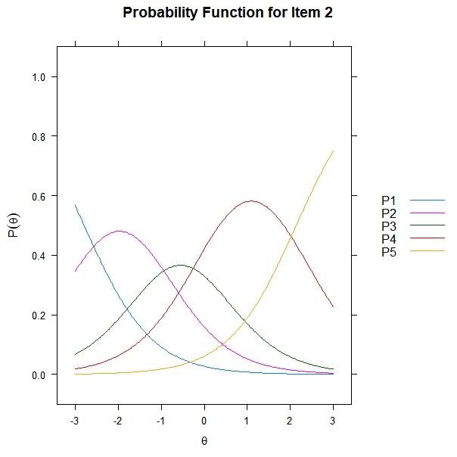

Appendix Figure 3
Item Characteristic Curves for Item 3
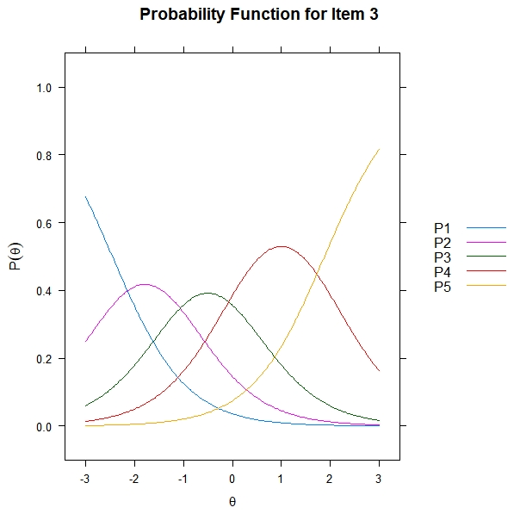
Appendix Figure 4
Item Characteristic Curves for Item 4
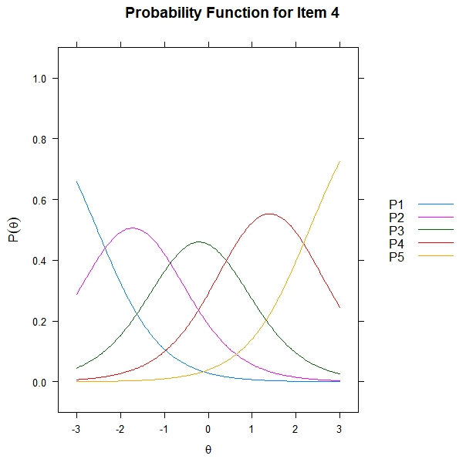
Appendix Figure 5
Item Characteristic Curves for Item 5
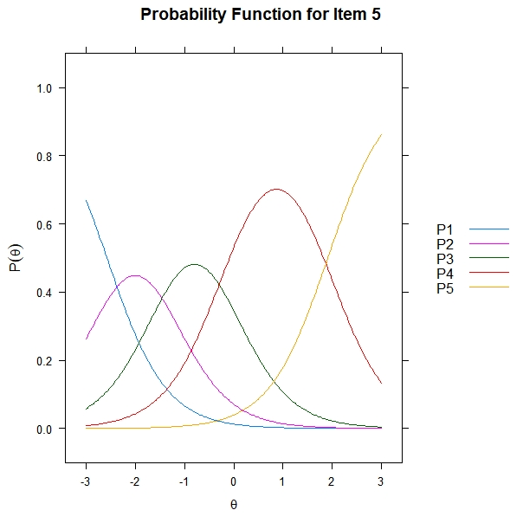
Appendix Figure 6
Item Characteristic Curves for Item 6
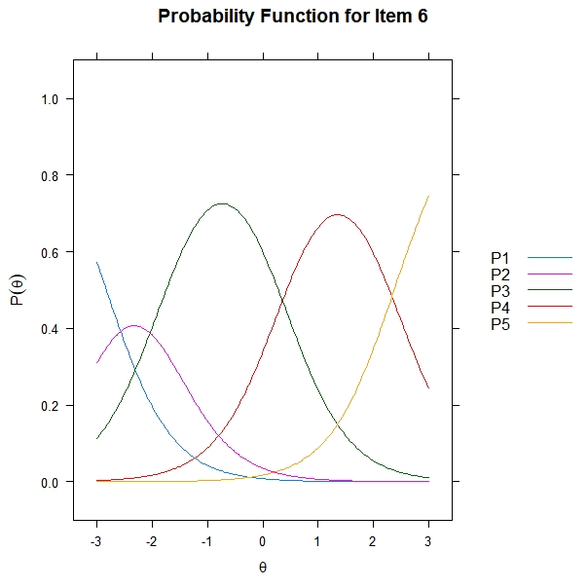
Appendix Figure 7
Item Characteristic Curves for Item 7
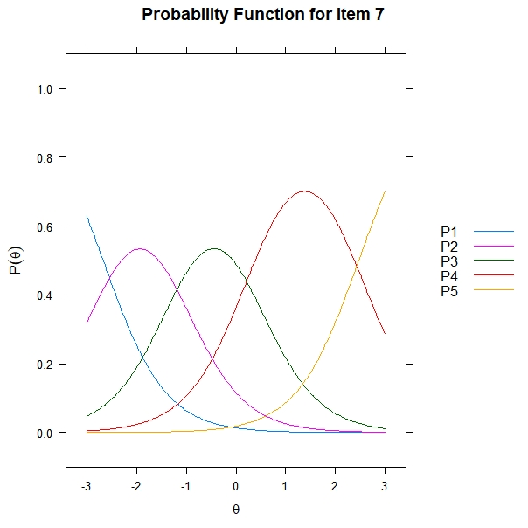
Appendix Figure 8
Item Characteristic Curves for Item 8
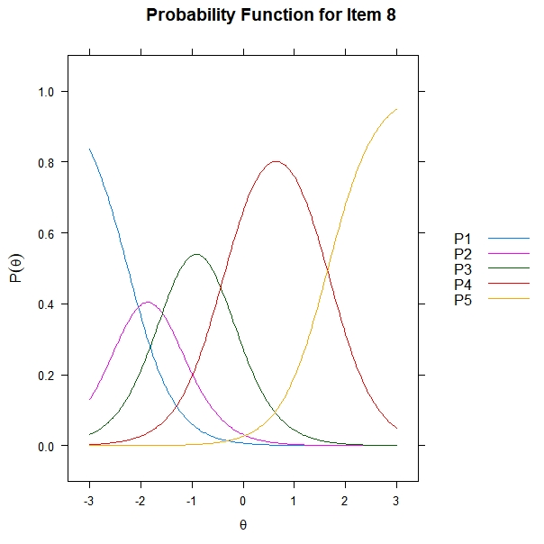
Appendix Figure 9
Item Characteristic Curves for Item 9
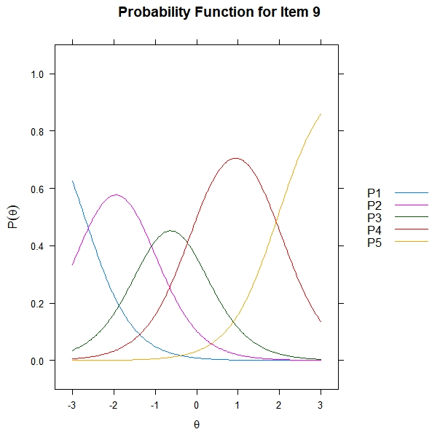
Appendix Figure 10
Item Characteristic Curves for Item 10
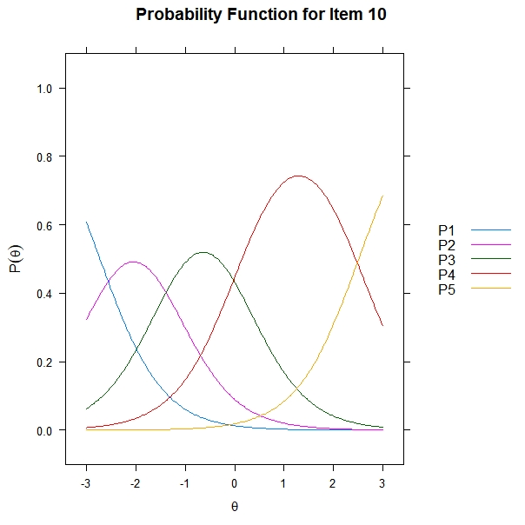
Appendix Figure 11
Item Characteristic Curves for Item 11
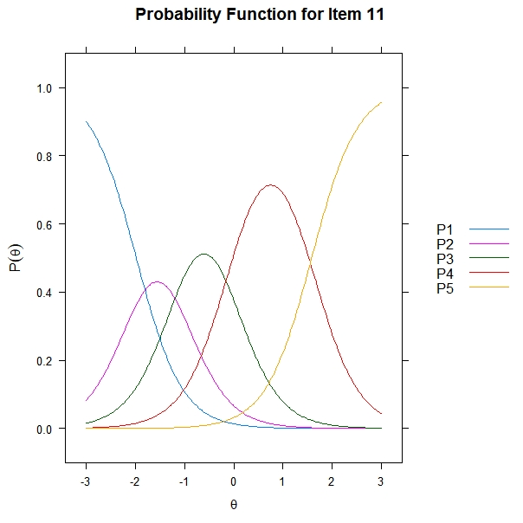
Appendix Figure 12
Item Characteristic Curves for Item 12
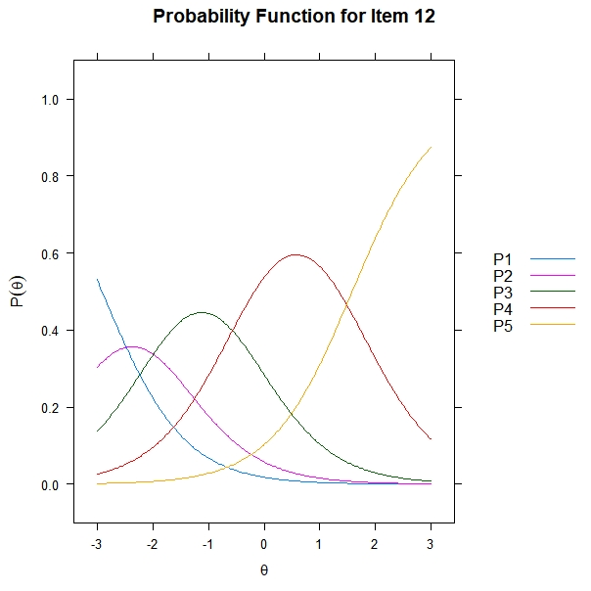
Appendix Figure 13
Item Characteristic Curves for Item 13
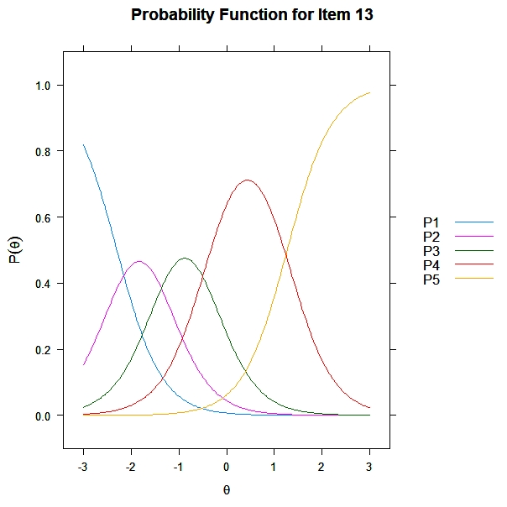
Appendix Figure 14
Item Characteristic Curves for Item 14
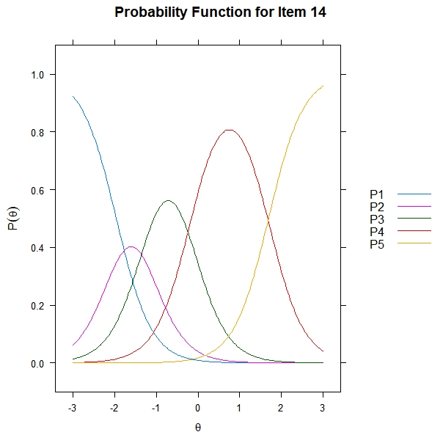
Appendix Figure 15
Item Characteristic Curves for Item 15
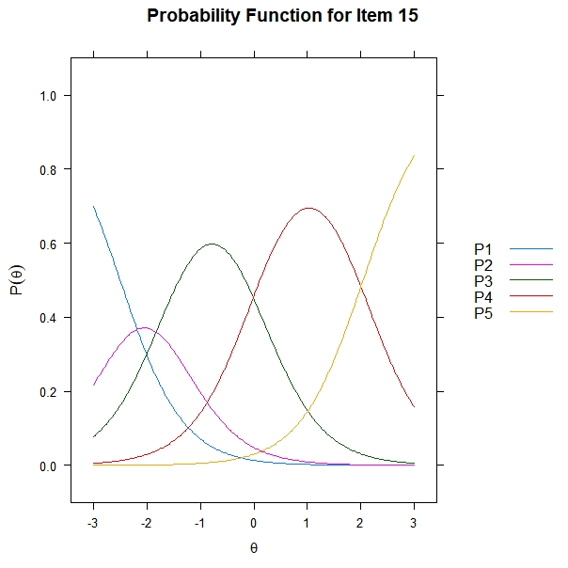
Appendix Figure 16
Item Characteristic Curves for Item 16
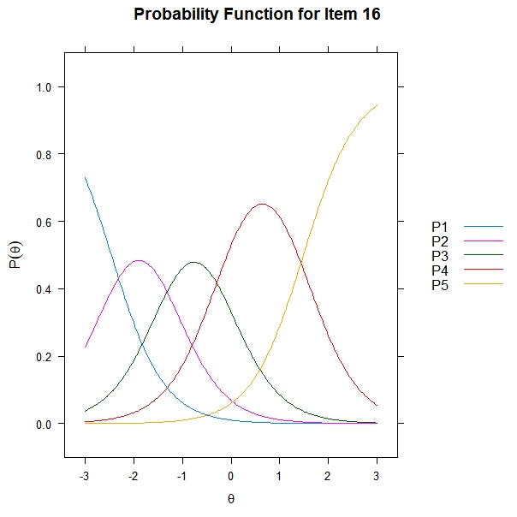
Appendix Figure 17
Item Characteristic Curves for Item 17
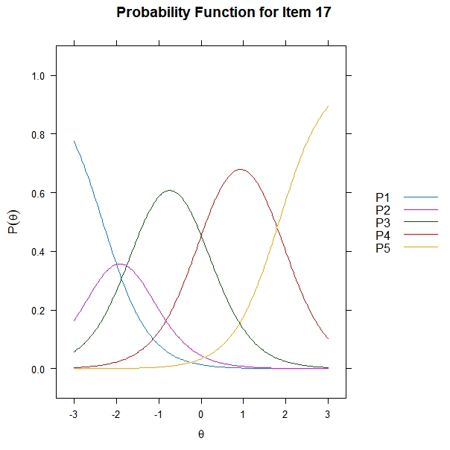
Appendix Figure 18
Item Characteristic Curves for Item 18
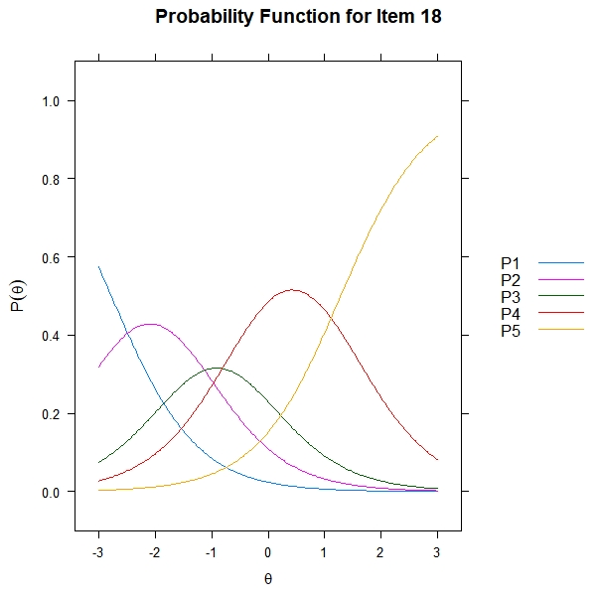
Appendix Figure 19
Item Characteristic Curves for Item 19
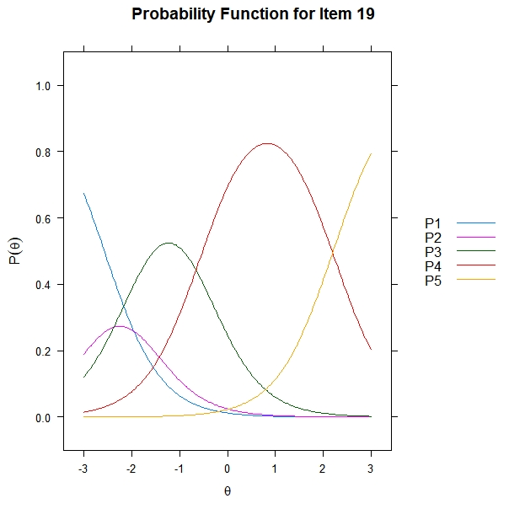
Appendix Figure 20
Item Characteristic Curves for Item 20
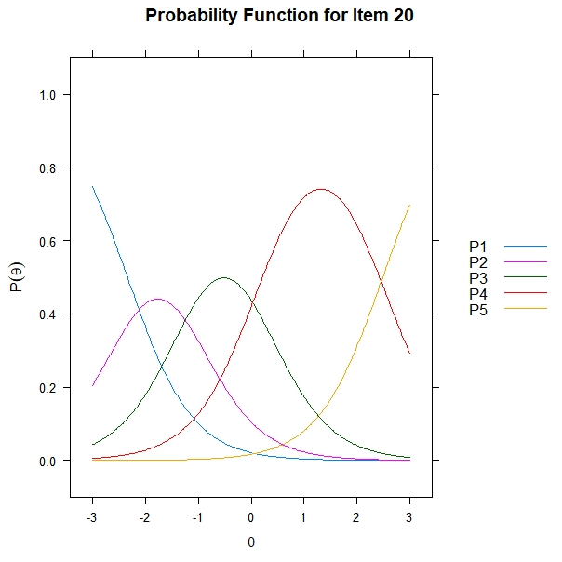

Appendix Table 1: RNSS and RNSS-C
Carefully read each statement and circle the correct answer. Use the scale below to make your choice. Please choose only one answer for each statement. There are no right or wrong answers. Be sure to answer every item.
NO. | RNSS | RNSS-C | Option
1 | My social circle consists of people who share a similar life experience to me (e.g., a hobby, a profession, belonging to the same group or online forum). | 1.我的社交圈是由和我有着相似生活经历的人组成的(比如爱好、职业、属于同一个小组或在线论坛) | 1 = completely disagree  2 = disagree  3 = not sure  4 = agree  5 = completely agree
2 | I hardly have to hide anything in the company of people close to me. | 2.和我亲近的人在一起，我几乎不需要隐瞒什么
3 | I have a strong, stable, and protective person in my life whom I can rely on. | 3.在我的生活中，我有一个坚强的，稳定的，可以保护我的人，我可以依靠的人
4 | I know a capable individual who would help me if I found myself in trouble. | 4.我认识一个很有能力的人，如果我遇到困难他会帮助我
5 | I know people who experience some things similarly to me. | 5.我认识一些和我有类似经历的人
6 | Others often take my advice to heart. | 6.其他人会把我的建议放在心上
7 | Other people often help me even if I do not speciﬁcally ask them to. | 7.别人经常帮助我，即使我没有特别要求他们帮助我
8 | I know people with a world-view similar to mine. | 8.我认识一些和我世界观相似的人
9 | Other people sometimes surprise me in a nice way. | 9.其他人有时会给我一个惊喜
10 | People close to me would sometimes do things for me without me having to ask. | 10.我身边的人有时候会在我没有做出任何要求的情况下帮我主动分担一些事
11 | I feel free to show my feelings to others and speak my mind because I know they accept me for who I am. | 11.我可以向别人表达我的感受，说出我的想法，因为我知道他们接受真实的我
12 | I do not have to pretend with people who are important to me. | 12. 在于我而言很重要的人面前，我不会伪装自己
13 | I have at least one person in my life who encourages me, protects me or provides me with the information I need. | 13.在我的生活中，我至少有一个人鼓励我，保护我，或向我提供我所需要的信息
14 | There are people in my life with whom I share similar experiences. | 14.在我的生活中，我和一些人有着相似的经历
15 | I feel that I have an inﬂuence on others. | 15.我觉得我对别人有影响
16 | I can show my true self to people who are important to me without fear of rejection. | 16.我可以在对我重要的人面前展现真实的自我，而不用担心被拒绝
17 | In times of trouble, I have someone who stands by me and who is strong enough to handle my problems. | 17.我身边有着当我遇到困难时能够支持我并有足够的能力帮我解决问题的人。
18 | No-one ever prepares a nice surprise for me. | 18.从来没有人为我准备过惊喜
19 | I have noticed that other people sometimes follow my suggestions. | 19.我注意到别人有时会听从我的建议
20 | Other people often ask about my opinion on a certain topic. | 20.别人经常问我对某个话题的看法
Notes: Authenticity: 2, 11,12, 16; Protection: 3, 4, 13, 17; Having an impact: 6, 15, 19, 20; Initiative from other: 7, 9, 10, 18; Shared experience: 1, 5, 8, 14.
RNSS-C with permission from Žvelc, G, Jovanoska, K, & Žvelc, M. (2020). Development and Validation of the Relational Needs Satisfaction Scale. Frontiers in Psychology, 11:901. doi: 10.3389/fpsyg.2020.00901. Available from: https://www.mcip.eu/relational-needs-satisfaction-scale/.

