Supplementary Materials
< Figure S1>
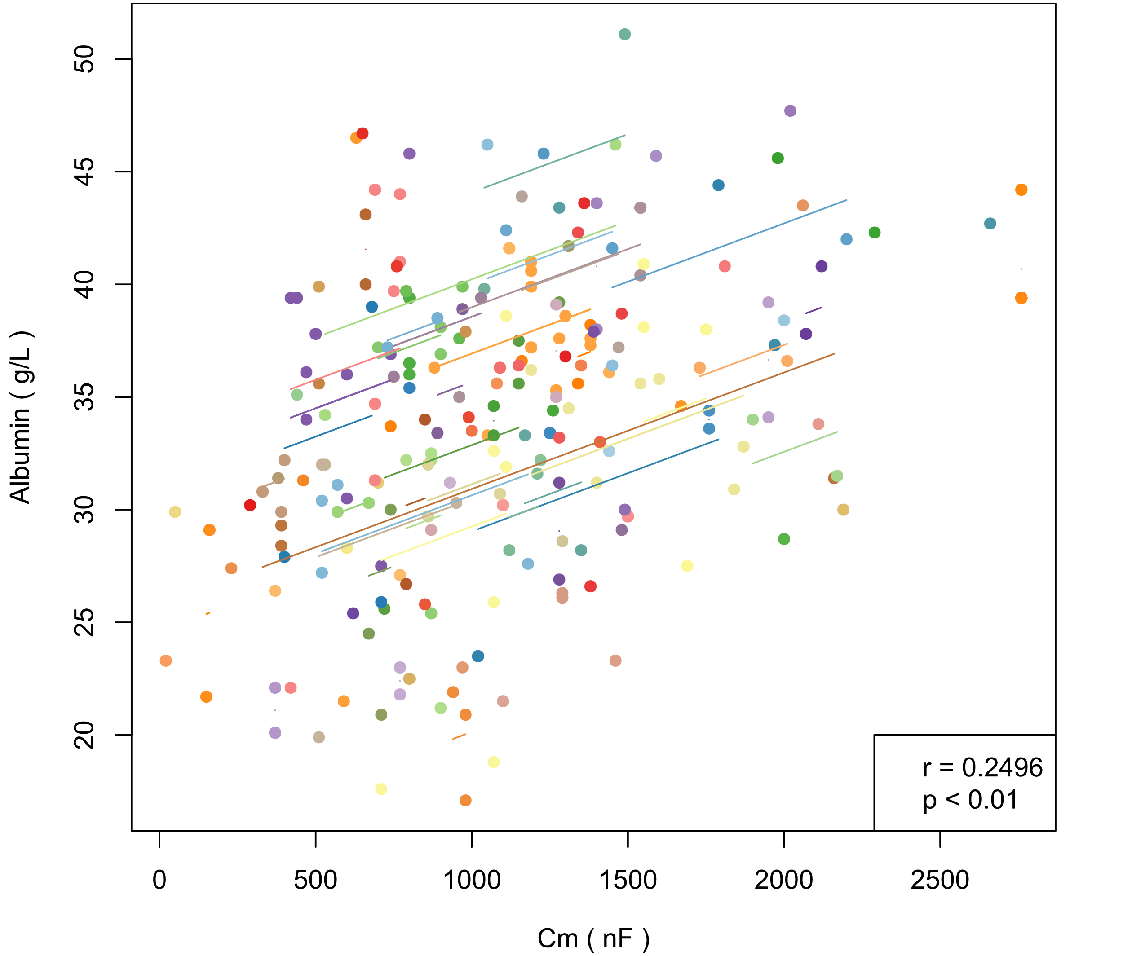  (a) Alb and Cm | 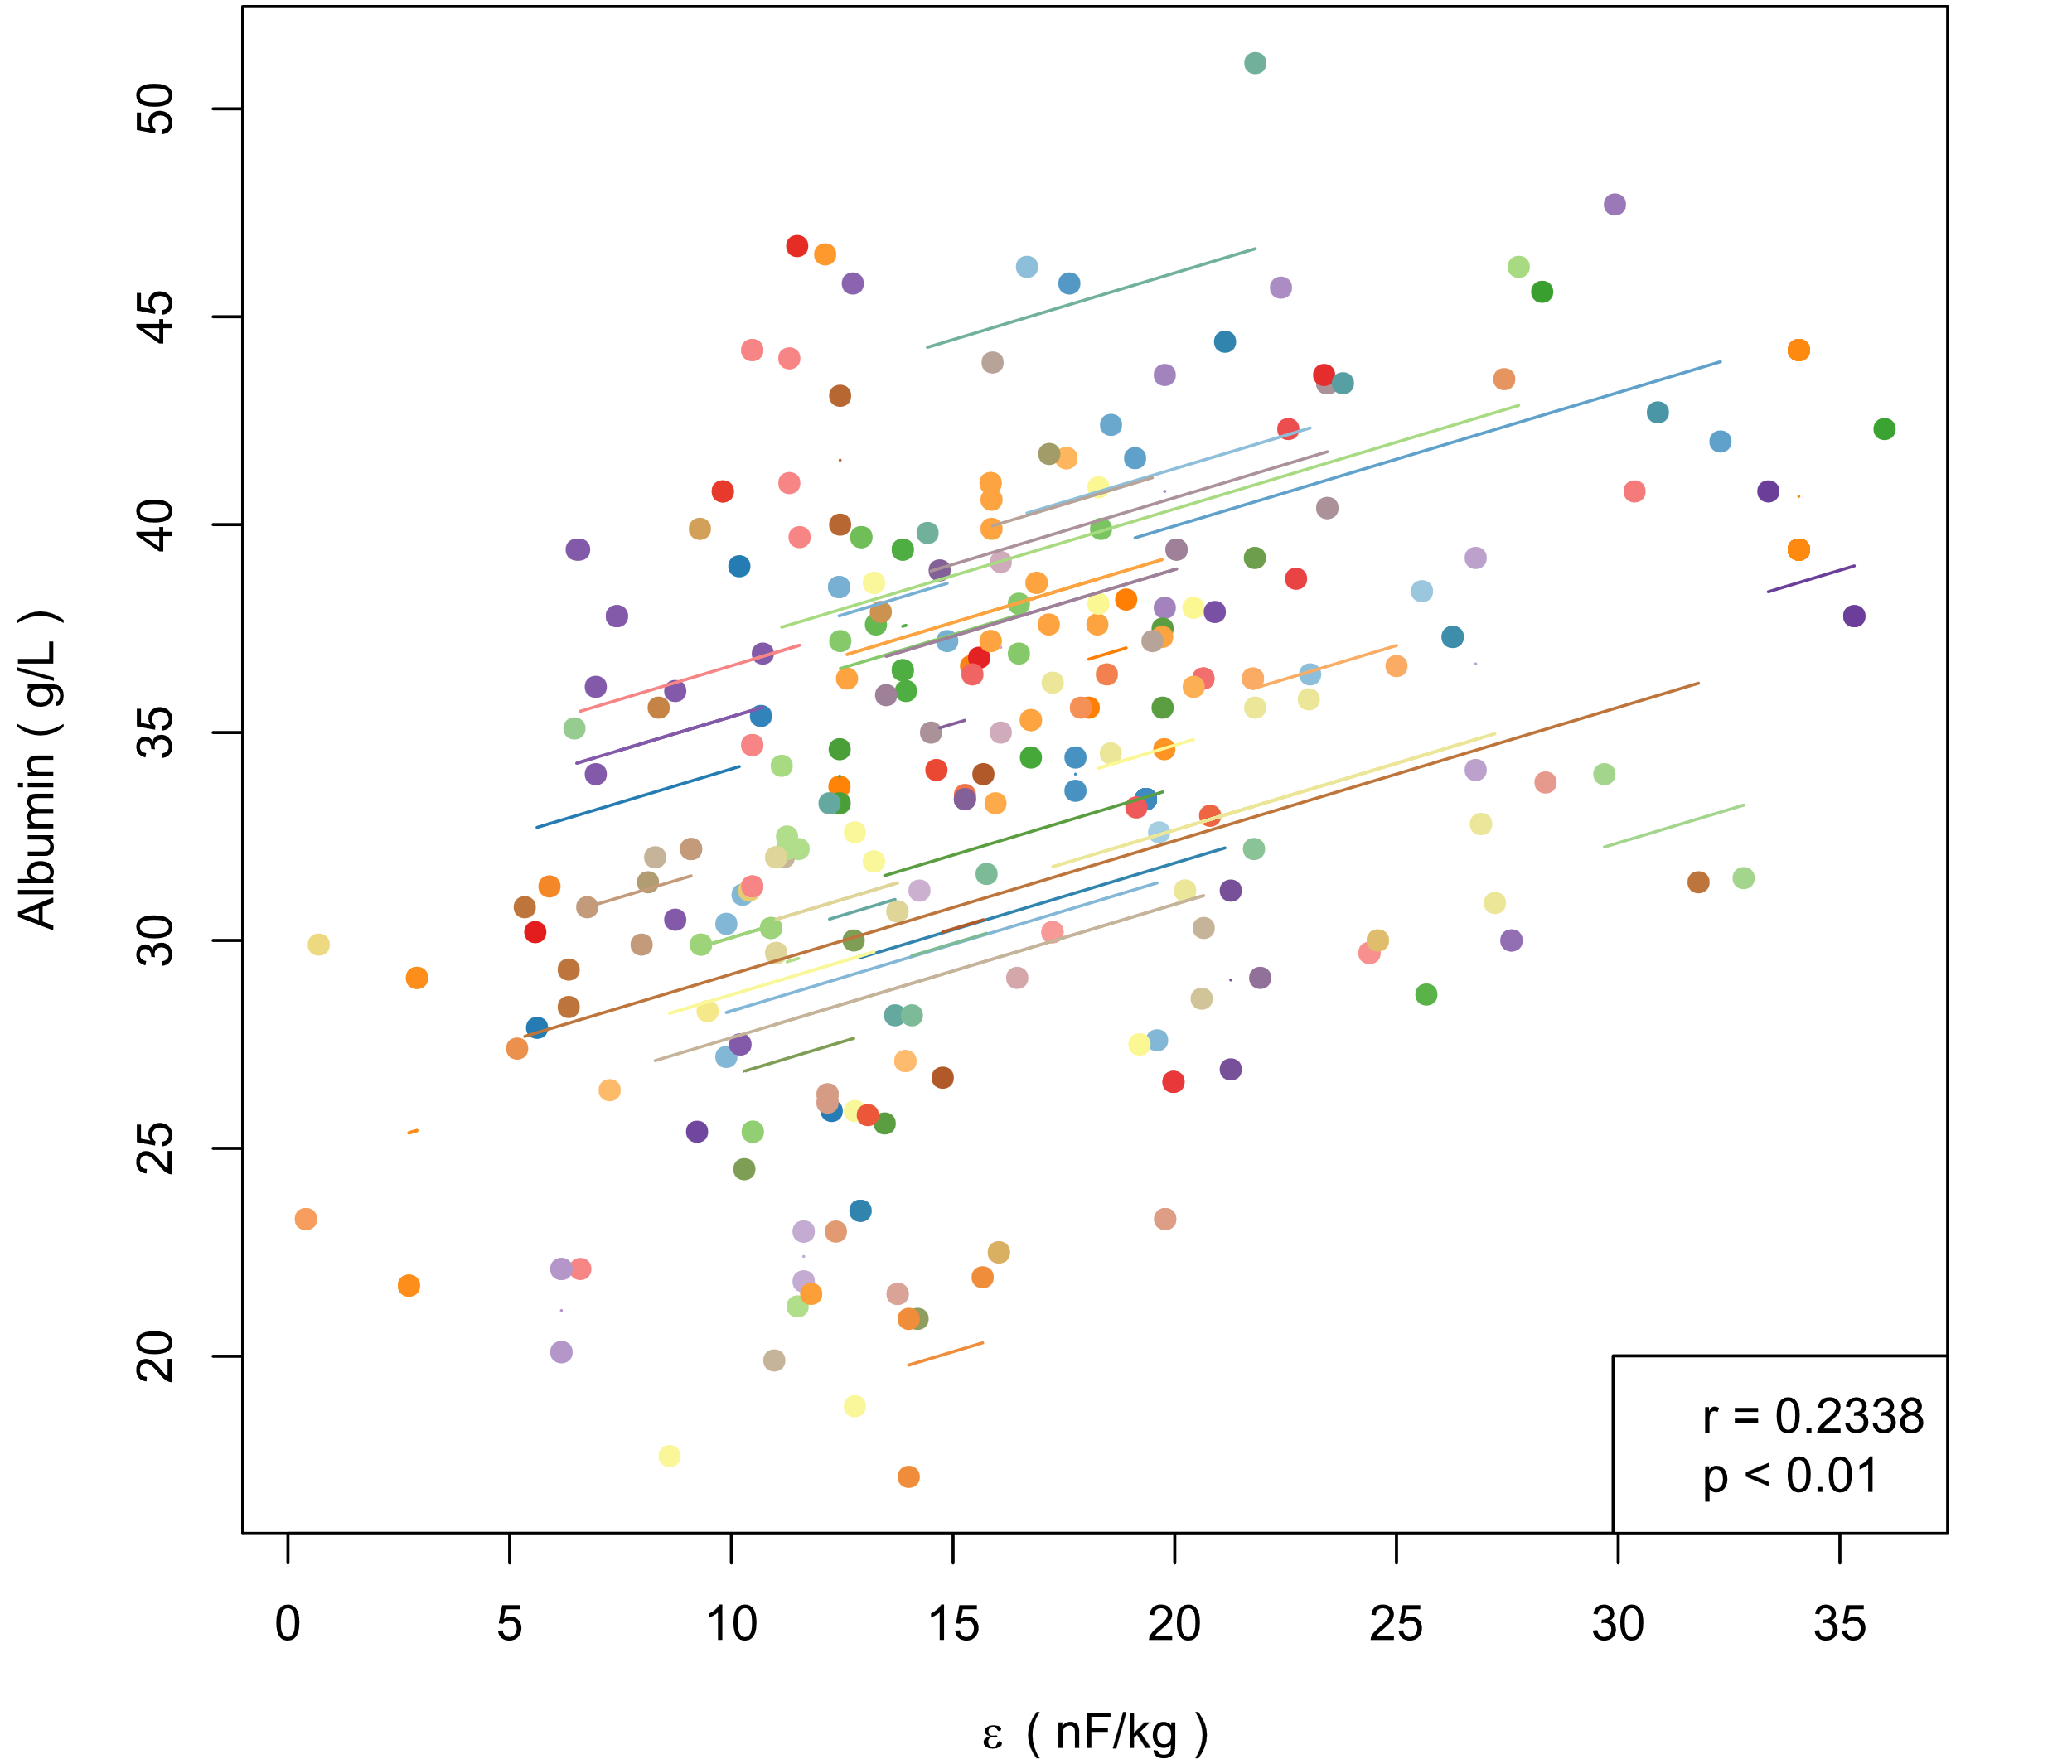  (b) Alb and ε
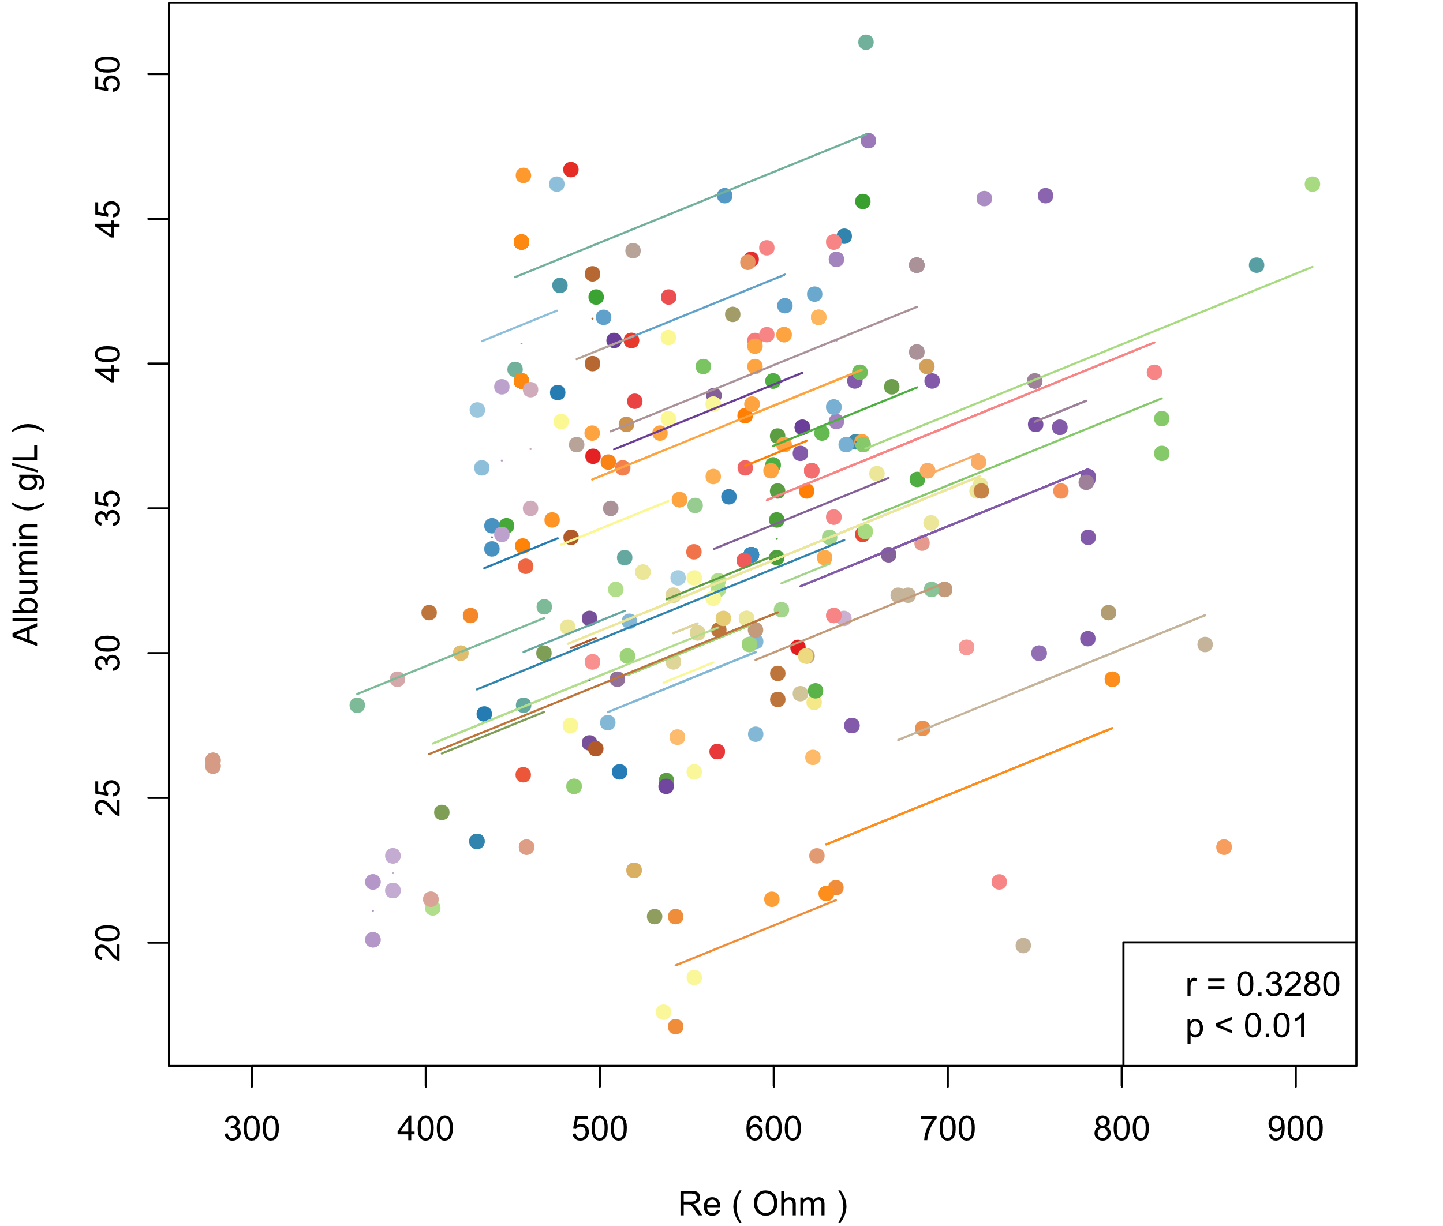  (c) Alb and Re | 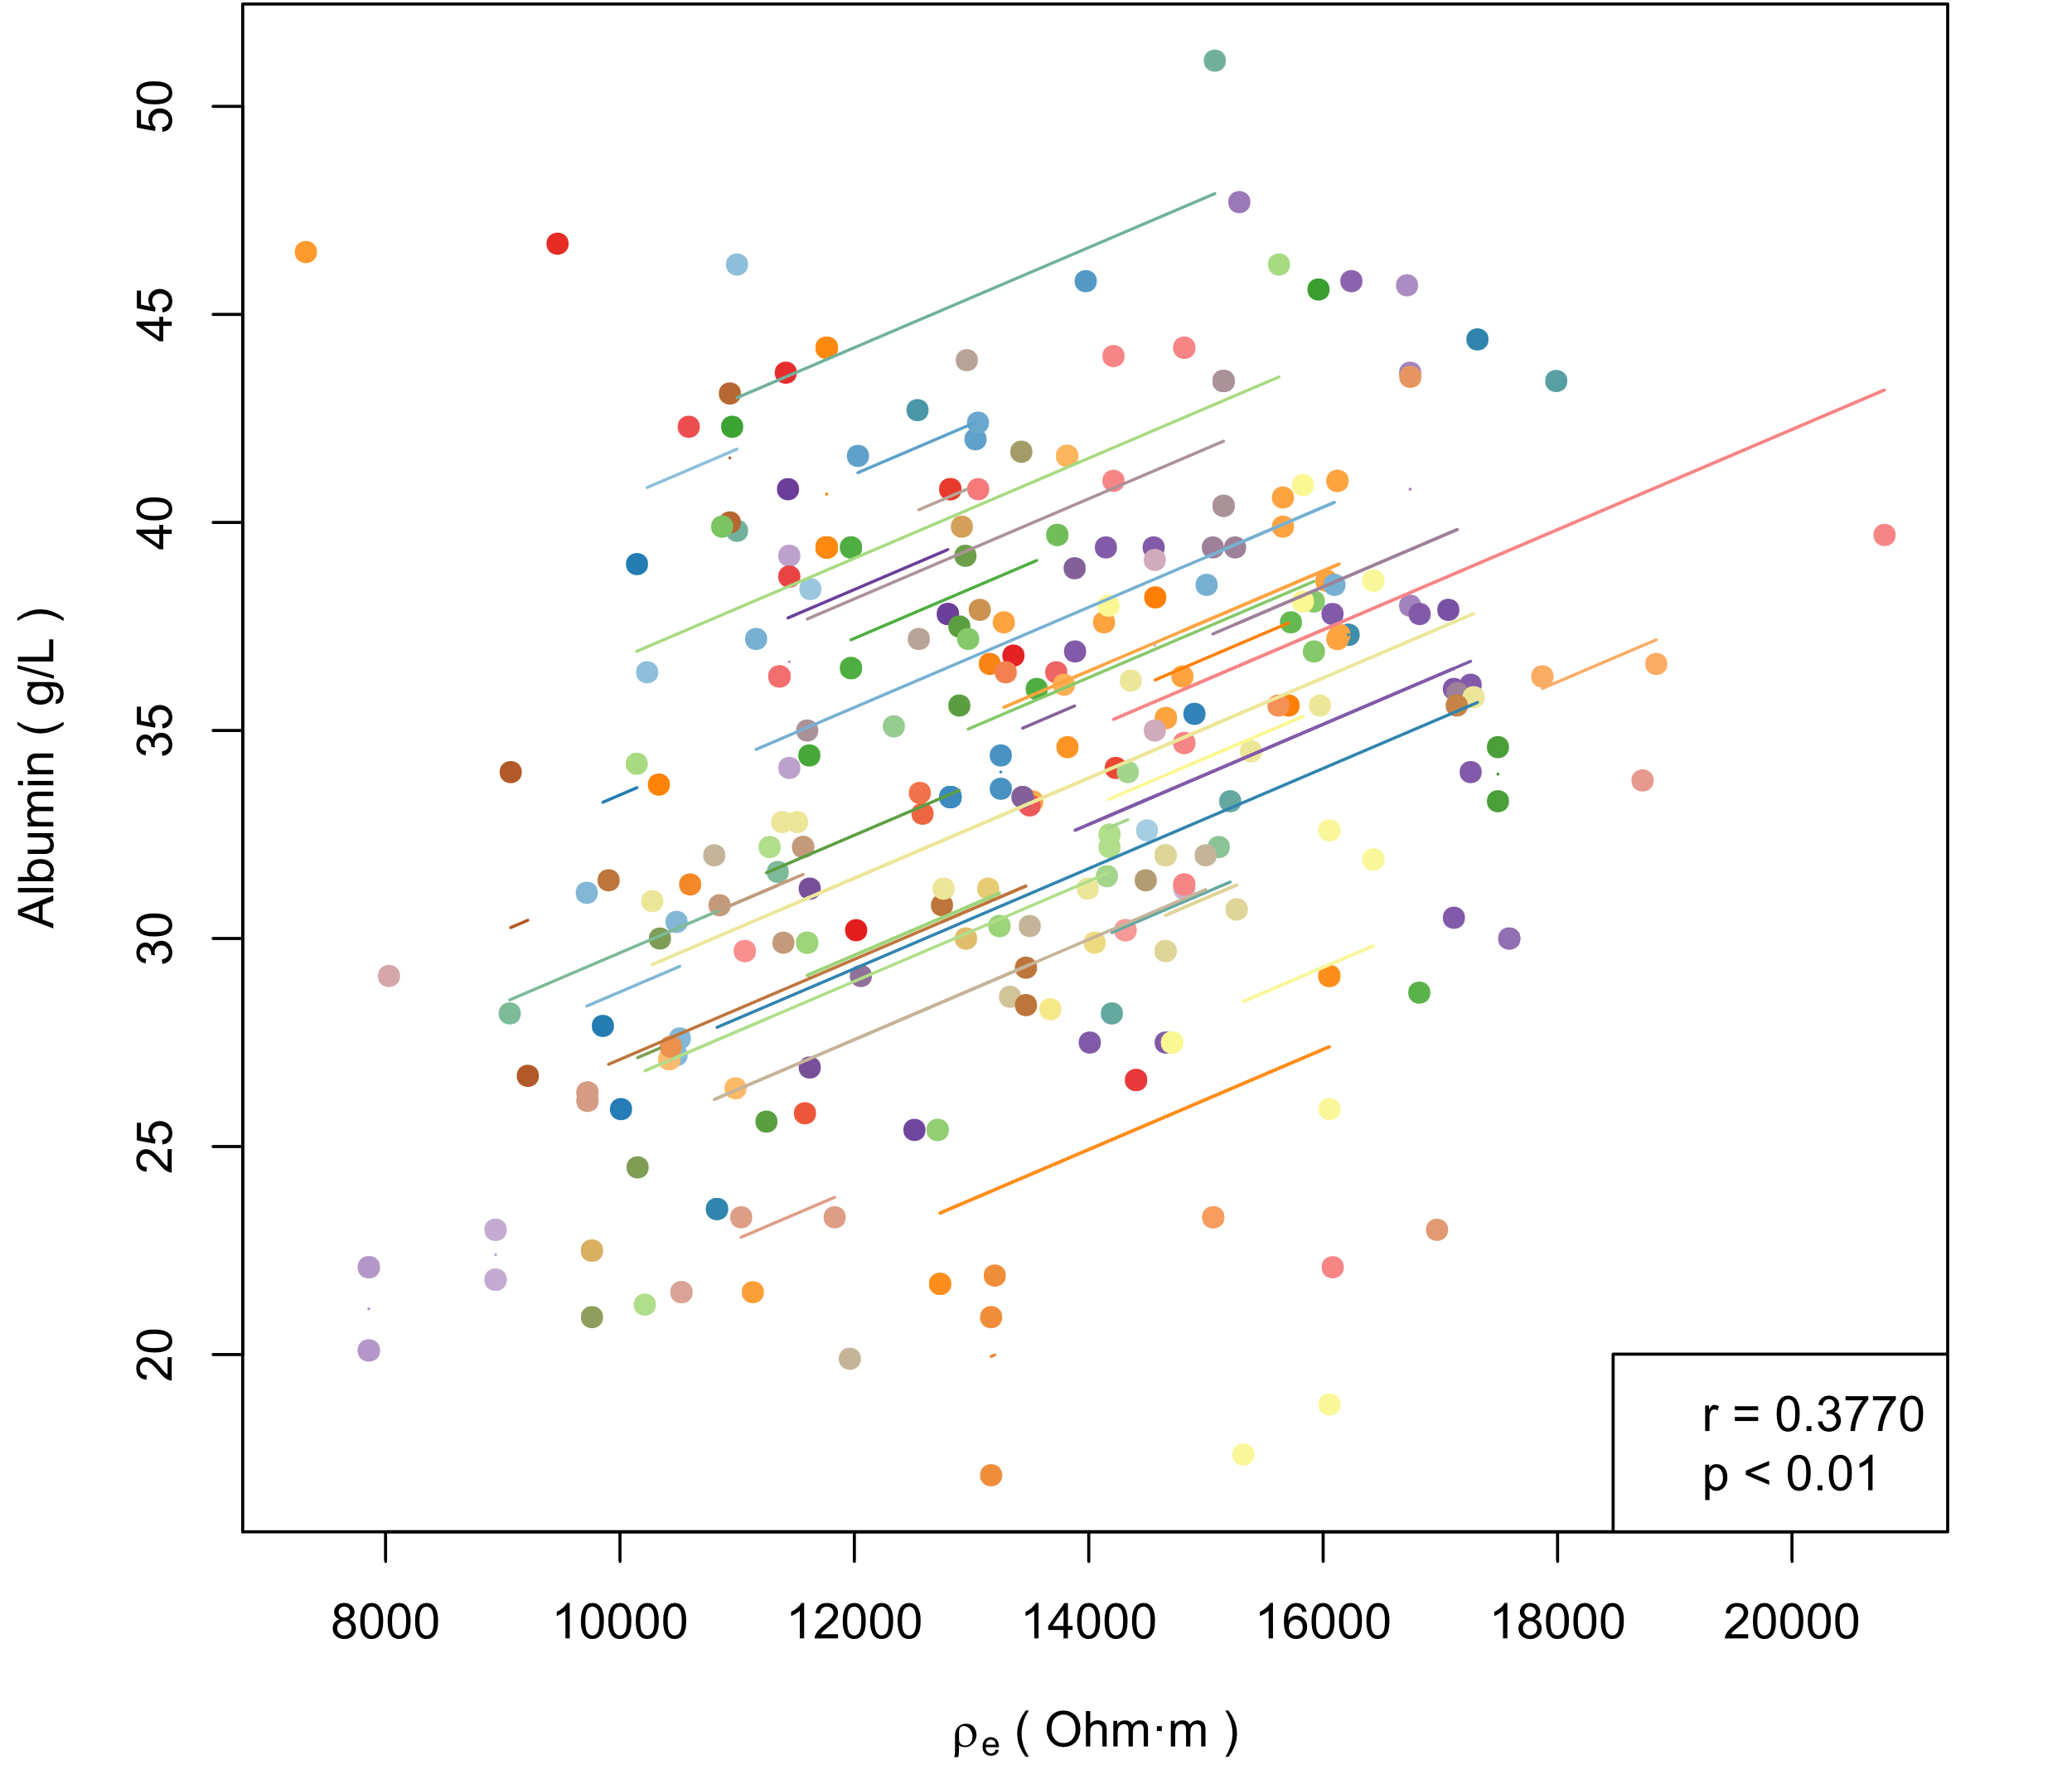  (d) Alb and ρe
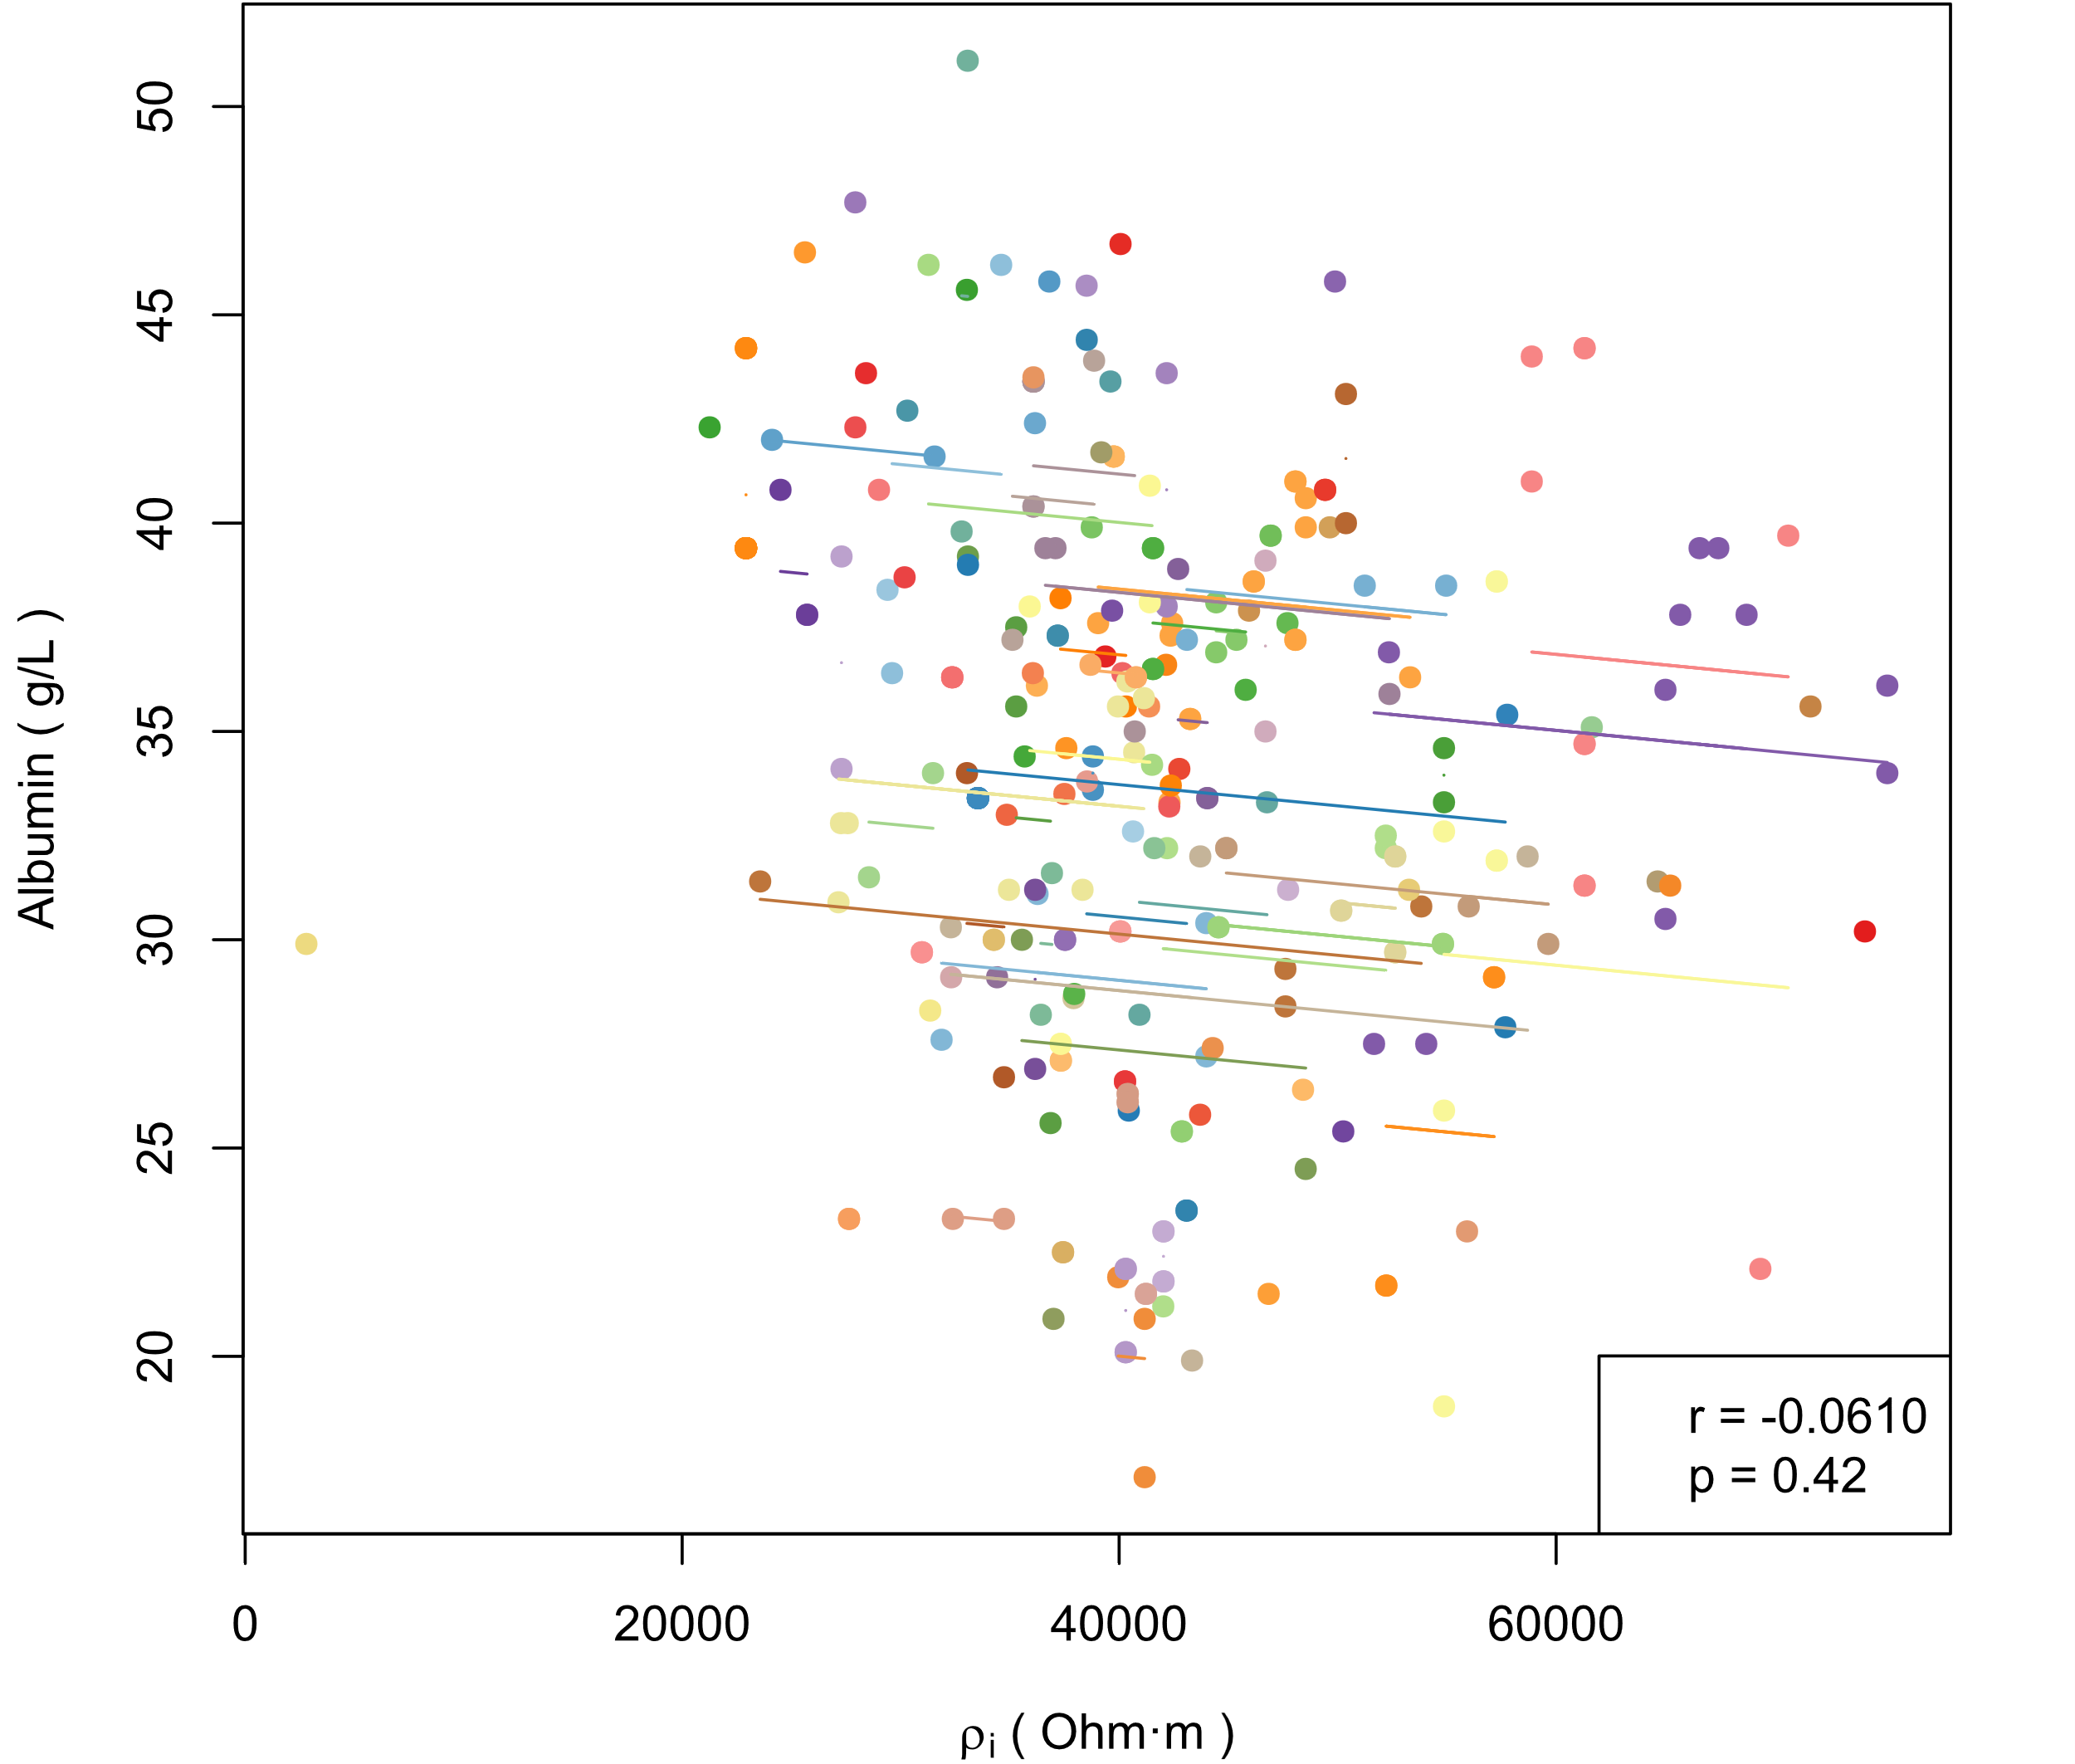  (e) Alb and ρi | 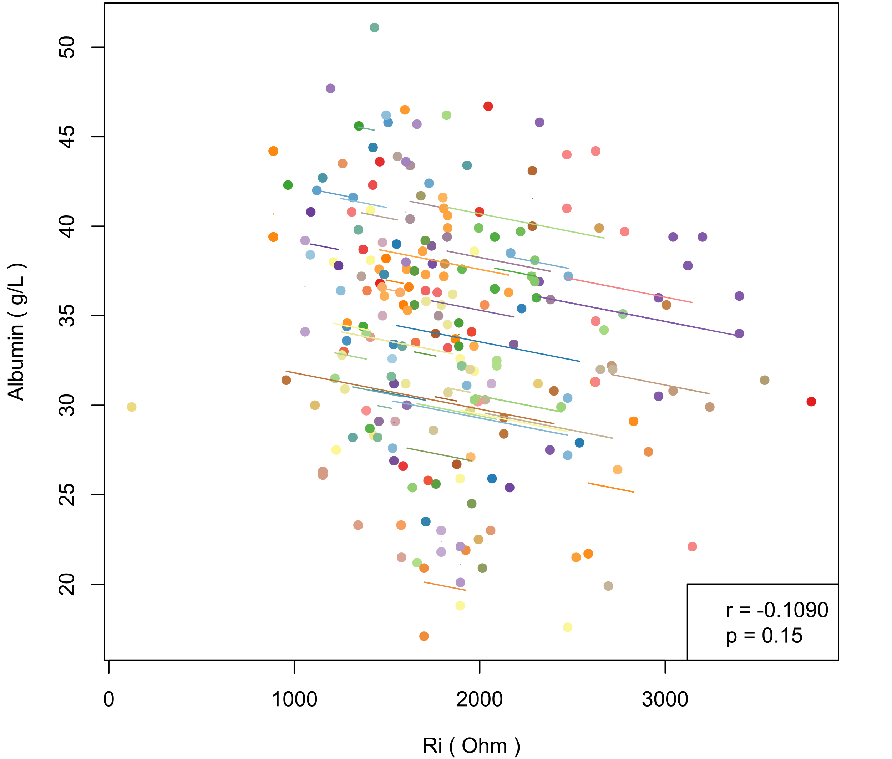  (f) Alb and Ri
Figure S1. (a-f) Intra-individual correlations between albumin (Alb) and bioelectrical indices in men (each color represents a patient, different points in each color represent samples of the patient measured at different times, line of the color represents the regression result of intra-individual correlation on the samples of this patient. r and p in the legend are the correlation coefficient and p value of hypothesis testing in repeated measures correlation)

< Figure S2>
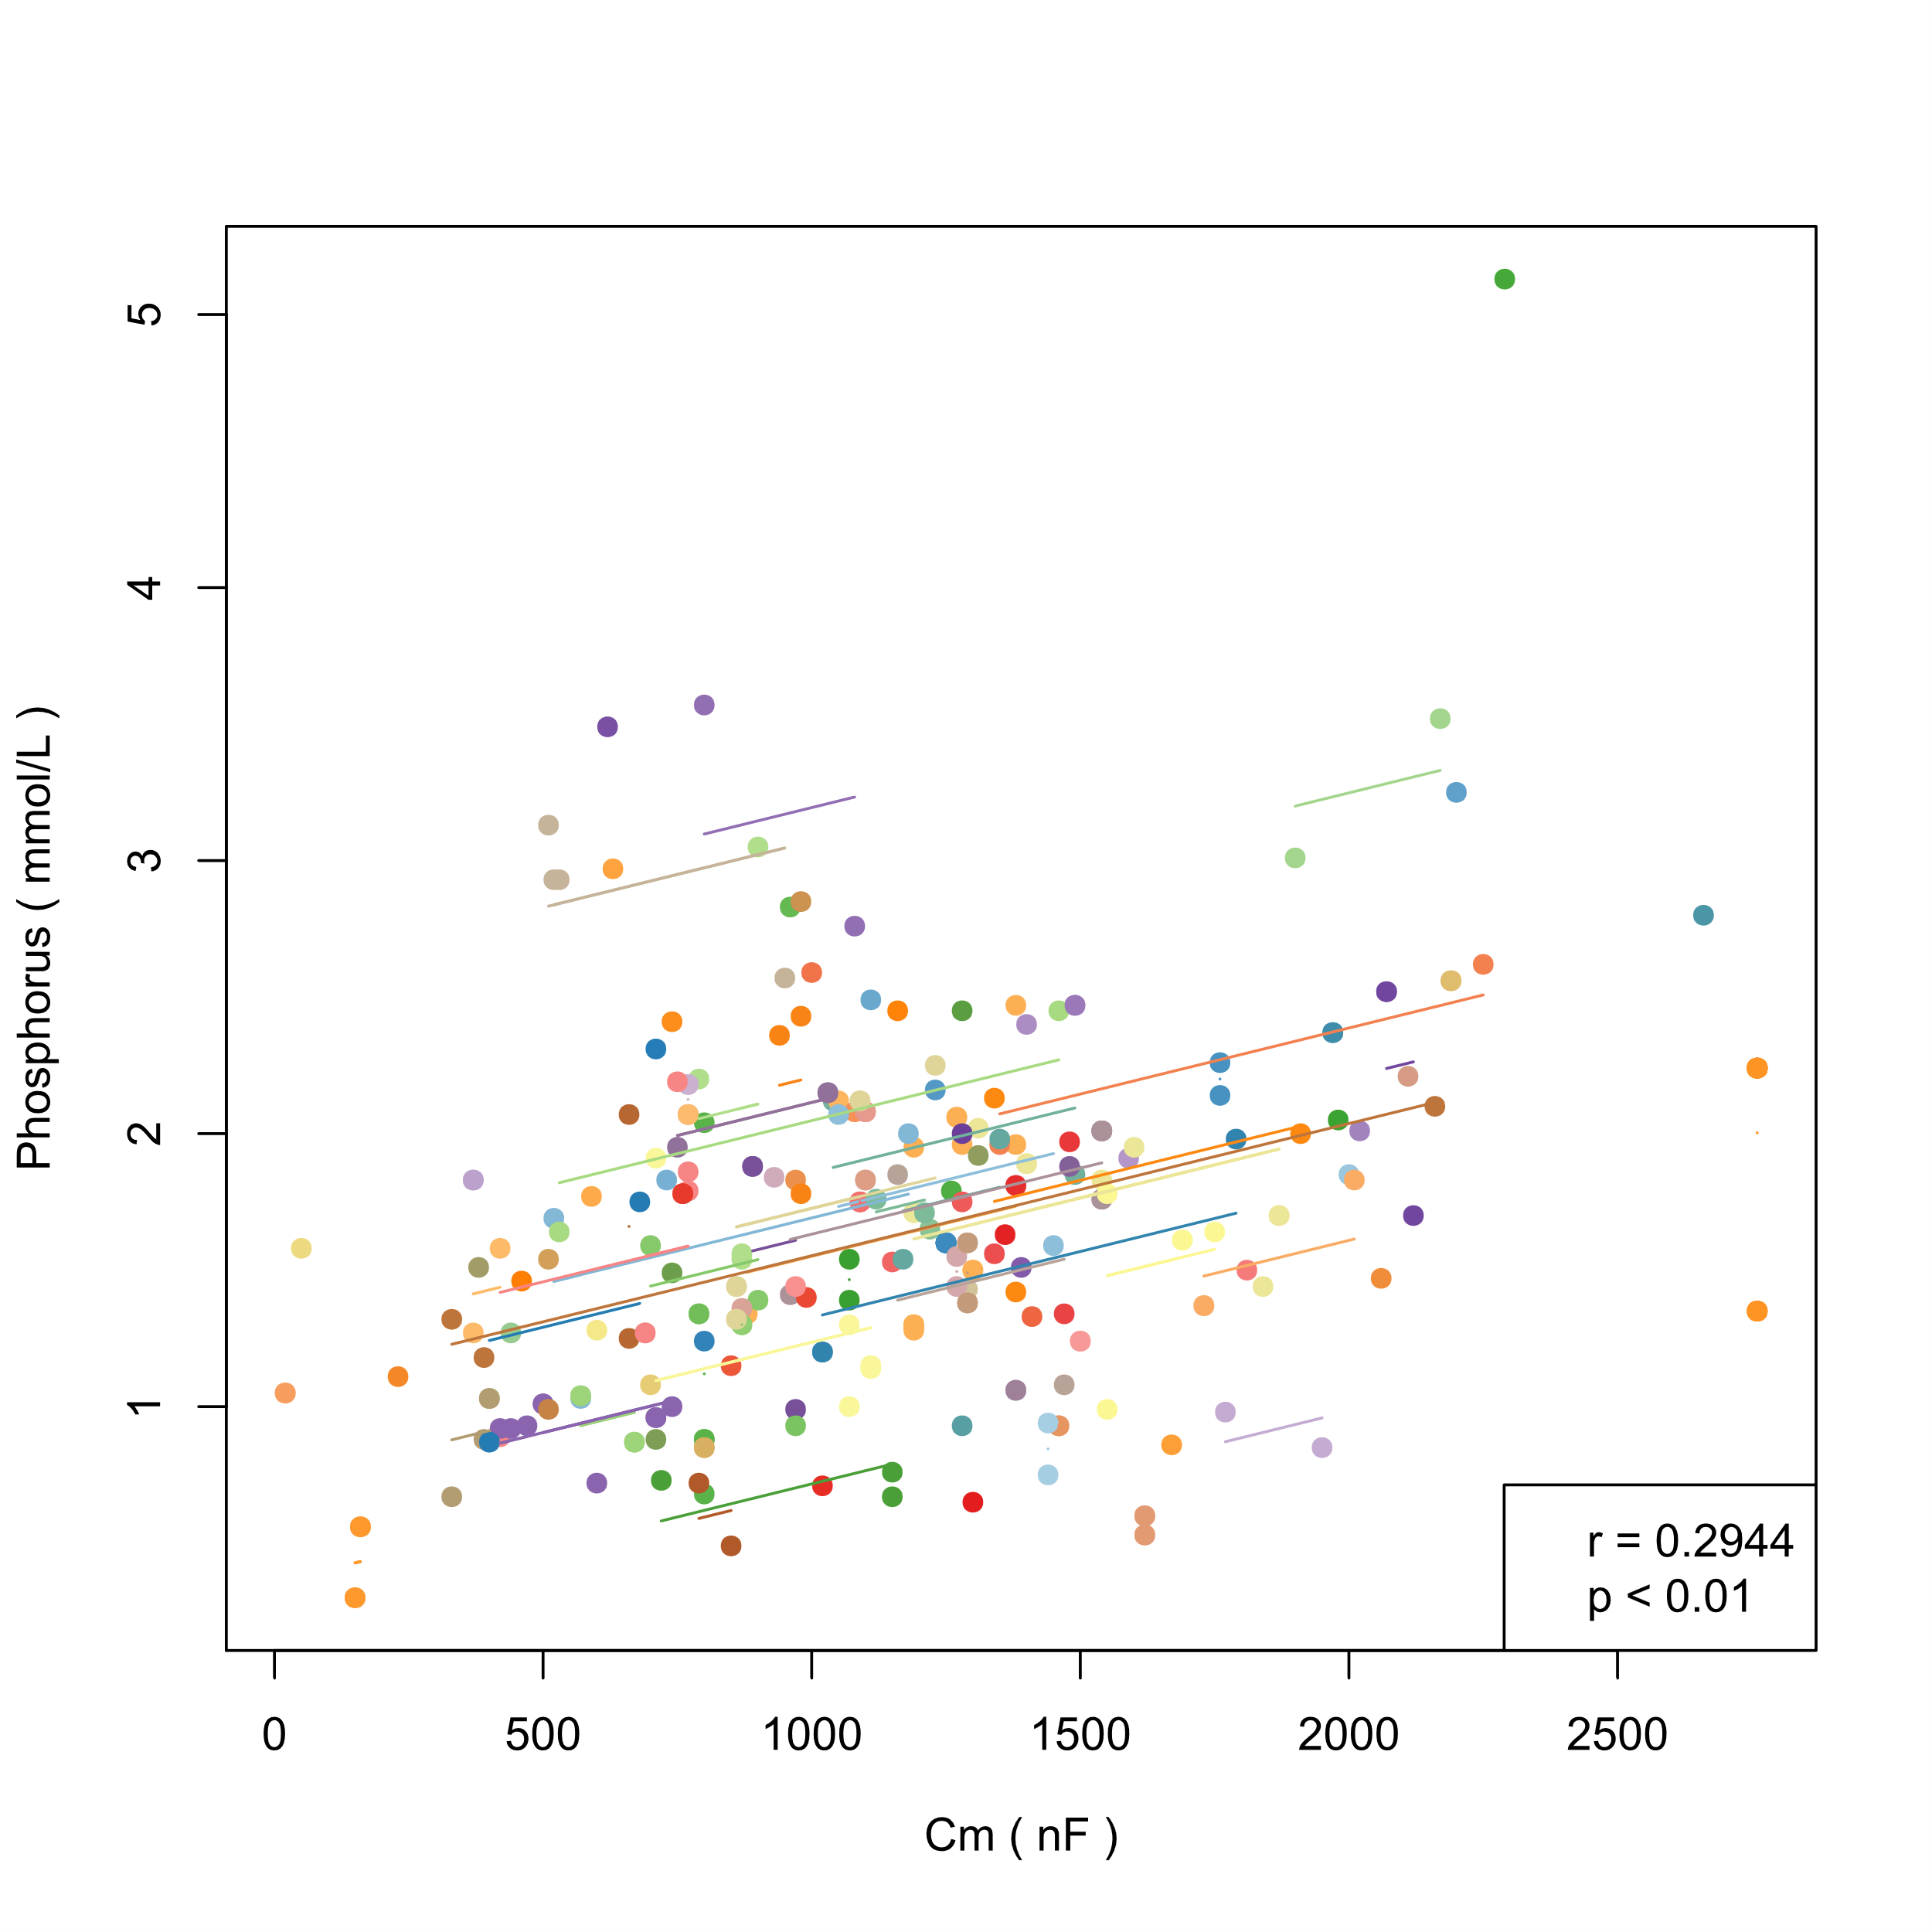(a) P and Cm | 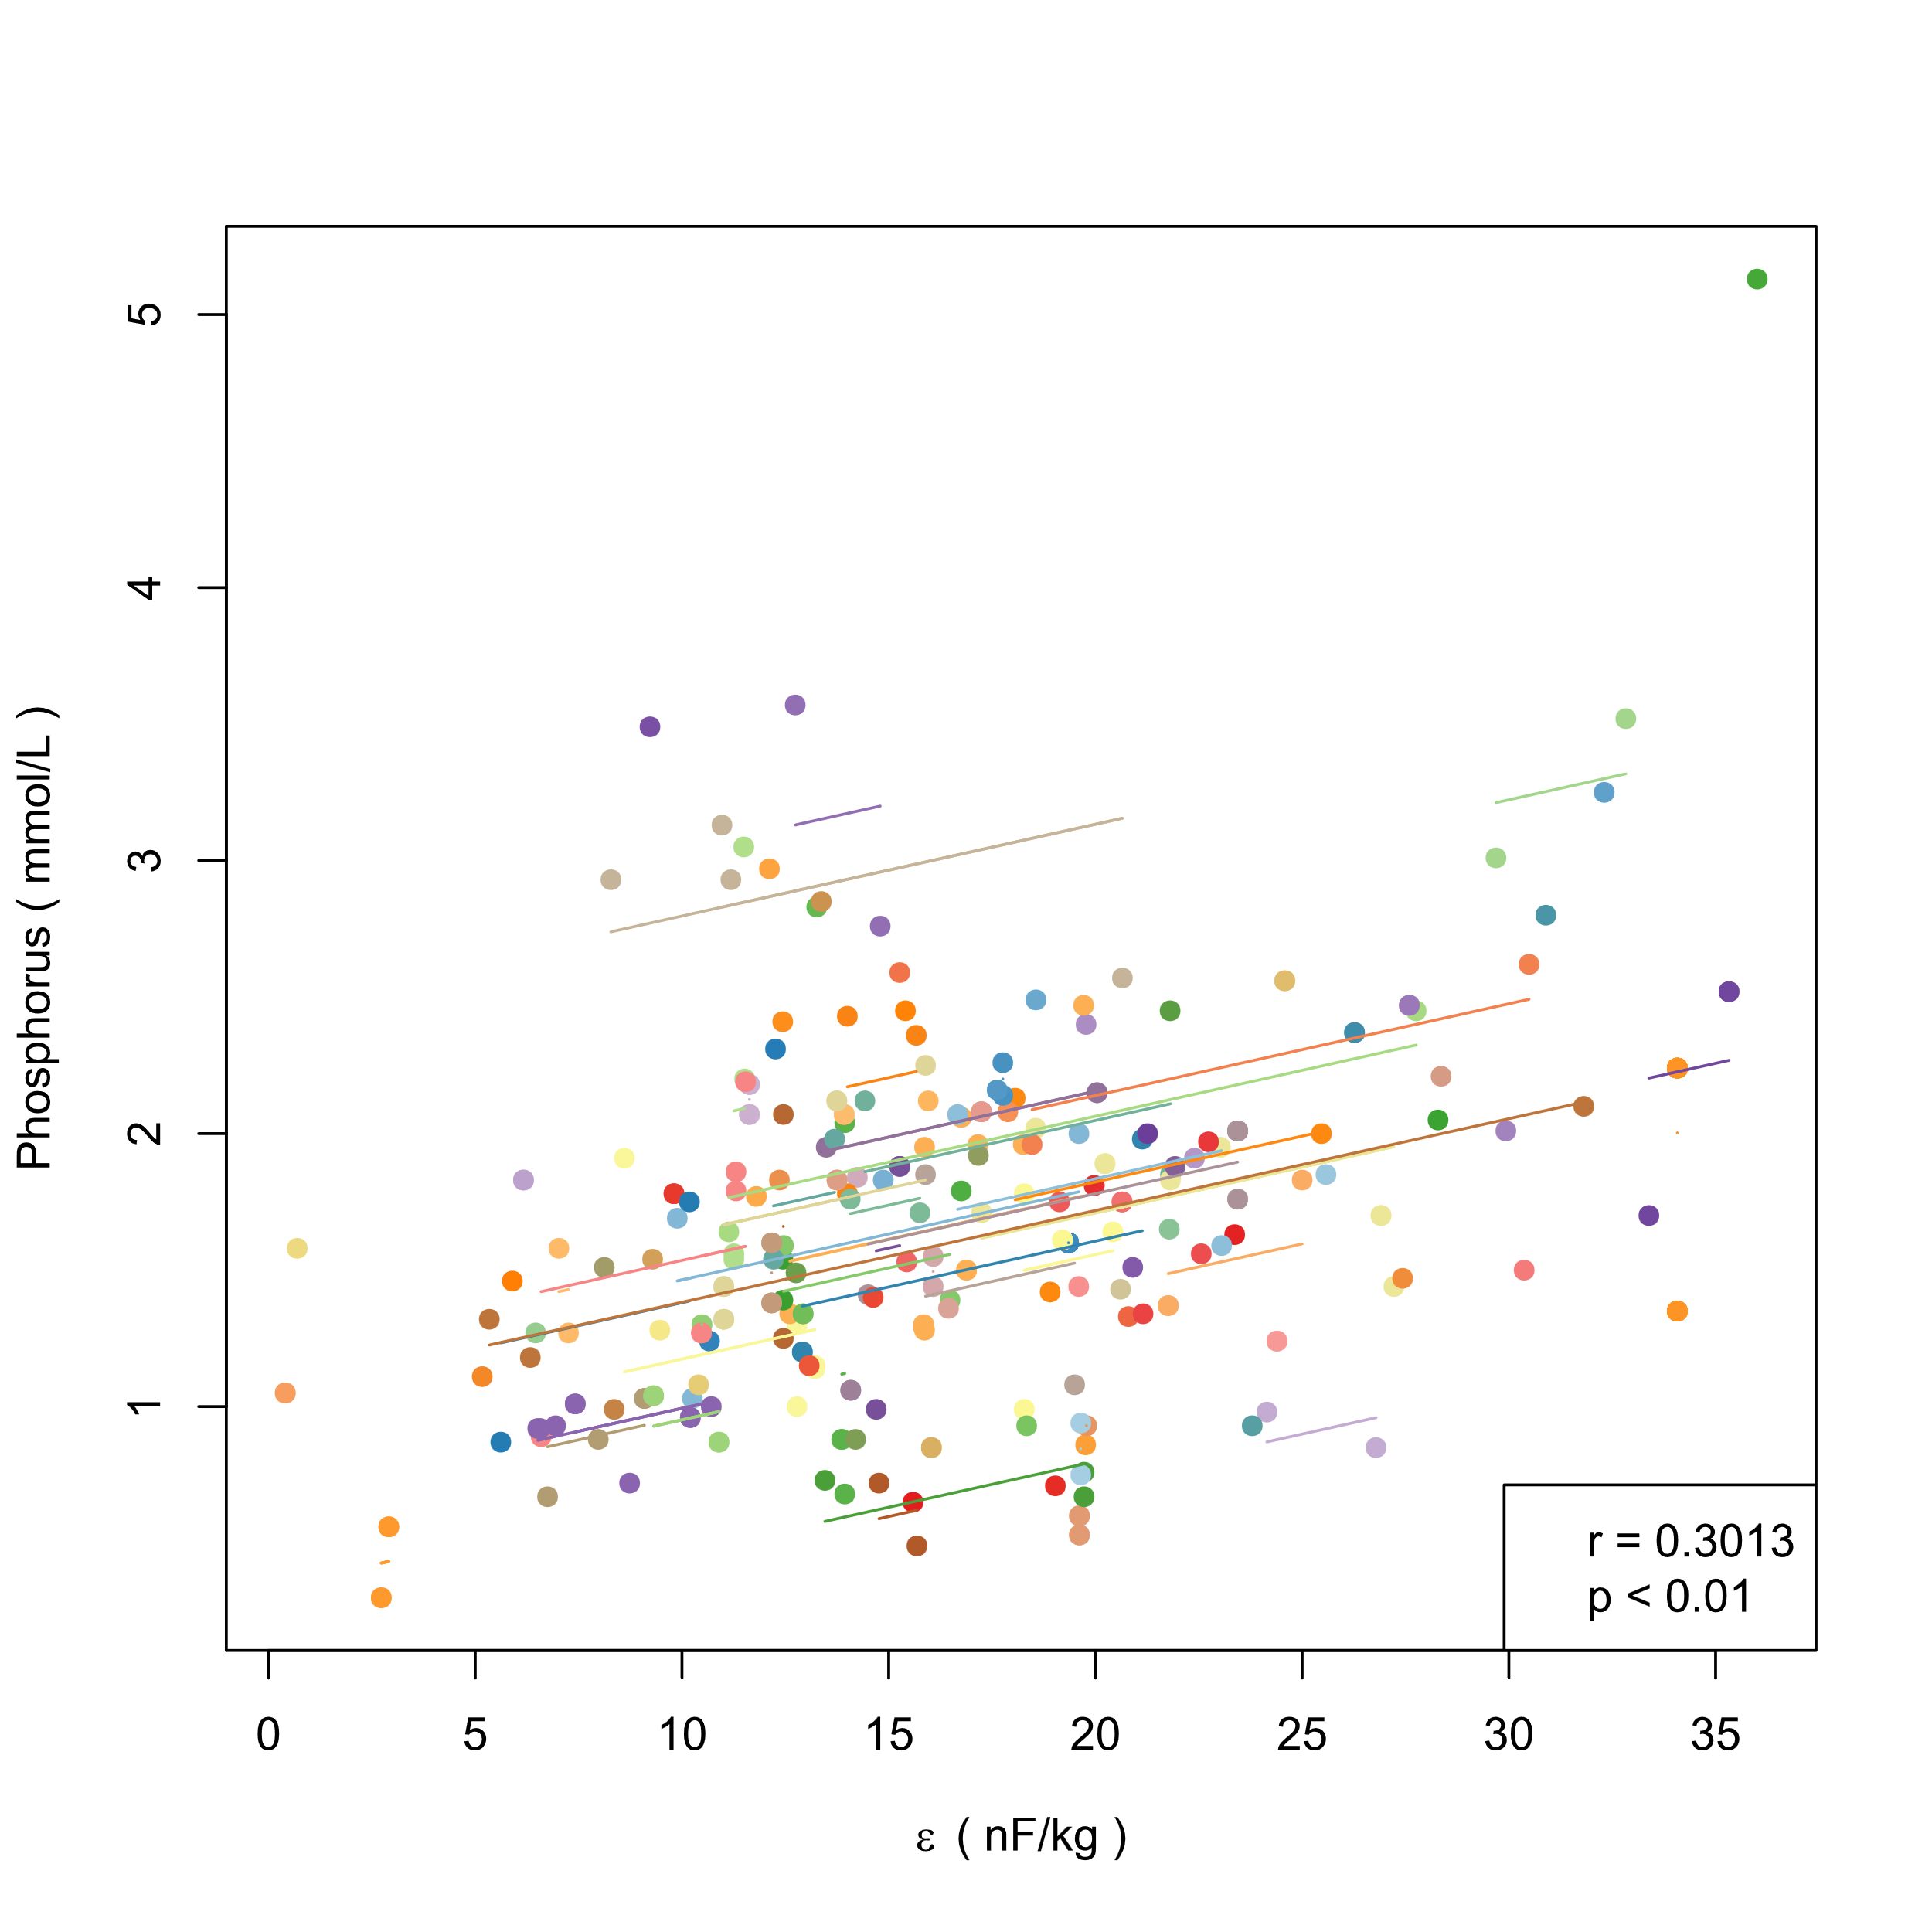(b) P and ε
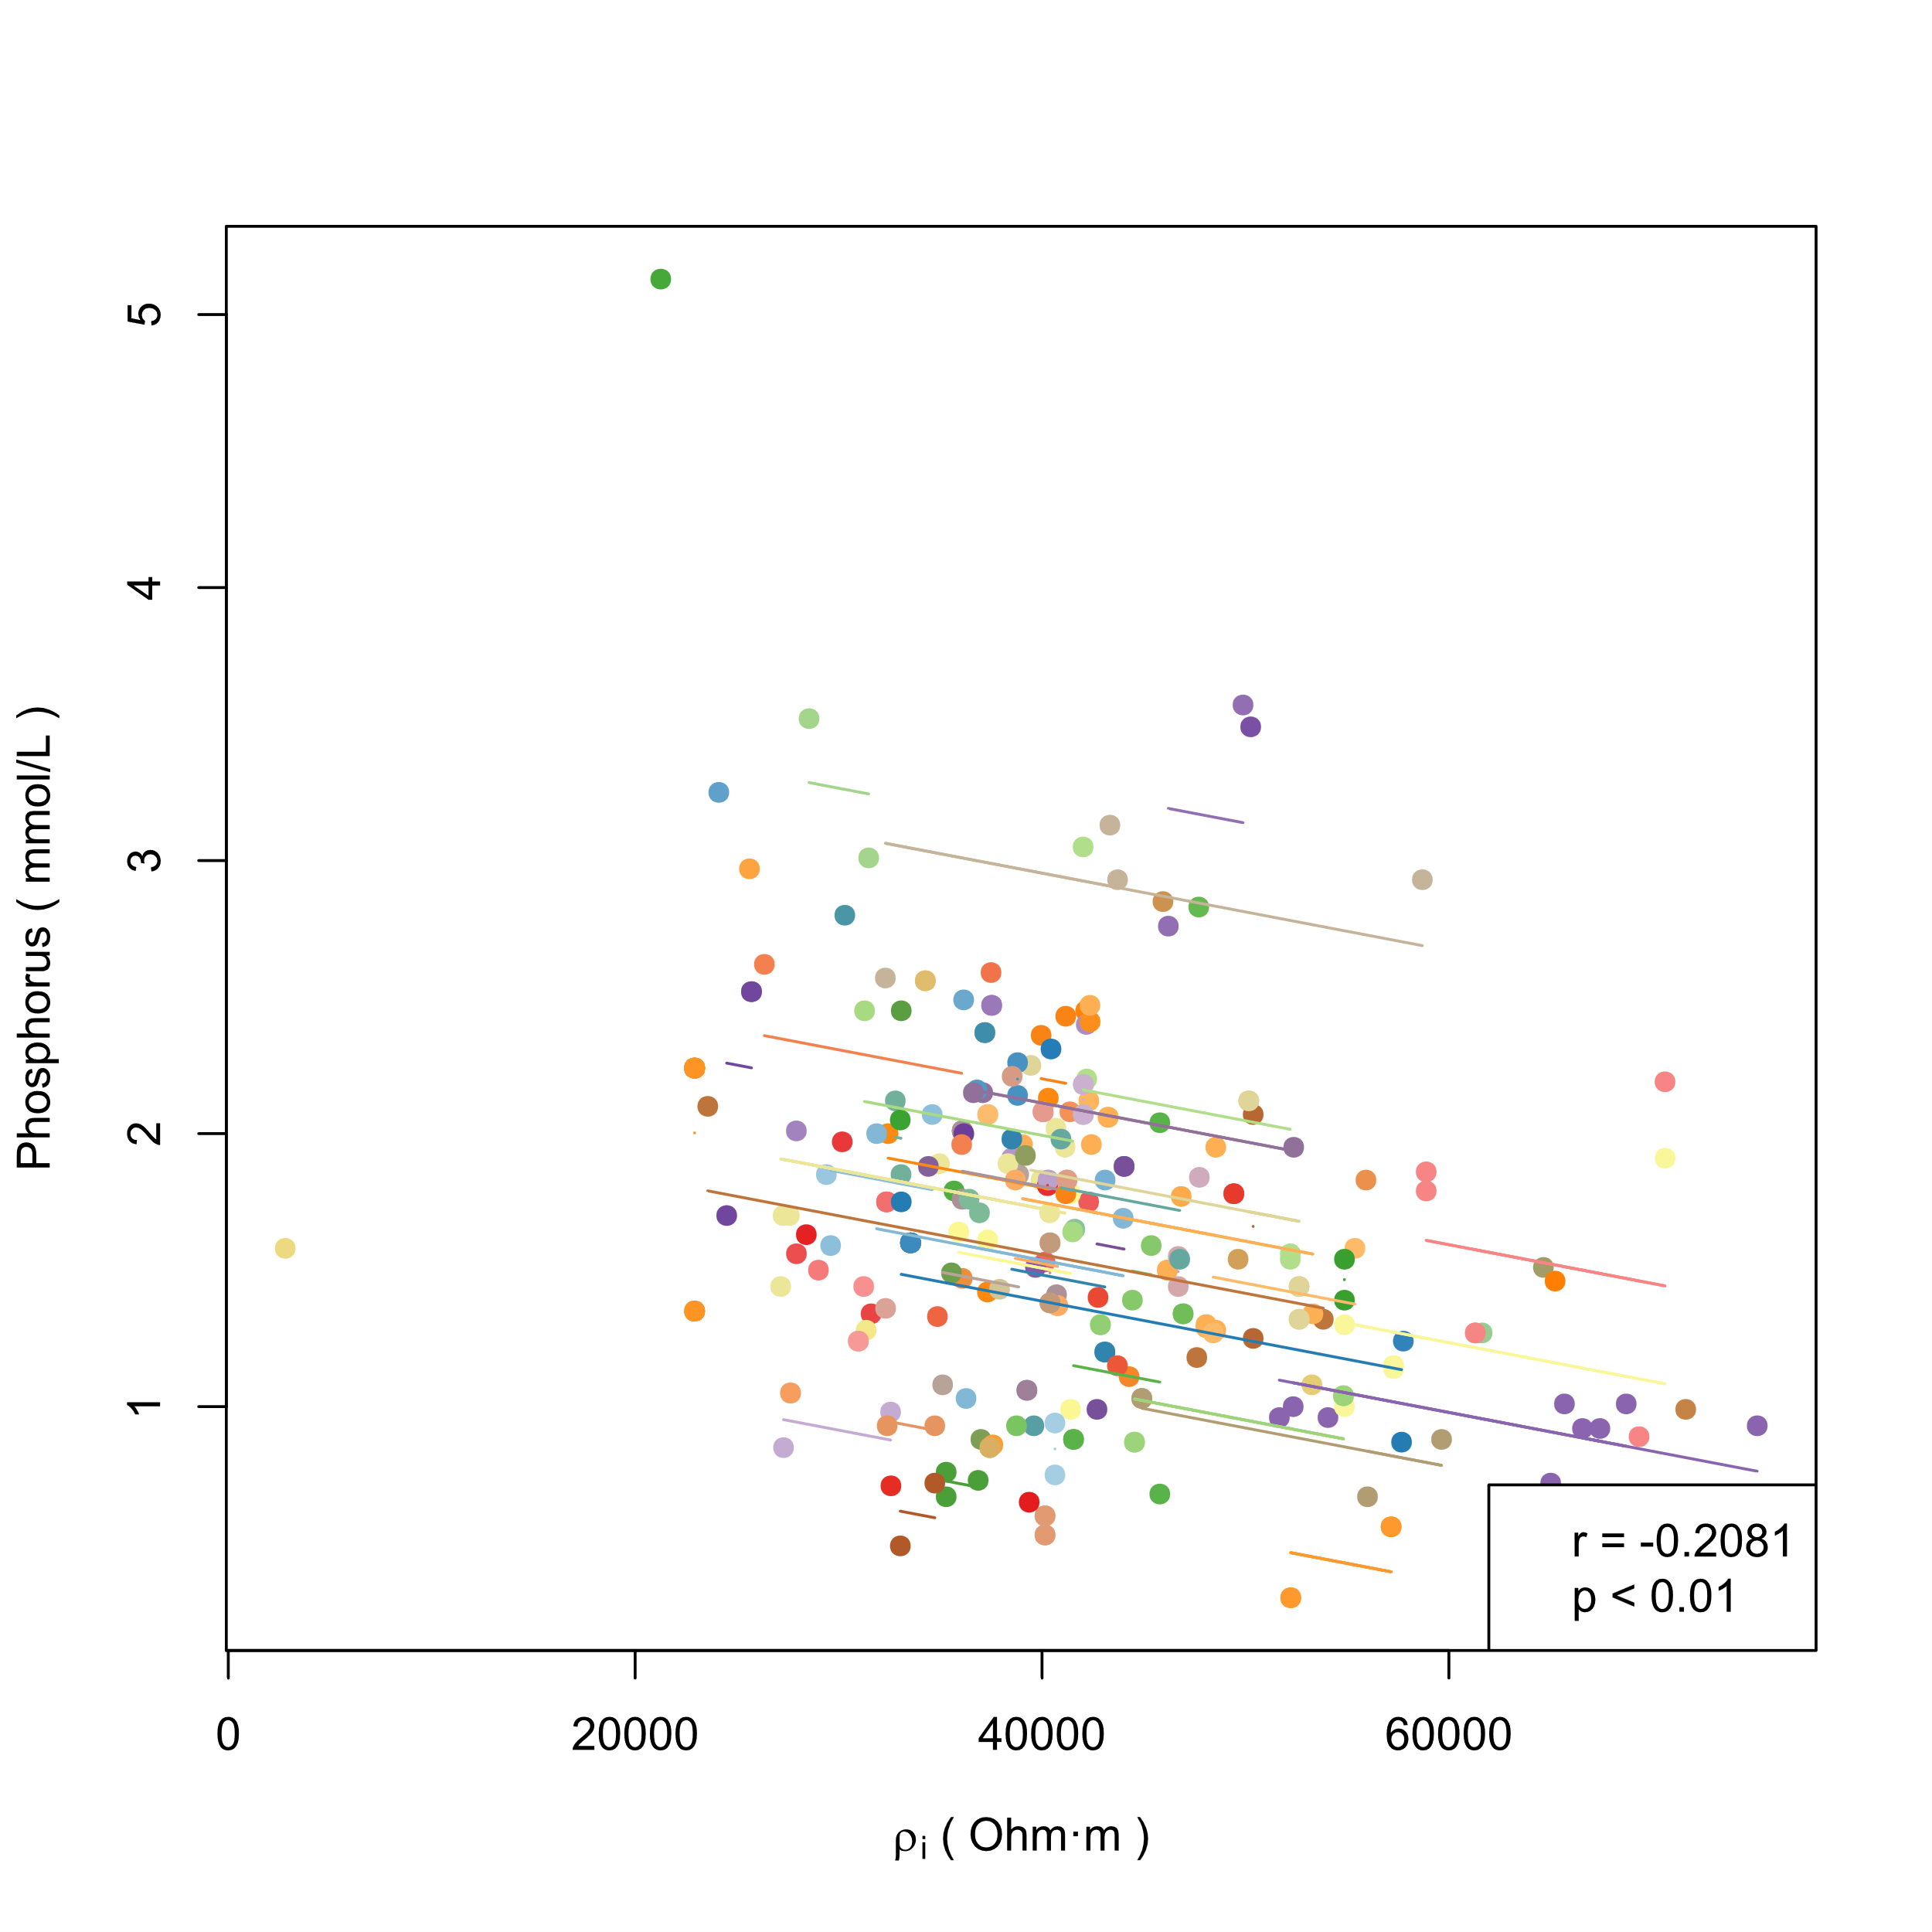(c) P and ρi | 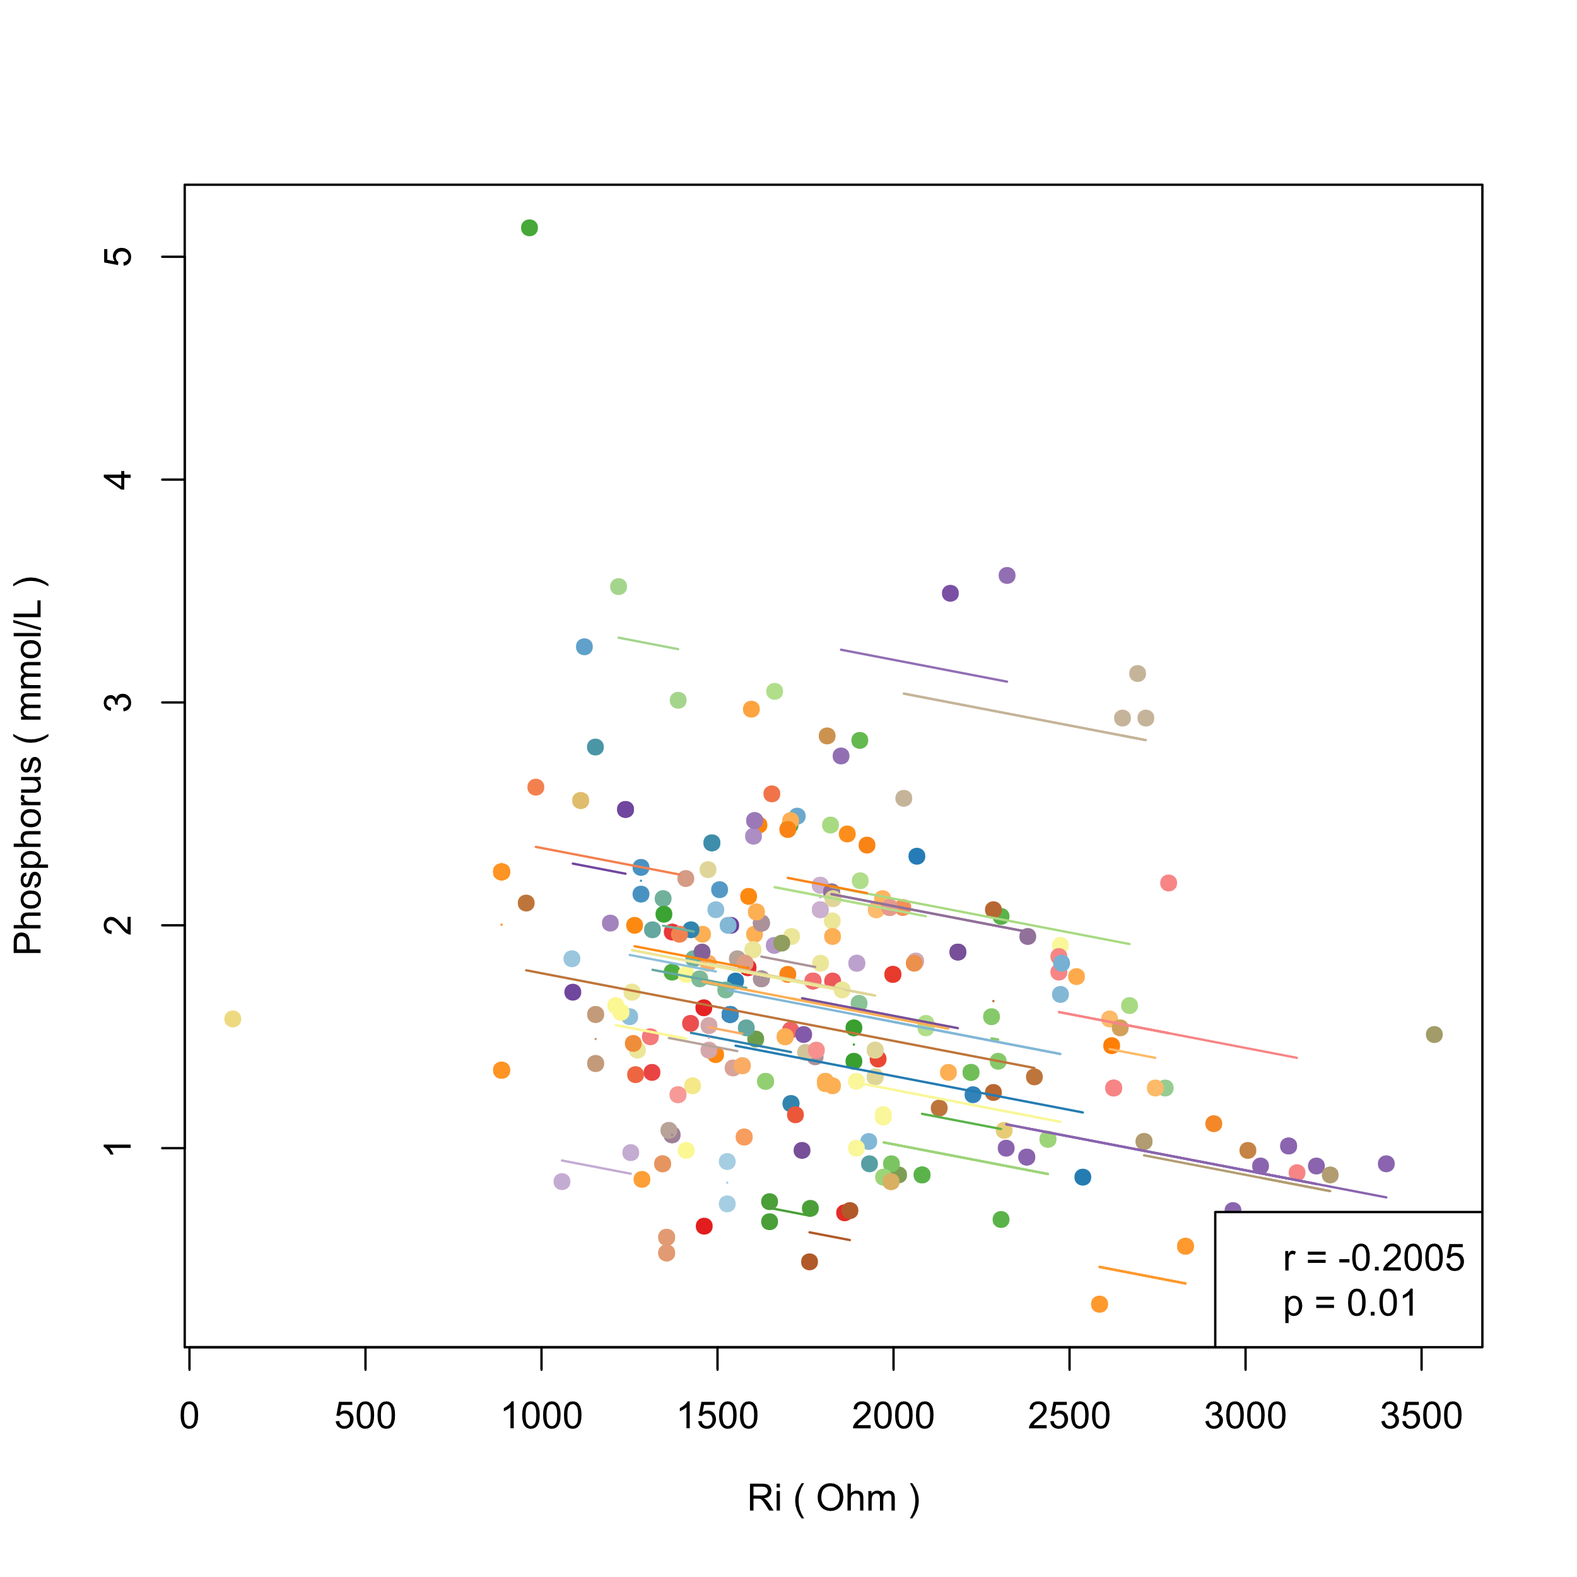(d) P and Ri
Figure S2. (a-d) Intra-individual correlations between phosphorus (P) and bioelectrical indices in men (each color represents a patient, different points in each color represent samples of the patient measured at different times, line of the color represent the regression result of intra-individual correlation on the samples of this patient. r and p in the legend are the correlation coefficient and p value of hypothesis testing in repeated measures correlation)

< Figure S3>
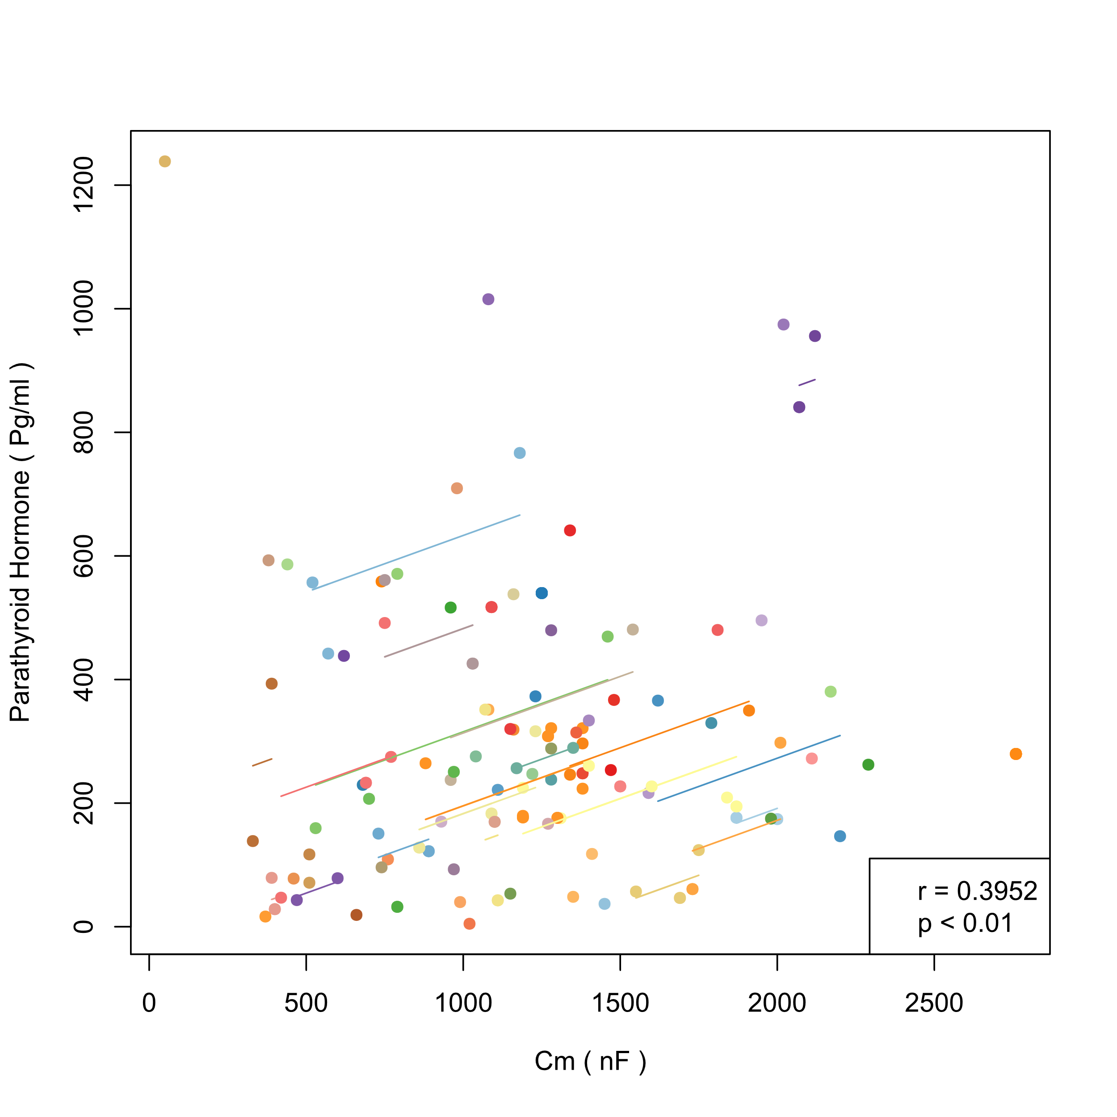 (a) PTH and Cm | 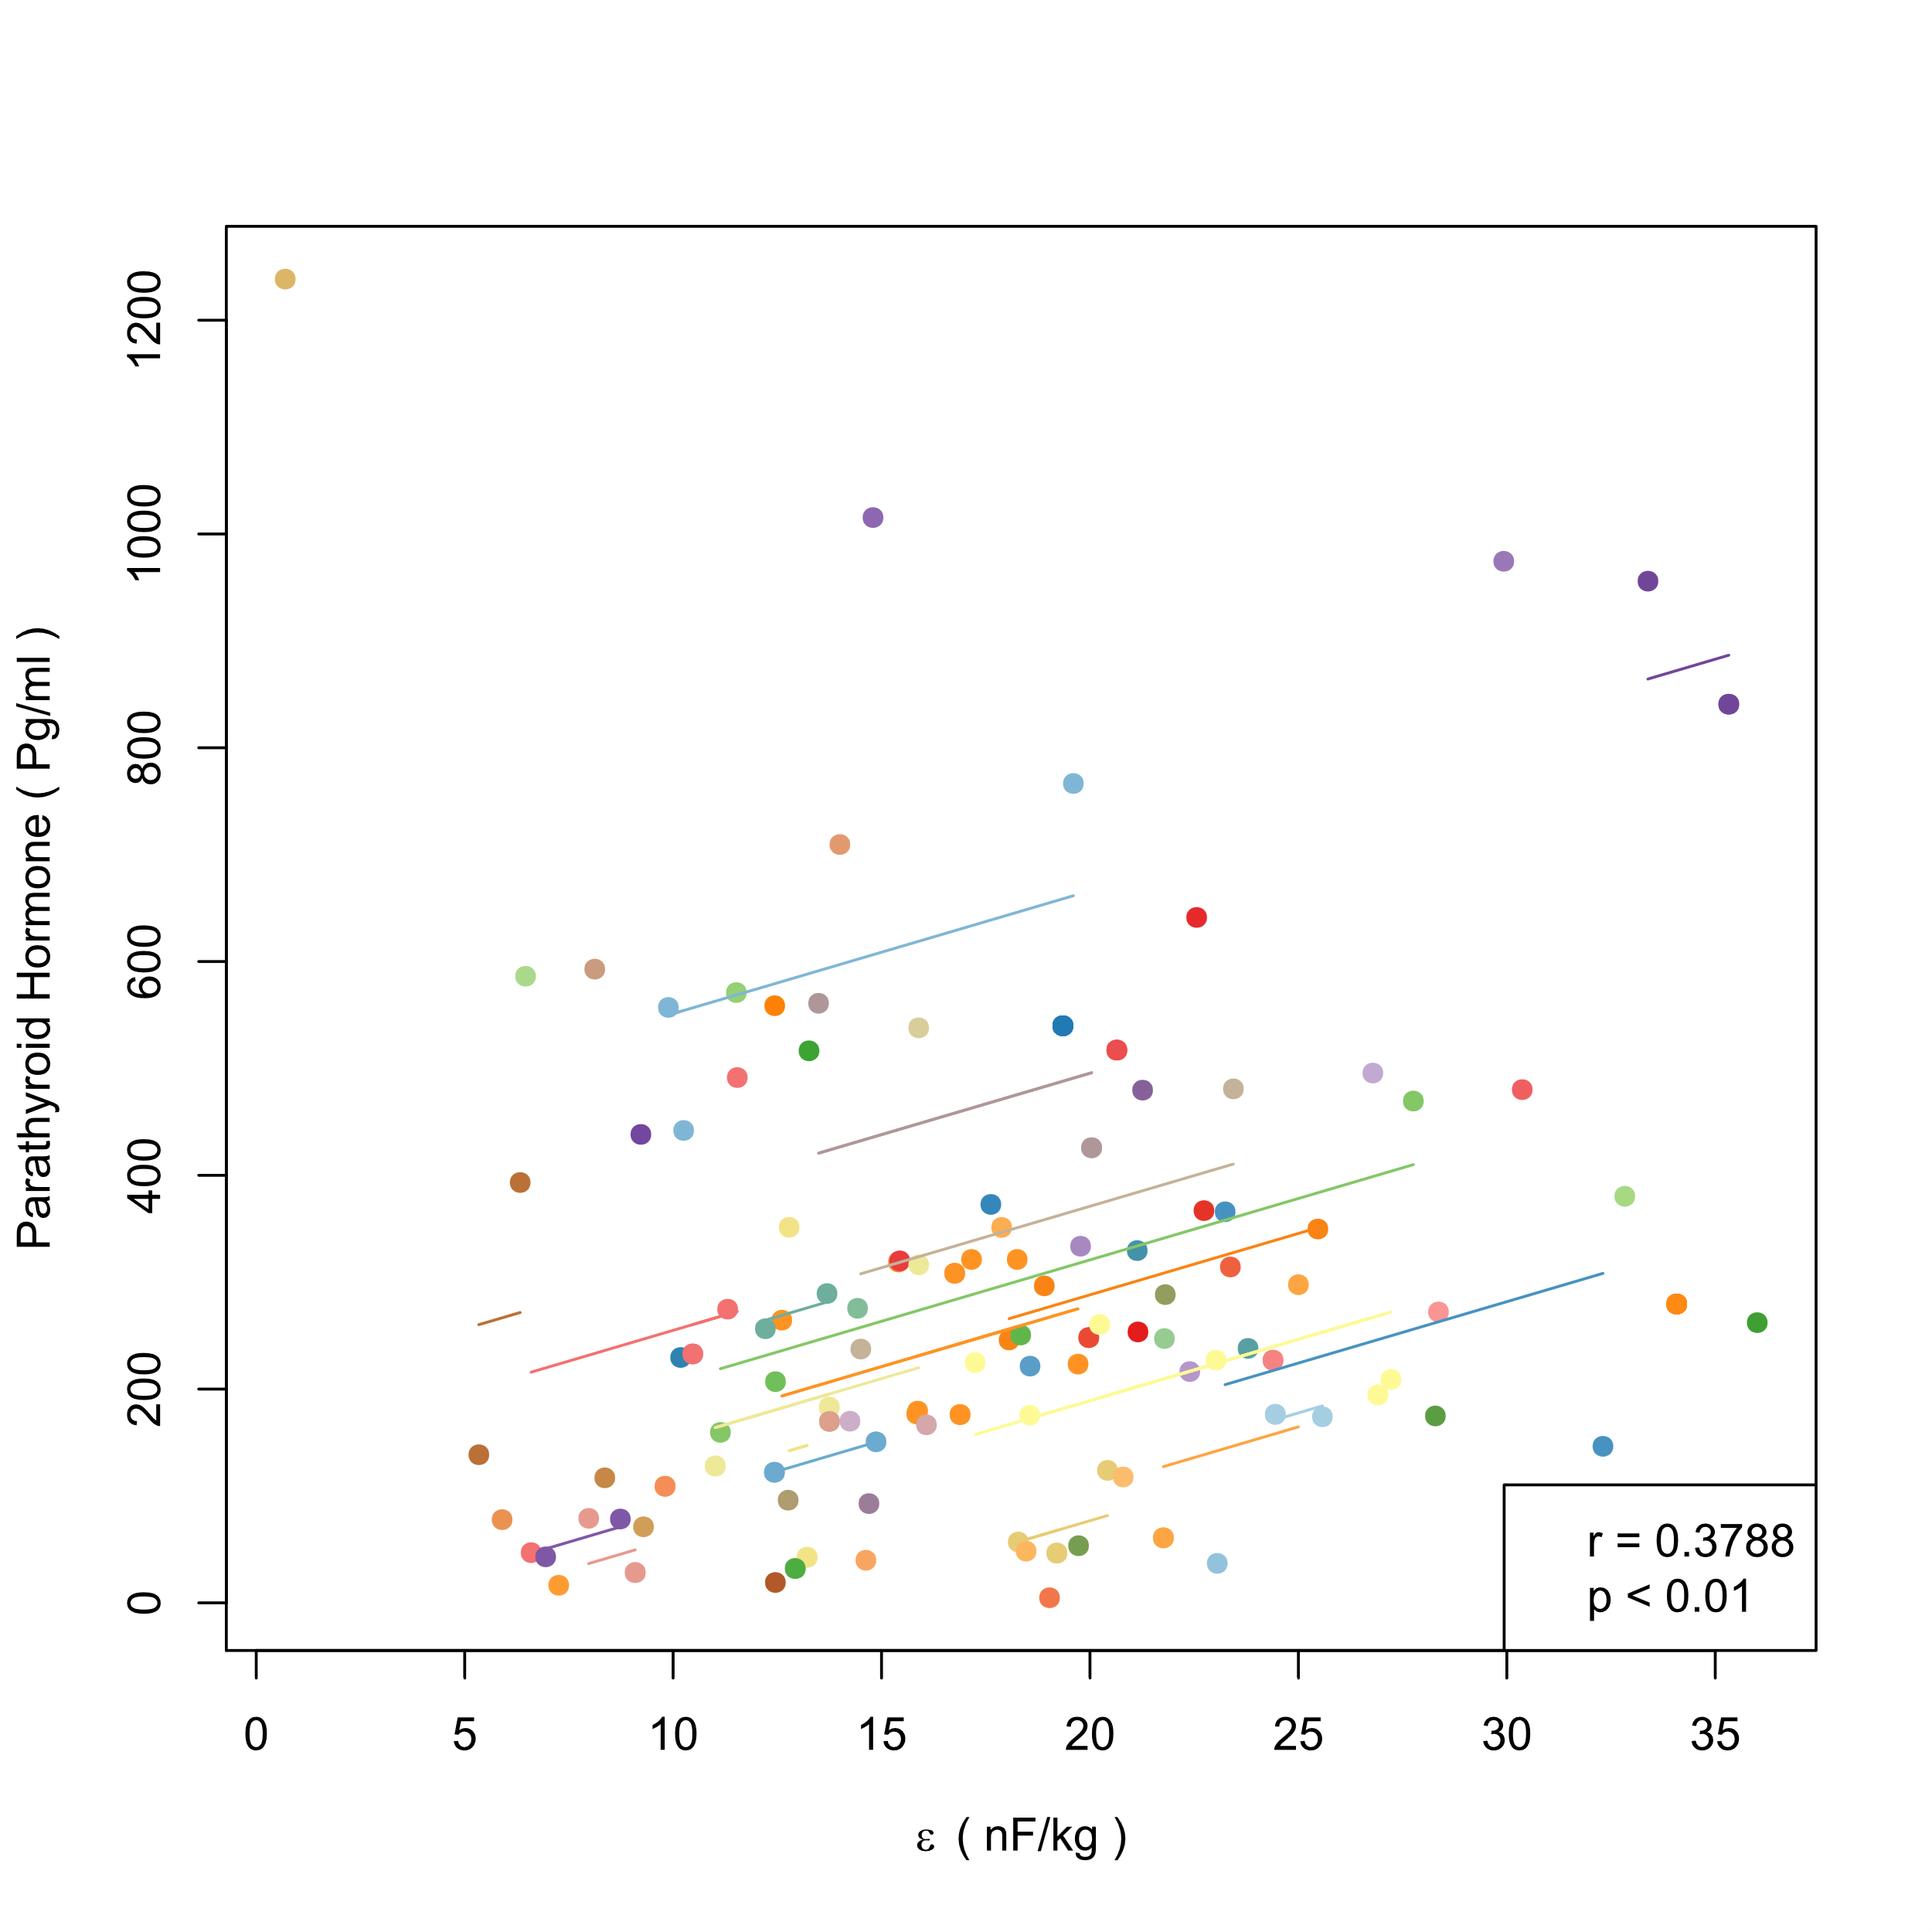 (b) PTH and ε
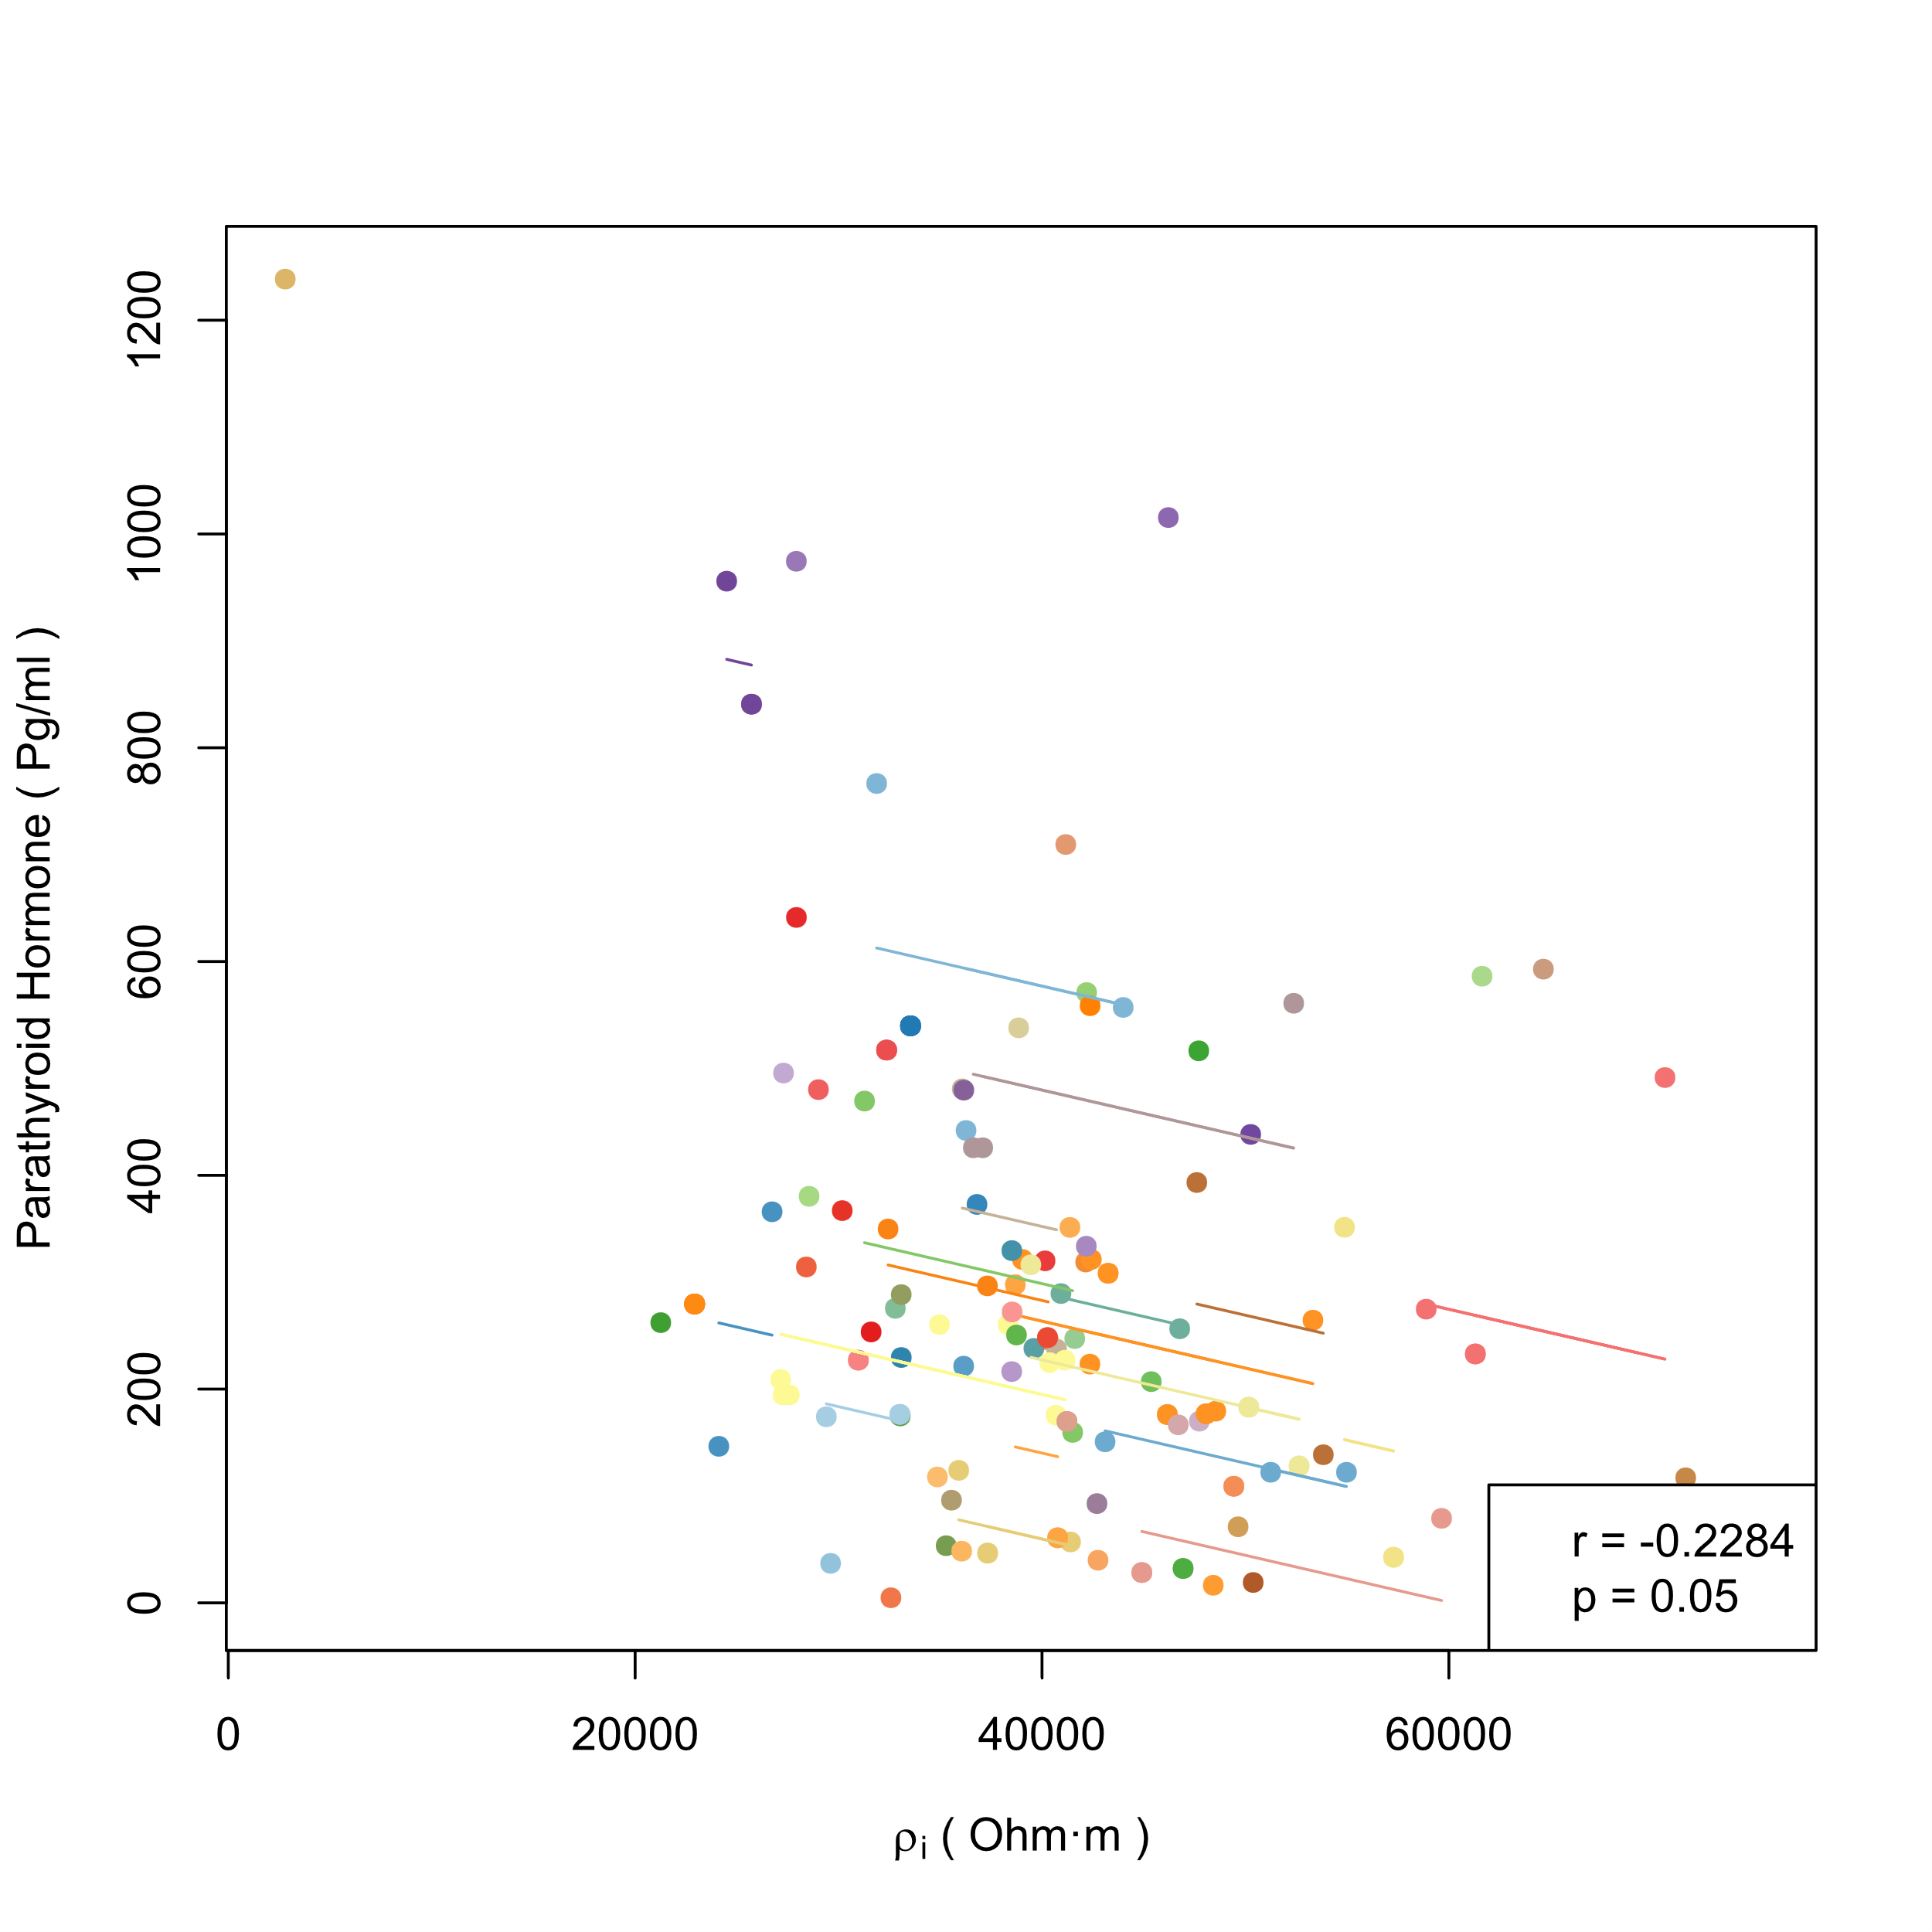 (c) PTH and ρi | 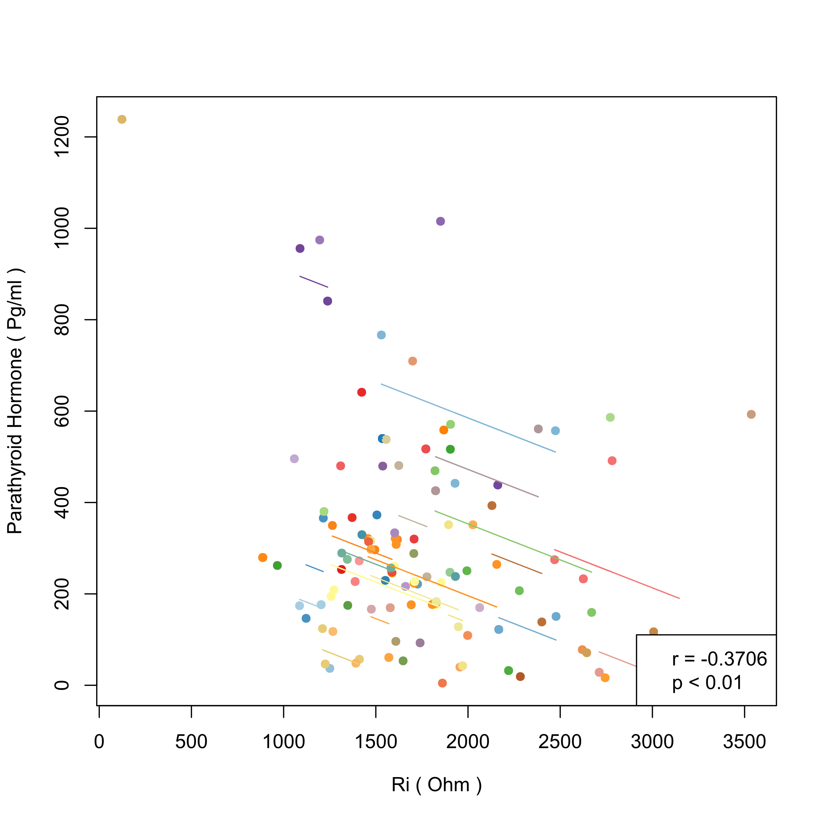 (d) PTH and Ri
Figure S3. (a-d) Intra-individual correlations between parathyroid hormone (PTH) and bioelectrical indices in men (each color represents a patient, different points in each color represent samples of the patient measured at different times, line of the color represents the regression result of intra-individual correlation on the samples of this patient. r and p in the legend are the correlation coefficient and p value of hypothesis testing in repeated measures correlation)

< Figure S4>
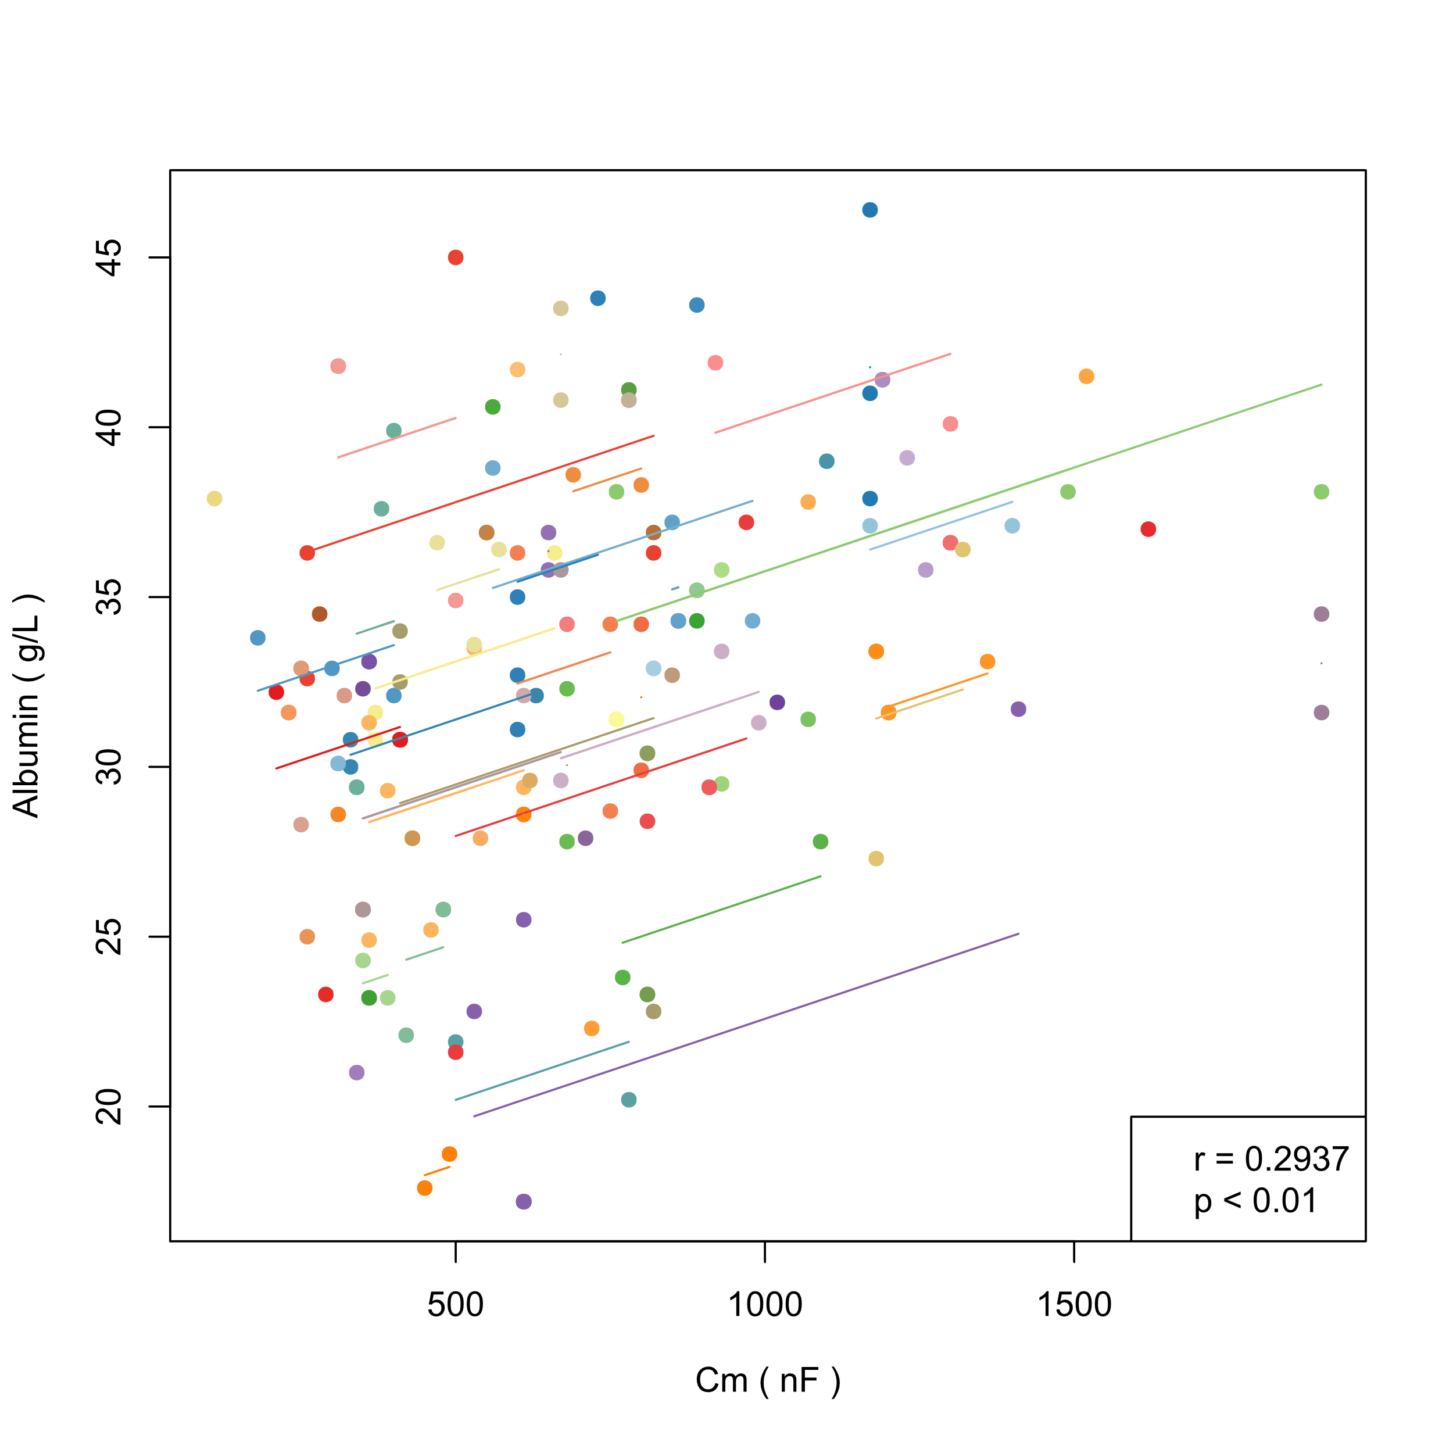 (a) Alb and Cm | 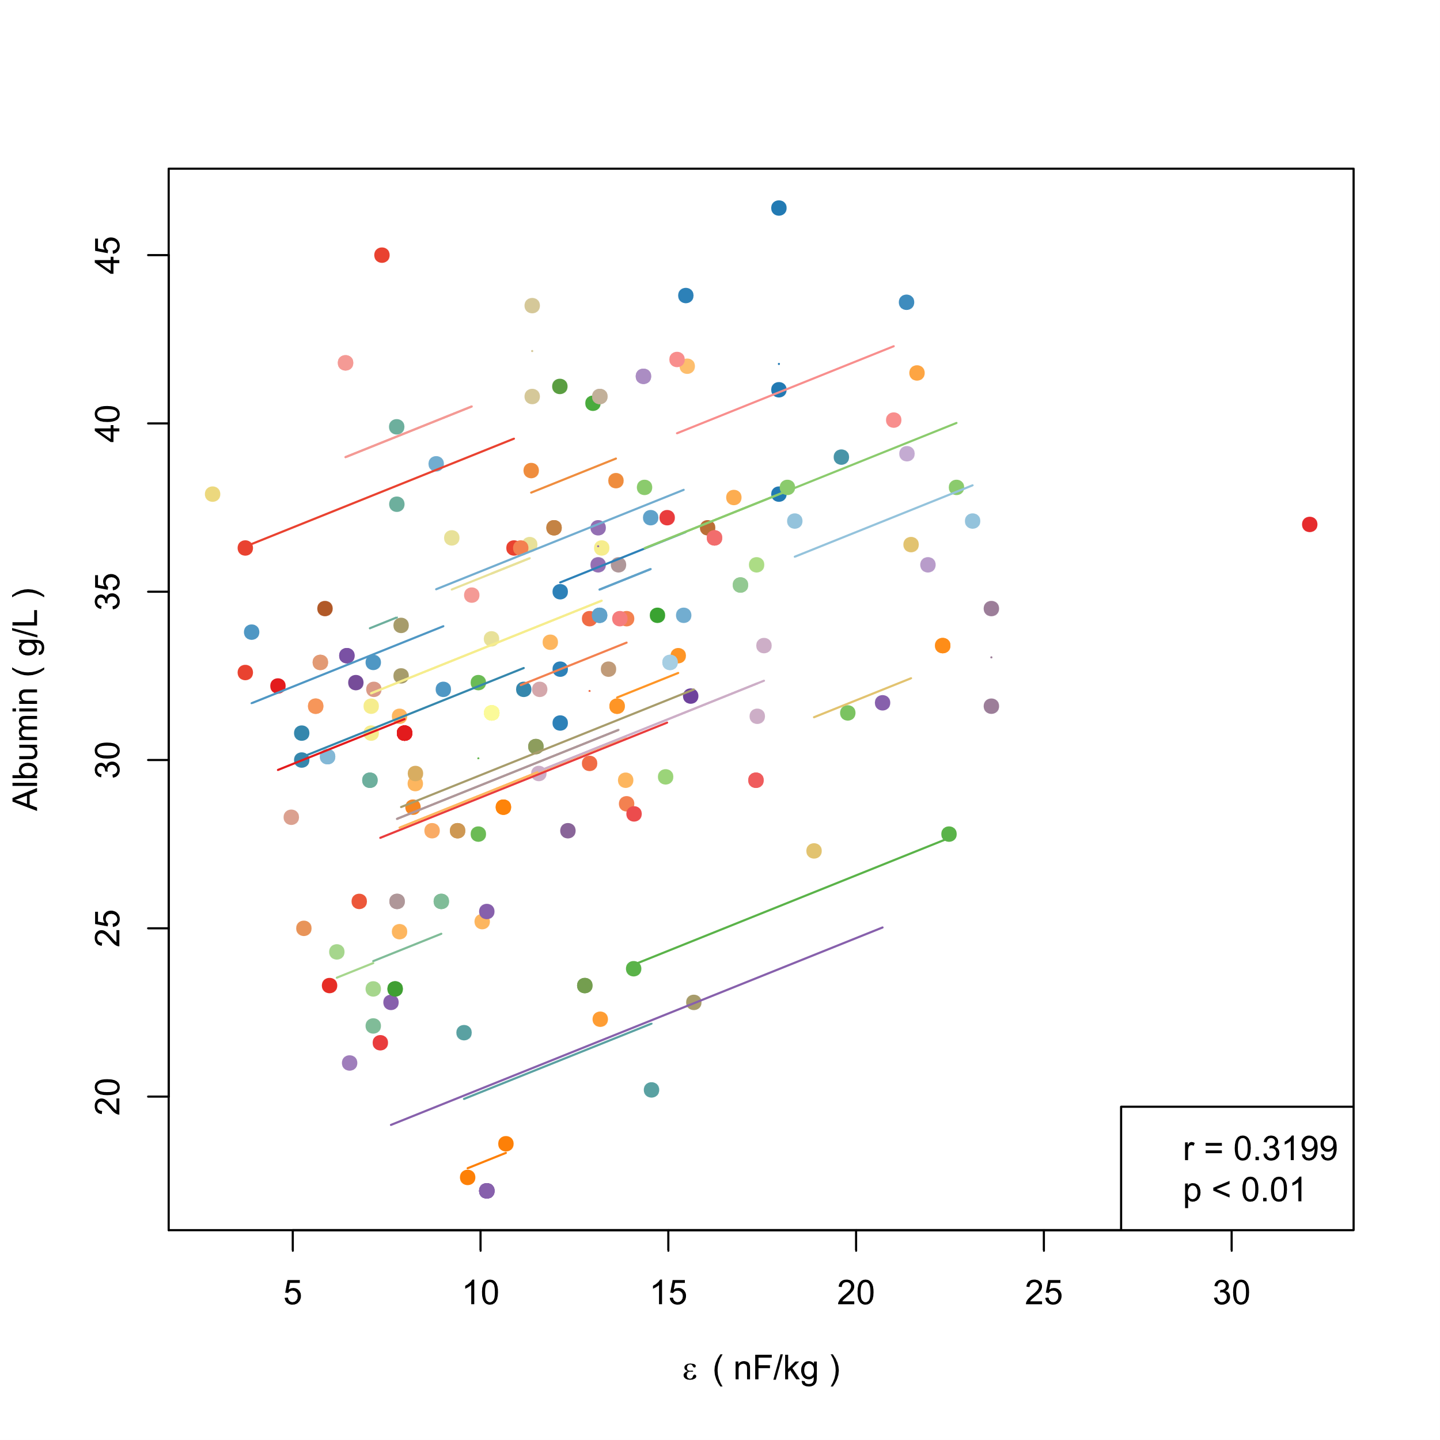 (b) Alb and ε
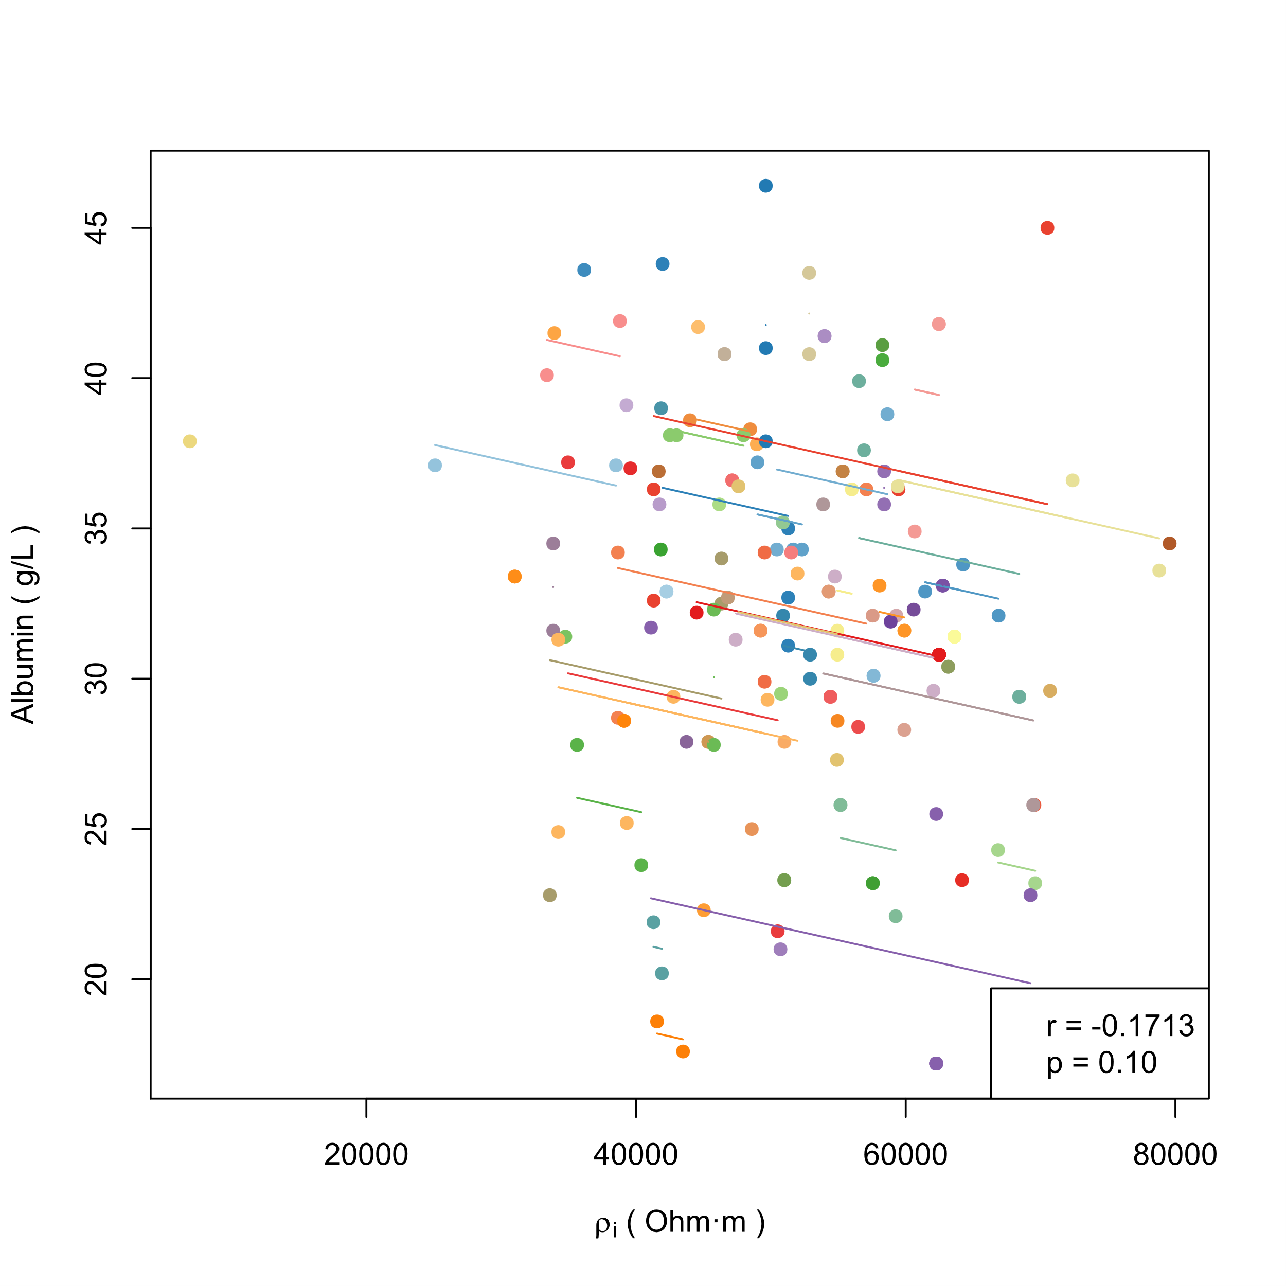 (c) Alb and ρi | 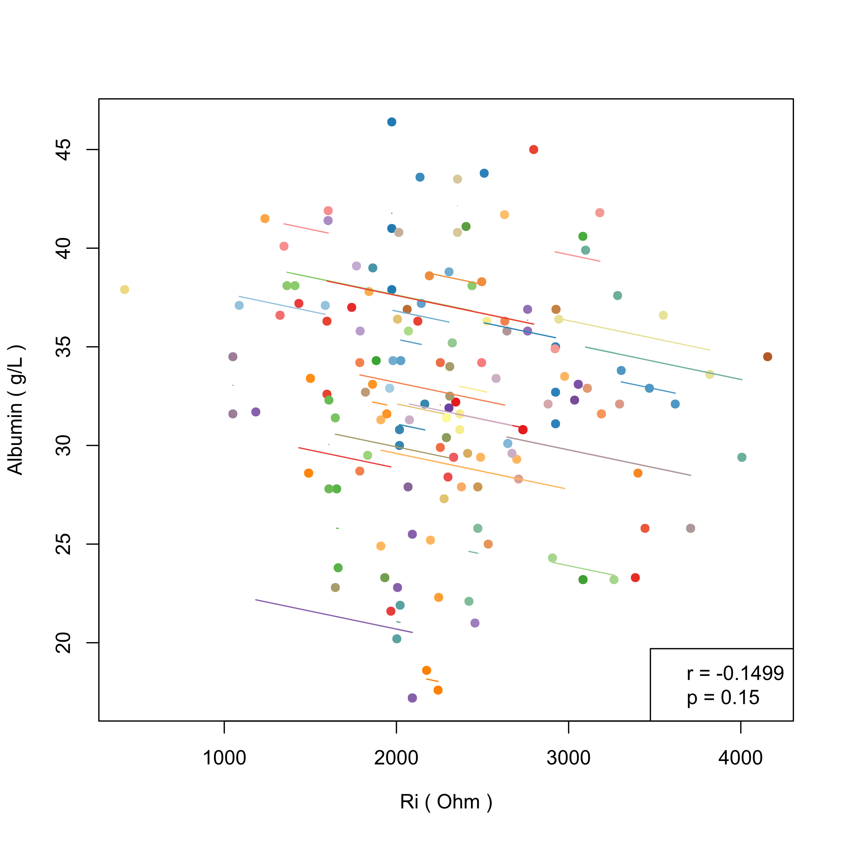 (d) Alb and Ri
Figure S4. (a-d) Intra-individual correlations between albumin (Alb) and bioelectrical indices in women (each color represents a patient, different points in each color represent samples of the patient measured at different times, line of the color represents the regression result of intra-individual correlation on the samples of this patient. r and p in the legend are the correlation coefficient and p value of hypothesis testing in repeated measures correlation)

< Figure S5>
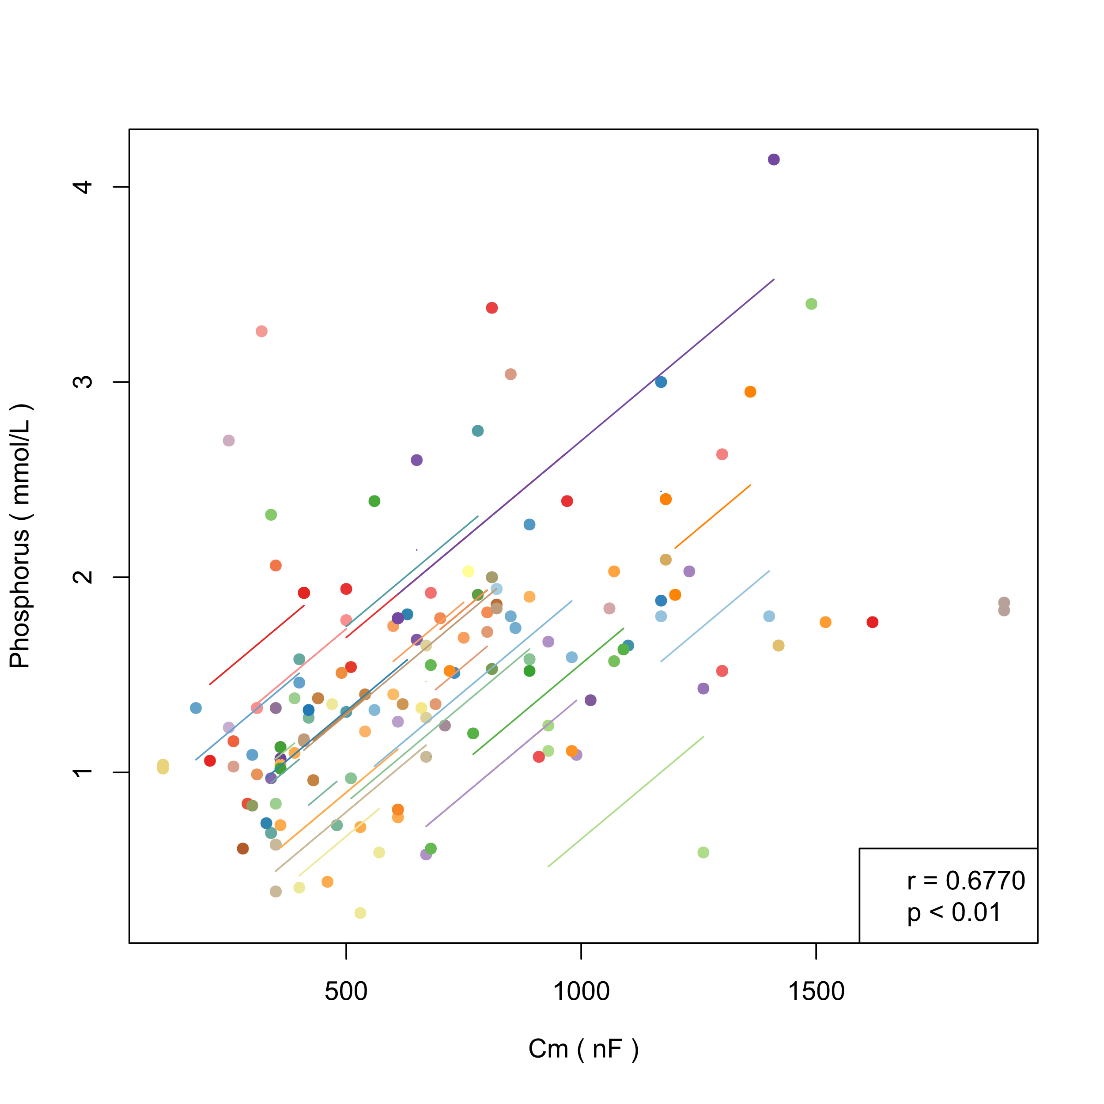 (a) P and Cm | 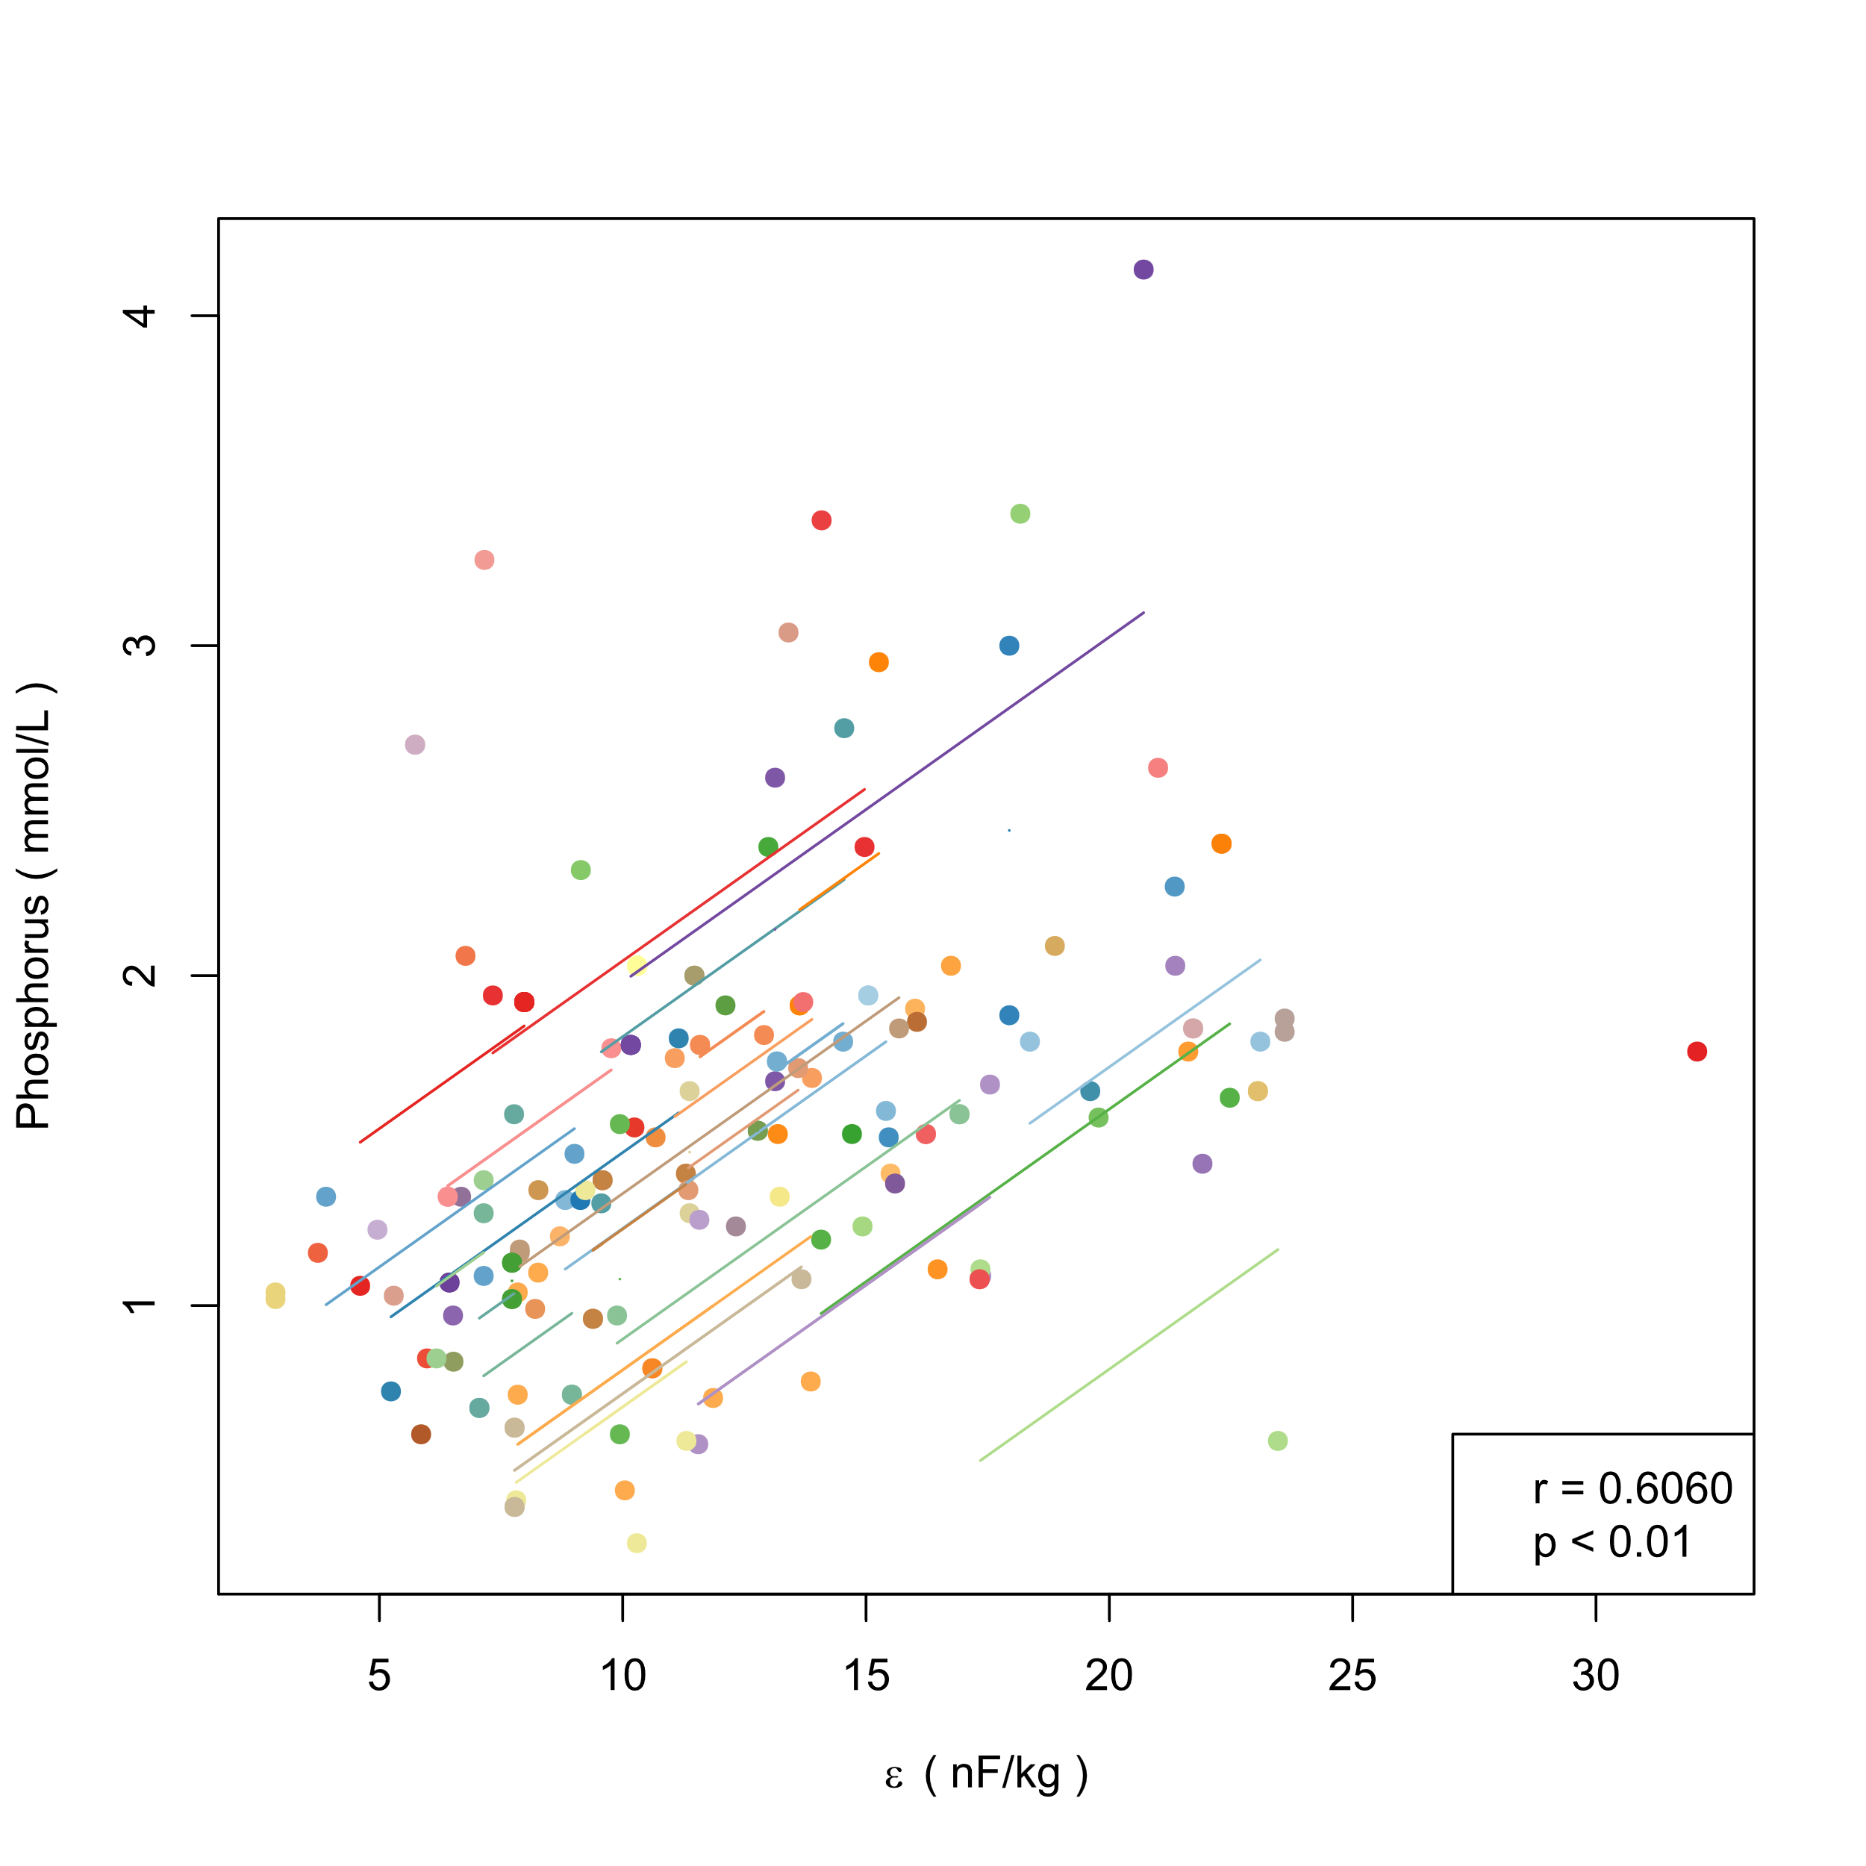 (b) P and ε
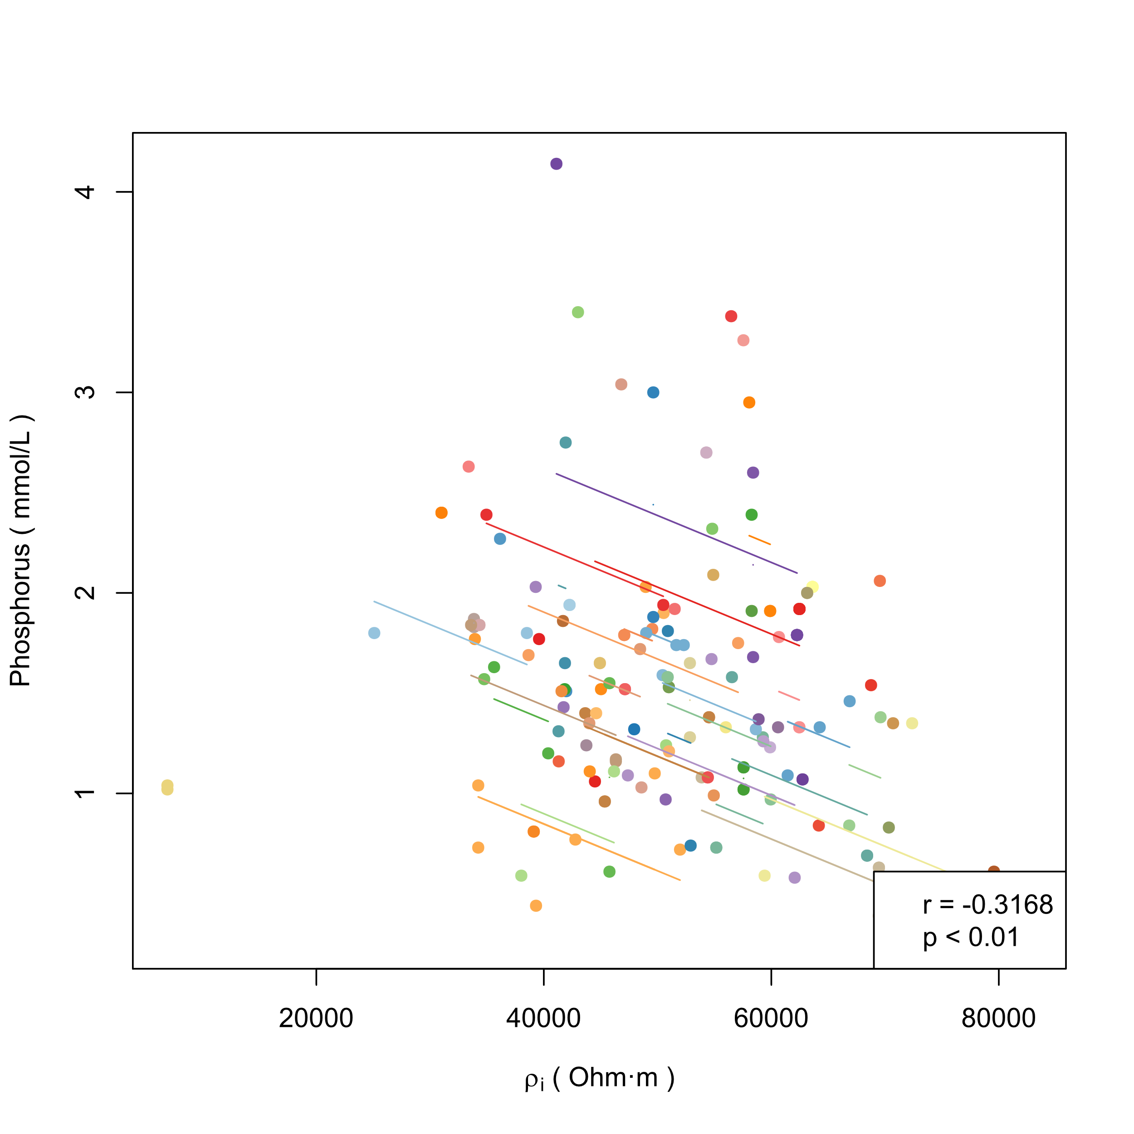 (c) P and ρi | 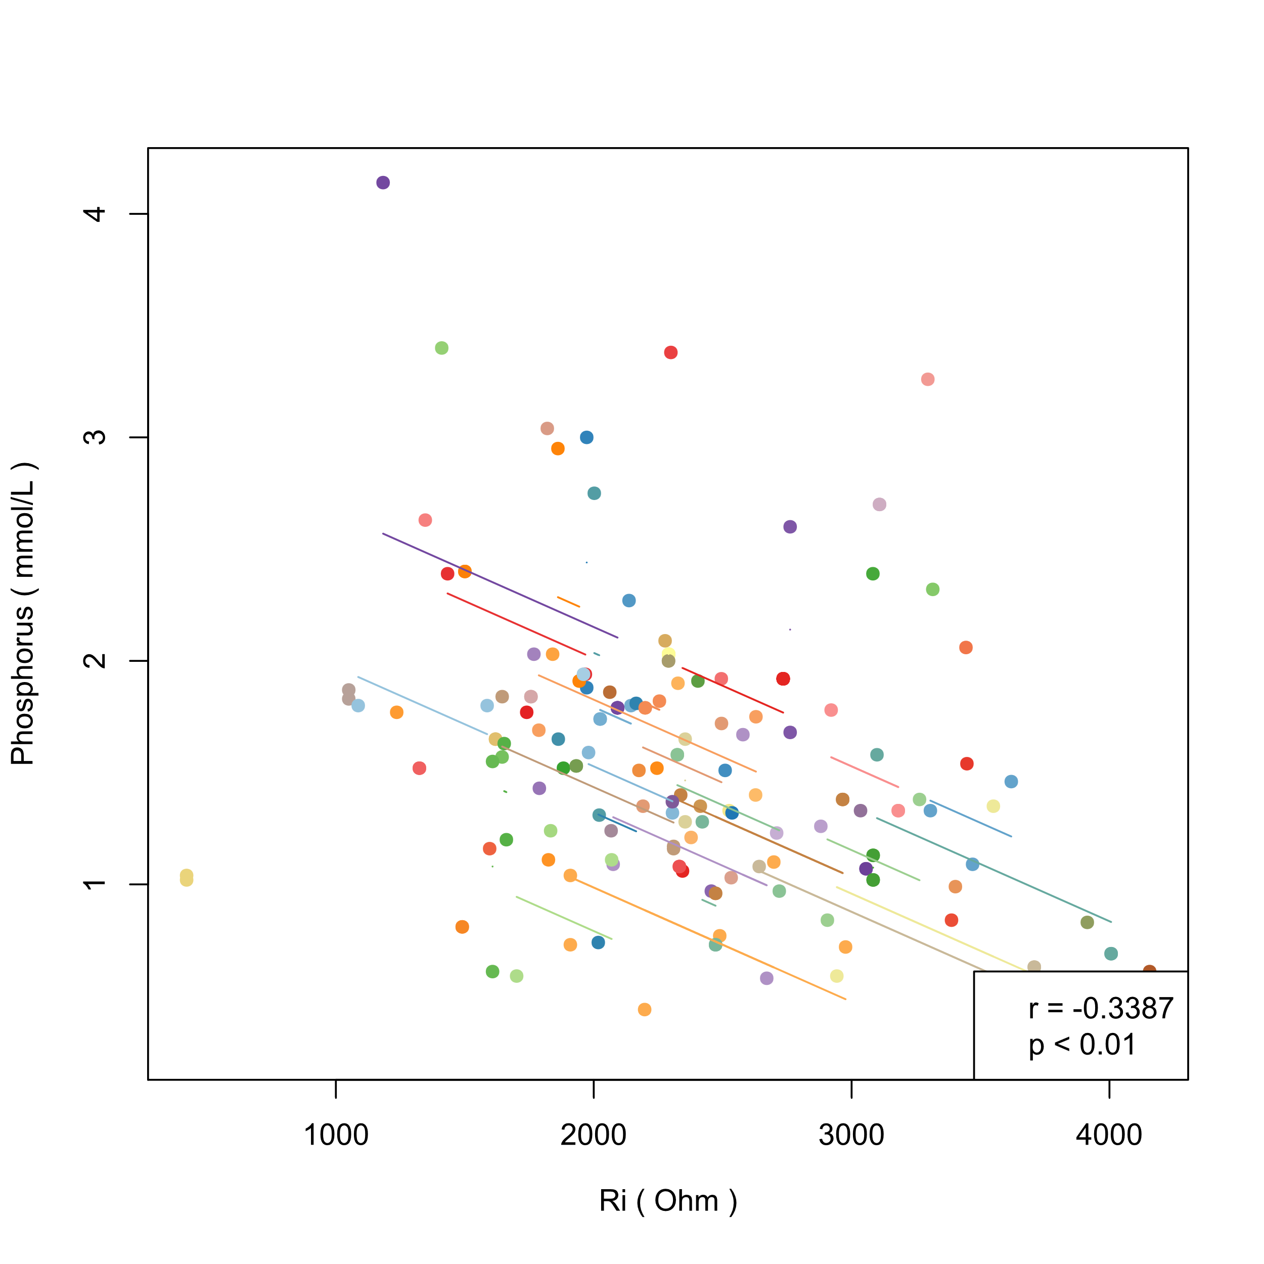 (d) P and Ri
Figure S5. (a-d) Intra-individual correlations between P and bioelectrical indices in women (each color represents a patient, different points in each color represent samples of the patient measured at different times, line of the color represents the regression result of intra-individual correlation on the samples of this patient. r and p in the legend are the correlation coefficient and p value of hypothesis testing in repeated measures correlation)

< Figure S6>
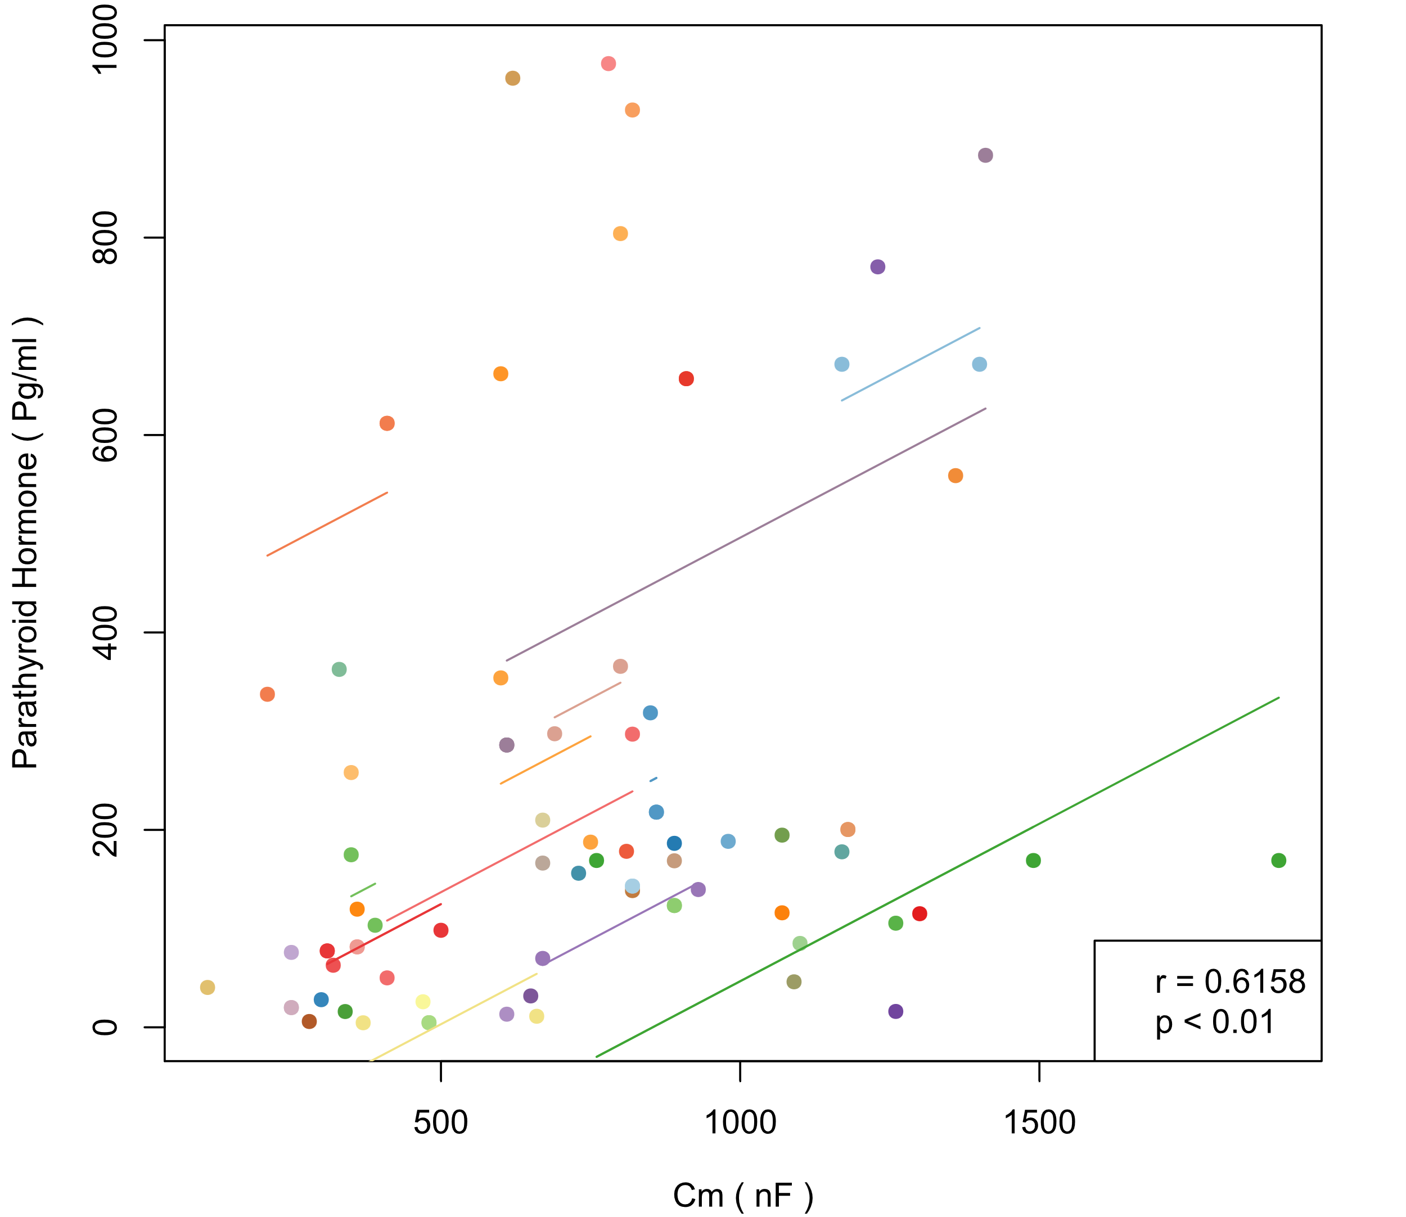  (a) Alb and Cm | 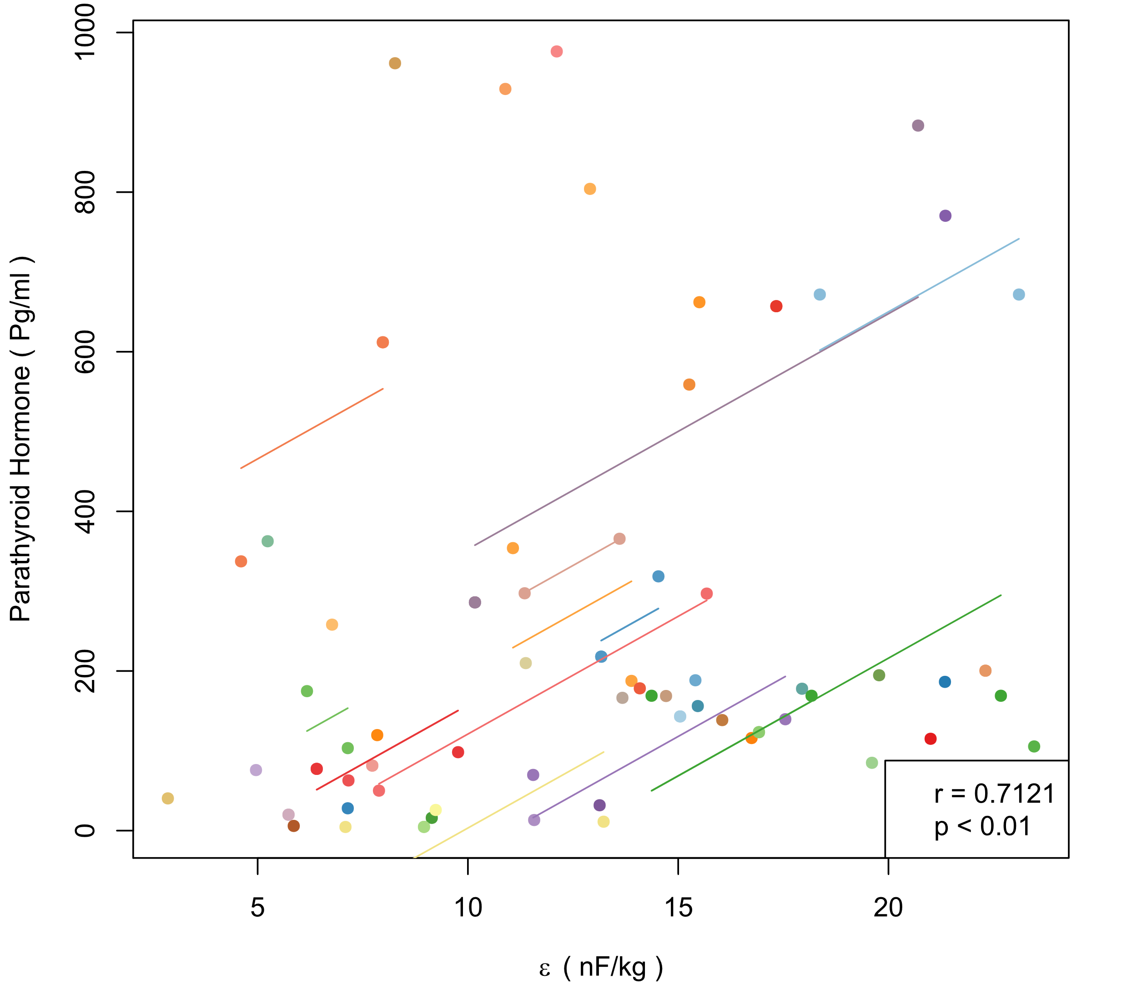  (b) Alb and ε
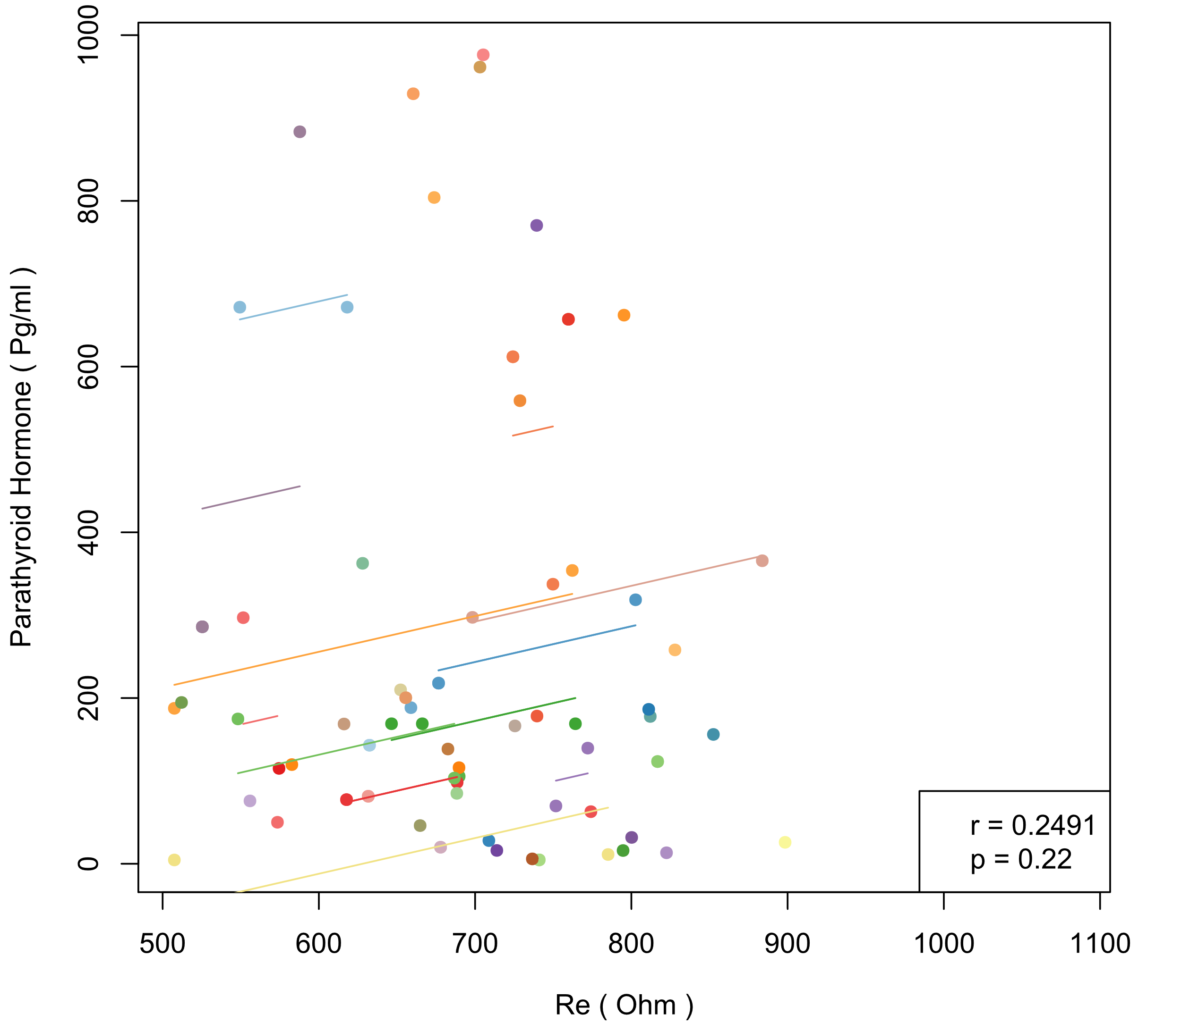  (c) Alb and Re | 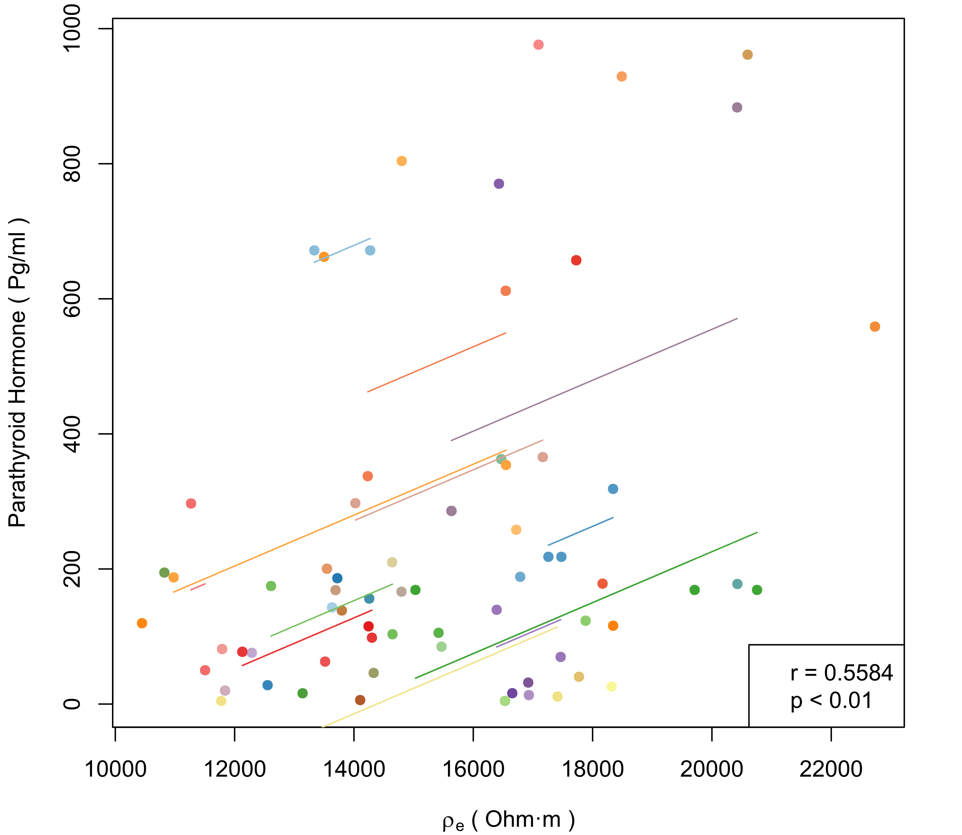  (d) Alb and ρe
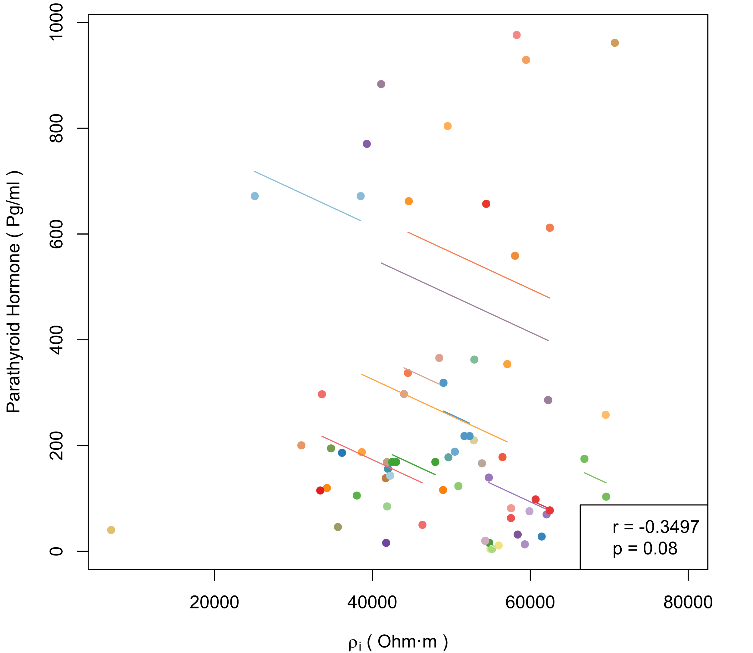  (e) Alb and ρi | 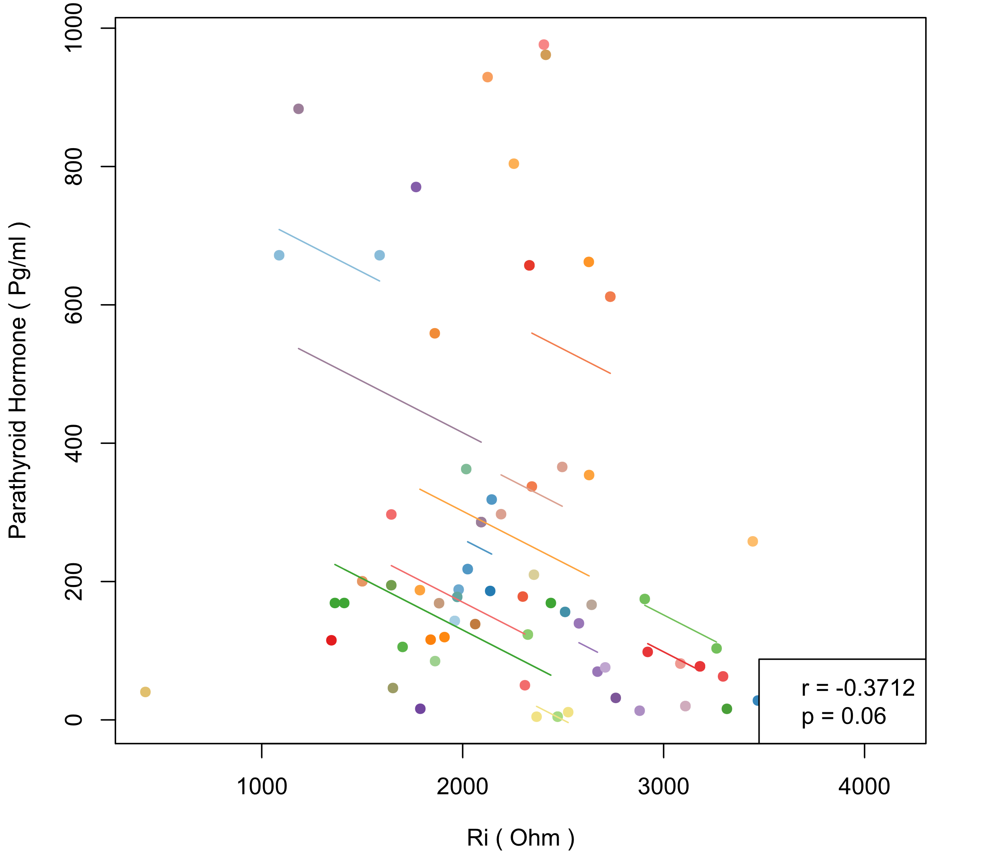  (f) Alb and Ri
Figure S6. (a-f) Intra-individual correlations between parathyroid hormone (PTH) and bioelectrical indices in women (each color represents a patient, different points in each color represent samples of the patient measured at different times, line of the color represents the regression result of intra-individual correlation on the samples of this patient. r and p in the legend are the correlation coefficient and p value of hypothesis testing in repeated measures correlation)

