Supplementary materials
table1 inclusion and exclusion criteria
groups | criteria
Inclusion criteria
ATB | - Age≥18 years old; and  - Mtb culture or/and acid-fast staining or/and Xpert Mtb/RIF or/and Mtb nucleic acid positive; and  - Clinical manifestations of ATB (fever, cough, night sweats or weight loss, etc.); and  No antituberculosis therapy or antituberculosis therapy within 2 weeks.
Fever | - Age≥16 years old; and  - Fever＞38.5℃; and  - IGRAs negative; and  - Imaging without evidence of active TB and previous history of TB  - Other diseases were diagnosed and responded to treatment.
LTBI | - Age≥16 years old; and  - No clinical manifestations of ATB (fever, cough, night sweats or weight loss, etc.); and  - IGRAs positive; and  - Other diseases were diagnosed and responded to treatment.
HC | - Age≥16 years old; and  - No clinical manifestations of ATB (fever, cough, night sweats or weight loss, etc.); and  - IGRAs negative; and  - NO other diseases were diagnosed.
Exclusion criteria | - HIV-infected people;  - Pregnant or lactating patients;  - Malignant tumors of the hematologic system  - Other diseases that can cause an inflammatory response.

Figures
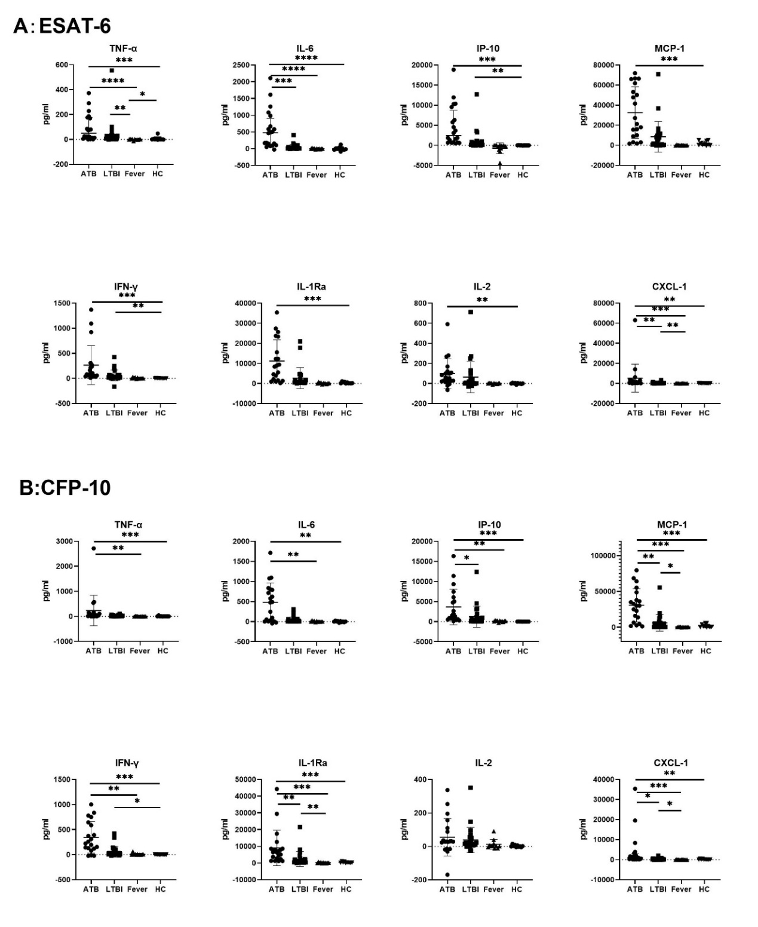
Figure 1 Cytokine/chemokines secretion in four groups with stimulation by ESAT-6 (A) and CFP-10 (B). (*: p < 0.05, **: p < 0.01, ***: p < 0.001)
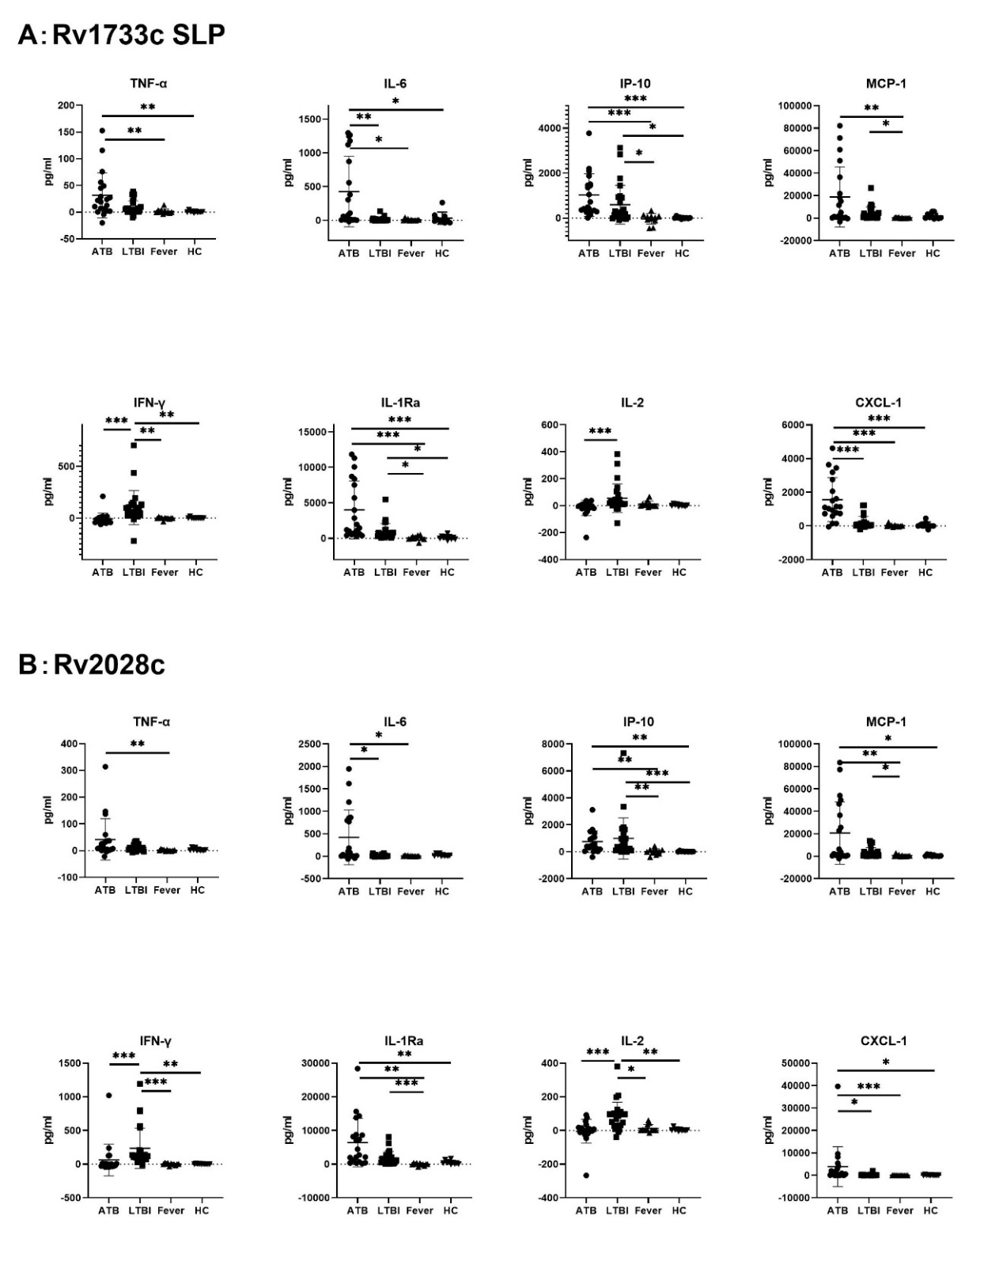
Figure 2 Cytokine/chemokines secretion in four groups with stimulation by Rv1733c SLP Antigen(A) and Rv2028c Antigen(B). (*: p < 0.05, **: p < 0.01, ***: p < 0.001)

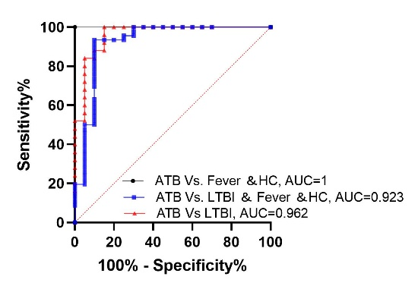

Figure 3 The diagnostic efficacy of tuberculosis-specific IFN-γ secretion for different tuberculosis infection states

