Table S1: Docking results of shortlisted polyphenols against disease target (PI3K)
S.No | Target | Ligand | Binding score
1 | 7TZ7 | Ellagic acid | -6.60
2 | 7TZ7 | Ferulic acid | -3.83
3 | 7TZ7 | Kaempferol | -4.89
4 | 7TZ7 | Genistein | -4.30
5 | 7TZ7 | Luteolin | -4.39
6 | 7TZ7 | Naringenin | -4.67
7 | 7TZ7 | Quercetin | -3.87
8 | 7TZ7 | Apigenin | -4.61

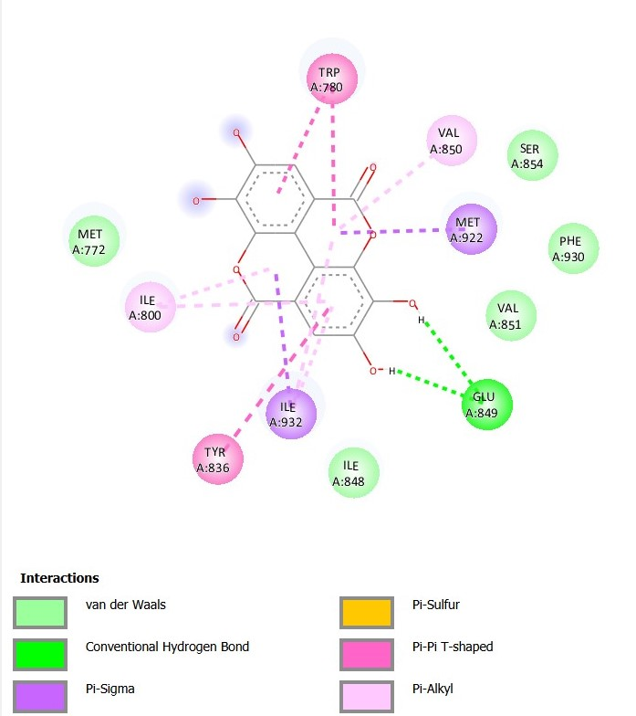
Figure S1 2D Docking interactions of Ellagic acid with PI3K
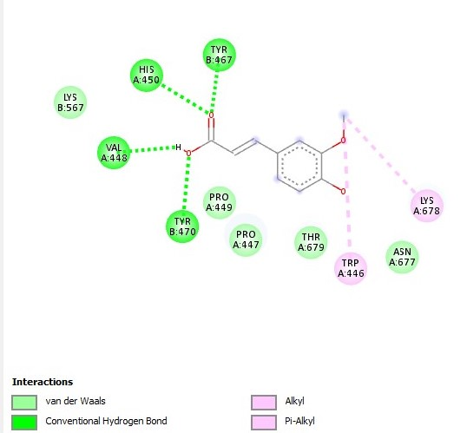
Figure S2 2D Docking interactions of Ferulic acid with PI3K

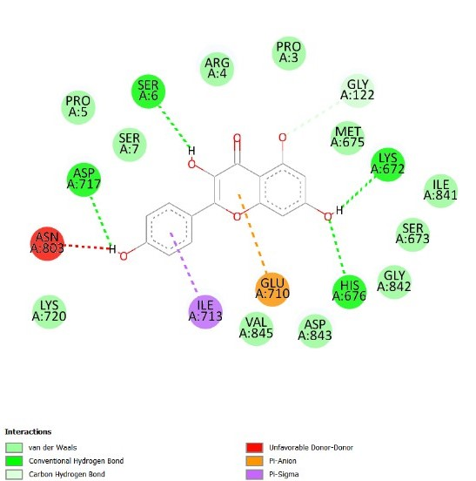
Figure S3 2D Docking interactions of Kaempferol with PI3K

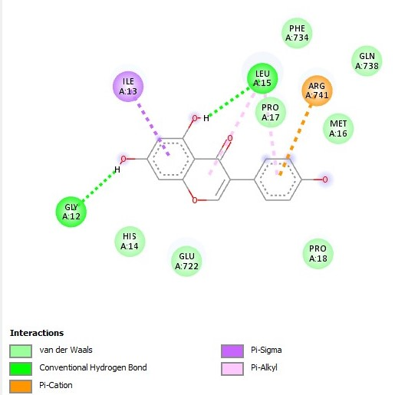
Figure S4 2D Docking interactions of Genistein with PI3K
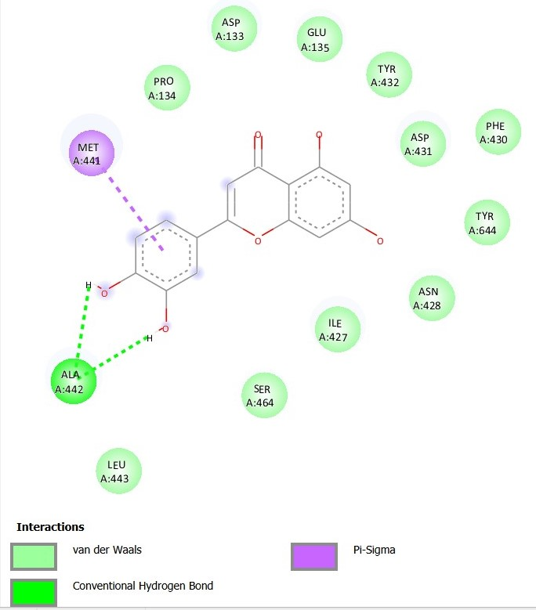
Figure S5 2D Docking interactions of Luteolin with PI3K
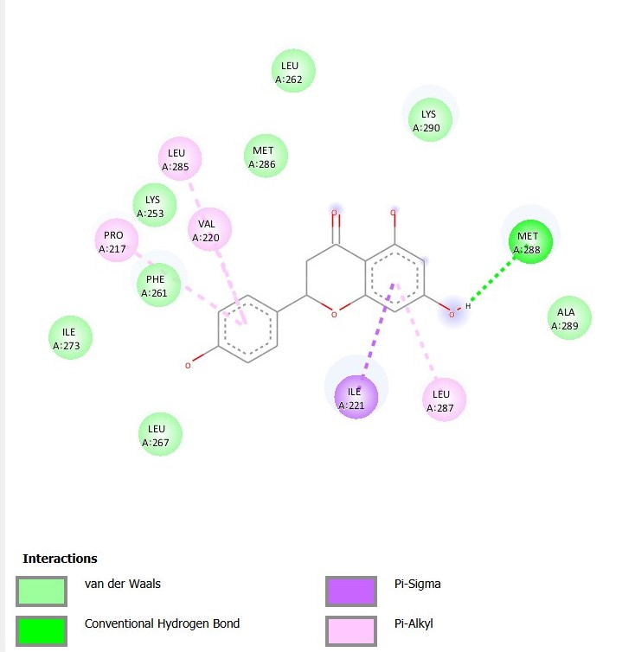
Figure S6 2D Docking interactions of Naringenin with PI3K
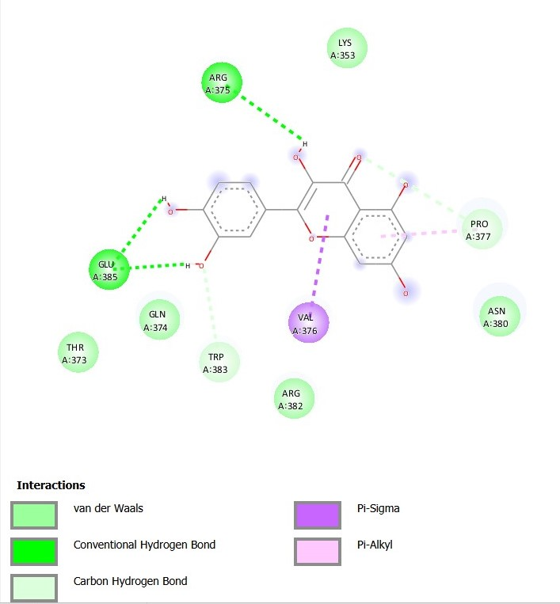
Figure S7 2D Docking interactions of Quercetin with PI3K
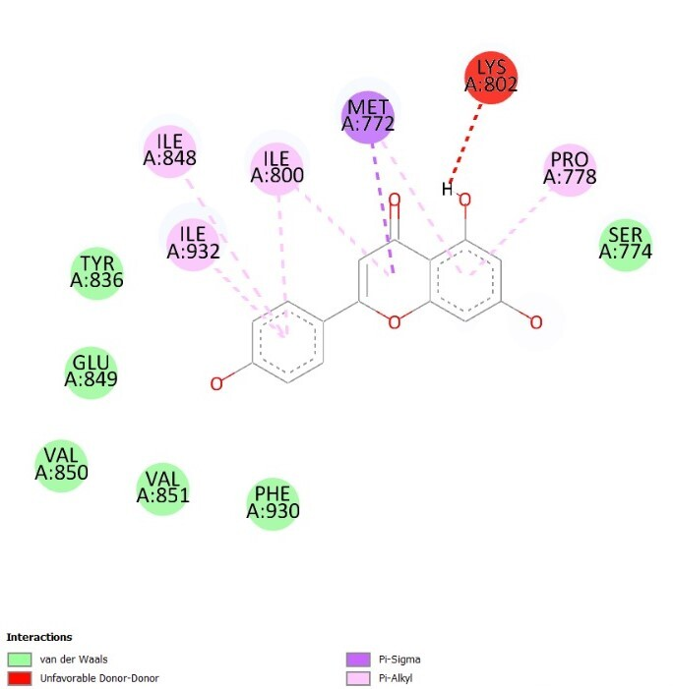
Figure S8 2D Docking interactions of Apigenin with PI3K

