Supporting information

Ultrasound-responsive nanodelivery system of GPC3-targeting and sonosensitizer for visualized hepatocellular carcinoma therapy
Juying Zhang,¹ Xia Luo,¹ Xin Yang,¹ Hanmei Li,¹ Qiong Jiang,¹ You Yang,¹ Menglin Luo,¹ Zijun Ma,¹ Ping He,¹ Linli Feng,¹ Ling Li,¹ Maochun Zhang,¹ Yang Li,^{2,3} and Jinhong Yu^{1,3}
¹ Department of Ultrasound, Affiliated Hospital of North Sichuan Medical College, Innovation Centre for Science and Technology of North Sichuan Medical College, Nanchong, 637000 Sichuan, China; ² Department of Radiology, Affiliated Hospital of North Sichuan Medical College, Nanchong, 637000 Sichuan, China; ³ Department of Ultrasound, Yuechi People’s Hospital, Guangan, 638300 Sichuan, China
Correspondence: Jinhong Yu, E-mail: yujinhong@nsmc.edu.cn.

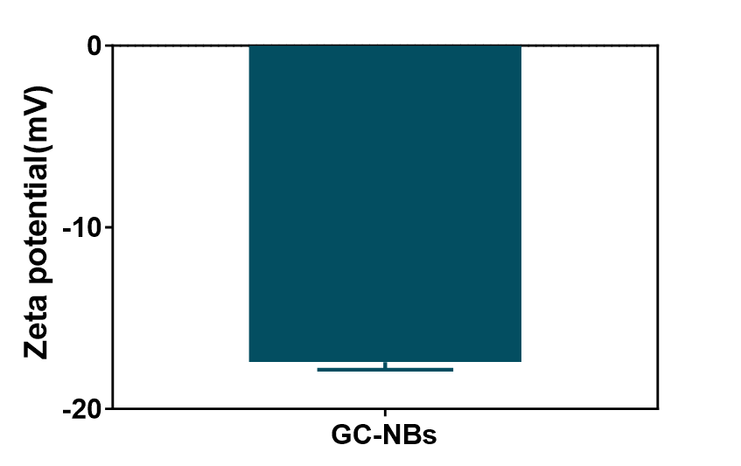
Figure S1. Zeta potential of GC-NBs.
Figure S2. Standard curve of Ce6.
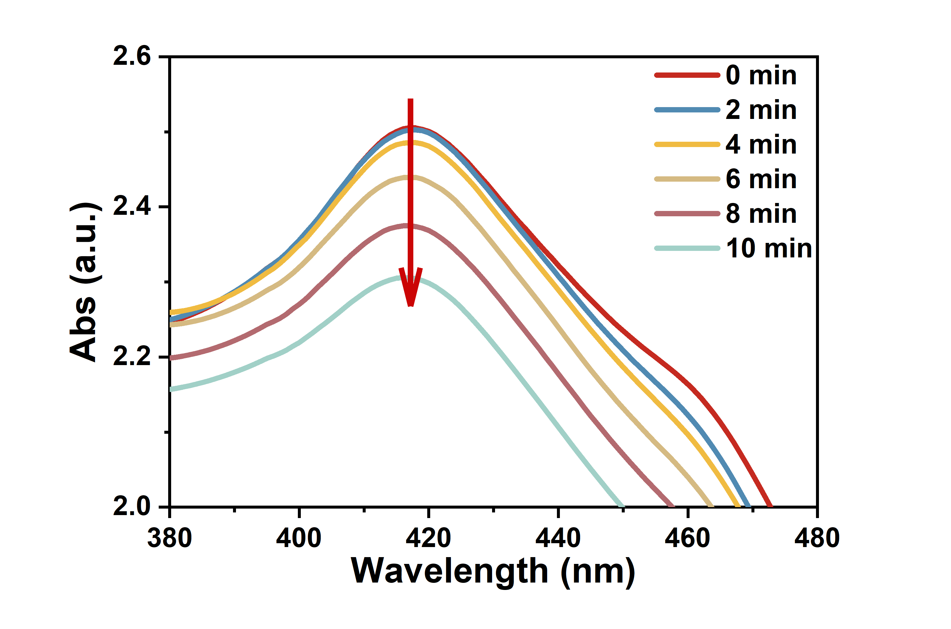
Figure S3. ¹O2 production of GC-NBs under ultrasound irradiation.

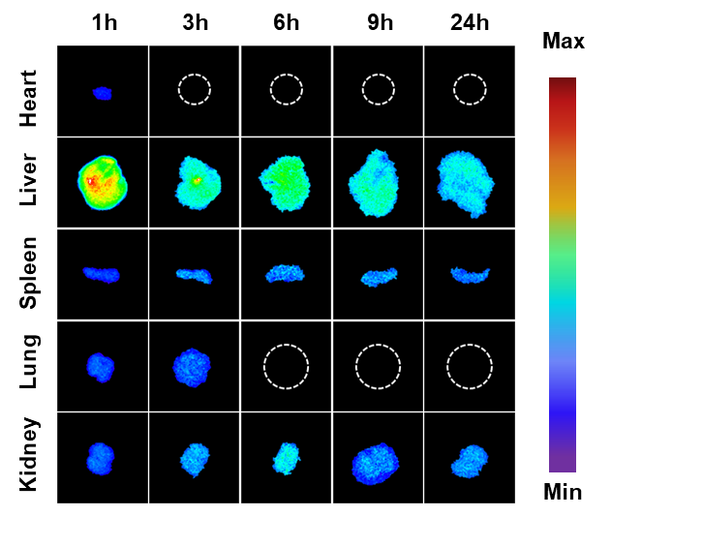
Figure S4. Biodistribution of GC-NBs.
Figure S5. (A) Statistical results of apoptosis rate in tumor tissue. (B) Proliferation index of tumor tissue. Data are presented as mean ± SD, n = 3; *P < 0.05, **P < 0.01, ***P < 0.001.
A
B

Figure S6. The changes of alanine aminotransferase (ALT) and aspartate aminotransferase (AST) of mice after different treatments. (Data are presented as mean ± SD, n = 3).
Figure S7. Major organs indexes of mice after different treatments. Data are presented as mean ± SD, n = 3.

Figure S8. H&E staining of major organs from different groups. Scale bar: 100 μm.

