Supplementary tables
Clinical Trial Number | Year of Publication | Study Design | Study Population | Number of Baseline Participants |  | Age (Mean (Range)) |  | Sex (Measure (Percent))
 |  |  |  | DEXTENZA | Placebo Vehicle | DEXTENZA | Placebo Vehicle | DEXTENZA | Placebo Vehicle
NCT02062905 | 2019 | Randomized Controlled Trial | Chronic Allergic Conjunctivitis | 35 | 33 | 45.5 (20–69) | 43.1 (21–71) | Female: 18 (51.4%)  Male: 17 (48.6%) | Female: 17 (51.5%)  Male: 16 (48.5%)
NCT02988882 | 2020 | Randomized Controlled Trial | Chronic Allergic Conjunctivitis | 44 | 42 | 39.1 (20–68) | 42.2 (18–70) | Female: 26 (59.1%)  Male: 18 (40.9%) | Female: 25 (59.5%)  Male: 17 (40.5%)
NCT02445326 | 2018 | Randomized Controlled Trial | Chronic Allergic Conjunctivitis | 35 | 38 | 38.2 (19–66) | 36.3 (18–62) | Female: 17 (48.6%)  Male: 18 (51.4%) | Female: 14 (36.8%)  Male: 24 (63.2%)
NCT04050865 | 2021 | Randomized Controlled Trial | Chronic Allergic Conjunctivitis | 48 | 48 | 43.8 | 46 | Female: 27 (56.3%)  Male: 21 (43.8%) | Female: 24 (50%)  Male: 24 (50%)

Supplementary Table 1. Trial characteristics.

Supplementary figures:
Supplementary Figure 1. Risk of bias summary.
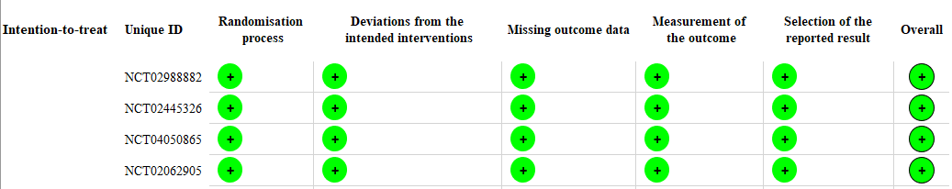
Supplementary Figure 2. Forest plot of sensitivity analysis of ocular itching in the conjunctival allergen challenge (CAC) model. CI, confidence interval; SD, standard deviation.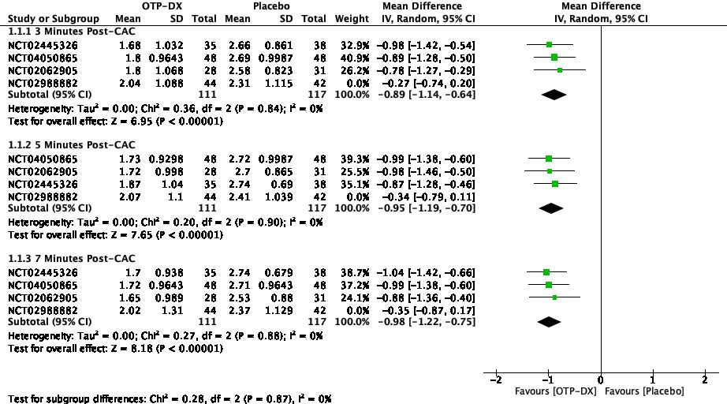
Supplementary Figure 3. Forest plot of adverse events. CI, confidence interval; SD, standard deviation.
