SUPPLEMENTARY MATERIAL
Temperature and Ultrasound-responsive Nanoassemblies for Enhanced Organ Targeting and Reduced Cardiac Toxicity
Mingzhou Jiang ^{1†}, Yiming Wang ^{2†}, Jinjin Zhang ^{2†}, Xi Fan ¹, Milayi Jieensi ¹, Fang Ding ², Yiqing Wang ^{1*}, Xiaotian Sun ^{1*}
1 Department of Cardiothoracic Surgery, Huashan Hospital of Fudan University, Shanghai, China.
2 Department of Cardiology, Huashan Hospital of Fudan University, Shanghai, China.
† These authors contributed equally to this work.
*Corresponding Author:
Yiqing Wang, M.D., Ph.D.
Department of Cardiothoracic Surgery, Huashan Hospital of Fudan University, 12 Wulumuqi Rd, Shanghai, 200040, China (E-mail: wangyiqing@huashan.org.cn)
Xiaotian Sun, M.D., Ph.D.
Department of Cardiothoracic Surgery, Huashan Hospital of Fudan University, 12 Wulumuqi Rd, Shanghai, 200040, China (E-mail: drsunxiaotian@126.com)

Experimental Cell Lines
The rat cardiomyocytic cell line (H9C2; Shanghai Institute of Biochemistry and Cell Biology, China), the adrenal pheochromocytoma cell line (PC12; Institute of Cell Biology, Chinese Academy of Sciences, Shanghai, China), and the human glioblastoma (GBM) cell line (U87MG; Shanghai Yu Bo Biotech Co., Ltd., Shanghai, China) were utilized in this work. H9C2 cells were cultured in H9C2 cell medium consisting of high glucose DMEM supplemented with 10% fetal bovine serum (FBS), 2 mM L-glutamine, 1 mM sodium pyruvate and 1% penicillin-streptomycin. PC12 and U87MG cells were cultured in DMEM containing 5% FBS and 1% penicillin/streptomycin. All cells were maintained under standard culture conditions at 37 ℃ with 5% CO_{2.}
In vitro Cytotoxicity Assessment of DOX-MPL-p
Distinct concentrations of DOX were independently added into the culture mediums of cardiomyocytes, neural cells, and tumor cells. Compounds were introduced into a 96-well flat-bottomed tissue culture dish, with each well containing 1x10⁴ cells and 100 µL of the culture medium. The concluding concentrations of DOX in each group were standardized at 0.1, 1.0, 5.0, 10, and 20 µg/mL. To adhere to the DOX concentrations, we calculated DOX-MPL-p’s concentrations (0.25, 2.5, 12.5, 25, and 50 µg/mL) to ensure an equivalent amount of drug between the nanoparticles and free DOX groups. Following incubation for 24 h, the cells were cleansed with PBS and treated with 10 µL of CCK-8 solutions per well. Absorbance was measured at 450 nm using the Microplate Reader (MD, USA). Same volume of DI water was added into the Control group. Cell viability was expressed as the average percentage relative to the Control. Meanwhile, the lactate dehydrogenase (LDH) test kits (Sangon, Shanghai, China) were used to detect LDH levels according to the manufacturer's instructions.
Animal Purchase and Study Approval
C57BL/6N mice (20 g, 8 W) were sourced from Charles River, Italy. All animal experiments conducted in this study were approved by the Institutional Animal Care and Use Committee of the Department of Laboratory Animal Science at Fudan University (Grant No. 20160780A176). Moreover, compliance with the US National Institutes of Health's guidelines for the care and use of laboratory animals, as delineated in publication no. 85-23 (revised in 1996), was maintained throughout the study.
In vivo Cytotoxicity Assessment of DOX-MLP-p
Intravenous administration was conducted in mice by tail-vein injections, with a dose of DOX-MLP-p set at 10 mg/kg. Post-administration, the behavior and survival of the mice were monitored daily, then the mice were respectively euthanized at 24 h, 7 d, 14 d, and 21 d. The main organs including the brain, heart, liver, spleen, and kidney were extracted for immunohistochemical examination with tissue slices estimated at approximately 7 µm. Following Hematoxylin and Eosin (HE) staining, numerous high-magnification fields were indiscriminately chosen for observations under an optical microscope. The SMUP-E4 biosignal processing system was utilized to document the heart rate and blood pressure of mice over a period of 16 h. At each time point of 2 h, 24 h, and 7 d, mouse blood samples were simultaneously collected for hematological and serological evaluations.
Thermogravimetric Analysis
DOX-MPL-p (9.59 mg) was placed in a high-pressure aluminum crucible. The sample and reference material were heated simultaneously, and the temperature difference between them was recorded. The experimental temperature range typically spanned from 30°C to 800°C, with a heating rate of 10°C/min. Weight loss of the sample in the heating process was measured. The results were presented in Fig. S1.
Differential Scanning Calorimetry Experiment
DOX-MPL-p (7.14 mg) was placed in a high-pressure aluminum crucible. The sample was heated simultaneously, and the temperature difference between them was recorded. The experimental temperature range typically spanned from 30°C to 200°C, with a heating rate of 10°C/min. Heat flow changes during the heating or cooling process were measured to determine the phase transition temperature and enthalpy, exhibiting an endothermic effect of the nanoparticles around 37°C, which is caused by the collapse of polymers on the particle surface (Fig. S2).
Drug Release Kinetics Studies
To assess the in vitro drug release behavior of DOX-MLP-p under various conditions, DOX-MLP-p loaded with 5 mg of DOX was dispersed in 5 mL of phosphate-buffered saline (pH 7.4). The resulting solution was placed inside a dialysis bag with a molecular weight cutoff of 2 kDa. Subsequently, the dialysis bag was immersed in 15 mL of PBS and continuously agitated. During different interventions such as temperature variations (37°C or 4°C) and ultrasonic stimulation (1 MHz,10min), and at predetermined time intervals, 2 mL of the release medium (out of 15 mL) was extracted. An equivalent volume of PBS was replenished after each sampling. The in vitro DOX concentration was quantified using a high-performance liquid chromatography system (Agilent Technologies, 1260 Infinity, CA, USA).
The in vivo plasma DOX concentrations were quantified via a microplate reader utilizing a pre-established standard curve for calibration (Fig. S3). For drawing the standard curve of DOX, a stock solution of DOX was prepared by dissolving 1mg of DOX in deionized (DI) water, yielding a working solution with a concentration of 2000 µg/mL. This solution was then subjected to stepwise dilution to produce a series of DOX solutions with varying concentrations (125 µg/mL, 31.25 µg/mL, 7.81 µg/mL, 1.95 µg/mL, 0.49 µg/mL, 0.12 µg/mL, 0.04 µg/mL). The UV-vis absorbance (A ab=485nm) for each solution was meticulously measured by a Microplate Reader (MD, USA). The derived data were correlated with corresponding DOX concentrations to construct a standard curve. The constructed standard curve illustrated a linear relationship within the concentration range of 0.04 μg/mL to 7.81 µg/mL.This release experiment was conducted three times under different conditions.
$$\begin{aligned}Percentage of drug released\left(\%\right)=\frac{\text{Cumulative drug release}\text{ concentration}}{\text{Initial drug loading}\text{ concentration}}×100\%\#\end{aligned}$$
Safety Evaluation of Long-Term and Multiple Administration of DOX-MPL-p
DOX-MLP-p was administered via tail vein injection at a dose of 10 mg/kg, with dosing every three days. Cardiac structure and function were evaluated at 7 d, 30 d, 60 d, and 90 d post-administration using Vevo 3100 echocardiography, and representative M-mode cardiac ultrasound images were identified. Stroke volume, ejection fraction (EF), and fractional shortening (FS) were calculated. Mice were euthanized in batches at the same time points, and major organs, including the brain, heart, liver, spleen, and kidneys, were collected for immunohistochemical analysis. Tissue sections were prepared at approximately 7 µm thickness. After hematoxylin and eosin (HE) staining, multiple high-power fields were randomly selected and observed under a light microscope.
Hematoxylin and eosin (H&E) staining revealed no significant pathological damage to the examined tissues (Figure. S4a). The neuronal cell membranes and soma remained intact and were neatly arranged. In the heart, the cardiomyocyte cytoplasm, nuclei, and tissue structures appeared normal and well-organized. The hepatic ductal regions exhibited normal morphology, with intact hepatic lobular structures. No obvious abnormalities were observed in the spleen tissues, pulmonary alveolar structures, or renal glomeruli and tubular structures. These findings indicate that DOX-MPL-p administration did not induce notable organ toxicity. In addition to the histological assessments, cardiac function was evaluated using Vevo 3100 echocardiography at 7 d, 30 d, 60 d, and 90 d post-injection Figure. S4b. Despite a slight decline in stroke volume, ejection fraction (EF), and fractional shortening (FS) over the 90-d period, all parameters remained within normal physiological ranges, suggesting preserved cardiac function throughout the study (Figure. S4c-e).

Figure. S1
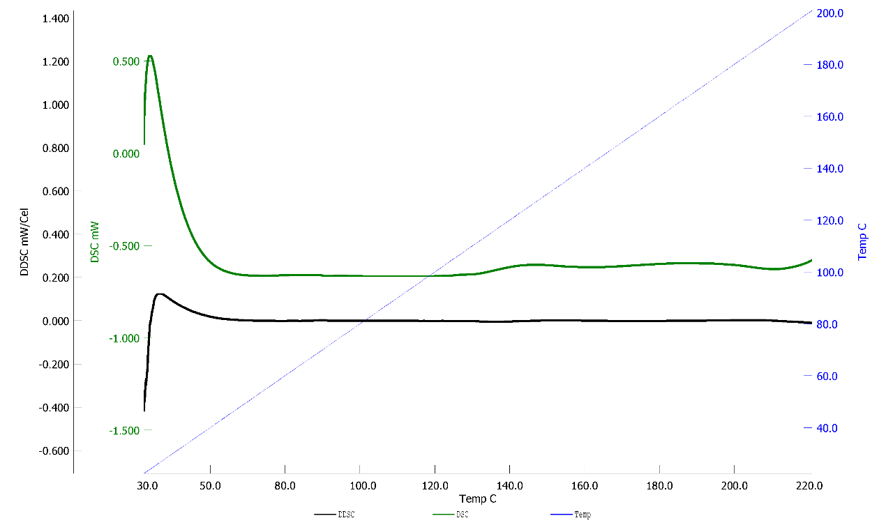
Figure. S1. Thermogravimetric Analysis (TGA) results of DOX-MPL-p after vacuum freeze-drying.

Figure. S2
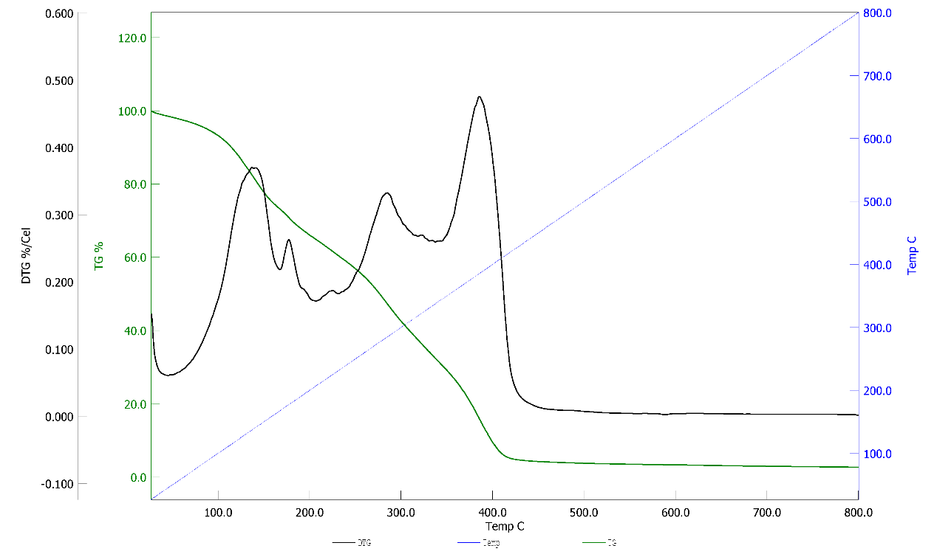
Figure. S2. Results of (DSC) differential scanning calorimetry of DOX-MPL-p.

Figure. S3
DOX standard curve
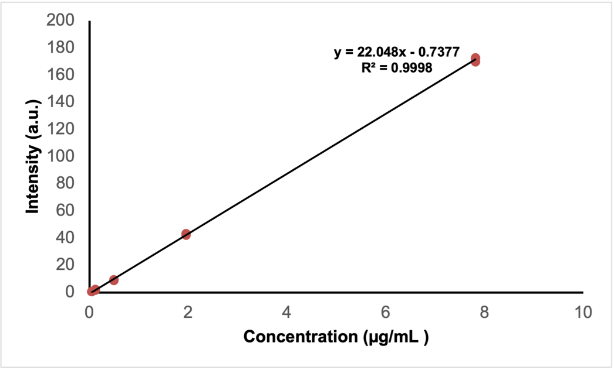
Figure. S3. The calculated standard curve of DOX.

Figure. S4
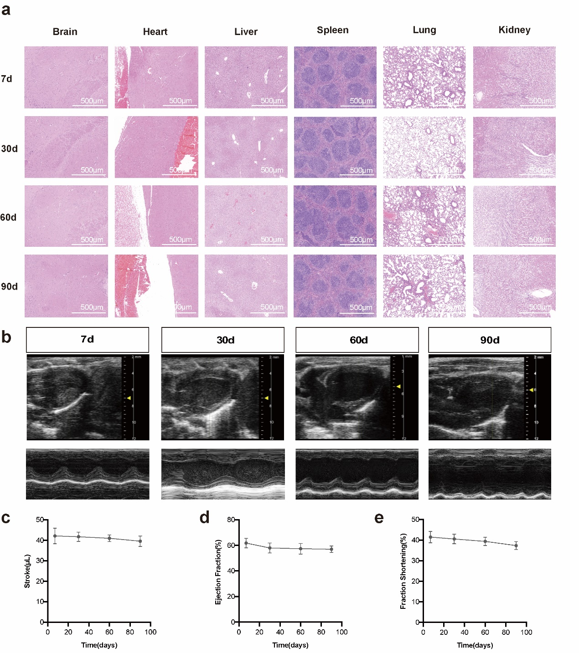
Figure. S4. (a) The H&E staining results of the vital organs of mice injected with DOX-MPL-p (10 mg/kg/q3d) observed at 40x magnification, revealed no significant pathological damage. This observation was consistent across various time points: 7 d, 30 d, 60 d, and 90 d post-administration; (b) Representative M-mode echocardiographic images at 7 d, 30 d, 60 d, and 90 d after drug administration; (c) Changes in stroke volume, ejection fraction (d) and fractional shortening (e) measured by echocardiography at 7 d, 30 d, 60 d, and 90 d after administration (n=3).
Figure. S5
Figure. S5. Ex vivo imaging of DiR@MPL-p, DiR@MION, Free DiR, PBS, and MION.

Table. S1
Hematological and serological results of mice treated with DOX-MPL-p
 | Control | 2h | 24h | 7d
WBC [K μL⁻¹] | 9.87±0.72 | 10.36±1.49 | 9.53±2.32 | 9.94±2.07
NEU % | 13.43±1.72 | 15.8±1.51 | 13.73±6.22 | 14.53±3.46
LY % | 78.93±1.72 | 73.9±6.55 | 72.3±11.18 | 77.07±4.29
RBC [M μL⁻¹] | 10.82±0.62 | 10.53±0.72 | 10.45±0.77 | 9.63±0.7
HGB [g dL⁻¹] | 162±3.61 | 157.67±6.51 | 157.67±8.02 | 150±8.04
HCT % | 55.27±0.83 | 53.47±1.76 | 53.23±2 | 50.57±3.73
PLT [K μL⁻¹] | 508.67±29.91 | 590.33±62.68 | 616±36.35 | 547±28.91
ALT [U L⁻¹] | 16.33±7.02 | 19±1.73 | 21.33±6.11 | 22.33±3.45
AST [U L⁻¹] | 43.67±2.52 | 40.67±5.86 | 49.33±17.21 | 50.67±7.51
BUN [mg dL⁻¹] | 6.07±1.5 | 6.57±0.7 | 6±0.75 | 5.37±1.09
CRE [mg dL⁻¹] | 5.67±0.58 | 5±1 | 4.33±1.15 | 3.67±1.6
Data were presented as mean ± SEM (n = 3). There were no statistically significant differences observed in the data across the various groups. The parameters measured included white blood cells (WBC), neutrophils (NEU), lymphocytes (LY), red blood cells (RBC), hemoglobin level (HGB), hematocrit (HCT), platelets (PLT), alanine aminotransferase (ALT), aspartate aminotransferase (AST), urea nitrogen levels (BUN) and serum creatinine levels (CRE).

