Comparing the Self-Reported Acceptability of Discrete Choice Experiment and Best-Worst Scaling: An Empirical Study in Patients with Type 2 Diabetes Mellitus

Fuming Li^{1,2}, Shimeng Liu^{1,2*}, Yuanyuan Gu³, Shunping Li⁴, Ying Tao^{1,2}, Yan Wei^{1,2}, Yingyao Chen^{1,2*}

¹ School of Public Health, Fudan University, Shanghai, China
² National Health Commission Key Laboratory of Health Technology Assessment (Fudan University), Shanghai, China
³ Macquarie University Centre for the Health Economy, Macquarie Business School & Australian Institute of Health Innovation, Macquarie University, Macquarie Park, New South Wales, Australia
⁴ Centre for Health Management and Policy Research, School of Public Health, Cheeloo College of Medicine, Shandong University, Jinan, China

*Corresponding Author: Shimeng Liu; Email: smliu19@fudan.edu.cn; Yingyao Chen; E-mail: yychen@shmu.edu.cn

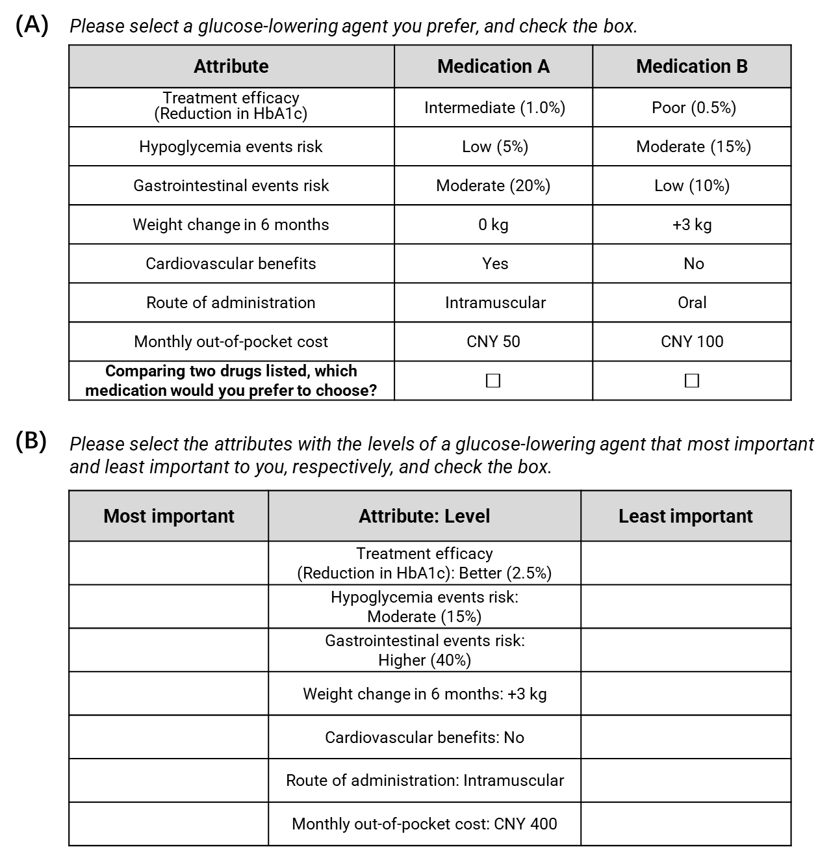
Figure S1 Examples of the DCE and BWS-2 choice tasks. (A) the DCE choice task, (B) the BWS-2 choice task.
Abbreviations: CNY, Chinese Yuan.

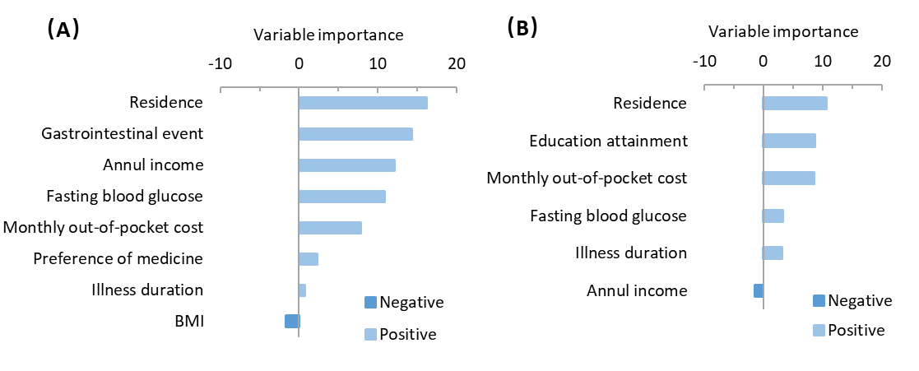
Figure S2 Random forest to classify comprehension complexity and response preference in sensitivity analyses. (A) permutation variable importance measures for comprehension complexity among DCE and BWS-2, (B) permutation variable importance measures for response preference among DCE and BWS-2.
Notes: Variables with positive importance values increased the accuracy of the random forest algorithm, whereas negative values decreased the accuracy.
Abbreviations: BMI body mass index.

Table S1 Self-reported Baseline Sociodemographic and Disease-related Characteristics of The Respondents
Variable |  | Respondents Who Were Included (n=3,286), No. (%) | All Respondents (n=3,487), No. (%) | P Value
Age | <60 | 1,357 (41.3) | 1,437 (41.2) | 0.94
 | ≥60 | 1,929 (58.7) | 2,050 (58.8)
Gender | Male | 1,637 (49.8) | 1,732 (49.7) | 0.90
 | Female | 1,649 (50.2) | 1,755 (50.3)
Residence | Urban | 2,108 (64.2) | 2,256 (64.7) | 0.64
 | Rural | 1,178 (35.8) | 1,231 (35.3)
Marital status | Married | 2,982 (90.8) | 3,163 (90.7) | 0.99
 | Single | 57 (1.7) | 59 (1.7)
 | Divorced | 42 (1.3) | 46 (1.3)
 | Widowed | 205 (6.2) | 219 (6.3)
Education level | No formal or primary school | 961 (29.2) | 1,015 (29.1) | 0.96
 | Secondary school or equivalent | 1,839 (56.0) | 1,958 (56.2)
 | College or university or above | 486 (14.8) | 514 (14.7)
Annual income | <CNY 20,000 | 678 (20.6) | 710 (20.4) | 0.46
 | CNY 20,000-70,000 | 1,730 (52.6) | 1,824 (52.3)
 | CNY 80,000-130,000 | 719 (21.9) | 770 (22.1)
 | CNY 140,000-190,000 | 111 (3.4) | 125 (3.6)
 | ≥CNY 200,000 | 48 (1.5) | 58 (1.6)
Hospitalization | Hospitalized | 1,002 (30.5) | 1,069 (30.7) | 0.88
 | Outpatient | 2,284 (69.5) | 2,418 (69.3)
Illness duration | <5 | 975 (29.7) | 1,030 (29.5) | 0.90
 | ≥5 | 2,311 (70.3) | 2,457 (70.5)
Fasting blood glucose | Unclear | 229 (7.0) | 248 (7.1) | 0.99
 | <6.1 | 186 (5.7) | 198 (5.7)
 | 6.1-7.0 | 764 (23.2) | 805 (23.1)
 | ≥7.0 | 2,107 (64.1) | 2,236 (64.1)
BMI | <18.5 | 141 (4.3) | 146 (4.2) | 0.89
 | ≥18.5 and <24 | 1,517 (46.2) | 1,594 (45.7)
 | ≥24 | 1,628 (49.5) | 1,747 (50.1)
Medicine type | Unmedicated | 311 (9.5) | 319 (9.1) | 0.76
 | 1 | 937 (28.5) | 992 (28.5)
 | 2 | 1,385 (42.1) | 1,485 (42.6)
 | ≥3 | 653 (19.9) | 691 (19.8)
Current route of administration | Unmedicated | 311 (9.5) | 316 (9.1) | 0.88
 | Oral | 1,955 (59.5) | 2,073 (59.4)
 | Intramuscular | 278 (8.5) | 310 (8.9)
 | Mixed | 742 (22.5) | 788 (22.6)
Preferred route of administration | Oral | 2,873 (87.4) | 3,037 (87.1) | 0.68
 | Intramuscular | 413 (12.6) | 450 (12.9)
Monthly out-of-pocket costs | <CNY 50 | 683 (20.8) | 696 (20.0) | 0.49
 | CNY 50-100 | 604 (18.4) | 636 (18.2)
 | CNY 100-200 | 647 (19.7) | 699 (20.0)
 | CNY 200-400 | 751 (22.9) | 811 (23.3)
 | CNY 400-600 | 372 (11.3) | 404 (11.6)
 | ≥CNY 600 | 229 (7.0) | 241 (6.9)
Hypoglycemia event | Unclear | 305 (9.3) | 316 (9.0) | 0.83
 | No | 1,769 (53.8) | 1,861 (53.4)
 | Yes | 1,212 (36.9) | 1,310 (37.6)
Gastrointestinal event | Unclear | 320 (9.7) | 332 (9.5) | 0.81
 | No | 2,088 (63.5) | 2,200 (63.1)
 | Yes | 878 (26.7) | 955 (27.4)
Abbreviations: CNY, Chinese yuan; BMI, body mass index.

Table S2 Variable Assignments
Variable | Type | Assignment
Age | Independent | 0 = <60, 1 = ≥60
Gender | Independent | 0 = male, 1 = female
Residence | Independent | 0 = urban, 1 = rural
Marital status | Independent | 0 = married, 1 = single, 2 = divorced, 3 = widowed
Education level | Independent | 0 = no formal or primary school, 1 = secondary school or equivalent, 2 = college or university or above
Annual income | Independent | 0 = <CNY 20,000, 1 = CNY 20,000-70,000, 2 = CNY 80,000-130,000, 3 = CNY 140,000-190,000, 4 =≥CNY 200,000
Hospitalization | Independent | 0 = hospitalized, 1 = outpatient
Illness duration | Independent | 0 = <5 years, 1 = ≥5 years
Fasting blood glucose | Independent | 0 = unclear, 1 = <6.1 mmol/L, 2 = 6.1-7.0 mmol/L, 3 = ≥7.0 mmol/L
BMI | Independent | 0 = <18.5, 1 = ≥18.5 and <24, 2 = ≥24
Medicine type | Independent | 0 = unmedicated, 1 = one drug, 2 = two drugs, 3 = more than three drugs
Current route of administration | Independent | 0 = unmedicated, 1 = oral, 2 = intramuscular, 3 = mixed
Preferred route of administration | Independent | 0 = oral, 1 = intramuscular
Monthly out-of-pocket costs | Independent | 0 = <CNY 50, 1 = CNY 50-100, 2 = CNY 100-200, 3 = CNY 200-400, 4 = CNY 400-600, 5 = ≥CNY 600
Hypoglycemia event | Independent | 0 = unclear, 1 = no, 2 = yes
Gastrointestinal event | Independent | 0 = unclear, 1 = no, 2 = yes
Difficulty of DCE | Independent | 1 = very simple, 2 = simple, 3 = neither simple nor difficult, 4 = difficult, 5 = very difficult
Difficulty of BWS-2 | Independent | 1 = very simple, 2 = simple, 3 = neither simple nor difficult, 4 = difficult, 5 = very difficult
Comprehension complexity | Dependent | 0 = DCE, 1 = BWS-2
Response preference | Dependent | 0 = DCE, 1 = BWS-2
Abbreviations: DCE, discrete choice experiment; BWS-2, case 2 best-worst scaling; CNY, Chinese yuan; BMI, body mass index.

Table S3 Analysis of Comprehension Complexity between DCE and BWS-2 (n=3,286)
Variable |  | DCE,  No. (%) | BWS-2,  No. (%) | χ² | P Value
Age | <60 | 824 (60.7) | 533 (39.3) | 0.24 | 0.63
 | ≥60 | 1,155 (59.9) | 774 (40.1)
Gender | Male | 982 (60.0) | 655 (40.0) | 0.08 | 0.78
 | Female | 997 (60.5) | 652 (39.5)
Residence | Urban | 1,315 (62.4) | 793 (37.6) | 11.41 | < 0.001
 | Rural | 664 (56.4) | 514 (43.6)
Marital status | Married | 1,796 (60.2) | 1,186 (39.8) | 1.61 | 0.66
 | Single | 37 (64.9) | 20 (35.1)
 | Divorced | 22 (52.4) | 20 (47.6)
 | Widowed | 124 (60.5) | 81 (39.5)
Education level | No formal or primary school | 595 (61.9) | 366 (38.1) | 0.08 | 0.78
 | Secondary school or equivalent | 1,070 (58.2) | 769 (41.8)
 | College or university or above | 314 (64.6) | 172 (35.4)
Annual income | <CNY 20,000 | 430 (63.4) | 248 (36.6) | 12.05 | < 0.001
 | CNY 20,000-70,000 | 1,070 (61.9) | 660 (38.1)
 | CNY 80,000-130,000 | 389 (54.1) | 330 (45.9)
 | CNY 140,000-200,000 | 64 (57.7) | 47 (42.3)
 | ≥CNY 200,000 | 26 (54.2) | 22 (45.8)
Hospitalization | Hospitalized | 612 (61.1) | 390 (38.9) | 0.44 | 0.51
 | Outpatient | 1,367 (59.9) | 917 (40.1)
Illness duration | <5 | 620 (63.6) | 355 (36.4) | 6.55 | 0.01
 | ≥5 | 1,359 (58.8) | 952 (41.2)
Fasting blood glucose | Unclear | 119 (52.0) | 110 (48.0) | 7.49 | 0.06
 | <6.1 | 110 (59.1) | 76 (40.9)
 | 6.1-7.0 | 460 (60.2) | 304 (39.8)
 | ≥7.0 | 1,290 (61.2) | 817 (38.8)
BMI | <18.5 | 100 (70.9) | 41 (29.1) | 11.10 | < 0.01
 | ≥18.5 and <24 | 934 (61.6) | 583 (38.4)
 | ≥24 | 945 (58.1) | 683 (41.9)
Medicine type | Unmedicated | 206 (66.2) | 105 (33.8) | 0.74 | 0.39
 | 1 | 564 (60.2) | 373 (39.8)
 | 2 | 800 (57.8) | 585 (42.2)
 | ≥3 | 409 (62.6) | 244 (37.4)
Current route of administration | Unmedicated | 206 (66.2) | 105 (33.8) | 6.82 | 0.08
 | Oral | 1,150 (58.8) | 805 (41.2)
 | Intramuscular | 173 (62.2) | 105 (37.8)
 | Mixed | 450 (60.7) | 292 (39.3)
Preferred route of administration | Oral | 1,707 (59.4) | 1,166 (40.6) | 6.26 | 0.01
 | Intramuscular | 272 (65.9) | 141 (34.1)
Monthly out-of-pocket costs | <CNY 50 | 397 (58.1) | 286 (41.9) | 10.48 | < 0.01
 | CNY 50-100 | 341 (56.5) | 263 (43.5)
 | CNY 100-200 | 387 (59.8) | 260 (40.2)
 | CNY 200-400 | 464 (61.8) | 287 (38.2)
 | CNY 400-600 | 233 (62.6) | 139 (37.4)
 | ≥CNY 600 | 157 (68.6) | 72 (31.4)
Hypoglycemia event | Unclear | 179 (58.7) | 126 (41.3) | 1.14 | 0.56
 | No | 1,080 (61.0) | 689 (39.0)
 | Yes | 720 (59.4) | 492 (40.6)
Gastrointestinal events | Unclear | 185 (57.8) | 135 (42.2) | 8.24 | 0.02
 | No | 1,296 (62.1) | 792 (37.9)
 | Yes | 498 (56.7) | 380 (43.3)
Abbreviations: DCE, discrete choice experiment; BWS-2, case 2 best-worst scaling; χ², chi-square value; CNY, Chinese yuan; BMI, body mass index.

Table S4 Analysis of Response Preference between DCE and BWS-2 (n=3,286)
Variable |  | DCE,  No. (%) | BWS-2,  No. (%) | χ² | P Value
Age | <60 | 824 (60.7) | 533 (39.3) | 0.24 | 0.63
 | ≥60 | 1,155 (59.9) | 774 (40.1)
Gender | Male | 832 (50.8) | 805 (49.2) | 1.25 | 0.26
 | Female | 806 (48.9) | 843 (51.1)
Residence | Urban | 1,106 (52.5) | 1,002 (47.5) | 16.13 | < 0.001
 | Rural | 532 (45.2) | 646 (54.8)
Marital status | Married | 1,489 (49.9) | 1,493 (50.1) | 5.65 | 0.13
 | Single | 34 (59.7) | 23 (40.3)
 | Divorced | 15 (35.7) | 27 (64.3)
 | Widowed | 100 (48.8) | 105 (51.2)
Education level | No formal or primary school | 461 (48.0) | 500 (52.0) | 9.68 | < 0.01
 | Secondary school or equivalent | 895 (48.7) | 944 (51.3)
 | College or university or above | 282 (58.0) | 204 (42.0)
Annual income | <CNY 20,000 | 327 (48.2) | 351 (51.8) | 2.09 | 0.15
 | CNY 20,000-70,000 | 862 (49.8) | 868 (50.2)
 | CNY 80,000-130,000 | 361 (50.2) | 358 (49.8)
 | CNY 140,000-200,000 | 61 (55.0) | 50 (45.0)
 | ≥CNY 200,000 | 27 (56.3) | 21 (43.7)
Hospitalization | Hospitalized | 512 (51.1) | 490 (48.9) | 0.90 | 0.34
 | Outpatient | 1,126 (49.3) | 1,158 (50.7)
Illness duration | <5 | 529 (54.3) | 446 (45.7) | 10.78 | < 0.01
 | ≥5 | 1,109 (48.0) | 1,202 (52.0)
Fasting blood glucose | Unclear | 102 (44.5) | 127 (55.5) | 7.47 | 0.06
 | <6.1 | 105 (56.5) | 81 (43.5)
 | 6.1-7.0 | 396 (51.8) | 368 (48.2)
 | ≥7.0 | 1,035 (49.1) | 1,072 (50.9)
BMI | <18.5 | 81 (57.5) | 60 (42.5) | 5.64 | 0.06
 | ≥18.5 and <24 | 772 (50.9) | 745 (49.1)
 | ≥24 | 785 (48.2) | 843 (51.8)
Medicine type | Unmedicated | 174 (55.9) | 137 (44.1) | 2.16 | 0.14
 | 1 | 477 (50.9) | 460 (49.1)
 | 2 | 651 (47.0) | 734 (53.0)
 | ≥3 | 336 (51.4) | 317 (48.6)
Current route of administration | Unmedicated | 174 (55.9) | 137 (44.1) | 5.59 | 0.13
 | Oral | 969 (49.6) | 986 (50.4)
 | Intramuscular | 138 (49.6) | 140 (50.4)
 | Mixed | 357 (48.1) | 385 (51.9)
Preferred route of administration | Oral | 1,423 (49.5) | 1,450 (50.5) | 0.92 | 0.34
 | Intramuscular | 215 (52.1) | 198 (47.9)
Monthly out-of-pocket costs | <CNY 50 | 332 (48.61) | 351 (51.4) | 6.74 | < 0.01
 | CNY 50-100 | 277 (45.9) | 327 (54.1)
 | CNY 100-200 | 317 (49.0) | 330 (51.0)
 | CNY 200-400 | 389 (51.8) | 362 (48.2)
 | CNY 400-600 | 198 (53.2) | 174 (46.8)
 | ≥CNY 600 | 125 (54.6) | 104 (45.4)
Hypoglycemia event | Unclear | 157 (51.5) | 148 (48.5) | 2.61 | 0.27
 | No | 899 (50.8) | 870 (49.2)
 | Yes | 582 (48.0) | 630 (52.0)
Gastrointestinal events | Unclear | 154 (48.1) | 166 (51.9) | 3.93 | 0.14
 | No | 1,068 (51.2) | 1,020 (48.8)
 | Yes | 416 (47.4) | 462 (52.6)
Abbreviations: DCE, discrete choice experiment; BWS-2, case 2 best-worst scaling; χ², chi-square value; CNY, Chinese yuan; BMI, body mass index.

Table S5 Acceptability in Completing DCE and BWS-2 Tasks in Sensitivity Analyses (n=3,487)
Question |  | DCE,  No. (%) | BWS-2,  No. (%)
Completing difficulty | Very simple | 67 (1.9) | 84 (2.4)
 | Simple | 450 (12.9) | 446 (12.8)
 | Neither simple nor difficult | 2,268 (65.0) | 2,319 (66.5)
 | Difficult | 620 (17.8) | 573 (16.4)
 | Very difficult | 82 (2.4) | 65 (1.9)
Easier to comprehend |  | 2,096 (60.1) | 1,391 (39.9)
Preferred to response |  | 1,750 (50.2) | 1,737 (49.8)
Abbreviations: DCE, discrete choice experiment; BWS-2, case 2 best-worst scaling.

Table S6 Analysis of Comprehension Complexity between DCE and BWS-2 in Sensitivity Analyses (n=3487)
Variable |  | DCE,  No. (%) | BWS-2,  No. (%) | χ² | P Value
Age | <60 | 875 (60.9) | 562 (39.1) | 0.62 | 0.43
 | ≥60 | 1,221 (59.6) | 829 (40.4)
Gender | Male | 1,041 (60.1) | 691 (39.9) | 0.00 | 0.99
 | Female | 1,055 (60.1) | 700 (39.9)
Residence | Urban | 1,404 (62.2) | 852 (37.8) | 12.04 | < 0.001
 | Rural | 692 (56.2) | 539 (43.8)
Marital status | Married | 1,902 (60.1) | 1,261 (39.9) | 1.10 | 0.78
 | Single | 38 (64.4) | 21 (35.6)
 | Divorced | 25 (54.4) | 21 (45.6)
 | Widowed | 131 (59.8) | 88 (40.2)
Education level | No formal or primary school | 629 (62.0) | 386 (38.0) | 0.01 | 0.91
 | Secondary school or equivalent | 1137 (58.1) | 821 (41.9)
 | College or university or above | 330 (64.2) | 184 (35.8)
Annual income | <CNY 20,000 | 448 (63.1) | 262 (36.9) | 10.67 | < 0.01
 | CNY 20,000-70,000 | 1,122 (61.5) | 702 (38.5)
 | CNY 80,000-130,000 | 423 (54.9) | 347 (45.1)
 | CNY 140,000-200,000 | 72 (57.6) | 53 (42.4)
 | ≥CNY 200,000 | 31 (53.5) | 27 (46.6)
Hospitalization | Hospitalized | 649 (60.7) | 420 (39.3) | 0.23 | 0.63
 | Outpatient | 1,447 (59.8) | 917 (40.2)
Illness duration | <5 | 655 (63.6) | 375 (36.4) | 7.40 | < 0.01
 | ≥5 | 1,441 (58.7) | 1,016 (41.3)
Fasting blood glucose | Unclear | 124 (50.0) | 124 (50.0) | 11.62 | < 0.01
 | <6.1 | 118 (59.6) | 80 (40.4)
 | 6.1-7.0 | 487 (60.5) | 318 (39.5)
 | ≥7.0 | 1,367 (61.1) | 869 (38.9)
BMI | <18.5 | 103 (70.6) | 43 (29.4) | 9.84 | < 0.01
 | ≥18.5 and <24 | 975 (61.2) | 619 (38.8)
 | ≥24 | 1,018 (58.3) | 729 (41.7)
Medicine type | Unmedicated | 211 (66.1) | 108 (33.9) | 1.44 | 0.23
 | 1 | 598 (60.3) | 394 (39.7)
 | 2 | 862 (58.1) | 623 (41.9)
 | ≥3 | 425 (61.5) | 266 (38.5)
Current route of administration | Unmedicated | 208 (65.8) | 108 (34.2) | 6.11 | 0.11
 | Oral | 1,219 (58.8) | 854 (41.2)
 | Intramuscular | 190 (61.3) | 120 (38.7)
 | Mixed | 479 (60.8) | 309 (39.23)
Preferred route of administration | Oral | 1,805 (59.4) | 1,232 (40.6) | 4.48 | 0.03
 | Intramuscular | 291 (64.7) | 159 (35.3)
Monthly out-of-pocket costs | <CNY 50 | 402 (57.8) | 294 (42.2) | 9.13 | < 0.01
 | CNY 50-100 | 365 (57.4) | 271 (42.6)
 | CNY 100-200 | 419 (59.9) | 280 (40.1)
 | CNY 200-400 | 495 (61.0) | 316 (39.0)
 | CNY 400-600 | 250 (61.9) | 154 (38.1)
 | ≥CNY 600 | 165 (68.5) | 76 (31.5)
Hypoglycemia event | Unclear | 184 (58.2) | 132 (41.8) | 1.41 | 0.49
 | No | 1,135 (61.0) | 726 (39.0)
 | Yes | 777 (59.3) | 533 (40.7)
Gastrointestinal event | Unclear | 190 (57.2) | 142 (42.8) | 8.91 | 0.01
 | No | 1,364 (62.0) | 836 (38.0)
 | Yes | 542 (56.8) | 413 (43.2)
Abbreviations: DCE, discrete choice experiment; BWS-2, case 2 best-worst scaling; χ², chi-square value; CNY, Chinese yuan; BMI, body mass index.

Table S7 Association of Sociodemographic and Disease-related Factors with Comprehension Complexity between DCE and BWS-2 in Sensitivity Analyses ª
Variable |  | Estimate | S.E. | P Value | OR (95% CI)
Intercept |  | -1.33 | 0.26 | < 0.001
Residence |  | 0.36 | 0.08 | < 0.001 | 1.43 (1.22-1.67)
Annual income |  | 0.22 | 0.05 | < 0.001 | 1.25 (1.14-1.36)
Illness duration |  | 0.26 | 0.08 | < 0.001 | 1.30 (1.11-1.52)
Fasting blood glucose (Ref: ≥7.0) | Unclear | 0.30 | 0.11 | < 0.01 | 1.51 (1.15-1.97)
 | <6.1 | -0.07 | 0.12 | 0.53 | 1.04 (0.77-1.41)
 | 6.1-7.0 | -0.11 | 0.07 | 0.12 | 1.00 (0.84-1.18)
BMI (Ref: ≥24) | <18.5 | -0.33 | 0.13 | < 0.01 | 0.57 (0.39-0.83)
 | ≥18.5 and <24 | 0.10 | 0.07 | 0.17 | 0.87 (0.76-1.01)
Preferred route of administration |  | -0.20 | 0.11 | 0.07 | 0.82 (0.67-1.02)
Monthly out-of-pocket costs |  | -0.09 | 0.02 | < 0.001 | 0.91 (0.87-0.96)
Gastrointestinal event (Ref: Yes) | Unclear | 0.00 | 0.08 | 0.99 | 0.88 (0.68-1.15)
 | No | -0.13 | 0.05 | 0.02 | 0.78 (0.66-0.91)
Notes: ª The reference level for the odds ratios of dichotomous variables is represented by the first group, while for multicategorical variables, the reference level is represented by the last group.
Abbreviations: S.E., standard error; OR, odds ratio; CI, confidence interval; BMI, body mass index.

Table S8 Analysis of Response Preference between DCE and BWS-2 (n=3,487)
Variable |  | DCE,  No. (%) | BWS-2,  No. (%) | χ² | P Value
Age | <60 | 875 (60.9) | 562 (39.1) | 0.62 | 0.43
 | ≥60 | 1,221 (59.6) | 829 (40.4)
Gender | Male | 890 (51.4) | 842 (48.6) | 1.98 | 0.16
 | Female | 860 (49.0) | 895 (51.0)
Residence | Urban | 1,193 (52.9) | 1,063 (47.1) | 18.56 | < 0.001
 | Rural | 557 (45.2) | 674 (54.8)
Marital status | Married | 1,588 (50.2) | 1,575 (49.8) | 5.08 | 0.17
 | Single | 36 (61.0) | 23 (39.0)
 | Divorced | 18 (39.1) | 28 (60.9)
 | Widowed | 108 (49.3) | 111 (50.7)
Education level | No formal or primary school | 491 (48.4) | 524 (51.6) | 10.02 | < 0.01
 | Secondary school or equivalent | 959 (49.0) | 999 (51.0)
 | College or university or above | 300 (58.4) | 214 (41.6)
Annual income | <CNY 20,000 | 340 (47.9) | 370 (52.1) | 4.46 | 0.03
 | CNY 20,000-70,000 | 911 (50.0) | 913 (50.0)
 | CNY 80,000-130,000 | 396 (51.4) | 374 (48.6)
 | CNY 140,000-200,000 | 70 (56.0) | 55 (44.0)
 | ≥CNY 200,000 | 33 (56.9) | 25 (43.1)
Hospitalization | Hospitalized | 545 (51.0) | 524 (49.0) | 0.39 | 0.53
 | Outpatient | 1,205 (49.8) | 1,213 (50.2)
Illness duration | <5 | 566 (55.0) | 464 (45.0) | 13.28 | < 0.001
 | ≥5 | 1,184 (48.2) | 1,273 (51.8)
Fasting blood glucose | Unclear | 110 (44.4) | 138 (55.6) | 8.85 | 0.03
 | <6.1 | 114 (57.6) | 84 (42.4)
 | 6.1-7.0 | 417 (51.8) | 388 (48.2)
 | ≥7.0 | 1,109 (49.6) | 1,127 (50.4)
BMI | <18.5 | 83 (56.9) | 63 (43.1) | 4.76 | 0.09
 | ≥18.5 and <24 | 816 (51.2) | 778 (48.8)
 | ≥24 | 851 (48.7) | 896 (51.3)
Medicine type | Unmedicated | 178 (55.8) | 141 (44.2) | 2.70 | 0.10
 | 1 | 513 (51.7) | 479 (48.3)
 | 2 | 704 (47.4) | 781 (52.6)
 | ≥3 | 355 (51.4) | 336 (48.6)
Current route of administration | Unmedicated | 176 (55.7) | 140 (44.3) | 5.03 | 0.17
 | Oral | 1035 (49.9) | 1038 (50.1)
 | Intramuscular | 158 (51.0) | 152 (49.0)
 | Mixed | 381 (48.4) | 407 (51.6)
Preferred route of administration | Oral | 1,512 (49.8) | 1,525 (50.2) | 1.51 | 0.22
 | Intramuscular | 238 (52.9) | 212 (47.1)
Monthly out-of-pocket costs | <CNY 50 | 336 (48.3) | 360 (51.7) | 7.63 | < 0.01
 | CNY 50-100 | 299 (47.0) | 337 (53.0)
 | CNY 100-200 | 346 (49.5) | 353 (50.5)
 | CNY 200-400 | 418 (51.5) | 393 (48.5)
 | CNY 400-600 | 219 (54.2) | 185 (45.8)
 | ≥CNY 600 | 132 (54.8) | 109 (45.2)
Hypoglycemia event | Unclear | 160 (50.6) | 156 (49.4) | 2.29 | 0.32
 | No | 954 (51.3) | 907 (48.7)
 | Yes | 636 (48.6) | 674 (51.4)
Gastrointestinal event | Unclear | 159 (47.9) | 173 (52.1) | 3.57 | 0.17
 | No | 1,131 (51.4) | 1,069 (48.6)
 | Yes | 460 (48.2) | 495 (51.8)
Abbreviations: DCE, discrete choice experiment; BWS-2, case 2 best-worst scaling; χ², chi-square value; CNY, Chinese yuan; BMI, body mass index.

Table S9 Association of Sociodemographic and Disease-related Factors with Response Preference between DCE and BWS-2 ª
Variable |  | Estimate | S.E. | P Value | OR (95% CI)
Intercept |  | -0.55 | 0.25 | 0.03
Residence |  | 0.26 | 0.08 | < 0.01 | 1.29 (1.11-1.51)
Education attainment |  | -0.06 | 0.06 | 0.32 | 0.94 (0.84-1.06)
Annual income |  | 0.01 | 0.05 | 0.81 | 1.01 (0.92-1.11)
Illness duration |  | 0.28 | 0.08 | < 0.001 | 1.32 (1.14-1.53)
Fasting blood glucose (Ref: ≥7.0) | Unclear | 0.21 | 0.11 | 0.05 | 1.17 (0.89-1.52)
 | <6.1 | -0.24 | 0.12 | 0.04 | 0.74 (0.55-1.00)
 | 6.1-7.0 | -0.03 | 0.07 | 0.71 | 0.92 (0.78-1.08)
Monthly out-of-pocket costs |  | -0.07 | 0.02 | < 0.01 | 0.93 (0.89-0.97)
Notes: ª The reference level for the odds ratios of dichotomous variables is represented by the first group, while for multicategorical variables, the reference level is represented by the last group.
Abbreviations: S.E., standard error; OR, odds ratio; CI, confidence interval.
Table S10 Acceptability in The Order of Completing DCE and BWS-2 Tasks in Sensitivity Analyses (n=3,286)
Question |  | DCE first  (n=1710) | BWS-2 first  (n=1576) | P Value
Question |  | No. (%) | No. (%) | P Value
Completing difficulty of DCE | Very simple | 35 (2.0) | 17 (1.1) | < 0.01
 | Simple | 208 (12.2) | 216 (13.7) | < 0.01
 | Medium | 1,080 (63.2) | 1,057 (67.1) | < 0.01
 | Difficult | 346 (20.2) | 249 (15.8) | < 0.01
 | Very difficult | 41 (2.4) | 37 (2.3) | < 0.01
(Mean score) |  | 3.09 ± 0.70 | 3.05 ± 0.66
Completing difficulty of BWS | Very simple | 45 (2.6) | 25 (1.6) | < 0.01
 | Simple | 196 (11.5) | 227 (14.4) | < 0.01
 | Medium | 1,128 (66.0) | 1,058 (67.1) | < 0.01
 | Difficult | 312 (18.2) | 233 (14.8) | < 0.01
 | Very difficult | 29 (1.7) | 33 (2.1) | < 0.01
(Mean score) |  | 3.05 ± 0.68 | 3.01 ± 0.66
Easier to comprehend | DCE | 1,028 (60.1) | 951 (60.3) | 0.90
 | BWS-2 | 682 (39.9) | 625 (39.7) | 0.90
Preferred to response | DCE | 829 (48.5) | 809 (51.3) | 0.10
 | BWS-2 | 881 (51.5) | 767 (48.7) | 0.10
Abbreviations: DCE, discrete choice experiment; BWS-2, case 2 best-worst scaling.

