Supplementary Material
Evaluating Inflammatory Bowel Disease related quality of life based on interpretable machine learning approach: A multicenter study in China
Junhai Zhen, Chuan Liu, Jixiang Zhang, Fei Liao, Huabing Xie, Cheng Tan, Ping An, Zhongchun Liu, Changqing Jiang, Jie Shi, Kaichun Wu, Weiguo Dong
Supplementary Table 1. The IJMEDI checklist for the evaluation of the quality of ML in medical field. AI, artificial intelligence. IJMEDI, International Journal of Medical Informatics.
Supplementary Table 2. Baseline characteristics of the enrolled IBD patients with impaired QOL, and normal QOL.
Supplementary Table 3. Best hyperparameter of models. Grid search combined with 10-fold cross-validation (CV) was used to find the best hyperparameters combination.
Supplementary Figure 1. The distribution of samples in both classes with impaired QOL or with normal QOL. This figure depicts the distribution of samples in impaired QOL and normal QOL classes, and showing that the dataset’s classes are imbalanced and suggesting the need to balance the data, this study finally used the Borderline synthetic minority oversampling technique (Borderline-SMOTE) to mitigate the imbalance distribution effect.
Supplementary Figure 2. 10-fold cross-validation (CV) schematic diagram for tuning hyperparameters. In grid search combined with 10-fold CV, the training dataset was randomly divided into ten parts. Then, the AI models were trained by nine parts while the remaining one part was used to get the classification performance (accuracy), after ten iterations, ten accuracy values were generated and the average values of the 10-fold CV results were further calculated. All the hyperparameters combination repeated the above processes, the hyperparameters combination with the highest accuracy was used to develop the final AI model.
Supplementary Figure 3. The enrolment flow chart of eligible IBD patients. We initially enrolled 2,843 IBD patients, of which, 154 disagreed to be investigated, 60 with incomplete clinical data, 71 younger than 18 years old, 11 with a previous history of mental illness (8 with depression and 3 with schizophrenia), 8 have diseases that seriously affect the QOL, 61 with undetermined colitis, therefore, 360 patients in all were excluded, 2478 IBD patients (1371 with UC and 1107 with CD) were included in this study in the end, 1982 patients in the training dataset and 496 in the testing dataset.

Supplementary Table 1 The IJMEDI checklist for the evaluation of the quality of ML in medical field.

Requirement | Authors
 | NA | No | Yes
Problem understanding
1. Is the study population described, also in terms of inclusion/exclusion criteria (e.g., patients older than 18 tested for COVID-19; all inpatients hospitalized for 24 or more hours)? |  |  | 
2. Is the study design described? (e.g., retrospective, prospective, cross-sectional, observational, randomized control trial) |  |  | 
3. Is the study setting described? (e.g., teaching tertiary hospital; primary care ambulatory, nursing home, medical laboratory, R&D laboratory) |  |  | 
4. Is the source of data described? (e.g., electronic specialty registry; laboratory information system; electronic health record; picture archiving and communication system) |  |  | 
5. Is the medical task reported? (e.g., diagnostic detection, diagnostic characterization, diagnostic staging, prognosis (on which endpoint), event prediction, risk stratification, anatomical structure segmentation, treatment selection and planning, monitoring) |  |  | 
6. Is the data collection process described, also in terms of setting-specific data collection strategies (e.g., whether body temperatures are measured only in the morning; whether some blood tests are performed only in light of a specific diagnostic hypothesis)? Any consideration about data quality is appreciated, e.g., in regard to completeness, plausibility, and robustness with respect to upcoding or downcoding practices |  |  | 
Data understanding
7. Are the subject demographics described in terms of  - average age (mean or median);  - age variability (standard deviation (SD) or inter-quartile range (IQR)  - gender breakdown (e.g., 55% female, 44% male, 1% not reported)  - main comorbidities  - ethnic group (e.g., Native American, Asian, South East Asian, African, African American, Hispanic, Native Hawaiian or Other Pacific Islander, European or American White);  - socioeconomic status? |  |   There is no ethnic group and socioeconomic status in this study, however, we described the following demographics information: age, age variability, gender breakdown and main comorbidities.
8. If the task is supervised, is the gold standard described? (e.g., “100 manually annotated clinical notes and pain scores recorded in EHR, Death, re-admission and International Classification of Disease (ICD) codes in discharge letters”). |  |  | 
9. In the case of tabular data, are the features described (also in regard to how they were used in the model in terms of categories or transformation)? This description should be done for all, or, in the case that the features exceed 20, for a significant subset of the most predictive features in the following terms: name, short description, type (nominal, ordinal, continuous), and  - If continuous: unit of measure, range (min, max), mean and standard deviation (or median and IQR). Violin plots of some relevant continuous features are appreciated. If data are hematochemical parameters, also mention the brand and model of the analyzer equipment.  - If nominal, all codes/values and their distribution. Feature transformation (e.g., one-hot encoding) should be reported if applied. Any terminology standard should be explicitly mentioned (e.g., LOINC, ICD-11, SNOMED) if applied. |  |  | 
Data preparation
10. Is outlier detection and analysis performed and reported? If the answer is yes, the definition of an outlier should be given and the techniques applied to manage outliers should be described (e.g., removal through application of an Isolation Forest model). |  |   There is no outlier, and extreme value in the raw data.
11. Is missing-value management described? This description should be reported in the following terms:  - The missing rate for each feature should be reported;  - The technique of imputation, if any, should be described, and reasons for its choice should be given. If the missing rate is higher than 10%, a reflection about the impact on the performance of a technique with respect to others would be appreciable. |  |   There is no missing value in the raw data.
12. Is feature pre-processing performed and described? This description should be reported in terms of scaling transformations (e.g., normalization, standardization, log-transformation) or discretization procedures applied to continuous features, and encoding of categorical or ordinal variables (e.g., one-hot encoding, ordinal encoding). |  |  | 
13. Is data imbalance analysis and adjustment performed and reported? The authors should describe any imbalance in the data distribution, both in regard to the target (e.g., only 10% of the patients were affected by a given disease); and in regard to important predictive features (e.g., female patients accounted for less than 10% of the total cases). The authors should also report about any technique (if any) applied to adjust the above-mentioned imbalances (e.g., under- or over-sampling, SMOTE). |  |  |  The minority of the enrolled IBD patients were judged as impaired QOL (only 37.7% patients), we introduced the Borderline-SMOTE to mitigate the imbalance distribution effect in our study.
Modeling
14. Is the model task reported? (e.g., binary classification, multi-class classification, multi-label classification, ordinal regression, continuous regression, clustering, dimensionality reduction, segmentation) § |  |  |   Binary classification.
15. Is the model output specified? (e.g., disease positivity probability score, probability of infection within 5 days, postoperative 3-month pain scores) § |  |  |   Risk stratification models to evaluate IBD related impaired QOL.
16. Is the model architecture or type described? (e.g., SVM, Random Forest, Boosting, Logistic Regression, Nearest Neighbors, Convolutional Neural Network) |  |  |   Random Forest (RF), K-Nearest Neighbor (KNN), Support vector classify (SVC), eXtreme Gradient Boosting (XGBoost), Categorical boosting (CatBoost), Multilayer Perceptron (MLP), stacking ensemble model and soft voting ensemble-based model.
Validation
17. Is the data splitting described (e.g., no data splitting; k-fold cross-validation (CV); nested k-fold CV; repeated CV; bootstrap validation; leave-one-out CV; 80%/10%10% train/validation/test)? In the case of data splitting, the authors must explicitly state that splitting was performed before any pre-processing steps (e.g., normalization, standardization, missing value imputation, feature selection) or model construction steps (training, hyper-parameter optimization), so to avoid data leakage and overfitting. |  |  | 
18. Is the model training and selection described? In particular, the training procedure, hyper-parameter optimization or model selection should be described in terms of  - Range of hyper-parameters;  - Method used to select the best hyper-parameter configuration (e.g., Hyper-parameter selection was performed through nested k-fold CV based grid search);  - Full specification of the hyper-parameters used to generate results;  - Procedure (if any) to limit over-fitting, in particular as related to the sample size. |  |  |   Method: Hyper-parameter selection was performed through 10-fold CV based grid search.  Best Hyper-parameter were listed in Supplementary Table S3.
19. (classification models) Is the model calibration described? If the answer is yes, the Brier score should be reported, and a calibration plot should be presented |  |  | 
20. Is the internal/internal-external model validation procedure described (e.g., internal 10-fold CV, time-based cross-validation)? The authors should explicitly specify that the sets have been splitted before normalization, standardization and imputation, to avoid data leakage (also refer to item 17 of this guideline). If possible, the authors should also comment on the adequacy of the available sample size for model training and validation. Moreover, the authors should try to choose the test set so that it is the most diverse with respect to the remainder of the sample (w.r.t. some multivariate similarity function) and how this choice relates to conservative (and lower-bound) estimates of the model's accuracy (and performance) |  |  | 
21. Has the model been externally validated? If the answer is yes, the characteristics of the external validation set(s) should be described. For instance, the authors could comment about the heterogeneity of the data with respect to the training set (e.g., degree of correspondence, Data Representativeness Criterion) and the cardinality of the external sample. If the performance on external datasets is found to be comparable with (or better than) that on training and internal datasets, the authors should provide some explanatory conjectures for why this happened (e.g., high heterogeneity of the training set, high homogeneity of the external dataset) |  | 
22. Are the main error-based metrics used?  - Classification performance should be reported in terms of: Accuracy, Balanced accuracy, Specificity, Sensitivity (recall), Area Under the Curve (if the positive condition is extremely rare – as in case of stroke events – authors could consider the “Area under the Precision-Recall Curve”). Optionally also in terms of: positive and negative predictive value, F1 score, Matthew coefficient, F score of sensitivity and specificity, the full confusion matrix, Hamming Loss (for multi-label classification), Jaccard Index (for multi-label classification).  The above estimates should be expressed, whenever possible, with their 95% (or 90%) confidence intervals (CI), or with other indicators of variability, with respect to the evaluation metrics reported. In this case, the authors should report which methods were applied for the computation of the confidence intervals (e.g., whether k-fold CV or bootstrap was applied, normal approximation). When comparing multiple models, the authors should discuss the statistical significance of the observed differences (e.g., through CI comparisons, or hypothesis testing). When comparing multiple regression models, a Taylor diagram could be reported and discussed. |  |  |   AUC, Accuracy, Sensitivity (Recall), Specificity, Precision, and F1 scores were calculated to assess the performance of AI models.
23. Are some relevant errors described? The authors should describe the characteristic of some noteworthy classification errors or cases for which the regression prediction was much higher (>2×) than the MAE. If these cases represent statistical outliers for some covariates, the authors should comment on that. To detect relevant cases, the authors could focus on those cases on which the inter-rater agreement (either re ground truth or by comparing human vs. model's performance) is lowest. | 
Deployment
24. Is the target user indicated? (e.g., clinician, radiologist, hospital management team, insurance company, patients) |  |  |   Mainly for gastroenterologists.
25. (classification models) Is the utility of the model discussed? The authors should report the performance of a baseline model (e.g., logistic regression, Naive Bayes). Additionally, the authors could report the Net Benefit or similar metrics and present utility curves. In particular, the authors are encouraged to discuss the selection of appropriate risk thresholds; the relative value of benefits (true positives/negatives) and harms (false positives/negatives); and the clinical utility of the proposed models. |  |  |   We reported the results of our prior conventional logistic regression model which was developed with the same data of this study.
26. Is information regarding model interpretability and explainability available (e.g., feature importance, interpretable surrogate models, information about the model parameters)? Claims of “high” or “adequate” model interpretability (e.g., by means of visual aids like decision trees, Variable Importance Plots or Shapley Additive Exlanations Plots (SHAP)) or model causability should always be supported by some user study, even qualitative or questionnaire-based. In the case surrogate models were applied, the authors should report about their fidelity. |  |  |   Bar chart of feature importance based on the best AI model by using a visualization python package called “Yellowbrick”, and the algorithm was implemented to explain how the AI model makes the classification decision in a IBD patient.
27. Is there any discussion regarding model fairness, ethical concerns or risks of bias (for a list of clinically relevant biases)? If possible, the authors should report the model performance stratified for particularly relevant population strata (e.g., model performance on male vs. female subjects, or on minority groups) |  |   Subgroup analysis based on the diagnosis of UC and CD was not performed for the small sample size after grouping in each subgroup, so the information for the evaluation ability in specific IBD types is still limited.
28. Is any point made about the environmental sustainability of the model, or about the carbon footprint, of either the training phase or inference phase (use) of the model? If the answer is yes, then such a footprint should be expressed in terms of carbon dioxide equivalent (CO₂eq) and details about the estimation method should be given. Any efforts to this end will be appreciated, including those based on tools available online, as well as any attempts to popularise this concept, e.g., through equivalences with the consumption of everyday devices such as smartphones or kilometres travelled by a fossil-fuelled car. |  | 
29. Is code and data shared with the community? If not, are reasons given? If code and data are shared, institutional repositories such as Zenodo should be preferred to private-owned repositories (arxiv, GitHub). If code is shared, specification of dependencies should be reported and a clear distinction between training code and evaluation code should be made. The authors should also state whether the developed system, either as a sandbox or as fully-operating system, has been made freely accessible on the Web. |  |   The patients' data and code were not shared with the community without the agreement for the privacy reasons. The developed system, or fully-operating system, has also not been made freely accessible on the Web.
30. Is the system already adopted in daily practice? If the answer is yes, the authors should report on where (setting name) and since when. Moreover, appreciated additions would regard: the description on the digitized workflow integrating the system; any comment about the level of use; a qualitative assessment of the level of efficacy of the system's contribution to the clinical process; any comment about the technical and staff training effort actually required. If the answer is no, the authors should be explicit in regard to the point in the clinical workflow where the ML model should be applied, possibly using standard notation (e.g., BPMN). Moreover, the authors should also propose an assessment of the technology readiness of the described system, with explicit reference to the Technology Readiness Level framework or to any adaptation of this framework to the AI/ML domain. In either above cases (yes/no), the authors should report about the procedures (if any) for performance monitoring, model maintenance and updating. |  |   The ML approach for IBD related impaired QOL assessment is feasible and effective, it provides a promising tool for gastroenterologists to early identiﬁcation of the IBD patients at risk of impaired QOL, which help gastroenterologists manage it in time and improve the prognosis of patients.

Note: Adapted from Int J Med Inform. Volume: 153. Cabitza F, Campagner A. The need to separate the wheat from the chaff in medical informatics: introducing a comprehensive checklist for the (self)-assessment of medical AI studies. 104510, copyright 2021, with permission from Elsevier.³¹
Abbreviations: AI, artificial intelligence. IJMEDI, International Journal of Medical Informatics.

Supplementary Table 2. Baseline characteristics of the enrolled IBD patients with impaired QOL, and normal QOL.
 | Impaired QOL (n=933) | Normal QOL (n=1545) | χ2 or t value | P value
Age, y | 38.66 ± 12.58 | 37.54 ± 12.51 | 2.15 | 0.03
Male, n (%) | 389 (41.69) | 542 (35.08) | 10.56 | <0.01
First visit, n (%) | 255 (27.33) | 238 (15.40) | 51.18 | <0.01
Severity, n (%)
Remission | 165 (17.68) | 781 (50.55) | 332.37 | <0.01
Mild activity period | 235 (25.19) | 353 (22.85) | 332.37 | <0.01
Moderate activity period | 384 (41.16) | 350 (22.65) | 332.37 | <0.01
Severe activity period | 149 (15.97) | 61 (3.95) | 332.37 | <0.01
Course of disease, n (%)
Less than 2 years | 393 (42.12) | 548 (35.47) | 11.91 | <0.01
2-5 years | 259 (27.76) | 505 (32.69) | 11.91 | <0.01
Over 5 years | 281 (30.12) | 492 (31.84) | 11.91 | <0.01
Outpatient diagnosis, n (%)
UC | 578 (61.95) | 793 (51.33) | 26.14 | <0.01
CD | 355 (38.05) | 752 (48.67) | 26.14 | <0.01
Symptom, n (%)
Diarrhoea | 665 (71.28) | 852 (55.15) | 63.07 | <0.01
Hematochezia | 521 (55.84) | 537 (34.76) | 104.83 | <0.01
Abdominal pain | 626 (67.10) | 793 (51.33) | 58.46 | <0.01
Systemic inflammatory symptoms | 45 (4.82) | 63 (4.08) | 0.61 | 0.44
Extraintestinal symptoms | 87 (9.32) | 111 (7.18) | 3.34 | 0.07
Complication manifestations | 66 (7.07) | 139 (9.00) | 2.59 | 0.11
Depression | 413 (44.27) | 324 (20.97) | 149.95 | <0.01
Anxiety | 360 (38.59) | 271 (17.54) | 134.63 | <0.01
Sleep disorders | 571 (61.20) | 640 (41.42) | 90.26 | <0.01
Prior therapies, n (%)
5-ASA | 677 (72.56) | 854 (55.28) | 72.89 | <0.01
Glucocorticoids | 232 (24.87) | 151 (9.77) | 100.25 | <0.01
Immunosuppressant | 121 (12.97) | 239 (15.47) | 2.73 | 0.10
Biological agents | 444 (47.59) | 829 (53.66) | 8.33 | <0.01
Surgery | 98 (10.50) | 206 (13.33) | 4.07 | 0.04
IBD, Inflammatory Bowel Disease; QOL, Quality of life; UC, Ulcerative colitis; CD, Crohn's disease; 5-ASA, 5-aminosalicylic acid.

Supplementary Table 3：Best hyperparameter of AI models.
Model | Best hyperparameter
RF | {'bootstrap': True, 'criterion': 'gini', 'max_depth': None, 'n_estimators': 100}
KNN | {'algorithm': 'brute', 'n_neighbors': 15}
SVC | {'C': 10, 'kernel': 'linear', 'tol': 0.001}
XgBoost | {'colsample_bytree': 1, 'learning_rate': 0.3, 'max_depth': 6, 'n_estimators': 18, 'random_state': 0, 'subsample': 1}
CatBoost | {'depth': 10, 'l2_leaf_reg': 1, 'learning_rate': 0.15}
MLP | {'activation': 'relu', 'alpha': 0.0001, ‘hidden_layer_sizes': (10,3)，'beta_1': 0.9, 'beta_2': 0.999, 'epsilon': 1e-08, 'max_iter': 200, 'random_state': 0, 'solver': adam', 'tol': 0.0001}
Abbreviations: RF, Random Forest; KNN, K-Nearest Neighbor; SVC, Support vector classify; XGBoost, eXtreme Gradient Boosting; CatBoost, Categorical boosting; MLP, Multilayer Perceptron.

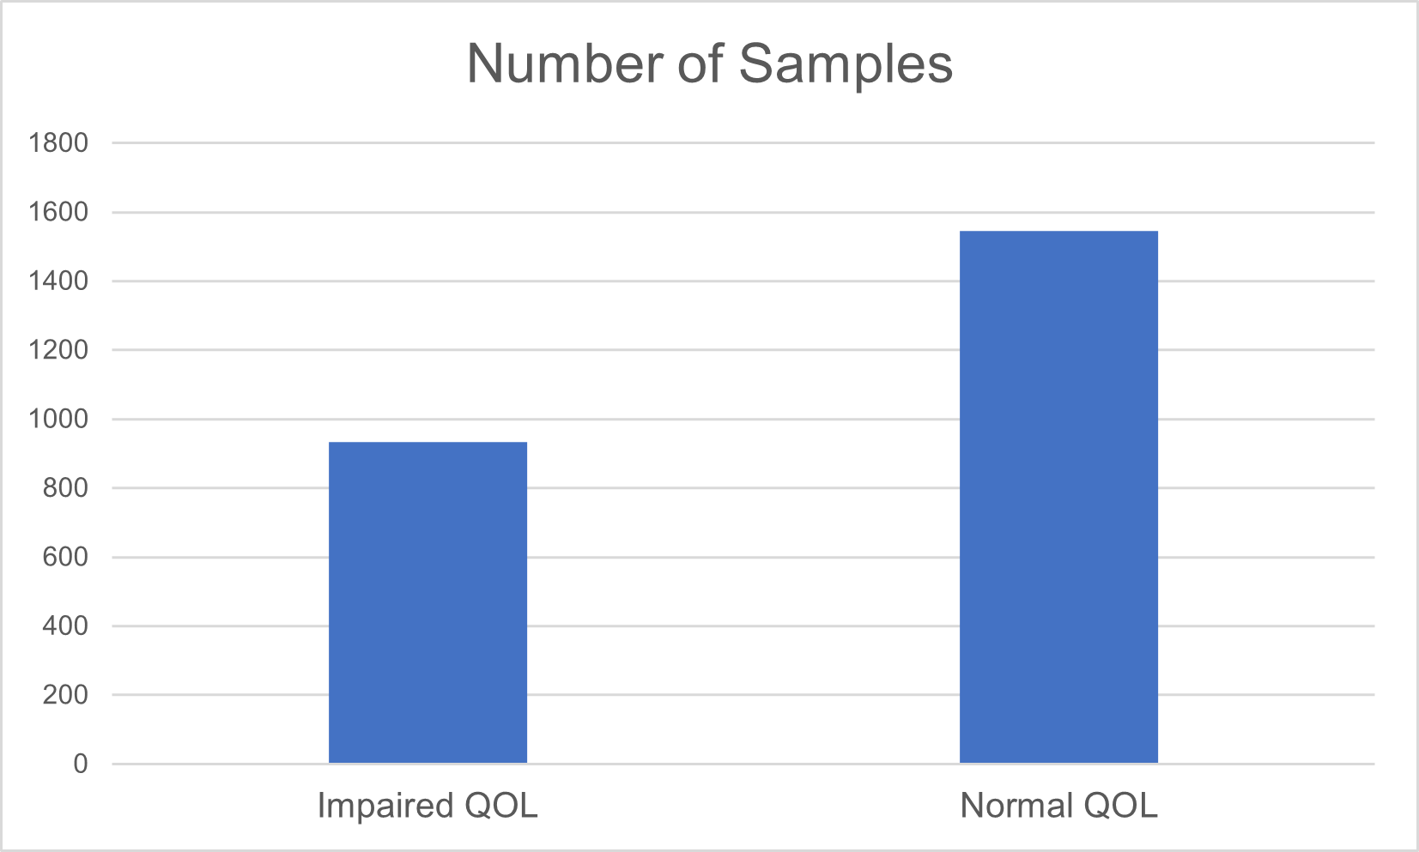
Supplementary Figure 1. The distribution of samples in both classes with impaired QOL or with normal QOL.

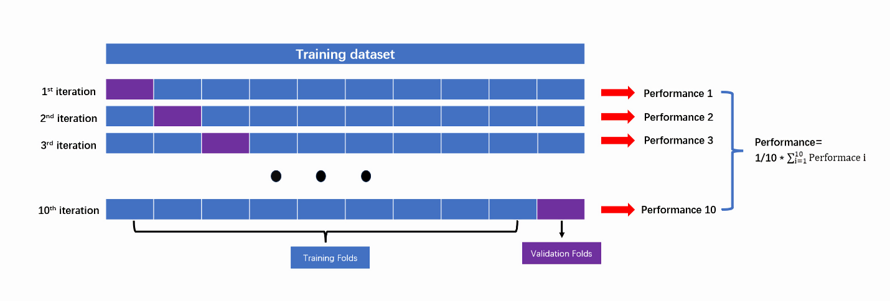
Supplementary Figure 2. 10-fold cross-validation (CV) schematic diagram for tuning hyperparameters.

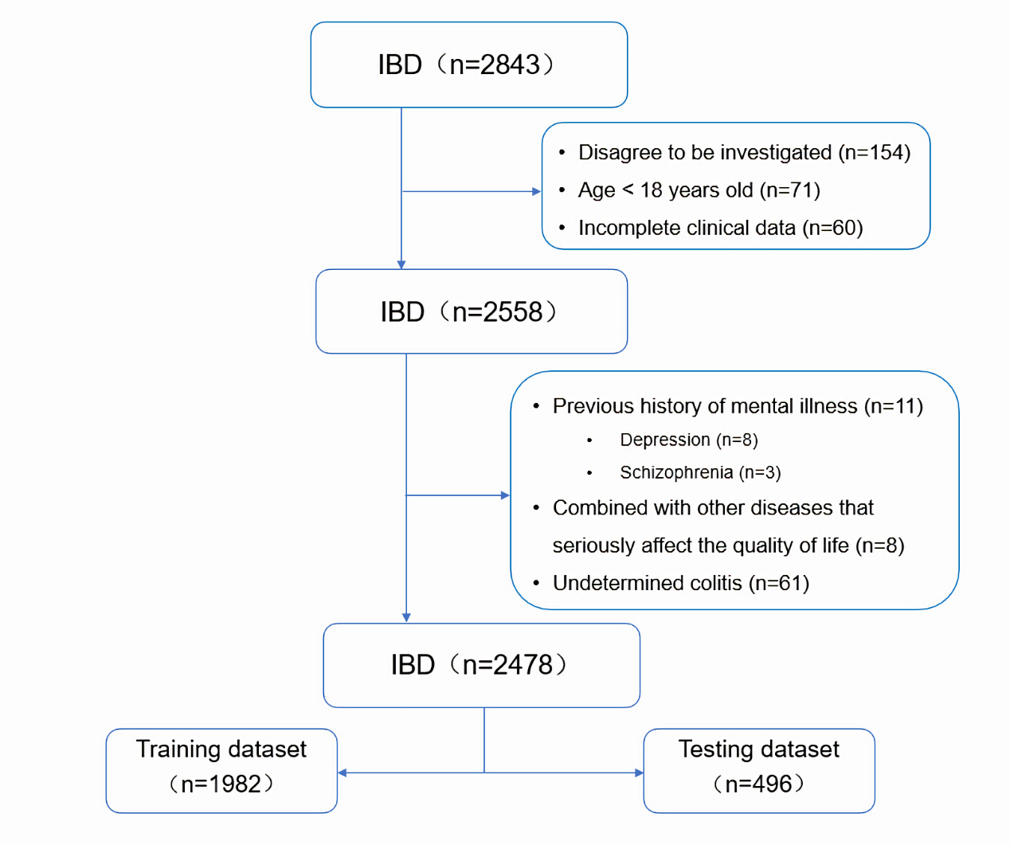
Supplementary Figure 3. The enrolment flow chart of eligible IBD patients.

