Supplementary Material
Supplemental tables

Suppl. Tab. 1: List of primers used for qPCR.

Gene |  | Sequence
Human
HO-1 | Forward | 5'-CCA GGC AGA GAA TGC TGA GTT C-3'
HO-1 | Reverse | 5'- AAG ACT GGG CTC TCC TTG TTG C-3'
B2 microglobulin (b2mg) | Forward | 5’-TGA CTT TGT CAC AGC CAA AGA TA-3'
B2 microglobulin (b2mg) | Reverse | 5’-AAT CCA AAT GCG GCA TCT TC-3'
Ferritin | Forward | 5'-TAC GAG CGT CTC CTG AAG ATG C-3'
Ferritin | Reverse | 5'-GGT TCA GCT TTT TCT CCA GGG C-3'
Nrf2 | Forward | 5'-CAC ATC CAG TCA GAA ACC AGT GG-3'
Nrf2 | Reverse | 5'-GGA ATG TCT GCG CCA AAA GCT G-3'
ASGPR1 | Forward | 5'-GAA GCA GTT CGT GTC TGA CCT G-3'
ASGPR1 | Reverse | 5'-AGC GAG AGA ACC AGT AGC AGC T-3'
ASGPR2 | Forward | 5'-AGA ACG CAC ACC TGG TGG TCA T-3'
ASGPR2 | Reverse | 5'-TTC CAA GAG CCA TCA CTG TCC G-3'
SCARF1 | Forward | 5'-AGC TAC CGT GTC CAG GAT GAA G-3'
SCARF1 | Reverse | 5'-GGC TCG ATG AAG CTG TGG TTG A-3'
TLR4 | Forward | 5’-CCC TGA GGC ATT TAG GCA GCT A-3'
TLR4 | Reverse | 5’-AGG TAG AGA GGT GGC TTA GGC T-3'
Mouse
HO-1 | Forward | 5’-AGG CTA AGA CCG CCT TCC T-3'
HO-1 | Reverse | 5’-TGT GTT CCT CTG TCA GCA TCA-3'
HO-1 | Probe | UPL #17 (Roche)
HPRT | Forward | 5’-GGT CCA TTC CTA TGA CTG TAG ATT TT-3'
HPRT | Reverse | 5’-CAA TCA AGA CGT TCT TTC CAG TT-3'
HPRT | Probe | UPL #22 (Roche)

Suppl. Tab. 2: Patient characteristics from a heavy drinking used for hepatic expression of ASGPR1 and serum levels of ASGPR1 (n=47) before and after alcohol detoxification.

Patient characteristics (N=47)
 | Normal range | Mean | SD
ASGPR1 (ng/mL, before detox) |  | 182.0 | 8.7
ASGPR1 (ng/mL, after detox) |  | 169.0 | 6.6
General information
Sex (1: male) |  | 66%
Age (years) |  | 52.7 | 13.0
BMI (kg/m2) | 18-25 | 25.5 | 5.1
Alcohol consumption (g/day) | <40 (m), <20 (f) | 187 | 124
Routine laboratory
AST (U/L) | <50 | 132 | 145
ALT (U/L) | <50 | 71 | 66
GGT (U/L) | <60 | 509 | 726
AP (U/L) | 40-130 (m), 35-105 (f) | 113 | 65
Bilirubin total (mg/dL) | <1.3 | 1.7 | 2.3
INR | 0.95-1.10 | 1.04 | 0.39
Hemoglobin (g/dL) | 13.5-17.5 (m), 12-16 (f) | 13.6 | 2.0
Hematocrit (%) | 40-53 (m), 36-48 (f) | 38.4 | 5.4
MCV (fL) | 80-96 | 95.3 | 7.1
Erythrocytes (/pL) | 4.5-5.9 (m), 4.1-5.1 (f) | 4.1 | 0.7
Leukocytes (/nL) | 3.7-10.0 (m), 3.5-10.0 (f) | 8.3 | 3.4
Platelets (/nL) | 150-360 | 184.2 | 74.0
Ferritin (ng/mL) | 30-400 (m), 13-150 (f) | 818 | 779
CRP (mg/L) | <0.5 | 12.7 | 31.5
Albumin (g/dL) | 3.8-5.9 | 4.1 | 0.7
Transferrin saturation (%) | 16-45 | 43.0 | 25.1
Serum iron (ug/dL) | 59-158 (m), 37-145 (f) | 125.2 | 68.8
Triglycerides (mg/dL) | <150 | 162.1 | 145.3
LDH (U/L) | <250 | 254 | 82
CD163 (ng/mL) | <800 | 1210 | 813
Ultrasound
Liver size (cm) | <16 | 16.4 | 4.4
Hepatic steatosis (US) (0-3) | 0 | 1.9 | 0.8
Spleen size (cm) | <11.5 | 10.1 | 1.9
Ascites (1 or 0) | 0 | 13%
Signs of cirrhosis (US) (1 or 0) | 0 | 18%
Liver stiffness (kPa) | <6 | 21.5 | 26.7
CAP (dB/m) | <240 | 300 | 48

Suppl. Tab. 3 Spearman Rho correlations with hepatic ASGPR1 mRNA levels. mRNA was measured by qPCR and obtained from liver specimen from a heavy drinking cohort (n=30 ALD).

 | ASGPR1 mRNA
Parameter | r | p
PCR
ASGPR1/b2mg | 1.000
HO1/b2mg | 0.473 | 0.0197
Nrf2/b2mg | 0.389 | 0.0604
CD163/b2mg | 0.022 | 0.9096

Numbers marked in bold represent significant correlations (p<0.05).

Suppl. Tab. 4 Spearman Rho correlations with serum levels of ASGPR1. ASGPR1 levels were measured by ELISA (see methods) in sera from a heavy drinking cohort (n=47 ALD).

Spearman Rho correlation with serum ASGPR1 levels
Parameter | r | p | n
Microgranulomas (0-1) | 0.741 | 1.6E-03 | 15
Right atrium size (cm) | 0.592 | 1.2E-02 | 17
TNF alpha (pg/mL) | 0.524 | 1.7E-03 | 33
Status Death (0-1) | 0.494 | 1.4E-03 | 39
CD163 (µg/mL) | 0.482 | 6.5E-05 | 63
Icteric serum (0-1) | 0.441 | 8.0E-03 | 35
IL-8 (pg/mL) | 0.433 | 1.3E-02 | 32
B2-Microglobulin (µg/mL) | 0.380 | 7.7E-03 | 48
ERFE (ng/mL) | 0.375 | 8.6E-03 | 48
LDH (U/L) | 0.352 | 1.1E-02 | 51
IL-6 (pg/mL) | 0.304 | 2.5E-02 | 54
Lipase (U/L) | 0.289 | 2.1E-02 | 64
Waist (cm) | 0.283 | 3.0E-02 | 59
Hip (cm) | 0.267 | 4.1E-02 | 59
Uric acid (mg/dL) | -0.492 | 4.5E-02 | 17
CK (U/L) | -0.601 | 1.1E-02 | 17
Protein total (g/dL) | 0.232 | 6.7E-02 | 63
Mallory hyaline (0-1) | 0.480 | 7.0E-02 | 15
Portal inflammation (0-1) | 0.463 | 8.2E-02 | 15

Numbers marked in bold represent significant correlations (p<0.05).

Supplemental figures

A
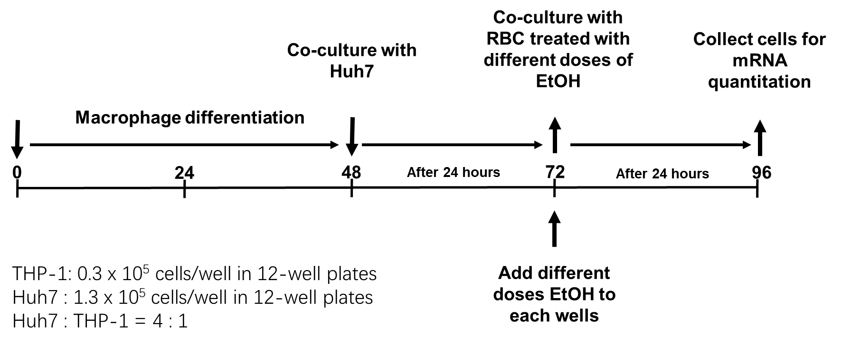

Suppl. Figure 1: Direct evidence for RBC efferocytosis by hepatocytes. A) Experimental design of co-culturing THP-1 macrophages with Huh7 hepatoma cells initially aimed at studying the modulation of erythrophagocytosis by hepatocytes. B) Life video of RBC efferocytosis (arrows) by cultured Huh7 cells.

A
B
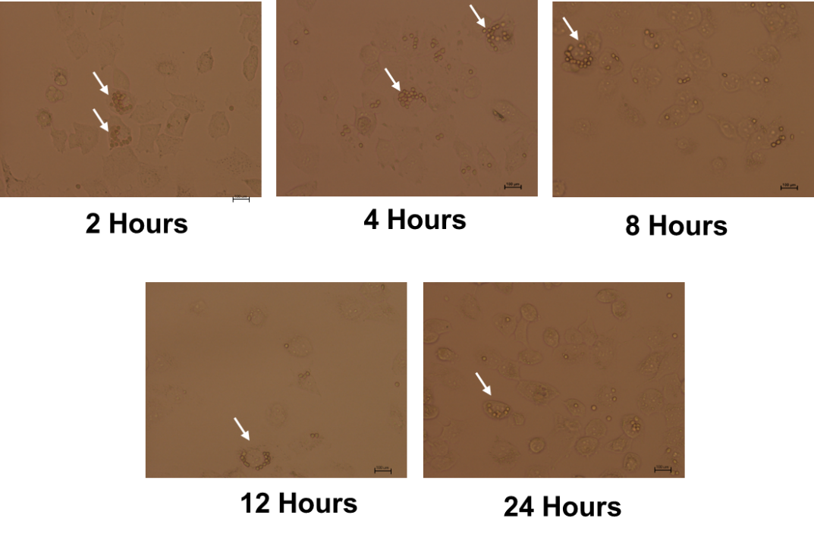
Suppl. Figure 2: Kinetics of A) HO-1 mRNA expression and B) microscopic images during RBC efferocytosis by Huh7 cells. RBC were oxidized by CuSO₄ for 2 hours and then co-cultured with hepatocytes (Huh7 cells). From 4- 24 hours, RBCs (1% hematocrit (HTC)) significantly induced HO-1 mRNA expression in hepatocytes. Also note that efferocytosis was already observed after 2 hours, confirming ingestion of RBCs within minutes (see also life video suppl. Fig. 1B). Scale bars, 100 µm. HO-1 mRNA was quantified by quantitative real-time PCR and the results are represented as mean of mRNA levels normalized to β2- microglobulin ± SD.

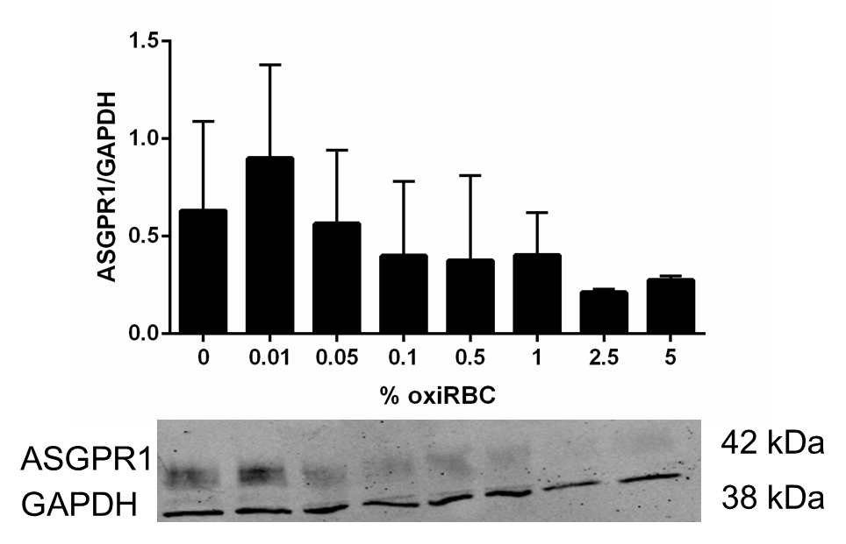
Suppl. Fig. 3: Protein expression levels of ASGRP1 in huh7 cells exposed to increasing concentrations of oxiRBCs. Note that protein expression of the scavenging receptor mirrors mRNA expression levels (see also Fig. 4C). Note that huh7 cells are known to have rather low expression levels of ASPGR1 (see also Witzigmann D et al Hepatol Res. 2016;46(7):686-696. doi:10.1111/hepr.12599). Antibodies for ASGPR1 expression were purchased from abcam (ab254261) and SantaCruz (sc-293254) and used at dilutions of 1:1000 and 1:400, respectively. A representative Western blot of three independent experiments is shown.

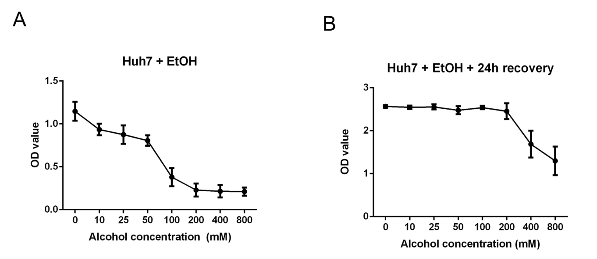
Suppl. Figure 4: Cellular toxicity of ethanol in cultured hepatocytes (Huh7 cells). A) Huh7 cells were seeded to 96-well plates and then treated with different concentrations of ethanol for 24 hours. The number of viable cells was measured by MTT test. Note that viability is significantly reduced at ethanol concentrations higher than 100mM. B) Huh7 were seeded to 96-well plates and treated with increasing concentrations of ethanol for 24 hours. After 25 hours, cultured medium was replaced and the cells were allowed to recover for another period of 24 hours. Cell viability was then measured using the MTT assay.

Suppl. Figure 5: Ethanol-mediated priming of human RBCs for both efferocytosis and erythrophagocytosis. Macrophages (THP1) and hepatocytes (Huh7 cells) were co-cultured using a physiological 1:4 ratio and exposed to human RBCs pretreated with increasing ethanol concentrations. HO-1 mRNA served as read-out for both efferocytosis and erythrophagocytosis.

Suppl. Figure 6: Ethanol-mediated inhibition of combined efferocytosis and erythrophagocytosis in cocultured macrophages and hepatocytes. Macrophages (THP1) and hepatocytes (Huh7 cells) were co-cultured using a physiological 1:4 ratio (28) and exposed to oxidized RBCs (1% hematocrit, oxidation by ascorbate/CuSO₄) in the presence of increasing ethanol concentrations for 24 hours. Note that heme degradation by combined both processes is inhibited starting from ethanol levels >400 mM. HO-1 mRNA was quantified by quantitative real-time PCR and the results are represented as mean of mRNA levels normalized to β2- microglobulin ± SD.

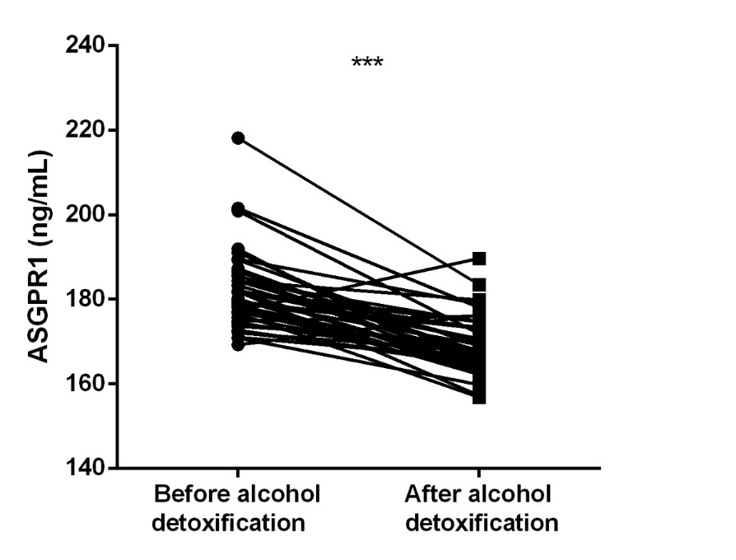

Suppl. Figure 7: ASGPR1 before and after one week of alcohol detoxification. ASGPR levels were measured by ELISA in serum of heavy drinkers (n=47). For patient characteristics, see suppl. Tab. 2. Comparison of changes in paired data was done using the paired samples t-test. Significant differences are marked by asterisks (***, p < 0.001).

