Supplementary Materials

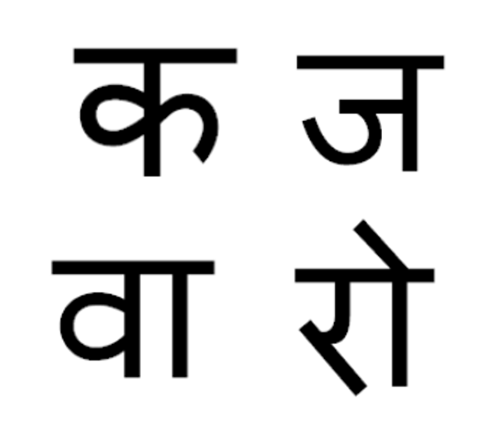
Supplementary Figure 1 Examples for Sanskrit pictographs used in Study 1.
Supplementary Table 1 The Representativeness and Word Frequency of Priming Words (Two Chinese Characters) Evaluated by 20 Psychology Students on 5-point Scales in Pilot Experiment.
Word | Representativeness for affiliation | Word  frequency | Word | Representativeness for isolation |  |  | Word  frequency
 | M(SD) | M(SD) |  |  | M(SD) | M(SD)
affiliate | 4.70(0.30) | 4.11(0.92) | independent |  | 4.15(0.38) |  | 4.15(0.83)
herding | 4.57(0.44) | 4.15(0.82) | alone |  | 4.50(0.33) | 4.75(0.28)
crowd | 4.25(0.38) | 4.78(0.54) | self |  | 4.46(0.88) | 4.95(0.27)
follow | 4.46(0.77) | 4.86(0.23) | lone |  | 4.22(0.74) | 4.50(0.48)
group | 4.25(0.51) | 4.89(0.49) | individual |  | 4.77(0.77) | 4.11(0.96)
along | 4.44(0.66) | 4.57(0.74) | single |  | 4.04(0.87) | 4.68(0.69)
conformity | 4.15(0.97) | 4.10(0.91) | isolate |  | 4.38(0.93) | 4.47(0.51)
join | 4.13(0.78) | 4.40(0.43） | personal |  | 4.15(0.90) | 4.17(0.69)
Notes: There was no significant difference between the average representativeness (M_{affiliation} (SD) = 4.26(0.19); M_{isolation} (SD) = 4.30(0.20); t (19) = -.61, p = 0.58) and the average word frequency of the two kinds of priming words (M_{affiliation} (SD) = 4.38(0.23); M_{isolation}(SD) = 4.44(0.19); t(19) = -0.95, p = 0.335).

