Supplementary Information
Supplementary Table 1 ICD-9-CM and ICD-10-CM Diagnosis Codes for Liver Disease
ICD-9-CM code | Code description
571 | Chronic liver disease and cirrhosis
571.4 | Chronic hepatitis
571.40 | Chronic hepatitis, unspecified
571.49 | Other chronic hepatitis
571.5 | Cirrhosis of liver without mention of alcohol
572.3 | Portal hypertension
572.4 | Hepatorenal syndrome
573.5 | Hepatopulmonary syndrome
572.8 | Other sequelae of chronic liver disease
571.8 | Other chronic nonalcoholic liver disease
571.9 | Unspecified chronic liver disease without mention of alcohol
573.8 | Other specified disorders of liver
573.9 | Unspecified disorder of liver
789.1 | Hepatomegaly
774.4 | Perinatal jaundice due to hepatocellular damage
782.4 | Jaundice, unspecified, not of newborn
ICD-10-CM code | Code description
K70.4 | Alcoholic hepatic failure
K70.40 | Alcoholic hepatic failure without coma
K70.41 | Alcoholic hepatic failure with coma
K71.8 | Toxic liver disease with other disorders of liver
K72 | Hepatic failure, not elsewhere classified
K72.0 | Acute and subacute hepatic failure
K72.00 | Acute and subacute hepatic failure without coma
K72.01 | Acute and subacute hepatic failure with coma
K72.1 | Chronic hepatic failure
K72.10 | Chronic hepatic failure without coma
K72.11 | Chronic hepatic failure with coma
K72.9 | Hepatic failure, unspecified
K72.90 | Hepatic failure, unspecified without coma
K72.91 | Hepatic failure, unspecified with coma
K73.8 | Other chronic hepatitis, not elsewhere classified
K73.9 | Chronic hepatitis, unspecified
K74 | Fibrosis and cirrhosis of liver
K74.0 | Hepatic fibrosis
K74.00 | Hepatic fibrosis, unspecified
K74.01 | Hepatic fibrosis, early fibrosis
K74.02 | Hepatic fibrosis, advanced fibrosis
K74.6 | Other and unspecified cirrhosis of liver
K74.60 | Unspecified cirrhosis of liver
K74.69 | Other cirrhosis of liver
K75 | Other inflammatory liver diseases
K75.8 | Other specified inflammatory liver diseases
K75.81 | Nonalcoholic steatohepatitis (NASH)
K75.89 | Other specified inflammatory liver diseases
K75.9 | Inflammatory liver disease, unspecified
K76.0 | Fatty (change of) liver, not elsewhere classified
K76.6 | Portal hypertension
K76.7 | Hepatorenal syndrome
K76.81 | Hepatopulmonary syndrome
K76.9 | Liver disease, unspecified
K77 | Liver disorders in diseases classified elsewhere
R16.0 | Hepatomegaly, not elsewhere classified
R16.2 | Hepatomegaly with splenomegaly, not elsewhere classified
P59.2 | Neonatal jaundice from other and unspecified hepatocellular damage
P59.20 | Neonatal jaundice from unspecified hepatocellular damage
P59.29 | Neonatal jaundice from other hepatocellular damage
P78.81 | Congenital cirrhosis (of liver)
R17 | Unspecified jaundice
ICD-9-CM, International Classification of Diseases, Ninth Revision, Clinical Modification; ICD-10-CM, International Classification of Disease, Tenth Revision, Clinical Modification.

Supplementary Table 2 ICD-9-CM and ICD-10-CM Diagnosis Codes for Lung Disease
ICD-9-CM code | Code description
466.0 | Acute bronchitis
490 | Bronchitis, not specified as acute or chronic
491 | Chronic bronchitis
491.0 | Simple chronic bronchitis
491.1 | Mucopurulent chronic bronchitis
491.2 | Obstructive chronic bronchitis
491.20 | Obstructive chronic bronchitis without exacerbation
491.21 | Obstructive chronic bronchitis with (acute) exacerbation
491.22 | Obstructive chronic bronchitis with acute bronchitis
491.8 | Other chronic bronchitis
491.9 | Unspecified chronic bronchitis
492 | Emphysema
492.0 | Emphysematous bleb
492.8 | Other emphysema
496 | Chronic airway obstruction, not elsewhere classified
494 | Bronchiectasis
494.0 | Bronchiectasis without acute exacerbation
494.1 | Bronchiectasis with acute exacerbation
518.82 | Other pulmonary insufficiency, not elsewhere classified
518.81 | Acute respiratory failure
518.84 | Acute and chronic respiratory failure
799.1 | Respiratory arrest
493.12 | Intrinsic asthma with (acute) exacerbation
493.22 | Chronic obstructive asthma with (acute) exacerbation
493.92 | Asthma, unspecified type, with (acute) exacerbation
ICD-10-CM code | Code description
J20.9 | Acute bronchitis, unspecified
J40 | Bronchitis, not specified as acute or chronic
J41 | Simple and mucopurulent chronic bronchitis
J41.0 | Simple chronic bronchitis
J41.1 | Mucopurulent chronic bronchitis
J41.8 | Mixed simple and mucopurulent chronic bronchitis
J42 | Unspecified chronic bronchitis
J43 | Emphysema
J43.0 | Unilateral pulmonary emphysema [MacLeod's syndrome]
J43.1 | Panlobular emphysema
J43.2 | Centrilobular emphysema
J43.8 | Other emphysema
J43.9 | Emphysema, unspecified
J44 | Other chronic obstructive pulmonary disease
J44.0 | Chronic obstructive pulmonary disease with (acute) lower respiratory  infection
J44.1 | Chronic obstructive pulmonary disease with (acute) exacerbation
J44.9 | Chronic obstructive pulmonary disease, unspecified
J47 | Bronchiectasis
J47.0 | Bronchiectasis with acute lower respiratory infection
J47.1 | Bronchiectasis with (acute) exacerbation
J47.9 | Bronchiectasis, uncomplicated
J80 | Acute respiratory distress syndrome
J96.0 | Acute respiratory failure
J96.00 | Acute respiratory failure, unspecified whether with hypoxia or hypercapnia
J96.01 | Acute respiratory failure with hypoxia
J96.02 | Acute respiratory failure with hypercapnia
J96.2 | Acute and chronic respiratory failure
J96.20 | Acute and chronic respiratory failure, unspecified whether with hypoxia or hypercapnia
J96.21 | Acute and chronic respiratory failure with hypoxia
J96.22 | Acute and chronic respiratory failure with hypercapnia
J96.9 | Respiratory failure, unspecified
J96.90 | Respiratory failure, unspecified, unspecified whether with hypoxia or  hypercapnia
J96.91 | Respiratory failure, unspecified with hypoxia
J96.92 | Respiratory failure, unspecified with hypercapnia
R06.03 | Acute respiratory distress
R09.2 | Respiratory arrest
J45.21 | Mild intermittent asthma with (acute) exacerbation
J45.901 | Unspecified asthma with (acute) exacerbation
ICD-9-CM, International Classification of Diseases, Ninth Revision, Clinical Modification; ICD-10-CM, International Classification of Disease, Tenth Revision, Clinical Modification.
Supplementary Figure 1 Examples of Follow-up Time Contributions to Different Health States During the Continuous Enrollment Period
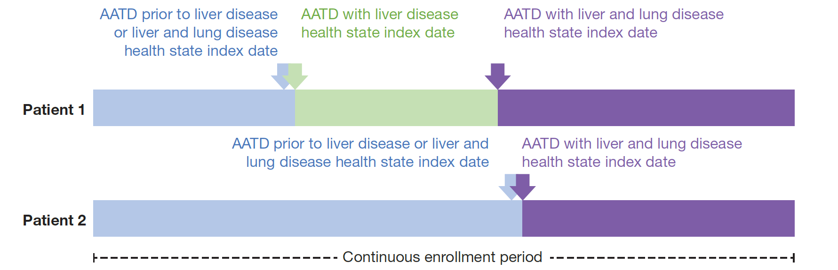
AATD, alpha-1 antitrypsin deficiency.

