Supplemental material
Table of content Page
Supplemental figure 1: Proportion of missing vital signs 2
Supplemental table 1: Overview of number of prehospital medical records 2
Supplemental table 2: Modified NEWS2 score 3
Supplemental figure 2: First primary diagnoses distribution 3
Supplemental table 3: First primary diagnoses distribution 4

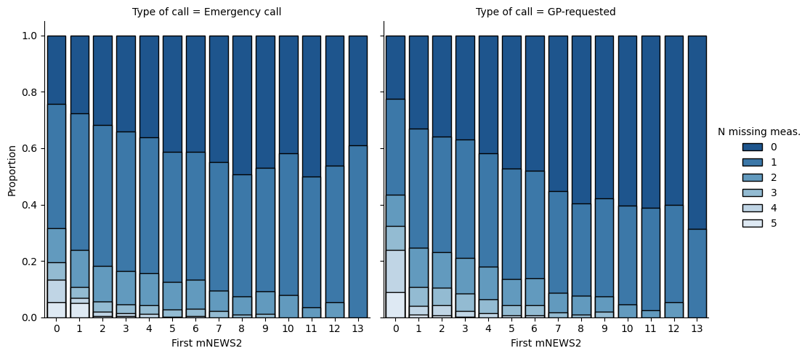
eFigure 1. Proportion of missing vital signs for each individual mNEWS2 score stratified by emergency call status (N=220,344).

Number of medical records | GP-requested only | Emergency call only | Mixed | Total
1 | 48596 | 36949 | 0 | 85545
2 | 5236 | 5009 | 10196 | 20441
3-5 | 1163 | 3071 | 16811 | 21045
6-10 | 10 | 301 | 5407 | 5718
10+ | 0 | 15 | 823 | 838
Total | 55005 | 45345 | 33237 | 133587

eTable 1: Overview of number of prehospital medical records created for each unique patient over the study period divided in solely GP-requested, solely emergency calls, and mixed GP-requested and emergency calls (patients with both ambulance runs requested by GP and following emergency call during the study period) (N=133587 unique patients).

 | GP-requested |  |  |  | Emergency call |  |  |  | All
Age group (years) | 0-16 | 17-40 | 41-65 | 66+ | 0-16 | 17-40 | 41-65 | 66+ | Total
mNEWS2 | - | 1 [0-3] | 2 [0-4] | 3 [1-5] | - | 2 [0-4]; p<0.001 | 2 [0-4]; p<0.001 | 3 [1-5]; p<0.001 | 2 [1-4]

eTable 2: Modified NEWS2 score (without temperature) calculated using first measured values for heart rate, systolic blood pressure, SpO2, Glasgow coma scale and respiratory rate. Stratified by age group and emergency call status (N=220,344).

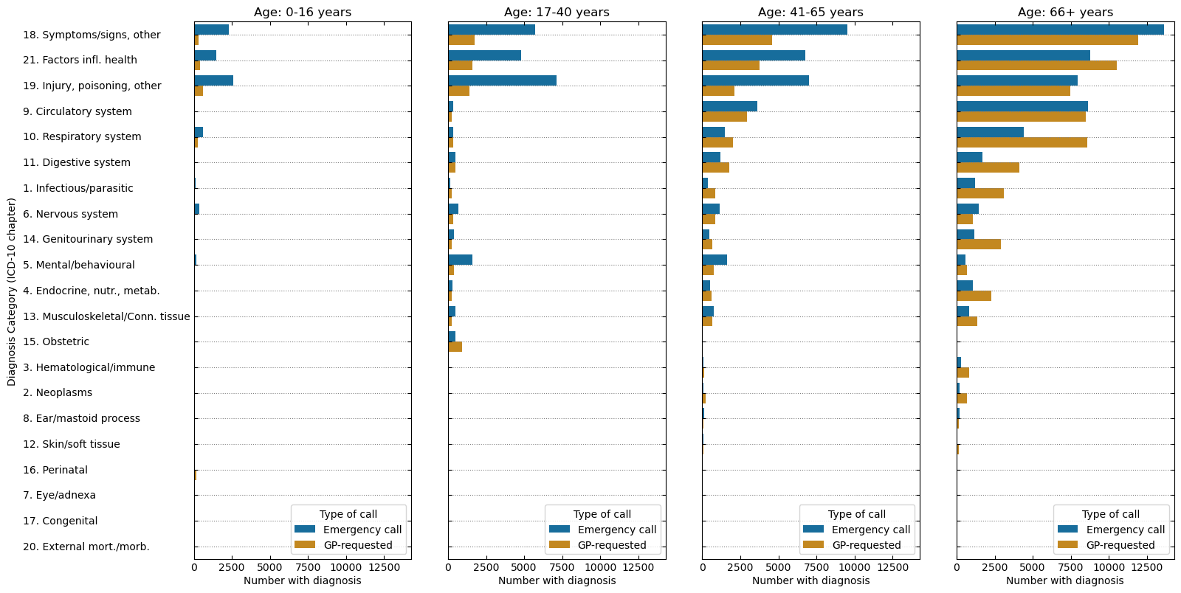

eFigure 2. First primary diagnosis distribution (absolute numbers) within each emergency call status groups, according to the International Classification of Diseases 10th Edition (ICD-10) and stratified by age groups for ambulance patients brought to hospital (N=97,112 GP-requested, N=118,102 Emergency call).

 |  | GP-requested |  |  |  |  | Emergency call
 |  | 0-16 years | 17-40 years | 41-65 years | 66+ years | All | 0-16 years | 17-40 years | 41-65 years | 66+ years | All
Chapter Description
1 | Infectious/parasitic | 92 (4.1) | 228 (2.7) | 863 (3.9) | 3102 (4.8) | 4285 (4.4) | 140 (1.8) | 169 (0.7) | 352 (1.0) | 1225 (2.3) | 1886 (1.6)
4 | Endocrine, nutrit., metabol. | 36 (1.6) | 246 (2.9) | 587 (2.7) | 2275 (3.5) | 3144 (3.2) | 67 (0.8) | 285 (1.2) | 487 (1.4) | 1085 (2.1) | 1924 (1.6)
5 | Mental/behavioural | 34 (1.5) | 377 (4.4) | 730 (3.3) | 680 (1.1) | 1821 (1.9) | 185 (2.3) | 1582 (6.9) | 1649 (4.7) | 594 (1.1) | 4010 (3.4)
6 | Nervous system | 67 (3.0) | 355 (4.1) | 844 (3.8) | 1086 (1.7) | 2352 (2.4) | 339 (4.3) | 674 (2.9) | 1128 (3.2) | 1469 (2.8) | 3610 (3.1)
9 | Circulatory system | 22 (1.0) | 239 (2.8) | 2947 (13.4) | 8487 (13.2) | 11695 (12.0) | 29 (0.4) | 336 (1.5) | 3632 (10.4) | 8643 (16.5) | 12640 (10.7)
10 | Respiratory system | 283 (12.8) | 344 (4.0) | 2018 (9.2) | 8574 (13.3) | 11219 (11.6) | 600 (7.5) | 357 (1.5) | 1498 (4.3) | 4403 (8.4) | 6858 (5.8)
11 | Digestive system | 70 (3.2) | 478 (5.6) | 1763 (8.0) | 4108 (6.4) | 6419 (6.6) | 59 (0.7) | 494 (2.1) | 1201 (3.4) | 1713 (3.3) | 3467 (2.9)
12 | Skin/soft tissue | 11 (0.5) | 38 (0.4) | 76 (0.3) | 157 (0.2) | 282 (0.3) | 31 (0.4) | 59 (0.3) | 67 (0.2) | 53 (0.1) | 210 (0.2)
13 | Musculoskeletal/Conn. tissue | 26 (1.2) | 229 (2.7) | 637 (2.9) | 1355 (2.1) | 2247 (2.3) | 41 (0.5) | 477 (2.1) | 753 (2.2) | 844 (1.6) | 2115 (1.8)
14 | Genitourinary system | 25 (1.1) | 260 (3.0) | 658 (3.0) | 2931 (4.6) | 3874 (4.0) | 30 (0.4) | 401 (1.7) | 458 (1.3) | 1145 (2.2) | 2034 (1.7)
18 | Symptoms/signs, other | 318 (14.3) | 1767 (20.6) | 4563 (20.7) | 11903 (18.5) | 18551 (19.1) | 2286 (28.7) | 5703 (24.8) | 9505 (27.3) | 13606 (26.1) | 31100 (26.3)
19 | Injury, poisoning, other | 606 (27.3) | 1385 (16.2) | 2096 (9.5) | 7463 (11.6) | 11550 (11.9) | 2583 (32.4) | 7119 (30.9) | 7002 (20.1) | 7973 (15.3) | 24677 (20.9)
21 | Factors infl. health | 409 (18.4) | 1592 (18.6) | 3735 (17.0) | 10518 (16.4) | 16254 (16.7) | 1477 (18.5) | 4809 (20.9) | 6774 (19.4) | 8781 (16.8) | 21841 (18.5)
 | Remaining chapters* (2,3,7,8,15,16,17,20) | 220 (9.9) | 1033 (12.1) | 487 (2.2) | 1679 (2.6) | 3419 (3.5) | 101 (1.3) | 576 (2.5) | 363 (1.1) | 690 (1.3) | 1730 (1.5)

eTable 3: First primary diagnoses distribution of all ambulance patients, according to the International Classification of Diseases 10th Edition (ICD-10), stratified by age and emergency call status (N=215,214).
*Chapters 2,3,7,8,15,16,17,20 collapsed into the category ‘remaining chapters’ to prevent reporting of microdata (<5 observation

