Supplementary Materials

Supplementary Figure S1. Observed concentrations versus population and individual predictions for the published 5 population pharmacokinetic models of amisulpride. A-E: representing M1-5. Closed circles represent observed blood concentrations. The identity line is shown in black and a trend line (red) has been drawn for each model. (i) individual predictions versus observed concentrations; (ii) population predictions versus observed concentrations.

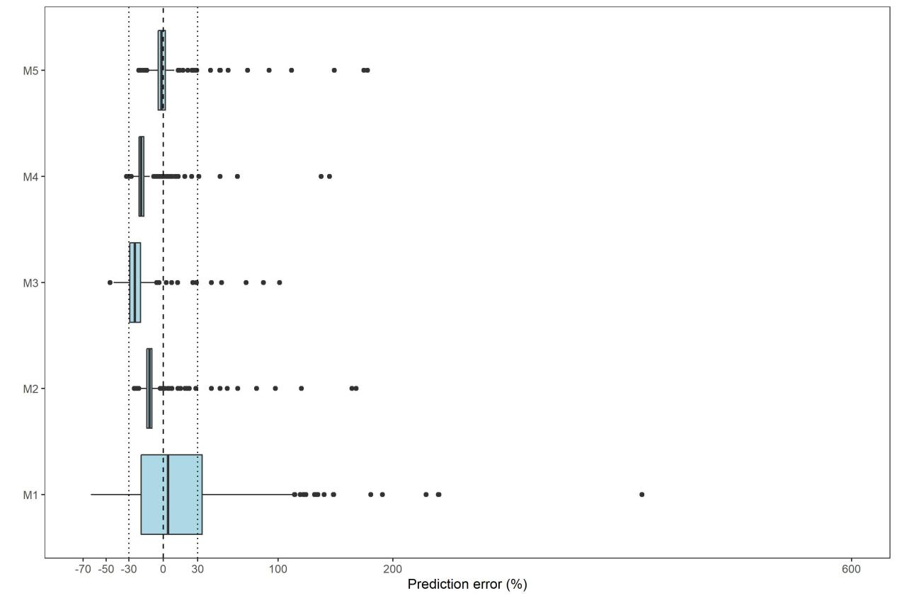

Supplementary Figure S2. Evaluate the individual prediction error (PE) distribution of the published 5(M1-M5) amisulpride population pharmacokinetic models using an independent dataset. In a boxplot, the upper edge of the box represents the 75th percentile, the line inside the box represents the median and the lower edge of the box represents the 25th percentile. The lines above and below the box respectively represent 1.5 times the interquartile range below the 25th percentile and above the 75th percentile. The points above and below the vertical line are defined as outliers. The solid black line inside the box represents a PE (Prediction Error) value of zero (no bias), while the black dashed line represents a PE within ±30% (acceptable bias).

Supplementary Figure S3. Normalized prediction distribution error (NPDE) plots of the published 5 amisulpride population pharmacokinetic models. A-E: representing M1-5. In plots (iii) and (iv), the prediction interval is plotted as a colored area (blue for the 5th and 95th prediction intervals and pink for the median), the red field represents the range of differences between the 95% confidence interval for the 5th, 50th, and 95th percentiles of the predicted value and the observed value's 5th, 50th, and 95th percentiles. Observations plotted as dots and the corresponding 5th, 50th and 95th of observation percentiles as solid lines. (i) Histogram of the NPDE. Theoretical distribution represented as shaded bars. (ii) quantile-quantile plot of the distribution of the NPDE against theoretical distribution; (iii) NPDE versus time after dose; (iv) NPDE vs. predicted concentrations (DV). npd: the normalized prediction distribution error.

Supplementary Figure S4. The prediction-corrected visual predictive checks (pcVPC) of the published 5 amisulpride population pharmacokinetic models. A-E: representing M1-5. Dots are the actual observations. The solid black line represents the 50th percentile in observed concentrations, the black dashed line represents the 50th percentile in observed concentrations, and the black segmented line represents the 95th percentile in observed concentrations. The solid blue line represents the 50th percentile in predicted concentrations, while the solid red lines correspond to the 5th and 95th percentiles in predicted concentrations.

Supplementary Figure S5. Remedial Strategies for a 30-Year-Old, 70 kg Adult on a 400 mg q24h Regimen. A: 6h delay with different remedial strategies(i Adherence to Schedule; ii Missed Single Dose; iii- viii Use Strategies A-F for Catch-up); B: 12h delay with different remedial strategies(i Adherence to Schedule; ii Missed Single Dose; iii- viii Use Strategies A-F for Catch-up); C: 24h delay with different remedial strategies(i Adherence to Schedule; ii Missed Single Dose; iii- viii Use Strategies A-F for Catch-up); D: 48h delay with different remedial strategies (i Adherence to Schedule; ii Missed Two Doses; iii- viii Use Strategies A-F for Catch-up) The deep pink and blue shading represents the distribution of the 5th to 95th percentile of simulated concentrations in 90% of the virtual subjects. The red and blue solid line indicates the median of the simulated concentrations. The black dashed line denotes the individual therapeutic range. The black solid line represents the deviation time.

Supplementary Table S1 The changes in OFV with covariates
Model Method | NO. | Model description | Delta-OFV | Sig.
Model forward inclusion
 | 1 | Basic model (one-compartment model)
 | 2 | Add eCLCR to CL/F on model 1 | -28.54 | ＜0.01
 | 3 | Add Cr to V/F on model 2 | -9.54 | ＜0.01
 | 4 | Add TP to V/F on model 3 | -7.56 | ＜0.01
Model backward elimination
 | 5 | Remove TP from V/F on model 4 | 7.56 | ＞0.001
 | 6 | Remove CRE from V/F on model 5 | 9.54 | ＞0.001
 | 7 | Remove eCLCR from CL/F on model 6 | 28.54 | ＜0.001
Abbreviations：CL/F, apparent clearance; OFV, objective function value; eCLcr, estimated creatinine clearance; Cr, creatinine;TP, total protein; V/F, apparent volume of distribution.

Supplementary Table S2 Comparison of Parameter Fitting Results
 | model1 |  | model2
 | estimates | RSE(%) | estimates | RSE(%)
OFV | 4384.108 |  | 4384.108
CL/F (1/h) | 45.1 | 3.6 | 45.1 | 3.5
V/F (L) | 466 | 19.4 | 466 | 19.2
ka(1/h) | 0.18 |  | 0.18
Covariate on CL/F | 0.364 | 19 | 0.364 | 18.9
Proportional residual | 0.314 | 6 | 0.314 | 6
interindividual variability
CL/F | 0.0429 | 31.5 | 0.0429 | 31.5

Abbreviations：Model 1: eCLcr was included as a single covariate. Model 2: Weight, age, gender, and creatinine were included as covariates.
OFV, objective function value; CL/F apparent clearance, Ka absorption rate constant, V/F apparent distribution volume

