Figure S1 In vitro cytotoxicity assay of HeyA8 cells treated with (A) OLA:RAPA=1:1, (B) OLA:RAPA=1:2, (C) OLA:RAPA=1:4, (D) OLA:RAPA=1:11, (E) OLA:RAPA=2:1, (F) OLA:RAPA=2:3, (G) OLA:RAPA=4:1, and (H) OLA:RAPA=11:1.
Abbreviations: OLA, olaparib; RAPA, rapamycin.
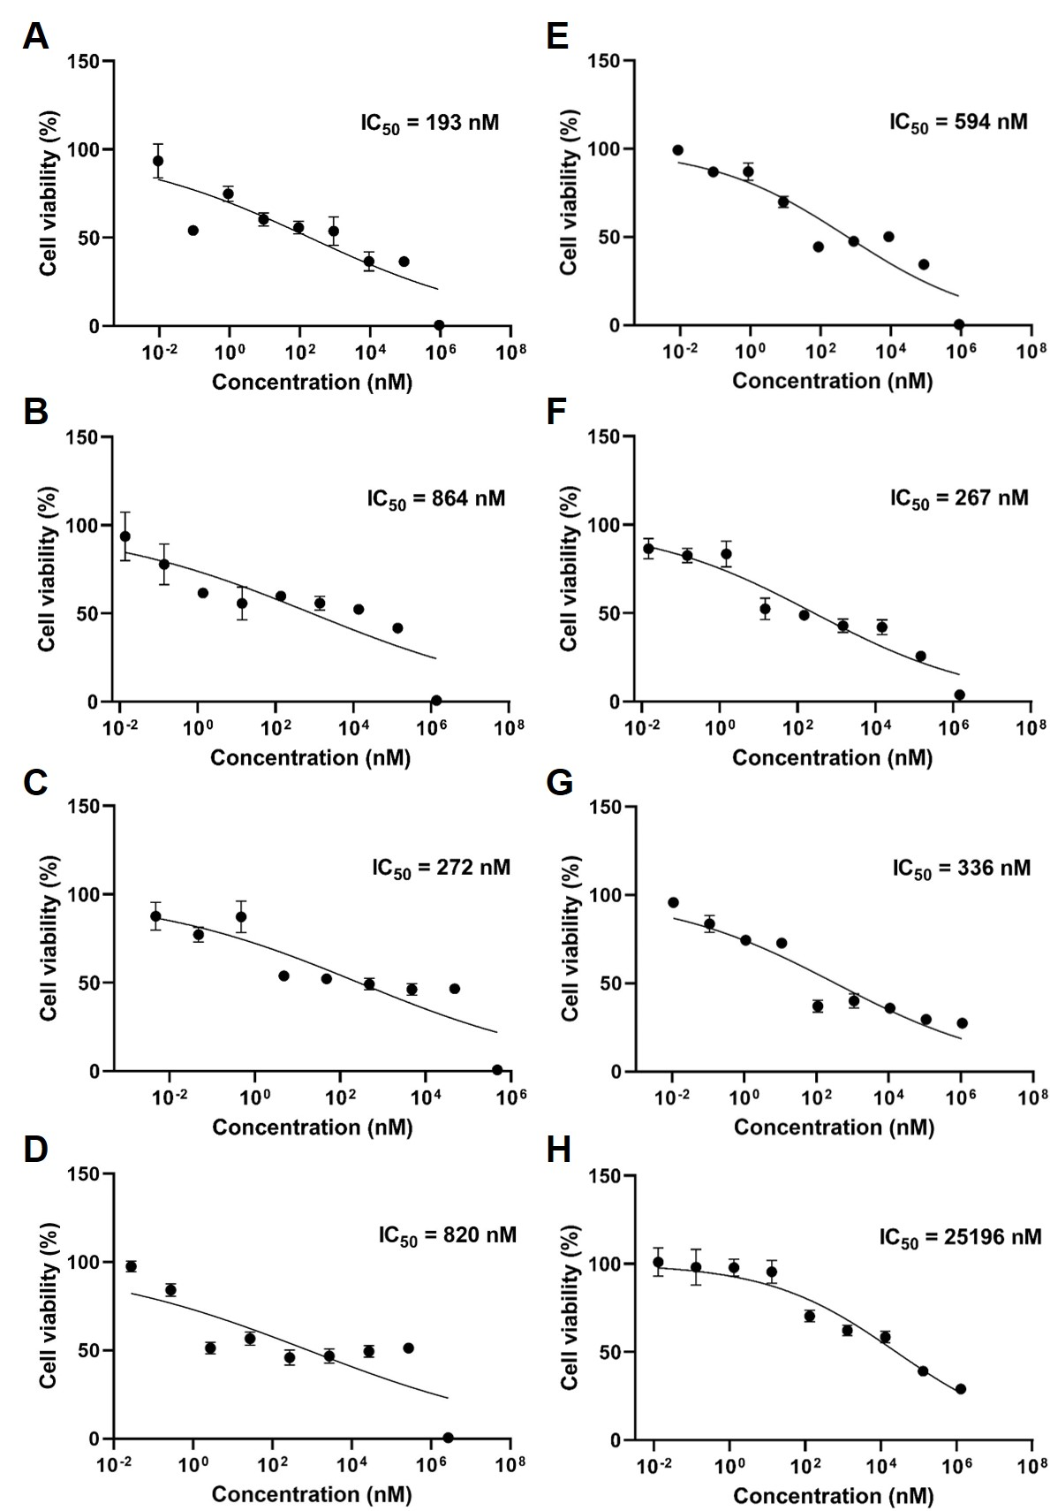

Figure S2 CI value of OLA and RAPA at various molar ratios based on OLA.
Abbreviations: CI, combination index; OLA, olaparib; RAPA, rapamycin.
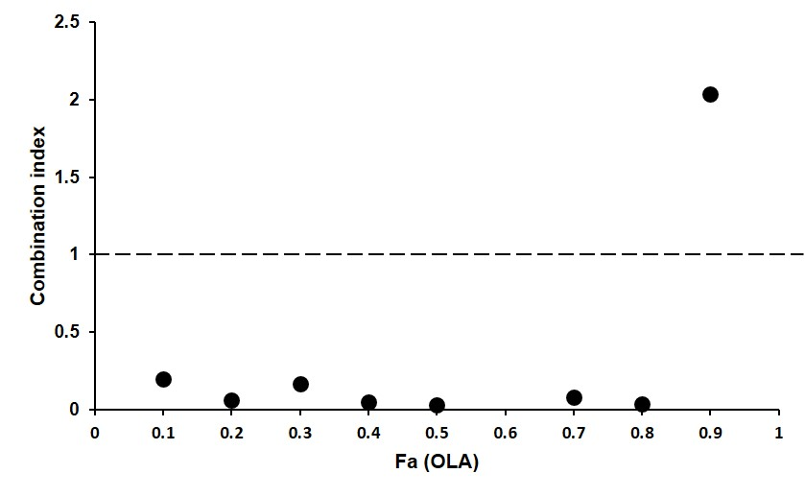

Figure S3 OLA/RAPA-TPGS and OLA/RAPA-SOL drug release profiles of OLA and RAPA in micelles. (A) OLA and RAPA release in TPGS and (B) OLA and RAPA release in SOL (n=3).
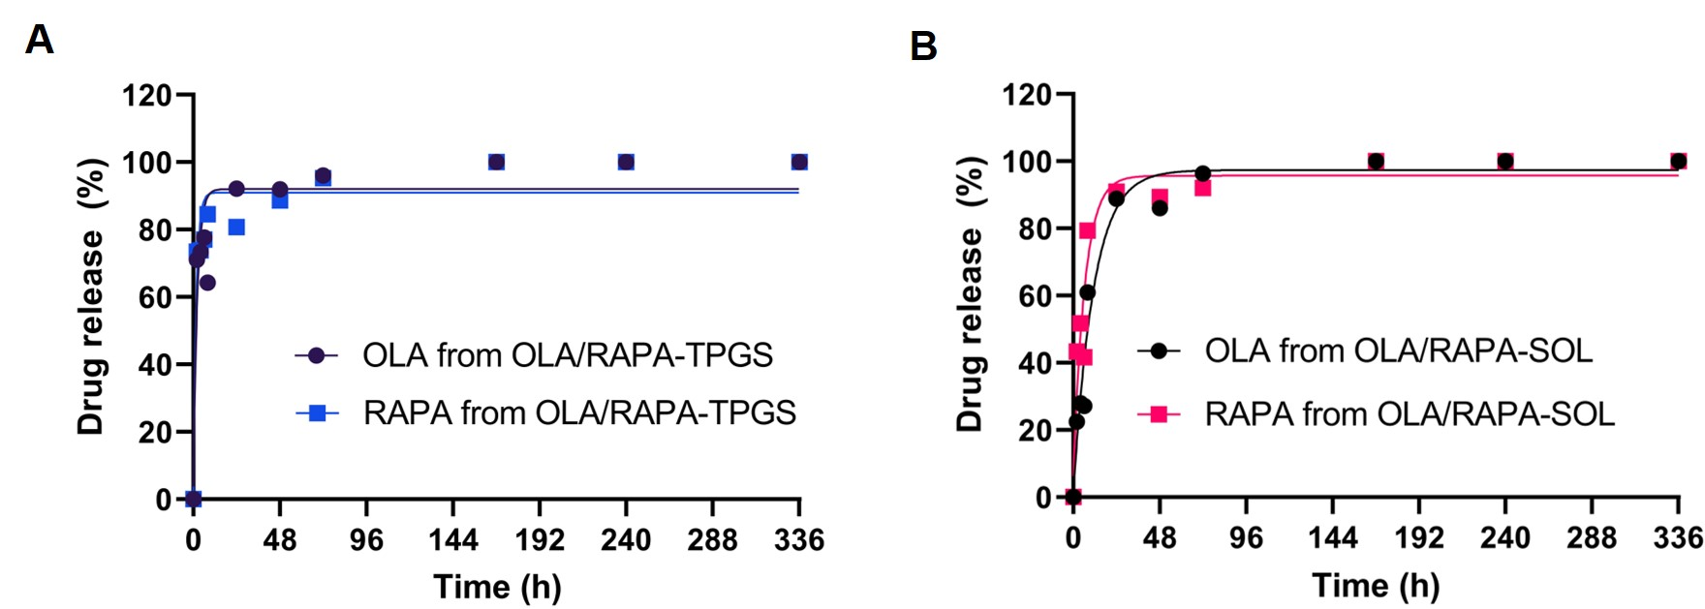
Figure S4 Representative morphology change of HeyA8 cell tumor spheroids in 2 weeks.

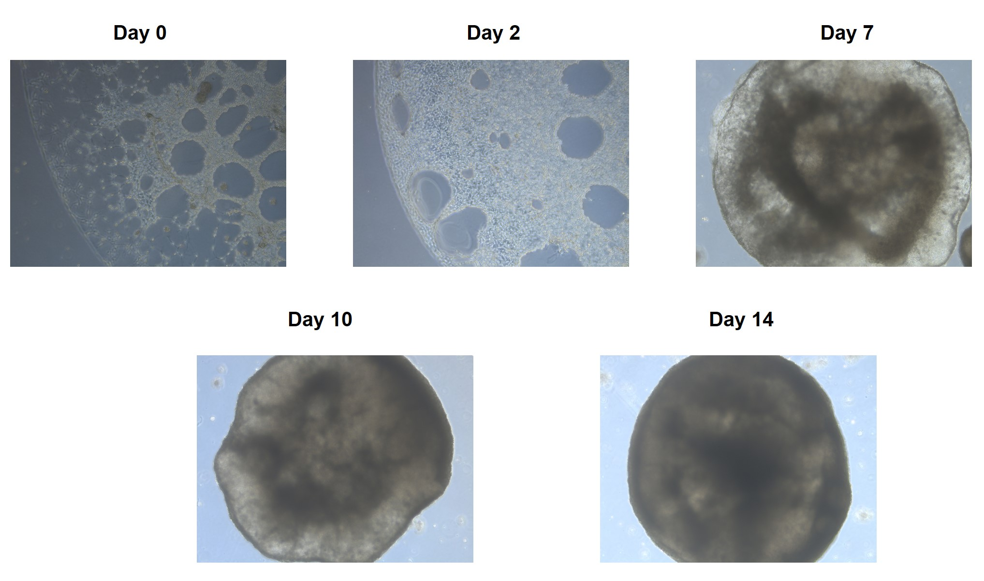

Figure S5 Image of a mouse at day 14 after evaluating anticancer efficacy in a HeyA8 cell xenograft model.
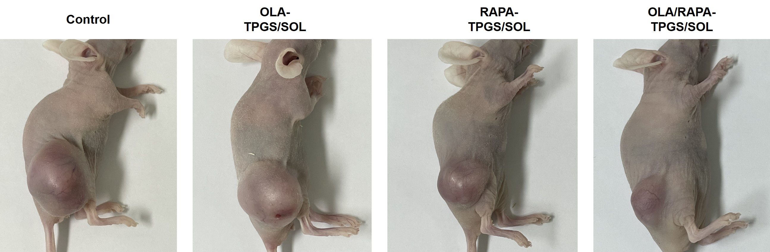

Figure S6 Anticancer efficacy in a HeyA8 cell intraperitoneal xenograft model based on (A) tumor weight and (B) body weight.
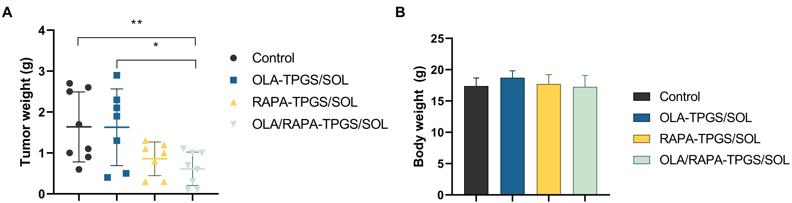
Table S1 Physicochemical properties of freeze-drying formulation after rotary evaporation
Abbreviations: OLA, olaparib; RAPA, rapamycin.
Method | Encapsulation efficiency (EE %) |  | Size (nm) | PolyDispersity Index (PDI) | Zeta Potential (mV)
Method | OLA | RAPA | Size (nm) | PolyDispersity Index (PDI) | Zeta Potential (mV)
Rotary evaporator | 66.1 ± 5.95 | 77.5 ± 5.09 | 13.4 ± 3.04 | 0.18 ± 0.06 | -5.60 ± 1.02
Freeze-drying after rotary evaporator | 75.1 ± 3.56 | 86.4 ± 9.43 | 13.1 ± 3.91 | 0.14 ± 0.03 | -2.00 ± 2.69

