Supplementary Data S1
Questionnaires for telephone based following up：
1. Hello, This is XXX (name of investigator), a researcher from the Rheumatology and Immunology Department of the Affiliated Hospital of Zunyi Medical University. Are you XXX (patient’s name)? I am calling you for following up on your physical condition. The questions may involve your privacy and may cause you discomfort. However, please answer the health questions honestly. Would you be willing to continue answering the questions?
(Continue asking questions after obtaining the verbal consent from the patient or patient’s guardian)
2. How long have you been diagnosed with RA? (Although we can obtain this information through the HIS system, the course of disease in some patients may be omitted in records, so we confirmed the course of each patient.)
3. Are you following the doctor's advice? (0-3 points) 0, never; 1, occasionally; 2, basically take medicine according to the doctor's advice; 3, completely take medicine according to the doctor's advice.
4. What is your overall satisfaction with the curative effect in the last year? (0-4 points) 0, very disappointing; 1, dissatisfied; 2, not bad; 3, satisfied; 4, very satisfied.
5. How much do you think the disease is improved or effectively controlled? (Estimated by percentage.)
6. Have there been any gastrointestinal adverse reaction during the treatment, such as, acid reflux, stomachache, dyspepsia, melena, abdominal pain, , diarrhea, constipation, ulcers proved by gastroscopy, ulcerative lesions indicated by colonoscopy, polyps lesions indicated by colonoscopy)?
7. Has there been any pulmonary infection in the last year? and how many times? (Diagnosis must be confirmed by a community center hospital or above.)
8. Has there been any other infections that occurred in the last year, such as, tympanitis, nasosinusitis, upper respiratory tract infections, shingles, urinary tract infections (frequent micturition, urgent micturition, odynuria), skin infections?

Supplementary Data S2
Supplementary table 1 Stratification analysis of IgM-RF titer in the two groups
IgM-RF titer (IU/mL) | (0, 20) | [20, 100) | [100, 300) | [300, 900) | ≥900
Reference group (n=323) | 4 | 114 | 97 | 75 | 33
Study group (n=397) | 8 | 131 | 94 | 114 | 50

Supplementary figure 1 Cases distribution by stratification analysis of IgM-RF titer.

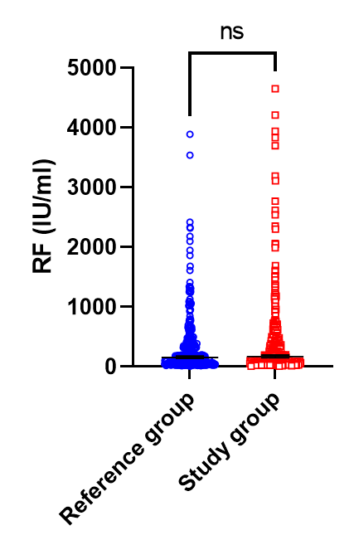
Supplementary figure 2 No significant differences of IgM-RF titer between the Reference and the Study groups by adjusted cases. ns, no significance.

