Supplementary material 1
Figure S1
In healthy controls (HC), nonclassical monocytes (NCM) expressed the highest median fluorescence intensity (MFI) level of L-Selectin and followed by classical monocytes (CM) and intermediate monocytes (IM). That may be due to the late appearance of NCM in peripheral blood and its longer life span. When in KD patients, there was an increased tendency of L-Selectin expression in CM and IM. And the L-Selectin MFI of NCM decreased in KD patients. We hypothesized that L-Selectin expression increased sharply at the gene level and slightly delayed at the protein level.
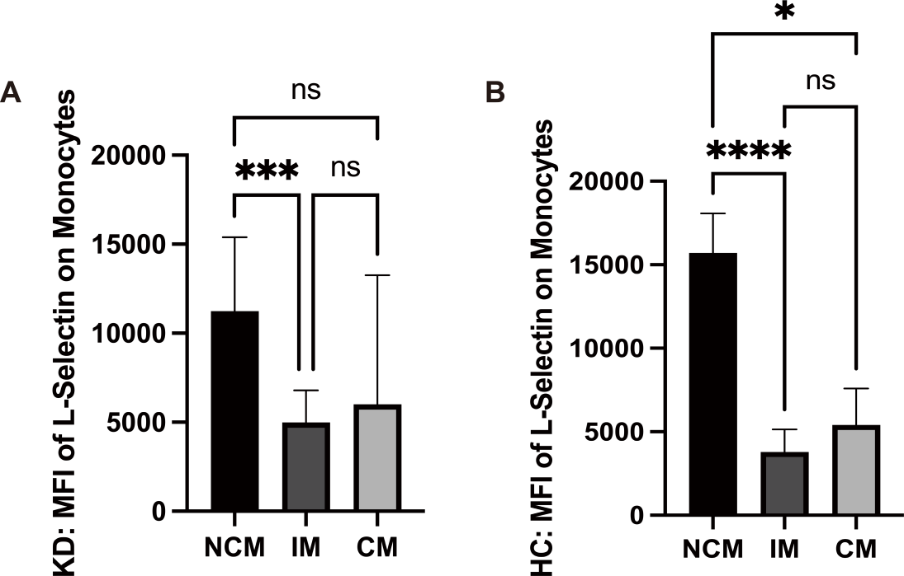

Supplementary Figure 1: The MFI of L-selectin on monocytes. (A) The MFI of surface L-Selectin on monocyte subsets in KD patients (p value: NCM vs CM=0.0666, NCM vs IM=0.0004, CM vs IM=0.3584). (B) The MFI of surface L-Selectin on monocyte subsets in Healthy controls (p value: NCM vs CM=0.0156, NCM vs IM<0.0001, CM vs IM=0.0618). Statistics were performed by Kruskal-Wallis test and data was expressed as medium with Interquartile range (IQR). ns: p>0.05. *: p<0.05. ***: p<0.001. ****: p<0.0001.

