Supplementary Table 1. Characteristics of genetic variants associated with daytime napping used in the Mendelian randomization analysis.
SNP | Chr | Position | Effect allele | Other allele | EAF | β estimate* | SE | P-value | F
rs2786547 | 1 | 33342304 | T | C | 0.18 | -0.011 | 0.002 | 1.00E-11 | 46.0
rs6665690 | 1 | 162836235 | C | A | 0.17 | -0.009 | 0.002 | 6.00E-09 | 32.7
rs12140153 | 1 | 62579891 | T | G | 0.10 | -0.025 | 0.002 | 2.40E-31 | 136.5
rs35039375 | 1 | 171516863 | G | A | 0.09 | 0.014 | 0.002 | 8.70E-11 | 41.8
rs301817 | 1 | 8503379 | A | C | 0.59 | 0.007 | 0.001 | 1.60E-09 | 35.3
rs11383197 | 1 | 34998659 | AG | A | 0.68 | 0.007 | 0.001 | 2.70E-08 | 30.9
rs35549521 | 1 | 46028185 | CT | C | 0.43 | -0.007 | 0.001 | 1.50E-08 | 33.3
rs1931175 | 1 | 96928273 | G | C | 0.38 | 0.008 | 0.001 | 4.60E-10 | 38.7
rs12042846 | 1 | 98667103 | C | T | 0.18 | 0.009 | 0.002 | 1.90E-08 | 32.1
rs200435329 | 1 | 174316633 | T | G | 0.24 | 0.010 | 0.001 | 9.90E-12 | 47.0
rs2250377 | 1 | 201860626 | G | A | 0.66 | -0.013 | 0.001 | 1.40E-24 | 105.7
rs13033444 | 2 | 23611438 | G | A | 0.28 | 0.010 | 0.001 | 3.60E-13 | 52.1
rs75022160 | 2 | 25311861 | T | C | 0.14 | -0.010 | 0.002 | 1.70E-08 | 31.2
rs9287862 | 2 | 151500518 | T | C | 0.91 | -0.012 | 0.002 | 2.00E-08 | 32.4
rs2202323 | 2 | 49408317 | C | G | 0.63 | -0.008 | 0.001 | 1.20E-09 | 36.4
rs7423968 | 2 | 59467016 | G | A | 0.43 | -0.008 | 0.001 | 4.80E-10 | 38.8
rs80163246 | 2 | 164574344 | C | T | 0.12 | 0.012 | 0.002 | 1.40E-10 | 40.0
rs7422655 | 2 | 208941004 | T | C | 0.74 | -0.008 | 0.001 | 1.10E-08 | 32.3
rs908442 | 2 | 236800163 | T | A | 0.41 | -0.010 | 0.001 | 1.40E-16 | 69.2
rs9309116 | 2 | 44557919 | T | C | 0.65 | 0.007 | 0.001 | 3.90E-09 | 33.6
rs62189006 | 2 | 162573586 | G | A | 0.09 | -0.012 | 0.002 | 8.30E-09 | 33.2
rs350785 | 2 | 52934600 | C | T | 0.88 | -0.013 | 0.002 | 1.50E-11 | 43.9
rs11682175 | 2 | 57987593 | C | T | 0.47 | 0.007 | 0.001 | 1.10E-08 | 32.7
rs12992648 | 2 | 206843819 | G | A | 0.28 | -0.008 | 0.001 | 2.40E-08 | 32.3
rs4511908 | 3 | 82770852 | G | T | 0.58 | 0.007 | 0.001 | 1.40E-08 | 32.0
rs1601440 | 3 | 84665393 | T | C | 0.72 | -0.009 | 0.001 | 1.90E-11 | 45.3
rs76824303 | 3 | 62459819 | C | A | 0.10 | -0.012 | 0.002 | 1.70E-08 | 32.2
rs2699869 | 3 | 133032892 | C | A | 0.55 | -0.007 | 0.001 | 3.10E-08 | 31.0
rs150538418 | 3 | 138064170 | GT | G | 0.22 | -0.009 | 0.002 | 7.20E-09 | 34.2
rs77154532 | 3 | 19377311 | G | A | 0.36 | -0.008 | 0.001 | 1.40E-09 | 36.7
rs936944 | 3 | 44385814 | A | G | 0.84 | -0.009 | 0.002 | 3.20E-08 | 30.9
rs1001817 | 3 | 183995341 | T | C | 0.49 | -0.008 | 0.001 | 1.70E-10 | 40.8
rs140008192 | 4 | 152967845 | GTA | G | 0.43 | 0.007 | 0.001 | 4.30E-08 | 29.4
rs7697461 | 4 | 79565819 | T | A | 0.74 | 0.008 | 0.001 | 6.00E-09 | 34.4
rs76536937 | 4 | 170222592 | TA | T | 0.48 | -0.008 | 0.001 | 8.00E-10 | 36.7
rs13150944 | 4 | 85408000 | G | A | 0.69 | 0.009 | 0.001 | 6.80E-11 | 42.3
rs2099810 | 5 | 112030173 | G | A | 0.50 | -0.008 | 0.001 | 2.80E-10 | 40.1
rs467897 | 5 | 102155610 | A | G | 0.68 | -0.010 | 0.001 | 2.60E-13 | 54.0
rs12657723 | 5 | 62760828 | T | C | 0.32 | 0.008 | 0.001 | 2.00E-10 | 39.7
rs13169872 | 5 | 62878799 | A | G | 0.32 | 0.007 | 0.001 | 3.00E-08 | 30.1
rs2943023 | 5 | 89597733 | T | C | 0.42 | -0.007 | 0.001 | 7.40E-09 | 33.3
rs2431108 | 5 | 103947968 | C | T | 0.33 | 0.013 | 0.001 | 7.70E-24 | 101.2
rs6452787 | 5 | 87712831 | G | A | 0.46 | -0.008 | 0.001 | 2.00E-10 | 40.3
rs10875606 | 5 | 143769614 | A | C | 0.68 | -0.007 | 0.001 | 1.30E-08 | 31.8
rs10875622 | 5 | 146693062 | A | G | 0.58 | 0.010 | 0.001 | 1.30E-17 | 72.5
rs73817091 | 5 | 159042652 | T | C | 0.04 | 0.017 | 0.003 | 3.80E-08 | 29.9
rs140506252 | 6 | 155129280 | T | A | 0.02 | -0.023 | 0.004 | 4.30E-08 | 30.9
rs3799380 | 6 | 26467182 | C | T | 0.20 | -0.009 | 0.002 | 1.30E-08 | 34.6
rs61332968 | 6 | 38467487 | GA | G | 0.29 | 0.008 | 0.001 | 4.20E-09 | 34.0
rs2653349 | 6 | 55142337 | G | A | 0.79 | -0.017 | 0.001 | 3.40E-29 | 126.0
rs1546977 | 6 | 84314423 | G | A | 0.44 | 0.008 | 0.001 | 1.00E-11 | 45.8
rs9389556 | 6 | 100079774 | G | C | 0.26 | 0.008 | 0.001 | 9.70E-10 | 37.0
rs785145 | 6 | 114650655 | G | T | 0.43 | 0.007 | 0.001 | 1.00E-08 | 32.5
rs614987 | 6 | 124920871 | C | A | 0.61 | 0.011 | 0.001 | 7.50E-19 | 77.8
rs6919087 | 6 | 37699156 | G | T | 0.31 | -0.011 | 0.001 | 1.00E-16 | 67.6
rs2143792 | 6 | 62182204 | A | G | 0.43 | -0.007 | 0.001 | 9.10E-09 | 33.4
rs34262487 | 6 | 36224315 | A | C | 0.07 | -0.015 | 0.002 | 1.20E-09 | 38.0
rs9460110 | 6 | 170621249 | C | T | 0.37 | 0.007 | 0.001 | 8.40E-09 | 34.2
rs35851551 | 7 | 31330785 | G | A | 0.10 | -0.011 | 0.002 | 3.50E-08 | 30.5
rs10257273 | 7 | 99188589 | T | A | 0.15 | -0.011 | 0.002 | 8.90E-10 | 39.7
rs76257331 | 7 | 106916279 | A | G | 0.20 | 0.009 | 0.002 | 1.20E-08 | 32.5
rs13263535 | 8 | 1175131 | T | G | 0.47 | -0.007 | 0.001 | 1.60E-08 | 31.9
rs285815 | 8 | 106108303 | A | T | 0.54 | -0.008 | 0.001 | 5.80E-10 | 38.1
rs351776 | 8 | 28191306 | C | A | 0.55 | 0.008 | 0.001 | 8.40E-10 | 38.3
rs2059639 | 8 | 67381858 | T | C | 0.52 | -0.007 | 0.001 | 2.40E-08 | 30.1
rs7814873 | 8 | 142213997 | T | C | 0.62 | -0.007 | 0.001 | 1.50E-08 | 32.5
rs17502738 | 9 | 37441650 | C | T | 0.20 | -0.009 | 0.002 | 2.00E-08 | 32.4
rs295278 | 9 | 86420144 | A | G | 0.39 | -0.008 | 0.001 | 2.20E-10 | 40.2
rs971415 | 9 | 108846445 | G | A | 0.12 | -0.011 | 0.002 | 1.20E-09 | 35.7
rs10811438 | 9 | 20962282 | C | G | 0.39 | -0.007 | 0.001 | 3.20E-09 | 33.7
rs13284688 | 9 | 81727018 | C | T | 0.21 | 0.015 | 0.001 | 1.70E-23 | 101.1
rs12346996 | 9 | 131840856 | C | T | 0.73 | -0.008 | 0.001 | 5.00E-09 | 34.0
rs4604518 | 9 | 120555845 | A | G | 0.45 | -0.007 | 0.001 | 1.40E-08 | 32.1
rs11258652 | 10 | 13868855 | A | C | 0.24 | -0.010 | 0.001 | 3.70E-13 | 53.0
rs224111 | 10 | 64552010 | A | G | 0.39 | -0.008 | 0.001 | 1.60E-10 | 40.9
rs10840017 | 11 | 8335754 | G | A | 0.23 | -0.009 | 0.001 | 2.00E-09 | 36.4
rs271057 | 11 | 92769748 | T | C | 0.75 | -0.009 | 0.001 | 6.50E-10 | 38.1
rs11224896 | 11 | 101479583 | C | T | 0.11 | -0.011 | 0.002 | 1.10E-08 | 33.1
rs174541 | 11 | 61565908 | C | T | 0.36 | 0.010 | 0.001 | 4.40E-15 | 61.2
rs10835420 | 11 | 28866669 | A | T | 0.25 | -0.009 | 0.001 | 1.70E-10 | 40.3
rs60222088 | 12 | 108334477 | A | C | 0.15 | -0.011 | 0.002 | 6.40E-11 | 42.5
rs10772659 | 12 | 13504828 | A | T | 0.44 | 0.007 | 0.001 | 2.70E-09 | 35.5
rs35011311 | 12 | 38616581 | T | G | 0.27 | -0.009 | 0.001 | 4.40E-11 | 43.2
rs11615756 | 12 | 117942076 | T | C | 0.40 | 0.018 | 0.001 | 1.40E-49 | 217.4
rs2769916 | 13 | 107820389 | A | G | 0.69 | 0.009 | 0.001 | 1.70E-11 | 44.4
rs10149986 | 14 | 29721044 | G | T | 0.19 | 0.011 | 0.002 | 4.40E-12 | 48.8
rs2370926 | 14 | 79602542 | C | T | 0.37 | -0.008 | 0.001 | 1.70E-10 | 41.4
rs10152428 | 15 | 93510243 | C | G | 0.73 | 0.008 | 0.001 | 1.10E-08 | 32.5
rs11071755 | 15 | 63793936 | A | G | 0.43 | -0.007 | 0.001 | 5.20E-09 | 33.6
rs17158413 | 15 | 83235408 | A | G | 0.24 | 0.009 | 0.001 | 4.40E-11 | 41.9
rs9939355 | 16 | 23837048 | T | C | 0.56 | -0.007 | 0.001 | 4.50E-09 | 35.2
rs378421 | 16 | 28754684 | A | G | 0.42 | 0.007 | 0.001 | 2.40E-08 | 31.8
rs11860072 | 16 | 56193408 | T | C | 0.45 | -0.009 | 0.001 | 2.80E-13 | 52.5
rs13330072 | 16 | 69402831 | G | A | 0.29 | 0.008 | 0.001 | 4.80E-09 | 34.8
rs60920123 | 16 | 10134637 | A | G | 0.43 | -0.008 | 0.001 | 4.50E-10 | 38.7
rs3935190 | 17 | 79084367 | A | G | 0.54 | 0.008 | 0.001 | 5.40E-11 | 42.9
rs385199 | 17 | 43686419 | C | A | 0.23 | -0.021 | 0.001 | 7.50E-47 | 208.1
rs112520848 | 17 | 64308310 | C | G | 0.39 | 0.007 | 0.001 | 1.80E-08 | 31.5
rs12451365 | 17 | 35595368 | C | T | 0.20 | 0.011 | 0.002 | 1.50E-12 | 49.9
rs962247 | 18 | 23084118 | A | G | 0.48 | -0.008 | 0.001 | 5.70E-11 | 42.3
rs2033103 | 18 | 36097882 | T | C | 0.45 | 0.007 | 0.001 | 2.60E-09 | 35.4
rs9965170 | 18 | 44788274 | A | G | 0.42 | -0.014 | 0.001 | 7.80E-29 | 123.2
rs17265513 | 20 | 39832628 | C | T | 0.20 | 0.009 | 0.002 | 2.00E-09 | 36.1
rs910187 | 20 | 45841052 | A | G | 0.37 | -0.007 | 0.001 | 4.90E-09 | 33.9
rs3810484 | 20 | 62194103 | G | A | 0.44 | -0.007 | 0.001 | 2.20E-08 | 31.3
rs1883048 | 21 | 47397586 | C | T | 0.52 | 0.008 | 0.001 | 1.80E-10 | 41.4
rs2284015 | 22 | 37096573 | G | C | 0.26 | 0.008 | 0.001 | 4.10E-08 | 30.9
* The β estimates are defined for each additional effect allele. Positive β indicates more frequent daytime napping.
Abbreviations: Chr, chromosome; EAF, effect allele frequency; SNP, single nucleotide polymorphism; SE, standard error.

Supplementary Table 2. Characteristics of the studies included in the meta-analysis of daytime napping and NAFLD incidence events.
Author | Year | Country | Study design | Sample size | Age(years): mean ± SD /mean(range) | Male | Exposure groups (napping duration) | N | NAFLD Cases | OR (95%CI) | Diagnostic method
Peng, K. et al.¹ | 2016 | China | Observational | 8559 | 58.5±9.0 | 36.3% | 0  <=0.5h  >0.5h | 5883  759  1917 | 1748  230  622 | 1(ref)  1.03(0.88,1.22)  1.14(1.02,1.28) | ultrasonography
Hong, C. et al.² | 2022 | China | Observational | 3363 | NA | 63.6% | 0  <0.5h  0.5-1h  >1h | 400  357  1732  874 | 9  11  79  41 | 1(ref)  1.38 (0.57-3.37)  2.07(1.07-2.90)  2.14(1.05-3.12) | ultrasonography
Zarean, E. et al.³ | 2023 | Iran | Observational | 9151 | 49.1±9.2 | 46.4% | 0  >0 | 4149  5002 | 524  796 | 1(ref)  1.29(1.17,1.44) | ultrasonography
Yang, J. et al.⁴ | 2022 | China | Observational | 5011 | 63.6±10.8 | 40.1% | <=0.5h  >0.5h | 2973  2038 | 793  630 | 1(ref)  1.17(1.03,1.33) | ultrasonography
Zhao, X. et al.⁵ | 2020 | China | Observational | 3236 | 52.5±13.2 | 37.5% | 0  <0.5h  0.5-1h  >1h | 1272  882  778  304 | 500  300  306  127 | 1(ref)  0.78(0.65,0.93)  0.96(0.80,1.16)  1.08(0.84,1.40) | ultrasonography
Qu, H. et al.⁶-1 | 2014 | China | Observational | 6438 | 61(51,67) | 32.2% | 0  <0.5h  0.5-1h  >1h | 4949  464  576  449 | 431  45  64  75 | 1(ref)  1.17(0.76,1.78)  1.51(1.03,2.20)  1.96(1.36,2.82) | ultrasonography
Qu, H. et al.⁶-2 | 2014 | China | Observational | 170 | 60.3±7.0 | 38.8% | 0  <0.5h  0.5-1h  >1h | 80  17  42  31 | 9  5  14  15 | 1(ref)  2.32(0.55,9.85)  4.39(1.51,12.76)  8.06(2.63,24.72) | ultrasonography

Supplementary Figure 1. Flowchart of the study selection process. PRISMA figure adapted from Page MJ, McKenzie JE, Bossuyt PM, et al.⁷
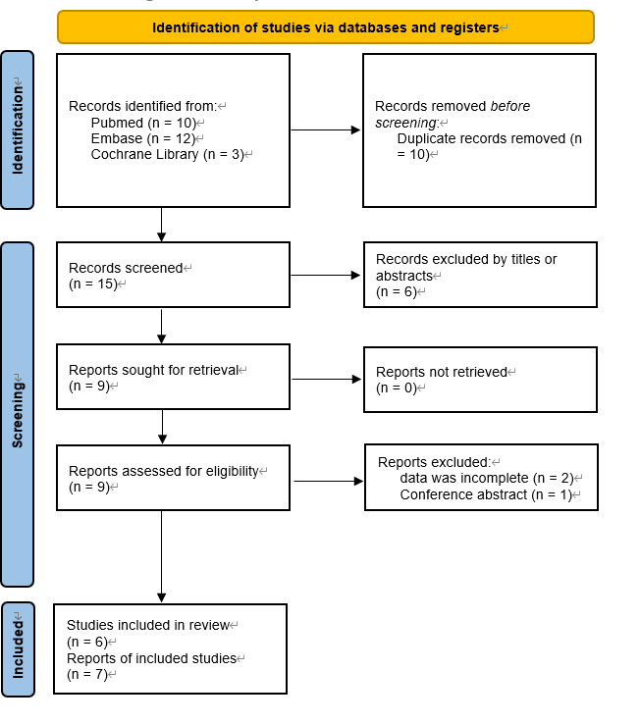

Supplementary Figure 2. Funnel plot of studies of napping and NAFLD.
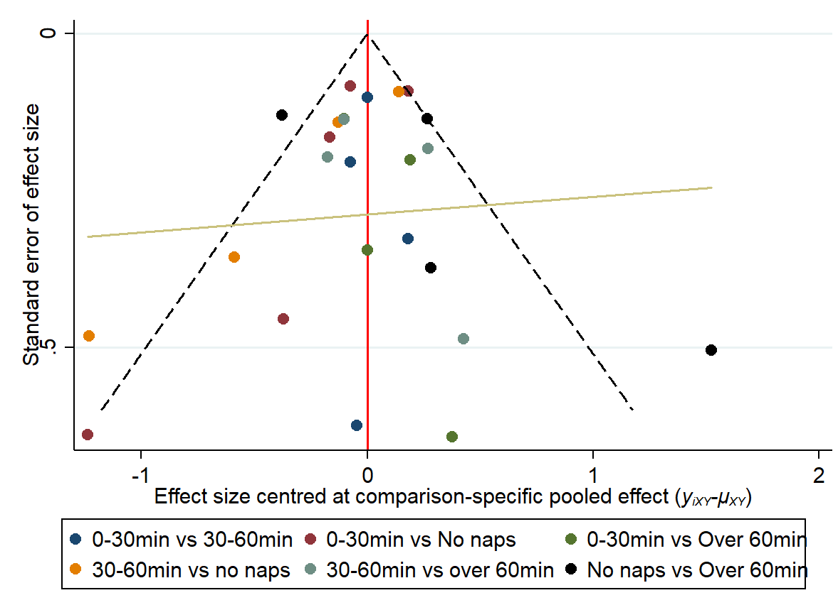
Supplementary Table 3. Risk of bias assessment using the Newcastle-Ottawa SCALE.
 | Study | Hong, C. et al.² | Peng, K. et al.¹ | Qu, H. et al.⁶ | Yang, J. et al.⁴ | Zarean, E. et al.³ | Zhao, X. et al.⁵
Selection | Representativeness of the exposed cohort
Selection | Selection of the non-exposed cohort
Selection | Ascertainment of exposure
Selection | Demonstration that outcome of interest was not present at start of study
Comparability | Comparability of cohorts on the basis of the design or analysis
Outcome | Assessment of outcome
Outcome | Was follow-up long enough for outcomes to occur
Outcome | Adequacy of follow up of cohorts
Quality score |  | 6 | 7 | 8 | 8 | 8 | 8
The star symbol represents an additional point. Except for comparability, which can be rated up to 2 stars, all other entries can be rated up to 1 star. The full score is 9 stars, and a higher score indicates higher research quality.

Supplementary Table 4. Cochran’s Q test, inverse variance weighted and sensitivity analyses of daytime napping and the risks of NAFLD.
Disease | Cochran's Q test | Inverse variance weighted |  |  |  | Sensitivity analysis
Disease | P-value | SNPs, n | β | SE | P-value | SE | P-value
NAFLD | 0.225 | 105 | 0.817 | 0.255 | 0.001 | 0.008 | 0.589
The Cochran’s Q test is a statistical test for heterogeneity.
The intercept term from inverse variance weighted method is a statistical test of horizontal pleiotropy.
Sensitivity analysis were performed after removing the SNPs that were significantly associated with potential confounders under the inverse-variance weighted model.
Abbreviations: NAFLD, non-alcoholic fatty liver disease.

Supplementary Figure 3. Leave-one-out sensitivity and two-sample MR analyses based on the inverse-variance weighted (IVW) model for determining the effects of daytime napping on NAFLD.
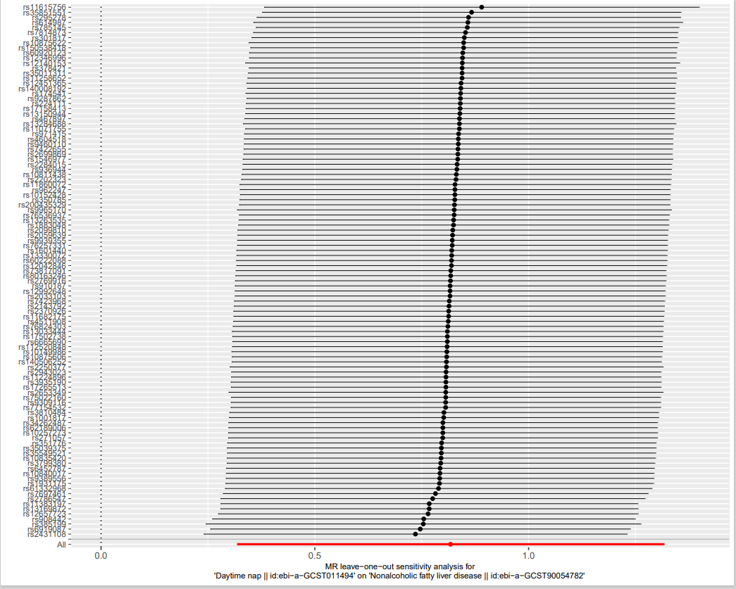

Supplementary Figure 4. Leave-one-out sensitivity and two-sample MR analyses based on the inverse-variance weighted (IVW) model for determining the effects of daytime napping on NAFLD.
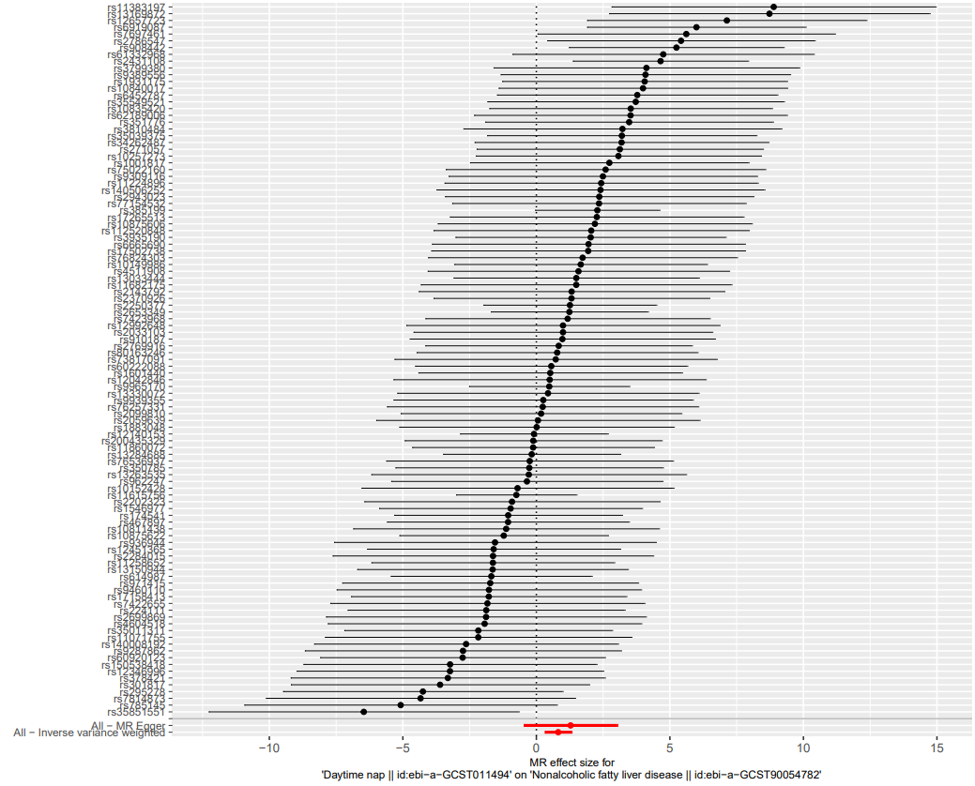
References
1. Peng K, Lin L, Wang Z, et al. Short sleep duration and longer daytime napping are associated with non-alcoholic fatty liver disease in Chinese adults. J Diabetes. 2017;9(9):827-836. doi: 10.1111/1753-0407.12489.
2. Hong C, Wu C, Ma P, et al. Positive association of nap duration with risk of non-alcoholic fatty liver disease in an occupational population in Guangdong Province, China: a cross-sectional study. BMC Gastroenterol. 2022;22(1):185. doi: 10.1186/s12876-022-02246-5.
3. Zarean E, Looha MA, Amini P, et al. Sleep characteristics of middle-aged adults with non-alcoholic fatty liver disease: findings from the Shahrekord PERSIAN cohort study. BMC Public Health. 2023;23(1):312. doi: 10.1186/s12889-023-15251-4.
4. Yang J, Luo S, Li R, et al. Sleep Factors in Relation to Metabolic Dysfunction-Associated Fatty Liver Disease in Middle-Aged and Elderly Chinese. J Clin Endocrinol Metab. 2022;107(10):2874-2882. doi: 10.1210/clinem/dgac428.
5. Zhao X, Cheng L, Zhu C, et al. A double-edged sword: the association of daytime napping duration and metabolism related diseases in a Chinese population. Eur J Clin Nutr. 2021;75(2):291-298. doi: 10.1038/s41430-020-00777-2.
6. Qu H, Wang H, Deng M, et al. Associations between longer habitual day napping and non-alcoholic fatty liver disease in an elderly Chinese population. PLos ONE. 2014;9(8):e105583. doi: 10.1371/journal.pone.0105583.
7. Page MJ, McKenzie JE, Bossuyt PM, et al. The PRISMA 2020 statement: an updated guideline for reporting systematic reviews. BMJ. 2021;372:n71. doi: 10.1136/bmj.n71.

