Supplementary Data

Puerarin-loaded liposomes Co-Modified by ischemic myocardium-targeting peptide and Triphenylphosphonium cations ameliorate myocardial ischemia-reperfusion injury

Yan Wang ^{1,2} #, Fengmei Li ^{1,2 #}, Shanshan Wei ^{1,2 #}, Wenqun Li^{1,2}, Junyong Wu^{1,2}, Shengnan Li^{1,2}, Xiongbin Hu^{1,2}, Tiantian Tang ^{1,2}, Xinyi Liu^{1,2}

¹ Department of Pharmacy, The Second Xiangya Hospital, Central South University, Changsha, China;
² Institution of Clinical Pharmacy, Central South University, Changsha, China;

Correspondence: Xinyi liu, Department of Pharmacy, The Second Xiangya Hospital, Central South University, Changsha, China, +86-731-8529-2095
E-mail address: liuxinyi128@csu.edu.cn

#These authors contributed equally to this work

Supplementary Methods
Synthesis and characterization of functional conjugates
The synthesis process of IMTP-PEG-PE (IMTP links with DSPE-PEG-NHS to form IMTP-PEG-PE polymer, 1,2-distearoyl-sn-glycero-3-phosphoethanolamine is abbreviated as PE) was briefly described as follows. 5 ml of anhydrous N,N-dimethylformamide (DMF) was used to dissolve 100 mg of DSPE-PEG-NHS and 35 mg of IMTP, followed by the addition of 50 µl of TEA. The N-hydroxysuccinimide of DSPE-PEG-NHS was reacted with the amino group in IMTP overnight in a light-proof environment to form the amide-linked IMTP-PEG-PE. The resulting product was dialyzed with a dialysis bag (MW.Cutoff: 2kDa) to remove the by-products and then freeze-dried to obtain the crude product of IMTP-PEG-PE polymer. The IMTP-PEG-PE was then further purified by preparative chromatography with a binary gradient elution of 40% to 100% acetonitrile as the oil phase and 0.1% trifluoroacetic acid (TFA) as the aqueous phase. The structure of the purified IMTP-PEG-PE polymer was confirmed by ¹H NMR and MALDI-TOF mass spectrometry (MALDI-TOF MS).
Briefly, EDC (1.4 eq) and NHS (1.4 eq) were first added to CTPP (1.2 eq) and the mixture was stirred for 4 h to activate the carboxyl group. Then DSPE-PEG-NH₂ (1.0 eq) was added to the above mixed solution and reacted in the dark. The mixture was gently stirred overnight at room temperature under argon protection, and then dialyzed against water for 24 h. Finally, the solution in the dialysis bag was freeze-dried to obtain TPP-PEG-PE powder, and the chemical structure of TPP-PEG-PE polymer was identified by ¹H NMR analysis.

The characterization of liposomes
The particle size and zeta potential of PUE@L, PUE@I-L, PUE@T-L and PUE@T/I-L were measured with dynamic light scattering (DLS) at 25°C using a Malvern Zetasizer Nano ZS instrument (Malvern Instruments Ltd, UK). A drop of PUE@T/I-L was deposited on a glow discharge carbon-coated grid. The morphology of PUE@T/I-L was then visually observed using transmission electron microscopy (TEM) at 200 kV (JEM-2100F, JEOL, Japan). The drug loading efficiency (DL%) and entrapment efficiency (EE%) for PUE in PUE@T/I-L were determined by HPLC system (LC-20, Japan) with the mobile phase of acetonitrile:water (17:83) and detection at 250 nm.

Fourier transform infrared spectrometer (FT-IR)
A thermo Fisher Nicolet iS10 Fourier transform infrared spectrometer (FT-IR) was used to characterize the PUE embedding state in PUE@T/I-L. First, a background spectrum of a blank KBr was run. Then PUE, blank liposomes (T/I-L) and PUE@T/I-L were gently coated on the KBr sheets, respectively. The FT-IR spectrum of these samples from 400 to 4000 cm⁻¹ was recorded by the KBr pellet method on a FT-IR spectrometer at room temperature.

Stability Studies
To investigate the storage stability of PUE@T/I-L, freshly prepared samples were placed in a 4°C refrigerator for 60 days and the particle size and potential of the liposomes were measured every ten days. In addition, PUE@T/I-L was co-cultured with 10% fetal bovine serum (FBS) to monitor serum stability. The changes in particle size and zeta potential of PUE@T/I-L were monitored by DLS measurements at 0, 4, 8, 12 and 24 h.

In vitro release
Dialysis (PBS buffer, pH7.4) method was used to study the release of PUE from drug-loaded liposomes in vitro. Briefly, free PUE, PUE@L, PUE@T-L, PUE@I-L and PUE@T/I-L at the same amount of 240 μg PUE were sealed in a dialysis bag (MW. Cutoff: 3kDa). The bag was dialyzed against 50 mL of PBS (pH 7.4) under horizontal shaking (100 rpm) at 37°C. 150 μL aliquots were collected at different time intervals for analysis and replaced with the same volume of fresh PBS. The cumulative release percentage of PUE was determined by HPLC method with acetonitrile and water (17:83) as the mobile phase, and the detection wavelength was 250 nm.The experiment was performed parallel in triplicate.

Hemolytic activity
Hemolytic activity is a requirement to be tested for intravenous drug delivery samples. The test is based on erythrocyte lysis induced by incubation with PUE@T/I-L. 10 female 3-month-old Sprague-Dawley (SD) rats (250-300 g) were housed in groups of two per cage under controlled temperature and humidity with a 12 h light/12 h dark cycle. Rats were allowed free access to food and water. The tails of SD rats were soaked in 42°C water for 40-50 seconds to dilate the blood vessels and the tails were dried with paper towels. Rats (in restraints) were placed face down with their tails on a heating pad in a naturally relaxed state. The tail vein to be bled was located and blood was drawn from the vein using an anticoagulant-soaked syringe. Immediately after 0.4 ml of blood was drawn from the rats, a sterile cotton ball was used to stop the bleeding by applying pressure at the location where the needle was inserted to draw blood. Monitor the animal until full recovery before returning it to its cage for subsequent studies, and do not introduce it to the company of other animals until fully recovered. This blood samples from the 10 rats were separated to obtain an erythrocyte suspension by the following method, collected by centrifugation at 3000 rpm for 5 minutes and repeatedly rinsed with PBS until the supernatant became clear. Purified RBCs were then mixed with free PUE and various concentrations of PUE-loaded liposomes (PUE@L, PUE@I-L, PUE@T-L and PUE@T/I-L) for 2 h at 37°C with gentle shaking, followed by 2000 rpm for 5 min. 100 μL of the resulting supernatant was then added to a 96-well plate. The absorbance value (A) of hemoglobin was measured using a Multiskan MK3 microplate reader at 540 nm. The experiment was performed parallel in triplicate. The values for 0% and 100% hemolysis were determined by incubating RBCs with PBS or distilled water. The hemolysis rate (HR %) was calculated as follows: HR (%) = [(A_{sample} - A_{negative})/ (A_{positive}-A_{negative})] × 100%.

Table S1 The lipid composition, size and zeta potential of liposomes
Liposomes | Composition (% of molar mole) |  |  |  | Size  (nm) | Zeta Potential  (mV)
Liposomes | SL | Chol | TPP-PEG-PE | IMTP-PEG-PE | Size  (nm) | Zeta Potential  (mV)
PUE@T/I-L | 52 | 26 | 14 | 8 | 159.4±1.4 | -27.8±0.7
PUE@T-L | 57 | 28 | 15 | - | 160.5±4.1 | -14.7±0.3
PUE@I-L | 60 | 30 | - | 10 | 152.6±5.9 | -39.1±2.6
PUE@L | 67 | 33 | - | - | 141.2±2.6 | -42.7±1.0

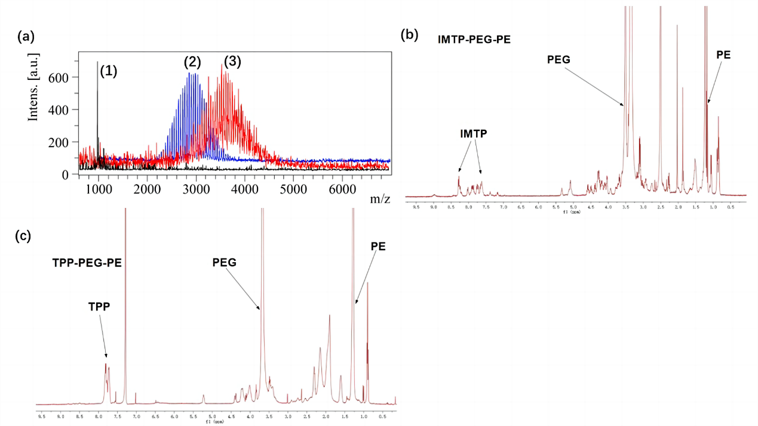
Figure S1. Characterization of functional conjugates. (a) MALDI-TOF-MS spectrum of IMTP (1) DSPE-PEG-NHS (2) and IMTP-PEG-PE (3); (b) ¹H NMR spectrum of IMTP-PEG-PE; (c) ¹H NMR spectrum of TPP-PEG-PE.
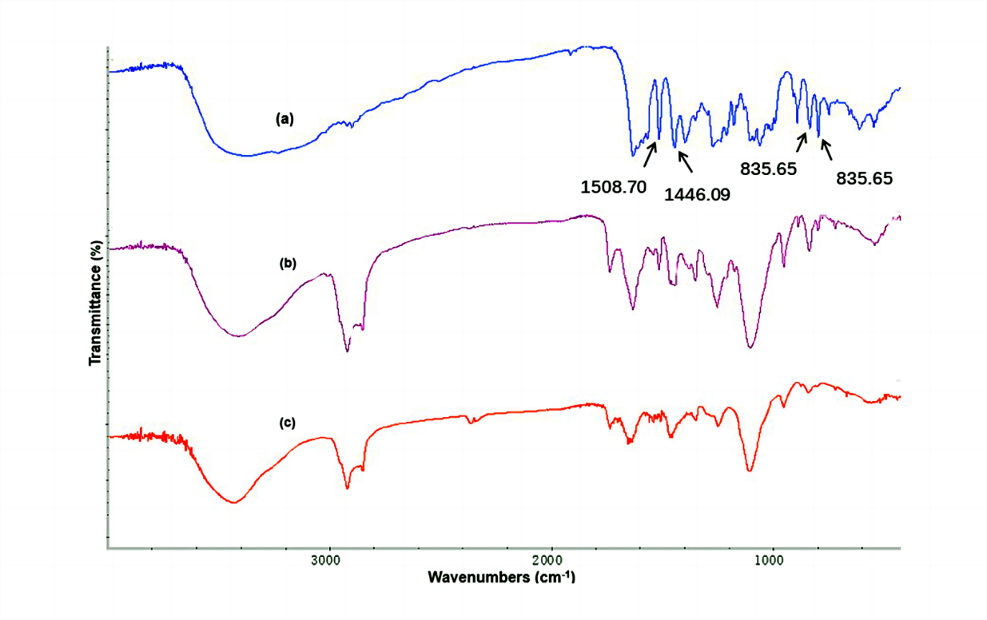
Figure S2. FT-IR analysis of puerarin encapsulated in liposomes. (a) PUE, (b) blank
T/I-L and (c) PUE@T/I-L.

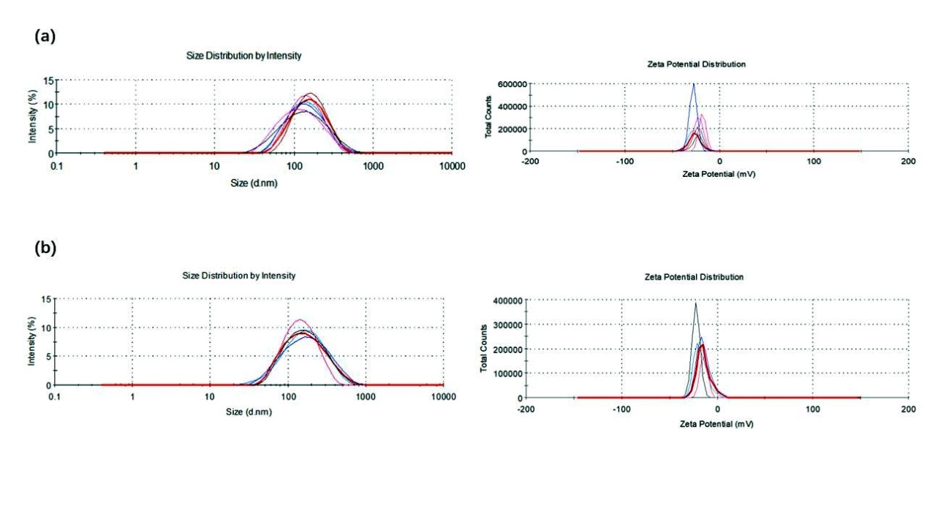
Figure S3. Particle size and zeta potential changes of PUE@T/I-L during 60 days of
storage (a) and 24 h of storage in 10% fetal bovine serum (b).

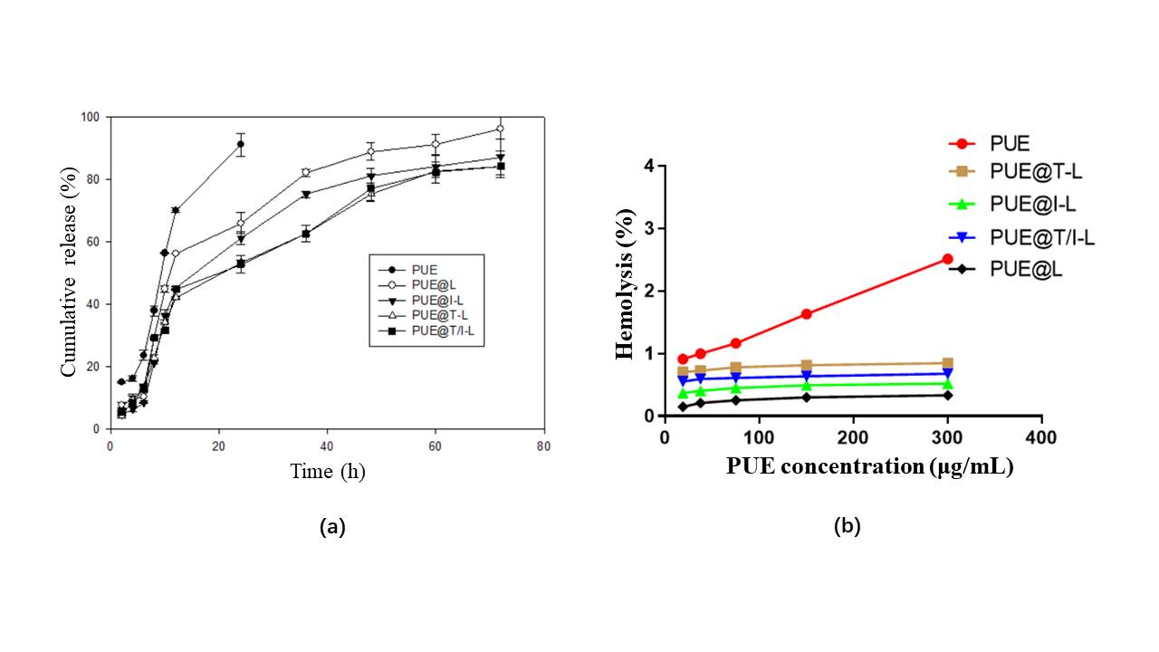
Figure S4. In vitro release (a) and hemolytic activity (b) of free PUE, PUE@L,
PUE@T-L, PUE@I-L and PUE@T/I-L (n = 3).

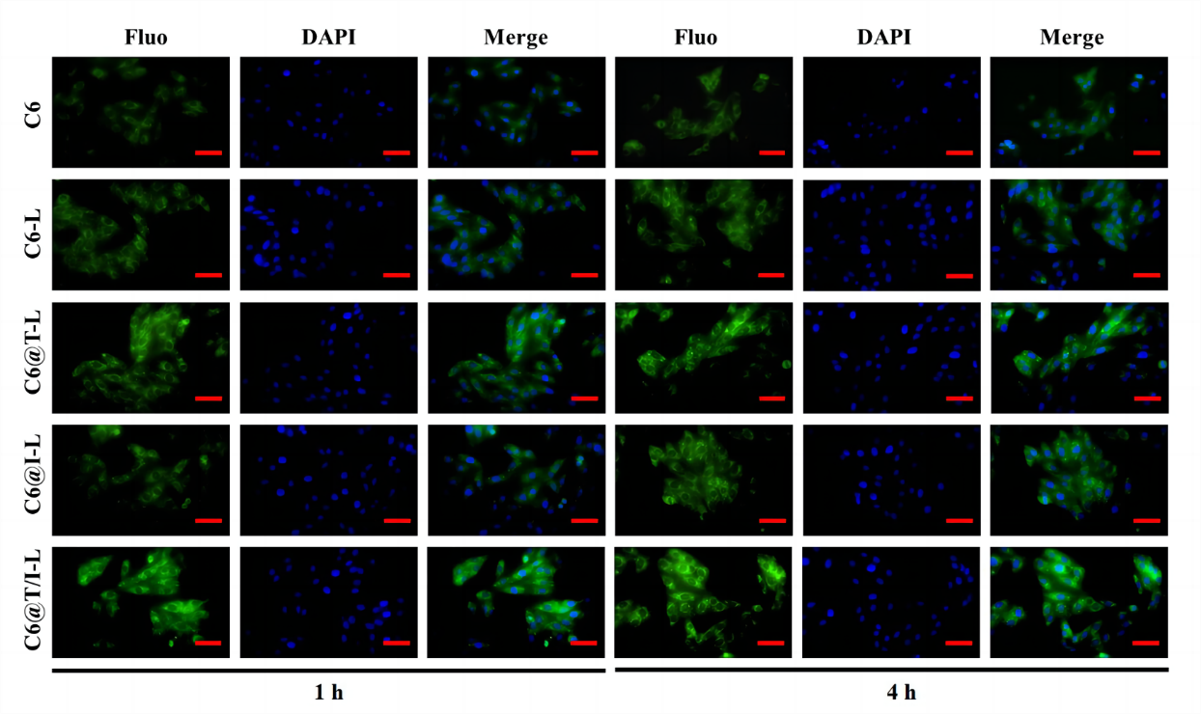
Figure S5. Cellular uptake behavior of free C6, C6@L, C6@I-L, C6@T-L and
C6@T/I-L after co-culture with normal H9c2 cells for 1 h and 4 h. Scale bar: 100 μm.

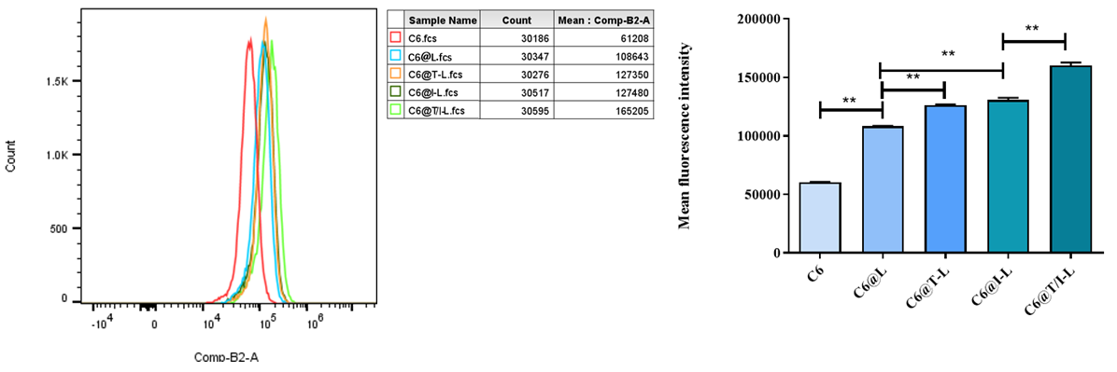
Figure S6. Intracellular fluorescence intensity of H/R-injured H9c2 cells incubated
with free C6, C6@L, C6@I-L, C6@T-L and C6@T/I-L was measured by flow
cytometry. (**p < 0.01).

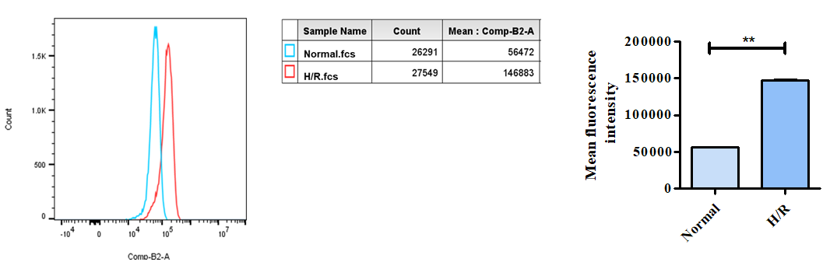
Figure S7. Intracellular fluorescence intensity was measured by flow cytometry after co-incubation of C6@T/I-L with H/R-injured H9c2 cells and normal H9c2 cells (**p < 0.01).

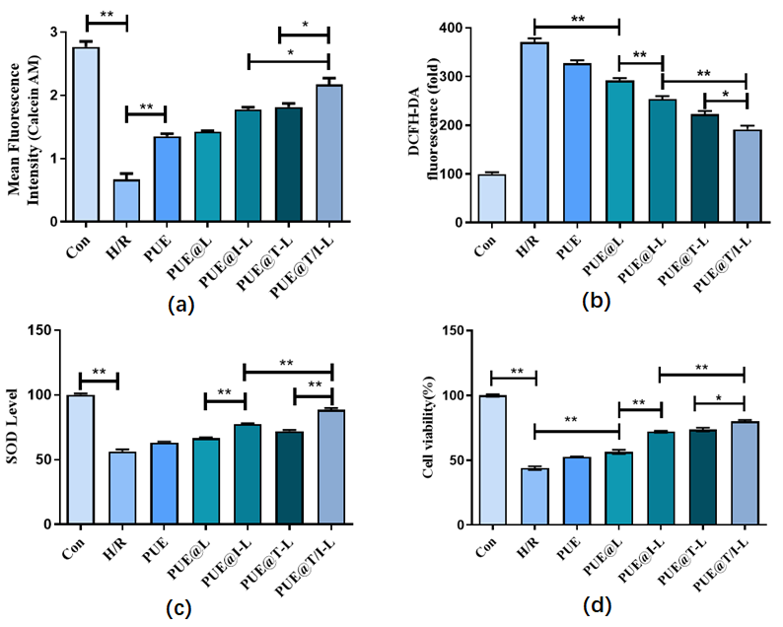
Figure S8. The protective effects of PUE@T/I-L on H/R-injured H9c2 cells. (a)
Calcien AM fluorescence intensity measured in H/R-injured H9c2 cells by flow cytometry. (b) ROS level was measured by DCFH-DA. (c) SOD level. (d) cell viability. (**p < 0.01, *p < 0.05).

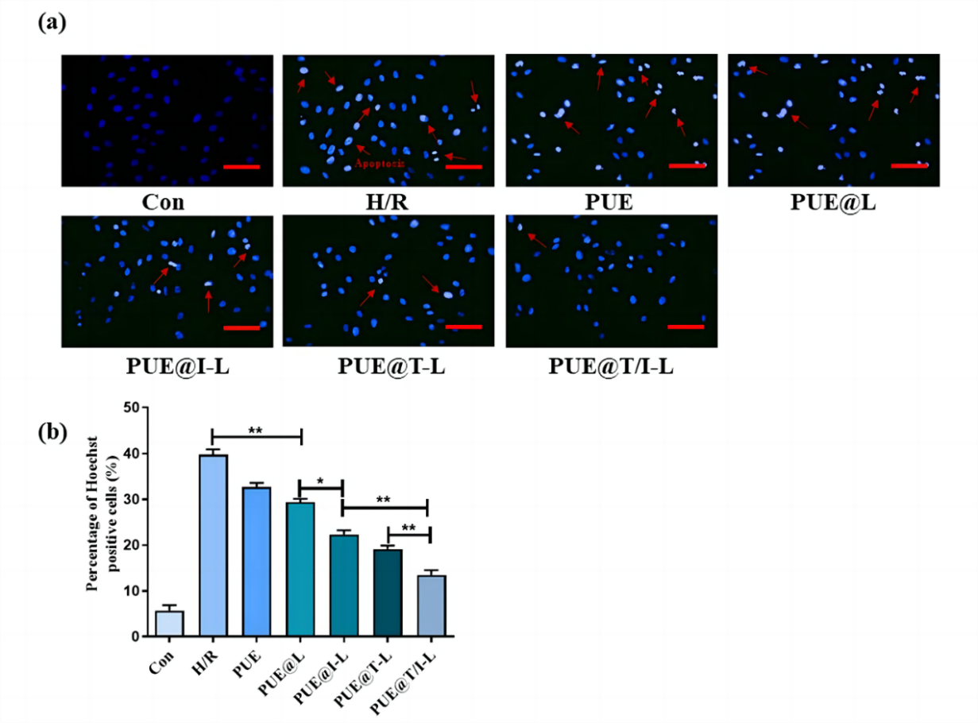
Figure S9. The effect of PUE@T/I-L on apoptosis of H/R-injured H9c2 cells. (a)
Representative Hoechst-stained micrographs. Plain blue for non-apoptotic cells and
bright blue for apoptotic cells. Arrowheads indicate the nuclei of apoptotic cells. (b)
Statistical analysis of apoptotic cells in different groups. (**p < 0.01, *p < 0.05).

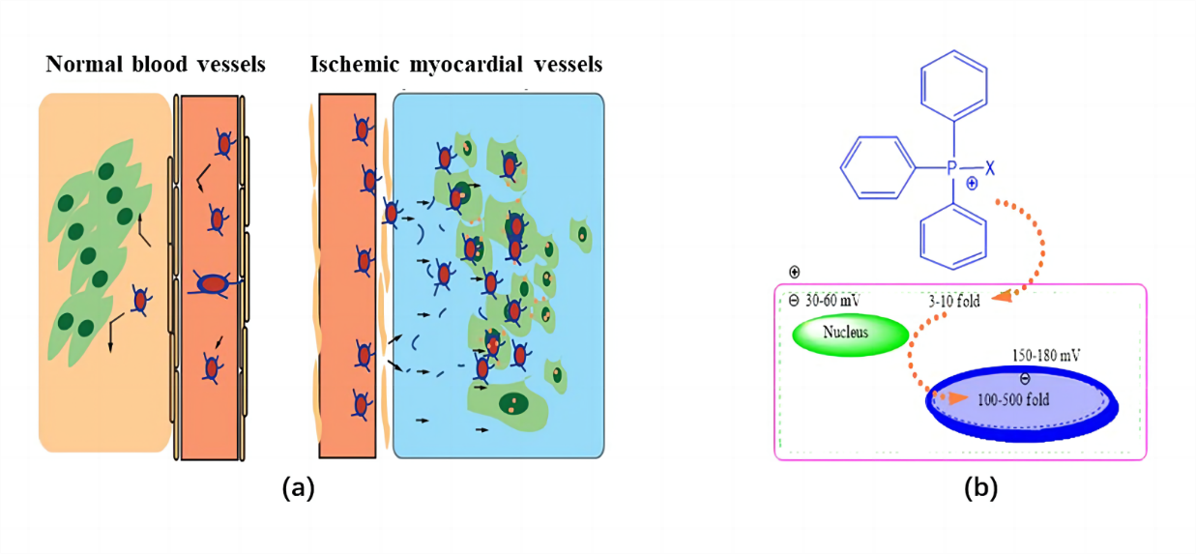
Figure S10. EPR effect of liposomes in ischemic myocardial sites (a). TPP cations
promote drug carrier targeting into mitochondria (b).

