Supporting Information

Supporting Figures
Figure S1. The Standard curve of DOX. A represents the peak area at 480 nm and C represents the corresponding concentration.
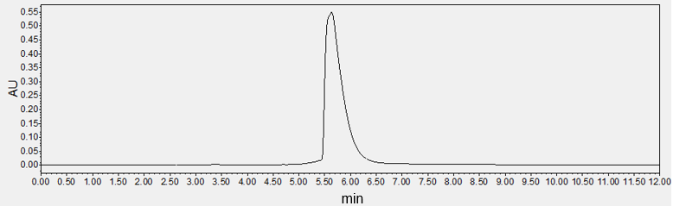

Figure S2. Absorption of the loading DOX in PDA-DOX at 480 nm.
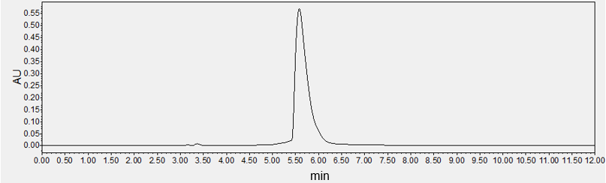

Figure S3. Absorption of the loading DOX in FA-PEG-PDA-DOX at 480 nm

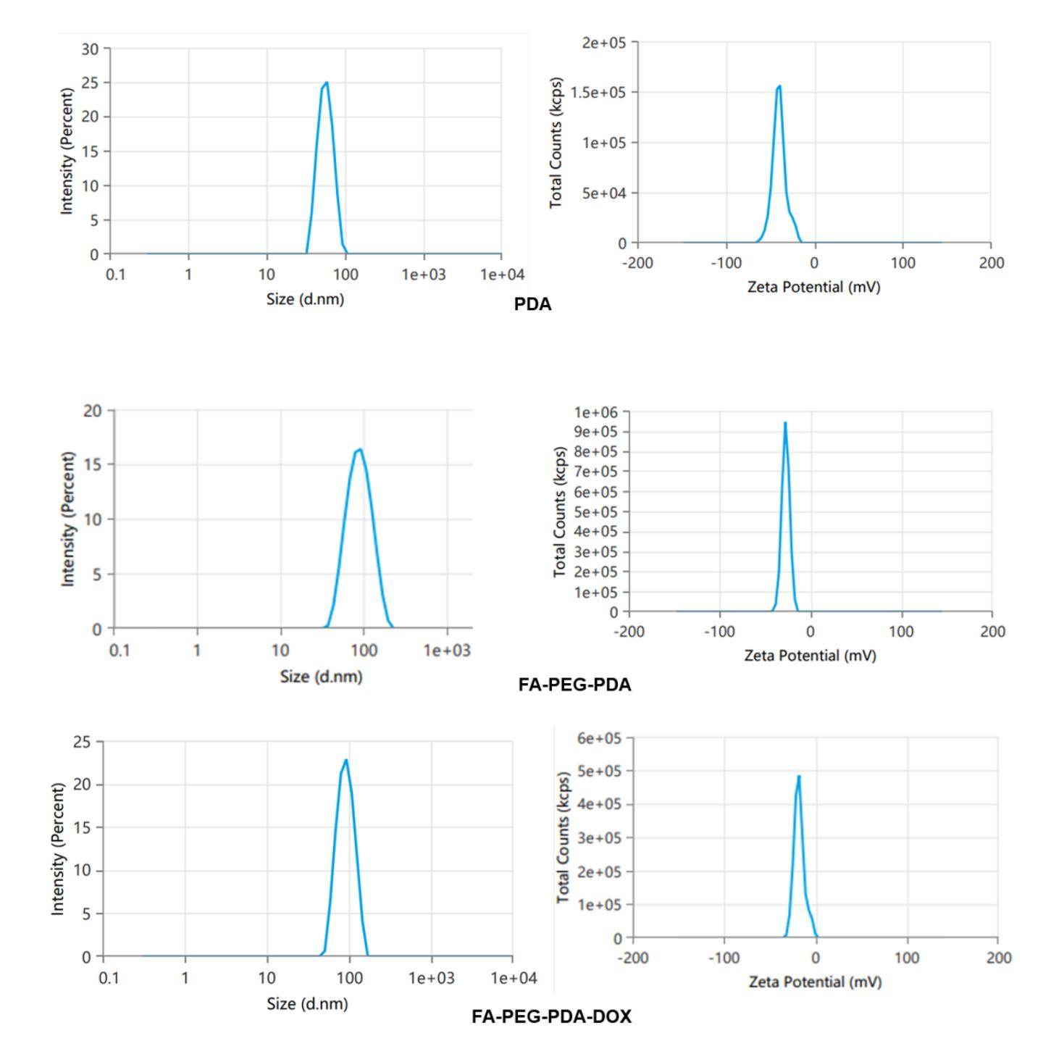
Figure S4. Size and zeta potential test of three NPs
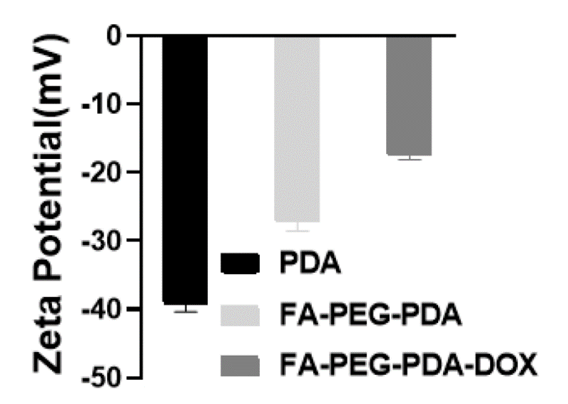
Figure S5. Zeta potential analysis of three NPs
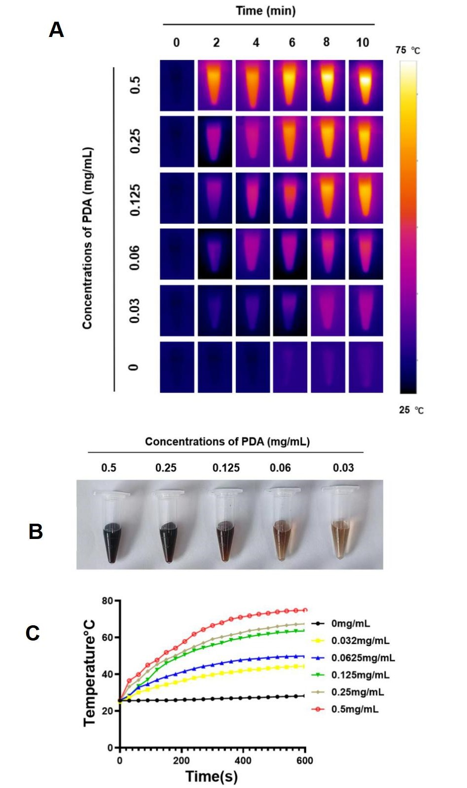
Figure S6. (A) Infrared thermal images of PDA. (B) PDA nanoparticles in different concentrations. (C)Concentration-dependent photothermal heating curves of PDA.
Figure S7. Microscopy images of the Y79 cells with control group (a) and FA-PEG-PDA-DOX＋Laser group for 48 h.

