Supplementary Materials
Supplementary Table 1. Physicochemical characterization of fluorescent PCL NPs.
Parameter
Ratio PCL/fluorescein (w/w) | 10:1
PCL/FITC (w/w) (mg/mg) | 10:1
Particle size distribution (nm) | 212.0 ± 2.17
Polidispersity (PDI) | 0.363 ± 0.01
ζ-potential (mV) | -11.3 ± 1.40

Physicochemical characterization of fluorescent PCL NPS.
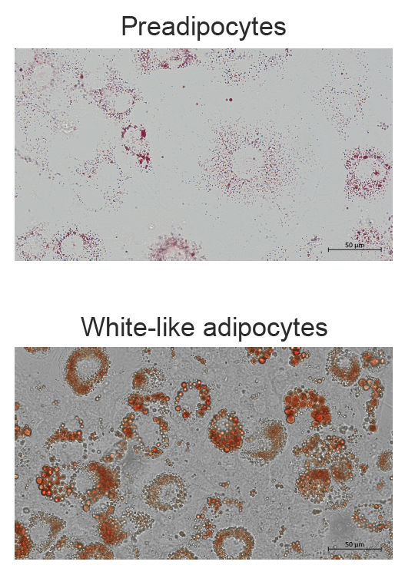
Supplementary Figure 1. Morphological analysis of preadipocytes and white-like adipocytes differentiated. Representative images of preadipocytes (up) and white-like adipocytes (down) at day 10 of differentiation stained with oil red. Cells were visualized by light microscopy with 20X magnification. Scale bar = 50 µm. The intracellular lipid droplets were stained with oil red reagent.
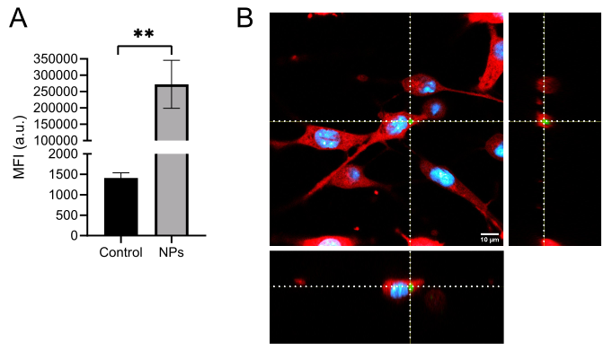
Supplementary Figure 2. PCL NPs associate and internalize into A549 cells. A) Median fluorescence intensity (MFI) quantification by flow cytometry on lung cancer A549 cells treated or not with 300 µg/mL of fluorescent PCL-fluorescein NPs after 24 h. Data are presented as mean ± SEM, with at least three independent experiments (n≥3) made in triplicate, and Student´s t-test. ** p<0.01 compared to Control group. B) Representative fluorescence images, acquired by laser scanning confocal microscopy, of the incorporation of PCL-fluorescein NPs (300 µg/mL) on lung cancer A549 cells after 24 h of incubation. Staining of cells is as follows: blue: DRAQ5-stained nuclei; red: calcein-red; and green: fluorescein-labeled PCL NPs. Each image is composed of a representative x, y projection of an optical section of the cells, along with its. Orthogonal projections in y, z and x, z, reconstructed from the optical section stacks, acquired with 1 μm of distance between each stack. Scale bars: 10 μm. Dotted lines: identification representative PCL-fluorescein NP cluster.

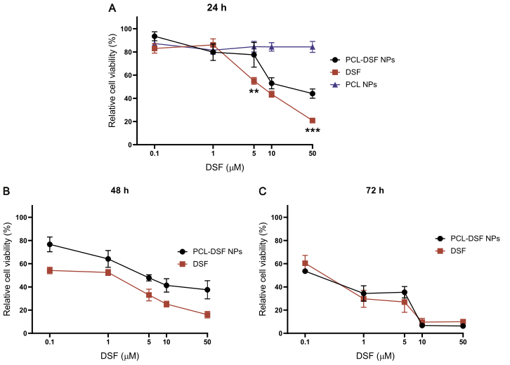
Supplementary Figure 3. Cell viability analysis on A549 cell line. A) Relative cell viability analysis on lung cancer cells A549, treated at different concentrations (0, 0.1, 1, 5, 10, and 50 μM) of PCL-DSF NPs and free DSF, and same proportion used at 0, 0.1, 1, 5, 10 and 50 μM of PCL NPs at 24 h, B) 48 h and C) 72 h. Data are presented as mean ± SEM with at least three independent experiments (n≥3) made in triplicate, and two-way ANOVA with posthoc Tukey multiple comparisons test. ** p<0.01, and *** p<0.001 compared between PCL-DSF NPs and DSF groups.
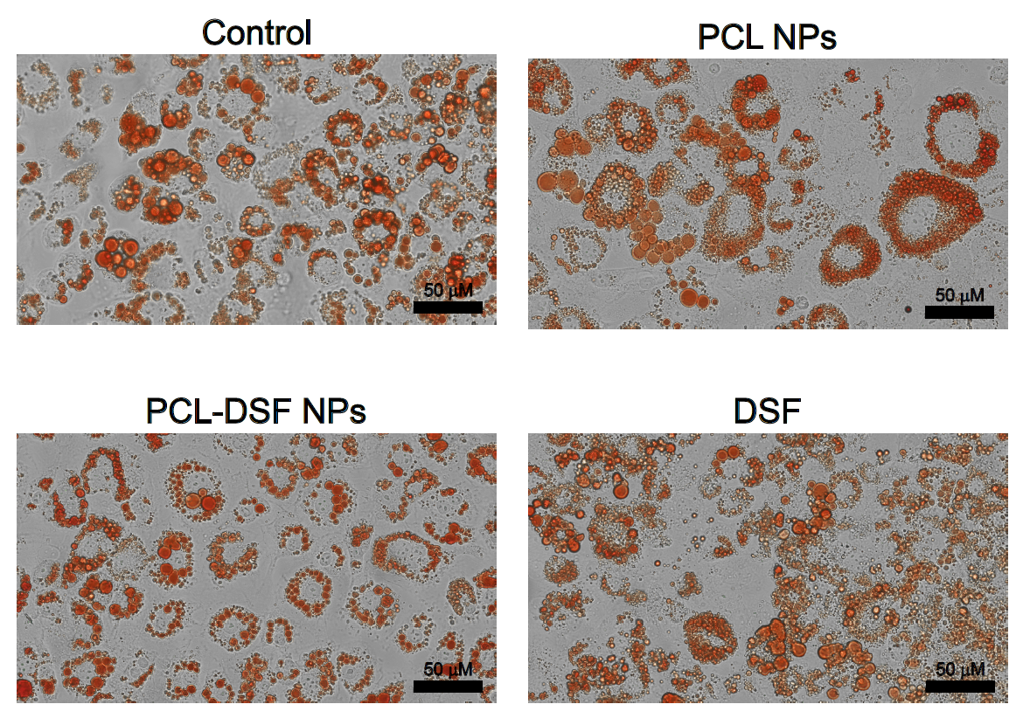
Supplementary Figure 4. Lipid droplets on white-like adipocytes. Representative images white-like adipocytes treated of not with PCL NPs, PCL-DSF or free DSF (10 µM) for 24 h and stained with oil red staining. Cells were visualized by light microscopy with 20X magnification. Scale bar = 50 µm., Germany) and the camera Zeiss-Axiocam 208 color (Zeiss, Oberkochen, Germany).

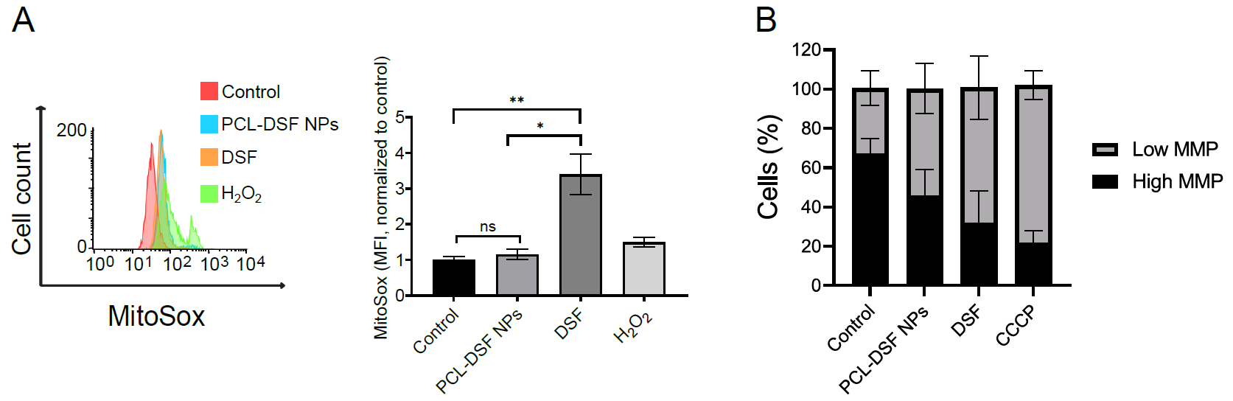
Supplementary Figure 5. Mitochondrial damage analysis on A549 cells. A) Representative mROS histograms (left) and quantification (right) by flow cytometry using Mitosox stain after 24 h exposure. B) ΔΨm quantification by flow cytometry using JC-1 stain after 24 h exposure. The concentration of DSF, free or encapsulated, was 10 μM. Data are presented as mean ± SEM, with at least three independent experiments (n≥3) made in triplicate, and one-way ANOVA with posthoc Tukey multiple comparisons test. * p<0.05 and ** p<0.01.
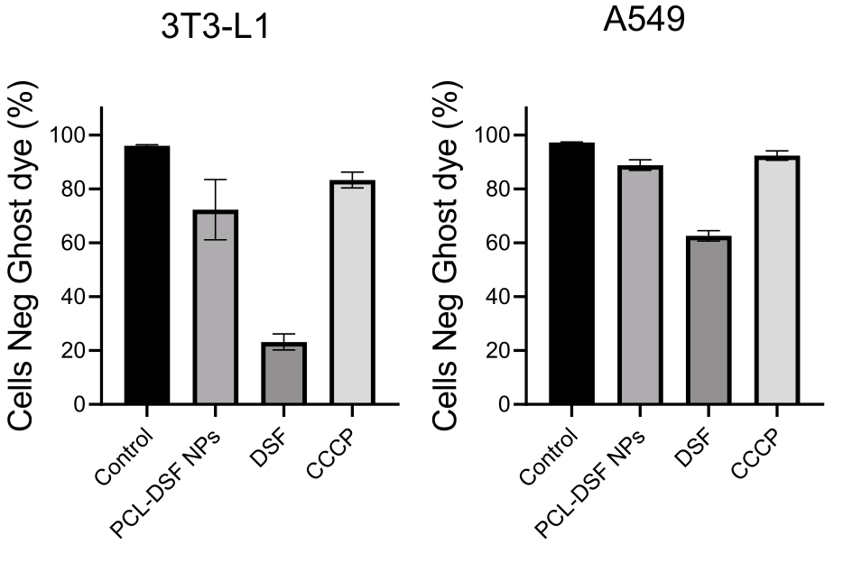
Supplementary Figure 6. Cell viability quantification. Quantification of cell viability quantification using Ghost dye stain by flow cytometry on preadipocytes 3T3-L1 and lung cancer A549 cells treated for 24 h with PCL-DSF NPs, free DSF or CCCP (80nM).
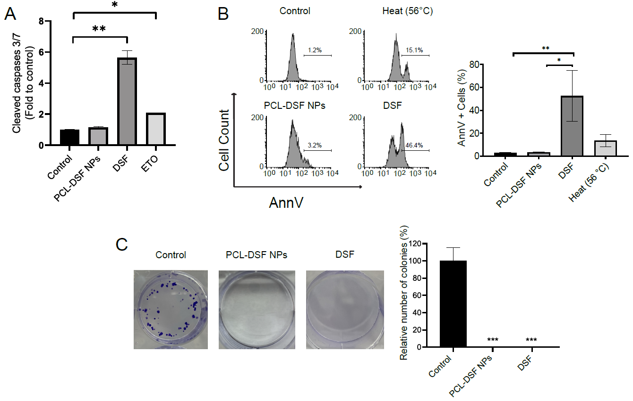Supplementary Figure 7. PCL-DSF NPs showed cytotoxicity similar to DSF on lung cancer A549 cells. A) Quantification of effector caspases 3/7 cleaved by luminescent kit after 24 h exposure. B) Phosphatidylserine exposure representative histograms (left) and quantification (right) after 24 h exposure. C) Representative photographs of clonogenicity study (left) and clonogenicity analysis colony formation after 24 h exposure and 10 days of culture (right) in A549 cells. The concentration of DSF, either free or encapsulated, was 10 μM. Data are presented as mean ± SEM, with at least three independent experiments (n≥3) made in triplicate, and one-way ANOVA with posthoc Tukey multiple comparisons test. * p<0.05, ** p<0.01, and *** p<0.001.

