Table S1 Primer sequences used for performing real-time PCR in the present work
Target genes | Primers (5’ - 3’) (F: forwards; R: reverse) | Length (nt) | Accession number
ALP | F: GCCTCTCAGCTTCAGATCGT | 20 | XM_006239136.4
 | R: CGCTCTTCCCCGTCTTACAG | 20 | XM_006239136.4
RUNX-2 | F: GCTGTTGTGATGCGTATTCCC | 21 | NM_001278484.2
 | R: TGAACCTGGCCACTTGGTTT | 20 | NM_001278484.2
OCN | F: ACTGCGTATTGGTTGACGCT | 20 | NM_25490.1
 | R: AAAGACGCAAATGAACCGGAC | 21 | NM_25490.1
OPN | F: CAGTATCCCGATGCCACA | 18 | NM_012881.2
 | R: TTTCCACGCTTGGTTCAT | 18 | NM_012881.2
GAPDH | F: AGACAGCCGCATCTTCTTGT | 20 | NM_017008.4
 | R: CTTGCCGTGGGTAGAGTCAT | 20 | NM_017008.4
Abbreviations: ALP, alkaline phosphatase; GAPDH, glyceraldehyde-3-phosphate dehydrogenase; OCN, osteocalcin; OPN, osteopontin; PCR, polymerase chain reaction; RUNX-2, Runt-related transcription factor 2.

Table S2 Experimental design of the in vivo determination
Subcutaneous implantation model in mice  (Time of sampling: week 2 and 4) |  | Calvarial bone defect model in rats  (Time of sampling: week 6 and 12)
Grouping | Number (n=24) | Grouping | Number (n = 48)
G | 6 | CTRL (without scaffolds) | 12
G/T | 6 | G/T | 12
G/T/GO | 6 | G/T/GO | 12
G/T/GO/Cu | 6 | G/T/GO/Cu | 12
Abbreviations: CTRL, control group; G, GelMA hydrogel; G/T, GelMA/TCP hydrogel; G/T/GO, GO nanosheet-incorporated GelMA/TCP, hydrogel; G/T/GO/Cu, GO/Cu nanocomposite- incorporated GelMA/TCP hydrogel.

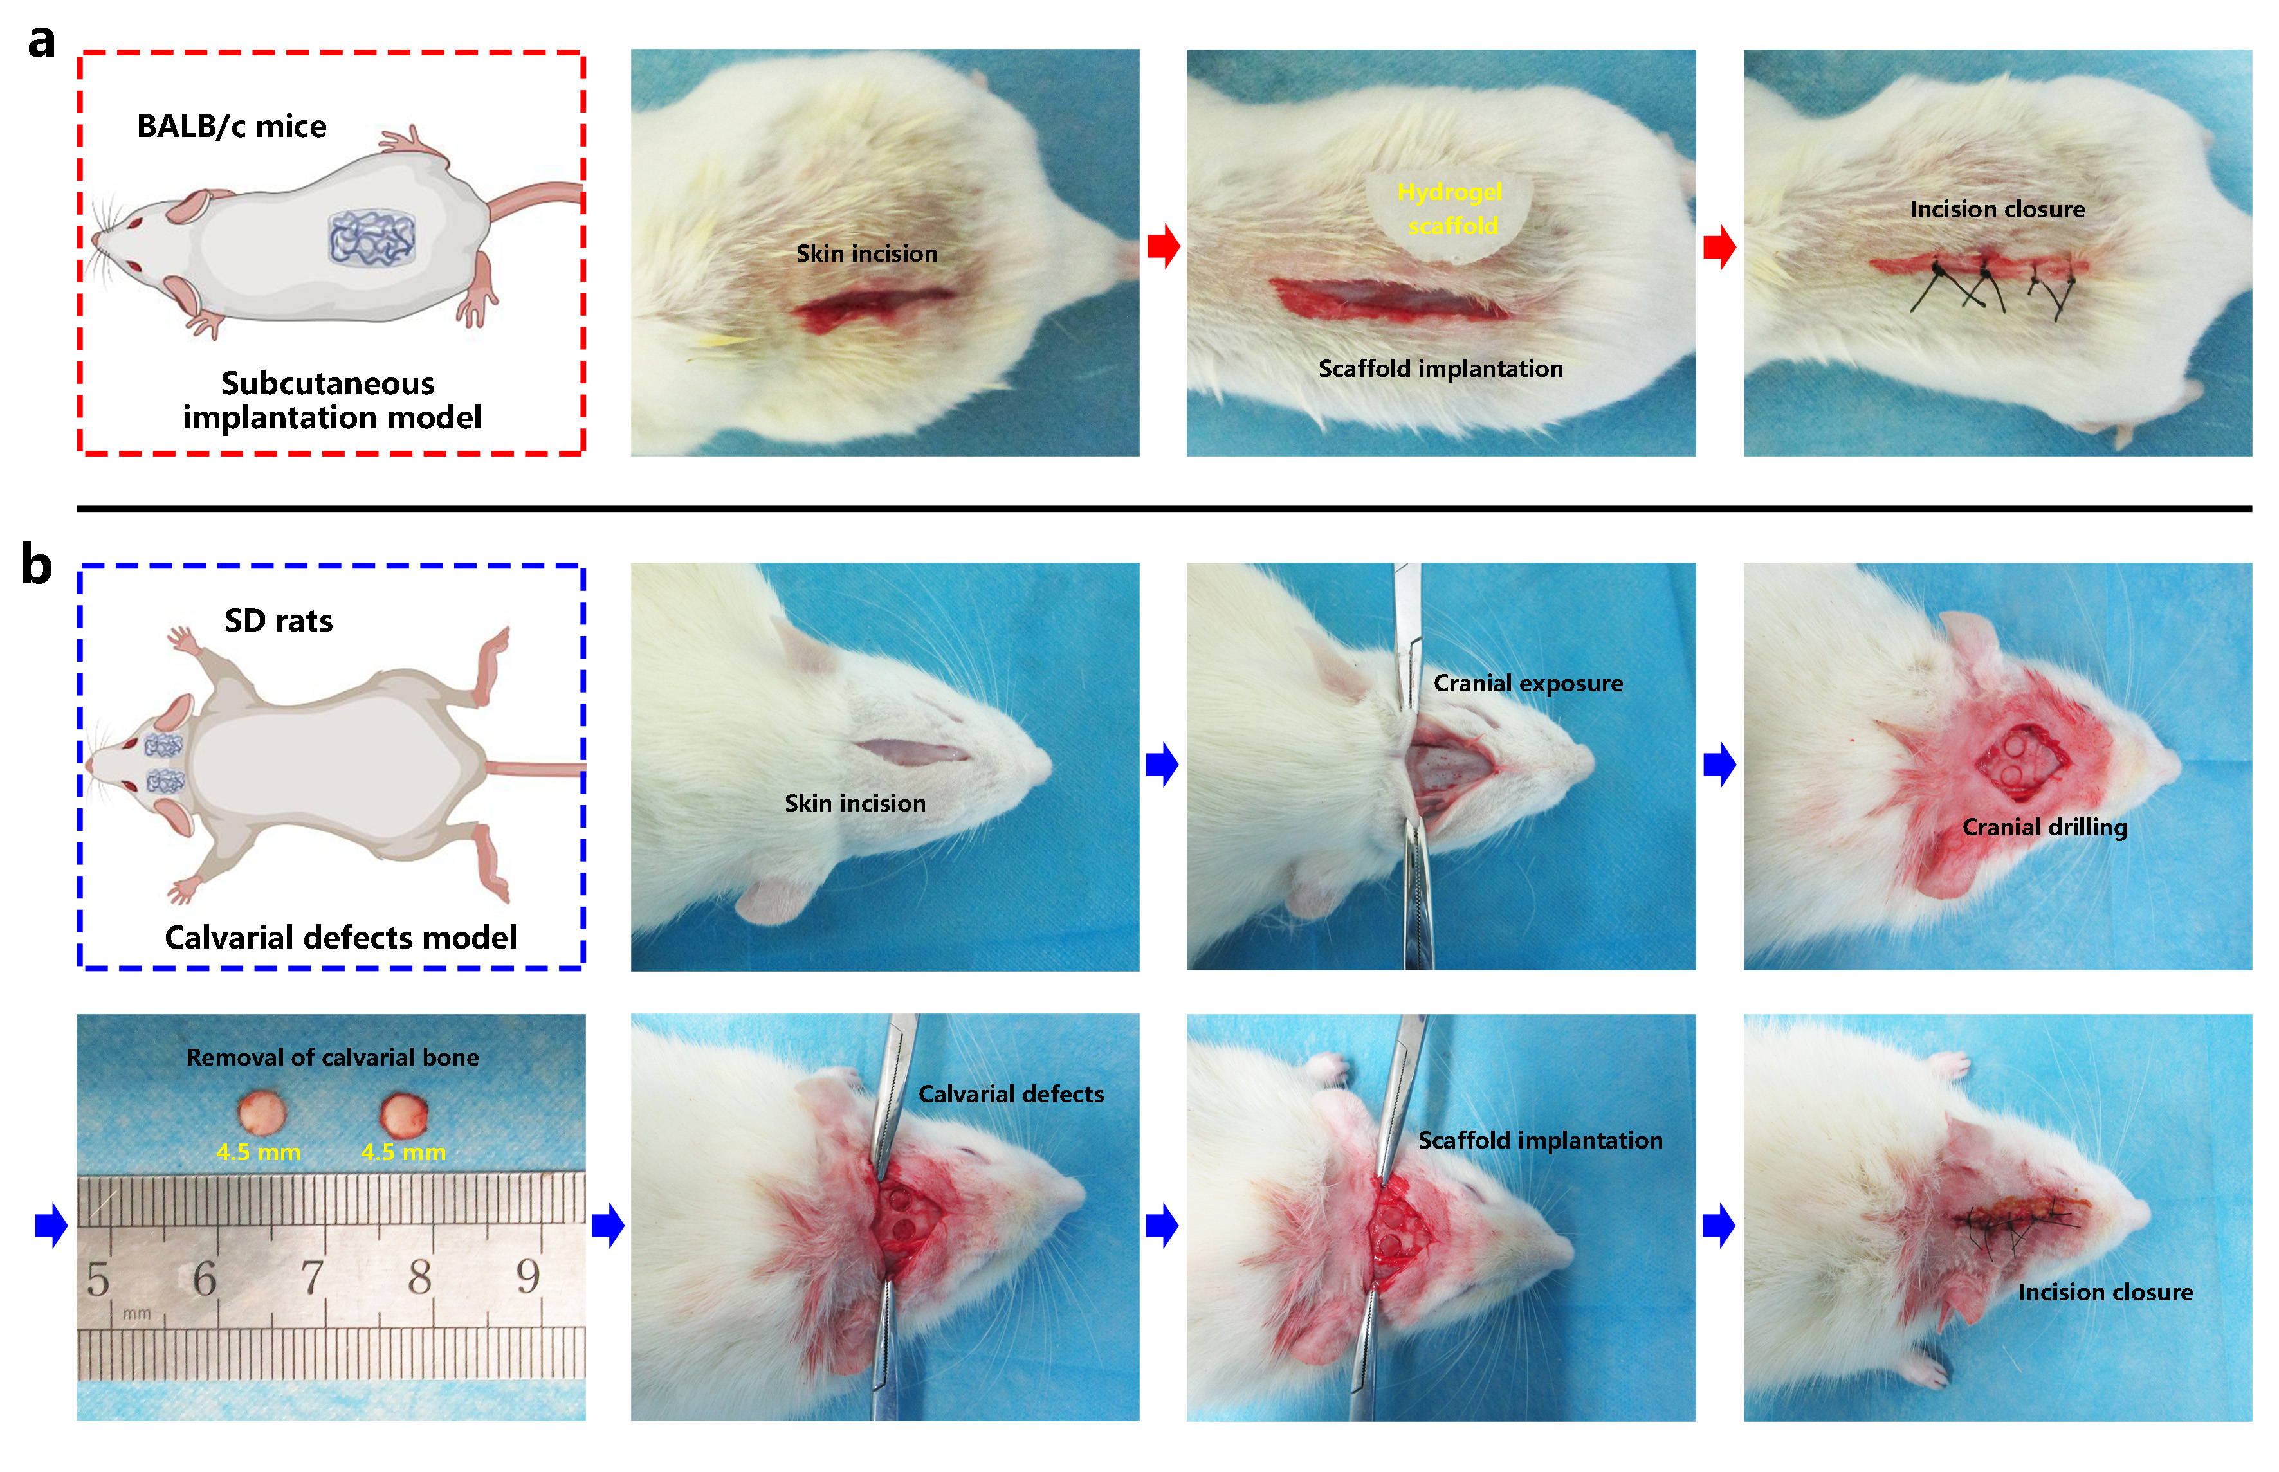
Figure S1 Establishment of animal models and corresponding surgical procedures (created with BioRender.com).
Notes: (a) Subcutaneous implantation model in BALB/c mice. (b) Calvarial bone defect model in SD rats.

Figure S2 The porosity of the prepared biohybrid hydrogel scaffolds (n = 5). Quantative analysis of these data was performed using Image J software.
Abbreviations: G, GelMA hydrogel; G/T, GelMA/TCP hydrogel; G/T/GO, GO nanosheet-incorporated GelMA/TCP, hydrogel; G/T/GO/Cu, GO/Cu nanocomposite- incorporated GelMA/TCP hydrogel.

Figure S3 EDS elemental mapping showing the elements distribution (C, O, N, P, Ca and Cu) of the hybrid hydrogel scaffolds.
Abbreviations: EDS, energy dispersive X-ray spectroscopy.
Figure S4 In vitro degradation profile of the prepared hydrogel scaffolds (n = 3) incubated in PBS containing collagenase type II (1.5 U/mL) for two weeks.
Abbreviations: G, GelMA hydrogel; G/T, GelMA/TCP hydrogel; G/T/GO, GO nanosheet- incorporated GelMA/TCP, hydrogel; G/T/GO/Cu, GO/Cu nanocomposite- incorporated GelMA/TCP hydrogel.

Figure S5 Polarization and expression of inflammatory cytokines in RAW264.7 macrophages in the biohybrid hydrogel scaffolds after 48 h of coculture.
Notes: (a) Fluorescence staining and quantification of an M1 marker (CCR7) and M2 marker (CD206). (b) Expression levels of typical inflammatory cytokines (IL-1β, TNF-α, IL-4 and IL-10) determined by ELISA.
Abbreviations: CCR7, Chemokine C-C-Motif Receptor 7; CD206, Cluster of Differentiation 206; ELISA, enzyme-linked immunosorbent assay; IL-1β, interleukin 1β; IL-4 interleukin; IL-10, interleukin 10; TNF-α, tumor necrosis factor-α.

Figure S6 Dual immunofluorescent staining of the biohybrid hydrogel scaffolds after 2 and 4 weeks of subcutaneous implantation in mice to clarify the in vivo effects of implanted hydrogel scaffolds on M1 (iNOS) and M2 (CD206) type polarization during macrophage recruitment.
Abbreviations: CD206, Cluster of Differentiation 206; DAPI, 4,6-diamidino-2-phenylindole; iNOS, inducible nitric-oxide synthase.
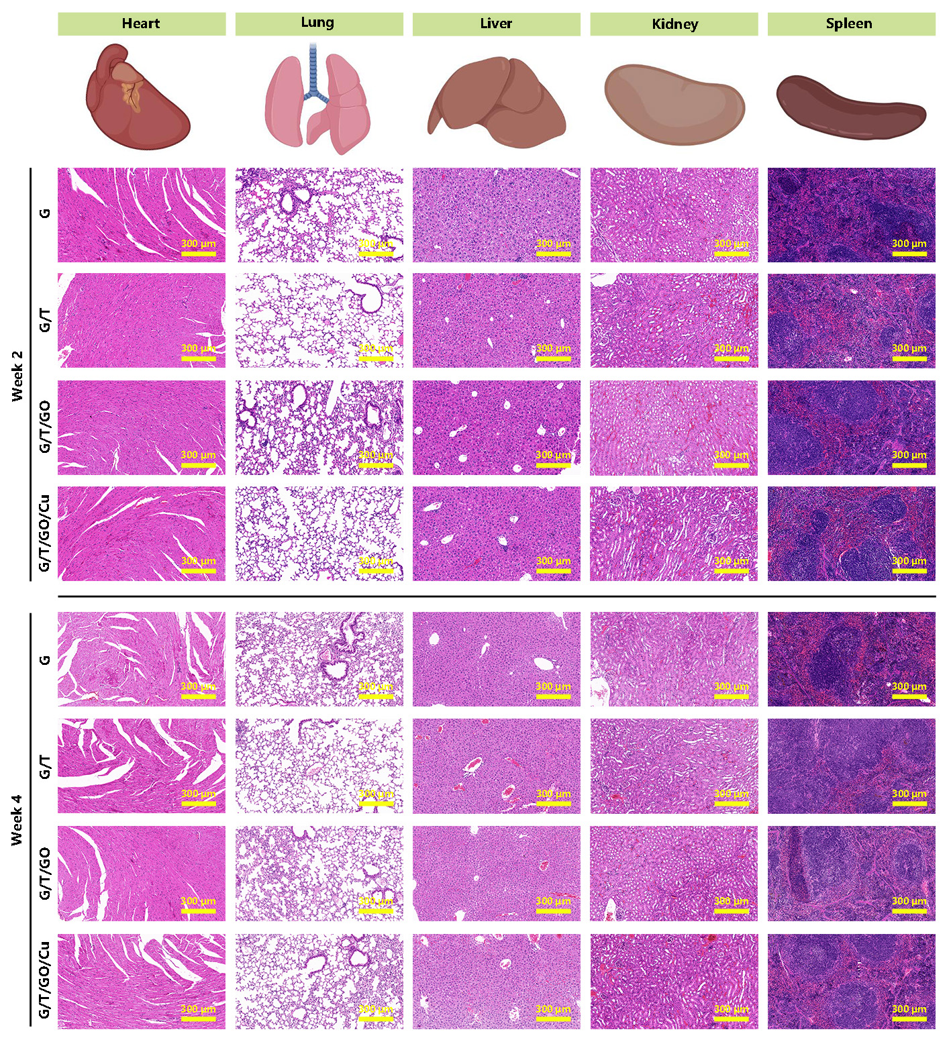
Figure S7 Determination of the in vivo biosafety of the biohybrid hydrogel scaffolds exacted from BALB/c mice (created with BioRender.com).
Notes: Vital organs including heart, lung, liver, kidney and spleen were obtained at week 2 and 4 after implantation, followed by H&E staining to examine the organizational structures of these organs.
Abbreviations: H&E, hematoxylin and eosin.
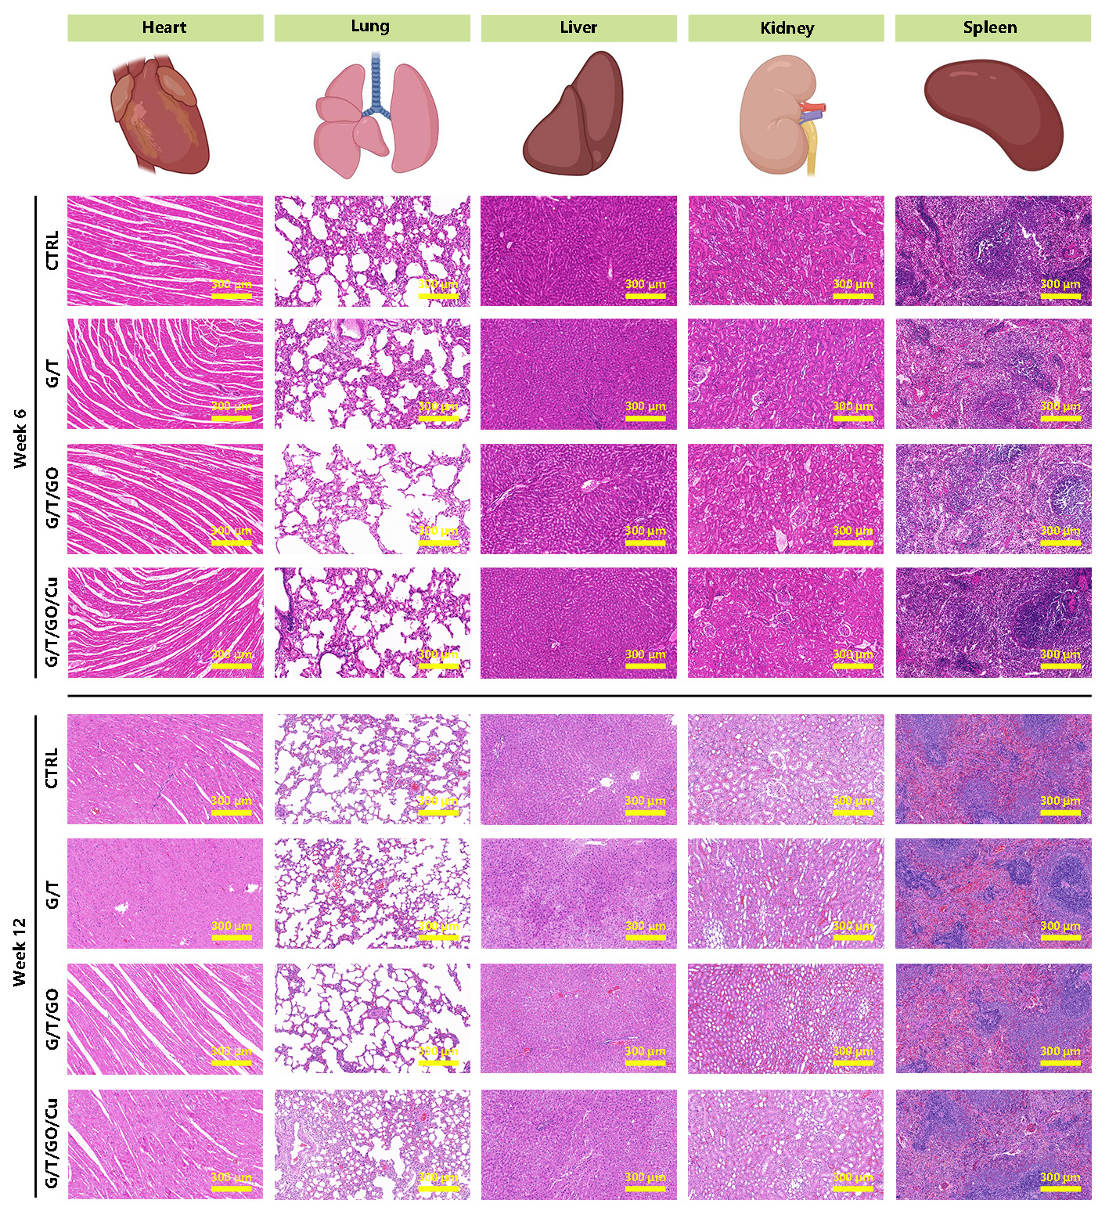
Figure S8 Determination of the in vivo biosafety of the biohybrid hydrogel scaffolds exacted from SD rats (created with BioRender.com).
Notes: Vital organs including heart, lung, liver, kidney and spleen were obtained at week 6 and 12 after implantation, followed by H&E staining to examine the organizational structures of these organs.
Abbreviations: H&E, hematoxylin and eosin; SD, Sprague-Dawley.

