Supporting Information

1.Materials and methods
1.1 Biocompatibility and biosafety evaluation
The biocompatibility of the MIBFP NPs on ZR75.1 and VMSCs was assessed by inoculating the cells in 96-well plates for 24 h, followed by the addition of fresh serum-free RPMI-1640 solutions containing varying concentrations (0–15 µg mL-1 ICG) of the MIBFP NPs. After incubating for 24 h, cell viability was measured using the standard CCK-8 method, with three replicates per group. The biocompatibilities of the different NPs (IP NPs, MIP NPs, MIBP NPs, IBFP NPs, and MIBFP NPs) in the different groups were determined using the same method at a concentration of 15 µg mL-1 ICG.
The in vivo biosafety of the MIBFP NPs was investigated in a cohort of healthy mice randomly assigned to five groups (control group and 7, 14, and 28 d post-injection groups; n = 3 per group). Following the administration of saline or MIB FP NPs (ICG: 3.5 mg kg-1), the mice were euthanized for subsequent analysis. Blood samples were collected for routine hematological and biochemical assessments. Additionally, major organs, including the heart, liver, spleen, lung, kidney, and brain, were harvested for H&E staining.
1.2 Cellular uptake
ZR75.1 cells and HMEC cells were cultured via CLSM for 24 h, followed by the addition of an MIBFP NP (pB-DOX, 6.0 μg mL⁻¹) solution and further incubation for different durations (2 h and 12 h). After washing three times with PBS, the cells were successively incubated with Hoechst 33,334 for 15 min. Subsequently, the cells were washed three times before being observed via CLSM. For the quantitative assessment of intracellular uptake, ZR75.1 cells and HMEC cells were seeded into six-well plates, incubated with the MIBFP NPs for various durations (2 h and 12 h), washed with PBS, and analyzed using FCM.

1.3 H&E staining of major organs after antitumor therapy
When the tumor volume reached 150–200 mm³, the ZR75.1 tumor-bearing mice were randomly divided into eight groups (n = 5): (1) PBS, (2) laser only, (3) MIBP NPs, (4) MIBFP NPs, (5) MIP NPs + laser, (6) MIBP NPs + laser, (7) IBFP NPs + laser, and (8) MIBFP NPs + laser (DOX equivalent of 3.0 mg kg⁻¹, ICG of 3.5 mg kg⁻¹). Treatment was administered via intravenous injection followed by irradiation of the laser group using a power intensity of 1 W cm⁻² for 2 min after a 12 h interval post-injection. On day 15, the mice of each group were sacrificed to obtain the major organs, including the heart, liver, spleen, lung, and kidney, and the organs were subsequently fixed in formalin and embedded in paraffin for hematoxylin and eosin staining (H&E).

Figure S1. Cell viability of ZR75.1 and VMSCs cells after coincubation with various ICG concentrations of MIBFP NPs.
Abbreviations: VMSCs, vascular smooth muscle cells; MIBFP NPs, mAbs, ICG, pB-DOX and Fe₃O₄, coloaded poly (lactic-co-glycolic acid) nanoparticles.

Figure S2 Cell viability of ZR75.1 and VMSCs cells after coincubation with different NPs (the concentration of ICG is 15 µg mL⁻¹).
Abbreviations: VMSCs, vascular smooth muscle cells; NPs, nanoparticles; ICG, indocyanine green.

Figure S3 Blood biochemical analysis and hematological data from the healthy mice in the control group and 7, 14 and 28 days after injection of MIBFP NPs.
Abbreviations: MIBFP NPs, mAbs, ICG, pB-DOX and Fe₃O₄, coloaded poly (lactic-co-glycolic acid) nanoparticles.

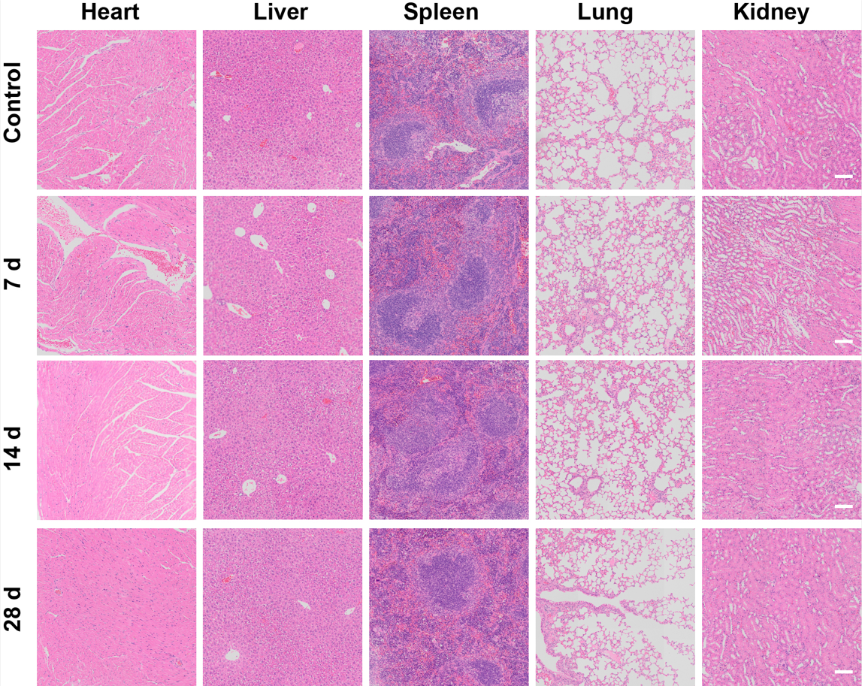
Figure S4 H&E staining of the major organs (heart, liver, spleen, lung and kidney) of the healthy mice in the control group and 7, 14 and 28 days after the injection of MIBFP NPs, the scale bar were 100 µm.
Abbreviations: H&E, hematoxylin and eosin staining; MIBFP NPs, mAbs, ICG, pB-DOX and Fe₃O₄, coloaded poly (lactic-co-glycolic acid) nanoparticles.

Figure S5 CLSM images and the FCM analysis of the intracellular uptake of MIBFP NPs by ZR75.1 cells after various intervals of incubation, the scale bar is 25 µm.
Abbreviations: CLSM, confocal laser scanning microscope; FCM, flow cytometry; MIBFP NPs, mAbs, ICG, pB-DOX and Fe₃O₄, coloaded poly (lactic-co-glycolic acid) nanoparticles.

Figure S6 CLSM images and the FCM analysis of the intracellular uptake of MIBFP NPs by HMEC cells after various intervals of incubation, the scale bar is 25 µm.
Abbreviations: CLSM, confocal laser scanning microscope; FCM, flow cytometry; MIBFP NPs, mAbs, ICG, pB-DOX and Fe₃O₄, coloaded poly (lactic-co-glycolic acid) nanoparticles.

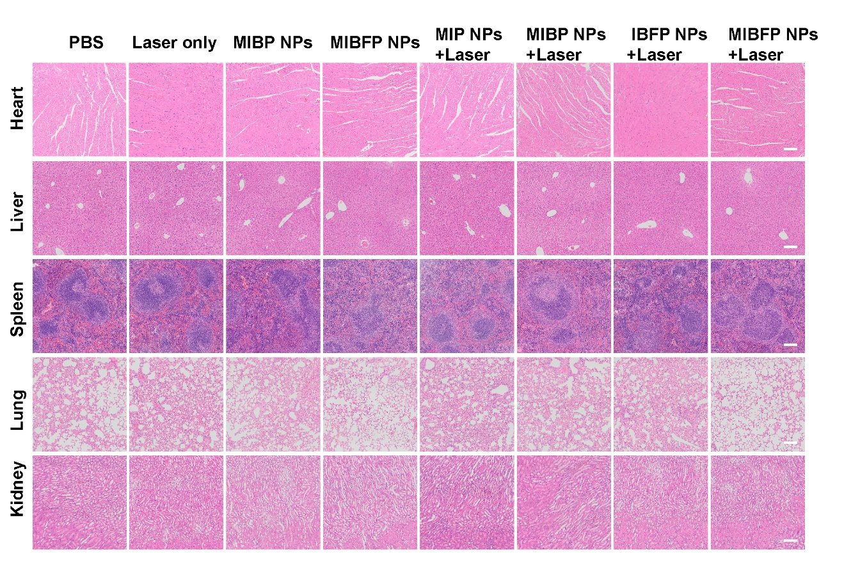
Figure S7 H&E staining images in major organs from each group. The Scale bars is 100 µm.
Abbreviations: H&E, hematoxylin and eosin staining; MIBFP NPs, mAbs, ICG, pB-DOX and Fe₃O₄, coloaded poly (lactic-co-glycolic acid) nanoparticles.

