Supporting Information:

Table S1. The particle sizes and PdI of AGM prepared with different GdCl₃·6H₂O concentrations.
Dopamine:GdCl₃·6H₂O (mg) | Size (nm) | PdI
45 | 342.5±2.7 | 0.427
30 | 278.3±3.5 | 0.488
22.5 | 240.3±1.1 | 0.207
18 | 301.6±2.4 | 0.532
15 | 319.7±0.9 | 0.574

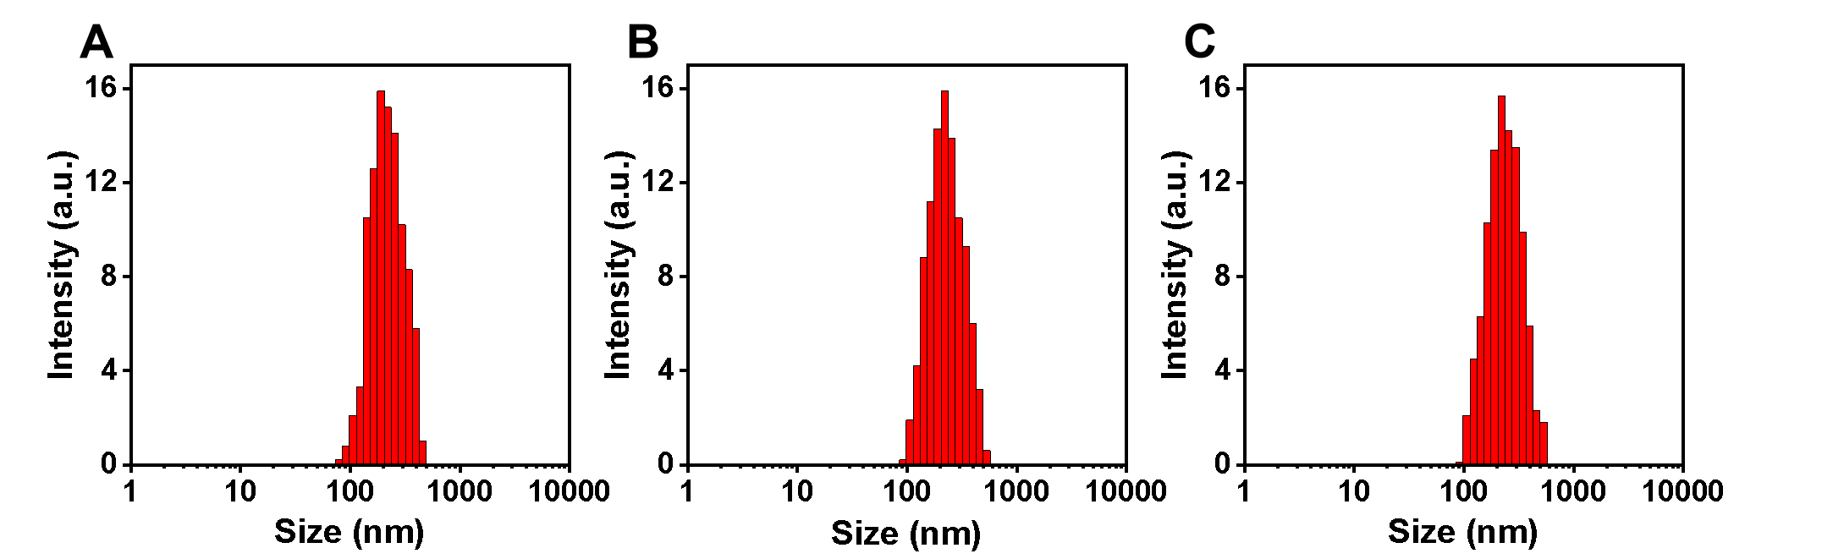
Figure S1. Size distribution of (A) GM, (B) AGM and (C) MAGM.

Table S2. Average size and zeta potential of GM, AGM and MAGM nanoparticles.
Sample | Average Size (nm) | PdI | Zeta Potential (mv)
GM | 228.4 | 0.322 | -18.9
AGM | 240.3 | 0207 | -19.7
MAGM | 247.1 | 0.256 | -19.4

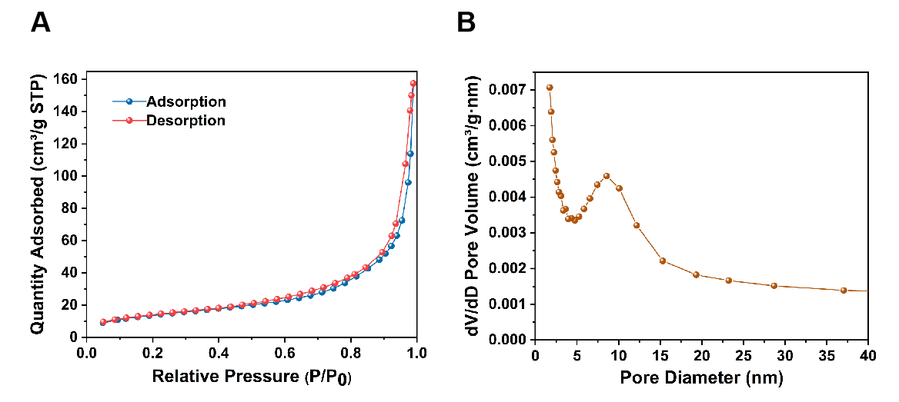
Figure S2. (A) N₂ adsorption-desorption isotherms of AGM; (B) Pore size distribution of AGM.

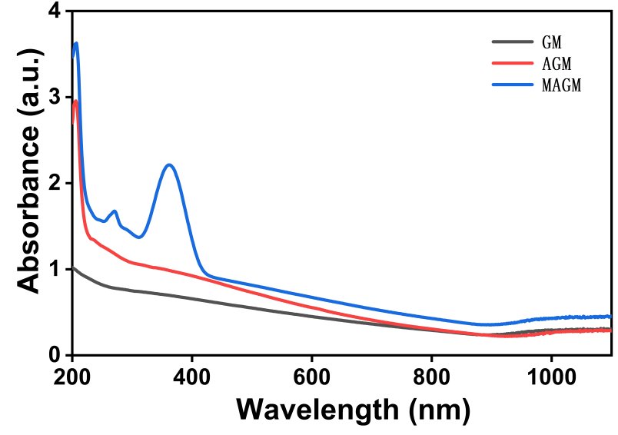
Figure S3. UV-Vis absorption spectra of GM, AGM and MAGM.

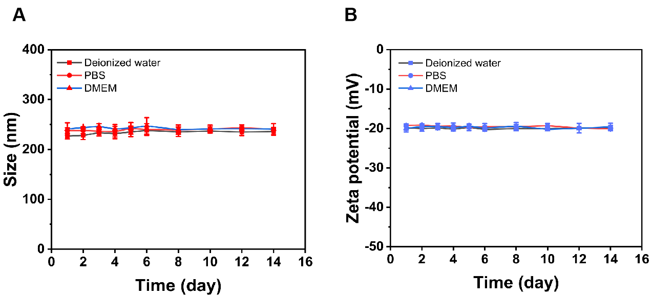
Figure S4. Stability of MAGM in different media (Deionized water, PBS, DMEM). (A) Particle size; (B) Zeta potential of MAGM at different time points.

Figure S5. Cumulative MX release of free MX and MAGM in 96 h (pH=6.5 or 7.4).
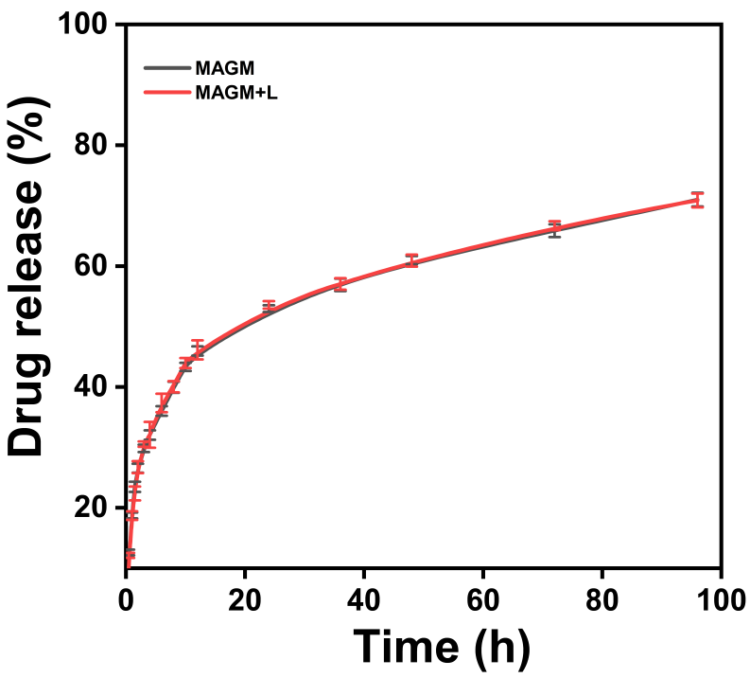
Figure S6. Drug release in the MAGM group versus the MAGM+L group (NIR light irradiation applied after 8h of slow release).

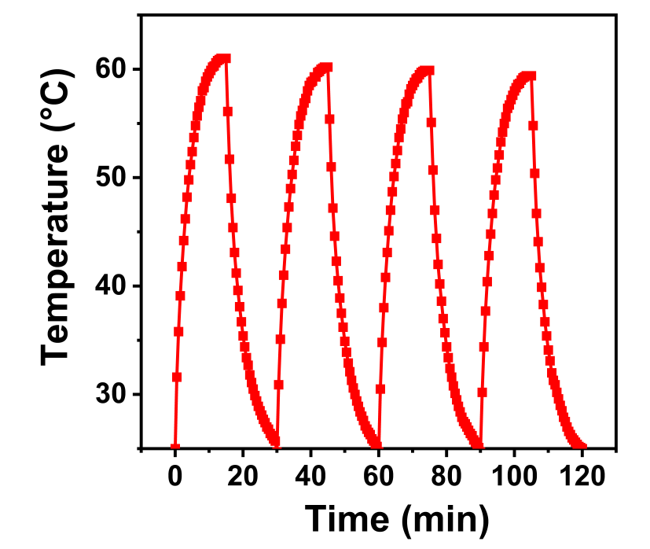
Figure S7. Photothermal stability of AGM (808 nm, 1 W/cm², 100 µg/mL).

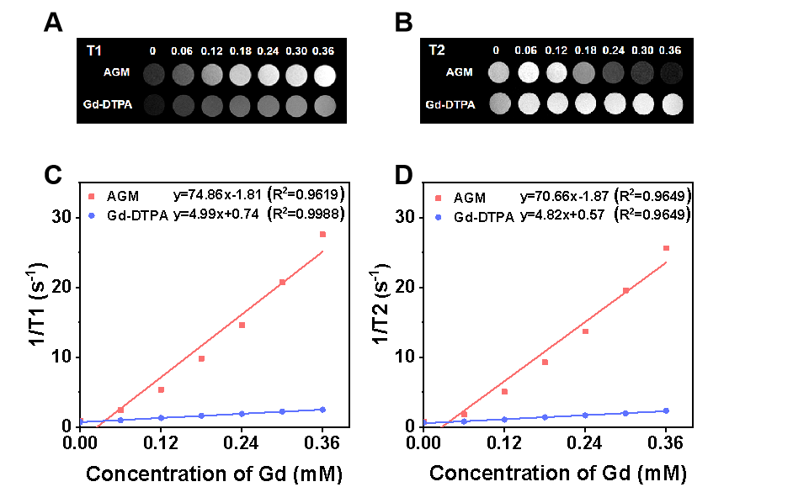
Figure S8. (A) T1-weighted and (B) T2-weighted MRI of AGM and Gd-DTPA; (C) Longitudinal relaxation rates and (D) transverse relaxation rates of AGM and Gd-DTPA (Field strength=3 T).

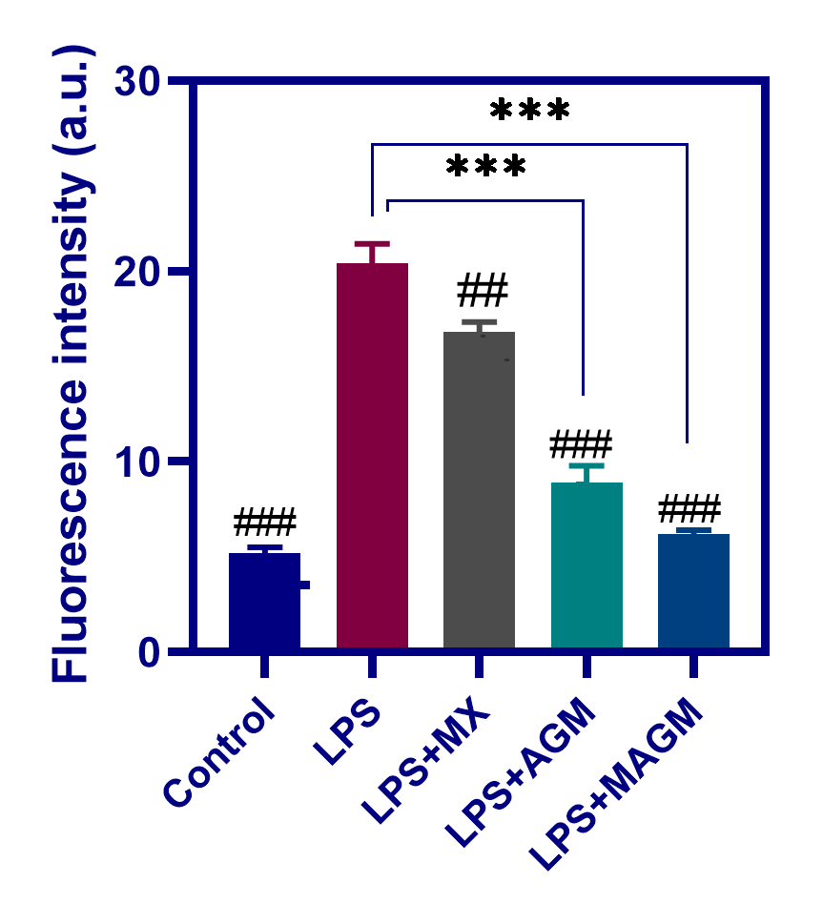
Figure S9. Fluorescence intensity of DCF in RAW264.7 cells after treatment with different groups of NPs, (n =3, ***p < 0.001; ##p < 0.01, and ###p < 0.001, compared with the blank group).

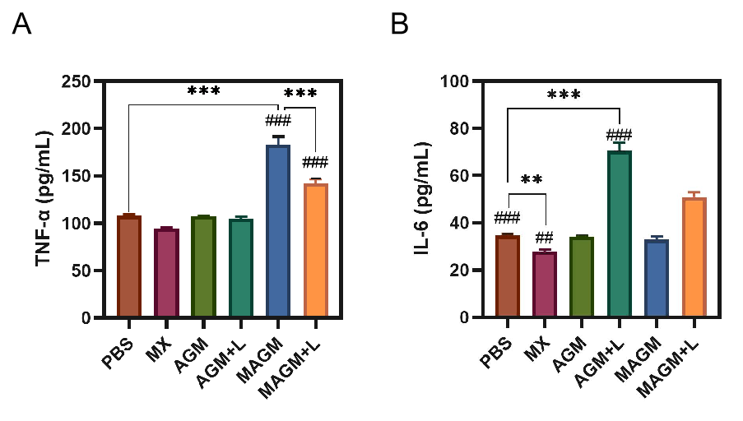
Figure S10. (A) TNF-αand (B) IL-6 levels in RAW 264.7 macrophages after treatment with media from different 4T1 cell samples. (n =3, **p < 0.01, and ***p < 0.001; ##p < 0.01, and ###p < 0.001, compared with the blank group).

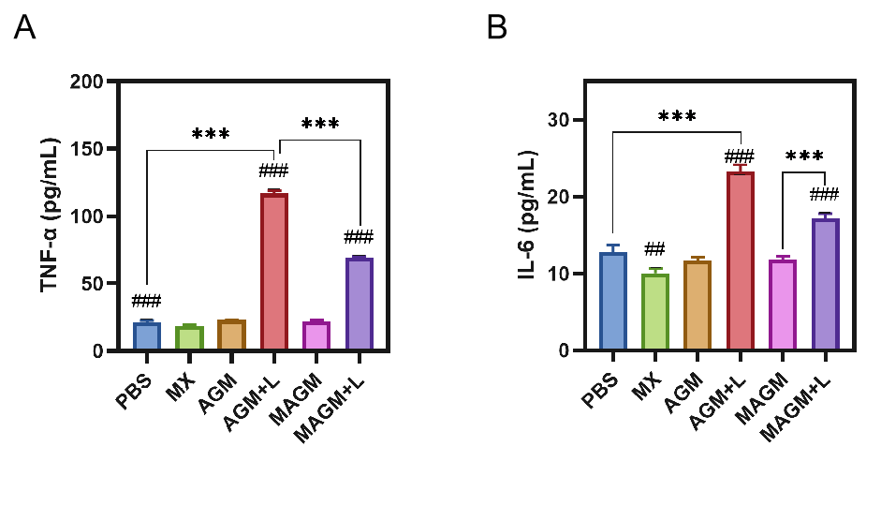
Figure S11. ELISA results about the inflammatory factors of tumor necrosis (A) TNF-α and (B) IL-6 after various treatments. (n =3, ***p < 0.001; ##p < 0.01, and ###p < 0.001, compared with the blank group).
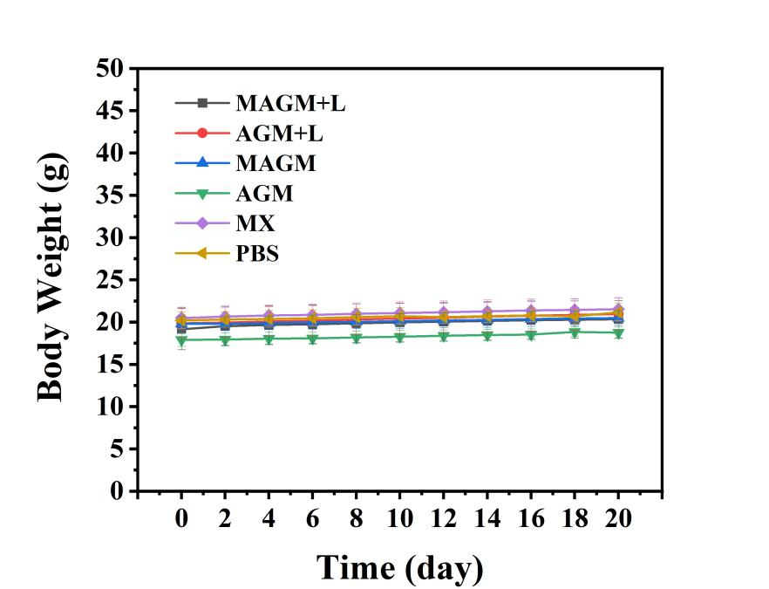
Figure S12. The body weight changes of mice during the treatment period.

