Supplementary file

eTable 1: Multivariate Analysis of Variance results according to EFC and MMC participation
 | EFC&MMC PARTICIPATION |  | P
MANOVA | Statistics | F
Wilks' lambda | 0.9133 | 7,85 | <0 ,001
Pillai's trace | 0.0867 | 7,85 | <0 ,001
Lawley Hotelling trace | 0.0949 | 7,85 | <0 ,001
Roy's larges root | 0.0949 | 7,85 | <0 ,001
Multivariate regression underlying the MANOVA | Coefficient | 95% CI
Overall perception of safety | 0,19 | 0,05 to 0,34 | 0,009
Frequency of event reporting | 0,20 | 0,01 to 0,38 | 0,041
Supervisor/Manager expectations and actions | 0,20 | 0,04 to 0,36 | 0,017
Organizational learning | 0,42 | 0,29 to 0,55 | <0,001
Teamwork within hospital units | 0,23 | 0,1 to 0,37 | 0,001
Communication openness | 0,22 | 0,08 to 0,36 | 0,002
Feedback and communication about error | 0,39 | 0,25 to 0,54 | <0,001
Non punitive response to error | 0,37 | 0,22 to 0,52 | <0,001
Staffing | -0,01 | -0,15 to 0,13 | 0,848
Hospital management support | -0,16 | -0,3 to -0,03 | 0,019
Teamwork across hospital units | 0,11 | -0,00 to 0,22 | 0,054
Hospital handsoff and transitions | 0,00 | -0,12 to 0,12 | 0,971
The model included the 12 dimensions scores as dependent variables and the EFC&MMC participation, sex, hospital sector, and healthcare profession category as independent variables.
eTable 2: Multivariate Analysis of Variance results according to EFC participation
 | EFC PARTICIPATION |  | P
MANOVA | Statistics | F
Wilks' lambda | 0.9492 | 4,4 | <0 ,001
Pillai's trace | 0.0508 | 4,4 | <0 ,001
Lawley Hotelling trace | 0.0535 | 4,4 | <0 ,001
Roy's larges root | 0.0535 | 4,4 | <0 ,001
Multivariate regression underlying the MANOVA | Coefficient | 95% CI
Overall perception of safety | 0,07 | -0,07 to 0,2 | 0,324
Frequency of event reporting | 0,14 | -0,03 to 0,32 | 0,111
Supervisor/Manager expectations and actions | 0,24 | 0,09 to 0,38 | 0,002
Organizational learning | 0,21 | 0,09 to 0,33 | 0,001
Teamwork within hospital units | 0,13 | 0,00 to 0,26 | 0,043
Communication openness | 0,24 | 0,11 to 0,37 | <0,001
Feedback and communication about error | 0,36 | 0,22 to 0,5 | <0,001
Non punitive response to error | 0,27 | 0,13 to 0,41 | <0,001
Staffing | 0,01 | -0,14 to 0,12 | 0,876
Hospital management support | -0,09 | -0,21 to 0,04 | 0,171
Teamwork across hospital units | -0,02 | -0,12 to 0,08 | 0,637
Hospital handsoff and transitions | 0,03 | -0,08 to 0,14 | 0,571
The model included the 12 dimensions scores as dependent variables and the EFC (only) participation, sex, hospital sector, and healthcare profession category as independent variables.

eTable 3: Multivariate Analysis of Variance results according to MMC participation
 | MMC PARTICIPATION |  | P
MANOVA | Statistics | F
Wilks' lambda | 0.9573 | 3,81 | <0 ,001
Pillai's trace | 0.0427 | 3,81 | <0 ,001
Lawley Hotelling trace | 0.0447 | 3,81 | <0 ,001
Roy's larges root | 0.0447 | 3,81 | <0 ,001
Multivariate regression underlying the MANOVA | Coefficient | 95% CI
Overall perception of safety | 0,11 | -0,03 to 0,25 | 0,116
Frequency of event reporting | 0,2 | 0,02 to 0,38 | 0,033
Supervisor/Manager expectations and actions | 0,13 | -0,03 to 0,28 | 0,107
Organizational learning | 0,21 | 0,08 to 0,33 | 0,001
Teamwork within hospital units | 0,03 | -0,10 to 0,16 | 0,66
Communication openness | 0,06 | -0,07 to 0,20 | 0,369
Feedback and communication about error | 0,17 | 0,02 to 0,31 | 0,024
Non punitive response to error | 0,21 | 0,06 to 0,35 | 0,005
Staffing | 0,1 | -0,04 to 0,24 | 0,144
Hospital management support | -0,16 | -0,29 to -0,04 | 0,012
Teamwork across hospital units | 0,03 | -0,08 to 0,13 | 0,63
Hospital handsoff and transitions | -0,07 | -0,19 to 0,05 | 0,242
The model included the 12 dimensions scores as dependent variables and the MMC (only) participation, sex, hospital sector, and healthcare profession category as independent variables.

eTable 4: Comparison of Safety Grade and Event Reporting according to QIP participation
 | Safety grade |  |  |  |  | Reported an event within the past 12 months
 | Excellent or very good |  | Good, Fair, or poor |  | P value | One or more |  | None |  | P value
Participation in quality improvement, n (%) |  |  |  |  | 0.02 |  |  |  |  | <0.0001
Yes | 287 | (50.3) | 284 | (49.7) |  | 425 | (74.4) | 146 | (25.6)
No | 389 | (43.9) | 497 | (56.1) |  | 507 | (57.2) | 379 | (42.8)
Participation in EFC only, n (%) |  |  |  |  | 0,1 |  |  |  |  | <0.0001
Yes | 88 | (50,6) | 86 | (49,4) |  | 136 | (78,2) | 38 | (21,8)
No | 389 | (43.9) | 497 | (56.1) |  | 507 | (57.2) | 379 | (42.8)
Participation in MMC only, n (%) |  |  |  |  | 0,2 |  |  |  |  | 0,02
Yes | 104 | (48,8) | 109 | (51,2) |  | 141 | (66,2) | 72 | (33,8)
No | 389 | (43.9) | 497 | (56.1) |  | 507 | (57.2) | 379 | (42.8)
Participation in MMC and EFC |  |  |  |  | 0,05 |  |  |  |  | <0.0001
Yes | 95 | (51,6) | 89 | (48,4) |  | 148 | (80,4) | 36 | (19,6)
No | 389 | (43.9) | 497 | (56.1) |  | 507 | (57.2) | 379 | (42.8)

eFigure 1: Comparison of HSOPS scores according to EFC participation (effect size)
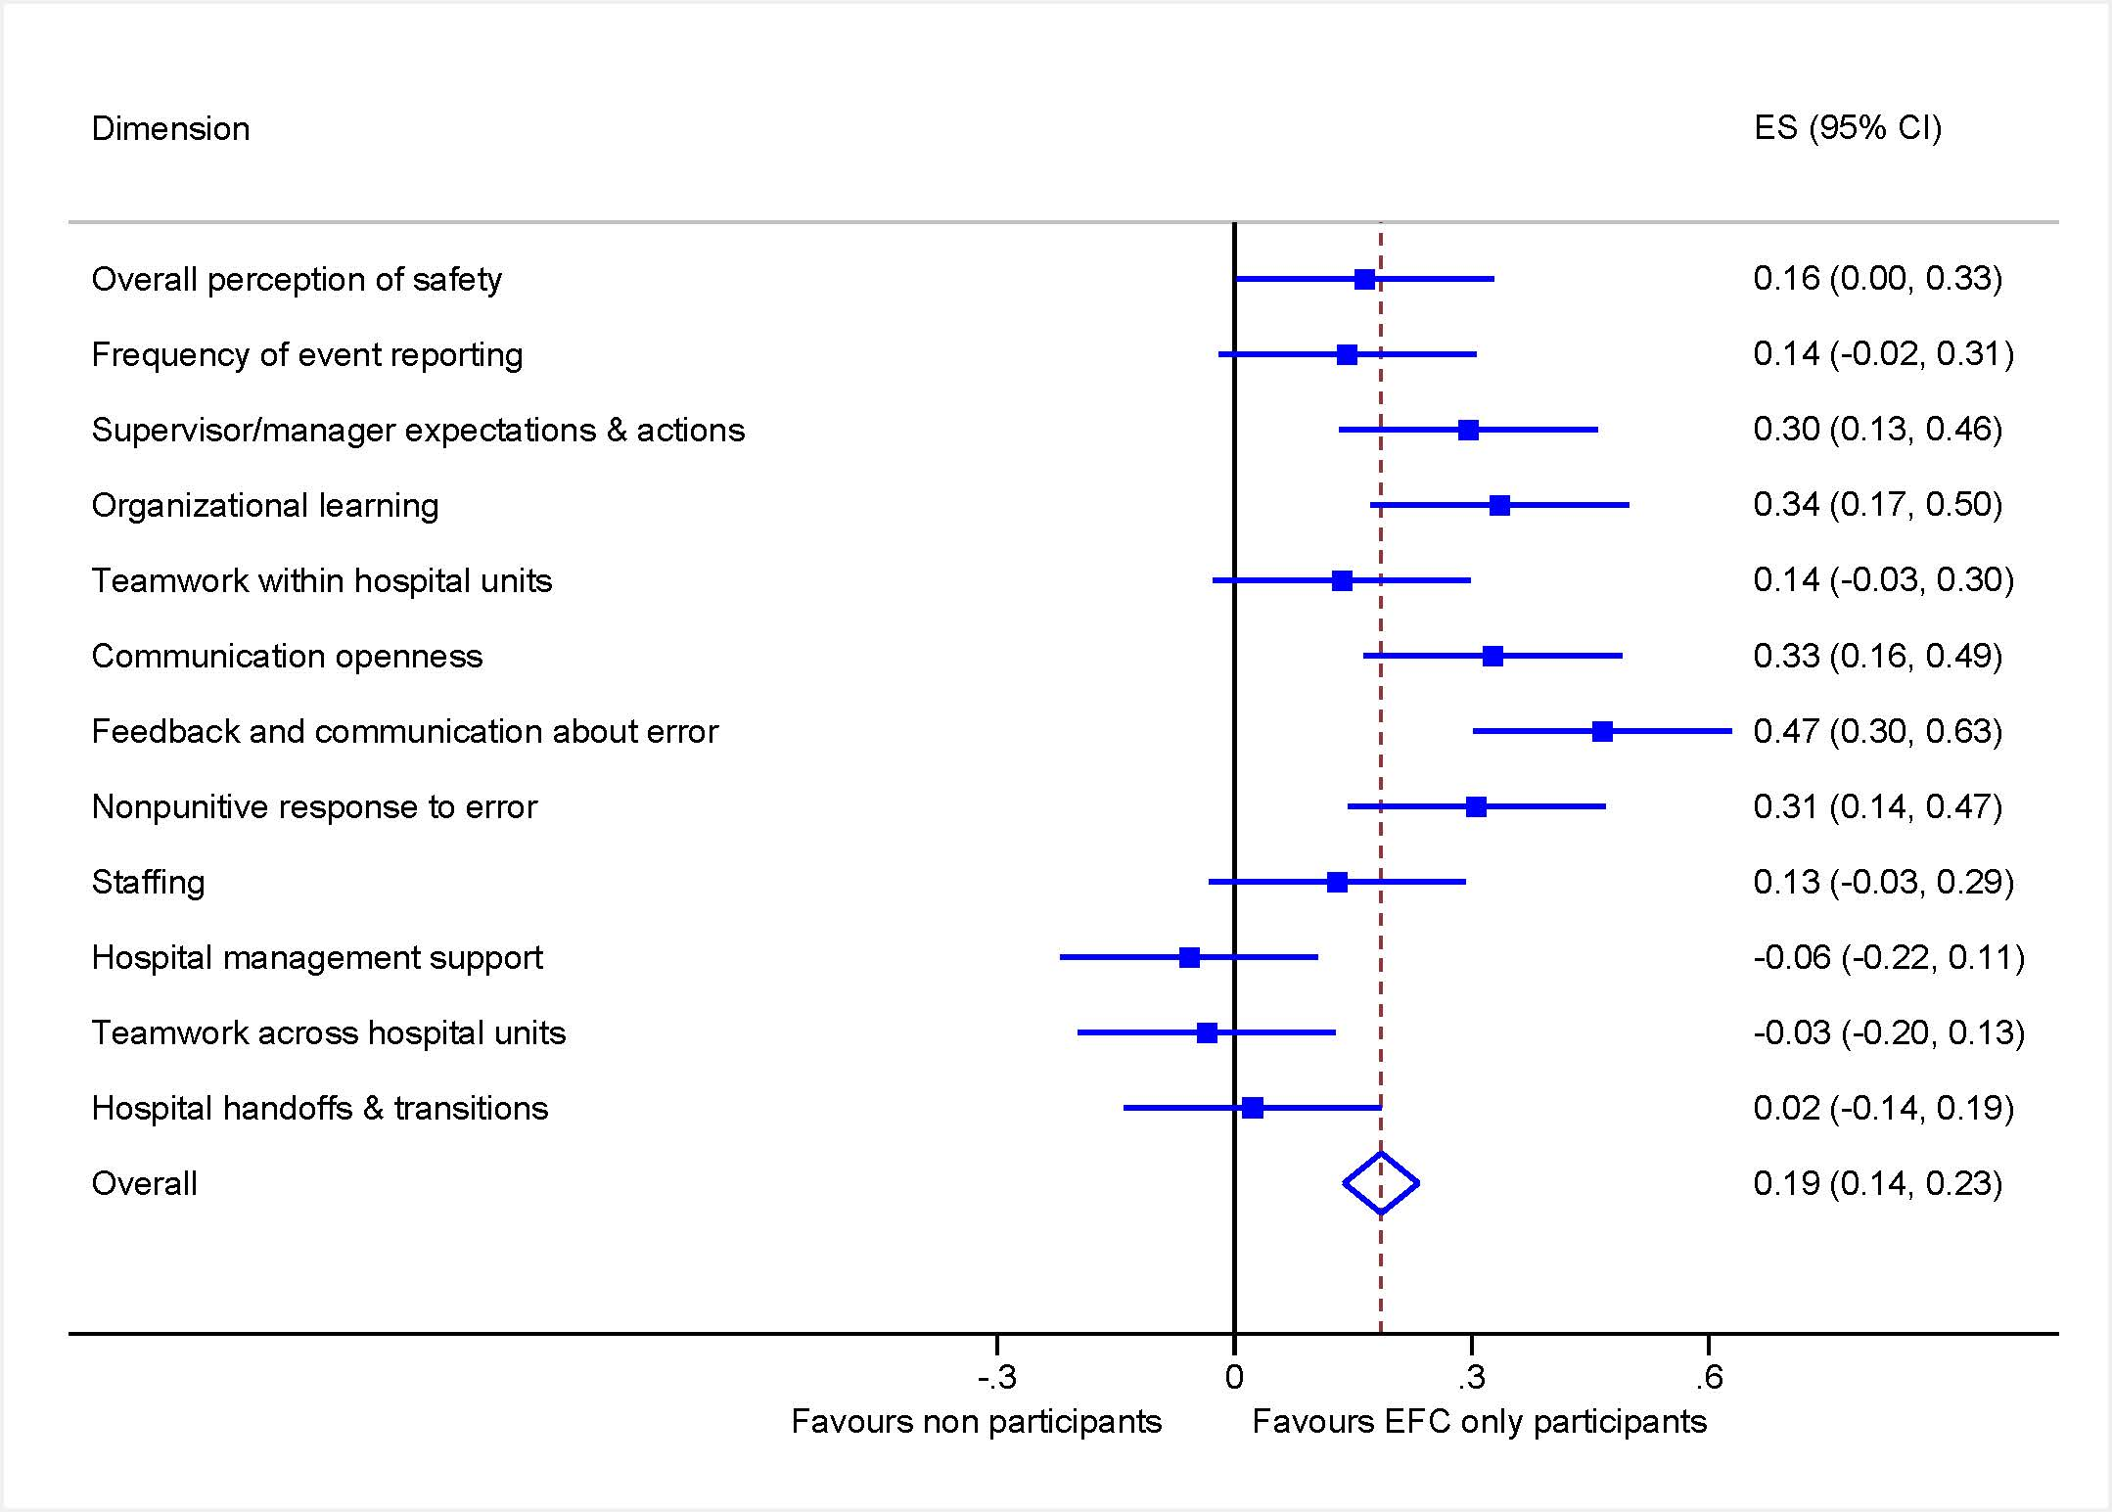
eFigure 2: Comparison of HSOPS scores according to MMC participation (effect size)
