Table S1. The number of different cellular subsets in LS USD and non-LS USD
Cell type | LS USD | non-LS USD
Endothelial cells | 4134 | 6957
Smooth muscle cells | 2243 | 904
Myeloid cells | 1333 | 194
Fibroblasts | 352 | 450
Epithelial cells | 151 | 26
T cells | 27 | 12
B cells | 21 | 20
Mast cells | 20 | 2
Plasma cells | 4 | 87

Table S2. The marker genes of different cellular subsets
Cell type | ABV | Marker genes
Myeloid cells | MCs | LYZ, MRC1, CD68, CD163, FCER1A
Endothelial cells | ECs | CDH5, PECAM1, VWF
Fibroblasts | FBs | DCN, COL1A2, COL1A1
Smooth muscle cells | SMCs | ACTA2, TAGLN, MYLK
Plasma cells | PCs | CD79A, JCHAIN, MZB1, IGHG1
Epithelial cells | EPCs | KRT5, KRT15, KRT14, KRT17, KRT13
T cells | TCs | CD2, CD3D, TRAC, TRBC1
B cells | BCs | MS4A1, CD79A, CD79B
Mast cells | Masts | TPSAB1, TPSB2, CPA3

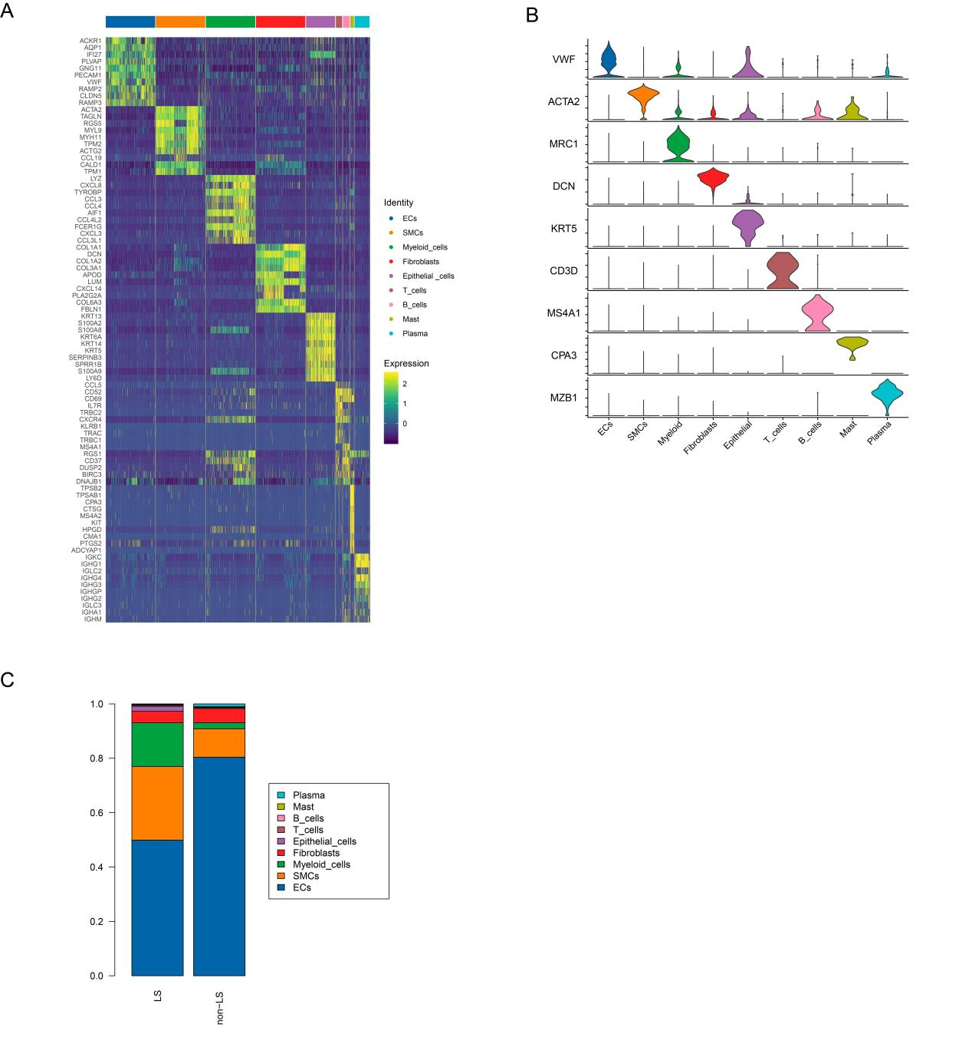
Figure S1. scRNA-seq reveals the cellular diversity of urethra stricture tissue in LS and non-LS patients.
A. The Heatmap displays expression of top 10 differentially expressed genes (columns) across the cellular subsets (rows). Yellow represents genes with high expression, while blue represents genes with low expression.
B. Violin plot showing the expression of canonical genes of each cell types in urethra stricture.
C. Bar chart showing the relative proportion of each cell types in LS USD and non-LS USD.

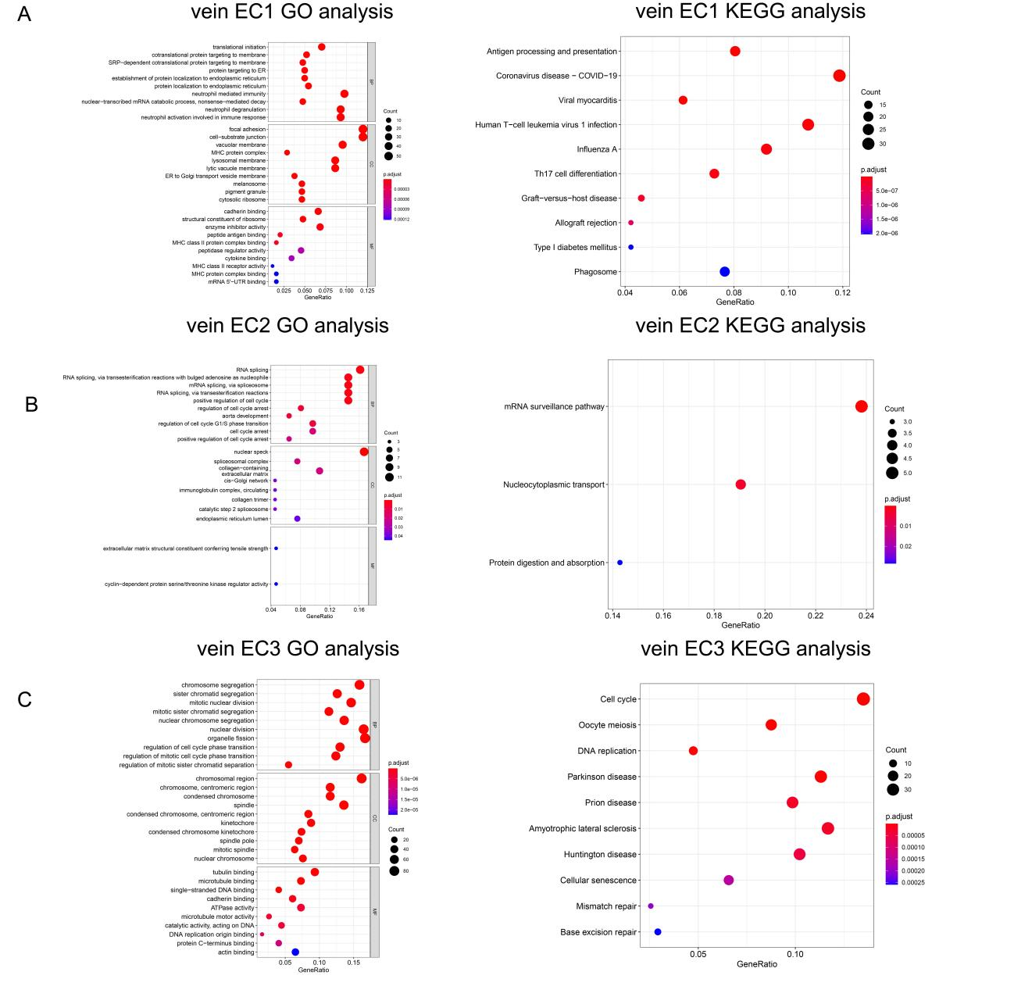
Figure S2. Representative signifcantly enriched GO and KEGG processes were performed with the signifcantly upregulated genes in vein EC1, vein EC2 and vein EC3.
- GO and KEGG analysis of upregulated DEGs in vein EC1.
- GO and KEGG analysis of upregulated DEGs in vein EC2.
- GO and KEGG analysis of upregulated DEGs in vein EC3.
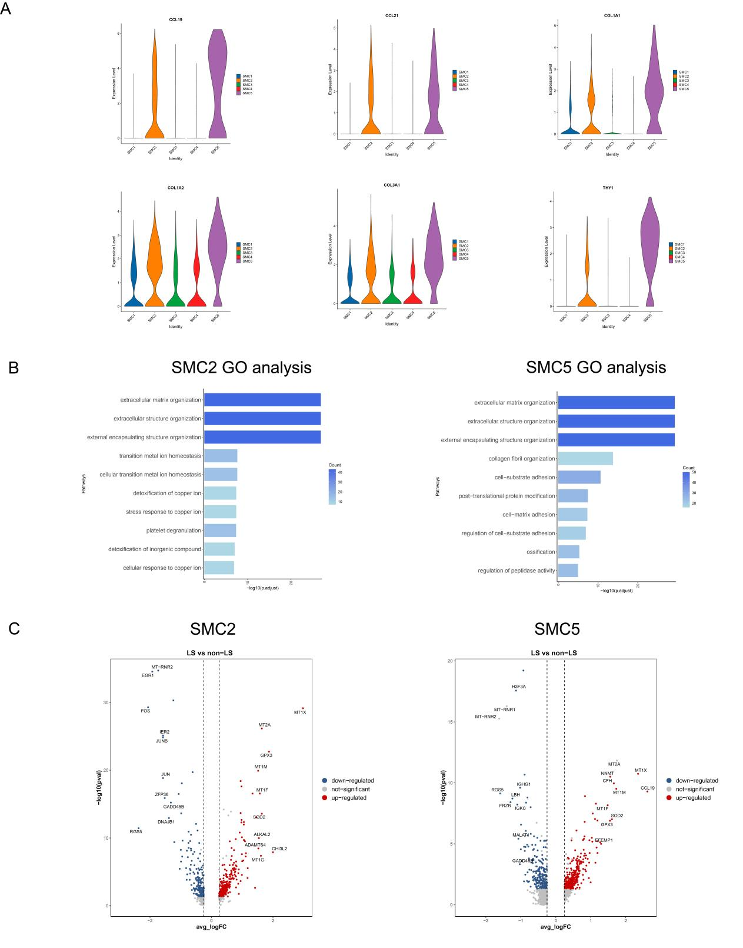
Figure S3. Characteristics of SMC2 and SMC5 in LS USD and non-LS USD
- Violin plot showing the expression of CCL19, CCL21, COL1A1, COL3A1 and THY1 in SMC subsets.
- Representative GO terms enriched by upregulated DEGs of SMC2 and SMC5.
- Volcano plots showing DEGs of SMC2 and SMC5 in LS/non-LS comparison.
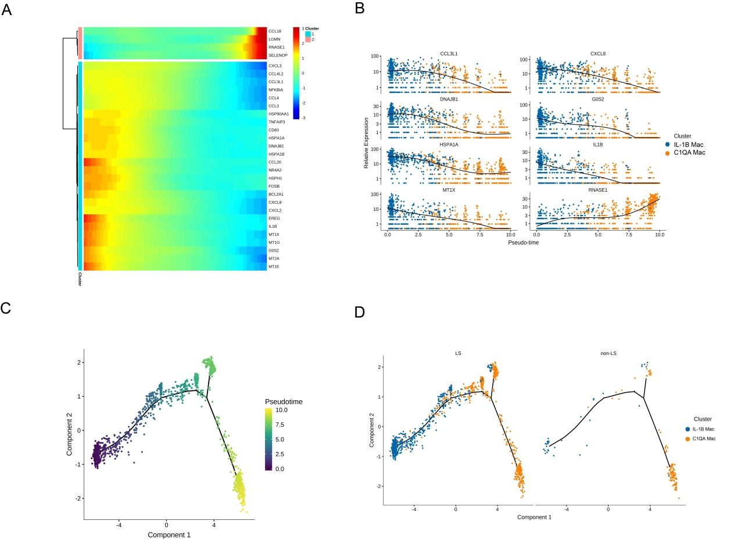
Figure S4. Pseudotime trajectories of Macs in LS USD and non-LS USD.
- Heatmap presenting the relative expressions of Mac markers along the supposed trajectories in two Mac gene sets. The red and blue branches represent the two differential directions.
B. Monocle pseudotime trajectory expression pattern of two Mac subsets.
C-D. Pseudotime trajectories of the Mac subsets in LS USD and non-LS USD.
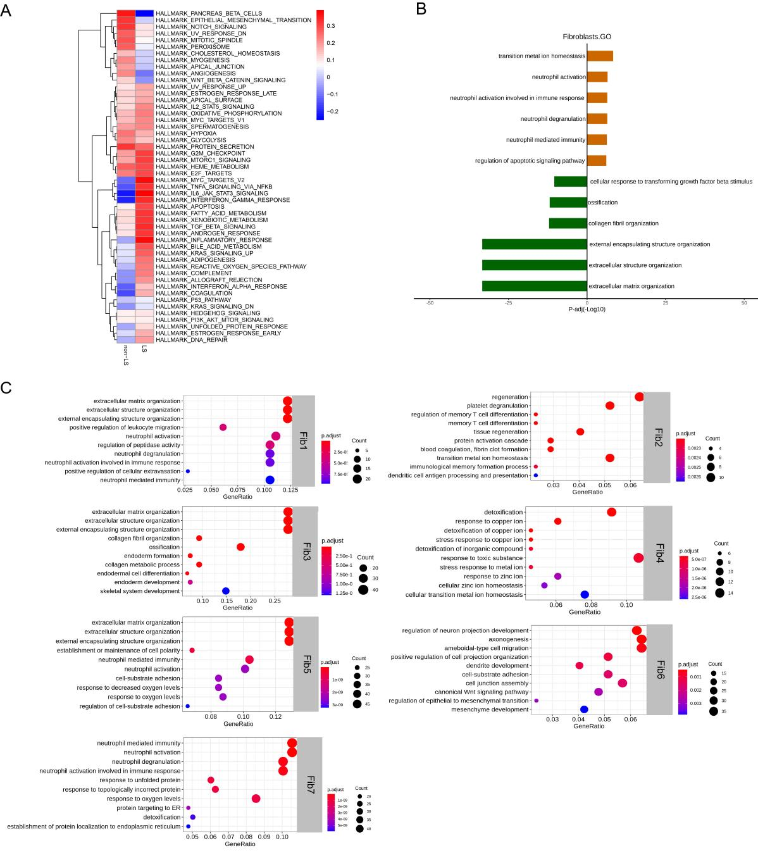
Figure S5. Functional enrichment analysis of FBs and FBs subsets.
- Activation of Hallmark pathways (scored per cell by GSVA) of FBs in LS/non-LS comparison.
- Representative GO terms enriched by upregulated and downregulated DEGs of FBs in LS/non-LS comparison.
- Representative GO terms enriched by upregulated DEGs of different FBs subsets.
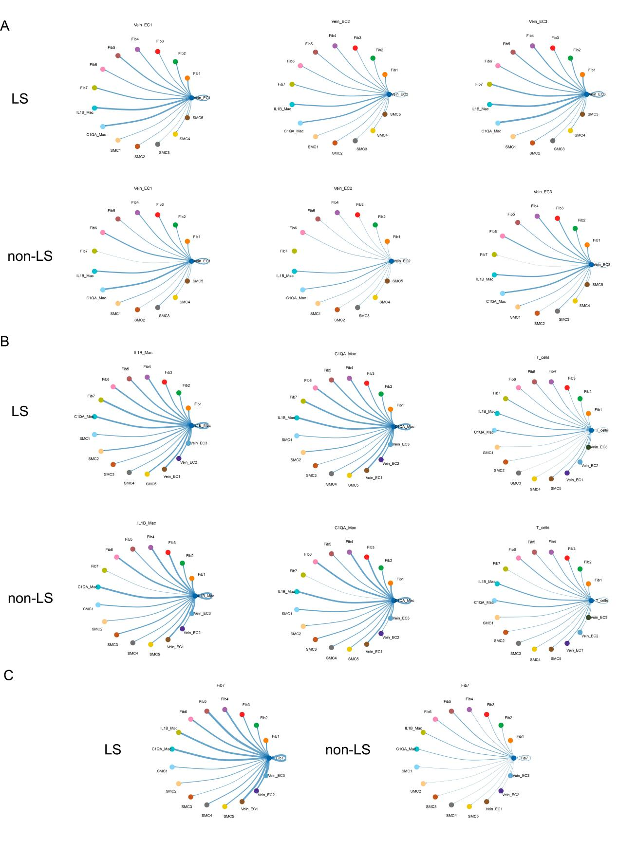
Figure S6. Cell communication between cellular subsets in LS USD and non-LS USD.
- The cellular interaction network between the major celluar subsets and vein EC1, vein EC2, vein EC3.
B. The cellular interaction network between the major celluar subsets and IL-1B Mac, C1QA Mac, and T cells.
C. The cellular interaction network between the major celluar subsets and Fib7.

