Supplementary Table 1. Association between sleep duration with cardiometabolic diseases among age and gender subgroups

Sleep duration | Overall | p value |  | ≤ 65 years | p value | > 65 years | p value |  | Female | p value | Male | p value
Sleep duration | PR (95% CI) | p value |  | PR (95% CI) | p value | PR (95% CI) | p value |  | PR (95% CI) | p value | PR (95% CI) | p value
CMDs
6-8h | Reference |  |  | Reference |  | Reference |  |  | Reference |  | Reference
< 6h | 1.140 (1.068-1.218) | < 0.001 |  | 1.340 (1.181-1.519) | < 0.001 | 1.110 (1.027-1.200) | 0.008 |  | 1.157 (1.062-1.260) | 0.001 | 1.120 (1.011-1.242) | 0.031
> 8h | 1.060 (0.961-1.169) | 0.244 |  | 0.973 (0.825-1.148) | 0.747 | 1.114 (0.986-1.258) | 0.084 |  | 1.143 (1.011-1.292) | 0.033 | 0.933 (0.792-1.098) | 0.403
P _{for trend} |  | 0.003 |  |  | 0.078 |  | 0.005 |  |  | 0.001 |  | 0.603
DM
6-8h | Reference |  |  | Reference |  | Reference |  |  | Reference |  | Reference
< 6h | 1.199 (1.115-1.290) | < 0.001 |  | 1.339 (1.167-1.537) | < 0.001 | 1.183 (1.085-1.291) | < 0.001 |  | 1.195 (1.087-1.314) | < 0.001 | 1.206 (1.075-1.353) | 0.001
> 8h | 1.072 (0.963-1.193) | 0.205 |  | 1.000 (0.840-1.190) | 0.999 | 1.116 (0.974-1.279) | 0.115 |  | 1.169 (1.023-1.334) | 0.021 | 0.919-(0.766-1.103) | 0.363
P _{for trend} |  | < 0.001 |  |  | 0.069 |  | 0.001 |  |  | < 0.001 |  | 0.326
Stroke
6-8h | Reference |  |  | Reference |  | Reference |  |  | Reference |  | Reference
< 6h | 1.206 (0.959-1.517) | 0.109 |  | 1.338 (0.879-2.039) | 0.175 | 1.229 (0.931-1.622) | 0.146 |  | 1.284 (0.930-1.774) | 0.129 | 1.155 (0.835-1.599) | 0.384
> 8h | 1.051 (0.718-1.538) | 0.799 |  | 0.791 (0.403-1.554) | 0.496 | 1.272 (0.800-2.021) | 0.310 |  | 1.221 (0.740-2.015) | 0.434 | 0.881 (0.489-1.587) | 0.674
P _{for trend} |  | 0.266 |  |  | 0.905 |  | 0.110 |  |  | 0.147 |  | 0.844
Ischemic stroke
6-8h | Reference |  |  | Reference |  | Reference |  |  | Reference |  | Reference
< 6h | 1.219 (0.952-1.561) | 0.117 |  | 1.250 (0.775-2.017) | 0.361 | 1.252 (0.932-1.683) | 0.136 |  | 1.270 (0.900-1.793) | 0.174 | 1.198 (0.839-1.709) | 0.320
> 8h | 0.960 (0.627-1.470) | 0.850 |  | 0.627 (0.276-1.426) | 0.266 | 1.215 (0.736-2.006) | 0.446 |  | 1.105 (0.638-1.914) | 0.722 | 0.807 (0.410-1.589) | 0.535
P _{for trend} |  | 0.447 |  |  | 0.637 |  | 0.150 |  |  | 0.299 |  | 0.899
Hemorrhagic stroke
6-8h | Reference |  |  | Reference |  | Reference |  |  | Reference |  | Reference
< 6h | 1.015 (0.590-1.746) | 0.958 |  | 1.468 (0.646-3.335) | 0.359 | 0.986 (0.482-2.016) | 0.968 |  | 1.351 (0.620-2.944) | 0.449 | 0.790 (0.369-1.695) | 0.546
> 8h | 1.719 (0.853-3.464) | 0.129 |  | 1.087 (0.333-3.542) | 0.890 | 2.650 (1.088-6.457) | 0.032 |  | 1.946 (0.677-5.595) | 0.217 | 1.551 (0.607-3.962) | 0.359
P _{for trend} |  | 0.237 |  |  | 0.574 |  | 0.127 |  |  | 0.178 |  | 0.703
CAD
6-8h | Reference |  |  | Reference |  | Reference |  |  | Reference |  | Reference
< 6h | 1.268 (1.097-1.466) | 0.001 |  | 1.458 (0.995-2.136) | 0.053 | 1.061 (0.906-1.242) | 0.463 |  | 1.410 (1.173-1.696) | < 0.001 | 1.084 (0.857-1.372) | 0.502
> 8h | 1.123 (0.884-1.426) | 0.341 |  | 1.039 (0.623-1.733) | 0.884 | 1.160 (0.886-1.519) | 0.281 |  | 1.112 (0.814-1.521) | 0.504 | 1.138 (0.787-1.646) | 0.492
P _{for trend} |  | 0.012 |  |  | 0.329 |  | 0.227 |  |  | 0.011 |  | 0.372

Multivariate Poisson regression analysis was utilized in these models, and were adjusted by age (continuous variable), gender (for age subgroups), height (continuous variable), rural residents, well educated, CCVD family history, high income, smoking, physical inactivity, vegetables insufficiency, fruits consumption habit

CMDs: cardiometabolic diseases; DM: diabetes mellitus; CAD: coronary artery disease; PR: prevalence ratio. CCVD: cardiac-cerebral vascular disease

Supplementary Table 2. Relation between sleep duration and cardiometabolic diseases among age with gender subgroups

Sleep duration | Overall | p value | Younger females | p value | Older females | p value | Younger males | p value | Older males | p value
Sleep duration | PR (95% CI) | p value | PR (95% CI) | p value | PR (95% CI) | p value | PR (95% CI) | p value | PR (95% CI) | p value
CMDs
6-8h | Reference |  | Reference |  | Reference |  | Reference |  | Reference
<6h | 1.140 (1.068-1.218) | < 0.001 | 1.344 (1.145-1.578) | < 0.001 | 1.132 (1.022-1.254) | 0.018 | 1.339 (1.092-1.642) | 0.005 | 1.086 (0.963-1.224) | 0.179
>8h | 1.060 (0.961-1.169) | 0.244 | 1.104 (0.903-1.349) | 0.335 | 1.169 (1.001-1.365) | 0.049 | 0.769 (0.575-1.028) | 0.077 | 1.025 (0.841-1.249) | 0.808
P _{for trend} |  | 0.003 |  | 0.015 |  | 0.005 |  | 0.789 |  | 0.341
DM
6-8h | Reference |  | Reference |  | Reference |  | Reference |  | Reference
<6h | 1.199 (1.115-1.290) | < 0.001 | 1.340 (1.125-1.595) | 0.001 | 1.182 (1.056-1.324) | 0.004 | 1.344 (1.074-1.681) | 0.010 | 1.188 (1.038-1.359) | 0.012
>8h | 1.072 (0.963-1.193) | 0.205 | 1.133 (0.917-1.401) | 0.248 | 1.192 (1.006-1.414) | 0.043 | 0.796 (0.587-1.079) | 0.141 | 0.992 (0.790-1.246) | 0.947
P _{for trend} |  | < 0.001 |  | 0.015 |  | 0.002 |  | 0.872 |  | 0.170
Stroke
6-8h | Reference |  | Reference |  | Reference |  | Reference |  | Reference
<6h | 1.206 (0.959-1.517) | 0.109 | 1.353 (0.768-2.386) | 0.295 | 1.333 (0.889-1.999) | 0.164 | 1.305 (0.695-2.449) | 0.408 | 1.184 (0.807-1.736) | 0.388
>8h | 1.051 (0.718-1.538) | 0.799 | 1.101 (0.506-2.394) | 0.808 | 1.332 (0.691-2.568) | 0.392 | 0.388 (0.095-1.588) | 0.188 | 1.226 (0.636-2.364) | 0.542
P _{for trend} |  | 0.266 |  | 0.483 |  | 0.146 |  | 0.493 |  | 0.343
Ischemic stroke
6-8h | Reference |  | Reference |  | Reference |  | Reference |  | Reference
<6h | 1.219 (0.952-1.561) | 0.117 | 1.249 (0.670-2.327) | 0.484 | 1.341 (0.873-2.061) | 0.180 | 1.239 (0.586-2.621) | 0.575 | 1.216 (0.808-1.832) | 0.348
>8h | 0.960 (0.627-1.470) | 0.850 | 0.861 (0.346-2.142) | 0.748 | 1.320 (0.661-2.635) | 0.432 | 0.264 (0.036-1.915) | 0.188 | 1.127 (0.543-2.339) | 0.748
P _{for trend} |  | 0.447 |  | 0.945 |  | 0.170 |  | 0.388 |  | 0.427
Hemorrhagic stroke
6-8h | Reference |  | Reference |  | Reference |  | Reference |  | Reference
<6h | 1.015 (0.590-1.746) | 0.958 | 1.721 (0.532-5.564) | 0.365 | 1.280 (0.444-3.691) | 0.648 | 1.348 (0.425-4.271) | 0.612 | 0.789 (0.294-2.118) | 0.637
>8h | 1.719 (0.853-3.464) | 0.129 | 1.634 (0.374-7.146) | 0.514 | 2.469 (0.533-11.436) | 0.248 | 0.624 (0.083-4.685) | 0.646 | 2.796 (0.929-8.417) | 0.067
P _{for trend} |  | 0.237 |  | 0.338 |  | 0.284 |  | 0.896 |  | 0.271
CAD
6-8h | Reference |  | Reference |  | Reference |  | Reference |  | Reference
<6h | 1.268 (1.097-1.466) | 0.001 | 1.059 (0.625-1.795) | 0.831 | 0.907 (0.723-1.137) | 0.397 | 1.349 (0.731-2.490) | 0.338 | 0.876 (0.676-1.134) | 0.313
>8h | 1.123 (0.884-1.426) | 0.341 | 1.300 (.714-2.368) | 0.391 | 1.030 (0.712-1.489) | 0.877 | 0.797 (0.290-2.193) | 0.660 | 1.193 (0.801-1.778) | 0.386
P _{for trend} |  | 0.012 |  | 0.413 |  | 0.696 |  | 0.892 |  | 0.318

The demarcation between the younger and older age was set at 65 years. Multivariate Poisson regression analysis was utilized in these models, and were adjusted by age (continuous variable), height (continuous variable), rural residents, well educated, CCVD family history, high income, smoking, physical inactivity, vegetables insufficiency, fruits consumption habit

CMDs: cardiometabolic diseases; DM: diabetes mellitus; CAD: coronary artery disease; PR: prevalence ratio. CCVD: cardiac-cerebral vascular disease

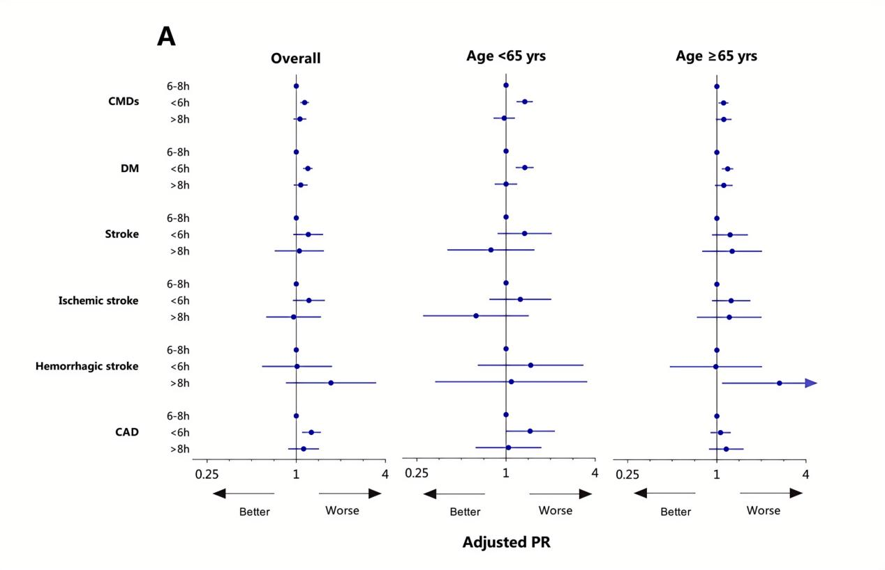
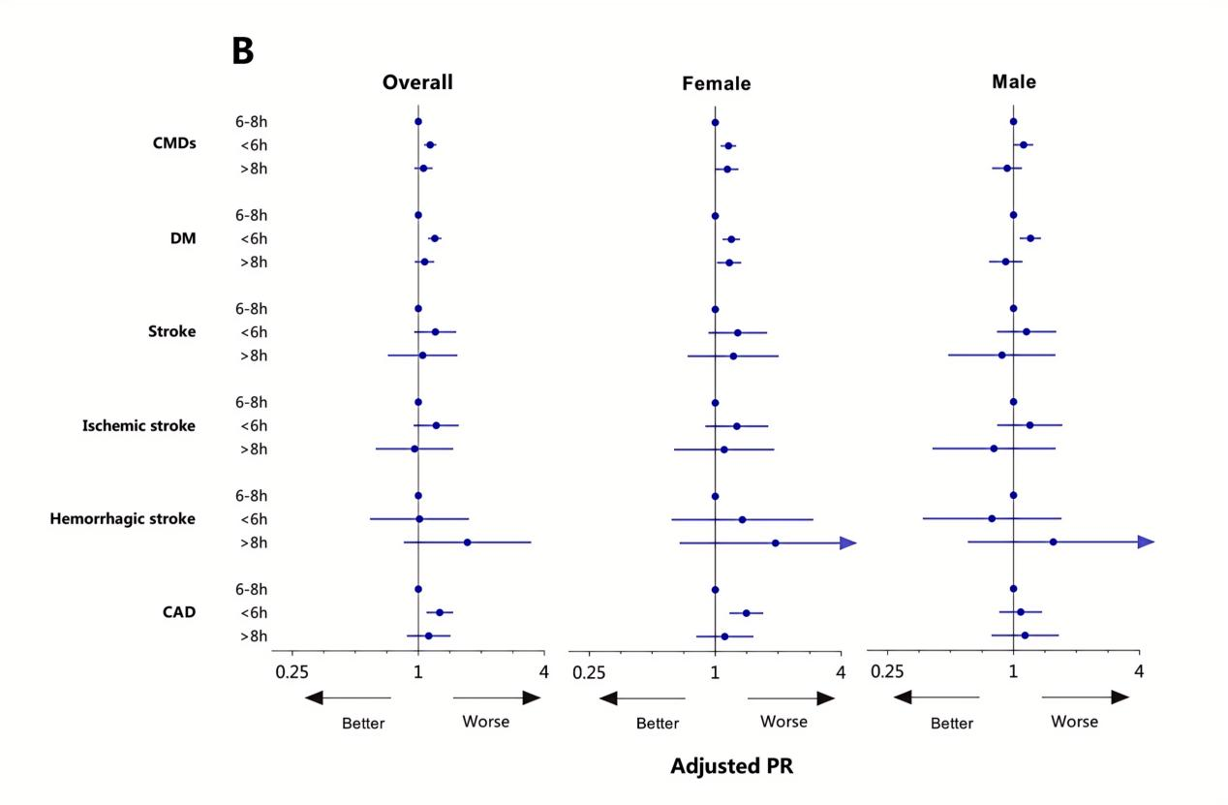
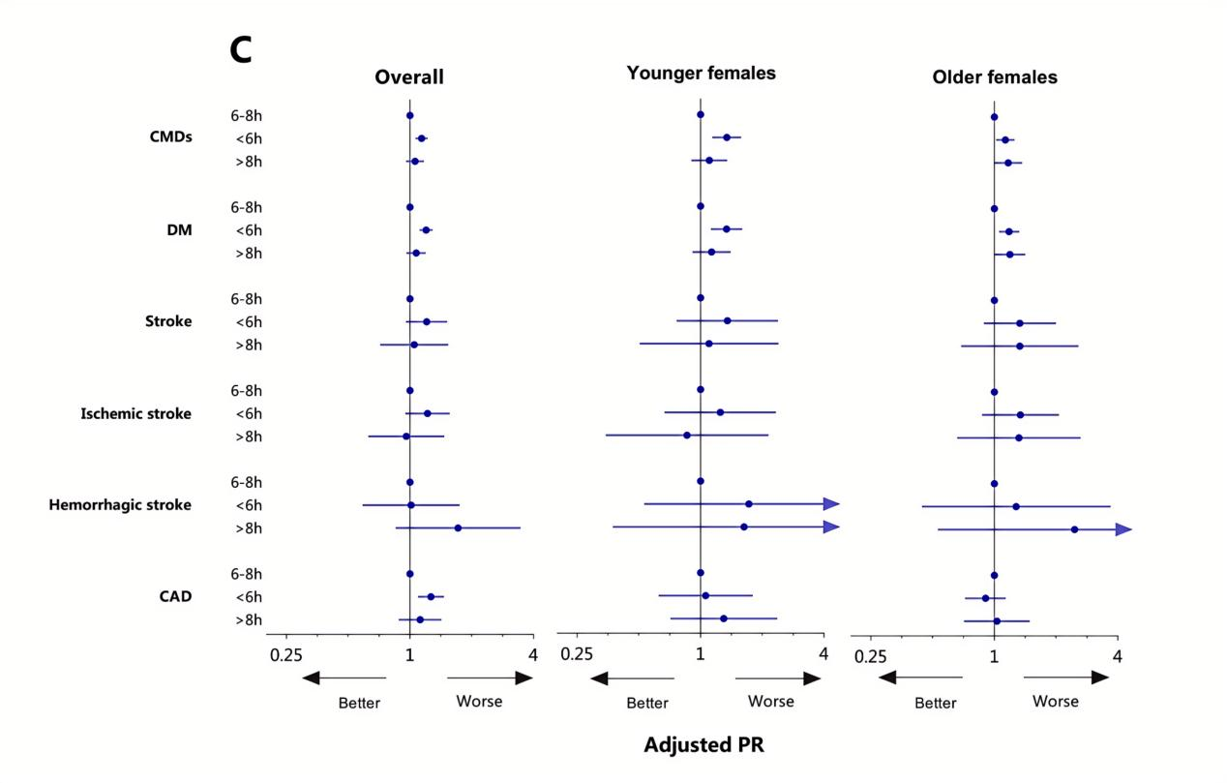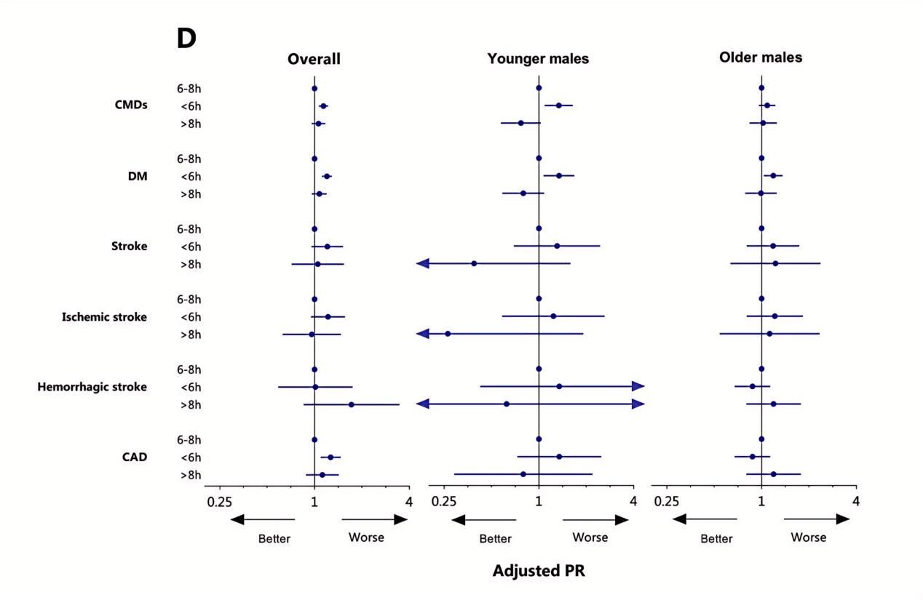
Supplementary Figure 1. Multivariate adjusted PR values for the association between sleep duration and cardiometabolic diseases and its components were analyzed within age subgroups (A), gender subgroups (B) and age with gender subgroups (C, D).

The demarcation between the younger and older age was set at 65 years. Multivariate Poisson regression models were utilized in these models, and were adjusted by age (continuous variable), gender (for A, C, D), height (continuous variable), rural residents, well educated, CCVD family history, high income, smoking, physical inactivity, vegetables insufficiency, fruits consumption habit.

CMDs: cardiometabolic diseases; DM: diabetes mellitus; CAD: coronary artery disease; PR: prevalence ratio. CCVD: cardiac-cerebral vascular disease.

