Supplementary Information
Near infrared -activatable Biomimetic Nanoplatform for Tumor-specific Drug Release, Penetration and Chemo-photothermal Synergistic Therapy of Orthotopic Glioblastoma
Ming Li¹*
Xinrui Zhang¹*
Yujie Zhou¹
Yuteng Chu¹
Jie Shen¹
Yue Cai¹
Xuanrong Sun¹
¹Author affiliations: Collaborative Innovation Center of Yangtze River Delta Region Green Pharmaceuticals, Zhejiang University of Technology, Hangzhou 310014, China;
*: These authors contributed equally to this work.
Correspondence：Xuanrong Sun，Collaborative Innovation Center of Yangtze River Delta Region Green Pharmaceuticals, Zhejiang University of Technology, Hangzhou 310014, China，E-mail：sunxr@zjut.edu.cn

Figure S1. The absorption spectra of ICG and AM-NP

Figure S2. (A) HPLC method for determining the standard curve of SN38. Chromatographic column: C18 reverse phase column ODS-3, 5 μm, 4.6×250 mm; mobile phase: acetonitrile:water = 60:40 (V/V); flow rate: 1 mL/min; detection wavelength: 360 nm; column temperature: 35°C; injection volume: 20 μL. (B) ICG standard curve was determined by measuring OD values at 780 nm.

Figure S3. Protein concentration standard curve

Figure S4. Tem image of NP after laser exposure for 5 min. scale bar: 500 nm.

Figure S5. Stability of AM-NP Charges (A) and TEM Variations (B) scale bar:100 µm

Figure S6. The cellular fluorescence uptake images at different incubation times. Scale bar: 100 µm.

Figure S7. Cellular fluorescence uptake images with/without Angiopep-2 pretreatment. Scale bar: 100 µm.

Figure S8. Fluorescence images of RAW264.7 cells uptaking NP and AM-NP. Scale bar: 100 µm.

Figure S9. The in vitro cytotoxicity of SN38.

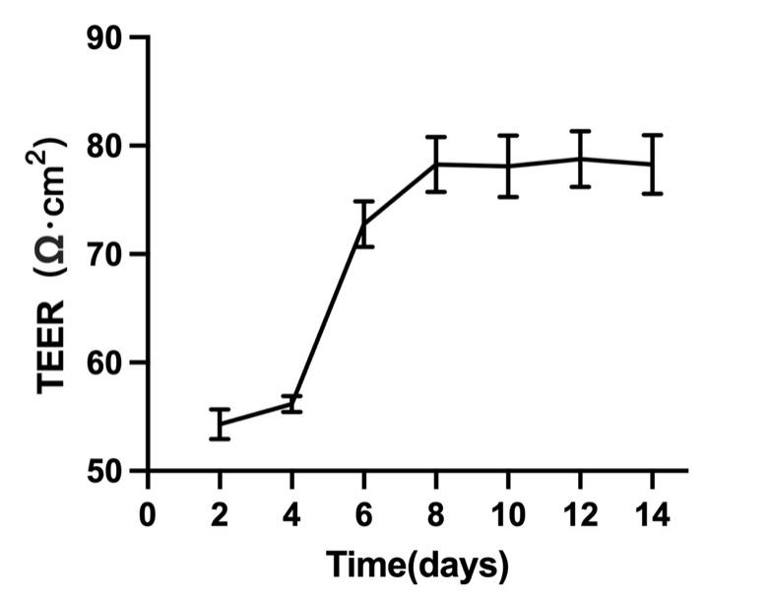
Figure S10. The change of the TEER values on the in vitro BBB model (n=3).

Figure S11. The effects of three phagocytosis inhibitors on the ingestion of AM-NP by bEnd.3 cells.

Figure S12. Subcellular distribution of AM-NP observed on bEnd.3 cells using laser confocal microscopy. scale bar: 30 µm

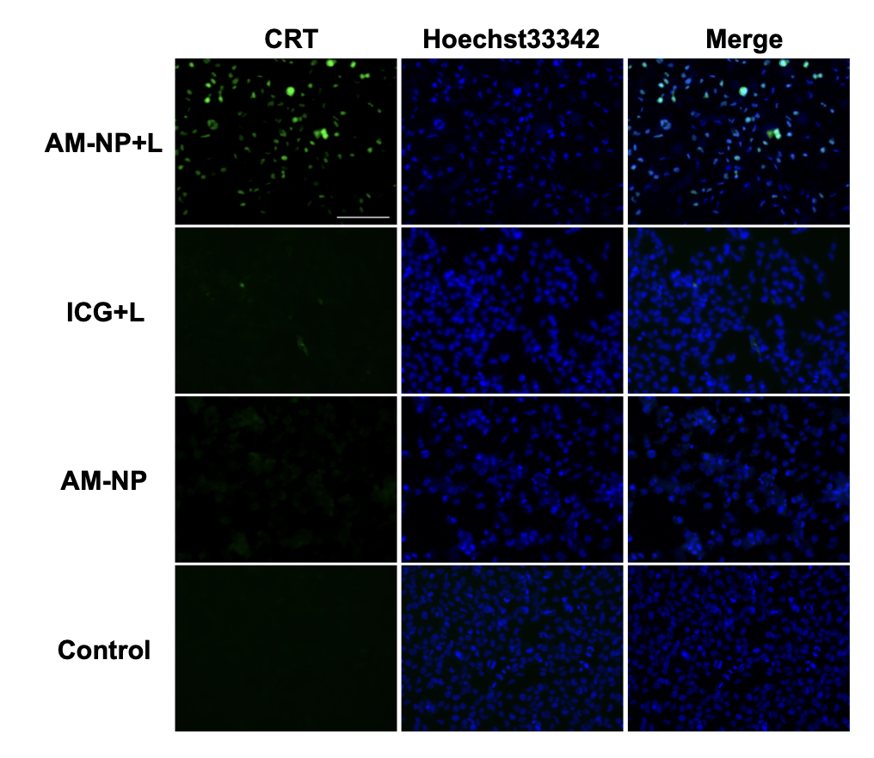
Figure S13. CRT distribution on the surface of GL261 tumor cells post AM-NP treatment and laser irradiation (photodensity of 1.0 W cm⁻², 5 min)

Figure S14. The ATP secretion under different treatments (**p < 0.01, ***p < 0.001)

Figure S15. The condition of brain tumors on the tenth day.

Figure S16. Images of TUNEL staining in normal brain tissue.

