Supplementary information

Results
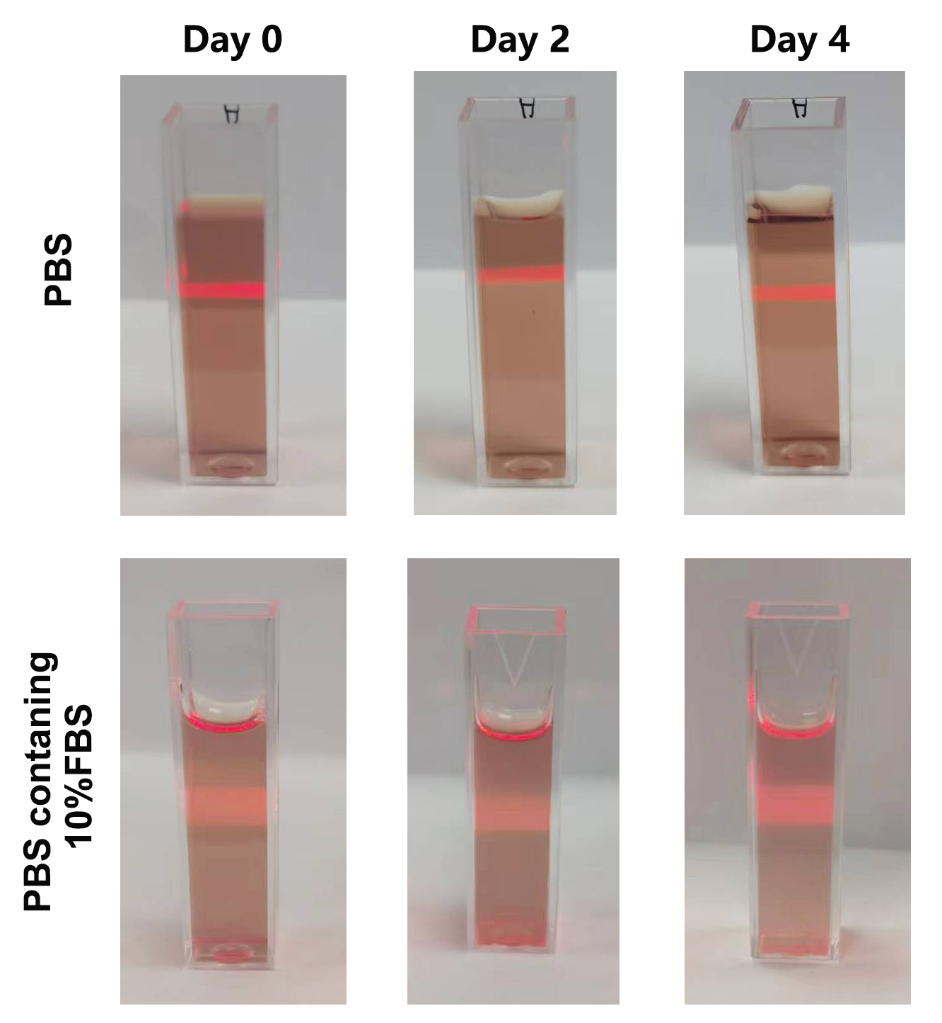
Figure S1 Photographs of PMOF@HA stored in PBS buffer or PBS buffer containing 10% FBS for different times.
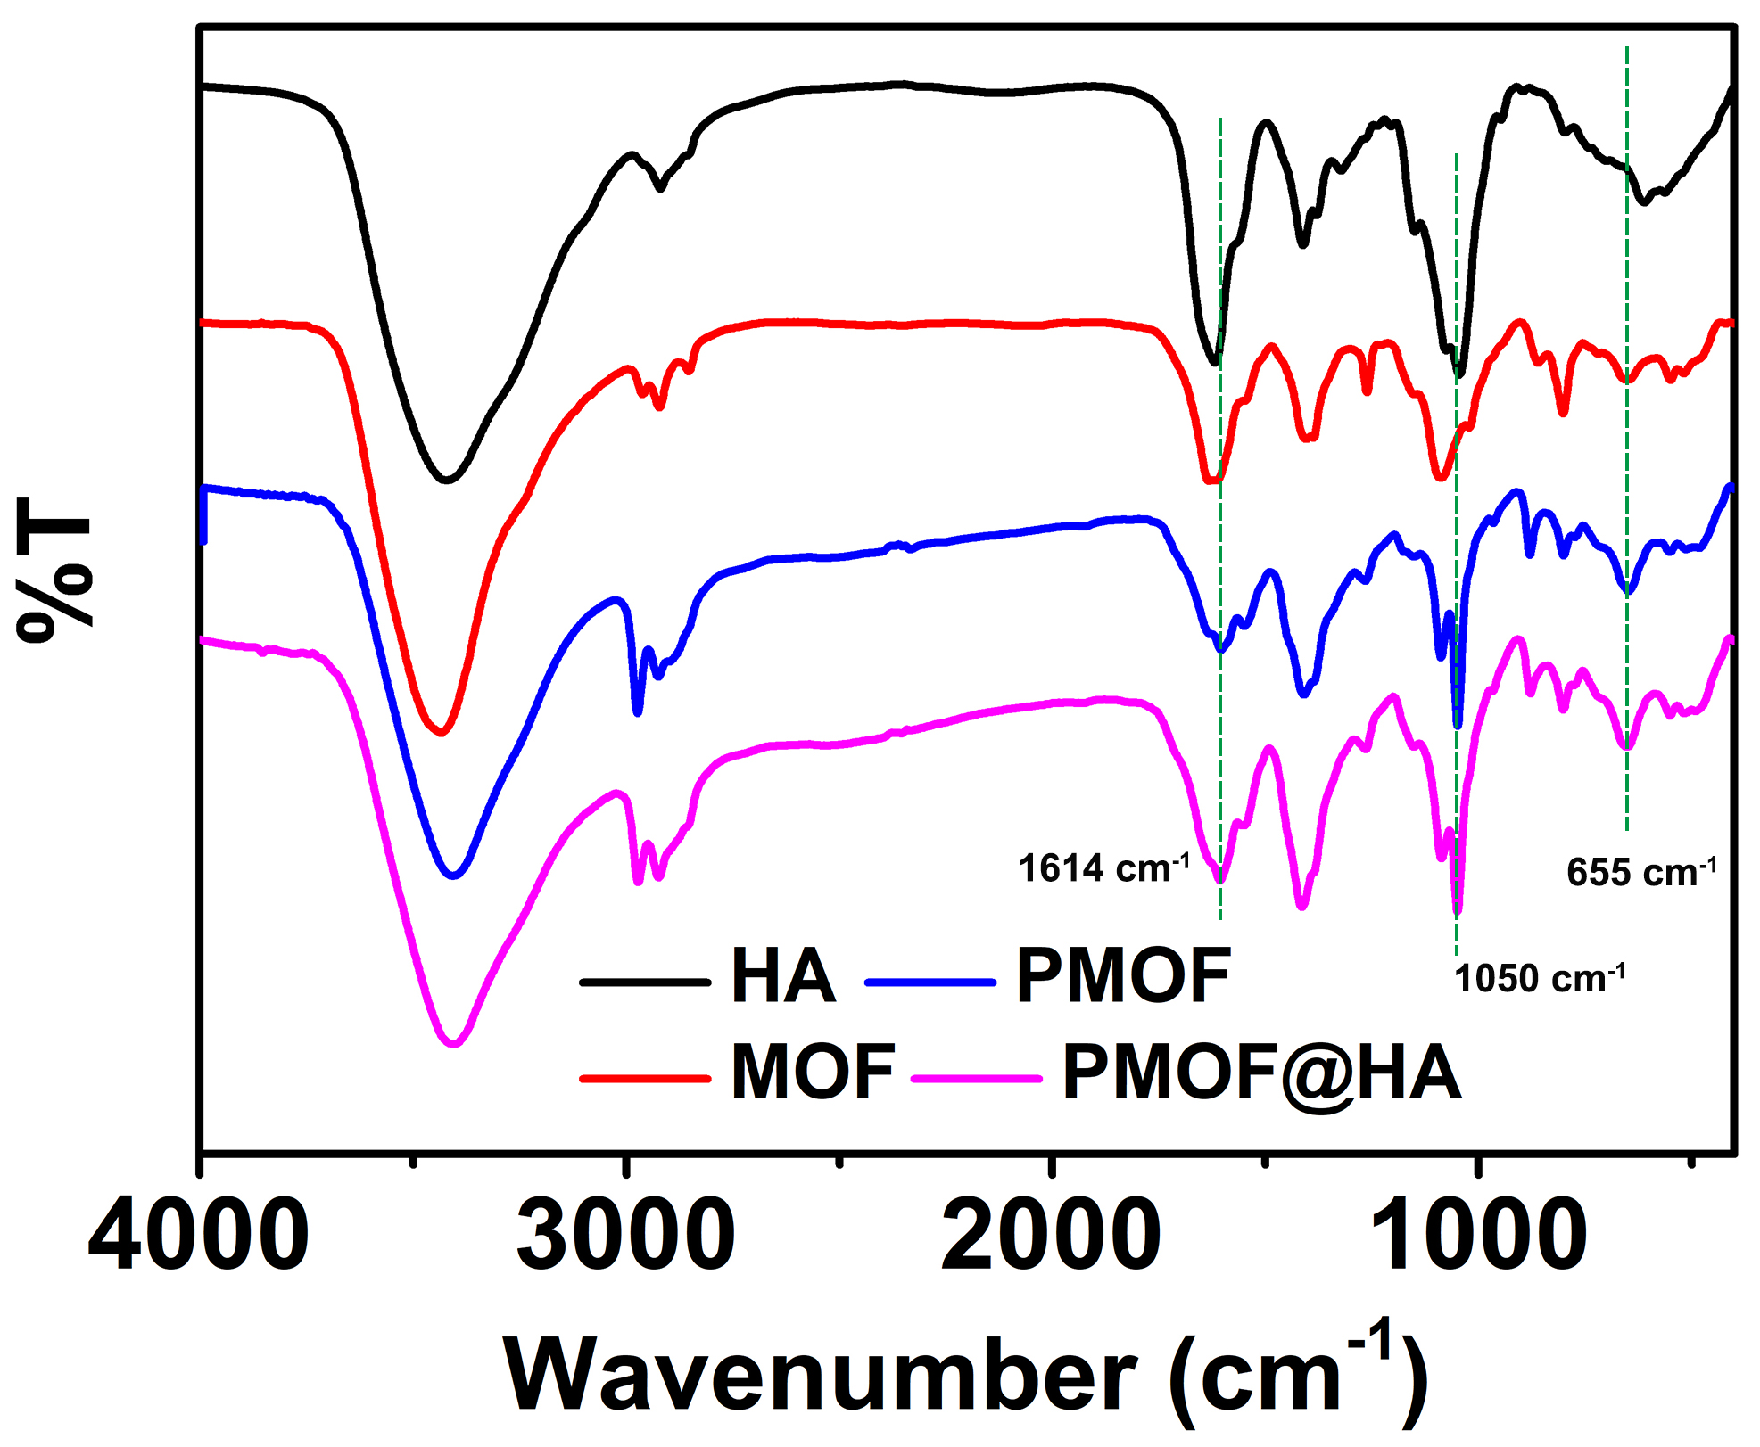
Figure S2 FT-IR spectra of HA, MOF, PMOF and PMOF@HA.
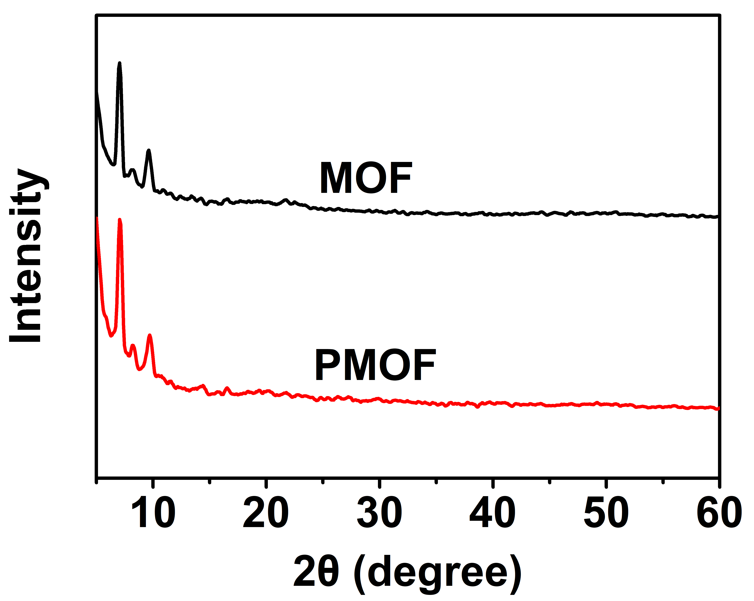
Figure S3 XRD patterns of MOF and PMOF nanosheets.
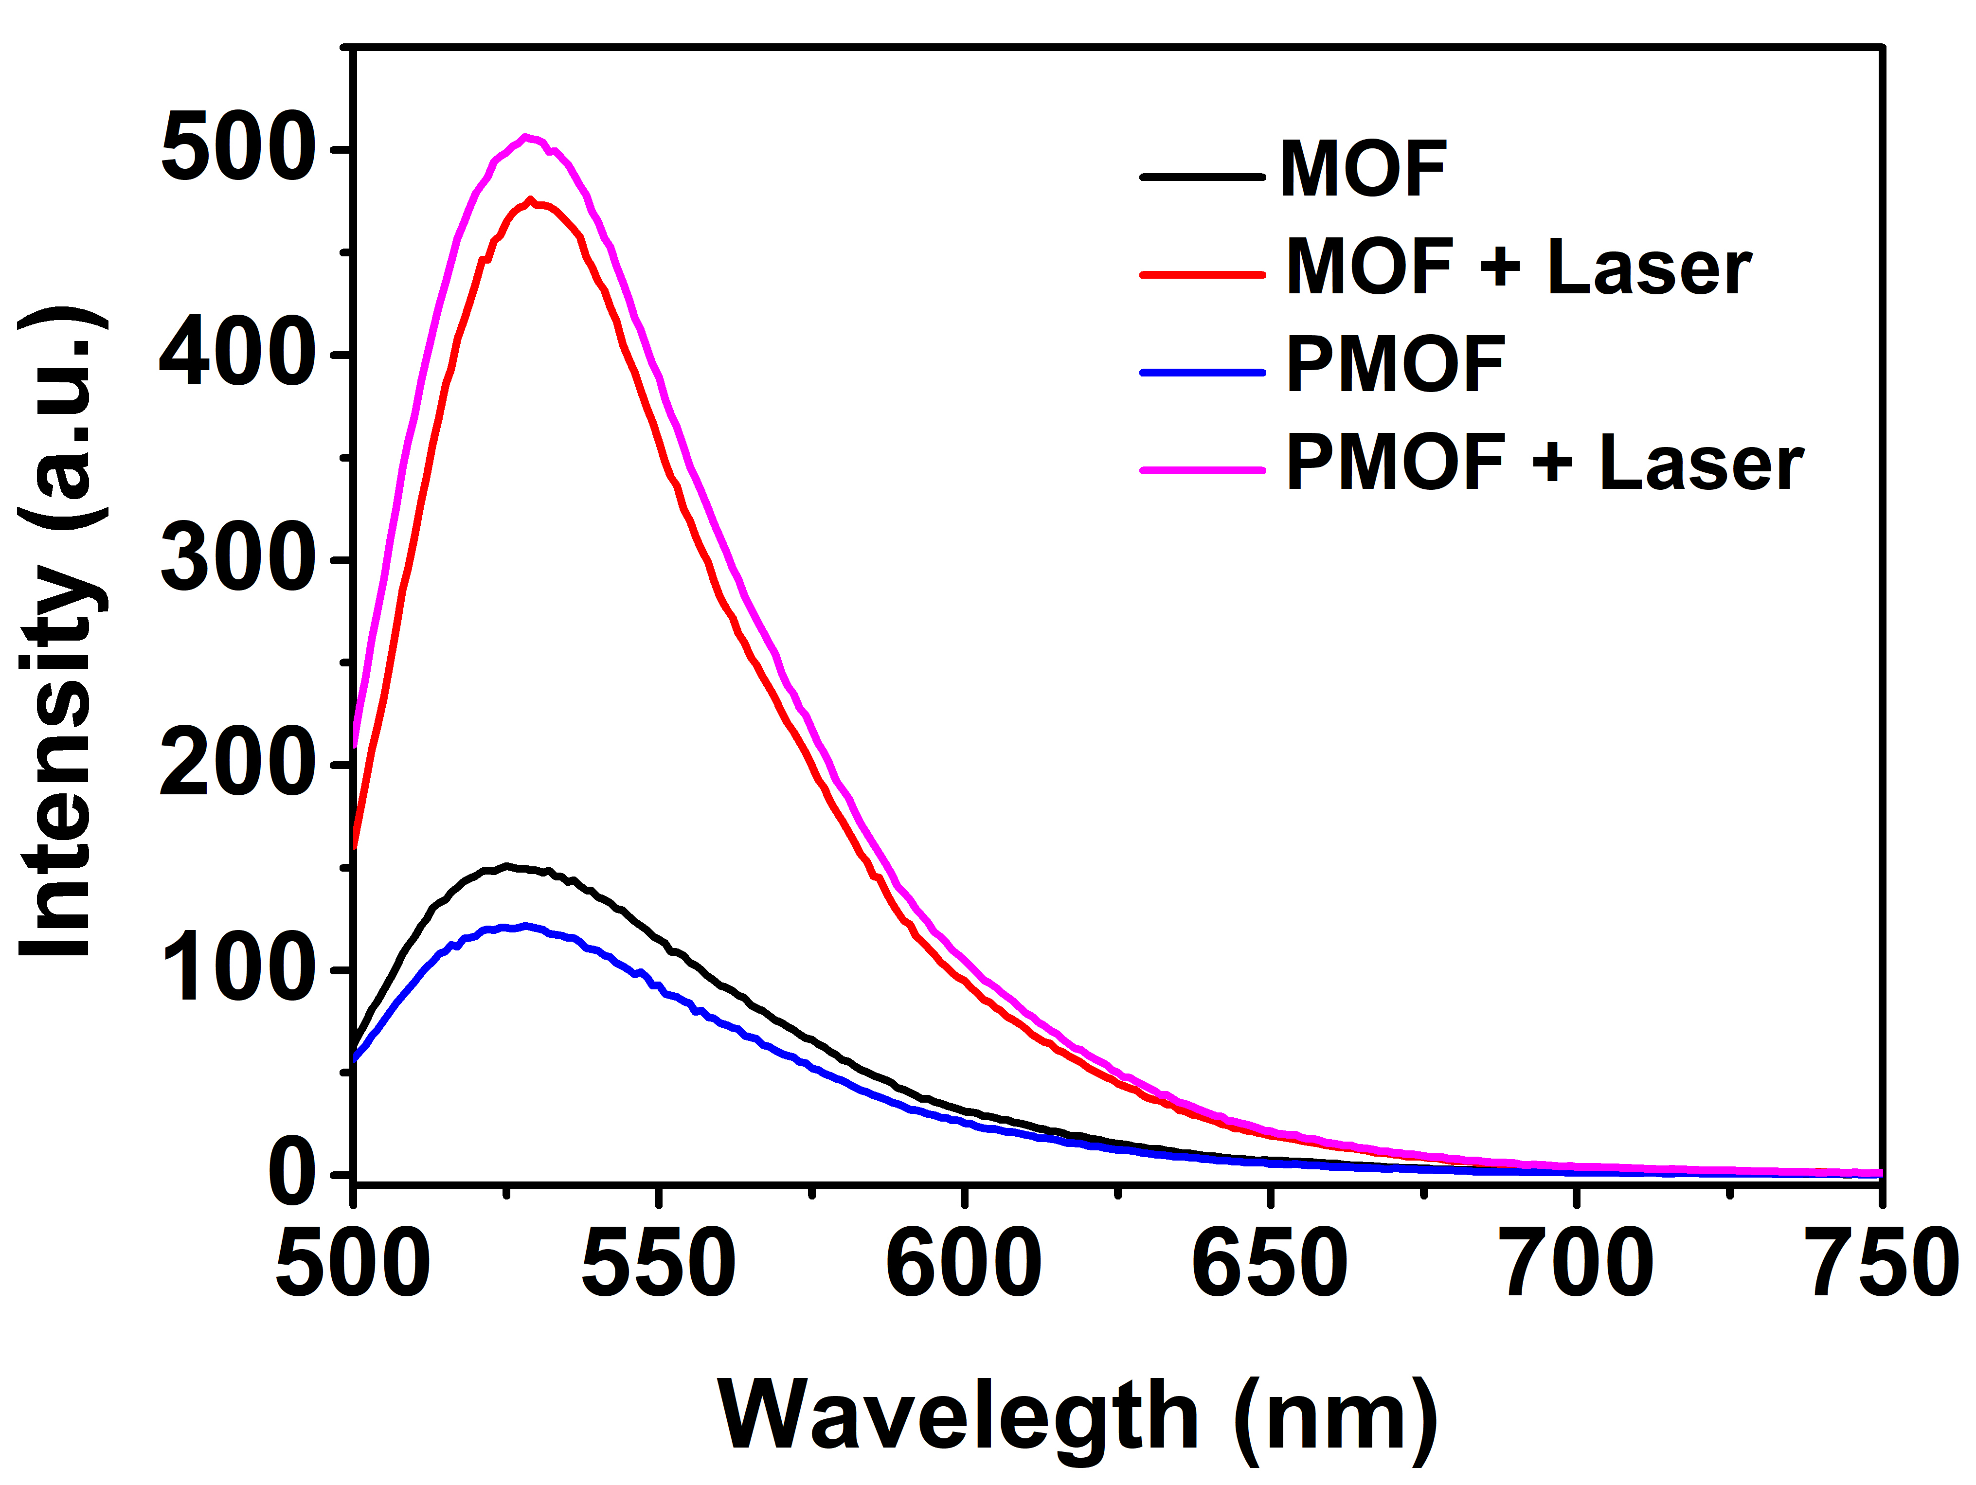
Figure S4 Fluorescence spectra of SOSG in the presence of MOF and PMOF nanosheets with or without laser irradiation.
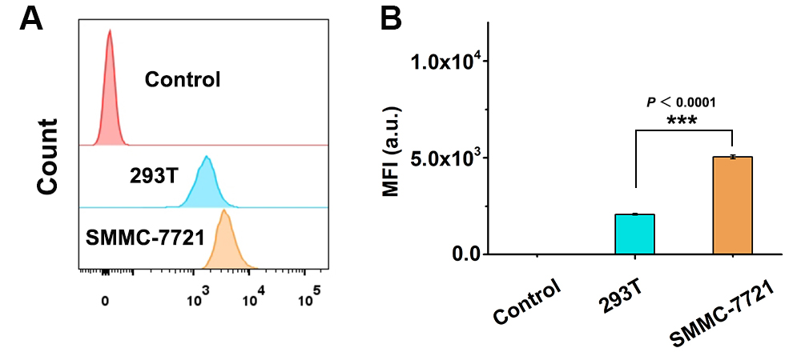
Figure S5 (A) Flow cytometry analysis of Cy5 fluorescence inside 293T and SMMC-7721 cells after incubated with Cy5-labeled PMOF@HA for 4 h. (B) The corresponding mean fluorescence intensity (MFI) in (A) (n = 3). ***P < 0.001.
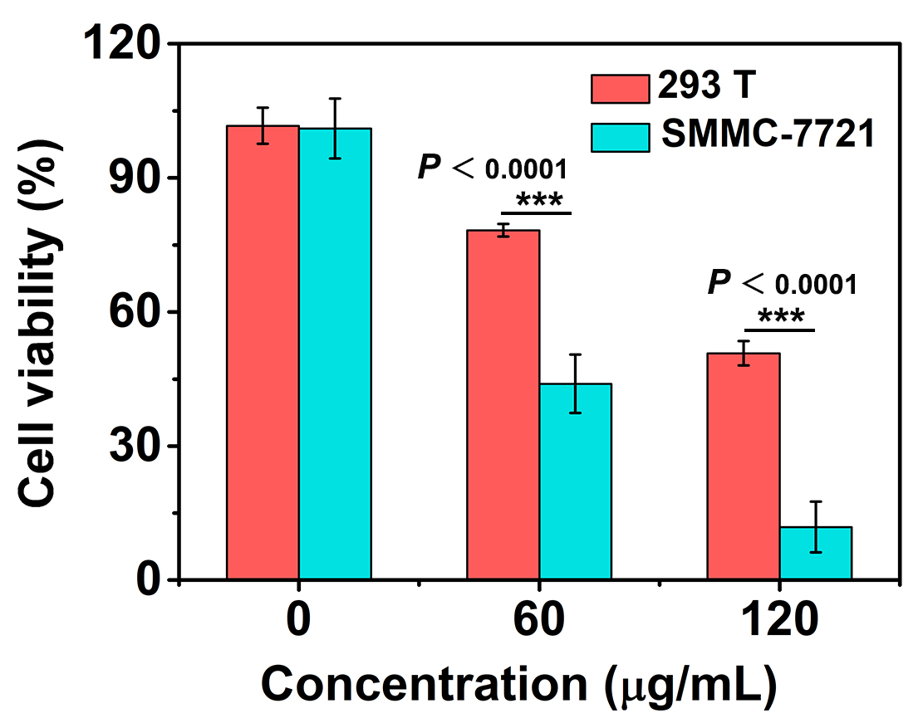
Figure S6 Cell viabilities of 293T and SMMC-7721 cells treated with various concentrations of PMOF@HA and laser irradiation (n = 4).
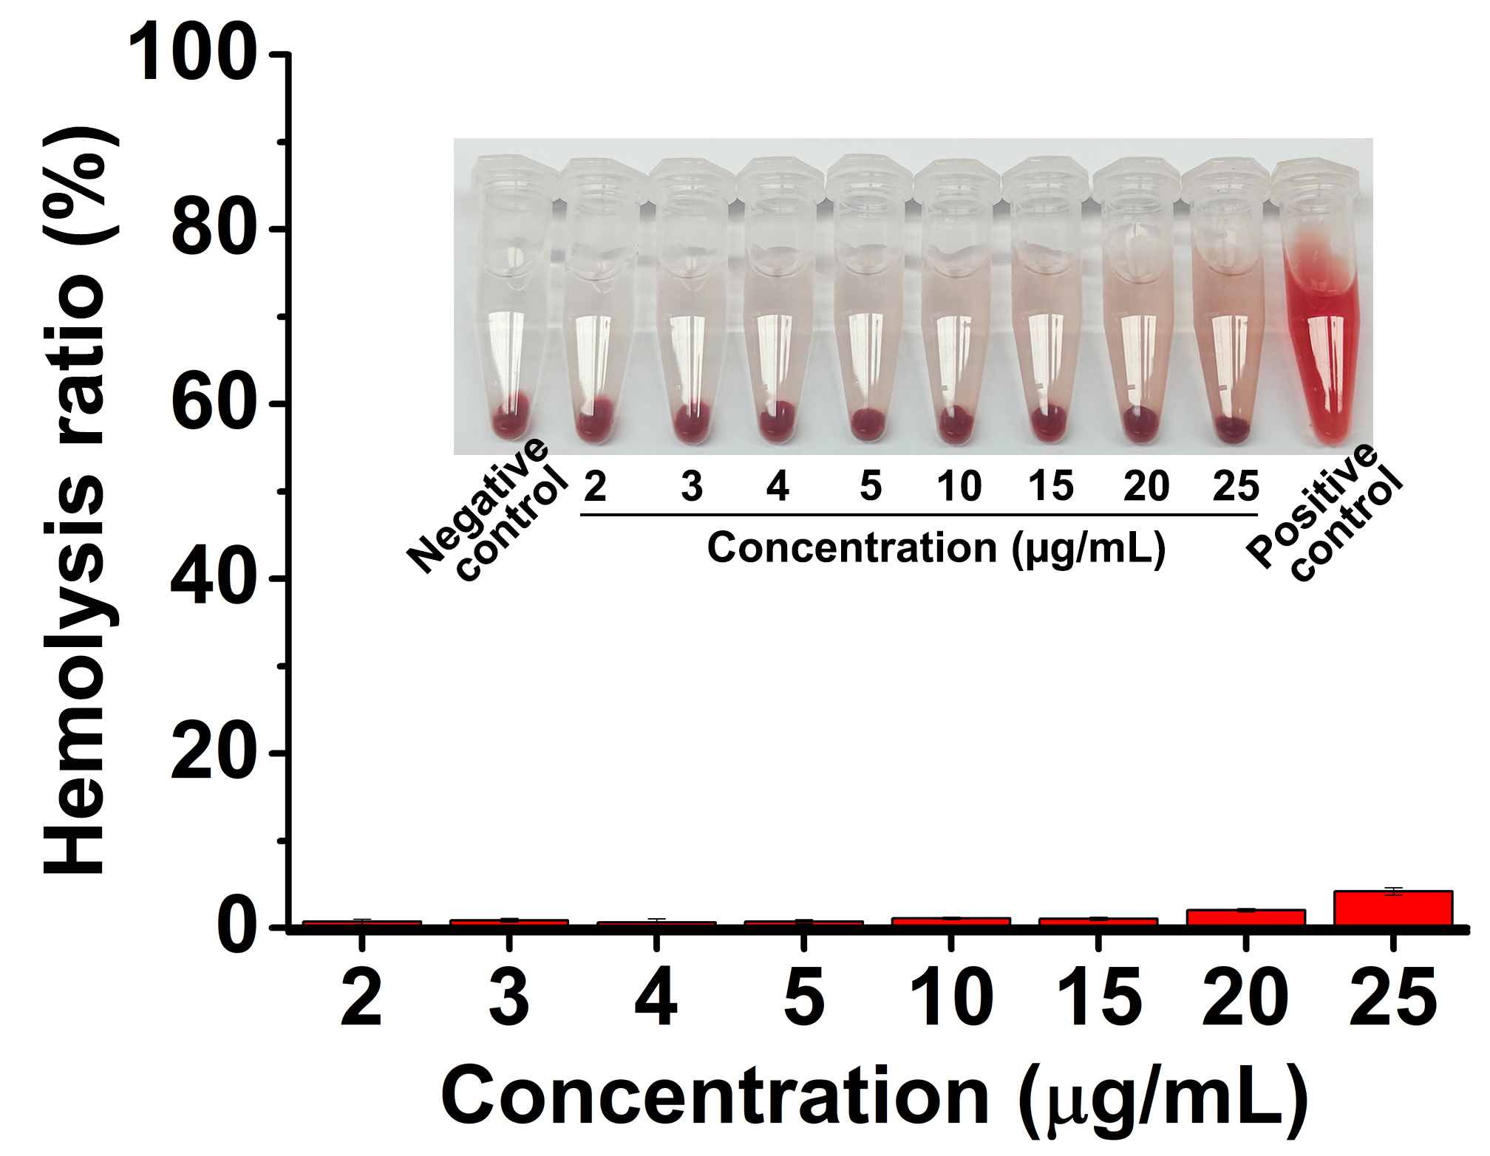
Figure S7 Hemolysis assay of PMOF@HA with various concentrations.
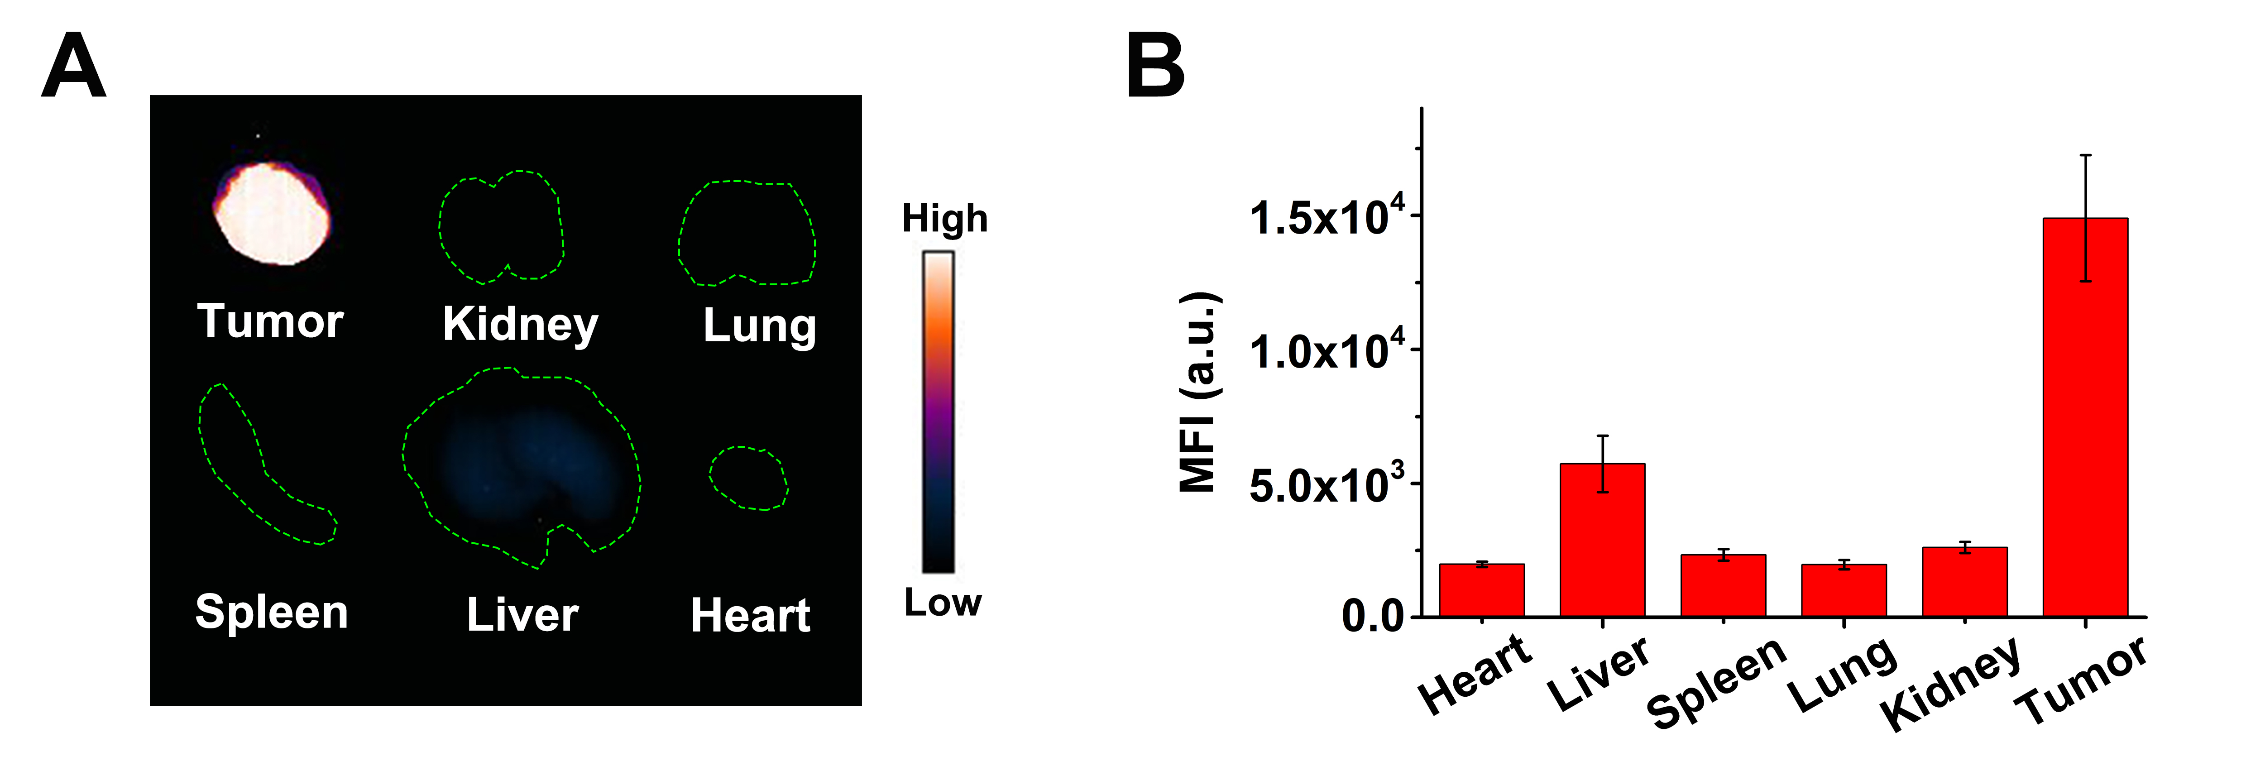
Figure S8 (A) Fluorescence images of excised major organs and tumor of mice after injection intratumorally with ICG labeled PMOF@HA for 72 h. (B) The mean fluorescence intensities of excised major organs and tumor in (A).

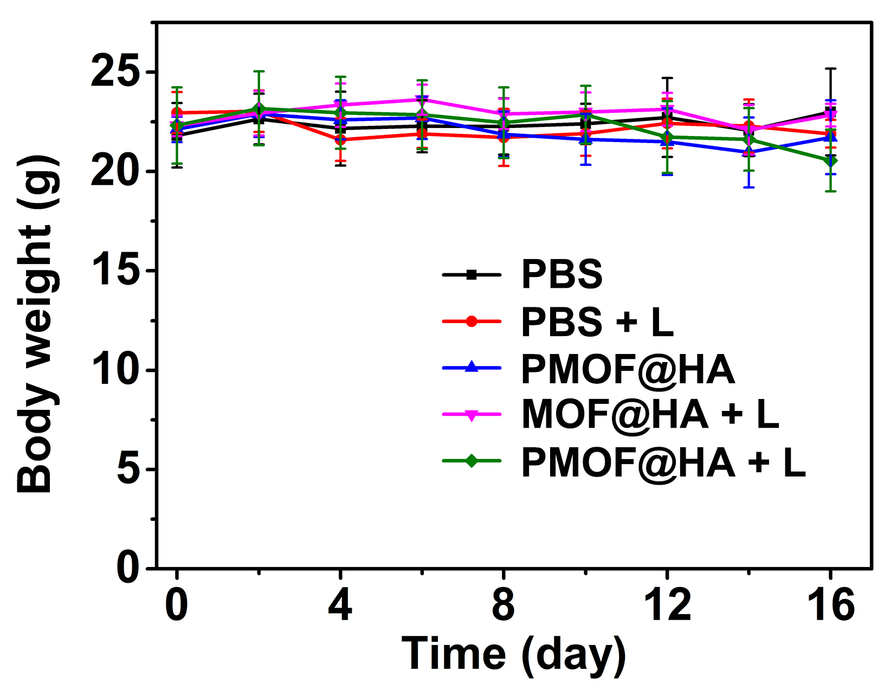
Figure S9 Average body weights of mice in different groups (n = 5).

