Supplementary Data

Fig S1 Survive rate of each group after tMCAO or sham operation
Group (n=26) | Sham | tMCAO | EtOH+tMCAO | LPS+tMCAO | EtOH+tMCAO+TAK-242
Survive rate(%) | 96.1 | 80.8 | 65.4 | 61.5 | 76.9

Fig S2 Relative TLR4 repression and cell viability after treatment with a serious concentration of LPS
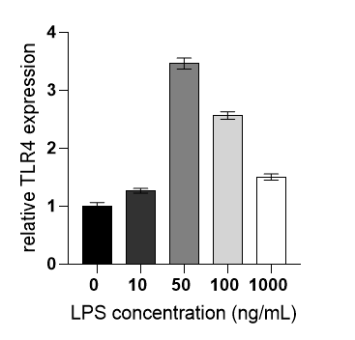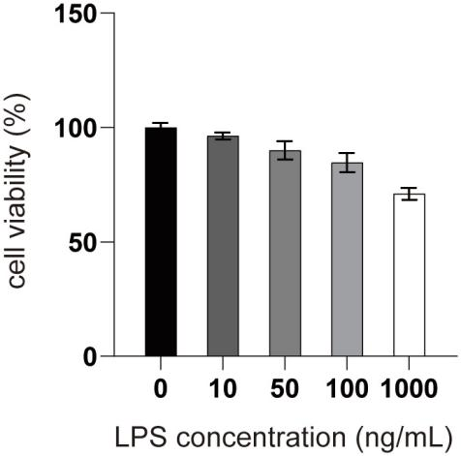
Cell Counting Kit-8 was used to determine cell viability followed by the manufacture’s instruction (Beyotime, China, C0037). The absorbance was then detected at 450 nm using a microplate reader.

