NIR-II-absorbing NDI Polymer with Superior Penetration Depth for Enhanced Photothermal Therapy Efficiency of Hepatocellular Carcinoma
Bei Li^{1,2,#}, Yuting Luo^{1,2,#}, Geng Liu^{1,2}, Maling Gou³, Lei Feng^{1,2}, Xiwen Ye^{1,2}, Jianrong Xu^{1,2}, Yaotian Fan^{1,2}, Zhen You^{1,2,}*

1. Division of Biliary Surgery, Department of General Surgery, West China Hospital,
Sichuan University, Chengdu 610041, Sichuan, China
2. Research Center for Biliary Diseases, West China Hospital, Sichuan University,
Chengdu 610041, Sichuan, China.
- Department of Biotherapy, Cancer Center and State Key Laboratory of Biotherapy，West China Hospital, Sichuan University，Chengdu 610041, Sichuan, China

#These authors contributed to the work equally.
*Correspondence:Prof. Zhen You, E-mail: youzhen@wchscu.cn, Fax: +86 028 85423823, Tel: +86 028 85423823

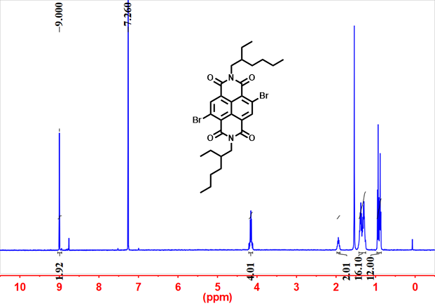

Figure S1. The ¹H NMR spectrum of NDI-2Br.

Figure S2. The Gel Permeation Chromatography (GPC)of NDI polymer.

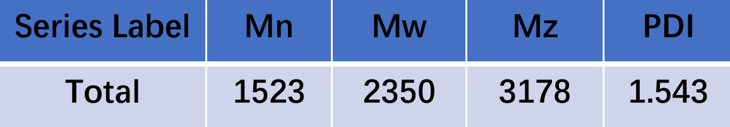
Figure S3. The GPC analysis of NDI polymer (Mn: number-average molecular weight, Mw: weight-average molecular weight, Mz: z-average molecular weight, PDI: polymer dispersity index).

Figure S4. The related temperature value of PBS and NDI polymer solution (0.1 mg/mL) in the presence of 808 nm laser treatment (1.0 W/cm², 5 min).
Figure S5. The semi-quantitative NIR-II fluorescence analysis of NDI polymer at different concentrations under 980 nm laser.

Figure S6. The NIR-II fluorescent images of Huh-7 cells in Control group with 980 nm laser.

