Supplementary material 1

Summary of the utilized data sources
Country | Register/database | Register/database holder | Type of data
Germany | German Pharmacoepidemiological Research Database | Leibniz Institute for Prevention Research and Epidemiology BIPS | Demographics data, inpatient diagnoses and limited care data, outpatient primary and secondary care data,  outpatient drug prescriptions and dispensations data
Sweden | National Population Registry | Statistics Sweden | Demographics data
Sweden | Swedish Prescribed Drug Register | Swedish National Board of Health and Welfare | Prescribed drugs dispensed in community  pharmacies
Sweden | National Patient Register | Swedish National Board of Health and Welfare | Inpatient care data and outpatient secondary care data
Sweden | Swedish Cause of Death Register | Swedish National Board of Health and Welfare | Date and cause of death
Sweden | Swedish Cancer Registry | Swedish National Board of Health and Welfare | Confirmed cancer diagnoses
United States | Military Health System | Department of Defense | Demographics data, inpatient care data, outpatient primary and secondary care data, prescribed drugs
Norway | National Population Register | Tax Administration | Demographics
Norway | Norwegian Patient Register | Norwegian Directorate of Health | Inpatient care data and outpatient secondary care data
Norway | Cancer Registry of Norway | Oslo University Hospital Trust | Confirmed cancer diagnoses
Norway | Norwegian Cause of Death Registry | Norwegian Institute of Public Health | Date and cause of death
Norway | Norwegian Prescription Database | Norwegian Institute of Public Health | Prescribed drug dispensations
GER, Germany; NOR, Norway; SWE, Sweden; US, United States.

Description of the data sources

German database
In Germany, data obtained from the German Pharmacoepidemiological Research Database (GePaRD), built by the Leibniz Institute for Prevention Research and Epidemiology - BIPS in Bremen, was used (Haug and Schink 2021). This database collects medical claims data from four German statutory health insurance (SHI) providers (Pigeot and Ahrens 2008) and includes data of more than 25 million insured individuals who have been insured with one of the participating providers since 2004 or later. Per data year, there is information on approximately 20% of the general population and all geographical regions of Germany are represented. Core data contain information on sex, year of birth, insurance status, and reason for deregistration from the SHI including death. In addition to demographic data, GePaRD contains information on drug dispensations as well as outpatient (i.e., from general practitioners and specialists) and inpatient services and diagnoses.. Information on smoking and other lifestyle related variables is not available in GePaRD. Hospital data comprise the date of admission and discharge, different types of diagnoses including the admission, main discharge, secondary and ancillary diagnoses as well as diagnostic and therapeutic procedures, and the reason for hospital discharge including death. Outpatient medical care data incorporate diagnoses on a quarterly basis with their diagnostic certainty (confirmed, suspected, excluded, and status post), and types and dates of outpatient diagnostic and therapeutic procedures. All diagnoses in GePaRD are coded according to the ICD-10-GM. For simplicity all ICD-10-GM codes that exactly match ICD-10 codes are presented as ICD-10 codes. Where use of a particular code applies to the German cohort, ICD-10-GM codes are presented. Dispensation data contain information on prescriptions dispensed in a pharmacy and reimbursed by the respective SHI. Drugs purchased over the counter and in-hospital medications are not covered in GePaRD with few exceptions, e.g. treatment with expensive drugs such as monoclonal antibodies. Dispensation information also includes the dates of the prescription and dispensation, the number of prescribed packages, and the central pharmaceutical number of the drug. Based on a central pharmaceutical reference database, information on the generic and brand name of the drug, packaging size, strength, DDD, and other pharmaceutical information can be linked to GePaRD. Preliminary analyses regarding age and sex distribution, the number of hospital admissions, and drug use have shown that the database is representative for Germany and that the insurance population is rather stable over time (Pigeot and Ahrens 2008). Two validation studies of all-cause mortality in GePaRD have been conducted showing acceptable data quality (Ohlmeier 2015, Ohlmeier 2016). Cause-of-death information is not contained in the database. Additionally, linkage of data to a cancer registry is not available in Germany.

Norwegian registries
In Norway, data from the national Norwegian registries were used. The registries are held by different authorities that managed the data extractions and data linkage. The National Population Register is held by the Tax Administration, the Norwegian Patient Register is held by the Norwegian Directorate of Health, the Cancer Registry of Norway is held by the Oslo University Hospital Trust, the Norwegian Cause of Death Registry and the Norwegian Prescription Database are both held by the Norwegian Institute of Public Health. These national registries hold data on all inhabitants in Norway and thus cover the complete population of 5.3 million inhabitants. Norwegian Prescription Database contains information on drugs dispensed by prescription from 2004 onwards. The Norwegian Patient Register registry includes all inpatient and outpatient, public and private, specialist healthcare from 2008 onwards. Norwegian Patient Register data has been shown to have a high degree of completeness (Bakken 2019). The Cancer Registry of Norway contains data from 1952 onwards and has relative high validity compared to other European registries (Larsen 2009). Primary care diagnoses are not captured in these registries and were ascertained by drug proxies. The Cause of Death Registry provides data from 1951 onwards.

Swedish registries
In Sweden, data from the Swedish National Board of Health and Welfare were utilized. These national databases hold data on all inhabitants in Sweden and thus cover the complete country population of 9.4 million inhabitants in 2011. The Swedish Prescribed Drug Register contains information on prescribed drugs dispensed by community pharmacies from 2005 onwards. According to a quality review of the register, PDR accounts for approximately 80% of total drug utilization and expenditure in Sweden (Wettermark 2007). The Swedish National Patient Register includes all inpatient care in Sweden (since 1987) and outpatient visits from 2001 onwards but does not cover primary care. Diagnoses recorded in primary care are therefore not captured in the Swedish data and were ascertained by use of proxy drugs. Diagnoses recorded in the NPR have been externally reviewed and are considered highly valid (Ludvigsson 2011). ICD-10 codes indicative of tobacco usage are available in Sweden. However, neither smoking status (currently/former/never), nor smoking intensity/cumulative use (eg, the number of cigarettes/day or packs/year) is recorded. The Swedish Cancer Register is considered to be of good quality mainly because approximately 99% of the cases are morphologically verified. A study in the 1980s showed that the proportion of cases not reported was estimated to be less than 2%, based on information from death certificates (Mattson and Wallgren 1984). The total number of patients in the Swedish Cancer Register (started in 1958) is more than 2 million. A quality study of the Cancer Register was published in 2009 (Barlow 2009) in which the coverage rate was evaluated in comparison to the inpatient registry. In this study, an average underreporting of 4 percent was estimated, but considerable variation exists depending on the cancer site. The Swedish Cause of Death Register provides data since 1953. Data on emigration were available and could be used for censoring, as appropriate.

US – Military Health System
In the US, data from the Military Health System (MHS) since 01 January 2009 were used. MHS is a comprehensive medical network within the US Department of Defense that provides healthcare to all US military personnel, their dependents, and retirees. MHS exclusively covers military service members and their families and has one of the largest health systems in the US, with nearly 10 million patients. Patients enrolled in the MHS receive benefits through the TRICARE nationwide managed care program, which combines healthcare claims from the US Department of Defense facilities with those from the private sector. The MHS is not linked with data streams from the VHA (Veterans Health Administration), as the MHS and the VHA are separate entities; therefore, this study does not contain data from the VHA patient population. MHS data contain records on all healthcare events (that are required to be reported) paid for by the MHS, regardless of setting. Patients are insured through MHS; however, they are not required to use military medical facilities. Many patients use their MHS coverage to obtain care in civilian facilities. The MHS contains robust historical beneficiary data, including coverage information, service-related information and demographics, and clinical data (e.g., vital signs, body mass index).
Diagnostic coding is based on International Classification of Diseases (ICD)-9 codes through October 2015 and ICD-10 codes thereafter (thus, ICD-9 codes were used for PS variables in this study). Information on procedures is available through codes of the Healthcare Common Procedures Coding System, including current procedural terminology codes. Information on drug dispensations is available as National Drug Code (NDC) Generic Product Identifier (GPI) and Anatomical Therapeutic Chemical (ATC) codes were mapped to NDC for this study). ICD-9 codes indicative of tobacco usage are available in the database. However, neither smoking status (currently/former/never), nor intensity/cumulative use (eg, the number of cigarettes/days or packs/years) is recorded. The MHS contains a death code and the date of death. Death data in the MHS comes from the following sources: deaths in military facilities (available near real-time), deaths within civilian facilities (available near real-time), combat-related deaths (available near real-time, though, irrelevant in this study), survivor self-report directly to TRICARE, and a contracted, recurring Social Security Death Index feed from the Social Security Administration. All death data are processed and directly linked to the beneficiary within a master death file. The lag in death reporting is minimal for deaths at military facilities (average 30 to 60 days), while deaths within civilian facilities are captured in the data within approximately 60 to 90 days. Remaining deaths occurring outside of a bedded facility (ie, from survivor self-report and/or the Social Security Death Index data) are captured within approximately 4 to 6 months.
The MHS data has been used by many research teams to examine all-cause mortality as well as specific causes of death, when linked to the US National Death Index (Andaya 2013, Capkun 2015, Lin 2016, Lin 2017, Manjelievskaia 2017, Meyers 2008, Nee 2017, Schoenfeld 2017, Zheng 2012, Zogg 2016). Cause of death is not available for this study, as the MHS data was not linked to the National Death Index. Furthermore, no linkage to a cancer registry was available in the US study, which resulted in the identification of new diagnoses of malignancies from the claims data only. The limitations of this setting for the study of cancer incidence include the lack of morphological confirmation of the diagnosis, limited staging information, and limited baseline observation period often insufficient to distinguish prevalent and incident cancer cases.

References
Andaya AA, Enewold L, Zahm SH, Shriver CD, Stojadinovic A, McGlynn KA, et al. Race and colon cancer survival in an equal-access health care system. Cancer Epidemiol Biomark Prev. 2013;22(6):1030-36.
Bakken IJ, Ariansen AMS, Knudsen GP, Johansen KI, Vollset SE. The Norwegian Patient Registry and the Norwegian Registry for Primary Health Care: research potential of two nationwide health-care registries. Scand J Public Health. 2020;48(1):49-55.
Barlow L, Westergren K, Holmberg L, Talbäck M. The completeness of the Swedish Cancer Register: a sample survey for year 1998. Acta Oncol. 2009;48(1):27-33.
Capkun G, Dahlke F, Lahoz R, Nordstrom B, Tilson HH, Cutter G, et al. Mortality and comorbidities in patients with multiple sclerosis compared with a population without multiple sclerosis: An observational study using the US Department of Defense administrative claims database. Mult Scler Relat Disord. 2015;4(6):546-54.
Haug U, Schink T. German Pharmacoepidemiological Research Database (GePaRD). In: Sturkenboom M, Schink T, editors. Databases for Pharmacoepidemiological Research: Springer Nature Switzerland AG; 2021.
Larsen IK, Småstuen M, Johannesen TB, Langmark F, Parkin DM,Bray F, et al. Data quality at the Cancer Registry of Norway: an overview of comparability, completeness, validity and timeliness. Eur J Cancer. 2009;45(7):1218-31.
Lin J, McGlynn KA, Carter CA, Nations JA, Anderson WF, Shriver CD, et al. The impact of preexisting mental health disorders on the diagnosis, treatment, and survival among lung cancer patients in the U.S. Military Health System. Cancer Epidemiol Biomarkers Prev. 2016;25(12):1564-71.
Lin J, Gill A, Zahm SH, Carter CA, Shriver CD, Nations JA, et al. Metformin use and survival after non-small cell lung cancer: a cohort study in the US Military Health System. Int J Cancer. 2017;141(2):254-63.
Ludvigsson JF, Andersson E, Ekbom A, Feychting M, Kim JL, Reuterwall C, et al. External review and validation of the Swedish national inpatient register. BMC Public Health. 2011;9;11:450.
Manjelievskaia J, Brown D, McGlynn KA, Anderson W, Shriver CD, Zhu K. Chemotherapy use and survival among young and middle-aged patients with colon cancer. JAMA Surg. 2017;152(5):452-9.
Mattson B, Wallgren A. Completeness of the Swedish Cancer Register. Non-notified cancer cases on death certificates in 1978. Acta Radiol Oncol. 1984;23(5):305-13.
Meyers JF, Robbins AS, Gildengorin GL, Grayson JK. Racial differences in mortality among men hospitalized in military hospitals. Mil Med. 2008;173(6):539-43.
Nee R, Fisher E, Yuan CM, Agodoa LY, Abbott KC. Pre-end-stage renal disease care and early survival among incident dialysis patients in the US Military Health System. Am J Nephrol. 2017;45(6):464-72.
Ohlmeier C, Langner I, Hillebrand K, Schmedt N, Mikolajczyk R, Riedel O, et al. Mortality in the German Pharmacoepidemiological Research Database (GePaRD) compared to national data in Germany: results from a validation study. BMC Public Health. 2015;15:570.
Ohlmeier C, Langner I, Garbe E, Riedel O. Validating mortality in the German Pharmacoepidemiological Research Database (GePaRD) against a mortality registry. Pharmacoepidemiol Drug Saf. 2016;25(7):778-84.
Pigeot I, Ahrens W. Establishment of a pharmacoepidemiological database in Germany: methodological potential, scientific value and practical limitations. Pharmacoepidemiol Drug Saf. 2008;17(3):215-23.
Schoenfeld AJ, Jiang W, Harris MB, Cooper Z, Koehlmoos T, Learn PA, et al. Association between race and postoperative outcomes in a universally insured population versus patients in the state of California. Ann Surg. 2017;266(2):267-73.
Wettermark B, Hammar N, Fored CM, Leimanis A, Otterblad Olausson P, et al. The new Swedish Prescribed Drug Register--opportunities for pharmacoepidemiological research and experience from the first six months. Pharmacoepidemiol Drug Saf. 2007;16(7):726-35.
Zheng L, Enewold L, Zahm SH, Shriver CD, Zhou J, Marrogi A, et al. Lung cancer survival among black and white patients in an equal access health system. Cancer Epidemiol Biomark Prev. 2012;21(10):1841-7.
Zogg CK, Jiang W, Chaudhary MA, Scott JW, Shah AA, Lipsitz SR, et al. Racial disparities in emergency general surgery: do differences in outcomes persist among universally insured military patients? J Trauma Acute Care Surg. 2016;80(5):764-775; discussion 775-7.

Supplementary material 2

Diagnosis and proxy drug codes for Chronic Obstructive Pulmonary Disease and Chronic Bronchitis
Diagnosis codes for COPD/chronic bronchitis |  | Proxy drugs (for COPD/chronic bronchitis diagnosis)
GER, NOR, SWE | US | GERª | NOR, SWE^{b} | US^{c}
ICD-10  J44  J41-J42 | ICD-9-CM  491.xx  492.xx  496.xx | ATC codes:  R03BB01 (ipratropium bromide)  R03BB04 (tiotropium bromide)  R03BB05 (aclidinium bromide)  R03DX07 (roflumilast) | ATC codes:  R03BB01 (ipratropium bromide)  R03BB04 (tiotropium bromide)  R03BB05 (aclidinium bromide)  R03BB06 (glycopyrronium bromide)  R03AL02 (salbutamol and ipratropium bromide)  R03AL03 (vilanterol and umeclidinium bromide)  R03AL04 (indacaterol and glycopyrronium bromide) | Select GPI codes:  2210x, 2220x,  441000x, 442010x, 442099x, 44300020x, 44400010x, 44400015x, 44400017x, 44400030x, 44400033x, 44400036x, 44400040x,444500x, 4991002x, 44993204x, 96445009x, 96445070x, 96448212x, 96488848x, 96526465x, 96527054x, 96568811x, 96645065x, 96665070x, 96667040x, 96807627x
ª Evaluated prior to or at the CED
^{b} Evaluated prior to CED
^{c} Evaluated prior to or at the CED (exposed cohort) or prior to CED (unexposed cohort)
ATC,Anatomical therapeutic code; CED, Cohort entry date; COPD, Chronic obstructive pulmonary disease; GER, Germany; GPI, Generic Product Identifier; ICD-9-CM, International Classification of Diseases, 9th Revision, Clinical Modification; ICD-10, International Classification of Diseases, 10th Revision; ICD-10-CM, International Classification of Diseases, 10th Revision, Clinical Modification; NOR, Norway; SWE, Sweden; US, United States.

Exposure variables
Variable | Description | Categories
Roflumilast (ATC code R03DX07)
“Ever use” | Time-varying variable, which has status “Never” at all times prior to the first roflumilast dispensation and “Ever” at all times thereafter | - Never  - Ever
“Use status” | Time-varying variable, which has status “Never” at all times prior to the first roflumilast dispensation, “Current use” if roflumilast exposure period is on-going or has ended within 1-5 days (chosen because of the long half life for roflumilast of 8-31 hours); “Recent use” if the most recent roflumilast exposure period has ended within 6-60 days; “Past use” if the most recent roflumilast exposure period has ended since over 60 days | - Never  - Current use  - Recent use  - Past use
“Cumulative duration” | Time-varying variable, which has initial value 0 days, (equivalent to 0 DDDs) at all times prior to the first roflumilast dispensation, and from the first dispensation onwards is equal to the total number of dispensed DDDs before the outcome date.  Prior to analyses, the calculated continuous values were categorized as: ‘Never’, ‘Up to 3 months, ‘3 to 12 months’, ‘12 to 24 months’, and ‘over 24 months’, which measure cumulative duration | - Never  - Up to 3 months (1 to 89 days)  - 3 to 12 months (90 to 364 days)  - 12 to 24 months (365 to 729 days)  - Over 24 months (730 days and more)
ATC, Anatomical therapeutic code; DDD, defined daily doses.

Independent variables included in propensity score model with respective coding
Variable | Description | Operational definition  ATC codes/GPI codes ICD-10 codes/ICD-9 codesª
Sex | Male/Female | -
Age | Age at CED [numeric] | -
SES | SES coded in the 12 months before cohort entry [nominal]. | Defined for each database with available information regarding socioeconomic status or proxy information.
Alcohol abuse | Alcohol abuse in the last 12 months before cohort entry [binary]. | Defined for each database based on available information on alcohol abuse or proxy (e.g., diagnostic) information
Obesity | Diagnosis (in- or outpatient) of obesity 12 months before cohort entry [binary]. Based on ICD-10 and ICD-9 codes | ICD-10: E66.9, E66.01, E66.2  ICD-9: 278.00, 278.01, 278.03
Time since COPD/CB diagnosis at CED | Time (in years) since diagnosis of COPD/chronic bronchitis at CED was computed as the interval between the first COPD/chronic bronchitis diagnosis or therapy (for patients included via use of a proxy drug), and CED. | Same ATC and ICD codes as used for inclusion  Not derived or included in the PS for Germany and the US
SAMA | Dispensation of SAMA within 4 months before cohort entry [binary]. | ATC: R03BB0[1-2], R03AL01, R03AL02; GPI: 44100030X  Only included in the PS for Germany
SABA | Dispensation of SABA within 4 months before cohort entry [binary]. | ATC: R03AC0[2-4], R03AK04, R03AL01, R03AL02;  GPI: 44201010x, 44201045x, 44201050x  Only included in the PS for Germany
LAMA | Dispensation of LAMA within 4 months before cohort entry [binary]. | ATC: R03BB0[4-7], R03AL0[3,4];  GPI: 44100007x, 44100080x  Only included in the PS for Germany
LABA | Dispensation of LABA within 4 months before cohort entry [binary]. | ATC: R03AC1[2,3,8], R03AK[06-11], R03AL0[3,4];  GPI: 44201012X, 44201027X, 44201042X, 44201058X  Only included in the PS for Germany
ICS | Dispensation of ICS within 4 months before cohort entry [binary]. | ATC: R03BA0[1,2,5,7,8], R03AK[06-11];  GPI: 44400010x, 44400015x, 44400017x, 44400030x, 44400033x, 44400036x, 44400040  Only included in the PS for Germany
Intensity of COPD treatment based on 5 binary variables in the last 4 months before cohort entry | Intensity of COPD treatment based on 5 binary variables in the last 4 months before cohort entry [category] defined as 5 binary variables (used as dummies):  • SAMA • SABA • LAMA • LABA • ICS  0 = no COPD treatment  1 = SABA or SAMA only  2 = LABA or LAMA or ICS (+/- SAMA or SABA)  3 = (LABA + LAMA) or (LABA + ICS) or (LAMA + ICS) (+/- SAMA or SABA)  4 = LABA + LAMA + ICS (+/- SAMA or SABA) | Codes as stated for each drug group above
Change in treatment intensity over the last year | To look at a possible change of severity, the difference was evaluated between intensity of COPD treatment in the last 4 months and in the month 12 to 8 months before cohort entry [category]. | ATC codes as stated for each drug group above ICS: R03BA0[1,2,5,7,8], R03AK[06-11];
Number of hospitalizations due to COPD exacerbations in the 12 months before CED | Number of hospitalizations in the 12 months before cohort entry due to COPD (defined as a hospital discharge diagnosis of COPD) [number]. Based on ICD-10 and ICD-9 codes | ICD-10: J44  ICD-9: 491.xx, 492.xx, 496.xx
Number of hospitalizations due to COPD exacerbations in the last 30 days before CED | Number of hospitalizations in the last 30 days before cohort entry due to COPD (defined as a hospital discharge diagnosis coded as J44) [number]. Based on ICD-10 and ICD-9 codes | ICD-10: J44  ICD-9: 491.xx, 492.xx, 496.xx
Number of respiratory disease related hospitalizations | Number of respiratory disease related hospitalizations in the 12 months before cohort entry [number]. Based on ICD-10 and ICD-9 codes | ICD-10: J09-J22, J40-J43, J45-J47  ICD-9: 460-466, 470-478, 490, 493, 494, 495, 500-508, 510-519
Number of emergency room visits for COPD in the last 12 months | Number of emergency room visits in the 12 months before cohort entry due to COPD exacerbations [number]. Based on ICD-10 or ICD-9 codes and emergency room codes | ICD-10: J44  ICD-9: 491.xx, 492.xx, 496.xx  Sweden: events coded as Jourläkarverksamhet, Intagnings- /Akutverksamhet, Akutklinik, Anestesi- och intensivvård were used. [On-call medical services, Emergency visits, Emergency department, Anesthesia and Intensive care]  Germany: emergency visits were identified from outpatient data according to outpatient service (EBM) codes 01210 – Emergency charge of organised emergency medical service and emergency charge for not SHI-credited physicians, institutes and hospitals; 01211 – Additional emergency charge to position 01210; 01214 – Emergency consultation charge I of organised emergency medical service and emergency charge for not SHI-credited physicians, institutes and hospitals; 01215 - Additional emergency charge to the position 01214; 01216 - Emergency consultation charge II of organised emergency medical service and emergency charge for not SHI-credited physicians, institutes and hospitals; 01217 - Additional emergency charge to the position 01216; 01218 - Emergency consultation charge III of organised emergency medical service and emergency charge for not SHI-credited physicians, institutes and hospitals; 01219 - Additional emergency charge to the position 01218;
Number of emergency room visits for COPD in the last 30 days | Number of emergency room visits in the last 30 days before cohort entry due to COPD exacerbations [number]. Based on ICD-10 or ICD-9 codes and emergency room codes | ICD-10: J44  ICD-9: 491.xx, 492.xx, 496.xx Sweden: events coded as Jourläkarverksamhet, Intagnings- /Akutverksamhet, Akutklinik, Anestesi- och intensivvård were used. [On-call medical services, Emergency visits, Emergency department, Anesthesia and Intensive care]  Germany: emergency visits were identified from outpatient data according to outpatient service (EBM) codes 01210 – Emergency charge of organised emergency medical service and emergency charge for not SHI-credited physicians, institutes and hospitals; 01211 – Additional emergency charge to position 01210; 01214 – Emergency consultation charge I of organised emergency medical service and emergency charge for not SHI-credited physicians, institutes and hospitals; 01215 - Additional emergency charge to the position 01214; 01216 - Emergency consultation charge II of organised emergency medical service and emergency charge for not SHI-credited physicians, institutes and hospitals; 01217 - Additional emergency charge to the position 01216; 01218 - Emergency consultation charge III of organised emergency medical service and emergency charge for not SHI-credited physicians, institutes and hospitals; 01219 - Additional emergency charge to the position 01218;
Number of moderate exacerbations | Number of dispensations, based on acute use of systemic corticosteroids and/or systemic antibiotics or inhaled use of nebulized budesonide during the last 12 months, not indicating chronic use (i.e., not exceeding 8-month supply) in conjunction with a diagnosis of COPD. | ATC: H02AB01, H02AB06, H02AB07, J01A, J01C, J01DB-DF, J01E, J01FA, J01M, J01R, J01XB01, J01GB01, J01GB03, R03BA02
Chronic use of systemic corticosteroids | Chronic use of systemic corticosteroids (defined as patients with more than 8- month supply (based on DDDs) of prednisone, prednisolone or betamethasone in the 12 months before CED [binary]. Based on ATC or GPI codes | ATC: H02AB01, H02AB06, H02AB07  GPI: 2210x, 2220x
Chronic use of systemic antibiotics | Chronic use of systemic antibiotics (defined as patients with more than 8-month supply (based on DDDs) of systemic antibiotics in the 12 months before cohort entry [binary]. Based on ATC or GPI codes | ATC: J01A, J01C, J01DB-DF, J01E, J01FA, J01M, J01R, J01XB01, J01GB01, J01GB03  GPI: 04x, 01x, 0210x, 0220x, 0230x, 0240x, 16000005x, 08x, 16000055x, 03x, 05x, 16000015x, 07000070x, 07000020x
Type of care | Type of care in the 12 months before CED [category]: 0: no care; 1: respiratory disease related primary care visit for COPD (or COPD medication dispensation in Sweden and Norway); 2: respiratory disease related secondary care outpatient contact; 3: respiratory disease related inpatient hospitalization | COPD: J44  Respiratory disease: ICD-10: J09-J22, J40-J44, J45-J47; ICD-9: 460-466, 470-478, 490-496, 500-508 or 510-519  COPD medications: ATC codes as described for SAMA/SABA/LAMA/LABA/ICS
Asthma | Diagnosis (in- or outpatient) of asthma any time before CED [binary]. Based on ICD-10 or ICD-9 codes | ICD-10: J45  ICD-9: 493.xx
Emphysema | Diagnosis (in- or outpatient) of emphysema any time before CED [binary]. Based on ICD-10 and ICD-9 codes | ICD-10: J43  ICD-9: 492.xx
Discharge into rehabilitation / managed care | Discharge into rehabilitation / managed care as proxy for functional stage in the 12 months before CED [binary]. | Classified as relevant in each database  Not available for Norway and Sweden  Germany: discharge into rehab or managed care was identified from reasons for hospital discharge, with discharge code 09 indicating discharge into a rehabilitation facility and code 10 indicating discharge into a nursing home facility; additionally, managed care/care in e.g. nursing home facilities was identified from outpatient service (EBM) codes 01415 - Urgent visit of a patient living in residential accommodations/special-care homes at the same day of call; 01420 - Assessment of need of and coordination of special care at home according to guidelines of Gemeinsamer Bundesausschuss; 16231 - Additional charge for continuous complementary treatment of a patient with a neurological disease living in residential accommodations/special-care homes; 40860 - Fixed charge for specialized outpatient palliative care (first prescription) according to guideline of The Federal Joint Committee (§37 b SGB V), once per treatment case; 40862 - Fixed charge for continuation of specialized outpatient palliative care (consecutive prescription) according to guideline of The Federal Joint Committee (§37 b SGB V), maximum twice per treatment case; 01425 - First prescription of specialised outpatient palliative care according to guideline of the Federal Joint Committee (§ 37 b SGB V); 01426 - Consecutive prescription for continuation of specialized outpatient palliative care according to guideline of the Federal Joint Committee (§ 37 b SGB V); 21231 - Additional charge for continuous complementary treatment of a patient with a psychiatric disease living in residential accommodations/special-care homes
Current use of theophylline | Current use of theophylline at CED. All dispensations overlapping CED or ending in the 14-day period before CED [binary]. Based on ATC or GPI codes | ATC: R03DA04, R03DA54, R03DA74, R03DB04  GPI: 4430004000x, 44993003301210, 44991002401225, 44991002400130
Current use of acetylcysteine | Current use of acetylcysteine at CED. All dispensations overlapping CED or ending in the 14-day period before CED [binary]. Based on ATC or GPI codes | ATC: R05CB01  GPI: 43300010002003, 43300010002005
Number of hospitalizations for any cause | Number of hospitalizations (for any cause) in the 12 months before CED [number].
Charlson Comorbidity Index | Charlson Comorbidity Index based on diagnoses any time before CED [Score].  Categorized as 0-2, 3-5, >5. | As defined in Coding Algorithms for Defining Comorbidities in ICD-9-CM and ICD-10 Administrative Data. Med Care 2005:43(11) 1130-1139.^{b}
Pneumonia and influenza | Diagnosis (in- or outpatient) of pneumonia and influenza in the 12 months before CED [binary].  Based on ICD-10 and ICD-9 codes | ICD-10: J09-J18  ICD-9: 480.xx-488.xx
Coronary heart disease, chronic ischemic heart disease | Diagnosis (in- or outpatient) of coronary heart disease, chronic ischemic heart disease any time before CED [binary]. Based on ICD-10 and ICD-9 codes | ICD-10: I20, I24, I25  ICD-9: 410.xx-414.xx
Hip fracture | Diagnosis (in- or outpatient) of hip fracture during 12 months before CED [binary]. Based on ICD-10 and ICD-9 codes | ICD-10: S72  ICD-9: 820.xx, 821.xx
Inflammatory bowel diseases | Diagnosis (in- or outpatient) of inflammatory bowel disease any time before CED [binary]. Based on ICD-10 and ICD-9 codes | ICD-10: K50, K51  ICD-9: 555.xx, 556.xx
Diverticulitis | Diagnosis (in- or outpatient) of diverticulitis during 12 months before CED [binary]. Based on ICD-10 and ICD-9 codes | ICD-10: K57  ICD-9: 562.11, 562.13
Osteoporosis | Diagnosis (in- or outpatient) of osteoporosis and/ or drug treatment for osteoporosis in the 12 months before CED [binary]. Based on ICD-10, ICD-9 and ATC codes | ICD-10: M80-M82  ICD-9: 733.0x  ATC: M05BA, M05BB, M05BX
Annual influenza vaccination | Influenza vaccination within 12 months before CED [binary]. Based on ICD-10, EBM, and CPT codes | ICD-10: Z25.1,  EBM: 89111, 89112  CPT: 90653, 90654, 90655, 90656, 90657, 90660, 90661, 90662, 90672, 90673, 90685, 90686, 90687, 90688, Q2033, Q2034, Q2035, Q2036, Q2037, Q2038, Q2039, G0008
Pneumococcal vaccination | Pneumococcal vaccination within the last 5 years before CED [binary]. Based on ICD-10, EBM, and CPT codes | ICD-10: Z23.8,  EBM: 89118A, 89118B, 89119, 89120, 89120R  CPT: 90669, 90670, 90732, G0009
Arterial hypertension | Diagnosis (in- or outpatient) of arterial hypertension any time before CED [binary]. Based on ICD-10 and ICD-9 codes | ICD-10: I10, I11, I12, I13, I15  ICD-9: 401.xx-405.xx
Hyperlipidemia | Diagnosis (in- or outpatient) of hyperlipidemia any time before CED [binary]. Based on ICD-10 and ICD-9 codes | ICD-10: E78  ICD-9: 272.0x-272.4x
Atrial fibrillation | Diagnosis (in- or outpatient) of atrial fibrillation any time before CED [binary]. Based on ICD-10 and ICD-9 codes | ICD-10: I48.0, I48.1, I48.2, I48.9  ICD-9: 427.31
Deep vein thrombosis | Diagnosis (in- or outpatient) of deep vein thrombosis during the last 12 months before CED [binary]. Based on ICD-10 and ICD-9 codes | ICD-10: I80  ICD-9: 453.4x
Beta-blockers | Dispensation of beta-blockers within 4 months before CED [binary]. Based on ATC or GPI codes | ATC: C07  GPI: 33x
Ca-channel blockers | Dispensation of Ca-channel blockers within 4 months before CED [binary]. Based on ATC or GPI codes | ATC: C08C, C08D, C08G  GPI: 34x
ACE inhibitors | Dispensation of ACE inhibitors within 4 months before CED [binary]. Based on ATC or GPI codes | ATC: C09A, C09B  GPI: 3610x
Angiotensin-Receptor blockers | Dispensation of Angiotensin-Receptor blockers within 4 months before CED [binary]. Based on ATC or GPI codes | ATC: C09C, C09D  GPI: 361500x
Renin inhibitor | Dispensation of renin inhibitor within 4 months before CED [binary]. Based on ATC or GPI codes | ATC: C09XA  GPI: 3617x
Diuretics | Dispensation of diuretics within 4 months before CED [binary]. Based on ATC or GPI codes | ATC: C03  GPI: 37x
Antiarrhythmic drugs | Dispensation of antiarrhythmic drugs within 4 months before CED [binary]. Based on ATC or GPI codes | ATC: C01B  GPI: 3505x, 3510x, 3520x, 3530x, 3540x, 3550x
Anti-obesity drugs | Dispensation of anti-obesity drugs within 4 months before CED [binary]. Based on ATC codes | ATC: A08AB01, A08AA10, A08AA11 Anti-obesity drugs not available in the US
Statins | Dispensation of statins within 4 months before CED [binary].  Based on ATC or GPI codes | ATC: C10AA, C10BA  GPI: 3940x, 3999x
Other lipid modifying drugs | Dispensation of lipid modifying drugs within 4 months before CED [binary]. Based on ATC or GPI codes | ATC: C10AB, C10AC, C10AD, C10AX  GPI: 3900x, 3910x, 3920x, 3930x, 3945x, 3948x, 3950x
Digitalis | Dispensation of digitalis within 4 months before CED [binary]. Based on ATC or GPI codes | ATC: C01AA  GPI: 31200010x
Oxygen | Dispensation of oxygen within 4 months before CED [binary]. Based on ATC, CPT or ICD-9 codes | ATC: V03AN01  CPT: E0424, E0425, E0430, E0431, E0433 - E0435, E0439 - E0444, E1390 - E1392, E1405, E1406, K0738, S8120, S8121  ICD-9: V46.2x  Not available in Germany and Norway
Treatment of AF/DVT | Dispensation of anti-thrombotics within 4 months before CED [binary]. Based on ATC or GPI code | ATC: warfarin (B01AA03), acenocoumarol (B01AA07), phenprocoumon (B01AA04), rivaroxaban (B01AX06), or dabigatran (B01AE07).  GPI: 8300x, 8310x, 8320x, 8330x, 8333x, 8337, 8340x
Platelet inhibitors | Dispensation of platelet inhibitors within 4 months before CED [binary]. Based on ATC or GPI codes | ATC: B01AC04, B01AC05, B01AC06, B01AC07, B01AC22  GPI: 8515x
Mood disorders related to depression | Diagnosis (in- or outpatient) of a mood disorder related to depression and/or use of antidepressant drugs any time before CED [binary]. Based on ICD-10, ATC, ICD-9 and GPI codes | ICD-10: F30-F39  ICD-9: 296.xx  ATC: N06A  GPI: 58x
Psychosis | Diagnosis (in- or outpatient) of a mood disorder related to psychosis and/or antipsychotic drug use any time before CED [binary]. Based on ICD-10, ICD-9 and ATC codes | ICD-10: F20-F29  ATC: N05AA-N05AL, N05AX  ICD-9: 295.xx, 290.9x, 298.1x, 298.4x, 298.8x, 298.9x
Anxiety disorders | Diagnosis (in- or outpatient) of an anxiety disorder in the last 12 months before CED [binary]. Based on ICD-10 and ICD-9 codes | ICD-10: F40-F44  ICD-9: 300.0x, 300.2x, 300.3x, 309.24, 309.28, 309.29, 309.81
Hyperthyroidism | Diagnosis (in- or outpatient) of hyperthyroidism (or prescription of antithyroid preparations) in the 12 months before CED [binary]. Based on ICD-10, ICD-9 and ATC codes | ICD-10: E05  ATC: H03BA, H03BB, H03BC  ICD-9: 242.x
Parkinson’s disease | Diagnosis (in- or outpatient) of Parkinson’s disease (or prescription of antiparkinsonian medication any time before CED [binary]. Based on ICD-10, ICD-9 and ATC codes | ICD-10: G20  ATC: N04  ICD-9: 332.0
Smoking | Diagnosis (in- or outpatient) of nicotine dependence, tobacco use NOS any time before CED [binary]. Based on ICD-10 and ICD-9 | ICD-10: Z72.0, F17, Z87.891, Z71.6  ICD-9: 305.1x, V15.82
Multiple sclerosis | Diagnosis (in- or outpatient) of multiple sclerosis any time before CED [binary]. Based on ICD-10 and ICD-9 codes | ICD-10: G35  ICD-9: 340.xx
Lupus erythematodes | Diagnosis (in- or outpatient) of lupus erythematodes any time before CED [binary]. Based on ICD-10 and ICD-9 codes | ICD-10: M32  ICD-9: 710.0x
Liver cirrhosis | Diagnosis (in- or outpatient) of cirrhosis any time before CED [binary]. Based on ICD-10 and ICD-9 codes | ICD-10: K70.3, K74.3, K74.4, K74.5, K74.6 ICD-9: 571.6
Immunosuppressive medication | Current use of immunosuppressive medication within 4 months before CED [binary]. Based on ATC, GPI, and CPT codes | ATC: L04  GPI: 66400010x, 66400015x, 90250515x, 21353010x, 66260010x, 99402540x, 99402540x, 66700015x, 99406010x, 99405015x, 99408020x, 99422015x, 66460020x, 52505020x, 99408020X, 99405030x, 85800050x, 90250527x, 66290030x, 99404035x, 62407025x, 66270040x, 52505040x, 66280050x, 99394050x, 21300050x, 66250050x, 99405050x, 99403030x, 62405050x, 21450080x, 66450060x, 99404070x, 99404080x, 62404070x, 99392070x, 66500070x, 66603065x, 90250585x  CPT: J0129, J0135, J0215, J9010, J7504, J7511, J7500, J7501, J0480, J0485, J0490, J0638, J0717, J7502, J7515, J7516, J7513, J1300, J1438, J7527, J1602, J1745, J9250, J9260, J8610, J7505, J7517, J2323, J2793, C9455, J7520, J7507, J7508, J7525, J3262, J3357, C9026
Suicidal ideation or action | Diagnosis (in- or outpatient) of suicidal ideation or action any time before CED [binary]. Based on ICD-10 and ICD-9 codes | ICD-10: X71-X83, X84.9 or Y21-Y33  ICD-9: V62.84, E950.xx-E959.xx
^{a.} ATC codes were used in Germany, Norway, and Sweden. In the US, NDC codes were mapped to GPI and ATC codes. ICD-9 and ICD-10 codes were used in the US. ICD-10 codes were used in Norway and Sweden. ICD-10-GM codes were used in Germany.
^{b.} Quan H, Sundararajan V, Halfon P, Fong A, Burnand B, Luthi JC, Saunders LD, Beck CA, Feasby TE, Ghali WA. Coding algorithms for defining comorbidities in ICD-9-CM and ICD-10 administrative data. Med Care. 2005 Nov;43(11):1130-9.
ACE, angiotensin converting enzyme; AF, atrial fibrillation; ATC, anatomical, therapeutic and chemical; CB, chronic bronchitis; CCI, Charlson Comorbidity Index; CED, cohort entry date; COPD, chronic obstructive pulmonary disease; CPT, current procedural terminology; DDD, defined daily dose; DVT, deep vein thrombosis; EBM, einheitlicher Bewertungsmaßstab (codes for remuneration of outpatient care in Germany); ICD, International Classification of Diseases and Related Health Problems; ICD-9-CM, International Classification of Diseases, 9th Revision, Clinical Modification; ICD-10, International Classification of Diseases, 10th Revision; ICD-10-GM, International Classification of Diseases, 10th Revision, German Modification; ICS, inhaled corticosteroid; LABA, long-acting β2-agonist; LAMA, long-acting muscarinic antagonist; NOS, not otherwise specified; PS, propensity score; SABA, short-acting β2-agonist; SAMA, short-acting muscarinic antagonist; SES, socioeconomic status, US, United States.

Supplementary material 3

Propensity score (PS) matching
A tailored PS was developed for each country. The PS was estimated as the probability of receiving roflumilast at cohort entry date (CED) for each patient. The PS was estimated using a multivariable logistic regression model separately for each month of each cohort entry year so that controls would have similar history at their assigned CED as their exposed matches. Each of the resulting monthly 36 PS models (Germany: 41) was evaluated using the CED of the exposed patients and either the first day (Sweden, Norway, and the US) or the 15th day (Germany) of the month for the potential unexposed patient matches.
Greedy nearest neighbor matching without replacement was performed on the logit of PS and exact matching variables to select up to 5 controls for each exposed patient. Exact matching variables were sex, age (± 1 year) at CED, and calendar year of CED. For a random exposed individual starting roflumilast, all eligible controls (matched on sex, age, and CED year) not previously selected as a matched control were considered as potential matches. The propensity score of the month of the CED of the exposed individual was used for matching. A pre-determined caliper width (Δ) of 0.2 times the SD of the logit of the PS was applied. If there were multiple potential matches (controls) within the caliper, then the control with the smallest absolute difference in the logit of the PS was selected as a match. Once matched, unexposed controls were assigned the same CED as their matched exposed patient. Matching was repeated for 5 subsequent rounds.

High-dimensional propensity score
A high-dimensional propensity score (HD-PS) was developed as a sensitivity analysis for the primary outcome. Unless otherwise specified, the implementation followed the description of Schneeweiss, Rassen, Glynn et al. (2009), summarized below.
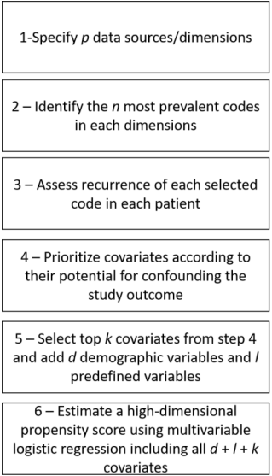
The HD-PS aims to empirically identify candidate covariates which may collectively be proxies for unobserved confounding of the outcome. The algorithm takes many possible confounding covariates extracted from longitudinal health data. It first removes covariates with low prevalence and then removes covariates with a low potential for causing bias. The resulting selected covariates were then entered in a conventional PS model.
The number of HD-PS data sources / dimensions p was 6 for Germany, 5 for the US and Sweden, and 3 for Norway. The look-back period was of 12 months preceding the CED. In each dimension, the n = 200 most prevalent codes were identified. Prevalence was affected by the granularity (number of code digits retained) chosen for each code type (ICD-10, ICD-9, KVÅ, OPS, EBM, HCPCS/CPT, and ATC codes).

High-dimensional propensity score data dimensions for each country
 | Germany |  | Sweden¹ |  | US |  | Norway¹
 | Codes | Digits | Codes | Digits | Codes | Digits | Codes | Digits
Prescription | ATC | 7 | ATC | 7 | ATC² | 7 | ATC codes | 7
Inpatient diagnoses | ICD-10 | 3 | ICD-10 | 3 | ICD-9 | 3 | ICD-10 | 3
Outpatient diagnosis | ICD-10 | 3 | ICD-10 | 3 | ICD-9-CM | 3 | ICD-10 | 3
Inpatient procedures | OPS | 4 | KVÅ | 3 | ICD-9-CM | 3 | NA | -
Outpatient procedures | OPS | 4 | KVÅ | 3 | HCPCS/CPT | NA³ | NA | -
Outpatient services | EBM | 4 | NA | - | NA | - | NA | -
1: Only the ICD-10, ATC, and procedure codes defined in the study protocol were available, since each variable has to be requested in the application procedure
2: NDC codes provided in the US data were mapped to ATC code
3: HCPSC/CPT codes were divided into 210 subcategories.
ATC, anatomical, therapeutic and chemical; CPT, Current Procedural Terminology; EBM, einheitlicher Bewertungsmaßstab (codes for remuneration of outpatient care in Germany); HCPCS, Healthcare Common Procedure Coding System; ICD, International Classification of Diseases and Related Health Problems; KVÅ, Swedish procedure coding system; NA, not applicable ; NDC, National Drug Code; OPS, Operationen- und Prozedurenschlüssel (the operation and procedure classification system, with codes for diagnostic tests and treatments).
Three binary recurrence variables were implemented as in the standard HD-PS algorithm: code occurred ≥ 1 times, code occurred ≥ median number of times, and code occurred ≥ 75th percentile number of times. The number of binary empirical covariates selected was k = 150. In addition, d = 3 demographic variables (age, sex, and cohort entry year) and l = 13 expert-defined markers of COPD severity and morbidity (Supplementary material 4) were forced into the model. Independent HD-PS models conditional on d + l + k covariates were fitted for each of the 12 timepoints in each yearly cohort, in line with the conventional PS computation.

Reference
Schneeweiss S, Rassen JA, Glynn RJ, Avorn J, Mogun H, Brookhart MA. High-dimensional propensity score adjustment in studies of treatment effects using health care claims data. Epidemiology. 2009;20(4):512-22.

Supplementary material 4

Markers of COPD severity and morbidity
Variables
Number of hospitalisations due to COPD exacerbations in the 12 months prior to CED:0/1/≥2
Hospitalisation due to COPD exacerbation in the 30 days prior CED: Yes/No
Number of respiratory disease related hospitalisations in the 12 months prior to CED: 0/1/≥2
Number of emergency room visits for COPD in the 12 months prior to CED: 0/1/≥2ª
Emergency room visit for COPD in the 30 days prior to CED: Yes/Noª
Prior use of oxygen: Yes/No^{b}
Current use of theophylline or acetylcysteine at CED: Yes/No
Charlson Comorbidity Index^{c}: 0-2, 3-5, ≥6
Emphysema: Yes/No
Number of moderate COPD exacerbations in the 12 months prior to CED: 0/1/≥2
Treatment intensity score^{d}: 0, 1-2, 3, 4
Chronic use of systemic corticosteroids: Yes/No
Number of outpatient physician office visits for COPD in the 30 days prior to CED
a: In Germany, emergency room codes only indicate emergency care, but it is not known whether this was emergency care in an emergency room at a hospital or emergency care in the outpatient setting.
b: Oxygen was not available in Germany and Norway.
c: an indicator scoring patient comorbidities adjusting for the category of comorbidity using weights from 1 to 6 based on the International Classification of Diseases (ICD) diagnosis codes. When the patient has no comorbidities, a score of 0 is assigned.
d: Treatment intensity score categories: 0=no COPD treatment; 1= SABA or SAMA only; 2=LABA or LAMA or ICS (±SAMA or SABA); 3=(LABA + LAMA) or (LABA + ICS) or (LAMA + ICS) (±SAMA or SABA); 4=LABA + LAMA + ICS (±SAMA or SABA).
CED, cohort entry date; COPD, chronic obstructive pulmonary disease; ICS, inhaled corticosteroid; LABA, long-acting beta agonist; LAMA, long-acting muscarinic antagonist; SABA, short-acting beta agonist; SAMA, short-acting muscarinic antagonist

Supplementary material 5

Patient accrual per country and study year
 | Number of patients in the study population  (PS matched cohort) | Number of roflumilast-exposed patients with matches | Number of unexposed patients | Number of roflumilast-exposed patients without matches | Number of patients counted twiceª
Germany
2011 | 28,916 | 4,959 | 23,957 | 166 | 0
2012 | 11,697 | 2,061 | 9,636 | 215 | 707
2013 | 9,954 | 1,763 | 8,191 | 161 | 695
All | 50,567 | 8,783 | 41,784 | 542 | 1,402
Norway
2011 | 3,226 | 557 | 2,660 | 9 | 0
2012 | 3,271 | 564 | 2,704 | 3 | 123
2013 | 2,975 | 503 | 2,466 | 6 | 137
All | 9,472 | 1,624 | 7,830 | 18 | 260
Sweden
2011 | 7,581 | 1,293 | 6,281 | 7 | 0
2012 | 7.124 | 1,210 | 5,909 | 5 | 348
2013 | 4,320 | 7,31 | 3,586 | 3 | 260
All | 19,025 | 3,234 | 15,776 | 15 | 608
US
2011 | 13,160 | 2,220 | 10,924 | 16 | 0
2012 | 26,299 | 4,451 | 21,829 | 19 | 750
2013 | 17,333 | 2,927 | 14,398 | 8 | 887
All | 56,792 | 9,598 | 47,151 | 43 | 1,637
Total (all countries and years) | 135,856 | 23,239 | 112,541 | 618 | 3,907

ªThe number of patients counted twice is the number of controls who became exposed during 2012 or 2013 and were included as exposed in that year, after having already been included as unexposed in earlier annual cohort (2011 or 2012). Their follow-up as unexposed in the earlier cohort ended when they switched to roflumilast.
PS, propensity score; US, United States.

Supplementary material 6

Standardized differences for the propensity score variables at cohort entry before and after matching including all study years

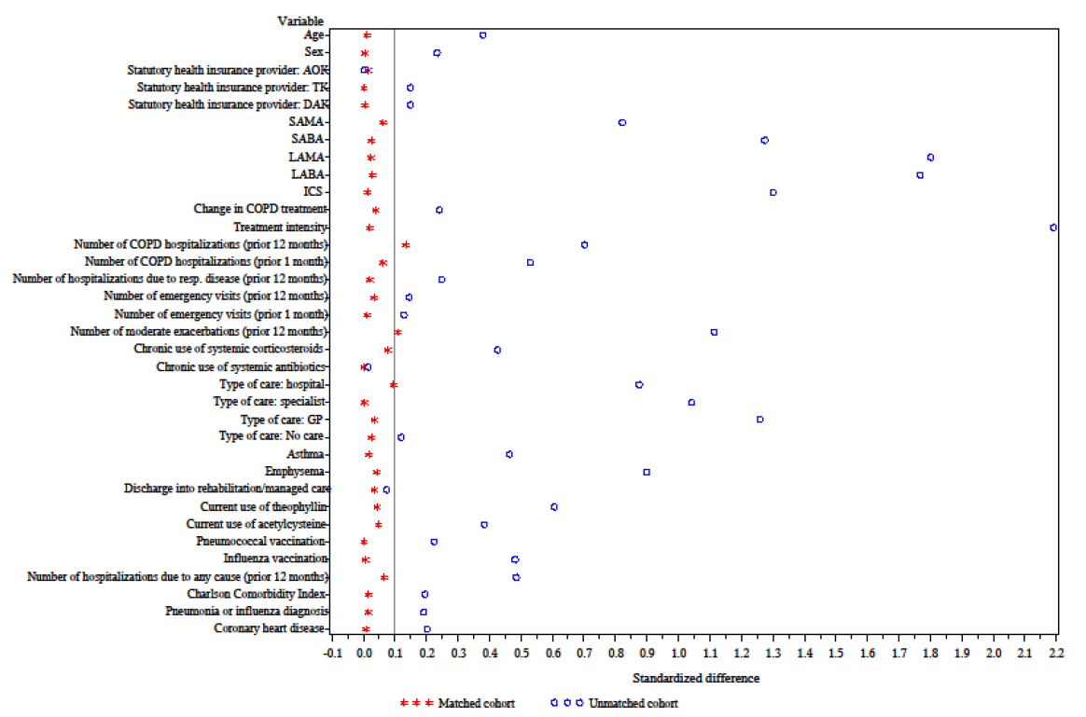
In Germany
COPD, chronic obstructive pulmonary disease; GP, general practitioner; ICS, inhaled corticosteroid; LABA, long-acting β2-agonist; LAMA, long-acting muscarinic antagonist; SABA, short-acting β2-agonist; SAMA, short-acting muscarinic antagonist.

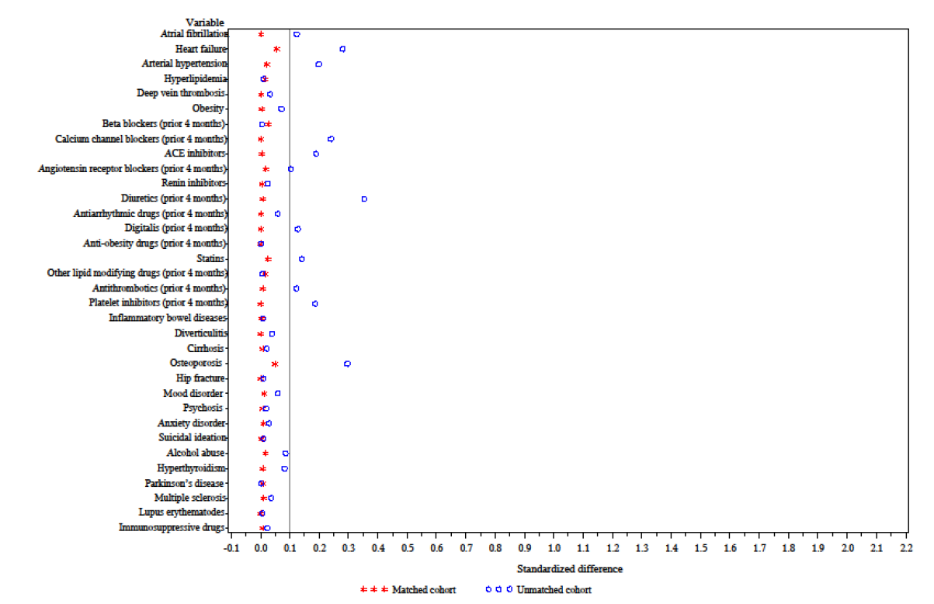
ACE, angiotensin converting enzyme.

In Norway
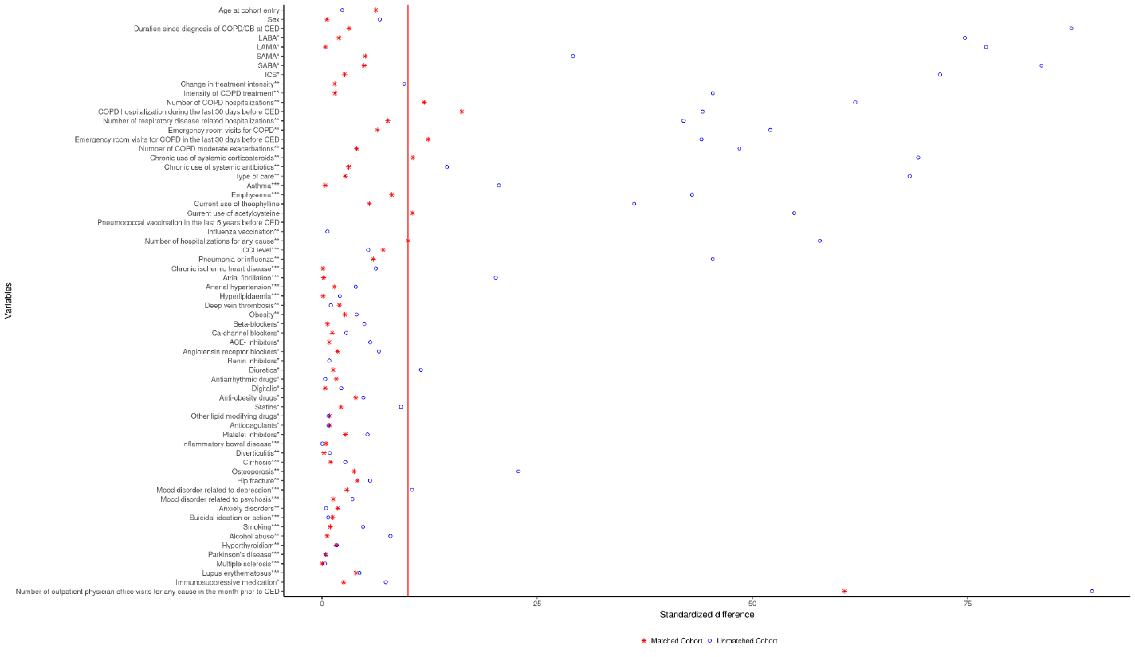
CB, chronic bronchitis; CCI, Charlson Comorbidity Index; CED, cohort entry date; COPD, chronic obstructive pulmonary disease; GP, general practitioner; ICS, inhaled corticosteroid; LABA, long-acting β2-agonist; LAMA, long-acting muscarinic antagonist; SABA, short-acting β2-agonist; SAMA, short-acting muscarinic antagonist.

Sweden
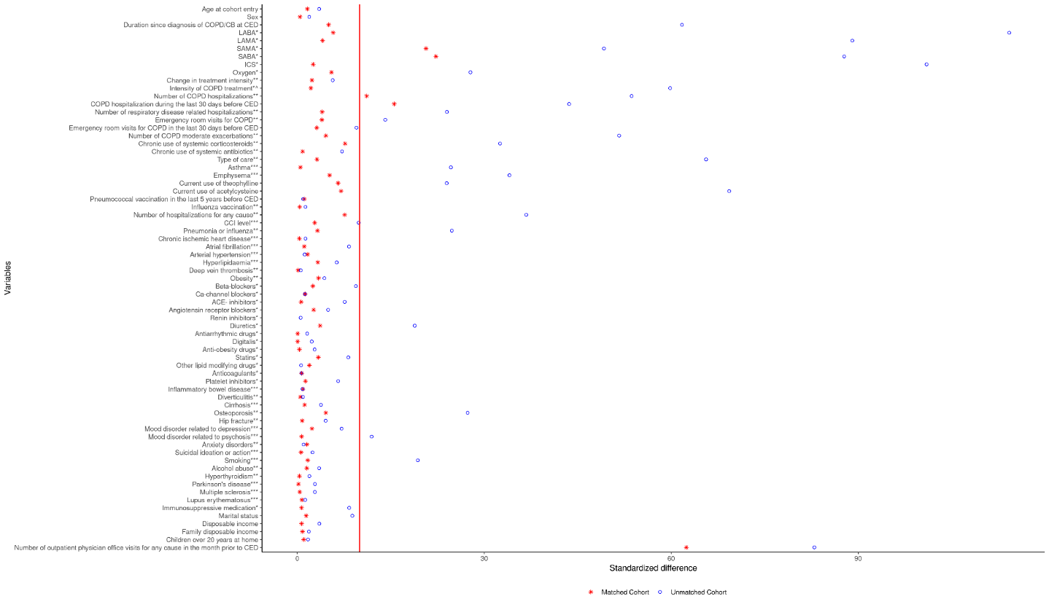
CB, chronic bronchitis; CCI, Charlson Comorbidity Index; CED, cohort entry date; COPD, chronic obstructive pulmonary disease; GP, general practitioner; ICS, inhaled corticosteroid; LABA, long-acting β2-agonist; LAMA, long-acting muscarinic antagonist; SABA, short-acting β2-agonist; SAMA, short-acting muscarinic antagonist.

In the US
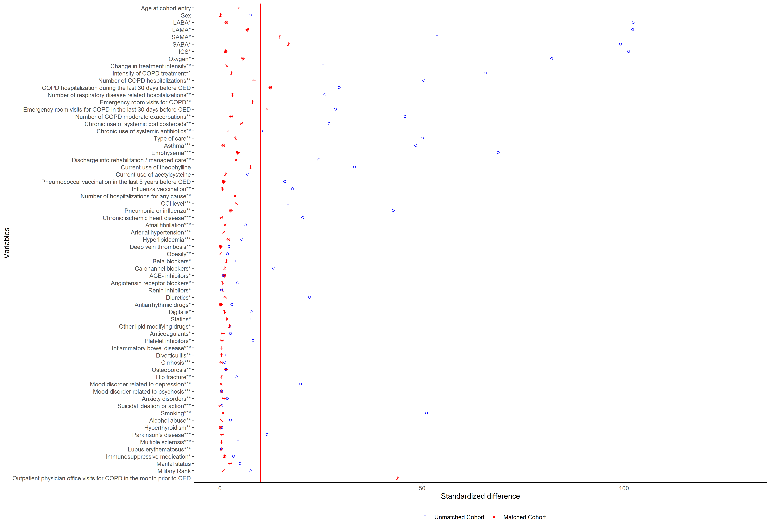
CB, chronic bronchitis; CCI, Charlson Comorbidity Index; CED, cohort entry date; COPD, chronic obstructive pulmonary disease; GP, general practitioner; ICS, inhaled corticosteroid; LABA, long-acting β2-agonist; LAMA, long-acting muscarinic antagonist; SABA, short-acting β2-agonist; SAMA, short-acting muscarinic antagonist.

Unbalanced variables at CED
Variables | GER | SWE | US | NOR
Number of hospitalizations due to COPD in the 12 months before CED | X | X | - | X
Number of emergency room visits due to COPD in the 12 months before CED | - | - | X | X
Number of hospitalizations due to COPD in the 30 days before CED | - | X | X | X
Number of emergency room visits due to COPD in the 30 days before CED | - | - | X | X
Number of moderate COPD exacerbations in the 12 months before CED | X | - | -
SABA/SAMA use in the last 4 months before CED | - | X | X
Current use of acetylcysteine | - | - | - | X
Number of outpatient physician office visits for COPD in the month prior to CED | - | - | - | X
Use of systemic corticosteroids | - | - | - | X
Number of hospitalizations for any cause | - | - | - | X
Note: Unbalance is defined by a cut-off value of >10% in the standardized difference between exposure groups
CED, cohort entry date; COPD, chronic obstructive pulmonary disease; GER, Germany; NOR, Norway; SABA, short-acting β2 agonists; SAMA, short-acting muscarinic antagonist; SWE, Sweden; US, United States.

Supplementary material 7

Time to discontinuation of continuous roflumilast treatment for roflumilast-exposed patients from CED in Germany
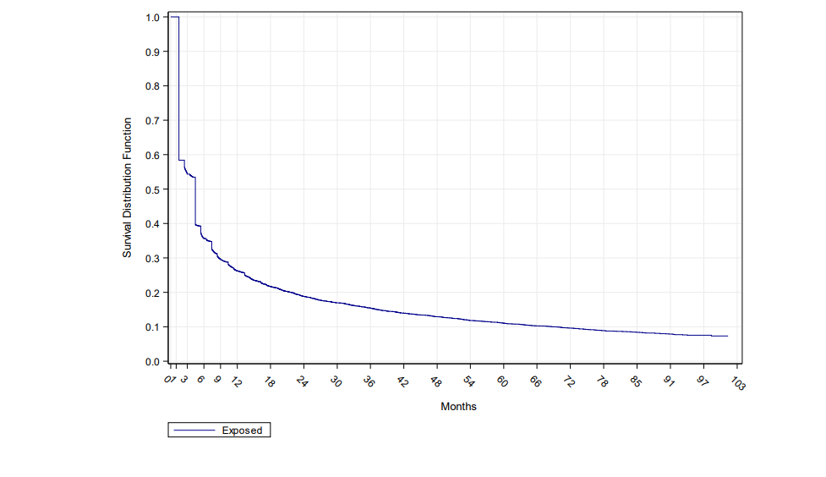

CED: Cohort entry date

Time to discontinuation of continuous roflumilast treatment for roflumilast-exposed patients from CED in Norway

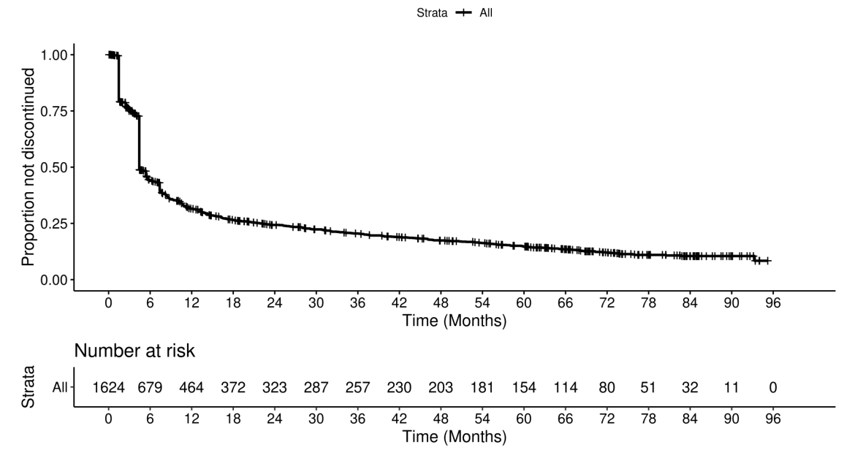

CED, Cohort entry date.

Time to discontinuation of continuous roflumilast treatment for roflumilast-exposed patients from CED in Sweden
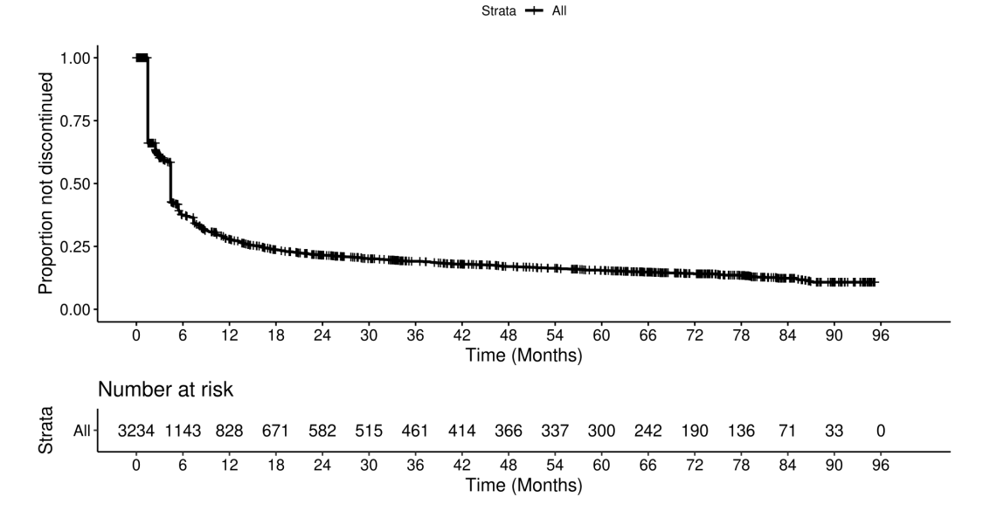

CED, Cohort entry date.

Time to discontinuation of continuous roflumilast treatment for roflumilast-exposed patients from CED in the US

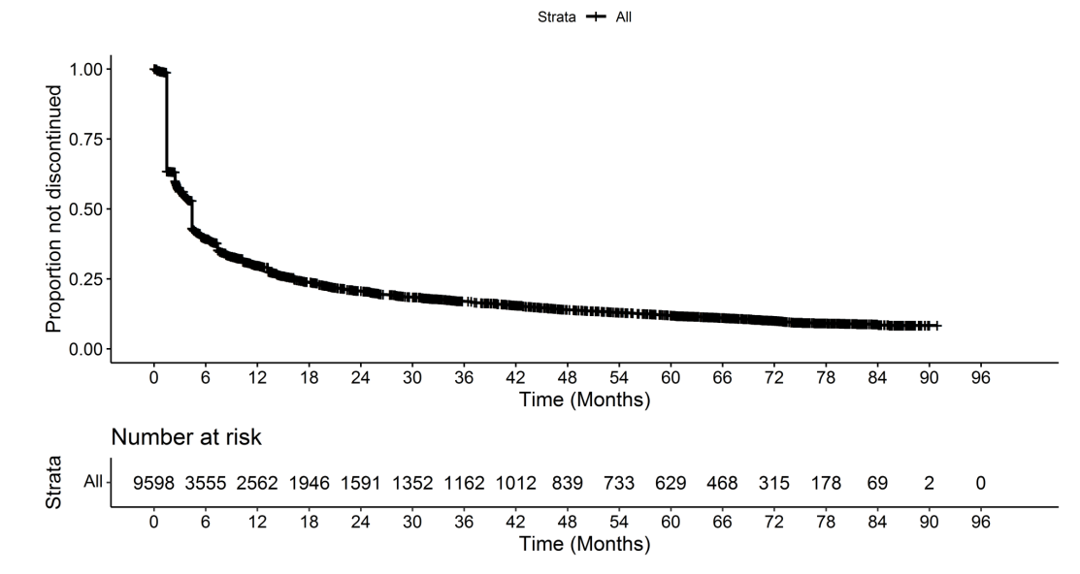
CED, Cohort entry date; US, United States.

Supplementary material 8

Five-Year all-cause mortality in “ever” versus “never” users of roflumilast: crude event rates and HRs
Country | Crude MR/1000 PY (95% CI) |  | crude HR  (95% CI)
Country | Ever exposed | Never exposed | crude HR  (95% CI)
Germany | 93.75  (90.54, 97.04) | 75.11  (73.77, 76.46) | 1.17  (1.13, 1.22)
Norway | 129.04  (120.29, 138.43) | 115.96  (112.04, 120.01) | 1.06  (0.98, 1.15)
Sweden | 121.51  (115.46, 127.87) | 105.98  (103.36, 108.68) | 1.11  (1.05, 1.18)
US | 131.97  (128.21, 135.85) | 102.16  (100.66, 103.68) | 1.25  (1.21, 1.29)
“Ever” users are patients with any exposure to roflumilast in a cohort entry year.
“Never” users are patients in the matched unexposed cohort, with no prior exposure to roflumilast.
CI, confidence interval; PY, person-years; MR, mortality rate; HR, hazard ratio; US, United States.

Five-year all-cause mortality for “current”, “recent”, and “past use” of roflumilast versus “never use”: crude event rates and HRs
Country | MR/1000 PY  (95% CI) | crude HR  (95% CI)
Germany
Never | 75.11 (73.77, 76.46) | 1
Current | 81.80 (77.32, 86.48) | 0.94 (0.88, 0.99)
Recent | 135.73 (117.61, 155.84) | 1.67 (1.45, 1.93)
Past | 100.45 (95.85, 105.22) | 1.36 (1.30, 1.43)
Norway
Never | 115.96 (112.04, 120.01) | 1
Current | 98.34 (87.04, 111.10) | 0.76 (0.67, 0.87)
Recent | 194.41 (144.18, 262.14) | 1.51 (1.11, 2.05)
Past | 149.75 (136.91, 163.80) | 1.30 (1.18, 1.43)
Sweden
Never | 105.98 (103.36, 108.68) | 1
Current | 99.63 (91.31, 108.70) | 0.85 (0.77, 0.93)
Recent | 127.93 (99.74, 164.08) | 1.06 (0.82, 1.36)
Past | 137.93 (129.24, 147.21) | 1.35 (1.26, 1.45)
US
Never | 102.16 (100.66, 103.68) | 1
Current | 117.27 (112.17, 122.60) | 1.06 (1.01, 1.11)
Recent | 206.46 (184.87, 230.56) | 1.90 (1.70, 2.13)
Past | 139.77 (134.21, 145.56) | 1.40 (1.34, 1.46)
“Current”, “recent”, and “past use” of roflumilast is defined using a time-varying variable dependent on the timing of roflumilast discontinuation.
“Never use” concern patients in the matched unexposed cohort, with no prior exposure to roflumilast.
CI, confidence interval; COPD, chronic obstructive pulmonary disease; HR, hazard ratio; MR, mortality rates; N, number of patients; PS, propensity score; PY, person-years; US, United States.

Five-year all-cause mortality for “cumulative use” (<3 months, 3 to 12 months, 12 to 24 months, >24 months) of roflumilast versus “never use”: crude event rates and HRs
 | MR/1000 PY  (95% CI) | Crude HR (95% CI)
Germany
Never | 75.11 (73.77; 76.46) | 1
<3 months | 88.37 (83.11; 93.87) | 1.13 (1.06, 1.21)
3 to 12 months | 98.54 (92.88: 104.46) | 1.26 (1.19, 1.35)
12 to 24 months | 101.39 (92.60; 110.79) | 1.26 (1.15, 1.38)
>24 months | 89.33 (82.08; 97.05) | 1.02 (0.94, 1.12)
Norway
Never | 115.96 (112.04, 120.01) | 1
<3 months | 140.83 (122.48, 161.93) | 1.11 (0.96, 1.28)
3 to 12 months | 135.82 (122.71, 150.32) | 1.15 (1.03, 1.28)
12 to 24 months | 115.38 (94.05, 141.54) | 0.96 (0.78, 1.19)
>24 months | 106.92 (89.20, 128.16) | 0.87 (0.72, 1.04)
Sweden
Never | 105.98 (103.36, 108.68) | 1
<3 months | 131.42 (120.42, 143.42) | 1.17 (1.07, 1.28)
3 to 12 months | 125.03 (115.31, 135.57) | 1.15 (1.06, 1.26)
12 to 24 months | 109.39 (94.08, 127.19) | 1.00 (0.86, 1.17)
>24 months | 104.34 (91.34, 119.19) | 0.98 (0.85, 1.12)
US
Never | 102.16 (100.66, 103.68) | 1
<3 months | 135.45 (128.67, 142.58) | 1.26 (1.19, 1.33)
3 to 12 months | 130.99 (124.62, 137.68) | 1.26 (1.19, 1.32)
12 to 24 months | 125.85 (116.75, 135.65) | 1.21 (1.12, 1.31)
>24 months | 133.07 (124.67, 142.04) | 1.26 (1.17, 1.34)
CI, confidence interval; COPD, chronic obstructive pulmonary disease; N, number of patients; MR, mortality rates; HR, hazard ratio; PY, person-years; US, United States.

Supplementary material 9

Sensitivity analysis: 5-year all-cause mortality for “ever” versus “never” exposure to roflumilast after HD-PS-matching: number of events and crude and adjusted HRs
5-year all-cause mortality | Number of ever exposed (PY) | Number of never exposed (PY) | Number of events (ever exposed) | Number of events (never exposed) | Crude HR (95% CI) | Adjusted HR* (95% CI)
Germany | 8,651 (34,026) | 41,047 (157,177) | 3,158 | 12,173 | 1.14 (1.10, 1.19) | 1.09 (1.05, 1.13)
Norway | 1,603 (7050) | 7,502 (31,643) | 925 | 3,659 | 1.02 (0.94, 1.11) | 0.99 (0.91, 1.08)
Sweden | 3,123 (14,208) | 14,205 (61,844) | 6,849 | 1,755 | 1.03 (0.97, 1.09) | 0.95 (0.90, 1.01)
US | 9,566 (40,515) | 46,499 (193,858) | 20,731 | 5,296 | 1.18 (1.15, 1.22) | 1.12 (1.08, 1.16)
*Adjusted for age + sex +country-specific variables imbalanced after PS-matching markers of COPD severity and morbidity. The models assume different baseline hazards for each stratum; strata were defined as PS quintiles per cohort entry year in each country.
CI, confidence interval; GER, Germany; HR, hazard ratio; PY, person-years; SWE, Sweden; US, United States.

Sensitivity analysis: 5-year all-cause mortality according to cumulative exposure duration (<3, 3 to 12, 12 to 24 months, >24 months) of roflumilast versus never use in which patients are censored after first discontinuation: number of events and crude and adjusted HRs
Country | All-cause mortality | Never (ref.) | <3 months | 3 to 12 months | 12 to 24 months | >24 months
NOR | Deaths (person-years) | 920 (7135) | 38 (338) | 52 (462) | 38 (373) | 65 (852)
NOR | N at risk | 7,830 | 1,624 | 1,158 | 426 | 310
NOR | Crude HR (95% CI) | 1.00 (Reference) | 0.60  (0.43, 0.85) | 0.65  (0.48, 0.88) | 0.79  (0.55, 1.15) | 0.55  (0.40, 0.75)
NOR | Adjusted HR* (95% CI) | 1.00 (Reference) | 0.59  (0.42, 0.83) | 0.61  (0.45, 0.83) | 0.69  (0.48, 1.00) | 0.47  (0.34, 0.65)
SWE | Deaths (person-years) | 1,582 (12680) | 81 (604) | 68 (793) | 62 (667) | 177 (1638)
SWE | N at risk | 15,776 | 3,234 | 1,832 | 761 | 566
SWE | Crude HR (95% CI) | 1 | 0.63 (0.50, 0.80) | 0.59 (0.46, 0.77) | 0.78 (0.59, 1.03) | 1.25 (1.02, 1.53)
SWE | Adjusted HR* (95% CI) | 1 | 0.59 (0.46, 0.74) | 0.51 (0.40, 0.66) | 0.66 (0.50, 0.87) | 0.98 (0.80, 1.21)
US | Deaths (person-years) | 4,378 (35101) | 240 (1,751) | 273 (2,460) | 212 (1,913) | 428 (3,651)
US | N at risk | 47,151 | 9,598 | 5,058 | 2,311 | 1,513
US | Crude HR (95% CI) | 1 | 0.73 (0.63, 0.83) | 0.86 (0.75, 0.98) | 0.95 (0.82, 1.11) | 1.15 (1.02, 1.30)
US | Adjusted HR* (95% CI) | 1 | 0.67 (0.58, 0.77) | 0.76 (0.67, 0.87) | 0.81 (0.70, 0.94) | 0.95 (0.84, 1.08)
*Adjusted for age + sex + country-specific variables imbalanced after PS-matching + markers of COPD severity and morbidity. The models assume different baseline hazards for each stratum; strata were defined as PS quintiles per cohort entry year in each country.
Note: Analysis was not conducted for Germany.
CI, confidence interval; COPD, chronic obstructive pulmonary disease; HR, hazard ratio; N, number of patients; NOR, Norway; PS, propensity score; SWE, Sweden; US, United States.

Sensitivity analysis: All-cause mortality associated with “ever use” versus “never use” of roflumilast, stratified by FEV₁ values in Germany: number of events and crude and adjusted HRs
 | Number at risk | Number of deaths (PY) | Crude HR (95% CI) | Adjusted HR* (95% CI)
FEV1 unspecified
Never use | 7442 | 1544 (31,593) | 1 (ref.) | 1 (ref.)
Ever use, FEV1 unspecified | 2576 | 806 (10,402) | 1.48 (1.35, 1.61) | 1.36 (1.24, 1.49)
FEV₁ <35%
Never use | 6,104 | 2,544 (19,799) | 1 (ref.) | 1 (ref.)
Ever use, FEV₁ <35% | 2,684 | 1,251 (9862) | 1.01 (0.95, 1.08) | 0.96 (0.90, 1.03)
FEV₁ ≥35% and <50%
Never use | 2,263 | 698 (8429) | 1 (ref.) | 1 (ref.)
Ever use, FEV₁ ≥35 % and <50% | 1,337 | 460 (5467) | 1.00 (0.89, 1.13) | 0.99 (0.87, 1.11)
FEV₁ ≥50% and <70%
Never use | 445 | 103 (1833) | 1 (ref.) | 1 (ref.)
Ever use, FEV₁ ≥50% and <70% | 339 | 102 (1384) | 1.31 (0.99, 1.72) | 1.30 (0.97, 1.73)
FEV₁ ≥70%
Never use | 15 | 2 (71) | 1 (ref.) | 1 (ref.)
Ever use, FEV₁ ≥70% | 15 | 3 (62) | 3.00 (0.31, 28.84) | NA**

*Adjusted for age + sex + country-specific variables imbalanced after PS-matching + markers of COPD severity and morbidity. The models assume different baseline hazards for each stratum; strata were defined as PS quintiles per cohort entry year in each country.
** Data were limited to very few patients in the stratum of FEV1 values over 70% and adjusted HRs could not be estimated.
CI, confidence interval; COPD, chronic obstructive pulmonary disease; FEV₁, forced expiratory volume in 1 second; GER, Germany; HR, hazard ratio; NA, not applicable; PY, person-years.

