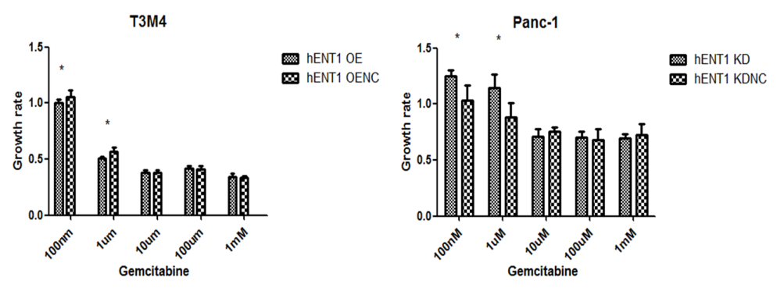
Supplementary Figure 1 The regulatory effect of hENT1 on the chemosensitivity of pancreatic cancer cells to Gemcitabine.

Supplementary Table 1: Relationship between hENT1 expression and clinical characteristics
Characteristics | Patients |  | hENT1 expression
Characteristics | n | % | High | Low | P value
All patients | 359 | 100 | 165 | 194 | -
Sex |  |  |  |  | 0.165
Male  Female | 204  155 | 56.8  43.2 | 87  78 | 117  77
Age |  |  |  |  | 0.432
<65  ≥65 | 239  120 | 66.6  33.4 | 106  59 | 133  61
Diabetes |  |  |  |  | 0.758
Yes  No | 48  308 | 13.4  85.8 | 21  144 | 27  164
Chronic pancreatitis |  |  |  |  | 1
Yes  No | 1  358 | 0.3  99.7 | 0  165 | 1  193
CA19-9, U/ml |  |  |  |  | 1
>467  <467 | 73  228 | 24.3  75.7 | 34  108 | 39  120
Pathological differentiation degree |  |  |  |  | 0.032
High  Low | 116  243 | 32.3  67.7 | 63  102 | 53  141
Capsular invasion |  |  |  |  | 0.458
Yes  No | 342  17 | 95.3  4.7 | 159  6 | 183  11
Vascular invasion |  |  |  |  | 0.167
Yes  No | 28  331 | 7.8  92.2 | 9  156 | 19  175
Neural infiltration |  |  |  |  | 0.525
Yes  No | 165  194 | 46.0  54.0 | 79  86 | 86  108
T classification |  |  |  |  | 0.653
T1/2  T3/4 | 21  338 | 5.8  94.2 | 11  154 | 10  184
N classification |  |  |  |  | 0.336
N0  N1/2 | 153  206 | 42.6  57.4 | 75  90 | 78  116
M classification |  |  |  |  | 1
M0  M1 | 336  23 | 93.6  6.4 | 154  11 | 182  12
TNM stage |  |  |  |  | 0.574
I/II  III/IV | 328  31 | 91.4  8.6 | 149  16 | 179  15

Supplementary Table 2: The univariate analysis of overall survival from the general population of patients and Gemcitabine-treated patients (N=299)
Characteristics | OS (overall survival)  General population Gemcitabine-treated patients
 | Hazard ratio (HR) | 95% CI  (confidence  interval) | P value | Hazard  Ratio  (HR) | 95% CI  (confidence  Interval) | P value
M classification | 0.65 | 0.22-1.91 | 0.433 | 1.03 | 0.32-3.36 | 0.963
TNM stage | 2.68 | 1.09-6.58 | 0.031 | 2.90 | 1.06-7.92 | 0.038
Capsular invasion | 0.84 | 0.37-1.92 | 0.682 | 0.87 | 0.38-1.98 | 0.734
CA19-9 | 1.19 | 0.85-1.67 | 0.309 | 1.16 | 0.82-1.65 | 0.395
hENT1 | 0.60 | 0.43-0.82 | 0.001 | 0.60 | 0.43-0.82 | 0.002

Supplementary Table 3: The univariate analysis of disease-free survival from the general population of patients and Gemcitabine-treated patients (N=298)
Characteristics | DFS (disease-free survival)  General population Gemcitabine-treated patients
 | Hazard ratio (HR) | 95% CI  (confidence  interval) | P value | Hazard  Ratio  (HR) | 95% CI  (confidence  Interval) | P value
M classification | 0.91 | 0.32-2.64 | 0.867 | 0.98 | 0.30-3.19 | 0.976
TNM stage | 1.88 | 0.77-4.59 | 0.169 | 2.31 | 0.85-6.28 | 0.100
Capsular invasion | 0.74 | 0.34-1.59 | 0.440 | 0.76 | 0.35-1.64 | 0.485
CA19-9 | 1.36 | 0.99-1.86 | 0.057 | 1.32 | 0.95-1.83 | 0.097
hENT1 | 0.53 | 0.39-0.72 | ＜0.001 | 0.56 | 0.41-0.77 | ＜0.001

