Supplementary Materials for SCI Manuscript

Contents

Supplementary Material 1: Exercise Rehabilitation Program for Knee Osteoarthritis (KOA)………………………………………….……………….page2-page9

A detailed outline of the tailored exercise rehabilitation program designed for patients with Knee Osteoarthritis.

Supplementary Material 2: Exercise Rehabilitation Training Diary………………………………………………………………………………………….page10
A formatted diary for patients to document their daily exercise activities, as part of their rehabilitation process.

Supplementary Material 3: Supplementary Table 1: Schedule of Enrollment, Interventions, and Assessments………….page11- page12
A comprehensive table detailing the timeline and activities involved in the study, from patient enrollment through intervention implementation to post-intervention assessments.

Supplementary Material 4: Supplementary Table 2: Summary of Exercise Program………………………………………………………….page13
A succinct summary table listing the components of the exercise program.
Exercise 1 ： Piaffe
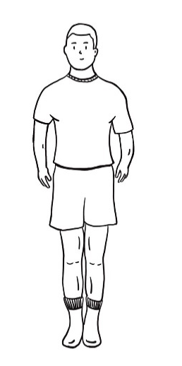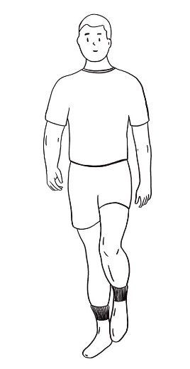 | Purpose: To warm up and prepare to avoid injury.  - Stand naturally and look straight ahead.  - Use the left leg as the support leg, bend the right leg and lift the foot, then swing the arm to switch legs.  - Use the right leg to support the leg and bend the left leg to lift the foot.  - Repeat *40.  - Take 1min.
Exercise Rehabilitation Program For KOA

Exercise Rehabilitation Program For KOA

Exercise 2 ： Forward Kick Training
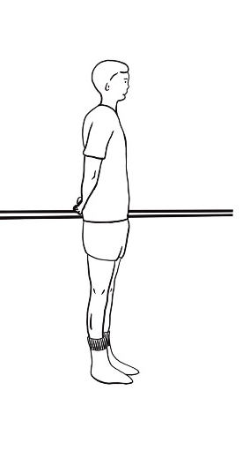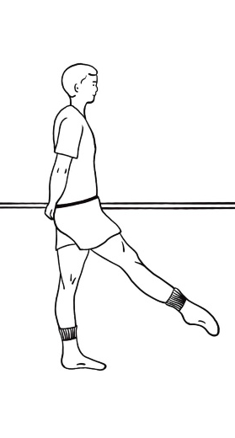 | Purpose: To strengthen the muscle strength of the lower limbs and enhance the proprioception and stability of the patients.  - Stand naturally with a fixed object in your hand and keep your upper body still.  - Use the left leg as the supporting leg first. In a straight state, lift the right leg forward off the ground (the toes are about 15cm from the ground, and the angle between the legs is about 30°).  - The right leg muscles (the quadriceps as the focus) are forced to contract while the foot is plantar flexed.  - After holding for 1 second, return to the natural standing state. Repeat x8.  - Replace the support legs and perform the above actions. Repeat x8.  - This training takes about 1 minute.

Exercise Rehabilitation Program For KOA
Exercise 3 ：Back Kick Training
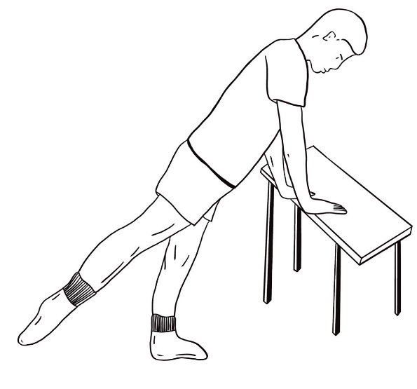 | Purpose: To strengthen the muscle strength of the lower limbs and enhance the proprioception and stability of the patients.  - Stand naturally with a fixed object in your hand and keep your upper body still.  - Use the left leg as the supporting leg first. In a straight state, lift the right leg back off the ground (the toes are about 15cm from the ground, and the angle between the legs is about 30°).  - The muscles of the right leg (with emphasis on the hamstrings and quadriceps) are contracted vigorously while the foot is plantar flexed.  - After holding for 1 second, return to the natural standing state. Repeat x8.  - Replace the support legs and perform the above actions. Repeat x8.  - This training takes about 1 minute.

Exercise 4 ： Side Kick Training
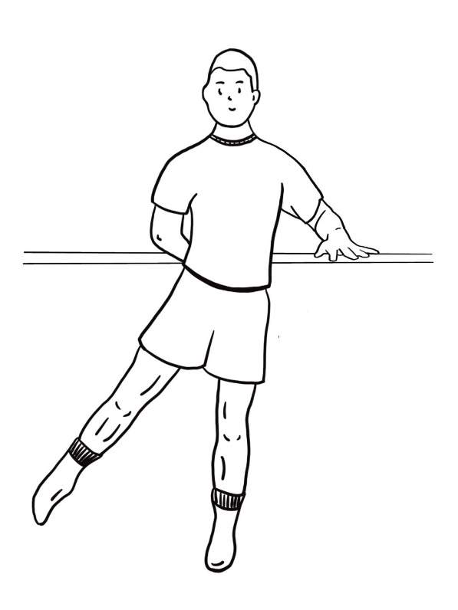 | Purpose: To strengthen the muscle strength of the lower limbs and enhance the proprioception and stability of the patients.  - Stand naturally with a fixed object in your hand and keep your upper body still.  - Use the left leg as the supporting leg first. In a straight state, lift the right leg off the ground to the right (the toes are about 15cm from the ground, and the angle between the legs is about 30°).  - The right leg muscles (the quadriceps as the focus) are forced to contract while the foot is plantar flexed.  - After holding for 1 second, return to the natural standing state. Repeat x8.  - Replace the support legs and perform the above actions. Repeat x8.  - This training takes about 1 minute.
Exercise Rehabilitation Program For KOA

Exercise Rehabilitation Program For KOA
Exercise 5 ：Ankle Pump Training
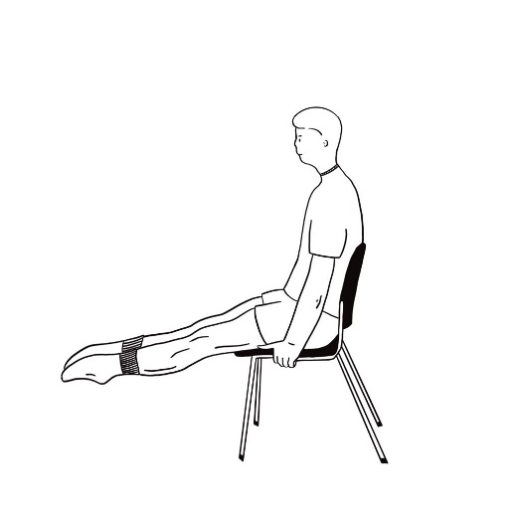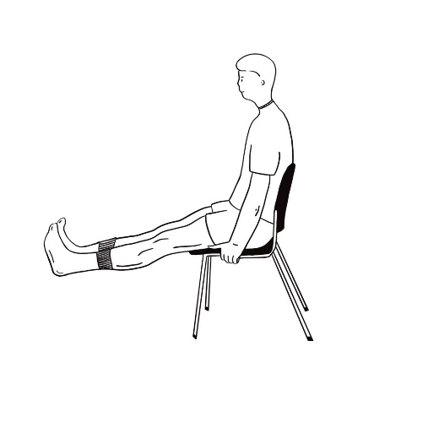 | Purpose: To improve the range of motion of the ankle joint.  - Sit on a chair and lift your legs straight off the ground.  - Plantar flex your feet as hard as possible and hold for 2 seconds.  - Dorsiflex your feet as hard as possible and hold for 2 seconds.  - Repeat ×16.  - This training takes about 1 minute.

Exercise Rehabilitation Program For KOA
Exercise 6 ： Triple Flexion Exercise
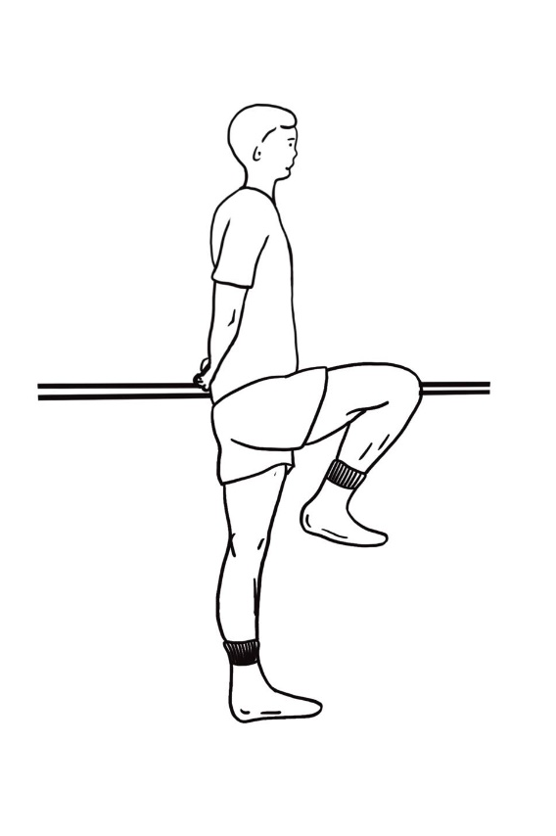 | Purpose: To improve the range of motion of the hip, knee and ankle joints.  - Stand naturally with a fixed object in your hand and keep your upper body still.  - Use the left leg as the supporting leg first. Simultaneously flex the right hip, knee, and ankle.  - After holding for 1 second, return to the natural standing state. Repeat x8.  - Replace the support legs and perform the above actions. Repeat x8.  - This training takes about 1 minute.

Exercise Rehabilitation Program For KOA
Exercise 7 : Touch The Opposite Knee With Your Hand While Flexing The Hip And Knee
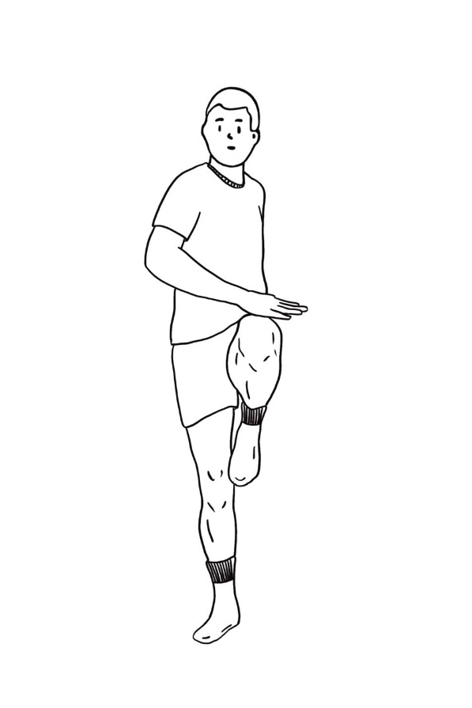 | Purpose: To strengthen the abdominal core muscles.  - Stand naturally.  - Use the left leg as the supporting leg first. Bend your right leg, hip and knee about 90° to your abdomen, while slapping your right knee with your left hand, then return to a natural standing position.  - Use the right leg as the support leg. Bend the left leg, hip and knee about 90° to the abdomen, while slapping the right knee with the left hand, and then return to a natural standing state.  - Repeat ×32.  - This training takes about 1 minute.

Exercise Rehabilitation Program For KOA
Exercise 8 : Hold The Bed With Both Hands And Stretch The Lower Limbs
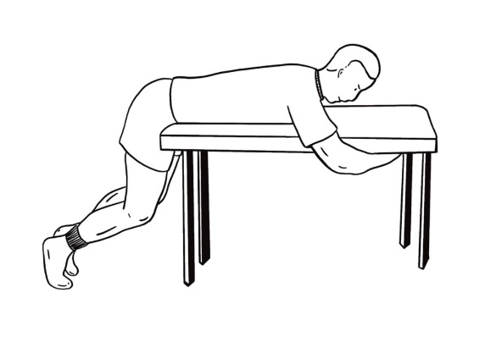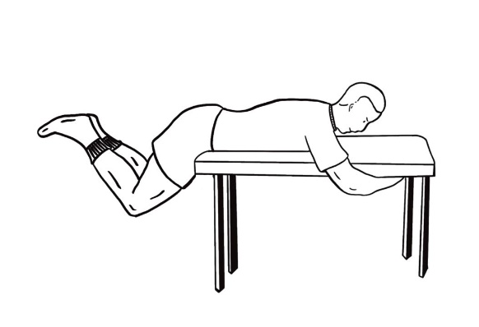 | Purpose: To strengthen the core muscles of the back.  - Bend over and hug the single bed tightly with both hands.  - Extend the hips and lift the legs slowly, hold for 2s, then slowly lower the legs to return to the original state.  - Repeat ×8.  - This training takes about 1 minute.

Exercise Rehabilitation Program For KOA
Exercise 9: Self-Massage Roller Relaxes Muscles
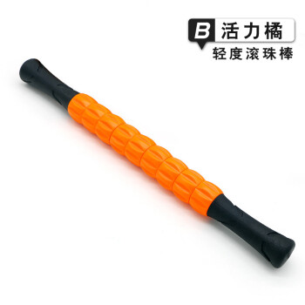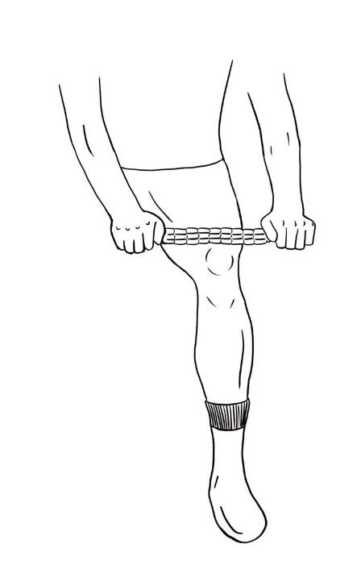 | Purpose: To relax the tense muscle groups around the knee joint of the patient and restore the balance of the mechanical structure around the knee joint.  - Sit on a bed or stool.  - Roll the massage roller longitudinally along the muscle bundle. Muscle groups include the front of the thigh (rectus femoris), the inner thigh (the vastus medialis, adductors), the outer thigh (the vastus lateralis, iliotibial band, tensor fascia lata), the back of the thigh (hamstrings) ), lateral calf (tibialis anterior) and posterior calf (gastrocnemius, soleus) in a total of 6 regions.  - During the rolling process, if the pressing force is too small, the effect will be poor (the muscles will feel tolerable soreness under the appropriate force). If some areas are very sore, you should press harder and scroll more slowly for better relaxation.  - Each area needs to be scrolled for about 1min. Avoid placing the roller directly on the knee joint and popliteal fossa.  - This training takes about 12 minutes.

Exercise rehabilitation training diary

Instructions: During treatment, please fill out a rehabilitation training diary to record your training. Keep training to keep your knees healthier.

Did you complete the following training today ?
Piaffe | Yes | No
Forward Kick Training | Yes | No
Back Kick Training | Yes | No
Side Kick Training | Yes | No
Ankle Pump Training | Yes | No
Triple Flexion Exercise | Yes | No
Touch The Opposite Knee With Your Hand While Flexing The Hip And Knee | Yes | No
Hold The Bed With Both Hands And Stretch The Lower Limbs | Yes | No
Self-Massage Roller Relaxes Muscles | Yes | No

Supplementary Table 1: Schedule of enrollment, intervention and assessments (SPIRIT Figure)
 | Enrollment stage | Intervention stage |  |  |  | follow-up stage
 | Baseline | W 1 | W 2 | W 3 | W 4 | W 8 | W 12
Enrollment
Eligibility screen | √
Informed consent | √
Randomization | √
Allocation | √
Intervention
Group A |  | √ | √ | √ | √
Group B |  | √ | √ | √ | √
Group C |  | √ | √ | √ | √
Assessments
X-ray | √
Serum test | √ |  |  |  | √
VAS | √ | √ | √ | √ | √ | √ | √
WOMAC | √ | √ | √ | √ | √ | √ | √
SF-12 | √ |  |  |  | √ | √ | √
FTSST | √ | √ | √ | √ | √ | √ | √
KRM | √ | √ | √ | √ | √ | √ | √
AEs |  | √ | √ | √ | √
Abbreviations: AEs = Adverse events. FTSST=Five times sit to stand test. KRM= Knee range of motion. SF-12=12-item Short-Form Health Survey. VAS= Visual analogue pain scale. WOMAC= Western Ontario and McMaster Universities Osteoarthritis Index.

Supplementary Table 2: Summary Of Exercise Program
Training program | Purpose
- Piaffe | To warm up and prepare to avoid injury.
- Forward Kick Training | To strengthen the muscle strength of the lower limbs and enhance the proprioception and stability of the patients.
- Back Kick Training | To strengthen the muscle strength of the lower limbs and enhance the proprioception and stability of the patients.
- Side Kick Training | To strengthen the muscle strength of the lower limbs and enhance the proprioception and stability of the patients.
- Ankle Pump Training | To improve the range of motion of the ankle joint.
- Triple Flexion Exercise | To improve the range of motion of the hip, knee and ankle joints.
- Touch The Opposite Knee With Your Hand While Flexing The Hip And Knee | To strengthen the abdominal core muscles.
- Hold The Bed With Both Hands And Stretch The Lower Limbs | To strengthen the core muscles of the back.
- Self-Massage Roller Relaxes Muscles | To relax the tense muscle groups around the knee joint of the patient and restore the balance of the mechanical structure around the knee joint.

