Supplementary Material

Materials and Method

Methodological approaches
1.1.1 The validation of the method selectivity
The specificity was assessed by analyzing blank samples to investigate potential endogenous interference with the retention time of the analyte. The chromatograms of blank samples, standard substance, and samples after administration of OBB were comparatively investigated.
1.1.2 Preparation of calibration standards
For acquiring the standard curve, the prepared stock solutions OBB and piperine (internal standard, IS) were diluted to a series of concentration gradient working solutions. Take 250 μL blood samples, add 25 μL piperine and OBB working solutions of different concentrations, and prepare samples with mass concentrations of 12.50, 6.25, 3.12, 1.56, 0.78, 0.39, and 0.19 μg/mL in the samples and analyzed by HPLC. The concentrations of the samples were used as the abscissa, and the ratios of the peak area of the samples to the IS were used as the ordinate. The linearity was fitted based on least-squares linear regression with a weighted factor (1/X²). The lower limit of quantification (LLOQ) was defined as the concentrations with its signal-to-noise ratio of 10, and the acceptable accuracy and precision were limited to 20 % in LLOQ.
1.1.4 Precision and accuracy
To determine the precision and accuracy of the assay, three levels (0.19, 1.56, 12.50 mg/mL) for OBB of QC samples were evaluated by six replicate measurements of the same samples within one day for the intra-day precision and determined twice a day for three consecutive days for the inter-day precision. Relative standard deviation (RSD) and relative error (RE) were used to express the precision and accuracy of intra-day and inter-day, respectively. The variation in precision and accuracy was less than 15 %.
1.1.5 Recovery
The extraction recovery was carried out by comparing the peak area of the biological samples at three levels of QC samples (A) with those in the acetonitrile at the same concentration (B) with six replicates. The ratio (A/B × 100) % was used to evaluate the extraction recovery. The relative recovery rate was calculated by the ratio of the measured concentration to added concentration of the drug.
1.1.6 Stability
Three levels of QC samples were prepared and stored at room temperature and -80℃, respectively. The stability was analyzed under three different circumstances: (a) the storage at room temperature for 24 h; (b) after three freeze-thaw cycles from -80℃ to room temperature; (c) at 40 ℃ for 1 month.
1.1.7 Statistical expression
All data were shown as mean ± strand deviation (SD).

Results

Method validation
A rapid, sensitive, and selective HPLC method was developed in this study. Fig. S1 indicated that drug-free samples had no interference at the retention time of OBB and the I.S. Calibration curves were linear over the concentration range of 0.19–12.50 μg/mL for OBB in blood with correlation coefficients above 0.990. LOQ was 0.05 μg/mL for OBB. As shown in Table S1-S3, for the inter- and intra-day precision values, the relative standard deviation (RSD) was within 10% and the accuracy relative recovery (RR) ranged from 90% to 110%. The results of the extraction recoveries ranged from 90% to 95%, with RSD values below 7%, and method recoveries ranged from 91% to 105%, with RSD values below 5%. OBB did not degrade significantly during the process of sample storage, preparation, and analysis. All method validation results indicated that the established method met the quantitative requirement. Taken together, a reliable and sensitive HPLC method was developed for the simultaneous quantification of OBB.

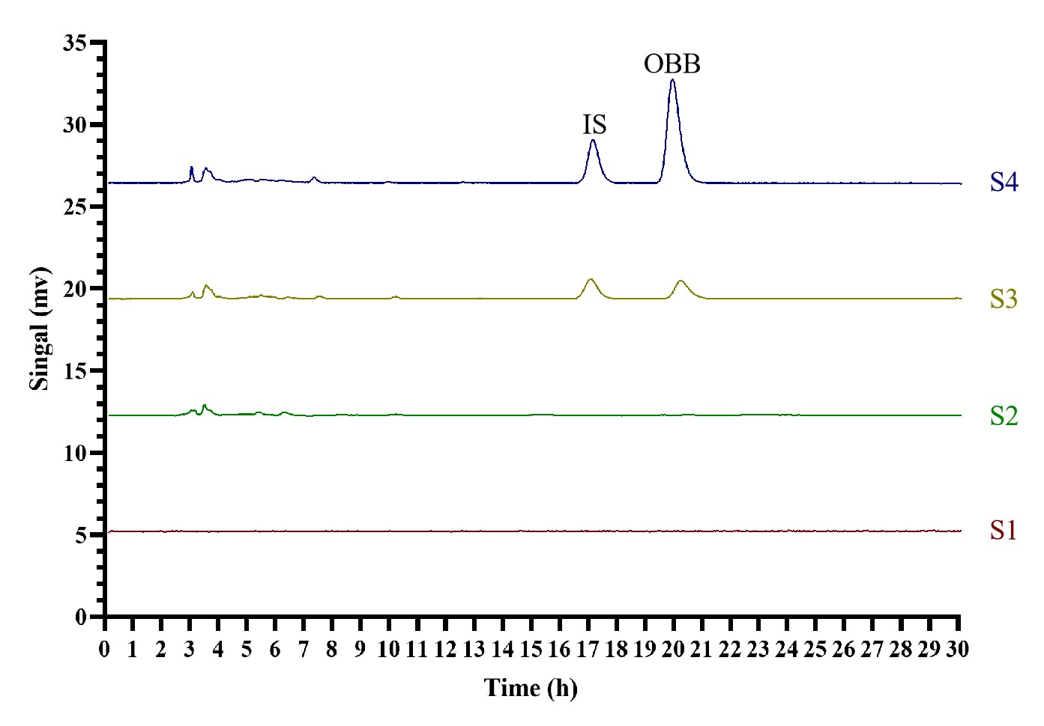
Supplementary Fig. S1. Validation of specificity of OBB and IS in HPLC analysis. (S1) Blank baseline; (S2) Blank blood samples treated by acetonitrile to precipitate protein (S3); Samples after administration with OBB; (S4) Standard of OBB and IS in black blood samples;
Supplementary Table S1 The intra-day and inter-day precision and accuracy of OBB in whole blood samples of rats.
Analyte | Samples concentration  (μg/mL) | Intra-day |  |  | Inter-day
Analyte | Samples concentration  (μg/mL) | Measured  concentration  (μg/mL) | RSD (%) | RE (%) | Measured  concentration  (μg/mL) | RSD (%) | RE (%)
Blood | 12.50 | 12.98±0.35 | 2.68 | 103.83 | 12.88±0.26 | 2.05 | 103.01
Blood | 1.56 | 1.50±0.04 | 2.49 | 96.00 | 1.49±0.02 | 1.53 | 95.27
Blood | 0.19 | 0.18±0.01 | 7.38 | 94.57 | 0.18±0.01 | 4.61 | 96.42

Supplementary Table S2 The recovery of unbound OBB in whole blood samples of rats.
Analyte | Samples concentration  (μg/mL) | Extract recovery (%) | RSD (%) | Method recovery (%) | RSD (%)
Blood | 12.50 | 90.76±1.05 | 1.16 | 97.41±3.33 | 3.41
Blood | 1.56 | 91.09±1.73 | 1.90 | 91.82±1.94 | 2.12
Blood | 0.19 | 93.81±6.07 | 6.47 | 103.38±6.84 | 6.62

Supplementary Table S3 The stability of OBB in whole blood samples under different storage conditions.
Analyte | Samples concentration (μg/mL) | Room Temp. for 24 h |  |  | Three-Freeze–Thaw Cycle |  |  | 4℃ for 1 Months
Analyte | Samples concentration (μg/mL) | Measured concentration (μg/mL) | RSD (%) | RE (%) | Measured concentration (μg/mL) | RSD (%) | RE (%) | Measured concentration (μg/mL) | RSD (%) | RE (%)
Blood | 12.50 | 12.69±0.85 | 6.72 | 101.56 | 12.02±0.6 | 5.00 | 96.19 | 12.55±0.56 | 4.46 | 100.36
Blood | 1.56 | 1.54±0.07 | 4.44 | 98.50 | 1.54±0.04 | 2.85 | 98.92 | 1.52±0.08 | 4.97 | 97.55
Blood | 0.19 | 0.18±0.02 | 8.93 | 92.25 | 0.17±0.01 | 5.30 | 89.61 | 0.18±0.02 | 9.13 | 94.52

