Supplementary Figures

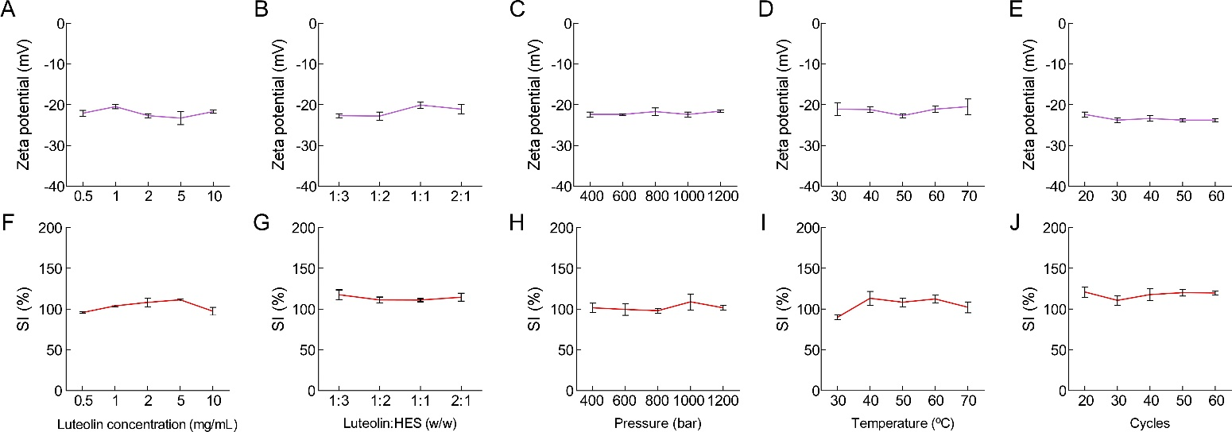
Figure S1. The effect of LUT concentration (A, F), LUT/HES weight ratio (B, G), homogenization pressure (C, H), homogenization temperature (D, I) and homogenization times (E, J) on zeta potential and SI of the prepared LUT-HES NCs suspension (mean ± SD, n = 3)
Notes: Data are reported as mean ± SD, n=3.
Abbreviations: LUT, luteolin; HES, hydroxyethyl starch; NCs, nanocrystals; LUT-HES NCs, HES-stabilized LUT NCs; SI, stability index.

Figure S2. Size distribution (A) and representative TEM image (B) of HES stabilized LUT NCs prepared by the precipitation method. To prepare HES stabilized LUT NCs, 15 mg LUT was dissolved in 5 mL sodium hydroxide solution of pH 13. Then, 75 mg HES was dissolved and dispersed into the above drug solution as the alkali solution phase. 5mL hydrochloric acid solution (0.1 M) was used as the acid solution phase. The acid solution phase was added to the base solution phase drop by drop under the condition of constant temperature stirring (25 °C, 450 rpm) after incubation to 25 °C, respectively. The obtained suspension was stirred for another 10 min to prepare HES stabilized LUT NCs.
Abbreviations: LUT, luteolin; HES, hydroxyethyl starch; NCs, nanocrystals; LUT-HES NCs, HES-stabilized LUT NCs.

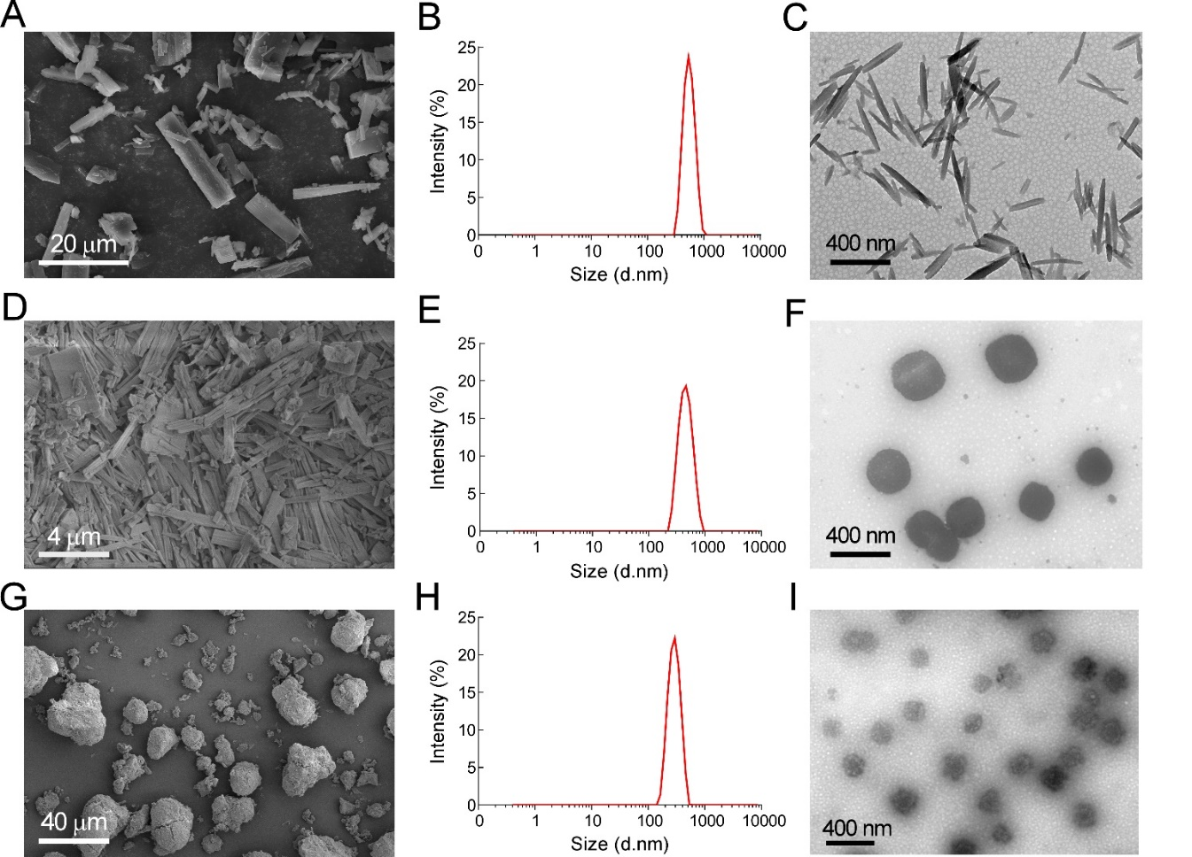
Figure S3. Representative SEM image of coarse crystal (A, quercetin; D, baicalin; G, hesperidin), DLS measurement and representative TEM image of HES stabilized nanocrystals (B-C, quercetin; E-F, baicalin; H-I, hesperidin).
Abbreviations: HES, hydroxyethyl starch.

Figure S4. Cell viability of Caco-2 cells exposed to different concentrations of different luteolin formulations at 30 μM (calculated as luteolin). For the cytotoxicity study, Caco-2 cells were seeded in 96-well plates (5000 cells/well) and cultured at 37 °C for 24 h. Then the cells were incubated with different luteolin formulations including LUT solution (dissolved in HBSS with 0.1% DMSO), physical mixture solution of LUT and HES (dissolved in HBSS with 0.1% DMSO) and LUT-HES NCs suspension dispersed in HBSS at 37 °C for 4 h. The cell viability was investigated with the CCK-8 assay kit thereafter.
Notes: Data are reported as mean ± SD, n=6.
Abbreviations: LUT, luteolin; HES, hydroxyethyl starch; NCs, nanocrystals; LUT-HES NCs, HES-stabilized LUT NCs; HBSS, Hanks Balanced Salt Solution; CCK-8, Cell Counting Kit-8.

