Supplementary figure S1:
vWF derived from HCC cells promotes tumor migration through inducing glycolysis in vitro. (A) vWF expression data in HCC tumor and normal tissues from GEPIA dataset. (B-C) Efficiency of vWF KD, vWF OE and control vectors were analyzed by Western blotting in HepG2 and SMMC-7721 cells. *P<0.05.
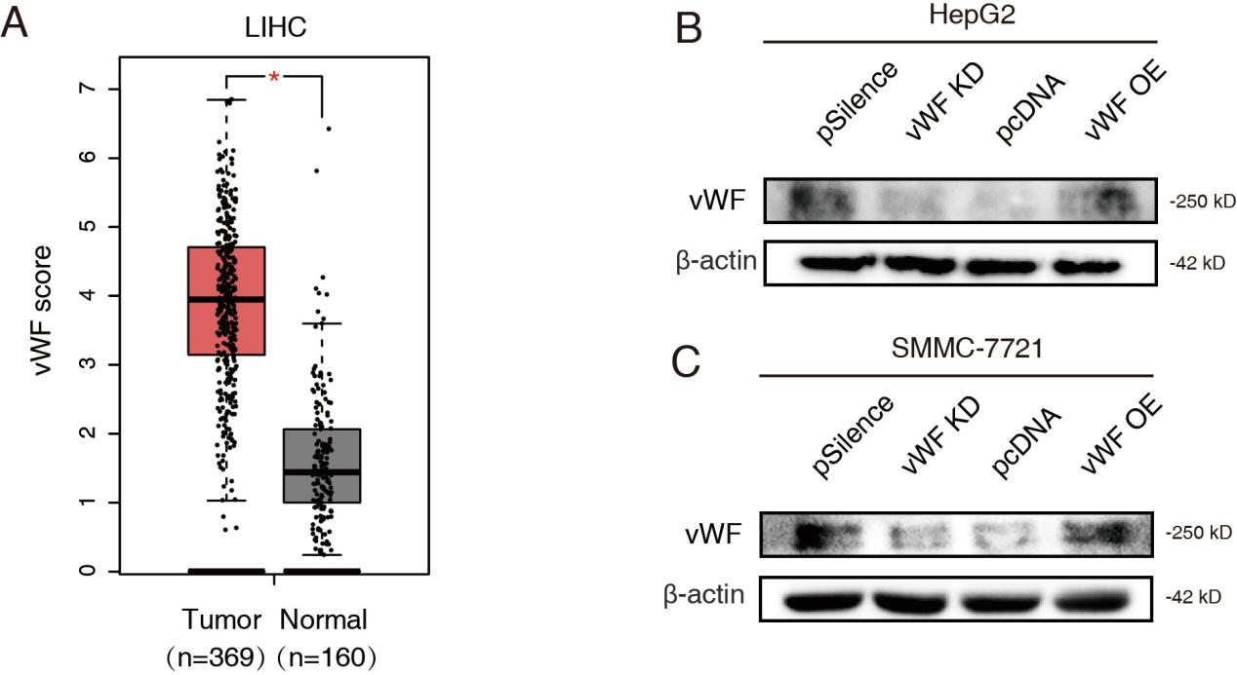

Supplementary figure S2:
IL-6/JAK1 signaling pathway activated by co-culture system regulates vWF mediated glycolysis and migration of HCC cells. (A) The concentrations of IL-6 in cell medium was detected by ELISA. (B) vWF expression levels in SMMC-7721 cells under the treatment of gradient concentrations of exogenous IL-6. (C) The phosphorylation levels of JAK2 in HCC cells with or without LX-2 cells co-culturing. (D) The effect of pyridone 6 on JAK1 phosphorylation under normal or co-culturing conditions was confirmed by Western blot. (E) Glycogen content of SMMC-7721 cells treating with vWF OE and pyridone 6 was detected by PAS staining. (F-G) Glycogen content of HepG2 and SMMC-7721 cells treating with vWF OE and pyridone 6 was detected by glycogen assays. (H-I) L-lactate content of HepG2 and SMMC-7721 cells treating with vWF OE and pyridone 6 was detected by L-lactate assays. (J-K) Migration ability of SMMC-7721 cells treating with vWF OE and pyridone 6 reflected by Wound-healing and Transwell assays. *P<0.05, **P<0.01, ***P<0.001; ns, no significance.
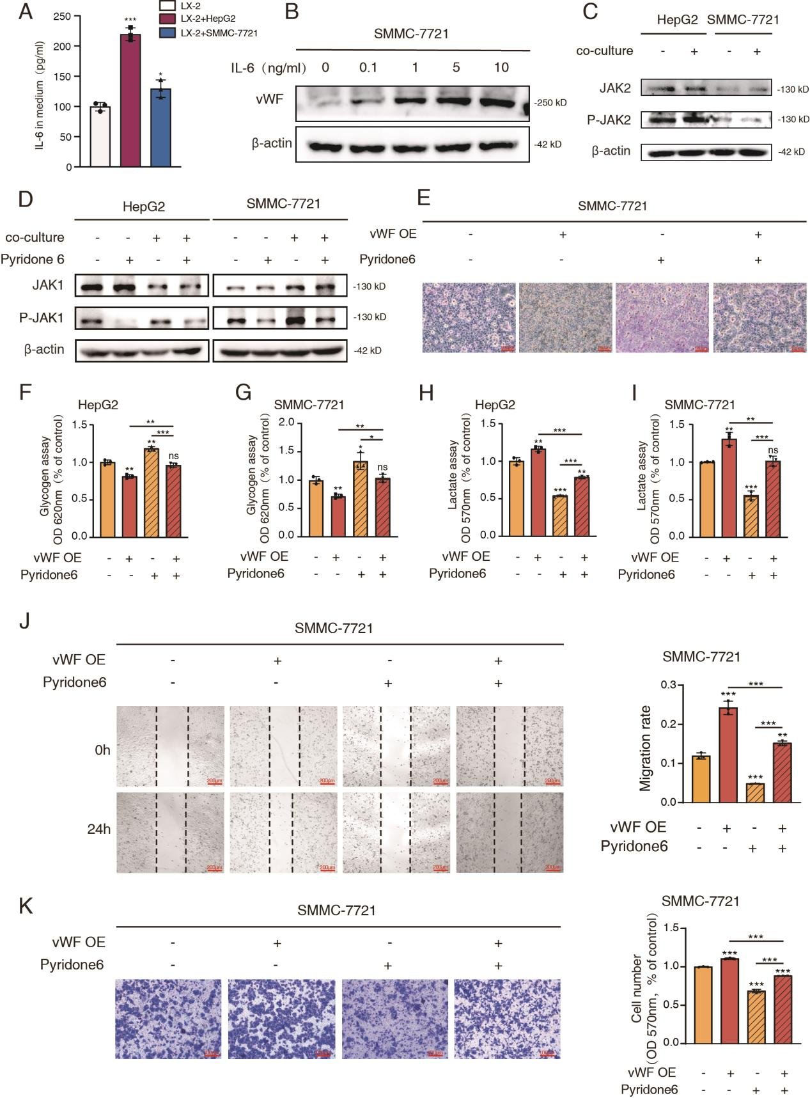

Supplementary figure S3:
LX-2 enhances vWF mediated TGFB1 expression and secretion by activating the JAK signaling pathway. (A) Relative mRNA expression data of PDGFB in HCC cells under pcDNA and vWF OE conditions. (B) Efficiency of si-TGFB1RII and si-control in LX-2 cells. (C) Efficiency of TGFB1 KD and control in HCC cells. (D-E) Functions of TGFB1 and TGFBR2 in mediating the migration ability of SMMC-7721 cells by Wound-healing. (F-G) Functions of TGFB1 and TGFB1RII in mediating the migration ability of SMMC-7721 cells by Transwell assays. *P<0.05, **P<0.01, ***P<0.001; ns, no significance.
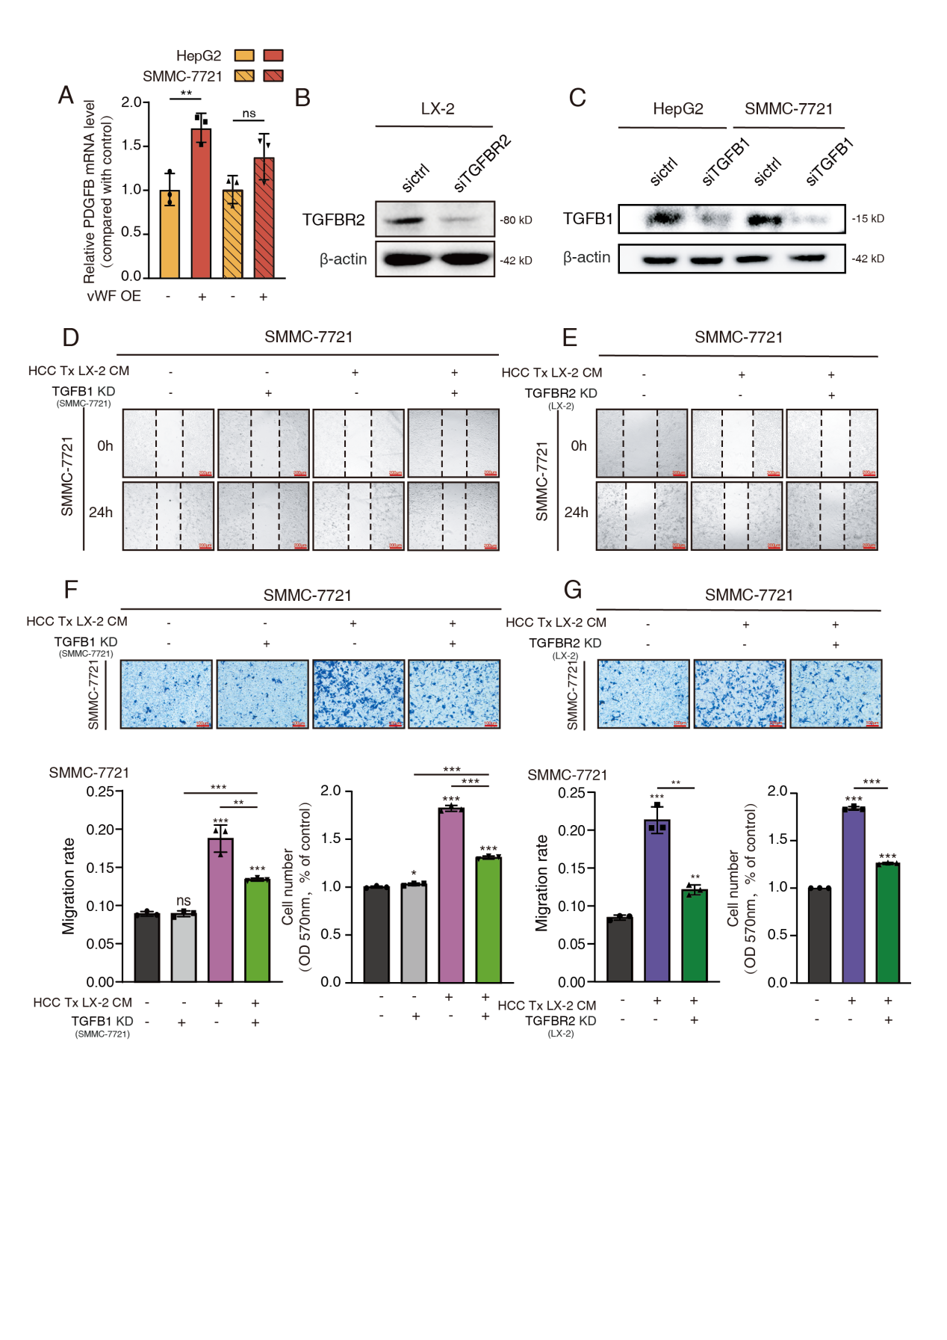

Supplementary figure S4:
TGFB1 derived from HCC cells promotes cancer cell migration and glycolysis through activating HSCs. SMMC-7721 cells transfected with vWF OE and si-TGFB1 or treated by pyridone 6 co-cultured with LX-2 cells transfected with si-TGFB1RII were used for (A) Western blot analysis of α-SMA levels of LX-2 cells; (B-C) Glycogen content reflected by PAS staining and glycogen assays; (D) L-lactate content tested by L-lactate assays; (E-F) Migration ability was examined by Wound-healing and Transwell assays. **P<0.01, ***P<0.001; ns, no significance.
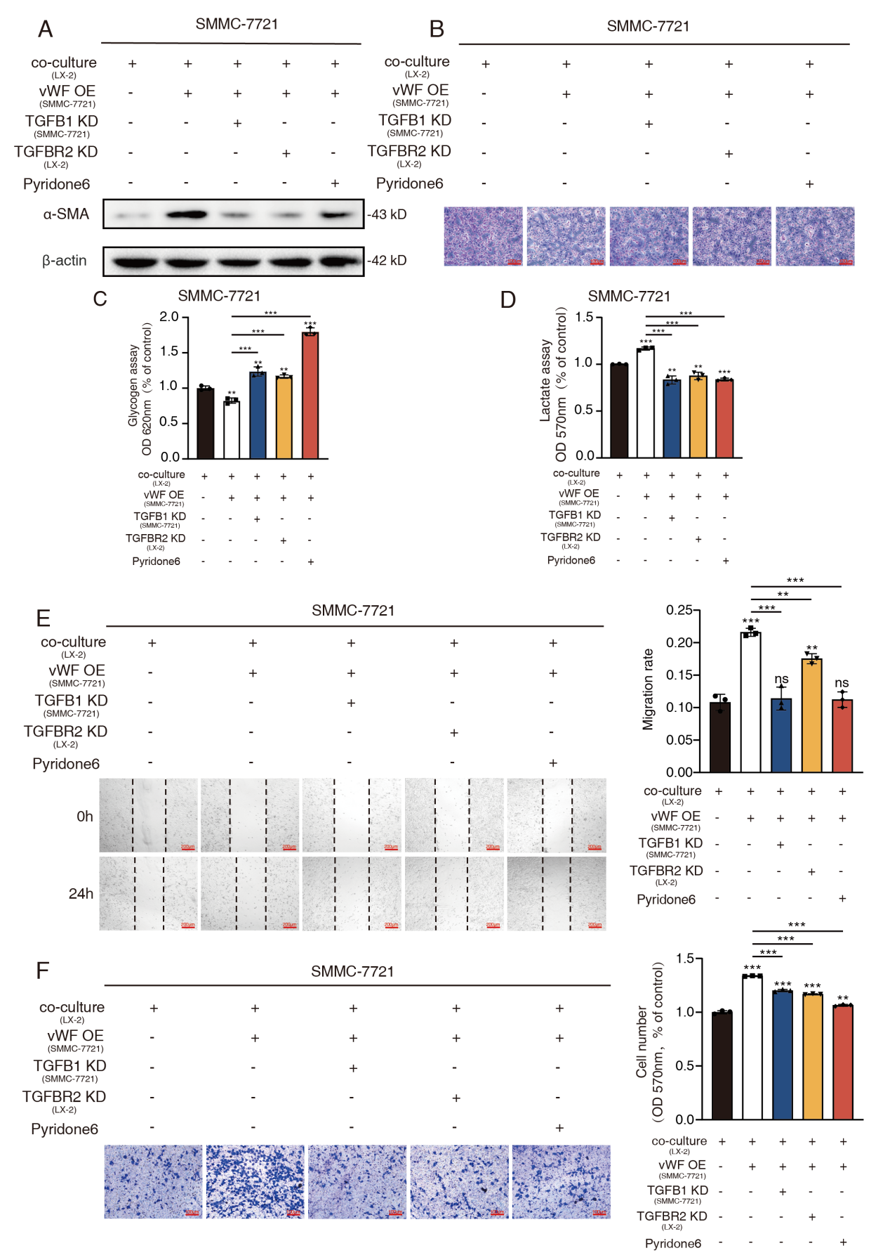

Supplementary Table S1:
List of plasmids and lentivirus used for transfection
Name | Sequence/Company
vWF shRNA | 5'-GCCAGAGCCTGTCTATCAATGTTCAAGAGACATTGATAGAC  AGGCTCTGGCTTTTTT-3'
vWF OE plasmid | Addgene, MA, USA ( (#124794)
TGFB1 shRNA | 5'-CAAGCAGAGTACACACAGCAT-3'
TGFBR2 shRNA | 5'-AATGACGAGAACATAACACT-3'

Supplementary Table S2:
List of Primers used in PCR
Gene name | Primers (5’-3’)
TGFB1 | forward | TGGTGGAAACCCACAACGAA
 | reverse | AGAAGTTGGCATGGTAGCCC
PDGFA | forward | CAGCGACTCCTGGAGATAGAC
 | reverse | GGACAGCTTCCTCGATGCTT
PDGFB | forward | GGAGTCGGCATGAATCGCT
 | reverse | AATGGGGTCCCCCTCGG
PDGFC | forward | AAATGAGCCTCTTCGGGCTT
 | reverse | TGAGGATCTTGTACTCCGTTCTG
PDGFD | forward | CTCAGGCGAGATGAGAGCAAT
 | reverse | GCACGTAGCCGTTTCCTTTC
VEGFA | forward | ACAAATGTGAATGCAGACCAAA
 | reverse | ACCAACGTACACGCTCCAG
CTGF | forward | CGCACAAGGGCCTATTCTGT
 | reverse | GAGCACCATCTTTGGCGGT
GAPDH | forward | GTCAGCCGCATCTTCTTTTG
 | reverse | GCGCCCAATACGACCAAATC

Supplementary Table S3:
List of antibodies used in western blot (WB)
Antibody name | Company | Application
Anti-vWF | SantaCruz Biotechnology, (#sc-53466) | WB/IHC
Anti-TGFB1 | Wanleibio, (WL02193) | WB/IHC
Anti-α-actin | Wanleibio, (WL02510) | WB/IHC
Anti-IL-6 | Wanleibio, (WL02841) | WB
Anti-JAK1 | Abways TECHOLOGY, (CY7173) | WB
Anti-p-JAK1 | Abways TECHOLOGY, (CY10423) | WB
Anti-JAK2 | Abways TECHOLOGY, (CY5287) | WB
Anti-p-JAK2 | Abways TECHOLOGY, (CY6570) | WB
Anti-TGFBR2 | Wanleibio, (WL02714) | WB
Anti-β-actin | Affinity Biosciences, (AF7018) | WB

